Software Requirements Specification

Version 2.0

*28th January 2016*

***Classroom Management System***

Submitted in partial fulfillment

Of the requirements of

CS 223 Software Engineering

This work is based upon the submissions of the course Software Engineering (CS223). The students who submitted this team projects were

* ***B Sree Siddharth***
* ***Vinay Kumar***
* ***Sandeep Charan***
* ***Snehal Azad***
* ***Hari Hara Reddy***

# Table of Contents

Table of Contents i

List of updates ii

1.0. Introduction 1

1.1. Purpose 1

1.2. Scope of Project 1

1.3 Constraints 1

1.4 Assumptions and Dependencies 1

1.4. References 2

1.5. Overview of Document 2

2.0. Overall Description 3

2.1 System Environment 3

2.2 Functional Requirements Specification 3

2.4 Activity Diagram 6

2.5 Sequence Diagram:- 8

2.6 User Characteristics 10

2.7 Non-Functional Requirements 10

Performance Requirements 10

*Performance* 10

*Safety* 10

*Reliability* 10

Software Quality Attributes 10

*Availability* 10

*Security* 10

*Usability* 10

3.0. Requirements Specification 12

3.1 Functional Requirements 12

3.1.1 Classroom Search 12

3.1.2 ***View Allotment of Classes*** 12

3.1.3 ***Booking History*** 13

3.1.4 ***Updation*** 13

3.3 Detailed Non-Functional Requirements 13

***3.3.1*** ***Logical Structure of the Data*** 13

4.0 Supporting information 14

4.1 Table of contents and index 14

4.2 Appendixes 14

# List of updates

***Version 1.1***

1. ***Addition of new use case login.***
2. ***Four use case Diagrams.***
3. ***One Class Diagram***
4. ***Two Activity Diagram***
5. ***Two Sequence Diagram.***

***Version 1.2***

1. ***Change in Class Diagram***
2. ***Change in Sequence Diagram.***

# 1.0. Introduction

## 1.1. Purpose

*The purpose of this document is to present a detailed description of* ***Class room******management system****. It is mainly for Institute’s educational needs. It will explain the purpose and features of the system, the interfaces of the system, what the system will do and under what constraints it will work.*

## 1.2. Scope of Project

*This software system will be designed to manage* ***Class room management system*** *through Institute Portal. More specifically, it will design and develop a simple system which takes care of the class room management of the institute. The system shall provide features to the user of an institute to view and manage the class room bookings and weekly time table of classes. When the faculty cancels the class they booked, a feature is added so that system will send a message to users. Admin also updates about the condition of the classroom (Equipments like projector). It also reminds the faculties that they have a class booked. Students can also view the timetable. The system also contains a relational database containing a list of Faculties, Students and Classroom details.*

## 1.3 Constraints

*1. Each Classroom booking has a time constraint of 1 hour for each booking.*

*2. Total number of classes is ten.*

*3. Time limit for classes- 8:00 AM to 6:00 PM.*

*4. Booking of extra classes can’t be booked before 3 days of the scheduled class.*

## 1.4 Assumptions and Dependencies

* The number of classes will be assumed.
* A class is assumed to have these features:-Normal, with Projector, with video conferencing.
* The Registration of faculties and students will be done by admin by directly including it in database, as they are not the focus of this software.
* There are two databases one for students and one for faculties.

***1.3. Glossary***

|  |  |
| --- | --- |
| **Term** | **Definition** |
| *Admin*  *User*  *Main Screen*  *Database*  *Reminder*  *Field*  *Faculty*  *Extra class* | *A group or a single person who has the right to alter all the features.*  *Includes both Faculty and Students.*  *Home Page of the Software.*  *Collection of all the information monitored by this system.*  *A form of message.*  *A blank to fill the required details.*  *A Person who teaches a group of students.*  *A class taken by faculty which is not specified in regular timetable.* |

## 1.4. References

IEEE. *IEEE Std 830-1998 IEEE Recommended Practice for Software Requirements Specifications.* IEEE Computer Society, 1998.

## 1.5. Overview of Document

The rest of the document is designed in the following way:

*The Requirements Specification section of this document is written in technical terms and gives details of the functionality of the product.*

# 2.0. Overall Description

## 2.1 System Environment

<< Keep blank for the time being >>

## 2.2 Functional Requirements Specification

. This section outlines the use cases for each of the actors separately.

***2.2.1*** ***Faculty use case:-***

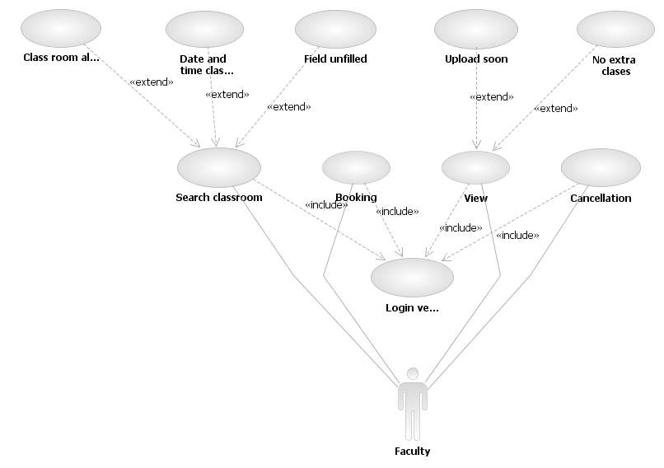

***2.2.2*** ***Student Use Case:-***

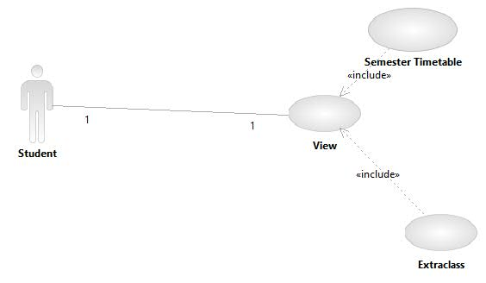

***2.2.3*** ***Admin Use Case:-***

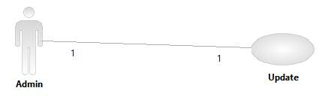

***2.2.4 Login Use Case:-***

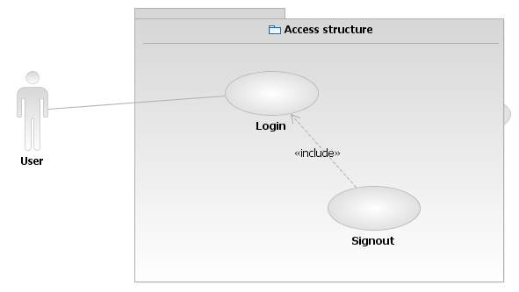

***2.3*** ***Class Diagram:-***

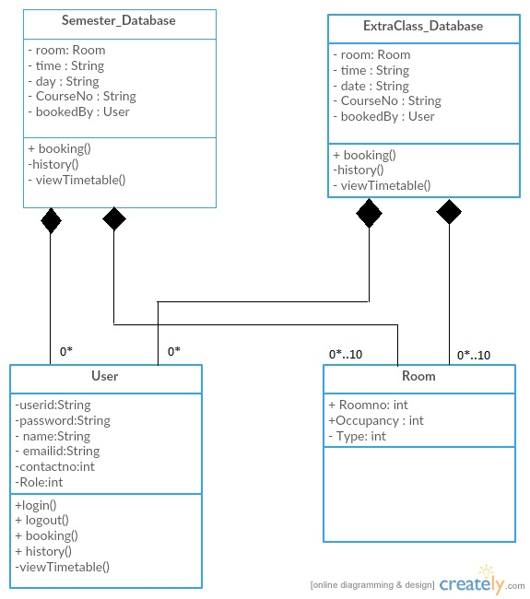

## 2.4 Activity Diagram

***2.4.1 Book Room***

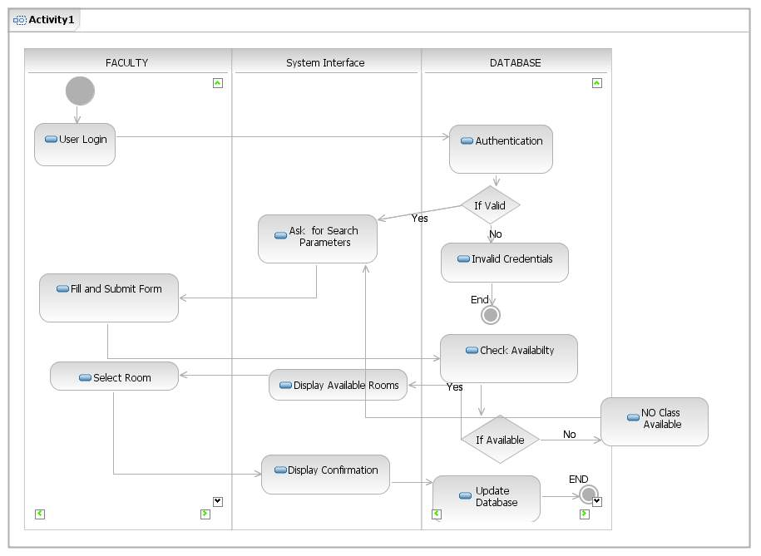

***2.4.2 Cancellation***

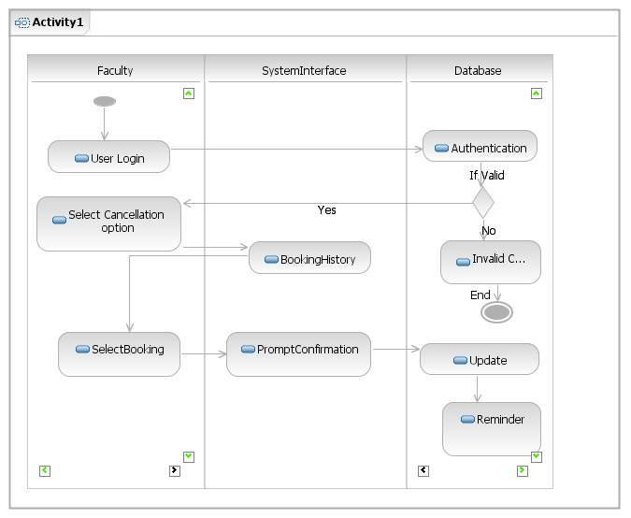

## 2.5 Sequence Diagram:-

***2.5.1 Booking***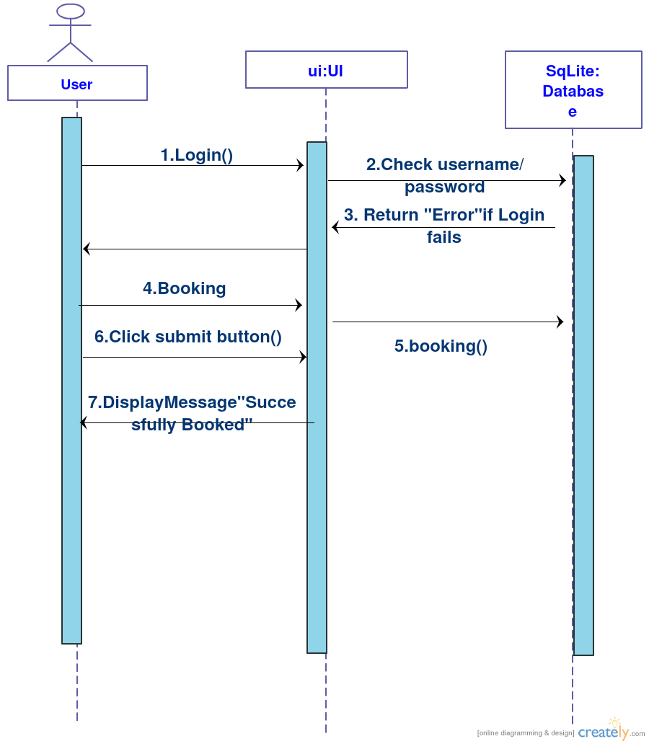

***2.5.2 Cancellation***



## 2.6 User Characteristics

*1. The User must be familiar with using the Internet.*

*2. User must be registered as student, staff or faculty member of IIT Jodhpur.*

*3. User must know how to use a search engine.*

## 2.7 Non-Functional Requirements

## Performance Requirements

### *Performance*

*The system must be interactive and the delays involved must be less .So in every action-response of the system, there are no immediate delays.*

### *Safety*

*Information transmission should be securely transmitted to server without any changes in information*

### *Reliability*

*As the system provides the right tools for discussion, problem solving it must be made sure that the system is reliable in its operations and for securing the sensitive details.*

## Software Quality Attributes

### *Availability*

*If the internet service gets disrupted while sending information to the server, the information can be sent again for verification.*

### *Security*

*The main security concern is for users account hence proper login mechanism should be used to avoid hacking. Hence, security is provided from unwanted use of recognition software.*

### *Usability*

*As the system is easy to handle and navigates in the most expected way with no delays. In that case the system program reacts accordingly and transverses quickly between its states.*

# 3.0. Requirements Specification

## 3.1 Functional Requirements

## 3.1.1 Classroom Search

|  |  |
| --- | --- |
| **Use Case Name** | *Search Classroom* |
| **Trigger** | *The Faculty selects a search link in main screen.* |
| **Precondition** | *The Faculty has accessed IITJ Classroom Booking main screen.* |
| **Basic Path** | 1. *The Faculty must select between semester or extra class booking .* 2. *The Options include Course number , occupancy of classroom, type of classroom (normal, with Projector, with video conferencing) , Period (extra class or full semester) and Date(including time).* 3. *After the search by Faculty, the system creates and presents a list of required Classroom (also shows the booked classrooms) in the database*. 4. *Faculty selects a Classroom.* |
| **Alternative Paths** | 1. *If in step 1, either field is blank, the reader is prompted to select or fill the choice.* |
| **Postcondition** | *The Selected Classroom is Booked.* |
| **Exception Paths** | *The Selected Classroom is already booked hence abandoning the search. The date and time clashes(i.e you have two classes)* |
| **Other** | *Your current activity is noted in the database.* |

### 3.1.2 ***View Allotment of Classes***

|  |  |
| --- | --- |
| **Use Case Name** | *View Allotment* |
| **Trigger** | *The user selects a view link.* |
| **Precondition** | *The user has accessed the IITJ Classroom Booking main screen.* |
| **Basic Path** | 1. *The user should choose either of the choices. The choices are Semester View and Extra Class.* 2. *If Semester view is selected, the system creates and presents a weekly timetable.* 3. *The user checks the timetable.* |
| **Alternative Paths** | 1. *If in step 2, Extra Class is selected the system displays date, time, class number and course number.* 2. *The user checks the timetable.* |
| **Postcondition** | *The Required Information is viewed.* |
| **Exception Paths** | *Timetable will be uploaded soon or No Extra Classes.* |
| **Other** | *None.* |

### 

### 3.1.3 ***Booking History***

|  |  |
| --- | --- |
| **Use Case Name** | *Booking History* |
| **Trigger** | *The Faculty selects the Booking History link.* |
| **Precondition** | *The Faculty has accessed the IITJ Classroom Booking main screen.* |
| **Basic Path** | 1. *The System displays the list of booked classrooms with details (i.e .Course number, Room number, date and time) in order by date of booking.* |
| **Alternative Paths** | *Can cancel bookings* |
| **Postcondition** | *The Required Information is viewed.* |
| **Exception Paths** | *None.* |
| **Other** | *None.* |

### 3.1.4 ***Updation***

|  |  |
| --- | --- |
| **Use Case Name** | *Updation* |
| **Trigger** | *The admin accesses the IITJ Classroom Booking Software.* |
| **Precondition** | *The admin has accessed IITJ Classroom Booking main screen.* |
| **Basic Path** | 1. *Admin sends messages to users that a specific component (i.e projector….) is not working in that classroom.* |
| **Alternative Paths** | *None* |
| **Postcondition** | None |
| **Exception Paths** | *None* |
| **Other** | *None* |

***3.1.5 Login***

|  |  |
| --- | --- |
| **Use Case Name** | *Login* |
| **Trigger** | *None* |
| **Precondition** | *Open the Software* |
| **Basic Path** | 1. *Username -> Password ->Login* |
| **Alternative Paths** | *None* |
| **Postcondition** | *The user has accessed the portal* |
| **Exception Paths** | *Invalid Password* |
| **Other** | *None* |

## 3.3 Detailed Non-Functional Requirements

### ***3.3.1 Logical Structure of the Data***

<< Keep this blank for the time being>>

# 4.0 Supporting information

## 4.1 Table of contents and index

## 4.2 Appendixes