**CS612 - Lab 6**

1. **Classification (Decision tree) Questions:** Draw the full decision tree for the parity function of four Boolean attributes, *A*, *B*, *C*, and *D*. Is it possible to simplify this tree? If yes, simplify it and redraw the simplified tree

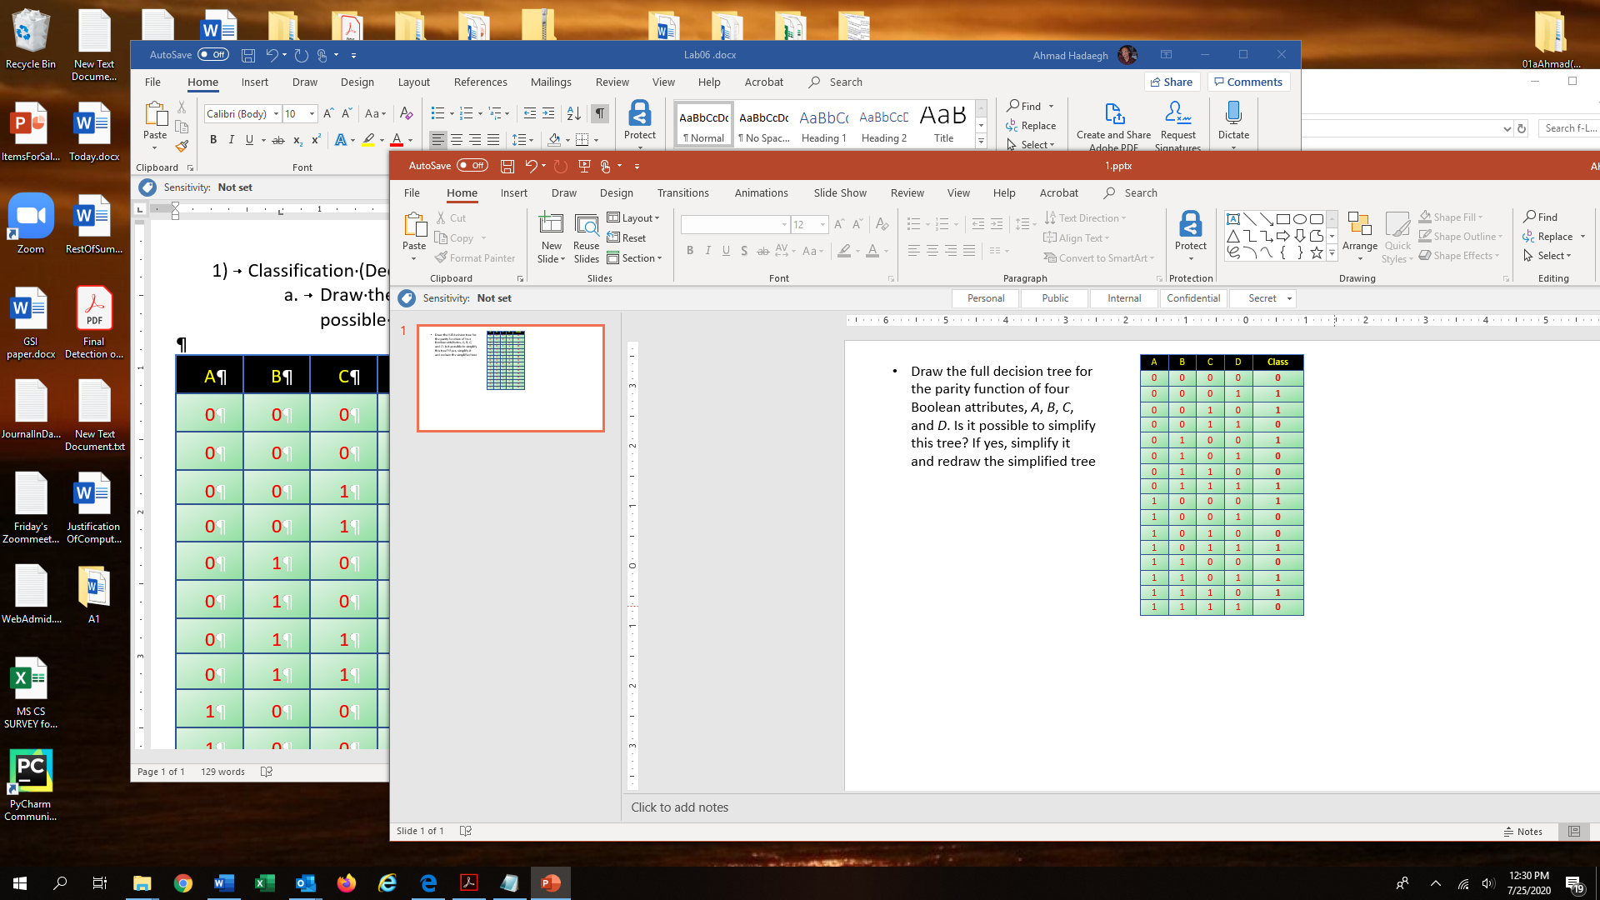

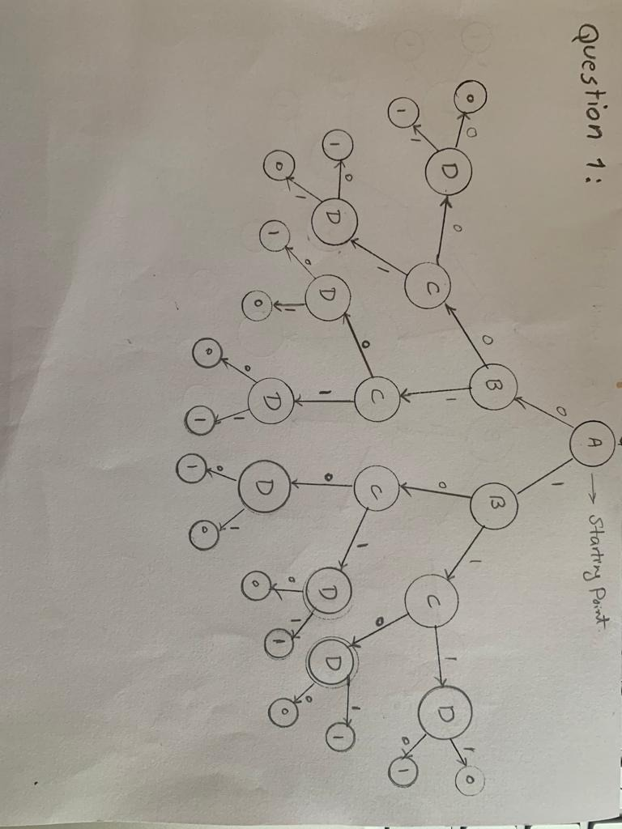

1. **Classification (Decision tree) Question:** Draw the full decision tree for the parity function of four Boolean attributes, *A*, *B*, *C*, and *D*. Is it possible to simplify this tree? If yes, simplify it and redraw the simplified tree

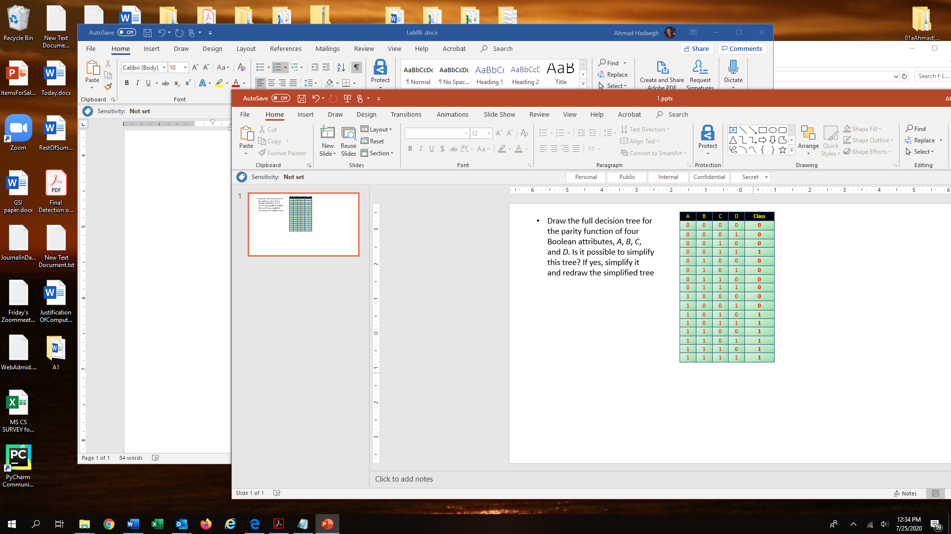

Step2 after simplify it:

1. ***Programming question***: Modify project 2 to add mutation. Every bit has a chance of 0.05 to be flipped.

***We wrote this mutation function to mutate each row of population***

def mutation(self, row):  
 #mu:mutation rate  
 mu =0.0005  
 #take a random number for each index in the row (mu_index contains random number for each index of a row)  
 mu_index = np.random.rand(self.TrainX.shape[1])  
 #Flip each bit of the row if the mu_index for that index is <= mu  
 row[ np.logical_and(mu_index <= mu , row == 0) ] = 1  
 row[np.logical_and(mu_index <= mu , row ==1)] = 0  
 return row

**Then this mutation function will be called in create_next_population () function 50 times to mutate all 50 rows of new population after doing the crossover( see last line of this code)**

#call mutation function for all rows in new population  
 for i in range(50):

self.population[i] = self.mutation(self.population[i])

**What to submit:**

* **Place Questions 1 and Question 2 in one file called it Lab6.docx**
* **Place only the sections of the code that you wrote for doing the mutation and called it CodeForLab6.py**
* **Place the above two files in a folder, call it based on your name and your partner’s name (ex: NancyJack-Lab6)**
* **Zip it and submit it through the cougar courses.**