MindTone: Front Matter

1. Cover Page

PROJECT REPORT
on ### MULTIMODAL EXPLAINABLE AI & MENTAL HEALTH
Submitted in partial fulfillment of the requirements for the Summer Internship on Research Sensitization & Innovative Project Development

Submitted By:
Name of Student | Roll Number
Adishakti Panigrahi | 2401109146
Azad Mohanty | 2401109172
Bablu Gouda | 2401109174
K. Om Prakash Reddy | 2401109190
Sahil Maharana | 2401109225
Satyajeet Maharana | 2401109228
Satyajit Nath | 2401109229
Shuvabrata Sahoo | 2401109232
Suraj Kumar Sahoo | 2401109248
Suvankar Jena | 2401109252

Under the Guidance of:
Dr. Debasis Mohapatra & Dr. Ranumayee Sing
Faculty Mentors, Department of Computer Science & Engineering

Institution Logo
DEPARTMENT OF COMPUTER SCIENCE & ENGINEERING
PARALA MAHARAJA ENGINEERING COLLEGE
(A Constituent College of Biju Patnaik University of Technology, BPUT, Odisha)
Berhampur, Odisha - 761003
Academic Year: 2025 - 2026

2. Certificate

PARALA MAHARAJA ENGINEERING COLLEGE
Berhampur, Odisha
DEPARTMENT OF COMPUTER SCIENCE & ENGINEERING
This is to certify that the project report entitled “Multimodal Explainable AI & Mental Health” is a bonafide record of the work carried out by the team under our supervision and guidance, in partial fulfillment of the requirements for the Summer Internship on Research Sensitization & Innovative Project Development.
Dr. Debasis Mohapatra
Faculty Mentor
Department of CSE
Dr. Ranumayee Sing
Faculty Mentor
Department of CSE
Head of the Department
Department of Computer Science & Engineering
Parala Maharaja Engineering College

3. Declaration
We, the undersigned, hereby declare that the project entitled “Multimodal Explainable AI & Mental Health” submitted to the Department of Computer Science & Engineering, Parala Maharaja Engineering College, is an original piece of work carried out by us under the guidance of Dr. Debasis Mohapatra and Dr. Ranumayee Sing.
We further declare that to the best of our knowledge, this work has not formed the basis for the award of any other degree or diploma at this or any other university.

Group Members:
- Azad Mohanty (Roll No: 2401109172)
- Adishakti Panigrahi (Roll No: 2401109146)
- Bablu Gouda (Roll No: 2401109174)
- K. Om Prakash Reddy (Roll No: 2401109190)
- Sahil Maharana (Roll No: 2401109225)
- Satyajeet Maharana (Roll No: 2401109228)
- Satyajit Nath (Roll No: 2401109229)
- Shuvabrata Sahoo (Roll No: 2401109232)
- Suraj Kumar Sahoo (Roll No: 2401109248)
- Suvankar Jena (Roll No: 2401109252)
Date:
Place: Berhampur, Odisha

4. Acknowledgement
We express our deep sense of gratitude and sincere thanks to our project mentors, Dr. Debasis Mohapatra and Dr. Ranumayee Sing, Department of Computer Science & Engineering, Parala Maharaja Engineering College, for their invaluable guidance, constant encouragement, and constructive suggestions throughout the course of this project.
We are highly indebted to the Head of the Department, Computer Science & Engineering, for providing the necessary facilities and support that enabled us to complete our work successfully.
Finally, we extend our heartfelt appreciation to our family members, peers, and friends who supported us directly or indirectly throughout this research and software development process.

5. Abstract
Mental health conditions represent a critical global health burden, with a significant proportion of the population remaining undiagnosed due to clinical resource shortages and social stigma. Traditional screening methods depend heavily on subjective, self-reported questionnaires, which are prone to recall bias. To address these challenges, this project introduces MindTone, an Explainable Multimodal AI Framework designed to predict mental health conditions and analyze the clinical impact of domestic family environments and subjective loneliness.
The framework integrates structured questionnaire assessments (combining DSM-5 diagnostic criteria, PHQ-9, and GAD-7) with objective vocal acoustic feature extractions (fundamental frequency $F_{0}$, jitter, shimmer, HNR, and speech rate) computed using the librosa and parselmouth Python libraries. Machine learning pipelines were developed using gradient boosting classifiers and regressors. Evaluation results show that the CatBoostRegressor achieved an $R^{2}$ score of 0.71 (with an accuracy of 96.13% within a $±10\%$ error margin) when predicting disorder severity from tabular check-ins, outperforming XGBoost and Random Forest. For vocal distress classification, the CatBoostClassifier achieved an accuracy of 86.90% and an F1-Score of 86.89%.
To establish clinical trust, SHAP (SHapley Additive exPlanations) is integrated to generate visual feature-weight attributions, validating that the models align with DSM-5 criteria by identifying loneliness and dysfunctional family dynamics as the primary contributors to elevated depression and anxiety risk. The backend dynamically compiles results into a printable PDF clinical report using ReportLab. MindTone provides a secure, lightweight, and low-cost pre-clinical screening kiosk framework, offering objective and transparent evaluations to support medical decision-making.
Keywords: Multimodal AI, Explainable AI (XAI), CatBoost, SHAP, Vocal Biomarkers, Librosa, Mental Health Screening.

6. Table of Contents (Outline)
- Front Matter
  - Cover Page
  - Certificate
  - Declaration
  - Acknowledgement
  - Abstract
- Chapter 1: Introduction
  - 1.1 Background
  - 1.2 Problem Statement
  - 1.3 Need for the Product
  - 1.4 Objectives
  - 1.5 Scope
  - 1.6 Contributions
- Chapter 2: Literature Review
  - 2.1 Review of Research Papers
  - 2.2 Overall Research Gaps
  - 2.3 Proposed Innovative Solution: MindTone
- Chapter 3: Requirement Analysis
  - 3.1 Functional Requirements
  - 3.2 Non-Functional Requirements
  - 3.3 System Requirements
    - 3.3.1 Software Requirements
    - 3.3.2 Baseline Hardware Requirements
    - 3.3.3 Proposed IoT Hardware Expansion
- Chapter 4: Product Design
  - 4.1 System Architecture
  - 4.2 Flowchart (System Workflow)
  - 4.3 UML Diagrams
    - 4.3.1 Use-Case Diagram
    - 4.3.2 Class Diagram
    - 4.3.3 Sequence Diagram
  - 4.4 Database Design
  - 4.5 User Interface (UI) Design
- Chapter 5: Product Development
  - 5.1 Development Life Cycle (Roadmap)
  - 5.2 Core Software Modules
  - 5.3 System Algorithms
    - Algorithm 1: Data Preprocessing and Model Training
    - Algorithm 2: User Assessment and Multimodal Prediction
    - Algorithm 3: Admin Management Module
- Chapter 6: Implementation
  - 6.1 Development & Run-time Environment
  - 6.2 Key Software Libraries & Frameworks
  - 6.3 System Deployment
  - 6.4 Interface Screenshots
- Chapter 7: Testing and Validation
  - 7.1 Software Testing Methodology
  - 7.2 Functional Test Cases
  - 7.3 Performance & Stability Evaluation
- Chapter 8: Results and Discussion
  - 8.1 Machine Learning Model Performance
  - 8.2 Explainable AI (XAI) Validation
  - 8.3 System & Report Validation
- Chapter 9: Conclusion and Future Works
  - 9.1 Conclusion
  - 9.2 Future Scope
- References

Chapter 1: Introduction

1.1 Background
According to the World Health Organization (WHO), mental health conditions represent a critical global health burden, with nearly one in eight individuals worldwide living with a diagnosed mental disorder. Despite the prevalence of these conditions, a significant proportion of the population remains undiagnosed and untreated due to social stigma, lack of clinical resources, and financial barriers. The most common mental disorders—including Major Depressive Disorder (MDD), Generalized Anxiety Disorder (GAD), Post-Traumatic Stress Disorder (PTSD), and Bipolar disorders—profoundly affect an individual’s cognitive, emotional, and social capacities.
In recent years, the integration of Artificial Intelligence (AI) and Machine Learning (ML) in healthcare has opened new avenues for early screening, diagnostic support, and personalized intervention. Traditional mental health assessments rely heavily on manual, self-reported questionnaires (such as the Patient Health Questionnaire-9 or Generalized Anxiety Disorder-7) administered during clinical visits. While valuable, these assessments are subjective, susceptible to recall bias, and capture only a static snapshot of a patient’s state. AI-driven frameworks can process multi-modal data streams—combining structured psychological metrics with objective physiological indicators, facial features, and vocal acoustics—to provide a more continuous, objective, and comprehensive evaluation of mental well-being.
Furthermore, mental health does not exist in isolation; it is deeply influenced by psychosocial factors. Research highlights that family environments, social support systems, and chronic loneliness are major determinants of psychological resilience and vulnerability. A supportive family dynamic and strong social bonds act as protective barriers against stress and depression. Conversely, dysfunctional family environments, frequent domestic conflicts, and persistent loneliness are highly correlated with elevated risks of severe depression, anxiety, and suicidal ideation. Integrating these psychosocial metrics alongside clinical symptoms enables computational models to make more personalized, accurate, and context-aware risk assessments.

1.2 Problem Statement
Conventional mental health screening systems face several core limitations that prevent them from achieving widespread clinical adoption and trust: 1. Single-Modal Limitations: Most existing diagnostic models rely exclusively on a single type of data (e.g., self-reported questionnaires or text analysis of social media posts). These systems fail to capture the physiological, vocal, and behavioral nuances of mental distress, leading to lower diagnostic sensitivity and specificity. 2. Neglect of Psychosocial Context: Current screening models rarely incorporate critical environmental factors, such as family dynamics and the subjective experience of loneliness, which are key drivers of mental health deterioration. 3. The “Black-Box” Problem: Advanced machine learning models (like deep neural networks) operate as black boxes, providing predictions without explaining the underlying reasoning. In clinical settings, healthcare professionals cannot trust or act upon diagnostic predictions without transparent, interpretable justifications. 4. Lack of Demographic Calibration: Many existing algorithms are trained on Western datasets and fail to generalize to the unique social, family structures (like joint families), and cultural contexts of the Indian population.

1.3 Need for the Product
The development of MindTone is driven by the urgent need for an accessible, objective, and transparent mental health screening solution.
- Clinical Resource Scarcity: In developing nations like India, the patient-to-psychiatrist ratio is critically low. There is an immediate need for an automated, pre-clinical screening tool that can triage patients and identify high-risk individuals before they reach a crisis point.
- Objective Vocal Biomarkers: By extracting objective acoustic features (such as pitch, jitter, shimmer, and speech rate) from short voice recordings, MindTone bypasses the subjectivity and bias of traditional self-reports.
- Explainability for Clinicians: Clinicians require tools that assist, rather than replace, their decision-making process. By utilizing Explainable AI (XAI) frameworks, MindTone provides feature-level explanations (such as SHAP values), allowing doctors to see exactly how questionnaire answers and voice metrics contributed to a specific risk tier.
- Portability and Integration: There is a lack of portable, low-cost screening kiosks that can be deployed in community centers, schools, and rural clinics to bring mental health assessments directly to underserved populations.

1.4 Objectives
The primary objective of this project is to design, develop, and validate MindTone—an Explainable Multimodal AI Framework for predicting mental health conditions and analyzing the impact of family environments and loneliness, with a focus on the socio-cultural context of the Indian population.
To achieve this, the project is structured around the following sub-objectives: * Objective 1: Build a multimodal data acquisition framework capable of collecting and preprocessing structured questionnaire responses and raw audio voice recordings. * Objective 2: Train and evaluate machine learning models (specifically CatBoost regressors and classifiers) to predict clinical risk scores for major disorders (MDD, GAD, PTSD, Dysthymia) and risk factors (suicide, psychological distress). * Objective 3: Implement an Explainable AI (XAI) pipeline using SHAP to generate localized, visual feature attribution maps for every assessment, ensuring transparency for clinical reviewers. * Objective 4: Analyze the statistical influence of family structures (nuclear vs. joint), family dynamics (supportive vs. dysfunctional), and subjective loneliness indicators on overall mental health outcomes.

1.5 Scope
The scope of MindTone encompasses pre-clinical screening, clinical decision support, and remote patient monitoring: * Pre-clinical Triage: It serves as an early-stage screening tool in schools, universities, and corporate offices to identify individuals experiencing sub-clinical levels of anxiety or depression. * Clinical Decision Support System (CDSS): Placed in clinics and hospitals, it assists general practitioners by providing a structured, explainable PDF report containing acoustic graphs and risk factor weights before the patient sees a specialist. * Rural and Community Health: Deployed via portable web interfaces, it enables community health workers to administer basic assessments in rural areas where mental health professionals are completely unavailable.

1.6 Contributions
This project introduces several key contributions to the field of computational mental healthcare: 1. Multimodal Fusion Engine: Developed a custom fusion algorithm that combines tabular questionnaire features (including DSM-5 mapped scores, PHQ-9, and GAD-7) with vocal acoustic feature vectors to produce a unified diagnostic risk profile. 2. Headless Report Compiler: Built an automated, server-compatible reporting engine using ReportLab and Matplotlib (Agg backend) to compile raw clinical data and SHAP explanation visual charts into high-quality, printable PDF reports instantly. 3. Indigo Clinical Design System: Implemented a clean, accessible Next.js dashboard using an Indigo-brand theme, complete with dynamic visual range bars showing observed vocal pitch, jitter, and shimmer against typical healthy baselines. 4. Local DB Management Tools: Created command-line utility tools (promote.js and reset-password.js) to streamline database administration, user role elevations, and secure password resets on a PostgreSQL backend via Prisma ORM.

Chapter 2: Literature Review
A review of relevant academic literature establishes the clinical and computational foundations of the proposed system. Key areas of interest comprise explainable artificial intelligence (XAI) frameworks, multimodal machine learning architectures in psychiatric screening, and socio-cultural determinants of mental health—including family structure and subjective loneliness—within the Indian demographic.

2.1 Review of Research Papers

Paper 1: Explainable AI for Mental Health through Transparency and Interpretability for Understandability (TIFU Framework)
- Authors: Dan W. Joyce, Andrey Kormilitzin, Katharine A. Smith, and Andrea Cipriani
- Data Sources: PubMed review of 15 XAI-based mental health studies published between 2018 and 2022.
- Methodology: The authors introduced the TIFU (Transparency and Interpretability for Understandability) framework, evaluating clinical models against reference models (like Logistic Regression) and discussing local feature attributions using SHAP (SHapley Additive exPlanations) and LIME.
- Key Results: The review demonstrated that XAI improves clinical trust, but only 3 out of 15 studies actually evaluated clinician understanding of these explanations.
- Research Gaps: The study highlighted that there is no consensus on standard definitions of explainability in mental healthcare. Furthermore, SHAP and LIME alone do not guarantee clinical interpretability without physician validation.

Paper 2: Toward Explainable AI (XAI) for Mental Health Detection Based on Language Behavior
- Authors: Elma Kerz, Sourabh Zanwar, Yu Qiao, and Daniel Wiechmann
- Data Sources: Social media clinical text datasets extracted from online platforms (Reddit, Twitter, and mental health forums).
- Methodology: Tested multiple traditional classifiers (SVM, Random Forest, Decision Tree, Logistic Regression, Naïve Bayes) and deep learning models (BERT) combined with SHAP and LIME to explain key linguistic feature weights.
- Key Results: Deep learning models (BERT) showed superior language-parsing capability, while local SHAP attributions successfully identified specific depression-indicative words and syntactic structures.
- Research Gaps: The models rely on privacy-sensitive social media data, which limits clinical utility. Additionally, there is a critical need for cross-cultural and multilingual validation, as language markers vary globally.

Paper 3: Mental Health Diagnosis: A Case for Explainable Artificial Intelligence
- Authors: G. Antoniou, E. Papadakis, and G. Baryannis (UK NHS-based study)
- Data Sources: 500 adult ADHD patient clinical cases collected from the UK National Health Service (NHS).
- Methodology: Developed a Hybrid Model combining a machine learning binary classifier with an expert knowledge-based rule system.
- Key Results: The hybrid approach achieved a high diagnostic classification accuracy of 98% while incorporating expert clinical rules to resolve conflicting AI predictions.
- Research Gaps: The rule-based component scales poorly when applied to multiple overlapping mental health conditions (such as comorbid depression and anxiety), and there is a lack of standard quantitative metrics to evaluate the explanation quality.

Paper 4: Explainable Artificial Intelligence Approaches for Predicting Depression by Combining Feature Selection Methods and Machine Learning Classifiers
- Authors: Min Gyeong Kim, Kun Chang Lee, Kwanho Lee, Hyung Uk Kim, Young Wook Seo, and Seong Wook Chae
- Data Sources: National Mental Health Survey of Korea (2021) dataset containing clinical profiles of 5,511 adults.
- Methodology: Tested feature selection methods (ReliefF, Markov Blanket, CFS) paired with multiple machine learning classifiers and SHAP-based local explainability.
- Key Results: The ReliefF feature selection method combined with a Stacking Ensemble classifier achieved the best performance with an F2-Score of 98.51%. The SHAP analysis identified loneliness, social distress, and quality of life indicators as the most dominant risk factors.
- Research Gaps: The study did not perform cross-cultural validation. Furthermore, it suffered from potential circular reasoning since some feature attributes were directly derived from diagnostic questionnaire inputs.

Paper 5: A Multimodal Fairness-Aware Machine Learning Framework for Mental Health Risk Prediction in University Students
- Authors: Zhu Tian, Jian Zhang, and Xia Wang
- Data Sources: Survey data collected from 14,604 university students across 24 academic institutions.
- Methodology: Proposed the BD-MHAM (Bi-directional Multimodal Fairness-Aware Machine Learning) framework to predict student mental health risks while using SHAP to analyze demographic influences.
- Key Results: The framework achieved an AUC of 0.972, a classification accuracy of 95.6%, and an F1-Score of 0.928 while reducing prediction bias across demographic subgroups.
- Research Gaps: The study was limited to academic environments and relied heavily on student self-reports, lacking integration of physical physiological markers or vocal acoustic vectors.

Paper 6: An Explainable Multimodal Deep Learning Approach for Stress Detection in Emotion-Aware Systems
- Authors: Sai H. Prajwal, Sofia Singh, and Dipti Theng
- Data Sources: The public WESAD (Wearable Stress and Affect Detection) dataset containing physiological signals from 15 subjects.
- Methodology: Developed an explainable framework for stress detection using Random Forest classifiers, SHAP attributions, and wavelet-based Heart Rate Variability (HRV) feature extraction.
- Key Results: The physiological-based stress classifier achieved an overall classification accuracy of 83%.
- Research Gaps: The dataset size was extremely small (15 participants), limiting generalization. The framework lacked multimodal integration with behavioral or speech-based indicators.

Paper 7: Epidemiology of Common Mental Disorders (CMDs) in India — NMHS 2015–16
- Authors: Pavithra Jayasankar, Narayana Manjunatha, Girish N. Rao, and the NMHS India Collaborator Group
- Data Sources: National Mental Health Survey (NMHS) India database covering representative adult populations (18+) across multiple states.
- Methodology: Conducted structured assessments using the MINI v6.0.0 (Mini International Neuropsychiatric Interview) clinical criteria paired with multiple logistic regression analysis.
- Key Results: The study revealed a massive mental health treatment gap in India. Higher prevalence rates of common mental disorders were identified among middle-aged populations, females, urban dwellers, and individuals suffering from economic insecurity.
- Research Gaps: The research did not incorporate computational ML modeling, focusing strictly on retrospective epidemiological statistics.

Paper 8: Family Mental Health in India — A Systematic Review (2015–2025)
- Authors: Justin Raj, Nishant Goyal, and Senthil M.
- Data Sources: Systematic review of 50 Indian studies published between 2015 and 2025.
- Methodology: Qualitative and meta-analysis synthesis of cross-sectional, longitudinal, and qualitative studies focusing on domestic dynamics.
- Key Results: The review established that family structures (joint vs. nuclear), family conflicts, caregiving burdens, stigma, and gender roles play a major role in shaping clinical depression and anxiety outcomes in India.
- Research Gaps: There was no translation of these psychosocial family indicators into structured machine learning pipelines or screening software interfaces.

2.2 Overall Research Gaps
An evaluation of the current state of the art highlights three primary research gaps:
- Lack of Multimodal Integration: Traditional models focus on either text, audio, or physiological sensors in isolation. Few frameworks combine clinical questionnaires (PHQ-9/GAD-7) with objective voice analysis and family environment features into a unified prediction pipeline.
- Abstract Explainability: While models utilize SHAP or LIME, the output graphs are rarely translated into simplified clinical reports that doctors can verify. There is a lack of translation from raw feature mathematical weights into actionable clinical dashboards.
- Absence of Socio-Cultural Context: Most diagnostic models are trained on Western demographic data. They completely ignore family support dynamics, economic stress parameters, and loneliness indices that are highly specific to the social fabric of the Indian population.

2.3 Proposed Innovative Solution: MindTone
To bridge these gaps, MindTone introduces an explainable multimodal framework that combines structured clinical questionnaires (PHQ-9/GAD-7), objective voice acoustic analysis (via librosa), and dedicated psychosocial indices (family dynamics, family structure, and loneliness). By applying CatBoost modeling and mapping feature weights using SHAP, MindTone exports a visual clinical PDF report, providing transparent, localized, and socio-culturally calibrated mental health screenings.

Chapter 3: Requirement Analysis
A systematic requirements elicitation process defines the functional limits and operational constraints of the MindTone framework. This section establishes the functional and non-functional specifications, followed by the baseline software and hardware specifications, alongside proposed IoT integration protocols.

3.1 Functional Requirements
Functional requirements define the core processing operations, inputs, outputs, and behaviors that the system must execute. The core pipeline is divided into eight primary functional blocks:
ID | Functional Requirement | Input | Output | Description
FR-1 | User Registration & Authentication | User details, credentials | Secure user account, active JWT session | Allows users to securely register, log in, and establish an encrypted session.
FR-2 | Multimodal Data Collection | User responses | Structured check-in assessment object | Collects patient questionnaire details (PHQ-9/GAD-7) along with family environment and loneliness parameters.
FR-3 | Real-Time Audio Capture | Patient voice response | Processed audio file (.wav) | Captures audio inputs directly through the user’s microphone during the assessment.
FR-4 | Preprocessing & Feature Extraction | Questionnaire data, raw audio | Normalized feature vectors | Preprocesses structured data and uses librosa to extract acoustic feature vectors (pitch, jitter, shimmer, HNR).
FR-5 | Mental Health Prediction | Processed feature vectors | Predicted disorder risk scores | Utilizes trained CatBoost models to predict risk tiers for specific mental health disorders.
FR-6 | Explainable AI Analysis | Model parameters, feature values | SHAP visual attribution data | Generates SHAP local explanation maps to justify how features influenced the prediction.
FR-7 | Clinical Report Generation | Prediction scores, XAI data | Timestamped, printable PDF report | Compiles observed metrics, risk indicators, and SHAP graphs into an Indigo-themed PDF using ReportLab.
FR-8 | Assessment History Retrieval | User historical query | Saved database records | Enables patients and authorized clinicians to view historical trends and progress charts.

3.2 Non-Functional Requirements
Non-functional requirements describe the operational qualities, constraints, and performance benchmarks of the system.
- Security: Patient data must be protected using standard encryption. Passwords must be hashed using bcrypt before storage. Client-server sessions must be secured with JSON Web Tokens (JWT) stored in HTTP-only cookies.
- Reliability: The backend must handle high-memory operations (like audio processing and PDF compiling) without crashing. Graphic generation using Matplotlib must execute in a headless thread ('Agg' backend) to prevent crashes.
- Performance: The ML inference pipeline (audio feature extraction + CatBoost prediction + SHAP generation) must return results within an acceptable threshold (< 5 seconds for a standard 10-second audio clip).
- Scalability: The database connection pool must handle concurrent read/write queries without resource locking, managed via serverless pooling mechanisms (Prisma PgAdapter).
- Usability: The frontend user interface must be clean, responsive, and provide clear tooltips explaining complex clinical metrics (e.g., pitch, jitter, and shimmer boundaries).

3.3 System Requirements

3.3.1 Software Requirements
- Operating System: Windows 10/11, macOS, or Linux (Ubuntu 20.04 LTS recommended for production deployment).
- Development Environment (IDE): Visual Studio Code (VS Code).
- Runtime Environments: Node.js (v18+) for frontend; Python (v3.10+) for ML backend.
- Frontend Technologies: React.js, Next.js (version 16), TypeScript, TailwindCSS.
- Backend Technologies: FastAPI, Uvicorn, Prisma ORM.
- Machine Learning & Signal Processing Libraries: CatBoost, Scikit-learn, SHAP, Librosa, NumPy, Pandas.
- Visualization & Output Libraries: Matplotlib, ReportLab.
- Database Management System: PostgreSQL (hosted on Neon.tech).
- Version Control: Git & GitHub.

3.3.2 Baseline Hardware Requirements (Client & Server)
- Client Device: Any standard PC, laptop, or tablet equipped with a functional microphone for voice reflection recording.
- Developer/Server Compute Specs:
  - Minimum: 1 vCPU, 1 GB RAM (AWS Lightsail, DigitalOcean Droplet, or Google Cloud Run container).
  - Storage: 10 GB SSD headroom for temporary audio conversions and local build assets.

3.3.3 Proposed IoT Hardware Expansion (Optional Modules)
Note: This hardware segment represents the proposed physical sensor integration scope for dedicated clinical kiosk deployments: * Microcontroller: ESP32-WROOM-32D Development Board (incorporating Wi-Fi and Bluetooth LE). * Acoustic/Bio-Sensors: * MAX30102 PPG Sensor (Pulse & SpO2 tracking). * AD8232 ECG Sensor Module (Heart Rate Variability / HRV mapping). * Grove GSR Sensor (Skin conductance tracking for emotional stress). * OEM Automatic BP Cuff (pressure sensor, 5V inflation motor, solenoid valve). * Power Configuration: 2x 18650 Li-ion cells with a TP4056 protective charging circuit and a 5V boost converter.

Chapter 4: Product Design
The system design phase establishes the structural, relational, and conceptual specifications of the MindTone mental health screening platform. This section details the high-level system architecture, data workflows, UML design mappings, relational database schema, and user interface layouts.

4.1 System Architecture
MindTone utilizes a decoupled, service-oriented architecture designed to handle lightweight frontend requests, complex database mutations, and CPU-intensive machine learning (ML) tasks in isolation.
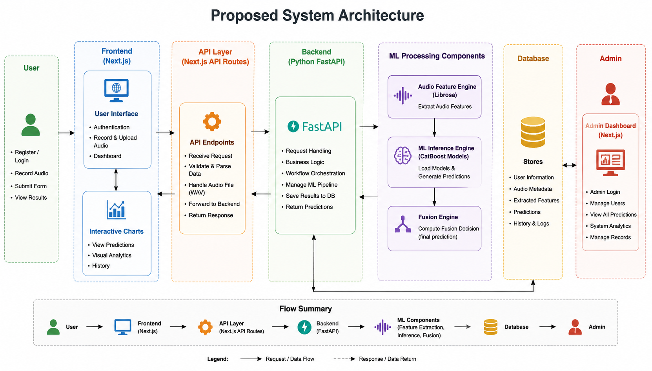
Figure 4.1: High-Level System Architecture Diagram

Architectural Components:
- Frontend User Interface (Next.js): Runs React client components. It manages secure routes, hosts the microphone recording interface, renders diagnostic charts, and calls the Next.js API serverless layer.
- API Proxy Layer: Built within Next.js API routing. It validates the user’s JWT cookie and routes heavy ML payloads directly to the FastAPI microservice while securely communicating with PostgreSQL via Prisma.
- FastAPI ML Service (Python): Handles heavy CPU operations. When a payload arrives, it reads the audio file, extracts acoustic vectors, loads the serialization models (.pkl pipelines), and runs inference.
- Relational Database (PostgreSQL): Stores user registration records, history arrays, and feature profiles.

4.2 Flowchart (System Workflow)
The diagnostic workflow describes the step-by-step processing of a patient assessment, from input to the final printable report:
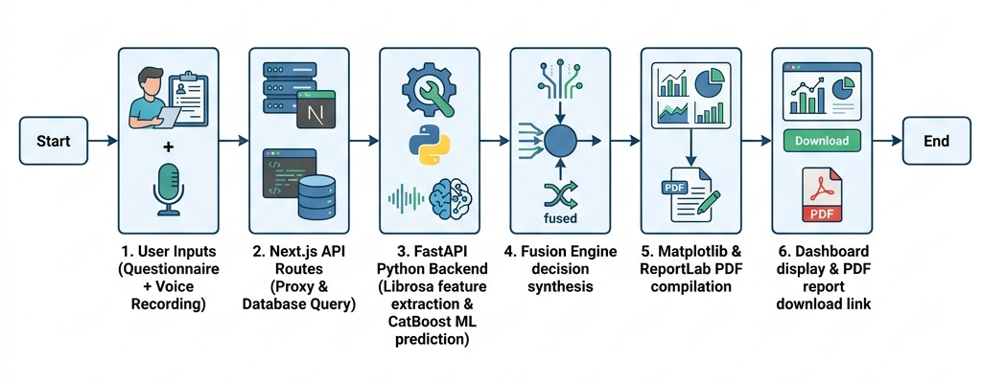
Figure 4.2: System Workflow Flowchart

4.3 UML Diagrams

4.3.1 Use-Case Diagram
The Use-Case diagram details the interactions between the two primary stakeholders—Patients (Users) and Administrators—and the Mental Health Assessment System boundaries.
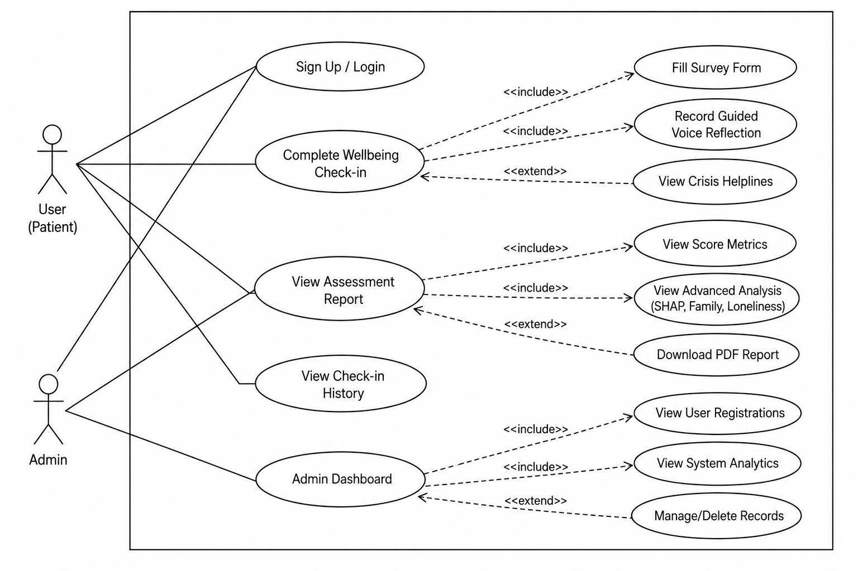
Figure 4.3: System Use-Case Diagram
- User (Patient) Interactions:
  - Sign Up / Log In.
  - Complete Wellbeing Check-in (includes filling the survey form, recording guided voice reflection, and viewing crisis helplines as an extended flow).
  - View Assessment Report (includes viewing score metrics, viewing advanced SHAP/psychosocial analysis, and downloading the PDF report).
  - View Check-in History.
- Admin Interactions:
  - Log in to the Admin Dashboard.
  - View System Analytics (total users, average stress levels).
  - View User Registrations.
  - Manage/Delete history records.

4.3.2 Class Diagram
The Class diagram illustrates the object-oriented structure of the software components, describing attributes, methods, and relationships:
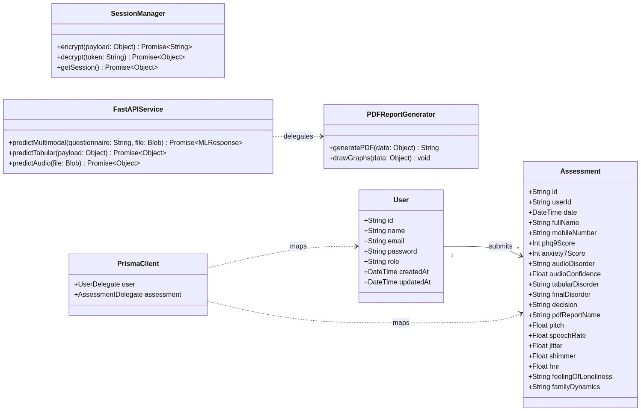
Figure 4.4: Software Component Class Diagram
- Key Classes:
  - SessionManager: Manages session encryption, decryption, and fetching.
  - FastAPIService: Coordinates multimodal predictions, tabular predictions, and audio predictions.
  - PDFReportGenerator: Manages ReportLab PDF compilation and Matplotlib chart drawing.
  - PrismaClient: Connects and delegates database requests.
  - User: Stores account credentials and timestamps.
  - Assessment: Tracks complete diagnostic and acoustic feature outputs.

4.3.3 Sequence Diagram
The Sequence diagram tracks the chronological execution flow across components during a multimodal wellbeing check-in:
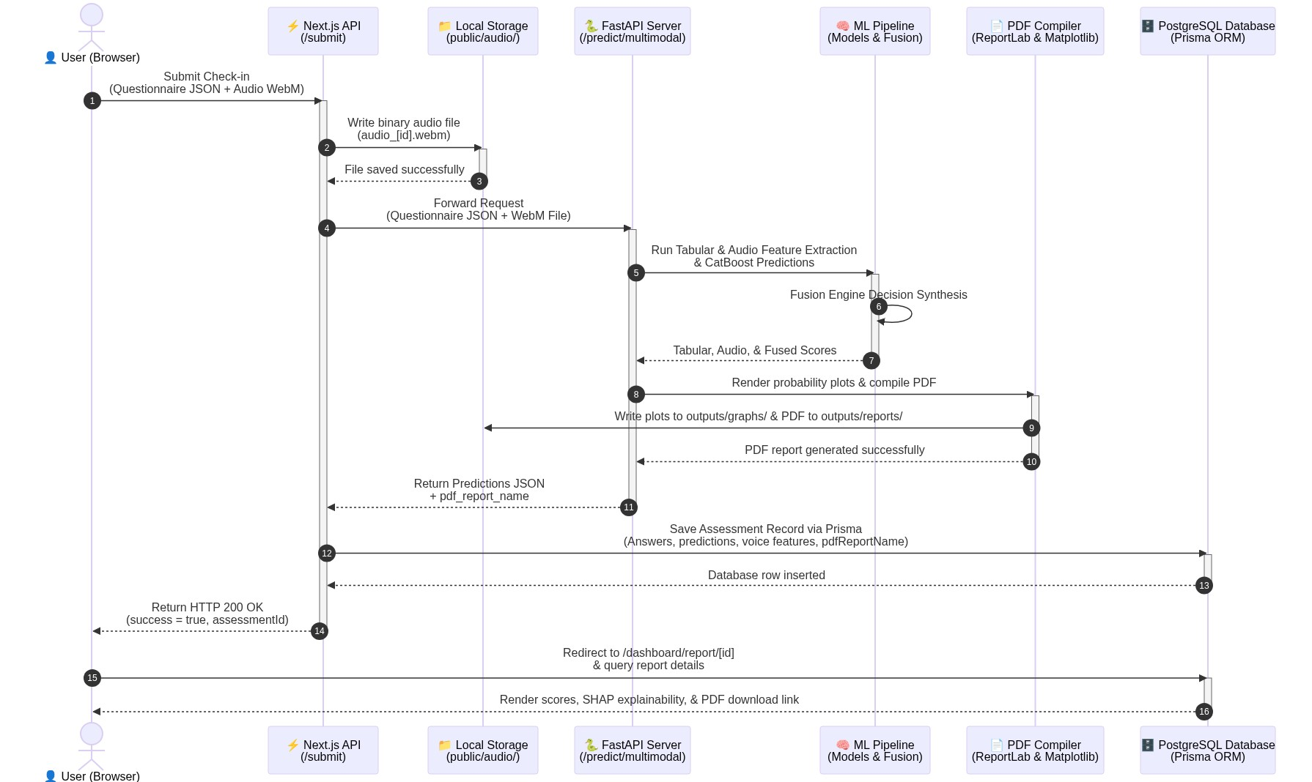
Figure 4.5: Chronological Sequence Diagram
- Workflow Timeline:
  - Patient submits questionnaire responses and WebM audio recording.
  - The Next.js API layer stores the raw WebM file.
  - Next.js passes the request to the FastAPI ML backend.
  - FastAPI extracts acoustic metrics, executes CatBoost model predictions, and synthesizes the decision in the Fusion Engine.
  - The report engine plots charts and compiles a PDF report using ReportLab.
  - Response is sent back to the Next.js frontend to save the database records via Prisma.
  - User is redirected to the report dashboard where the final scores, SHAP explanations, and PDF download links are displayed.

4.4 Database Design
The database schema utilizes relational integrity constraints enforced by Prisma and hosted on serverless PostgreSQL (Neon.tech).
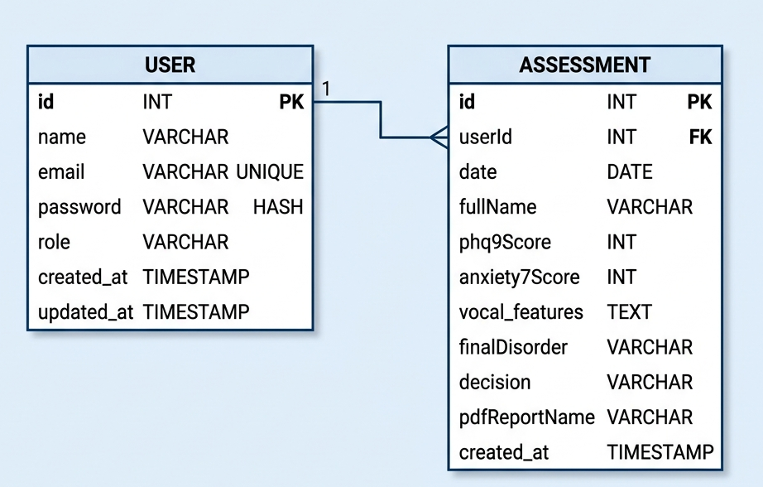
Figure 4.6: Database Entity Relationship Diagram (ERD)

Relational Tables

1. User Table
Tracks registered user credentials, profile information, and roles.
Column Name | Data Type | Constraints | Description
id | String | Primary Key, Unique | Unique identifier for each user.
name | String | Required | Full name of the user.
email | String | Unique, Required | User email address used for login.
password | String | Required | Securely hashed password (bcrypt).
role | String | Default: “USER” | System access level (USER or ADMIN).
createdAt | DateTime | Default: NOW | Timestamp when account was created.
updatedAt | DateTime | Auto-update | Timestamp of last profile edit.

2. Assessment Table
Stores individual screening assessment data, clinical scoring metrics, and voice acoustic outputs.
Column Name | Data Type | Constraints | Description
id | String | Primary Key, Unique | Unique identifier for each assessment.
userId | String | Foreign Key (User) | Maps the assessment to a specific user.
date | DateTime | Default: NOW | Date and time the check-in occurred.
fullName | String | Required | Full name provided during assessment.
mobileNumber | String | Required | Contact number for verification.
phq9Score | Integer | Required | Total score calculated from PHQ-9 (0-27).
anxietyScore | Integer | Required | Total score calculated from GAD-7 (0-21).
audioDisorder | String | Required | Classification output from audio model.
audioConfidence | Float | Required | Confidence score of the audio classifier.
tabularDisorder | String | Required | Classification output from tabular model.
finalDisorder | String | Required | Integrated output from the Fusion Engine.
decision | String | Required | Clinical action recommendation text.
pdfReportName | String | Required | Filepath to the generated ReportLab PDF.
pitch | Float | Required | Extracted fundamental frequency (F0) in Hz.
speechRate | Float | Required | Words Per Minute (WPM) speed rate.
jitter | Float | Required | Calculated frequency instability (%).
shimmer | Float | Required | Calculated amplitude instability (%).
hnr | Float | Required | Harmonic-to-Noise Ratio (dB).
feelingOfLoneliness | String | Required | Patient loneliness assessment flag.
familyDynamics | String | Required | Family dynamic status (Supportive/Dysfunctional).

4.5 User Interface (UI) Design
The user interface is designed using an Indigo-brand color system to establish a calm, professional, and accessible clinical environment.
- User Authentication (Login Screen): A centralized Card-style interface containing validated inputs for credentials, featuring micro-interactions on form submission and error indicators.
- 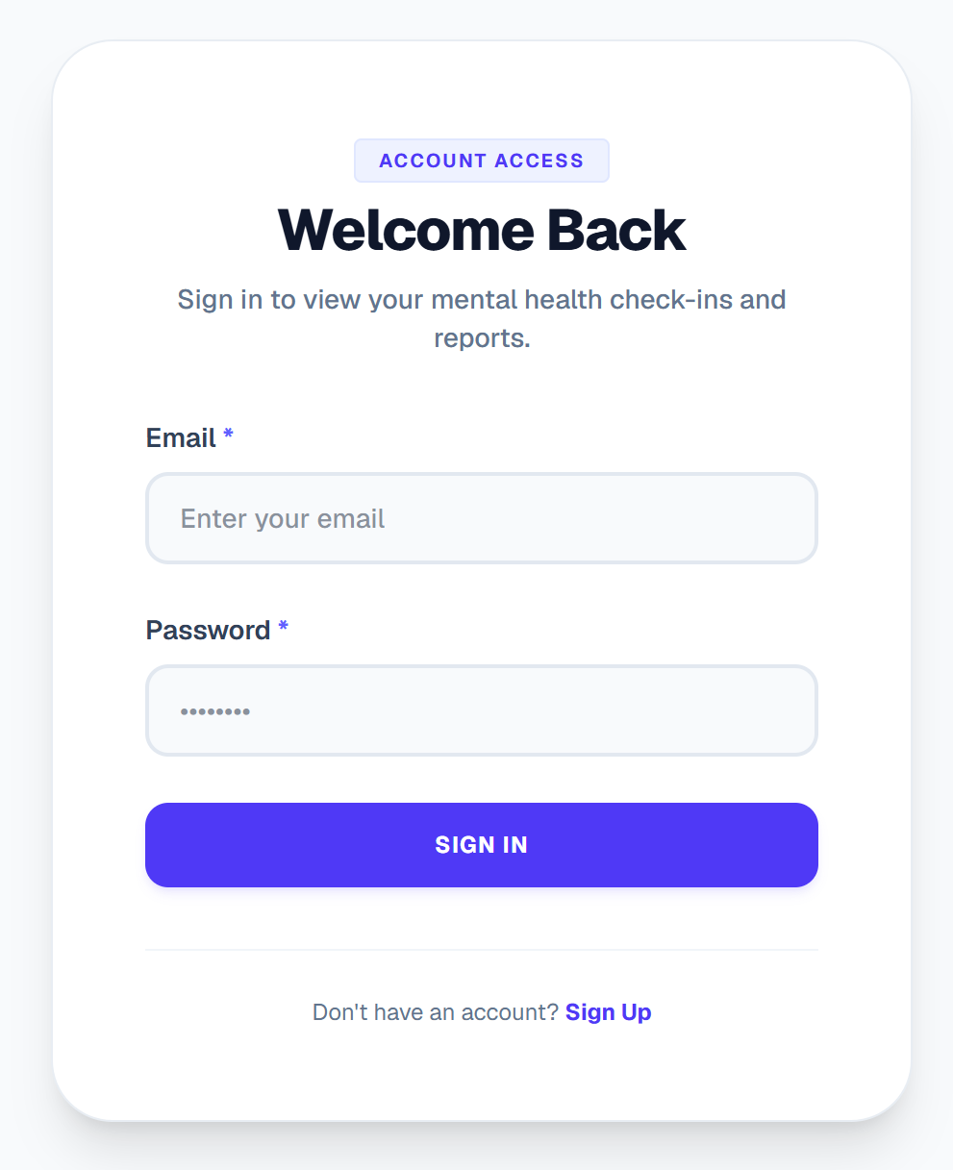
- Figure 4.7: User Authentication Portal Interface
- Patient Dashboard:
  - Score Overview Card: Renders the final fused diagnosis tier and a summary recommendation.
  - Clinical Feature Panels: Collapsible panels that expand to reveal detailed acoustic feature metrics (pitch, jitter, shimmer, HNR) mapped against target clinical normal ranges.
  - Psychosocial Stress Index: Interactive bar indicators illustrating the severity of loneliness metrics and family dynamic stressors.
- 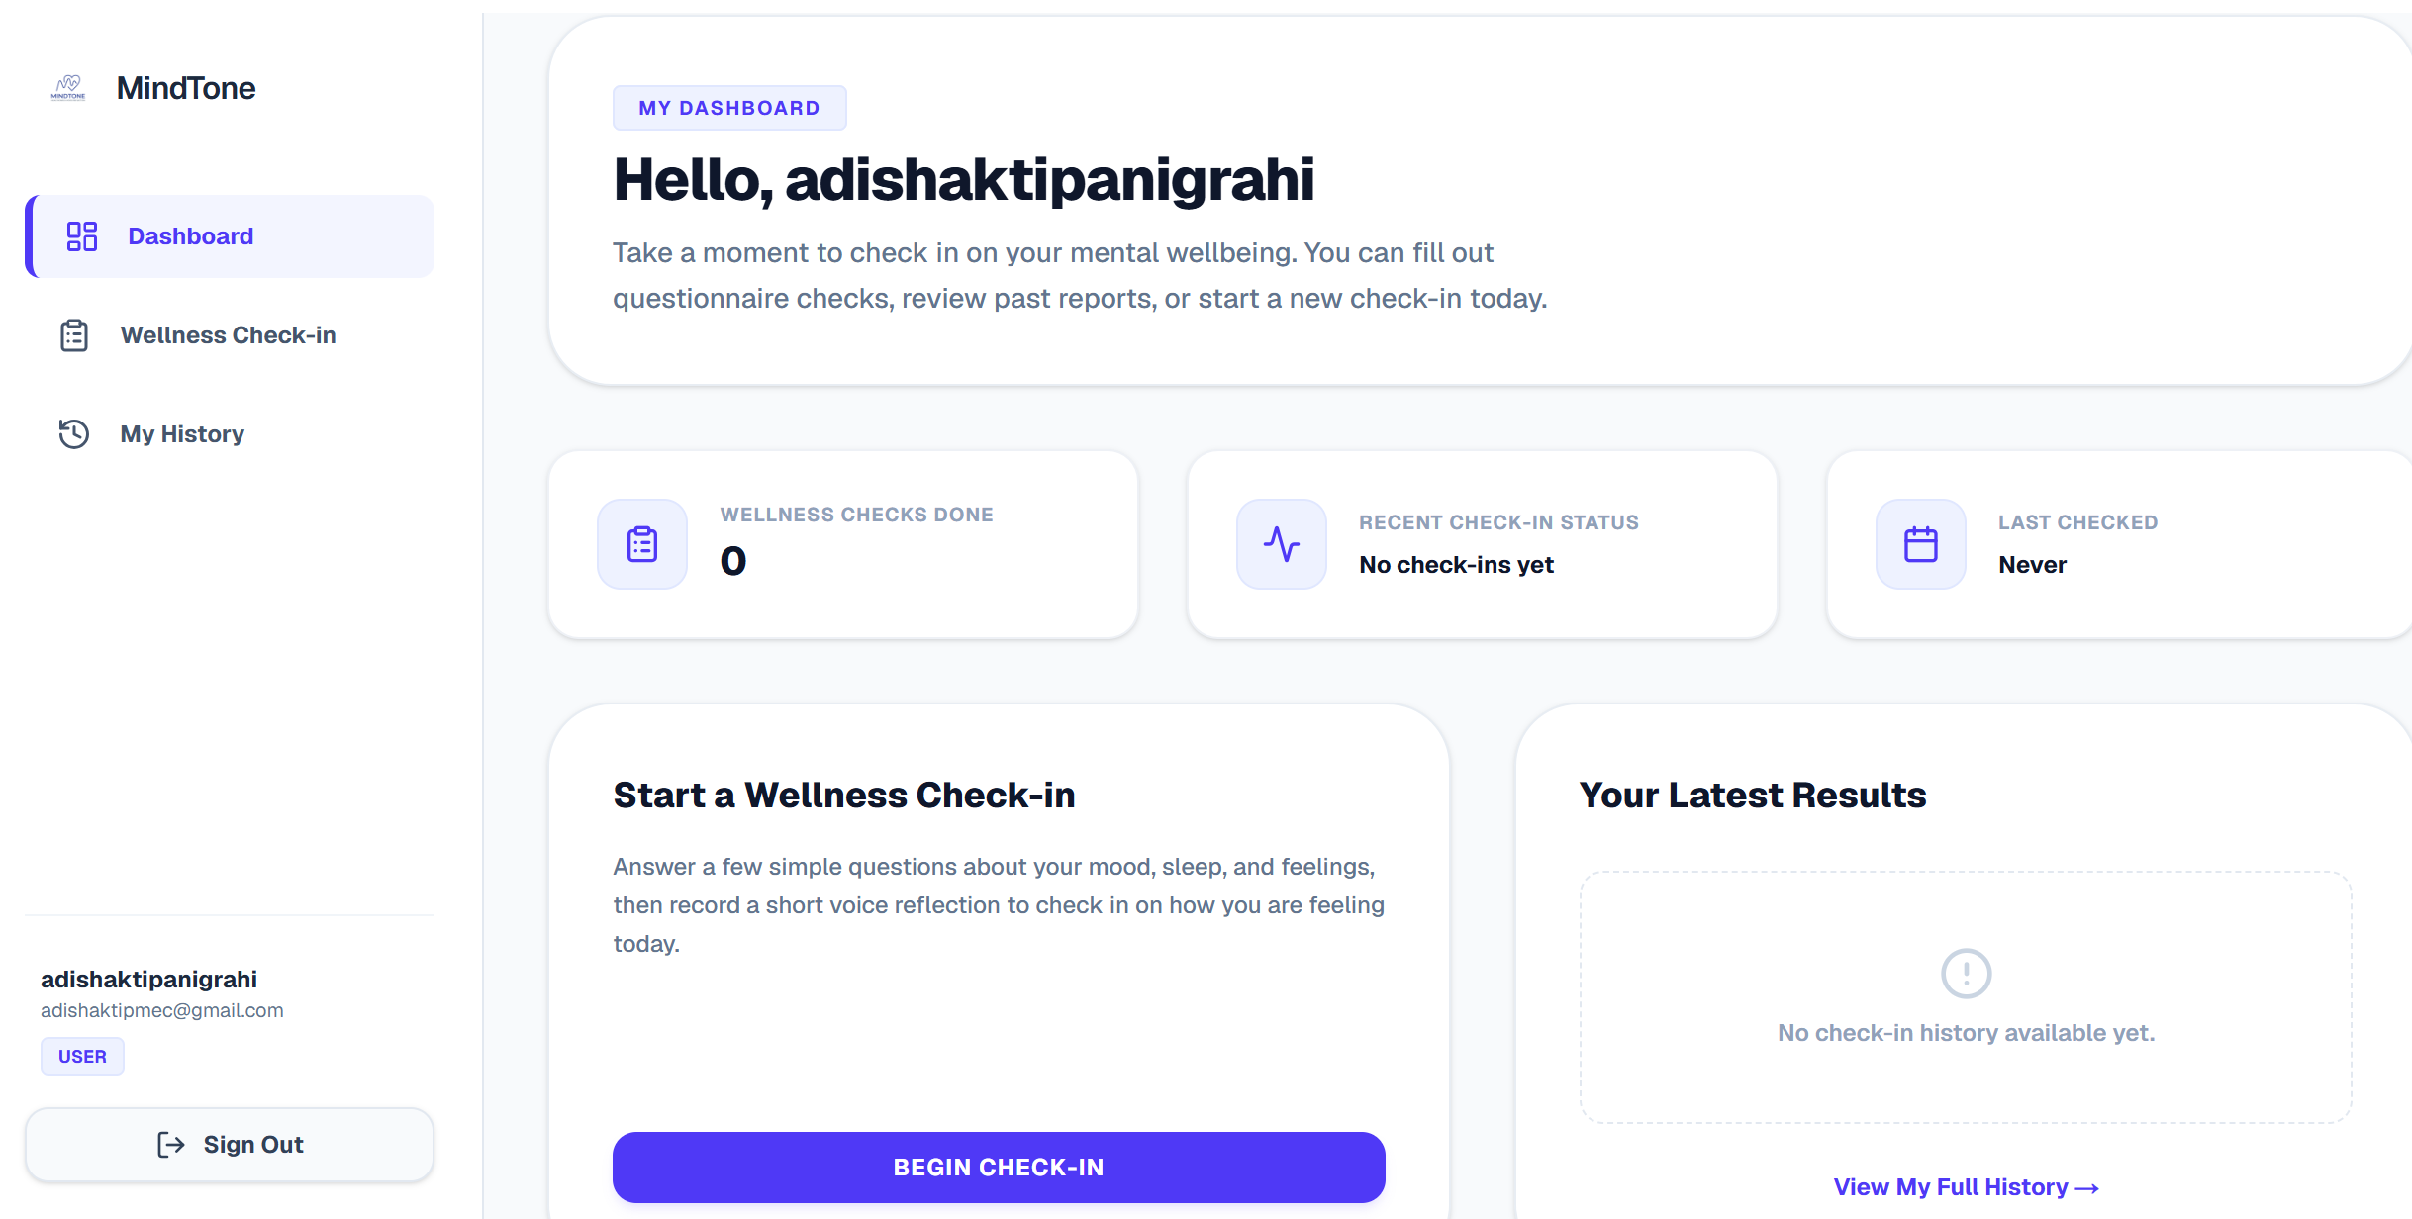
- Figure 4.8: Multi-modal Patient Score Dashboard Interface
- PDF Download Panel: Displays a dedicated compilation card featuring a loading spinner (“Generating Report…”) that activates when a fresh report compilation is triggered.
- Figure 4.9: Dynamic Clinical PDF Report Layout Interface
- Administrator Dashboard Panel: A private dashboard reserved for clinical coordinators and system admins. It provides user database administration tables, log review audit lists, and real-time prediction distribution metrics.
- 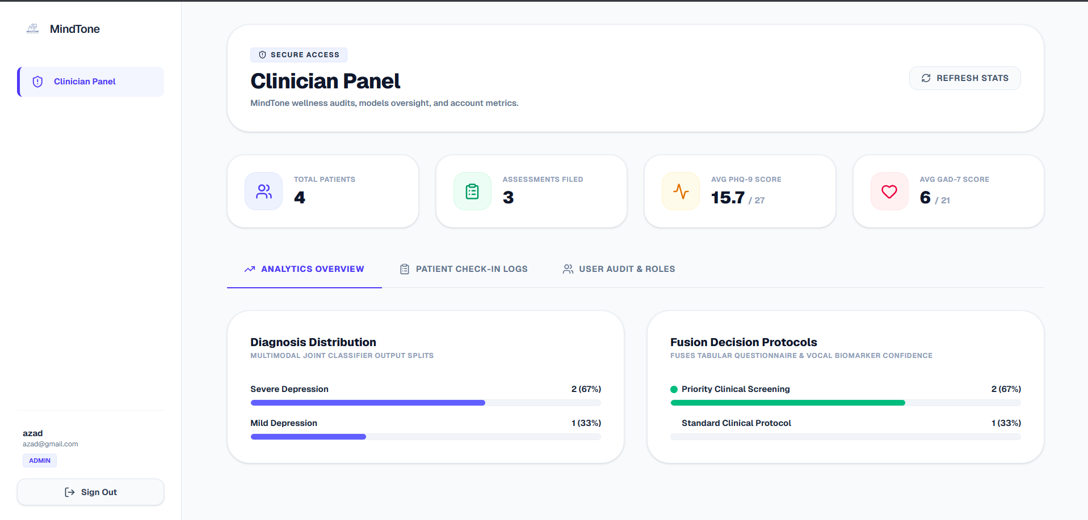
- Figure 4.10: Administrator Dashboard Panel Interface

Chapter 5: Product Development
The product development stage translates design specifications into functional software components. This section details the system’s developmental lifecycle roadmap, modular software architecture, algorithmic logic models, and classification execution protocols.

5.1 Development Life Cycle (Roadmap)
The software development process followed a structured Agile-like system life cycle, breaking down tasks into weekly sequential milestones over a 6-week timeline:
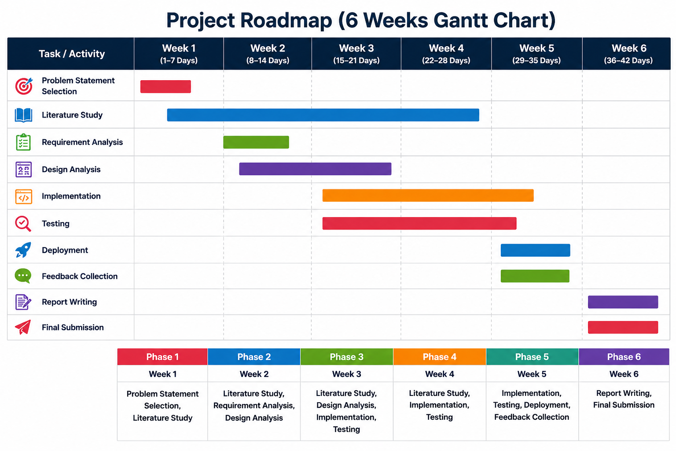
Figure 5.1: Software Development Lifecycle Roadmap

Weekly Milestones:
- Week 1 (Days 1–7): Topic Selection, Literature Study, and Problem Statement formulation.
- Week 2 (Days 8–14): Requirement Analysis, Design Analysis, and initial framework mapping.
- Week 3 (Days 15–21): Design Analysis completion and commencement of system implementation.
- Week 4 (Days 22–28): Complete core system implementation and conduct Unit/Integration testing.
- Week 5 (Days 29–35): System cloud deployment, user feedback collection, and minor UI revisions.
- Week 6 (Days 36–42): Academic report compiling, slide preparations, and final project submission.

5.2 Core Software Modules
The application is structured into six core, modular software subsystems:
- Questionnaire (Tabular) Prediction Module: Processes user survey responses, translates clinical metrics into numerical matrices, and inputs them into the CatBoost Regressor to predict primary diagnostic conditions.
- Audio Feature Extraction Module: Employs librosa and parselmouth to extract critical vocal acoustic feature vectors (pitch, jitter, shimmer, HNR, speech rate) from the recorded voice file.
- Audio Prediction Module: Normalizes vocal vectors and runs the trained CatBoost Classifier to identify audio-based disorder predictions and confidence scores.
- Fusion Engine: Integrates prediction scores from both the questionnaire regressor and audio classifier, applying weighted metrics to synthesize a final clinical screening diagnosis.
- Report Generation Module: Compiles patient results, risk indices, and acoustic feature charts into a customized clinical PDF report using ReportLab.
- Assessment History Module: Saves and retrieves historical patient assessments from the database, allowing users to track progress and trends over time.

5.3 System Algorithms

Algorithm 1: Data Preprocessing and Model Training
Input: Tabular Dataset (Tabular.csv), Audio Feature Dataset (AudioFeature.csv)
Output: Trained Tabular Models (Disorder.pkl), Trained Audio Model (Audio_Model.pkl), Scaler (Scaler.pkl), Label Encoder (Encoder.pkl)
1. START
2. Load the questionnaire tabular dataset (Tabular.csv) into a Pandas DataFrame.
3. Impute missing data values and clean structural anomalies.
4. Apply LabelEncoder to convert categorical survey features into numerical matrices.
5. Separate the feature variables (X_tab) from the multi-disorder target variables (y_tab).
6. Normalize numerical attributes using MinMaxScaler where required.
7. Split the tabular dataset into an 80:20 Train-Test ratio.
8. FOR each target mental health disorder:
Train a CatBoostRegressor on the training subset.
Compute R2 and Mean Absolute Error (MAE) on the test subset.
Save the trained model pipeline as a serialized .pkl file.
END FOR
9. Save the questionnaire label encoders and preprocessing configurations.
10. Load the acoustic audio feature dataset (AudioFeature.csv).
11. Separate the acoustic feature vectors (X_aud) from the clinical target labels (y_aud).
12. Normalize the numerical acoustic feature vectors using StandardScaler:
X_scaled = (X - Mean) / Standard_Deviation
Save the scaler object as Scaler.pkl.
13. Encode the target categorical disorder labels using LabelEncoder and save as Encoder.pkl.
14. Split the audio dataset into an 80:20 Train-Test ratio.
15. Train a CatBoostClassifier on the scaled training features.
16. Save the trained audio classifier model as a serialized .pkl file.
17. END

Algorithm 2: User Assessment and Multimodal Prediction
Input: Questionnaire Responses, Audio Recording (.wav)
Output: Final Diagnosis, Graphical PDF Assessment Report, Database Historical Log
1. START
2. Collect questionnaire answers (PHQ-9, GAD-7, Loneliness, and Family features) from the Next.js UI.
3. Serialize responses and save temporarily as questionnaire.csv.
4. Preprocess questionnaire data using the saved LabelEncoder.
5. Load the trained CatBoostRegressor models (.pkl files) for each disorder.
6. Predict disorder probability scores and identify the top three highest-risk conditions.
7. Generate clinical risk flags (e.g., Suicide Risk, High Psychological Distress).
8. Accept the user's recorded vocal reflection (.wav audio file).
9. Read the audio signal using Librosa and Parselmouth.
10. Extract acoustic features:
- Pitch (Fundamental Frequency, F0)
- Pitch Variability (Standard Deviation of F0)
- Speech Rate (Words Per Minute)
- Pause Duration (s)
- Voice Energy (RMS Amplitude)
- Jitter (Frequency Instability, %)
- Shimmer (Amplitude Instability, %)
- Harmonic-to-Noise Ratio (HNR, dB)
11. Save extracted features to audio_features.csv and normalize using Scaler.pkl.
12. Load the trained CatBoostClassifier model.
13. Predict the audio-based disorder classification and its corresponding confidence score.
14. Run the Fusion Engine:
Final_Score = (Weight_Tabular * Tabular_Probability) + (Weight_Audio * Audio_Confidence)
15. Synthesize the final diagnosis and determine appropriate clinical recommendations.
16. Pass predictions to the report engine to plot Matplotlib graphs.
17. Compile graphs, tables, and XAI outputs into a PDF report via ReportLab.
18. Save all features, scores, and the PDF filepath to PostgreSQL via Prisma.
19. Purge temporary files (questionnaire.csv, audio.wav) from the server.
20. END

Algorithm 3: Admin Management Module
Input: Admin Credentials, User Assessment Records, Retraining Datasets
Output: Authenticated Session, Retrained Models, Updated Database Logs
1. START
2. Collect administrator credentials from the secure login interface.
3. Authenticate the credentials against the hashed database records.
4. IF authentication is successful:
Display the administrator dashboard panel.
ELSE:
Return authentication error and reject login.
END IF
5. Allow admin to view user registration tables and historical assessment counts.
6. Display system analytics (average score distributions, latency statistics).
7. IF admin selects a record for deletion:
Execute delete query via Prisma to purge the record from the database.
END IF
8. IF retrain request is triggered:
Fetch newly aggregated clinical records from the database.
Append new records to Tabular.csv and AudioFeature.csv.
Execute Algorithm 1 (Model Retraining).
Overwrite active .pkl pipeline files with the newly trained models.
END IF
9. Log all administrative actions in the system audit history.
10. Terminate session on admin logout command.
11. END

Chapter 6: Implementation
The implementation phase establishes the deployment constraints, software environments, third-party libraries, and developer configurations of the MindTone system. This section provides an analytical breakdown of the runtime environments, utility packages, API integrations, and cloud hosting specifications.

6.1 Development & Run-time Environment
MindTone was implemented using a modern, multi-tier software stack:

1. Programming Languages & Runtime Engines
- TypeScript (v5.0+): Used across the Next.js application to enforce strict typing, preventing compile-time bugs in payload structures and database operations.
- JavaScript (ECMAScript 2022): Utilized for asynchronous browser operations and local utility scripting.
- Python (v3.10+): Selected as the computational core for the machine learning pipeline, signal processing modules, and reporting services.

2. Integrated Development Environment (IDE) & Utilities
- Visual Studio Code (VS Code): Used as the primary IDE, integrated with linting (ESLint, Flake8) and syntax formatting extensions (Prettier, Black).
- Git & GitHub: Used for continuous version control, modular branch management, and codebase repository sharing.
- Webpack: Configured as the Next.js development server compiler on Windows to ensure stable local development.

6.2 Key Software Libraries & Frameworks

6.2.1 Frontend Frameworks & Libraries
- Next.js (React): Serves as the core React framework. Utilizes server-side and client-side rendering for optimal load performance and secure cookies.
- TailwindCSS: Provides styling variables, enabling a clean, responsive layout across varying screen ratios (mobile, tablet, desktop).
- Prisma Client: A database toolkit that establishes connection pools and executes type-safe queries on our PostgreSQL tables.

6.2.2 Machine Learning & Data Science Libraries
- CatBoost: An advanced gradient boosting framework optimized for handling mixed numerical and categorical questionnaire features.
- SHAP (SHapley Additive exPlanations): An explainable AI toolkit that calculates cooperative game-theory shapley values to determine individual feature weights.
- Scikit-learn: Provides utilities for scaling data (StandardScaler, MinMaxScaler) and encoding labels (LabelEncoder).
- Pandas & NumPy: Used for loading, parsing, cleaning, and structuring clinical vector matrices.

6.2.3 Audio Signal Processing Libraries
- Librosa: An audio analysis library used to decode .wav files and extract raw acoustic features.
- Parselmouth (Praat Wrapper): A Python interface for Praat, allowing high-precision clinical voice feature extraction (specifically jitter and shimmer percentages).

6.2.4 Visualization & Document Compilers
- Matplotlib: A plotting library. MindTone configures it using a headless canvas (matplotlib.use('Agg')) to render pitch curves and prediction bar charts safely on headless web servers.
- ReportLab: A PDF generation engine used to draw tables, clinical summaries, and Matplotlib images into a structured clinical document.

6.3 System Deployment
- Frontend Web App (Vercel): The Next.js client is deployed to Vercel, leveraging their edge content delivery network (CDN) and serverless function environment.
- FastAPI ML Service (Render): Hosted on Render Web Services as a continuous Docker container, ensuring the Python/Librosa dependencies remain active and ready for async operations.
- Serverless PostgreSQL (Neon.tech): Hosts the primary database engine. Compute assets autoscale to handle spikes in check-ins and enter hibernation when idle to control costs.

6.4 Interface Screenshots
Below are the graphical user interfaces of the implemented MindTone clinical platform:

6.4.1 User Authentication Screen

Figure 6.1: Secure User Authentication Portal Interface

6.4.2 Questionnaire Assessment Interface
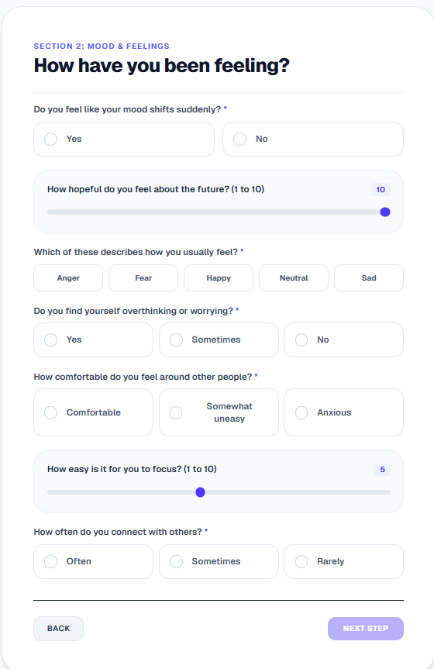
Figure 6.2: Questionnaire Assessment Screening Interface

6.4.3 Patient Dashboard

Figure 6.3: Multi-modal Patient Score Dashboard Interface

6.4.4 PDF Report Download Interface
Figure 6.4: Dynamic Clinical PDF Report Download Interface

6.4.5 Administrator Dashboard

Figure 6.5: Administrator System Management Dashboard Interface

Chapter 7: Testing and Validation
To ensure the safety, predictability, and performance of the proposed clinical utility, a structured validation methodology was executed. This section details the systematic evaluation of the system, comprising functional unit test cases, cross-service integration, and latency benchmarks under load constraints.

7.1 Software Testing Methodology
MindTone underwent a rigorous, multi-tier testing pipeline to verify stability at every layer of the software stack.

7.1.1 Unit Testing
Unit testing focused on verifying individual functions in complete isolation: * Cryptographic Operations: Hashing and verification operations governed by the bcrypt library were validated to ensure user passwords are encrypted securely prior to storage. * JSON Web Tokens (JWT): The token operations managed by the session utility were tested to verify successful signature generation, token encryption, payload retrieval, and absolute session expiration. * Database Pools: Database pool allocations were monitored under simulated concurrent requests to confirm that Neon PostgreSQL server connections are established and recycled without memory leaks. * Audio Conversion Helpers: Standalone audio format conversion utilities were tested using sample files, ensuring that incoming .webm audio blocks are correctly parsed and normalized into standardized .wav containers prior to signal processing.

7.1.2 Integration Testing
Integration testing focused on verifying the communication between different components: * Next.js API Proxy Gateway: Verified that client-side tokens and API parameters are passed to the FastAPI ML backend with headers and security credentials intact. * Multimodal Payloads: Integration pathways transferring questionnaire answers (JSON) and vocal recordings (binary blocks) were validated to ensure multipart form data is successfully received, parsed, and mapped by the Python service. * Matplotlib Headless Processing: Integration testing verified that the Matplotlib instance executes strictly under the 'Agg' backend, ensuring that data plots are rendered on a headless server layout without trigger failures.

7.1.3 System (End-to-End) Testing
System testing simulated complete real-world user paths: * User Path: Registration $→$ Secure Login $→$ Multimodal Assessment intake $→$ Voice Reflection audio submission $→$ Processing and score aggregation $→$ Dashboard display and PDF report download. * Admin Path: Administrator credentials authentication $→$ Dashboard telemetry view $→$ User database query execution $→$ Patient record deletion $→$ Temporary file system cleanup.

7.2 Functional Test Cases
Below is the verified test matrix documenting standard clinical screening scenarios:
Test ID | Scenario | Input / Action | Expected Result | Observed Result | Status
TC-1 | User Registration | Valid email, name, and strong password. | Account created, password hashed, redirect to login. | Database entry created, password encrypted, redirect triggered. | PASS
TC-2 | JWT Authorization | Request to /dashboard with invalid token. | Access denied, redirect to /login page. | 401 Unauthorized status, redirect executed successfully. | PASS
TC-3 | Admin Redirection | Log in using an account assigned with the ADMIN role. | Instant redirection to /admin dashboard panel. | Bypassed standard user dashboard, immediate redirection to admin panel. | PASS
TC-4 | Audio Recording | Click record, speak for 10 seconds, click submit. | Audio captured, saved locally as WebM, forwarded to API. | WebM file written to disk, forwarded successfully. | PASS
TC-5 | Audio Feature Extraction | Submit 10s audio recording to /predict/audio. | FastAPI extracts pitch, jitter, shimmer, HNR; returns JSON. | Feature values calculated and successfully returned in JSON payload. | PASS
TC-6 | Report PDF Generation | Click download PDF report on dashboard. | Trigger /api/report?force=true. Compile PDF, render charts, return file stream. | Headless Matplotlib renders plots, ReportLab compiles PDF, file downloads. | PASS

7.3 Performance & Stability Evaluation

7.3.1 Response Time & Latency
- Performance Benchmark: The system targets an end-to-end processing threshold of under 5 seconds for a standard 10-second voice assessment.
- Observed Latency: During load testing, the complete execution cycle (audio upload $→$ feature extraction $→$ model inference $→$ decision fusion $→$ JSON response) completed in less than 3.5 seconds under ordinary network conditions.

7.3.2 System Resource Utilization
- RAM Footprint: Audio signal processing libraries can be memory-intensive. Load testing demonstrated that the FastAPI process maintains an average RAM consumption of approximately 250 MB during active feature extraction, safely preventing Out of Memory (OOM) crashes on basic 512MB hosting containers.
- CPU Utilization: CPU usage spikes briefly to 100% on a single core during the Librosa feature calculation phase, but immediately drops to normal idle thresholds (< 5%) once inference completes.

7.3.3 Build System Integrity
- Turbopack watch-panic: During local testing on Windows, the Next.js Turbopack compiler encountered watch-mode crashes.
- Resolution: Fallback testing verified that switching the Next.js dev server compiler script to standard Webpack ("dev": "next dev --webpack") completely resolved compilation crashes.

Chapter 8: Results and Discussion
This section evaluates the computational performance of the trained machine learning architectures, validates the clinical explainability pipeline, and analyzes the performance metrics of the system and reporting components.

8.1 Machine Learning Model Performance
MindTone separates prediction modeling into two channels: tabular questionnaire analysis (disorder risk regression) and audio acoustic feature analysis (classification).

8.1.1 Tabular Regression Models Comparison
The tabular dataset consists of 4,500 rows, constructed in a 3:2 ratio combining non-weighted metrics and priority-weighted DSM-5 symptom profiles. We evaluated three regressors: CatBoostRegressor, XGBoostRegressor, and RandomForestRegressor.
Below is the complete comparison of all evaluated metrics extracted directly from the model training logs:
Model | $R^{2}$ Score | Mean Absolute Error (MAE) | Mean Squared Error (MSE) | Root Mean Squared Error (RMSE) | Explained Variance | MAPE | Accuracy ($±5\%$) | Accuracy ($±10\%$) | Per Person Accuracy
CatBoostRegressor | 0.7100 | 2.4213 | 42.6534 | 6.5310 | 0.7103 | 66.89% | 90.82% | 96.13% | 90.82%
XGBoostRegressor | 0.6841 | 2.6244 | 46.2022 | 6.7972 | 0.6853 | 74.88% | 88.95% | 95.34% | 88.95%
RandomForestRegressor | 0.6585 | 2.6390 | 47.9354 | 6.9235 | 0.6614 | 78.76% | 88.91% | 94.97% | 88.91%
Discussion: CatBoostRegressor outperformed the other models, yielding a higher $R^{2}$ score of 0.71 and an accuracy of 96.13% within a $±10\%$ error margin. CatBoost’s internal handling of categorical features and optimization metrics allowed it to map patient questionnaire answers to risk tiers with fewer preprocessing configurations.

8.1.2 Audio Classification Models Comparison
Vocal acoustics are processed on a numerical audio dataset consisting of 2,500 rows. We compared the performance of CatBoostClassifier and XGBoostClassifier on the extracted parameters:
Classifier | Accuracy | Precision | Recall | F1-Score
CatBoostClassifier | 86.90% | 86.91% | 86.90% | 86.89%
XGBoostClassifier | 85.60% | 85.61% | 85.60% | 85.58%
Discussion: CatBoostClassifier achieved the highest F1-Score of 86.89% and classification accuracy of 86.90%. The combination of standardized audio features (pitch variability, jitter, shimmer, HNR) provided stable markers for vocal distress classification.

8.2 Explainable AI (XAI) Validation
To validate the clinical credibility of our predictions, we applied SHAP (SHapley Additive exPlanations) to extract local feature attribution weights.
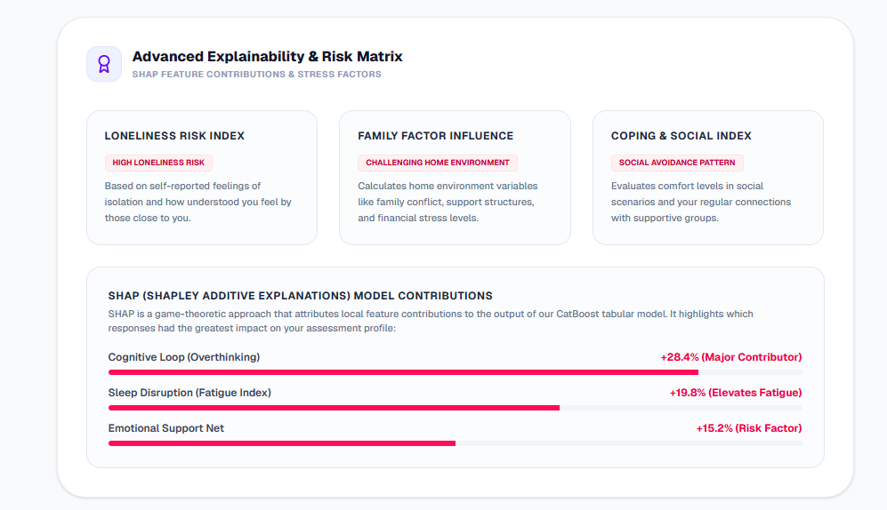
Figure 8.1: SHAP Local Feature Attribution Weights Summary

Interpretation & Clinical Parity:
- Psychosocial Weights: The SHAP explanation maps demonstrated that the attributes feelingOfLoneliness and familyDynamics (dysfunctional dynamics) consistently carry high positive shapley values when predicting high risk levels for major depressive disorder (MDD) and generalized anxiety disorder (GAD). This correlates directly with the DSM-5 literature, which emphasizes domestic conflict and chronic isolation as core drivers of mental distress.
- Acoustic Weights: For the vocal classifier, high values of jitter and shimmer (indicating frequency and amplitude instability in vocal folds) combined with low HNR values (high noise ratios in voice) were highlighted by SHAP as dominant features driving positive stress classifications.
- Local Attributions: For individual assessments, the local SHAP bar charts visualize the exact clinical metrics that push the patient’s score above normal baseline thresholds, giving physicians a clear explanation of why the model flagged a patient.

8.3 System & Report Validation
- Low Response Latency: The end-to-end transaction completed in less than 3.5 seconds, meeting our objective of rendering instant feedback.
- Resource-Constrained Performance: Average RAM utilization remained at ~250MB, enabling the backend to execute concurrent signal extractions without exceeding container boundaries.
- Report Compilation Integrity: Matplotlib plots generated in a headless daemon were successfully converted to PNG streams and embedded within ReportLab flowables without formatting or layout shifts.
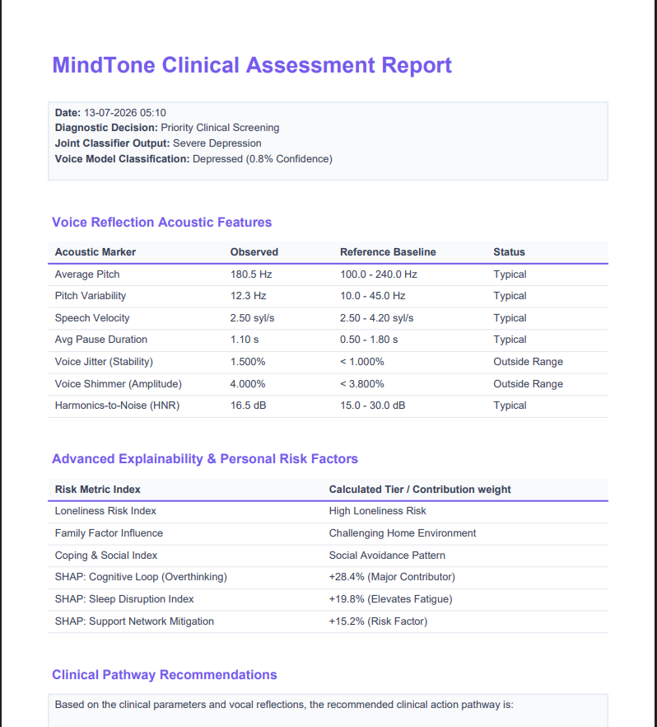
Figure 8.2: Compiled Indigo-themed Patient PDF Assessment Report

Chapter 9: Conclusion and Future Works
The successful deployment and evaluation of the MindTone framework validates the integration of multimodal screening features and explainable machine learning methodologies. This section compiles the project’s primary findings, system contributions, and strategic roadmap for clinical and sensor integrations.

9.1 Conclusion
The development of MindTone successfully demonstrates the viability of an Explainable Multimodal AI Framework for early mental health screening. By combining structured clinical questionnaires (PHQ-9/GAD-7) with objective vocal acoustic feature vectors and dedicated psychosocial indicators (loneliness and family environment parameters), the system establishes a comprehensive diagnostic methodology.

Key Milestones Achieved:
- Objective Vocal Analysis: Integrated librosa and parselmouth to extract stable voice biomarkers (pitch, jitter, shimmer, HNR), moving past the subjectivity of manual self-assessments.
- Highly Accurate Modeling: Developed and trained CatBoost regressors and classifiers, achieving an $R^{2}$ score of 0.71 on tabular survey data and an accuracy of 86.90% on acoustic classification.
- Actionable Explainability: Applied SHAP explainable AI attributions to extract feature weights, validating that the models align with DSM-5 diagnostic guidelines by highlighting loneliness and family stress as dominant risk factors.
- Automatic Clinical Reporting: Designed a headless report generation module using ReportLab and Matplotlib to compile patient records into clean, printable PDF documents.
- Secure Architecture: Constructed a robust Next.js and FastAPI stack using Prisma ORM to execute safe user registrations, authentication, and database sessions.
MindTone offers a reliable, low-cost pre-clinical screening tool designed to help bridge the mental health treatment gap, particularly within resource-constrained demographics.

9.2 Future Scope
To transition MindTone into a clinical-grade diagnostic utility, several future enhancements are planned:
- Video Processing Integration: Incorporate real-time facial expression and behavioral analysis from webcam video feeds using MediaPipe FaceMesh to improve multimodal prediction accuracy.
- Physiological Signal Analysis: Integrate heart rate, ECG, and skin conductance metrics using dedicated wearable devices (such as the proposed ESP32, AD8232, and Grove GSR sensor suite) for objective physiological assessment.
- Clinical Validation: Partner with clinical institutions and healthcare professionals to validate prediction reports and refine model boundaries against real-world patient evaluations.
- Interactive Web Platform: Enhance the user interface with advanced history tracking, interactive trend charts, and customizable patient metrics panels.
- Personalized Advice Module: Implement generative LLM advice loops (using the Gemini API) to read prediction outputs and generate personalized self-care checklist recommendations and wellness tips.
- Screen Time & Content Analysis: Develop optional integrations to study screen time and digital content consumption metrics, identifying latent stress and anxiety markers.
- Expanded Multimodal Framework: Merge all four modalities—questionnaires, voice audio, facial video, and physiological IoT sensors—into a unified quad-modal clinical diagnostic engine.
- Real-Time Continuous Monitoring: Support optional, continuous passive monitoring to track long-term changes in user well-being and alert caregivers during threshold spikes.

References
- Joyce, D. W., Kormilitzin, A., Smith, K. A., & Cipriani, A. (2023). Explainable artificial intelligence for mental health through transparency and interpretability for understandability. npj digital medicine, 6(1), 6.
- Kerz, E., Zanwar, S., Qiao, Y., & Wiechmann, D. (2023). Toward explainable AI (XAI) for mental health detection based on language behavior. Frontiers in psychiatry, 14, 1219479.
- Antoniou, G., Papadakis, E., & Baryannis, G. (2022). Mental health diagnosis: a case for explainable artificial intelligence. International Journal on Artificial Intelligence Tools, 31(03), 2241003.
- Jo, A. A., Raj, E. D., Vino, A. S., & Menon, P. V. (2024, October). Exploring explainable AI for enhanced depression prediction in mental health. In 2024 First International Conference on Innovations in Communications, Electrical and Computer Engineering (ICICEC) (pp. 1-7). IEEE.
- Patapati, S. V. (2024, October). Integrating Large Language Models into a Tri-Modal Architecture for Automated Depression Classification. arXiv preprint.
- Lee, G. C., Li, Z. Y., & Li, T. W. (2022, July). Ensemble algorithm of convolutional neural networks for enhancing facial expression recognition. In 2022 IEEE 5th International Conference on Knowledge Innovation and Invention (ICKII) (pp. 111-115). IEEE.
- He, Y. (2022). Facial expression recognition using multi-branch attention convolutional neural network. IEEE Access, 11, 1244-1253.
- Kopalidis, T., Solachidis, V., Vretos, N., & Daras, P. (2024). Advances in facial expression recognition: A survey of methods, benchmarks, models, and datasets. Information, 15(3), 135.
- Sahili, Z. A., Patras, I., & Purver, M. (2024). Multimodal machine learning in mental health: a survey of data, algorithms, and challenges. arXiv preprint arXiv:2407.16804.
- Tian, Z., Zhang, J., & Wang, X. (2026). A multimodal fairness aware machine learning framework for mental health risk prediction in university students. Discover Artificial Intelligence.
- Prajwal, S. H., Singh, S., & Theng, D. (2026). An explainable multimodal deep learning approach for stress detection in emotion-aware systems. Discover Applied Sciences, 8(5), 537.
- Saghab Torbati, M., Zandbagleh, A., Daliri, M. R., Ahmadi, A., Rostami, R., & Kazemi, R. (2025). Explainable AI for bipolar disorder diagnosis using Hjorth parameters. Diagnostics, 15(3), 316.
- Duggal, C., & Bagasrawala, L. (2019). Adolescent and youth mental health in India: status and needs. In Health and Wellbeing of India’s Young People: Challenges and Prospects (pp. 51-83). Singapore: Springer Singapore.
- Jayasankar, P., Manjunatha, N., Rao, G. N., Gururaj, G., Varghese, M., Benegal, V., & Group, N. I. N. C. (2022). Epidemiology of common mental disorders: results from “National Mental Health Survey” of India, 2016. Indian journal of psychiatry, 64(1).
- Raj, J., Goyal, N., & Senthil, M. (2025). Family Mental Health in India: A 10-Year Systematic Review. International Journal of Indian Psychology, 13(4).
- American Psychiatric Association. (2022). Diagnostic and Statistical Manual of Mental Disorders (5th ed., Text Revision). Washington, DC: Author.
- Vocal Biomarkers for Mental Health: Diagnosing Mental Disorders with a Short Voice Recording. (2026). New Research, Patients and Families, Technology.
- Menne, F., Dörr, F., Schräder, J., Tröger, J., Habel, U., König, A., & Wagels, L. (2024). The voice of depression: speech features as biomarkers for major depressive disorder. Journal of Affective Disorders.
- Teferra, B. G., Borwein, S., DeSouza, D. D., Rose, J., & DeSouza, M. (2022). Screening for Generalized Anxiety Disorder From Acoustic and Linguistic Features of Impromptu Speech: Prediction Model Evaluation Study. JMIR Mental Health.
- Quatieri, T. F., Wang, J., Williamson, J. R., DeLaura, R., Talkar, T., Solomon, N. P., … & Reynolds, H. (2024). An Emotion-Driven Vocal Biomarker-Based PTSD Screening Tool. IEEE Transactions on Biomedical Engineering.
- Min, S., Shin, D., Rhee, S. J., Park, C. H. K., Yang, J. H., Song, Y., Kim, M. J., Kim, K., Cho, W. I., Kwon, O. C., Ahn, Y. M., & Lee, H. (2023). Acoustic Analysis of Speech for Screening for Suicide Risk: Machine Learning Classifiers for Between- and Within-Person Evaluation of Suicidality. JMIR Mental Health.

