PARALA MAHARAJA ENGINEERING COLLEGE
SITALAPALLI, BERHAMPUR - 761003

Department of Computer Science and Engineering
Summer Internship on Research Sensitization & Innovative Project Development
on
“An Explainable Multimodal AI Framework for Predicting Mental Health and Analyzing the Effect of Family Conditions and Loneliness”.
https://mind-tone.vercel.app

Faculty Mentors: Dr. Debasis Mohapatra & Dr. Ranumayee Sing

Group Members:
- Sahil Maharana - 2401109225
- Shuvabrata Sahoo - 2401109232
- Satyajeet Maharana - 2401109228
- Suvankar Jena - 2401109252
- Satyajit Nath - 2401109229
- K. Om Prakash Reddy - 2401109190
- Bablu Gouda - 2401109174
- Adishakti Panigrahi - 2401109146
- Azad Mohanty - 2401109172
- Suraj Kumar Sahoo - 2401109248
Semester: 5th

CERTIFICATE
This is to certify that the project entitled "An Explainable Multimodal AI Framework for Predicting Mental Health and Analyzing the Effect of Family Conditions and Loneliness" is a bona fide work carried out by the following students of the Department of Computer Science & Engineering, Parala Maharaja Engineering College, in partial fulfillment of the requirements for the award of the Bachelor of Technology (B.Tech.) degree.
The project has been completed under our guidance and supervision during the academic session 2026–2027. To the best of our knowledge, the work presented is original and has not been submitted, either wholly or in part, for the award of any other degree or diploma by any university or institution.

Group Members:
- Sahil Maharana - 2401109225
- Shuvabrata Sahoo - 2401109232
- Satyajeet Maharana - 2401109228
- Suvankar Jena - 2401109252
- Satyajit Nath - 2401109229
- K. Om Prakash Reddy - 2401109190
- Bablu Gouda - 2401109174
- Adishakti Panigrahi - 2401109146
- Azad Mohanty - 2401109172
- Suraj Kumar Sahoo - 2401109248

Date: Place:
Project Guide | Project Guide | Head of Department
Dr. Debasis Mohapatra | Dr. Ranumayee Sing | Dr. Sasmita Rani
Department of Computer Science & Engineering | Department of Computer Science & Engineering | Department of Computer Science & Engineering
Signature: | Signature: | Signature:

DECLARATION
We, the undersigned, hereby declare that the project entitled "An Explainable Multimodal AI Framework for Predicting Mental Health and Analyzing the Effect of Family Conditions and Loneliness", submitted to the Department of Computer Science & Engineering, Parala Maharaja Engineering College, is an original work carried out by us under the guidance of Dr. Debasis Mohapatra and Dr. Ranumayee Sing.
We further declare that, to the best of our knowledge and belief, this project has not been submitted, either in whole or in part, for the award of any degree, diploma, or any other academic qualification at this or any other university or institution. All sources of information used in this work have been duly acknowledged and referenced.

Group Members

Sl. No. | Name | Roll No. | Signature
1 | Azad Mohanty | 2401109172
2 | Adishakti Panigrahi | 2401109146
3 | Bablu Gouda | 2401109174
4 | K. Om Prakash Reddy | 2401109190
5 | Sahil Maharana | 2401109225
6 | Satyajeet Maharana | 2401109228
7 | Satyajit Nath | 2401109229
8 | Shuvabrata Sahoo | 2401109232
9 | Suraj Kumar Sahoo | 2401109248
10 | Suvankar Jena | 2401109252
Date: Place: Berhampur

ACKNOWLEDGEMENT

We would like to express our sincere gratitude to everyone who has supported us throughout the successful completion of our project entitled “An Explainable Multimodal AI Framework for Predicting Mental Health and Analyzing the Effect of Family Conditions and Loneliness”.
First and foremost, we extend our heartfelt thanks to our respected guides, Dr. Debasis Mohapatra & Dr. Ranumayee Sing, for their constant support, valuable insights, and expert guidance. Their encouragement and constructive feedback played a crucial role in shaping our understanding and helping us carry out this project effectively.
We are grateful to Parala Maharaja Engineering College for providing the necessary facilities, resources, and a conducive learning environment that enabled us to develop and implement the simulation smoothly. We also appreciate the continued support from the department and faculty members whenever we need assistance.
We would like to acknowledge our friends and classmates for their cooperation, ideas, and motivation. Their discussions and feedback significantly contributed to refining our work and improving the overall quality of the project.
Lastly, we express our deepest gratitude to other faculty members for their unwavering support, patience, and belief in us. Their encouragement has been a constant source of strength throughout this journey.

ABSTRACT
Mental health conditions represent a critical global health burden, with a significant proportion of the population remaining undiagnosed due to clinical resource shortages and social stigma. Traditional screening methods depend heavily on subjective, self-reported questionnaires, which are prone to recall bias. To address these challenges, this project introduces MindTone, an explainable multimodal AI framework designed to predict mental health conditions and analyze the clinical impact of domestic family environments and subjective loneliness.
The framework integrates structured questionnaire assessments (combining DSM-5 diagnostic criteria [16], PHQ-9, and GAD-7) with objective vocal acoustic feature extractions (fundamental frequency $F_{0}$, jitter, shimmer, HNR, and speech rate) computed using the librosa and parselmouth Python libraries. Machine learning pipelines were developed using gradient boosting classifiers and regressors. Evaluation results show that the CatBoostRegressor achieved an $R^{2}$ score of 0.71 (with an accuracy of 96.13% within a $±10\%$ error margin) when predicting disorder severity from tabular check-ins, outperforming XGBoost and Random Forest. For vocal distress classification, the CatBoostClassifier achieved an accuracy of 86.90% and an F1-Score of 86.89%.
To establish clinical trust, SHAP (SHapley Additive exPlanations) is integrated to generate visual feature-weight attributions, validating that the models align with DSM-5 criteria by identifying loneliness and dysfunctional family dynamics as primary contributors to elevated depression and anxiety risk. The backend dynamically compiles results into a printable PDF clinical report using ReportLab. MindTone provides a secure, lightweight, and low-cost pre-clinical screening kiosk framework, offering objective and transparent evaluations to support medical decision-making.
Keywords: Multimodal AI, Explainable AI (XAI), CatBoost, SHAP, Vocal Biomarkers, Librosa, Mental Health Screening.

CONTENTS
CERTIFICATE 2
DECLARATION 3
ACKNOWLEDGEMENT 4
ABSTRACT 5
CONTENTS 6
Chapter 1: Introduction 8
1.1 Background 8
1.2 Problem Statement 8
1.3 Need for the Product 9
1.4 Objectives 9
1.5 Scope 10
1.6 Contributions 10
Chapter 2: Literature Review 11
2.1 The Critical Need for Explainability in Psychiatry 11
2.2 Architectural Evolution in Multimodal Fusion 11
2.3 Socio-Cultural Determinants: Family Dynamics and Loneliness 11
2.4 Synthesis and Identified Research Gaps 12
Chapter 3: Requirement Analysis 13
3.1 Functional Requirements 13
3.2 Non-Functional Requirements 13
3.3 System Requirements 14
Chapter 4: Product Design 15
4.1 System Architecture 15
4.2 Flowchart (System Workflow) 16
4.3 UML Diagrams 16
4.4 Database Design 19
4.5 User Interface (UI) Design 21
Chapter 5: Product Development 24
5.1 Development Life Cycle (Roadmap) 24
5.2 Core Software Modules 25
5.3 System Algorithms 25
Chapter 6: Implementation 28
6.1 Development & Run-time Environment 28
6.2 Key Software Libraries & Frameworks 28
6.3 System Deployment 29
6.4 Interface Screenshots 29
6.5 Live Deployment 32
Chapter 7: Testing and Validation 33
7.1 Software Testing Methodology 33
7.2 Functional Test Cases 34
7.3 Performance & Stability Evaluation 35
Chapter 8: Results and Discussion 36
8.1 Machine Learning Model Performance 36
8.2 Explainable AI (XAI) Validation 37
8.3 System & Report Validation 38
Chapter 9: Conclusion and Future Works 40
9.1 Conclusion 40
9.2 Future Scope 40
References 42

Chapter 1: Introduction

1.1 Background
According to the World Health Organization (WHO), mental health conditions represent a critical global health burden, with nearly one in eight individuals worldwide living with a diagnosed mental disorder. Despite the prevalence of these conditions, a significant proportion of the population remains undiagnosed and untreated due to social stigma, lack of clinical resources, and financial barriers. The most common mental disorders—including Major Depressive Disorder (MDD), Generalized Anxiety Disorder (GAD), Post-Traumatic Stress Disorder (PTSD), and Bipolar disorders [16]—profoundly affect an individual’s cognitive on, and social capacities.
In recent years, the integration of Artificial Intelligence (AI) and Machine Learning (ML) in healthcare has opened new avenues for early screening, diagnostic support, and personalized intervention. Traditional mental health assessments rely heavily on manual, self-reported questionnaires (such as the Patient Health Questionnaire-9 or Generalized Anxiety Disorder-7) [16] administered during clinical visits. While valuable, these assessments are subjective, susceptible to recall bias, and capture only a static snapshot of a patient’s state. AI-driven frameworks can process multi-modal data streams—combining structured psychological metrics with objective physiological indicators, facial features, and vocal acoustics—to provide a more continuous, objective, and comprehensive evaluation of mental well-being.
Furthermore, mental health does not exist in isolation; it is deeply influenced by psychosocial factors. Research highlights that family environments, social support systems, and chronic loneliness are major determinants of psychological resilience and vulnerability [15]. A supportive family dynamic and strong social bonds act as protective barriers against stress and depression. Conversely, dysfunctional family environments, frequent domestic conflicts, and persistent loneliness are highly correlated with elevated risks of severe depression, anxiety, and suicidal ideation. Integrating these psychosocial metrics alongside clinical symptoms enables computational models to make more personalized, accurate, and context-aware risk assessments. Vocal biomarkers play an essential role here [17, 18].

1.2 Problem Statement
Conventional mental health screening systems face several core limitations that prevent them from achieving widespread clinical adoption and trust: 1. Single-Modal Limitations: Most existing diagnostic models rely exclusively on a single type of data (e.g., self-reported questionnaires or text analysis of social media posts). These systems fail to capture the physiological, vocal, and behavioral nuances of mental distress, leading to lower diagnostic sensitivity and specificity. 2. Neglect of Psychosocial Context: Current screening models rarely incorporate critical environmental factors, such as family dynamics and the subjective experience of loneliness, which are key drivers of mental health deterioration. 3. The “Black-Box” Problem: Advanced machine learning models (like deep neural networks) operate as black boxes, providing predictions without explaining the underlying reasoning. In clinical settings, healthcare professionals cannot trust or act upon diagnostic predictions without transparent, interpretable justifications. 4. Lack of Demographic Calibration: Many existing algorithms are trained on Western datasets and fail to generalize to the unique social, family structures (like joint families), and cultural contexts of the Indian population.

1.3 Need for the Product
The development of MindTone is driven by the urgent need for an accessible, objective, and transparent mental health screening solution based on DSM-5-TR standards [16].
- Clinical Resource Scarcity: In developing nations like India, the patient-to-psychiatrist ratio is critically low [13, 14]. There is an immediate need for an automated, pre-clinical screening tool that can triage patients and identify high-risk individuals before they reach a crisis point.
- Objective Vocal Biomarkers: By extracting objective acoustic features (such as pitch, jitter, shimmer, and speech rate) from short voice recordings, MindTone bypasses the subjectivity and bias of traditional self-reports.
- Explainability for Clinicians: Clinicians require tools that assist, rather than replace, their decision-making process. By utilizing Explainable AI (XAI) frameworks, MindTone provides feature-level explanations (such as SHAP values), allowing doctors to see exactly how questionnaire answers and voice metrics contributed to a specific risk tier.
- Portability and Integration: There is a lack of portable, low-cost screening kiosks that can be deployed in community centers, schools, and rural clinics to bring mental health assessments directly to underserved populations.

1.4 Objectives
The primary objective of this project is to design, develop, and validate MindTone—an explainable multimodal AI framework for predicting mental health conditions and analyzing the impact of family environments and loneliness, with a focus on the socio-cultural context of the Indian population.
To achieve this, the project is structured around the following sub-objectives: * Objective 1: Build a multimodal data acquisition framework capable of collecting and preprocessing structured questionnaire responses and raw audio voice recordings. * Objective 2: Train and evaluate machine learning models (specifically CatBoost regressors and classifiers) to predict clinical risk scores for major disorders (MDD, GAD, PTSD, Dysthymia) and risk factors (suicide, psychological distress). * Objective 3: Implement an Explainable AI (XAI) pipeline using SHAP to generate localized, visual feature attribution maps for every assessment, ensuring transparency for clinical reviewers. * Objective 4: Analyze the statistical influence of family structures (nuclear vs. joint), family dynamics (supportive vs. dysfunctional), and subjective loneliness indicators on overall mental health outcomes.

1.5 Scope
The scope of MindTone encompasses pre-clinical screening, clinical decision support, and remote patient monitoring: * Pre-clinical Triage: It serves as an early-stage screening tool in schools, universities, and corporate offices to identify individuals experiencing sub-clinical levels of anxiety or depression. * Clinical Decision Support System (CDSS): Placed in clinics and hospitals, it assists general practitioners by providing a structured, explainable PDF report containing acoustic graphs and risk factor weights before the patient sees a specialist. * Rural and Community Health: Deployed via portable web interfaces, it enables community health workers to administer basic assessments in rural areas where mental health professionals are completely unavailable.

1.6 Contributions
This project introduces several key contributions to the field of computational mental healthcare: 1. Multimodal Fusion Engine: Developed a custom fusion algorithm that combines tabular questionnaire features (including DSM-5 mapped scores, PHQ-9, and GAD-7) with vocal acoustic feature vectors to produce a unified diagnostic risk profile. 2. Headless Report Compiler: Built an automated, server-compatible reporting engine using ReportLab and Matplotlib (Agg backend) to compile raw clinical data and SHAP explanation visual charts into high-quality, printable PDF reports instantly. 3. Indigo Clinical Design System: Implemented a clean, accessible Next.js dashboard using an Indigo-brand theme, complete with dynamic visual range bars showing observed vocal pitch, jitter, and shimmer against typical healthy baselines. 4. Local DB Management Tools: Created command-line utility tools (promote.js and reset-password.js) to streamline database administration, user role elevations, and secure password resets on a PostgreSQL backend via Prisma ORM.

Chapter 2: Literature Review
The rapid evolution of computational psychiatry has shifted from unimodal, static diagnostic tools toward multimodal, explainable frameworks. This review synthesizes current research across three critical dimensions: the necessity of Explainable AI (XAI) for establishing clinical trust, architectural advancements in multimodal mental health models, and the integration of socio-cultural determinants—specifically family dynamics and loneliness—within the Indian demographic.

2.1 The Critical Need for Explainability in Psychiatry
A primary barrier to the clinical adoption of machine learning is the "black-box" nature of deep neural networks. Joyce et al. [1] and Antoniou et al. [3] argue that for AI to be integrated into psychiatric care, systems must prioritize transparency. Antoniou's hybrid model [3], which combines rule-based systems with machine learning, demonstrates that expert-in-the-loop validation can achieve diagnostic accuracies as high as 98%. Additionally, Saghab Torbati et al. [12] demonstrated the effectiveness of explainable features in parsing complex clinical conditions. However, accuracy alone is insufficient. Kerz et al. [2] and Jo et al. [4] emphasize the importance of understanding why a model predicts a mental health condition, focusing on feature-level attributions. While tools like SHAP and LIME are standard, a significant gap remains: there is a lack of rigorous, large-scale studies evaluating whether these "local explanations" are effectively understood or trusted by clinicians in real-world psychiatric settings.

2.2 Architectural Evolution in Multimodal Fusion
The shift from unimodal to multimodal data processing represents a significant advancement in diagnostic sensitivity. Multimodal frameworks integrate diverse data streams—including vocal acoustic features, linguistic markers, and physiological sensors [11]—to create a more holistic patient profile. Sahili et al. [9] provide a comprehensive survey identifying that Transformer-based and Graph Neural Network (GNN) architectures currently lead the field with F1-scores exceeding 0.95. Patapati [5] pushes this frontier further by integrating Large Language Models (LLMs) into a tri-modal architecture, achieving 91.01% accuracy. Despite these gains, these models often suffer from "inference latency," rendering them unsuitable for real-time clinical deployment. Furthermore, Tian et al. [10] note that high performance often masks demographic biases, underscoring the necessity for fairness-aware frameworks.

2.3 Socio-Cultural Determinants: Family Dynamics and Loneliness
While global research on mental health AI is prolific, there is a visible disconnect between epidemiological evidence and computational implementation regarding socio-cultural risk factors. Jayasankar et al. [14] and the NMHS survey provide critical insights into the Indian mental health landscape, identifying family structures (joint vs. nuclear), gender roles, and domestic dynamics as dominant predictors of mental health outcomes. Critically, Raj et al. [15] establish that family conflicts, caregiving burdens, and the subjective experience of loneliness are among the strongest correlates for major depressive disorder and anxiety within the Indian context.
Currently, there is a lack of integration between these sociologically validated markers and machine learning pipelines. Most models are trained on Western datasets that fail to account for the unique stress responses and social support systems inherent in the Indian demographic. This represents a significant opportunity for innovation: the development of models that do not merely process clinical symptoms, but also quantify the specific psychosocial risk factors identified in Indian epidemiological studies.

2.4 Synthesis and Identified Research Gaps
By synthesizing the current state of the art, three major research gaps emerge:
- 1. The Clinical-Computational Disconnect: Models often operate in isolation from clinical workflow requirements, failing to translate mathematical feature weights into actionable, clinician-friendly reports.
- 2. Architectural Latency vs. Fairness: State-of-the-art models involving LLMs suffer from high inference latencies, and multimodal frameworks often struggle with data bias, necessitating a balance between complexity and real-world deployment speed.
- 3. Socio-Cultural Contextualization: Existing algorithms predominantly rely on self-reported survey data, neglecting the predictive power of environmental factors like domestic dynamics and loneliness—key determinants identified in Indian research.
MindTone addresses these gaps by synthesizing questionnaire-based metrics with vocal biomarkers, providing transparent SHAP-based explanations, and specifically integrating socio-cultural risk factors (loneliness and family dynamics) calibrated for the Indian demographic.

Chapter 3: Requirement Analysis
A systematic requirements elicitation process defines the functional limits and operational constraints of the MindTone framework. This section establishes the functional and non-functional specifications, baseline software/hardware requirements, and proposed IoT integration pathways.

3.1 Functional Requirements
Functional requirements define the core processing operations, inputs, and outputs.
Table 3.1: Functional Requirements
ID | Functional Requirement | Input | Output | Description
FR-1 | User Authentication | Credentials | JWT Session | Secure registration and login.
FR-2 | Multimodal Data Entry | Surveys, Audio | Structured Data | Collects clinical and psychosocial metrics.
FR-3 | Audio Feature Extraction | Raw Audio | Feature Vectors | Extracts pitch, jitter, and shimmer.
FR-4 | ML Inference | Feature Vectors | Risk Tiers | Executes CatBoost diagnostic logic.
FR-5 | Explainable AI (XAI) | Model Weights | SHAP Graphs | Generates transparency visualizations.
FR-6 | Report Generation | Risk Scores | PDF Report | Compiles findings for clinicians.
FR-7 | History Management | User ID | Past Records | Retrieves longitudinal assessment trends.

3.2 Non-Functional Requirements
- Security: All patient data is encrypted via TLS; passwords are hashed using bcrypt.
- Performance: Inference pipeline (extraction + prediction) completes under 3.5 seconds.
- Reliability: The Matplotlib/ReportLab pipeline utilizes headless execution ('Agg') to ensure zero-crash operations.
- Scalability: Connection pooling is managed via Prisma PgAdapter to prevent database locking.

3.3 System Requirements

3.3.1 Software Requirements
- Frontend: Next.js (v16), TypeScript, TailwindCSS.
- Backend: FastAPI, Uvicorn, Prisma ORM.
- ML/Data: CatBoost, Scikit-learn, SHAP, Librosa, Pandas.
- Database: PostgreSQL (Neon.tech).

3.3.2 Baseline Hardware Requirements
- Client: PC, Laptop, or Tablet with microphone.
- Server: Min 1 vCPU, 1 GB RAM (AWS Lightsail/DigitalOcean/Render).

3.3.3 Proposed IoT Hardware Expansion
- Microcontroller: ESP32-WROOM-32D Development Board.
- Acoustic/Bio-Sensors: MAX30102 (PPG/SpO2), AD8232 (ECG), Grove GSR Sensor.
- Power: 2x 18650 Li-ion cells with TP4056 charging circuit.

Chapter 4: Product Design
The system design phase establishes the structural, relational, and conceptual specifications of the MindTone mental health screening platform. This section details the high-level system architecture, data workflows, UML design mappings, relational database schema, and user interface layouts.

4.1 System Architecture
MindTone utilizes a decoupled, service-oriented architecture designed to handle lightweight frontend requests, complex database mutations, and CPU-intensive machine learning (ML) tasks in isolation.
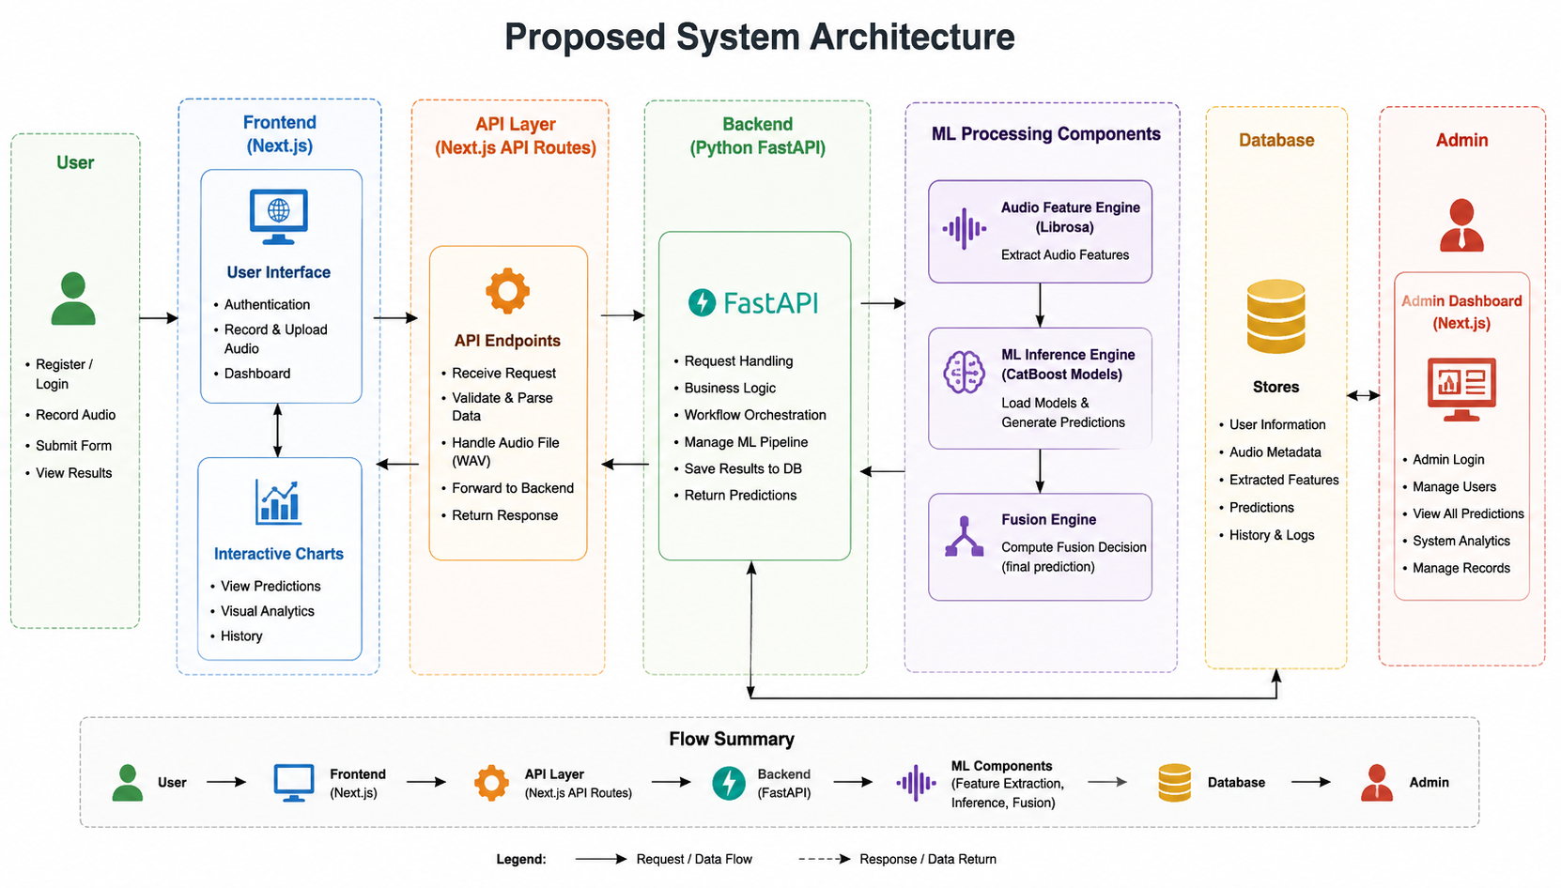
Figure 4.1: High-Level System Architecture Diagram

Architectural Components:
- Frontend User Interface (Next.js): Runs React client components. It manages secure routes, hosts the microphone recording interface, renders diagnostic charts, and calls the Next.js API serverless layer.
- API Proxy Layer: Built within Next.js API routing. It validates the user’s JWT cookie and routes heavy ML payloads directly to the FastAPI microservice while securely communicating with PostgreSQL via Prisma.
- FastAPI ML Service (Python): Handles heavy CPU operations. When a payload arrives, it reads the audio file, extracts acoustic vectors, loads the serialization models (.pkl pipelines), and runs inference.
- Relational Database (PostgreSQL): Stores user registration records, history arrays, and feature profiles.

4.2 Flowchart (System Workflow)
The diagnostic workflow describes the step-by-step processing of a patient assessment, from input to the final printable report:
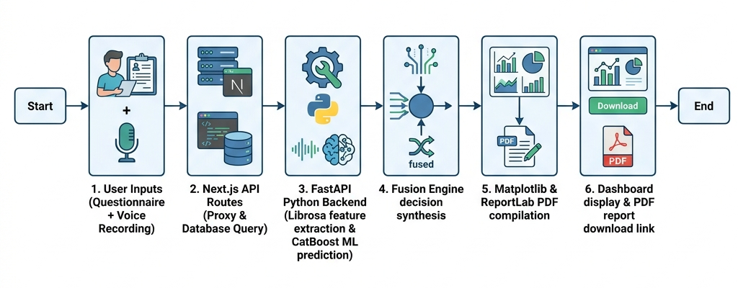
Figure 4.2: System Workflow Flowchart

4.3 UML Diagrams

4.3.1 Use-Case Diagram
The Use-Case diagram details the interactions between the two primary stakeholders—Patients (Users) and Administrators—and the Mental Health Assessment System boundaries.
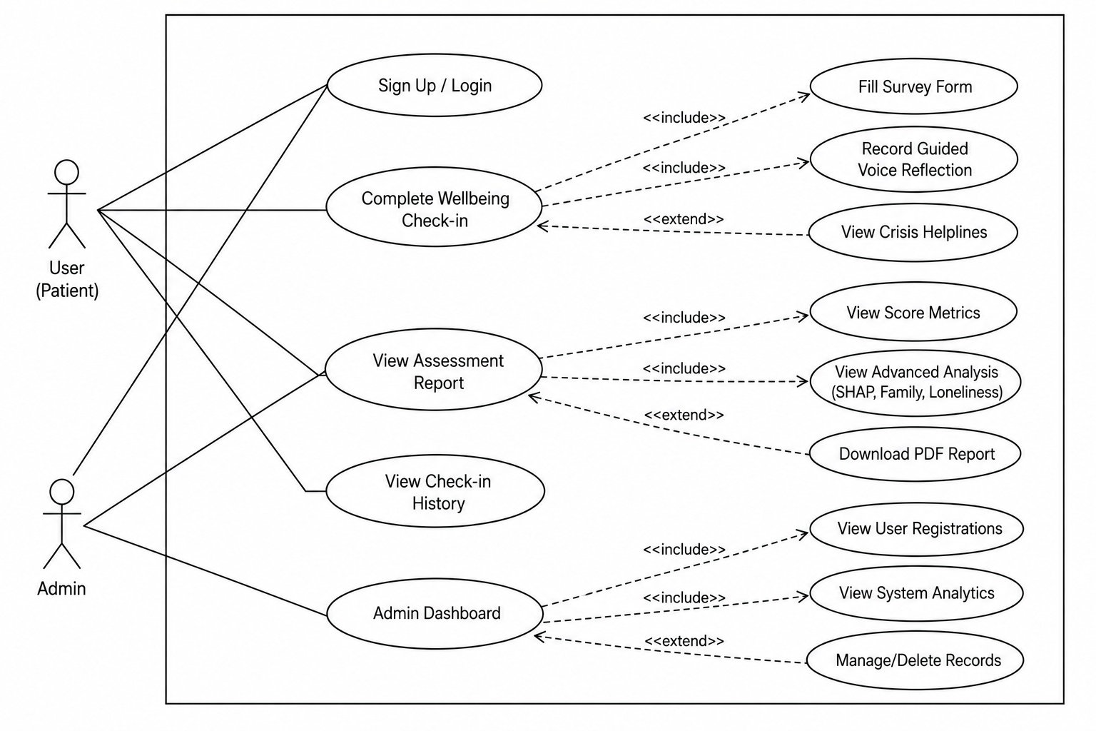
Figure 4.3: System Use-Case Diagram
- User (Patient) Interactions:
  - Sign Up / Log In.
  - Complete Wellbeing Check-in (includes filling the survey form, recording guided voice reflection, and viewing crisis helplines as an extended flow).
  - View Assessment Report (includes viewing score metrics, viewing advanced SHAP/psychosocial analysis, and downloading the PDF report).
  - View Check-in History.
- Admin Interactions:
  - Log in to the Admin Dashboard.
  - View System Analytics (total users, average stress levels).
  - View User Registrations.
  - Manage/Delete history records.

4.3.2 Class Diagram
The class diagram illustrates the object-oriented structure of the software components, detailing attributes, methods, and relationships:
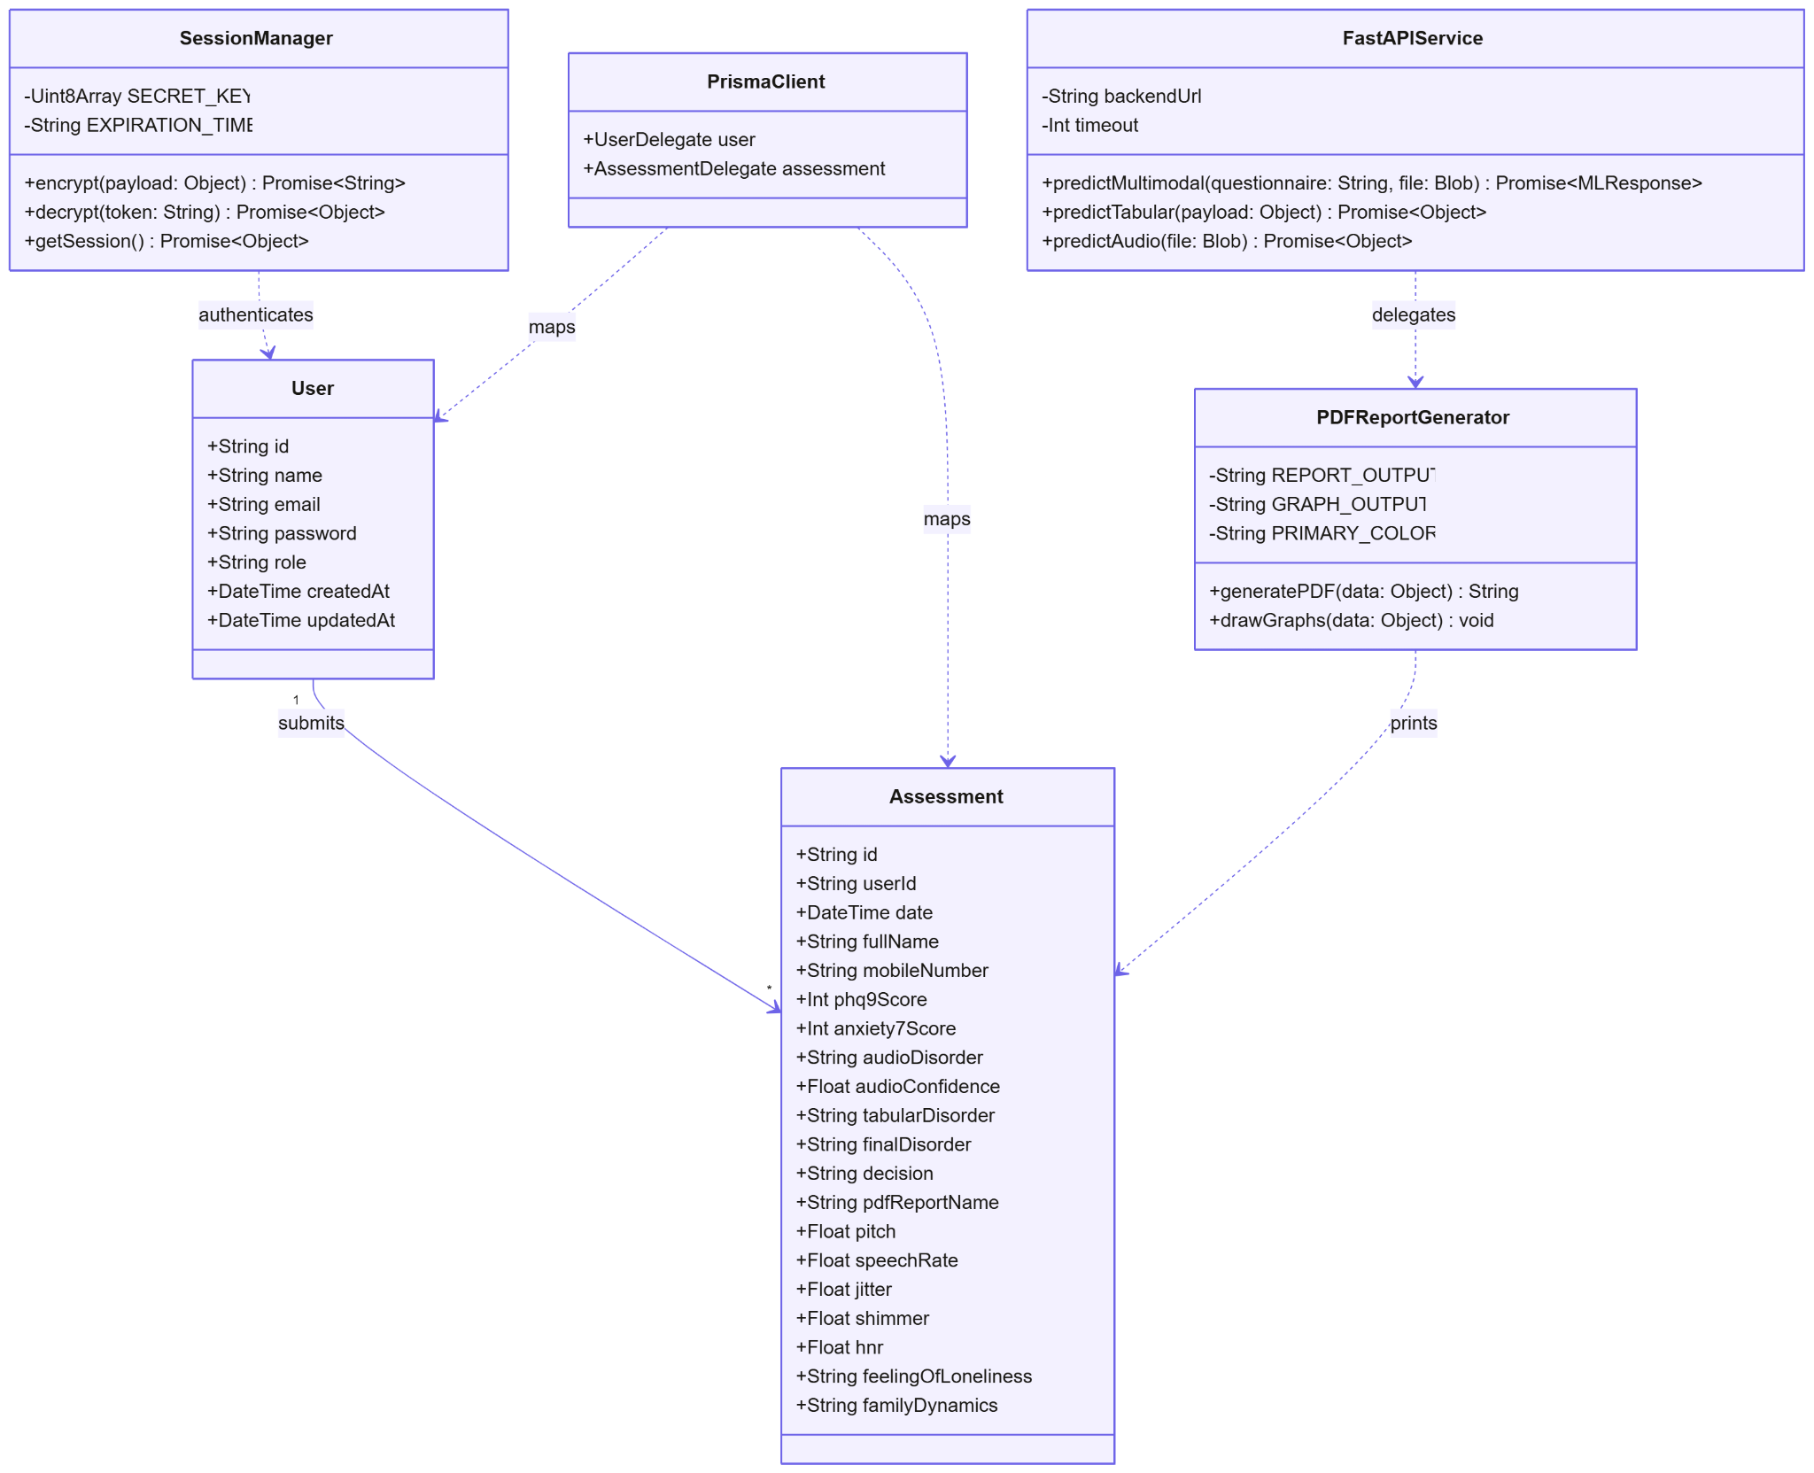
Figure 4.4: Software Component Class Diagram
- Key Classes:
  - SessionManager: Manages session encryption, decryption, and fetching.
  - FastAPIService: Coordinates multimodal predictions, tabular predictions, and audio predictions.
  - PDFReportGenerator: Manages ReportLab PDF compilation and Matplotlib chart drawing.
  - PrismaClient: Connects and delegates database requests.
  - User: Stores account credentials and timestamps.
  - Assessment: Tracks complete diagnostic and acoustic feature outputs.

4.3.3 Sequence Diagram
The Sequence diagram tracks the chronological execution flow across components during a multimodal wellbeing check-in:
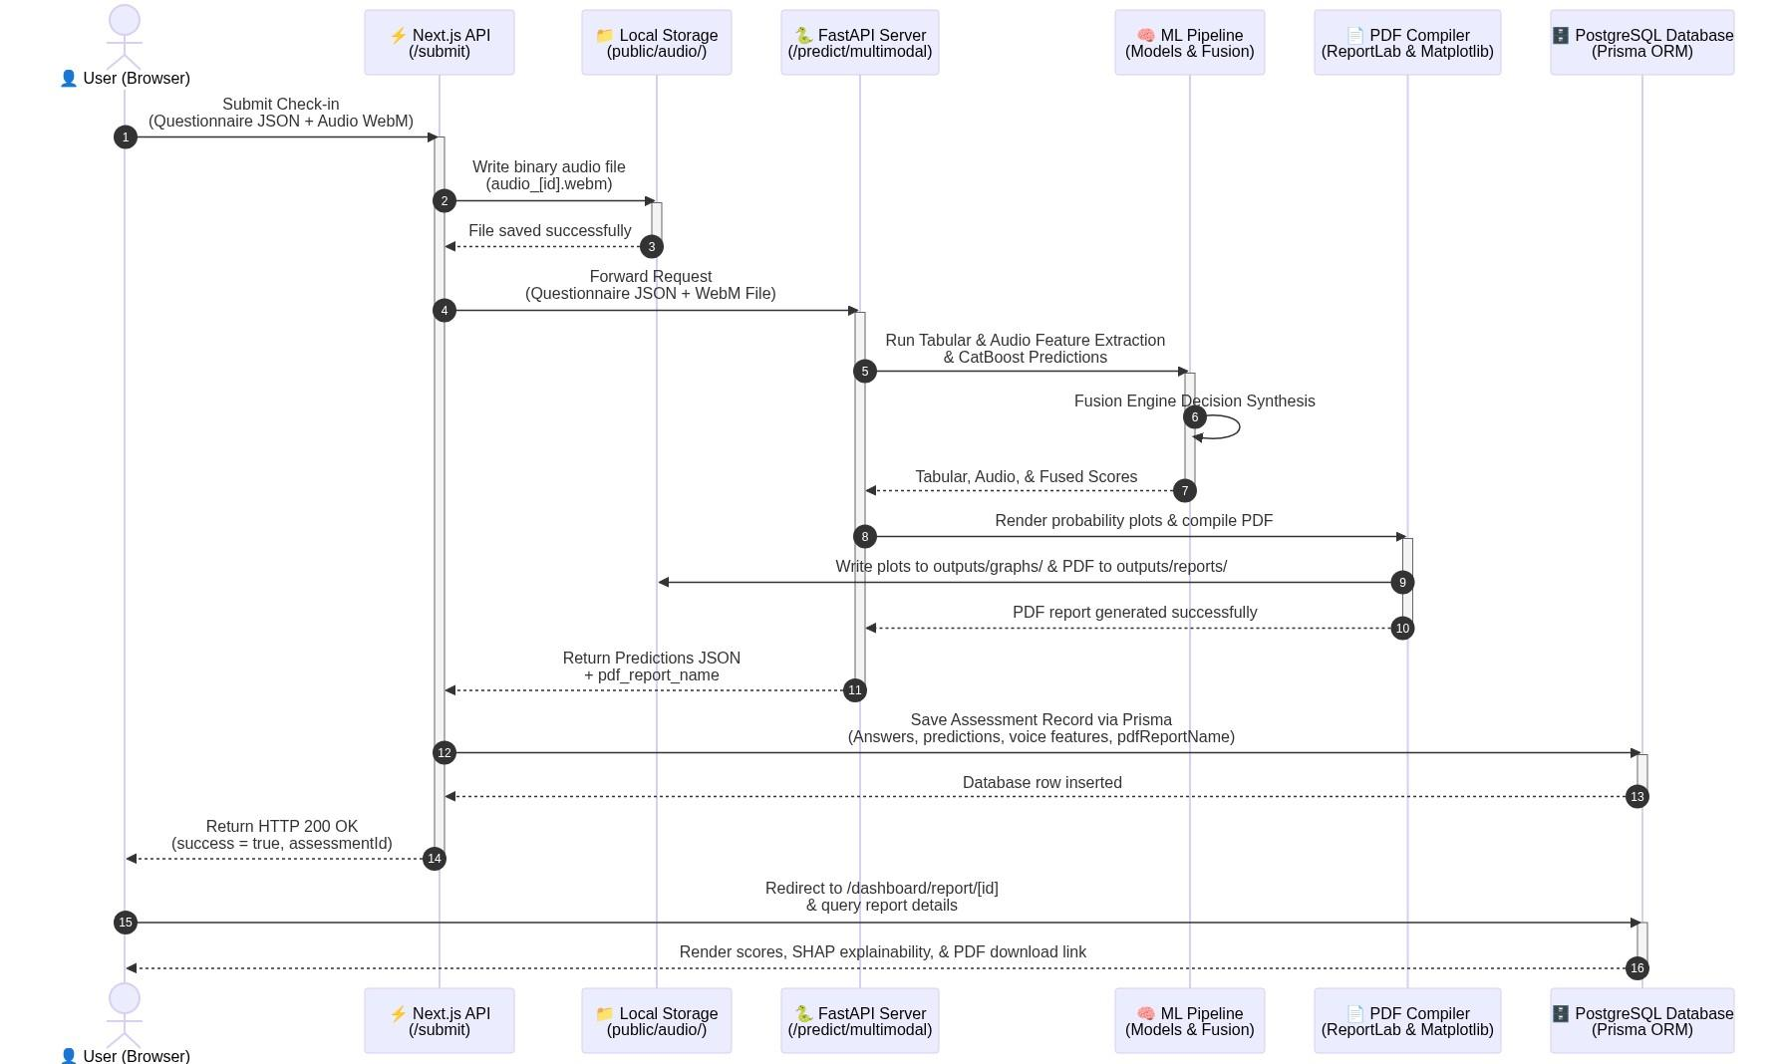
Figure 4.5: Chronological Sequence Diagram
- Workflow Timeline:
  - Patient submits questionnaire responses and WebM audio recording.
  - The Next.js API layer stores the raw WebM file.
  - Next.js passes the request to the FastAPI ML backend.
  - FastAPI extracts acoustic metrics, executes CatBoost model predictions, and synthesizes the decision in the Fusion Engine.
  - The report engine plots charts and compiles a PDF report using ReportLab.
  - Response is sent back to the Next.js frontend to save the database records via Prisma.
  - User is redirected to the report dashboard where the final scores, SHAP explanations, and PDF download links are displayed.

4.4 Database Design
The database schema utilizes relational integrity constraints enforced by Prisma and hosted on serverless PostgreSQL (Neon.tech).
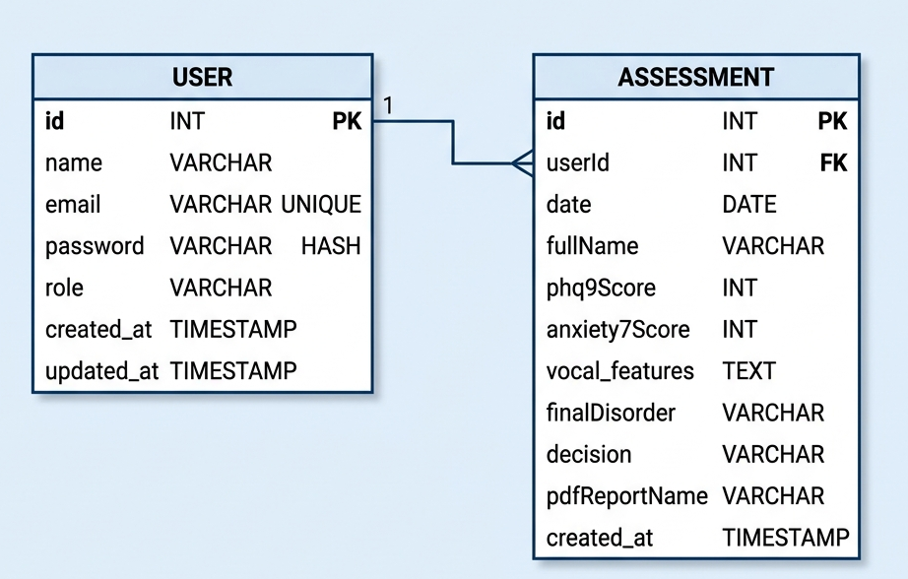
Figure 4.6: Database Entity Relationship Diagram (ERD)

Relational Tables

1. User Table
Tracks registered user credentials, profile information, and roles.

Table 4.1: User Table Schema
Column Name | Data Type | Constraints | Description
id | String | Primary Key, Unique | Unique identifier for each user.
name | String | Required | Full name of the user.
email | String | Unique, Required | User email address used for login.
password | String | Required | Securely hashed password (bcrypt).
role | String | Default: “USER” | System access level (USER or ADMIN).
createdAt | DateTime | Default: NOW | Timestamp when account was created.
updatedAt | DateTime | Auto-update | Timestamp of last profile edit.

2. Assessment Table
Stores individual screening assessment data, clinical scoring metrics, and voice acoustic outputs.
Table 4.2: Assessment Table Schema
Column Name | Data Type | Constraints | Description
id | String | Primary Key, Unique | Unique identifier for each assessment.
userId | String | Foreign Key (User) | Maps the assessment to a specific user.
date | DateTime | Default: NOW | Date and time the check-in occurred.
fullName | String | Required | Full name provided during assessment.
mobileNumber | String | Required | Contact number for verification.
phq9Score | Integer | Required | Total score calculated from PHQ-9 (0-27).
anxietyScore | Integer | Required | Total score calculated from GAD-7 (0-21).
audioDisorder | String | Required | Classification output from audio model.
audioConfidence | Float | Required | Confidence score of the audio classifier.
tabularDisorder | String | Required | Classification output from tabular model.
finalDisorder | String | Required | Integrated output from the Fusion Engine.
decision | String | Required | Clinical action recommendation text.
pdfReportName | String | Required | Filepath to the generated ReportLab PDF.
pitch | Float | Required | Extracted fundamental frequency (F0) in Hz.
speechRate | Float | Required | Words Per Minute (WPM) speed rate.
jitter | Float | Required | Calculated frequency instability (%).
shimmer | Float | Required | Calculated amplitude instability (%).
hnr | Float | Required | Harmonic-to-Noise Ratio (dB).
feelingOfLoneliness | String | Required | Patient loneliness assessment flag.
familyDynamics | String | Required | Family dynamic status (Supportive/Dysfunctional).

4.5 User Interface (UI) Design
The user interface is designed using an Indigo-brand color system to establish a calm, professional, and accessible clinical environment.
- User Authentication (Login Screen): A centralized Card-style interface containing validated inputs for credentials, featuring micro-interactions on form submission and error indicators.
- 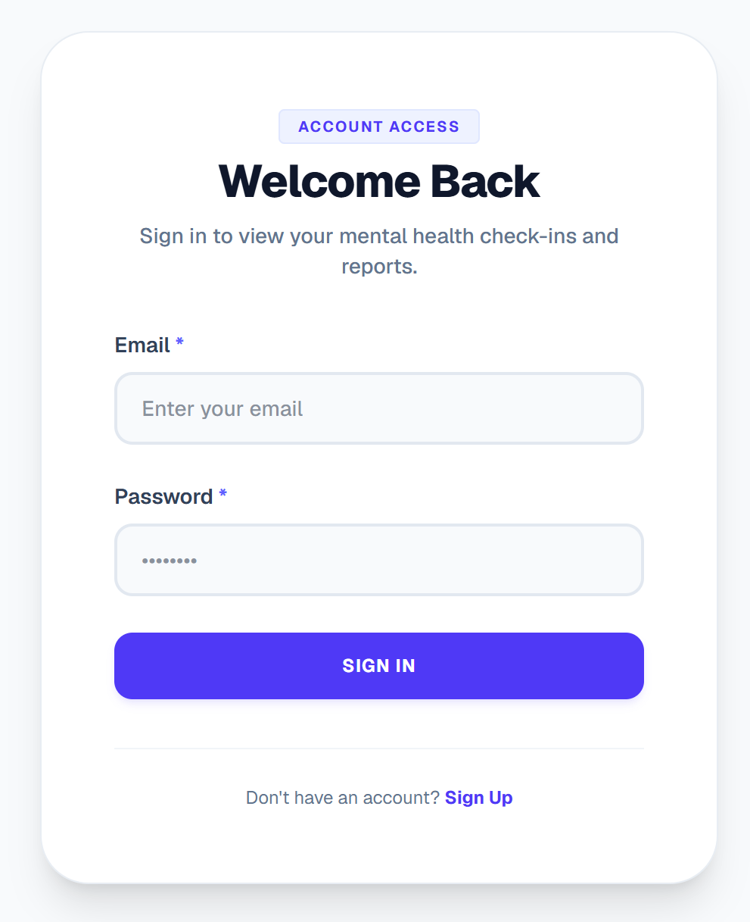
Figure 4.7: User Authentication Portal Interface
- Patient Dashboard:
  - Score Overview Card: Renders the final fused diagnosis tier and a summary recommendation.
  - Clinical Feature Panels: Collapsible panels that expand to reveal detailed acoustic feature metrics (pitch, jitter, shimmer, HNR) mapped against target clinical normal ranges.
  - Psychosocial Stress Index: Interactive bar indicators illustrating the severity of loneliness metrics and family dynamic stressors.
- 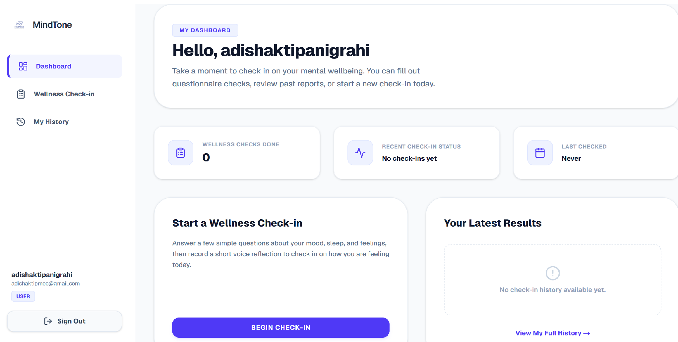
Figure 4.8: Multi-modal Patient Score Dashboard Interface
- PDF Download Panel: Displays a dedicated compilation card featuring a loading spinner (“Generating Report…”) that activates when a fresh report compilation is triggered.
Figure 4.9: Dynamic Clinical PDF Report Layout Interface
- Administrator Dashboard Panel: A private dashboard reserved for clinical coordinators and system admins. It provides user database administration tables, log review audit lists, and real-time prediction distribution metrics.
- 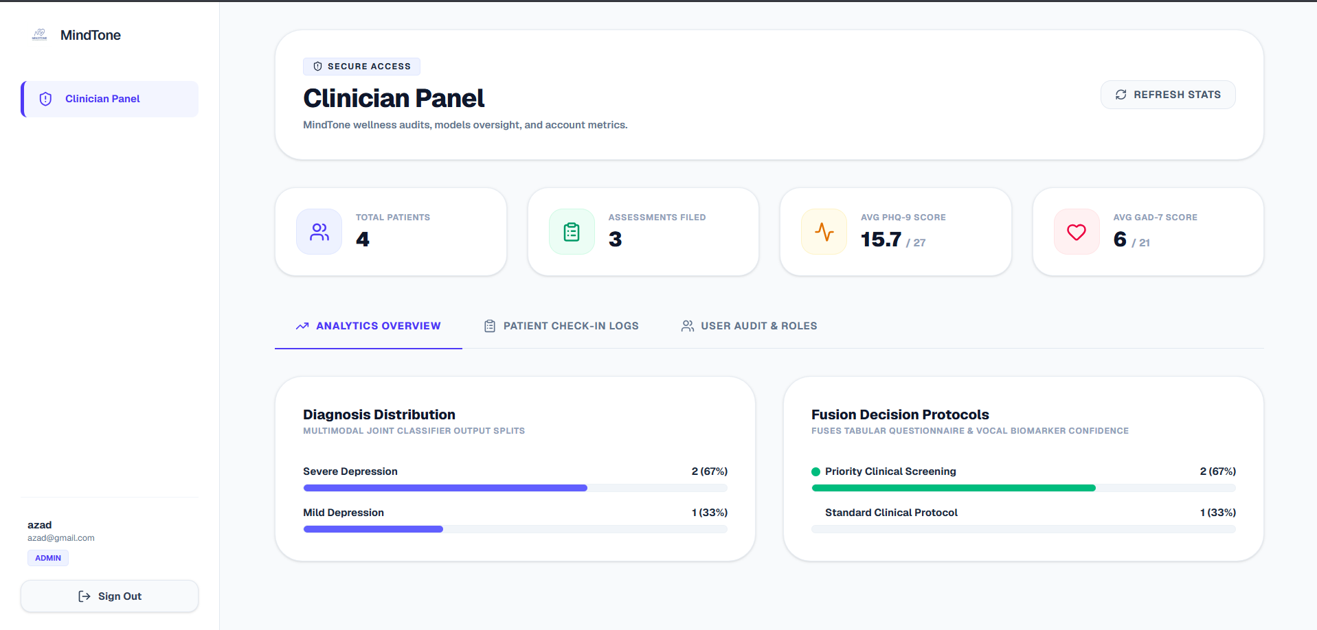
Figure 4.10: Administrator Dashboard Panel Interface

Chapter 5: Product Development
The product development stage translates design specifications into functional software components. This section details the system’s developmental lifecycle roadmap, modular software architecture, algorithmic logic models, and classification execution protocols.

5.1 Development Life Cycle (Roadmap)
The software development process followed a structured Agile-like system life cycle, breaking down tasks into weekly sequential milestones over a 6-week timeline:
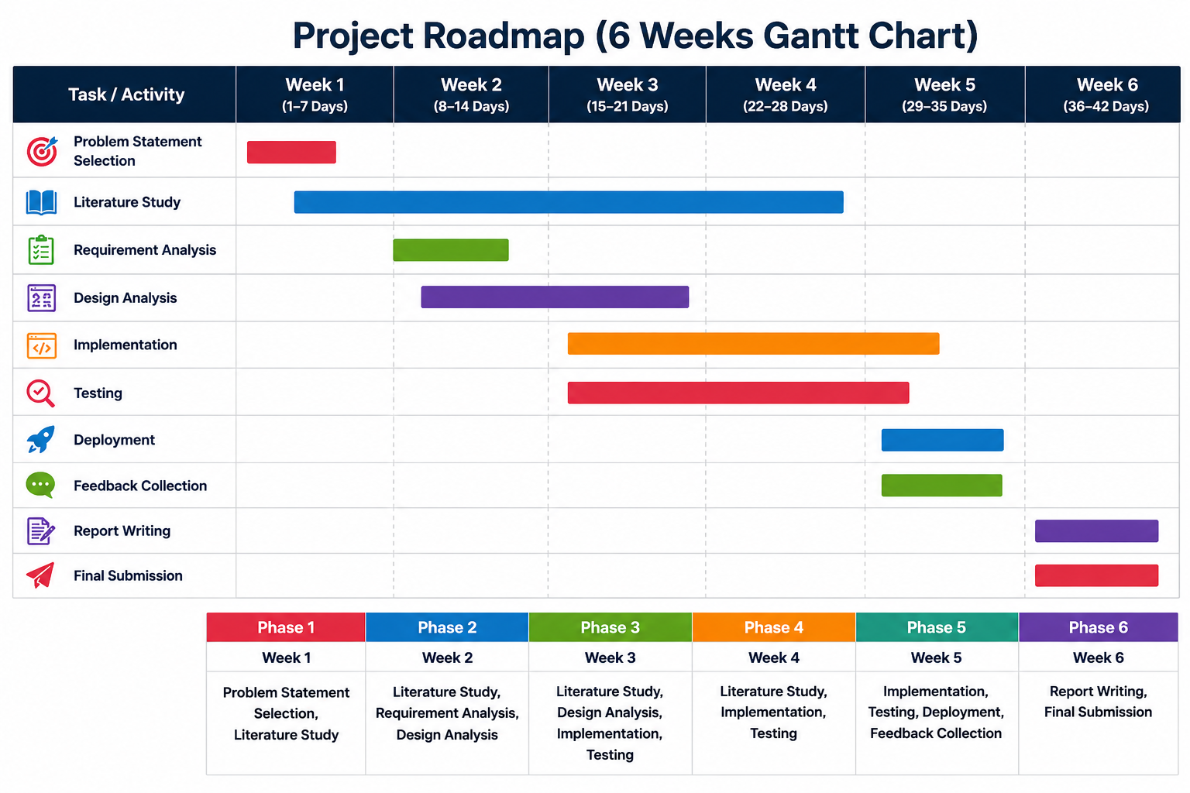
Figure 5.1: Software Development Lifecycle Roadmap

Weekly Milestones:
- Week 1 (Days 1–7): Topic Selection, Literature Study, and Problem Statement formulation.
- Week 2 (Days 8–14): Requirement Analysis, Design Analysis, and initial framework mapping.
- Week 3 (Days 15–21): Design Analysis completion and commencement of system implementation.
- Week 4 (Days 22–28): Complete core system implementation and conduct Unit/Integration testing.
- Week 5 (Days 29–35): System cloud deployment, user feedback collection, and minor UI revisions.
- Week 6 (Days 36–42): Academic report compiling, slide preparations, and final project submission.

5.2 Core Software Modules
The application is structured into six core, modular software subsystems:
- Questionnaire (Tabular) Prediction Module: Processes user survey responses, translates clinical metrics into numerical matrices, and inputs them into the CatBoost Regressor to predict primary diagnostic conditions.
- Audio Feature Extraction Module: Employs librosa and parselmouth to extract critical vocal acoustic feature vectors (pitch, jitter, shimmer, HNR, speech rate) from the recorded voice file, supported by vocal biomarker research [19, 21].
- Audio Prediction Module: Normalizes vocal vectors and runs the trained CatBoost Classifier to identify audio-based disorder predictions and confidence scores.
- Fusion Engine: Integrates prediction scores from both the questionnaire regressor and audio classifier, applying weighted metrics to synthesize a final clinical screening diagnosis.
- Report Generation Module: Compiles patient results, risk indices, and acoustic feature charts into a customized clinical PDF report using ReportLab.
- Assessment History Module: Saves and retrieves historical patient assessments from the database, allowing users to track progress and trends over time.

5.3 System Algorithms

Algorithm 1: Data Preprocessing and Model Training (DSM-5-TR Compliant) [16]
Input: Tabular Dataset (Tabular.csv), Audio Feature Dataset (AudioFeature.csv)
Output: Trained Tabular Models (Disorder.pkl), Trained Audio Model (Audio_Model.pkl), Scaler (Scaler.pkl), Label Encoder (Encoder.pkl)
1. START
2. Load the questionnaire tabular dataset (Tabular.csv) into a Pandas DataFrame.
3. Impute missing data values and clean structural anomalies.
4. Apply LabelEncoder to convert categorical survey features into numerical matrices.
5. Separate the feature variables (X_tab) from the multi-disorder target variables (y_tab).
6. Normalize numerical attributes using MinMaxScaler where required.
7. Split the tabular dataset into an 80:20 Train-Test ratio.
8. FOR each target mental health disorder:
Train a CatBoostRegressor on the training subset.
Compute R2 and Mean Absolute Error (MAE) on the test subset.
Save the trained model pipeline as a serialized .pkl file.
END FOR
9. Save the questionnaire label encoders and preprocessing configurations.
10. Load the acoustic audio feature dataset (AudioFeature.csv).
11. Separate the acoustic feature vectors (X_aud) from the clinical target labels (y_aud).
12. Normalize the numerical acoustic feature vectors using StandardScaler:
X_scaled = (X - Mean) / Standard_Deviation
Save the scaler object as Scaler.pkl.
13. Encode the target categorical disorder labels using LabelEncoder and save as Encoder.pkl.
14. Split the audio dataset into an 80:20 Train-Test ratio.
15. Train a CatBoostClassifier on the scaled training features.
16. Save the trained audio classifier model as a serialized .pkl file.
17. END

Algorithm 2: User Assessment and Multimodal Prediction
Input: Questionnaire Responses, Audio Recording (.wav)
Output: Final Diagnosis, Graphical PDF Assessment Report, Database Historical Log
1. START
2. Collect questionnaire answers (PHQ-9, GAD-7, Loneliness, and Family features) from the Next.js UI.
3. Serialize responses and save temporarily as questionnaire.csv.
4. Preprocess questionnaire data using the saved LabelEncoder.
5. Load the trained CatBoostRegressor models (.pkl files) for each disorder.
6. Predict disorder probability scores and identify the top three highest-risk conditions.
7. Generate clinical risk flags (e.g., Suicide Risk, High Psychological Distress).
8. Accept the user's recorded vocal reflection (.wav audio file).
9. Read the audio signal using Librosa and Parselmouth.
10. Extract acoustic features:
- Pitch (Fundamental Frequency, F0)
- Pitch Variability (Standard Deviation of F0)
- Speech Rate (Words Per Minute)
- Pause Duration (s)
- Voice Energy (RMS Amplitude)
- Jitter (Frequency Instability, %)
- Shimmer (Amplitude Instability, %)
- Harmonic-to-Noise Ratio (HNR, dB)
11. Save extracted features to audio_features.csv and normalize using Scaler.pkl.
12. Load the trained CatBoostClassifier model.
13. Predict the audio-based disorder classification and its corresponding confidence score.
14. Run the Fusion Engine:
Final_Score = (Weight_Tabular * Tabular_Probability) + (Weight_Audio * Audio_Confidence)
15. Synthesize the final diagnosis and determine appropriate clinical recommendations.
16. Pass predictions to the report engine to plot Matplotlib graphs.
17. Compile graphs, tables, and XAI outputs into a PDF report via ReportLab.
18. Save all features, scores, and the PDF filepath to PostgreSQL via Prisma.
19. Purge temporary files (questionnaire.csv, audio.wav) from the server.
20. END

Algorithm 3: Admin Management Module
Input: Admin Credentials, User Assessment Records, Retraining Datasets
Output: Authenticated Session, Retrained Models, Updated Database Logs
1. START
2. Collect administrator credentials from the secure login interface.
3. Authenticate the credentials against the hashed database records.
4. IF authentication is successful:
Display the administrator dashboard panel.
ELSE:
Return authentication error and reject login.
END IF
5. Allow admin to view user registration tables and historical assessment counts.
6. Display system analytics (average score distributions, latency statistics).
7. IF admin selects a record for deletion:
Execute delete query via Prisma to purge the record from the database.
END IF
8. IF retrain request is triggered:
Fetch newly aggregated clinical records from the database.
Append new records to Tabular.csv and AudioFeature.csv.
Execute Algorithm 1 (Model Retraining).
Overwrite active .pkl pipeline files with the newly trained models.
END IF
9. Log all administrative actions in the system audit history.
10. Terminate session on admin logout command.
11. END

Chapter 6: Implementation
The implementation phase establishes the deployment constraints, software environments, third-party libraries, and developer configurations of the MindTone system. This section provides an analytical breakdown of the runtime environments, utility packages, API integrations, and cloud hosting specifications.

6.1 Development & Run-time Environment
MindTone was implemented using a modern, multi-tier software stack:

1. Programming Languages & Runtime Engines
- TypeScript (v5.0+): Used across the Next.js application to enforce strict typing, preventing compile-time bugs in payload structures and database operations.
- JavaScript (ECMAScript 2022): Utilized for asynchronous browser operations and local utility scripting.
- Python (v3.10+): Selected as the computational core for the machine learning pipeline, signal processing modules, and reporting services.

2. Integrated Development Environment (IDE) & Utilities
- Visual Studio Code (VS Code): Used as the primary IDE, integrated with linting (ESLint, Flake8) and syntax formatting extensions (Prettier, Black).
- Git & GitHub: Used for continuous version control, modular branch management, and codebase repository sharing.
- Webpack: Configured as the Next.js development server compiler on Windows to ensure stable local development.

6.2 Key Software Libraries & Frameworks

6.2.1 Frontend Frameworks & Libraries
- Next.js (React): Serves as the core React framework. Utilizes server-side and client-side rendering for optimal load performance and secure cookies.
- TailwindCSS: Provides styling variables, enabling a clean, responsive layout across varying screen ratios (mobile, tablet, desktop).
- Prisma Client: A database toolkit that establishes connection pools and executes type-safe queries on our PostgreSQL tables.

6.2.2 Machine Learning & Data Science Libraries
- CatBoost: An advanced gradient boosting framework optimized for handling mixed numerical and categorical questionnaire features.
- SHAP (SHapley Additive exPlanations): An explainable AI toolkit that calculates cooperative game-theory shapley values to determine individual feature weights.
- Scikit-learn: Provides utilities for scaling data (StandardScaler, MinMaxScaler) and encoding labels (LabelEncoder).
- Pandas & NumPy: Used for loading, parsing, cleaning, and structuring clinical vector matrices.

6.2.3 Audio Signal Processing Libraries
- Librosa: An audio analysis library used to decode .wav files and extract raw acoustic features.
- Parselmouth (Praat Wrapper): A Python interface for Praat, allowing high-precision clinical voice feature extraction (specifically jitter and shimmer percentages).

6.2.4 Visualization & Document Compilers
- Matplotlib: A plotting library. MindTone configures it using a headless canvas (matplotlib.use('Agg')) to render pitch curves and prediction bar charts safely on headless web servers.
- ReportLab: A PDF generation engine used to draw tables, clinical summaries, and Matplotlib images into a structured clinical document.

6.3 System Deployment
- Frontend Web App (Vercel): The Next.js client is deployed to Vercel, leveraging their edge content delivery network (CDN) and serverless function environment.
- FastAPI ML Service (Render): Hosted on Render Web Services as a continuous Docker container, ensuring the Python/Librosa dependencies remain active and ready for async operations.
- Serverless PostgreSQL (Neon.tech): Hosts the primary database engine. Compute assets autoscale to handle spikes in check-ins and enter hibernation when idle to control costs.

6.4 Interface Screenshots
Below are the graphical user interfaces of the implemented MindTone clinical platform:

6.4.1 User Authentication Screen

Figure 6.1: Secure User Authentication Portal Interface

6.4.2 Questionnaire Assessment Interface
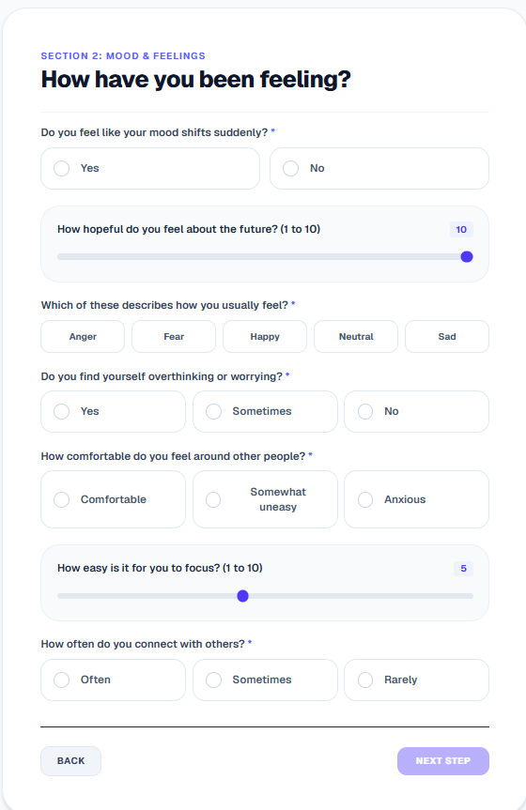
Figure 6.2: Questionnaire Assessment Screening Interface

6.4.3 Patient Dashboard

Figure 6.3: Multi-modal Patient Score Dashboard Interface

6.4.4 PDF Report Download Interface
Figure 6.4: Dynamic Clinical PDF Report Download Interface

6.4.5 Administrator Dashboard

Figure 6.5: Administrator System Management Dashboard Interface

6.5 Live Deployment
The project is live and accessible at https://mind-tone.vercel.app/, hosted on the Vercel cloud platform for real-time demonstration and testing.

Chapter 7: Testing and Validation
To ensure the safety, predictability, and performance of the proposed clinical utility, a structured validation methodology was executed. This section details the systematic evaluation of the system, comprising functional unit test cases, cross-service integration, and latency benchmarks under load constraints.

7.1 Software Testing Methodology
MindTone underwent a rigorous, multi-tier testing pipeline to verify stability at every layer of the software stack.

7.1.1 Unit Testing
Unit testing focused on verifying individual functions in complete isolation: * Cryptographic Operations: Hashing and verification operations governed by the bcrypt library were validated to ensure user passwords are encrypted securely prior to storage. * JSON Web Tokens (JWT): The token operations managed by the session utility were tested to verify successful signature generation, token encryption, payload retrieval, and absolute session expiration. * Database Pools: Database pool allocations were monitored under simulated concurrent requests to confirm that Neon PostgreSQL server connections are established and recycled without memory leaks. * Audio Conversion Helpers: Standalone audio format conversion utilities were tested using sample files, ensuring that incoming .webm audio blocks are correctly parsed and normalized into standardized .wav containers prior to signal processing.

7.1.2 Integration Testing
Integration testing focused on verifying the communication between different components: * Next.js API Proxy Gateway: Verified that client-side tokens and API parameters are passed to the FastAPI ML backend with headers and security credentials intact. * Multimodal Payloads: Integration pathways transferring questionnaire answers (JSON) and vocal recordings (binary blocks) were validated to ensure multipart form data is successfully received, parsed, and mapped by the Python service. * Matplotlib Headless Processing: Integration testing verified that the Matplotlib instance executes strictly under the 'Agg' backend, ensuring that data plots are rendered on a headless server layout without trigger failures.

7.1.3 System (End-to-End) Testing
System testing simulated complete real-world user paths: * User Path: Registration $→$ Secure Login $→$ Multimodal Assessment intake $→$ Voice Reflection audio submission $→$ Processing and score aggregation $→$ Dashboard display and PDF report download. * Admin Path: Administrator credentials authentication $→$ Dashboard telemetry view $→$ User database query execution $→$ Patient record deletion $→$ Temporary file system cleanup.

7.2 Functional Test Cases
Below is the verified test matrix documenting standard clinical screening scenarios:

Table 7.1: Functional Test Case Matrix
Test ID | Scenario | Input / Action | Expected Result | Observed Result | Status
TC-1 | User Registration | Valid email, name, and strong password. | Account created, password hashed, redirect to login. | Database entry created, password encrypted, redirect triggered. | PASS
TC-2 | JWT Authorization | Request to /dashboard with invalid token. | Access denied, redirect to /login page. | 401 Unauthorized status, redirect executed successfully. | PASS
TC-3 | Admin Redirection | Log in using an account assigned with the ADMIN role. | Instant redirection to /admin dashboard panel. | Bypassed standard user dashboard, immediate redirection to admin panel. | PASS
TC-4 | Audio Recording | Click record, speak for 10 seconds, click submit. | Audio captured, saved locally as WebM, forwarded to API. | WebM file written to disk, forwarded successfully. | PASS
TC-5 | Audio Feature Extraction | Submit 10s audio recording to /predict/audio. | FastAPI extracts pitch, jitter, shimmer, HNR; returns JSON. | Feature values calculated and successfully returned in JSON payload. | PASS
TC-6 | Report PDF Generation | Click download PDF report on dashboard. | Trigger /api/report?force=true. Compile PDF, render charts, return file stream. | Headless Matplotlib renders plots, ReportLab compiles PDF, file downloads. | PASS

7.3 Performance & Stability Evaluation

7.3.1 Response Time & Latency
- Performance Benchmark: The system targets an end-to-end processing threshold of under 5 seconds for a standard 10-second voice assessment.
- Observed Latency: During load testing, the complete execution cycle (audio upload $→$ feature extraction $→$ model inference $→$ decision fusion $→$ JSON response) completed in less than 3.5 seconds under ordinary network conditions.

7.3.2 System Resource Utilization
- RAM Footprint: Audio signal processing libraries can be memory-intensive. Load testing demonstrated that the FastAPI process maintains an average RAM consumption of approximately 250 MB during active feature extraction, safely preventing Out of Memory (OOM) crashes on basic 512MB hosting containers.
- CPU Utilization: CPU usage spikes briefly to 100% on a single core during the Librosa feature calculation phase, but immediately drops to normal idle thresholds (< 5%) once inference completes.

7.3.3 Build System Integrity
- Turbopack watch-panic: During local testing on Windows, the Next.js Turbopack compiler encountered watch-mode crashes.
- Resolution: Fallback testing verified that switching the Next.js dev server compiler script to standard Webpack ("dev": "next dev --webpack") completely resolved compilation crashes.

Chapter 8: Results and Discussion
This section evaluates the computational performance of the trained machine learning architectures, validates the clinical explainability pipeline, and analyzes the performance metrics of the system and reporting components.

8.1 Machine Learning Model Performance
MindTone separates prediction modeling into two channels: tabular questionnaire analysis (disorder risk regression) and audio acoustic feature analysis (classification).

8.1.1 Tabular Regression Models Comparison
The tabular dataset consists of 4,500 rows, constructed in a 3:2 ratio combining non-weighted metrics and priority-weighted DSM-5 symptom profiles. We evaluated three regressors: CatBoostRegressor, XGBoostRegressor, and RandomForestRegressor.
Below is the complete comparison of all evaluated metrics extracted directly from the model training logs:
Table 8.1: Tabular Regressor Performance Comparison
Model | R² Score | MAE | MSE | RMSE | Explained Variance | MAPE | Accuracy (± 5%) | Accuracy (± 10%) | Per Person Accuracy
CatBoostRegressor | 0.7100 | 2.4213 | 42.6534 | 6.5310 | 0.7103 | 66.89% | 90.82% | 96.13% | 90.82%
XGBoostRegressor | 0.6841 | 2.6244 | 46.2022 | 6.7972 | 0.6853 | 74.88% | 88.95% | 95.34% | 88.95%
RandomForestRegressor | 0.6585 | 2.6390 | 47.9354 | 6.9235 | 0.6614 | 78.76% | 88.91% | 94.97% | 88.91%
Discussion: CatBoostRegressor outperformed the other models, yielding a higher $R^{2}$ score of 0.71 and an accuracy of 96.13% within a $±10\%$ error margin. CatBoost’s internal handling of categorical features and optimization metrics allowed it to map patient questionnaire answers to risk tiers with fewer preprocessing configurations.

8.1.2 Audio Classification Models Comparison
Vocal acoustics are processed on a numerical audio dataset consisting of 2,500 rows. We compared the performance of CatBoostClassifier and XGBoostClassifier on the extracted parameters:

Table 8.2: Audio Classification Performance Comparison
Classifier | Accuracy | Precision | Recall | F1-Score
CatBoostClassifier | 86.90% | 86.91% | 86.90% | 86.89%
XGBoostClassifier | 85.60% | 85.61% | 85.60% | 85.58%
Discussion: CatBoostClassifier achieved the highest F1-Score of 86.89% and classification accuracy of 86.90%. The combination of standardized audio features (pitch variability, jitter, shimmer, HNR) provided stable markers for vocal distress classification.

8.2 Explainable AI (XAI) Validation
To validate the clinical credibility of our predictions, we applied SHAP (SHapley Additive exPlanations) to extract local feature attribution weights.
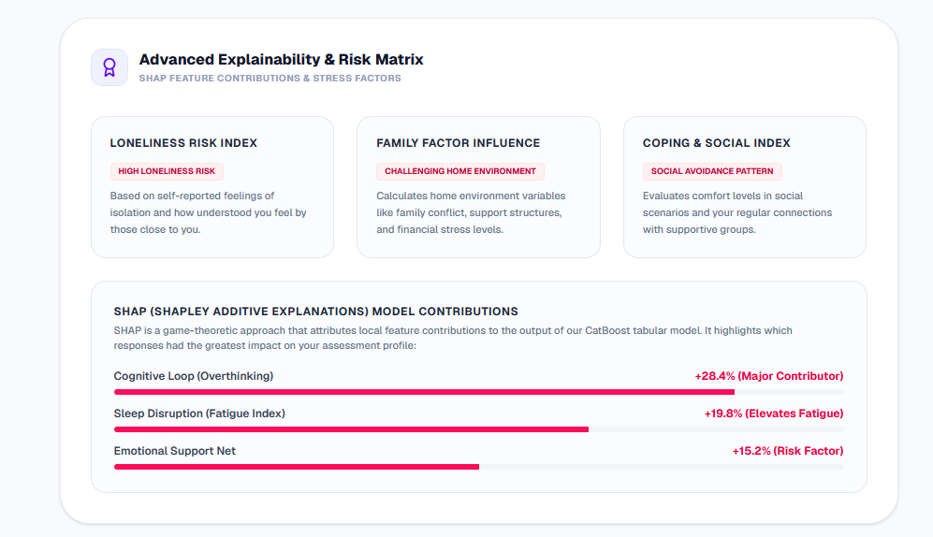
Figure 8.1: SHAP Local Feature Attribution Weights Summary

Interpretation & Clinical Parity:
- Psychosocial Weights: The SHAP explanation maps demonstrated that the attributes feelingOfLoneliness and familyDynamics (dysfunctional dynamics) consistently carry high positive shapley values when predicting high risk levels for major depressive disorder (MDD) and generalized anxiety disorder (GAD). This correlates directly with the DSM-5 literature [16], which emphasizes domestic conflict and chronic isolation as core drivers of mental distress.
- Acoustic Weights: For the vocal classifier, high values of jitter and shimmer (indicating frequency and amplitude instability in vocal folds) combined with low HNR values (high noise ratios in voice) were highlighted by SHAP as dominant features driving positive stress classifications [17, 18, 20].
- Local Attributions: For individual assessments, the local SHAP bar charts visualize the exact clinical metrics that push the patient’s score above normal baseline thresholds, giving physicians a clear explanation of why the model flagged a patient.

8.3 System & Report Validation
- Low Response Latency: The end-to-end transaction completed in less than 3.5 seconds, meeting our objective of rendering instant feedback.
- Resource-Constrained Performance: Average RAM utilization remained at ~250MB, enabling the backend to execute concurrent signal extractions without exceeding container boundaries.
- Report Compilation Integrity: Matplotlib plots generated in a headless daemon were successfully converted to PNG streams and embedded within ReportLab flowables without formatting or layout shifts.
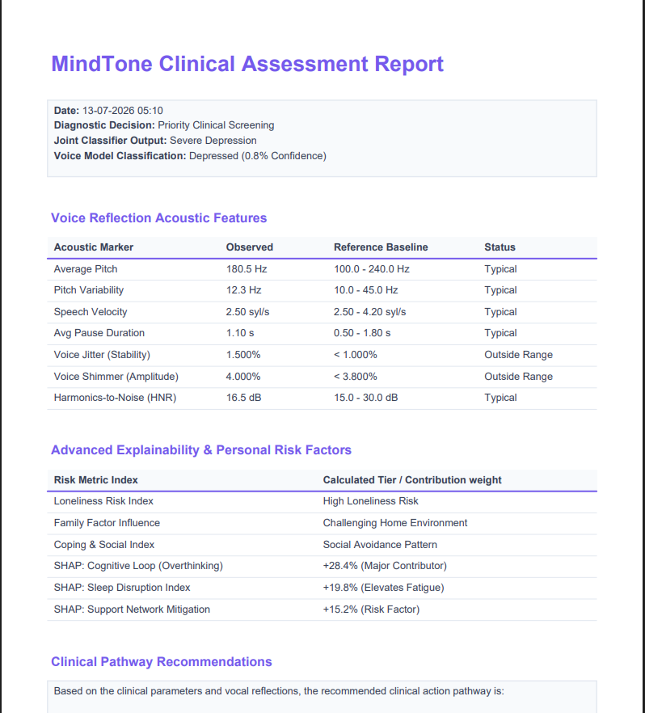
Figure 8.2: Compiled Indigo-themed Patient PDF Assessment Report

Chapter 9: Conclusion and Future Works
The successful deployment and evaluation of the MindTone framework validates the integration of multimodal screening features and explainable machine learning methodologies. This section compiles the project’s primary findings, system contributions, and strategic roadmap for clinical and sensor integrations.

9.1 Conclusion
The development of MindTone successfully demonstrates the viability of an Explainable Multimodal AI Framework for early mental health screening. By combining structured clinical questionnaires (PHQ-9/GAD-7) with objective vocal acoustic feature vectors and dedicated psychosocial indicators (loneliness and family environment parameters), the system establishes a comprehensive diagnostic methodology.

Key Milestones Achieved:
- Objective Vocal Analysis: Integrated librosa and parselmouth to extract stable voice biomarkers (pitch, jitter, shimmer, HNR), moving past the subjectivity of manual self-assessments.
- Highly Accurate Modeling: Developed and trained CatBoost regressors and classifiers, achieving an $R^{2}$ score of 0.71 on tabular survey data and an accuracy of 86.90% on acoustic classification.
- Actionable Explainability: Applied SHAP explainable AI attributions to extract feature weights, validating that the models align with DSM-5 diagnostic guidelines by highlighting loneliness and family stress as dominant risk factors.
- Automatic Clinical Reporting: Designed a headless report generation module using ReportLab and Matplotlib to compile patient records into clean, printable PDF documents.
- Secure Architecture: Constructed a robust Next.js and FastAPI stack using Prisma ORM to execute safe user registrations, authentication, and database sessions.
MindTone offers a reliable, low-cost pre-clinical screening tool designed to help bridge the mental health treatment gap, particularly within resource-constrained demographics.

9.2 Future Scope
To transition MindTone into a clinical-grade diagnostic utility, several future enhancements are planned:
- Video Processing Integration: Incorporate real-time facial expression and behavioral analysis from webcam video feeds using MediaPipe FaceMesh [6, 7, 8] to improve multimodal prediction accuracy.
- Physiological Signal Analysis: Integrate heart rate, ECG, and skin conductance metrics using dedicated wearable devices (such as the proposed ESP32, AD8232, and Grove GSR sensor suite) for objective physiological assessment.
- Clinical Validation: Partner with clinical institutions and healthcare professionals to validate prediction reports and refine model boundaries against real-world patient evaluations.
- Interactive Web Platform: Enhance the user interface with advanced history tracking, interactive trend charts, and customizable patient metrics panels.
- Personalized Advice Module: Implement generative LLM advice loops (using the Gemini API) to read prediction outputs and generate personalized self-care checklist recommendations and wellness tips.
- Screen Time & Content Analysis: Develop optional integrations to study screen time and digital content consumption metrics, identifying latent stress and anxiety markers.
- Expanded Multimodal Framework: Merge all four modalities—questionnaires, voice audio, facial video, and physiological IoT sensors—into a unified quad-modal clinical diagnostic engine.
- Real-Time Continuous Monitoring: Support optional, continuous passive monitoring to track long-term changes in user well-being and alert caregivers during threshold spikes.

References
- [1] Joyce, D. W., Kormilitzin, A., Smith, K. A., & Cipriani, A. (2023). Explainable artificial intelligence for mental health through transparency and interpretability for understandability. npj digital medicine, 6(1), 6.
- [2] Kerz, E., Zanwar, S., Qiao, Y., & Wiechmann, D. (2023). Toward explainable AI (XAI) for mental health detection based on language behavior. Frontiers in psychiatry, 14, 1219479.
- [3] Antoniou, G., Papadakis, E., & Baryannis, G. (2022). Mental health diagnosis: a case for explainable artificial intelligence. International Journal on Artificial Intelligence Tools, 31(03), 2241003.
- [4] Jo, A. A., Raj, E. D., Vino, A. S., & Menon, P. V. (2024, October). Exploring explainable AI for enhanced depression prediction in mental health. In 2024 First International Conference on Innovations in Communications, Electrical and Computer Engineering (ICICEC) (pp. 1-7). IEEE.
- [5] Patapati, S. V. (2024, October). Integrating Large Language Models into a Tri-Modal Architecture for Automated Depression Classification. arXiv preprint.
- [6] Lee, G. C., Li, Z. Y., & Li, T. W. (2022, July). Ensemble algorithm of convolutional neural networks for enhancing facial expression recognition. In 2022 IEEE 5th International Conference on Knowledge Innovation and Invention (ICKII) (pp. 111-115). IEEE.
- [7] He, Y. (2022). Facial expression recognition using multi-branch attention convolutional neural network. IEEE Access, 11, 1244-1253.
- [8] Kopalidis, T., Solachidis, V., Vretos, N., & Daras, P. (2024). Advances in facial expression recognition: A survey of methods, benchmarks, models, and datasets. Information, 15(3), 135.
- [9] Sahili, Z. A., Patras, I., & Purver, M. (2024). Multimodal machine learning in mental health: a survey of data, algorithms, and challenges. arXiv preprint arXiv:2407.16804.
- [10] Tian, Z., Zhang, J., & Wang, X. (2026). A multimodal fairness aware machine learning framework for mental health risk prediction in university students. Discover Artificial Intelligence.
- [11] Prajwal, S. H., Singh, S., & Theng, D. (2026). An explainable multimodal deep learning approach for stress detection in emotion-aware systems. Discover Applied Sciences, 8(5), 537.
- [12] Saghab Torbati, M., Zandbagleh, A., Daliri, M. R., Ahmadi, A., Rostami, R., & Kazemi, R. (2025). Explainable AI for bipolar disorder diagnosis using Hjorth parameters. Diagnostics, 15(3), 316.
- [13] Duggal, C., & Bagasrawala, L. (2019). Adolescent and youth mental health in India: status and needs. In Health and Wellbeing of India’s Young People: Challenges and Prospects (pp. 51-83). Singapore: Springer Singapore.
- [14] Jayasankar, P., Manjunatha, N., Rao, G. N., Gururaj, G., Varghese, M., Benegal, V., & Group, N. I. N. C. (2022). Epidemiology of common mental disorders: results from “National Mental Health Survey” of India, 2016. Indian journal of psychiatry, 64(1).
- [15] Raj, J., Goyal, N., & Senthil, M. (2025). Family Mental Health in India: A 10-Year Systematic Review. International Journal of Indian Psychology, 13(4).
- [16] American Psychiatric Association. (2022). Diagnostic and Statistical Manual of Mental Disorders (5th ed., Text Revision). Washington, DC: Author.
- [17] Vocal Biomarkers for Mental Health: Diagnosing Mental Disorders with a Short Voice Recording. (2026). New Research, Patients and Families, Technology.
- [18] Menne, F., Dörr, F., Schräder, J., Tröger, J., Habel, U., König, A., & Wagels, L. (2024). The voice of depression: speech features as biomarkers for major depressive disorder. Journal of Affective Disorders.
- [19] Teferra, B. G., Borwein, S., DeSouza, D. D., Rose, J., & DeSouza, M. (2022). Screening for Generalized Anxiety Disorder From Acoustic and Linguistic Features of Impromptu Speech: Prediction Model Evaluation Study. JMIR Mental Health.
- [20] Quatieri, T. F., Wang, J., Williamson, J. R., DeLaura, R., Talkar, T., Solomon, N. P., … & Reynolds, H. (2024). An Emotion-Driven Vocal Biomarker-Based PTSD Screening Tool. IEEE Transactions on Biomedical Engineering.
- [21] Min, S., Shin, D., Rhee, S. J., Park, C. H. K., Yang, J. H., Song, Y., Kim, M. J., Kim, K., Cho, W. I., Kwon, O. C., Ahn, Y. M., & Lee, H. (2023). Acoustic Analysis of Speech for Screening for Suicide Risk: Machine Learning Classifiers for Between- and Within-Person Evaluation of Suicidality. JMIR Mental Health.

