Malia: R6 and R7 Test Record
Project: Library Management System - Group 11
Tester: Malia Makisi
Branch: feature/malia-import-reports
Test dates: 14–15 October 2026
Environment: Windows, Visual Studio, .NET 10, local application at https://localhost:7016
1. Features tested
R6 - CSV importing: Upload, validation, preview and confirmation of library items.
R7 - Reports: Inventory, loan summaries, recorded fines, date/type filters and CSV/PDF downloads.

2. CSV import results
Test | Observed result | Status
Valid book import | Book successfully imported and appeared in the catalogue. | Passed
Valid music and toy import | Both items successfully imported. | Passed
Codes already in the database | Rows rejected with duplicate-code errors. | Passed
Duplicate codes within one CSV | Both rows rejected; preview showed 0 valid and 2 invalid rows. | Passed
Missing item name | Row rejected with “The item name is required.” | Passed
Mixed valid and invalid rows | Preview showed 1 valid and 1 invalid row. Import was blocked while errors remained. | Passed
Incorrect CSV headers | Missing required and unsupported headers were reported. | Passed
Malformed quotation marks | Clear formatting error displayed without crashing. Nothing imported. | Passed
PDF uploaded instead of CSV | Rejected with “Only CSV files are accepted.” | Passed
No file selected | Browser required a file before submitting. | Passed — browser validation

3. Report results
Test | Observed result | Status
Unfiltered report | Inventory, loans and recorded fines displayed. | Passed
Borrowed-date filtering | Selecting 1–14 October excluded the loan borrowed in September. | Passed
Inventory and date filters | Inventory totals remained unchanged when loan dates were filtered. | Passed
Reversed date range | Validation error displayed and report results were hidden. | Passed
Date range without loans | Zero loan totals and a clear empty-results message displayed. | Passed
Returned loan | Summary changed to 3 total, 2 active, 0 overdue and 1 returned. | Passed
Recorded unpaid fine | Report showed $12 assessed, $0 marked paid and $12 outstanding. | Passed
CSV export | Export contained matching summaries and loan details. | Passed
PDF export | Export contained matching summaries and readable loan details without clipping. | Passed
Filtered exports | Inspected filtered CSV and PDF contained the selected borrowed-date range and matching loans. | Passed
Loan table readability | Dates, codes and amounts remained readable; item titles wrapped normally. | Passed

4. Access control
Account | Observed result | Status
Admin | Could access Import and Reports. | Passed
Manager | Could access Reports; Import access denied. | Passed
Reception | Import and Reports access denied. | Passed
Logged-out user | Import and Reports redirected to login. | Passed
Manager CSV and PDF downloads were also manually checked and reported as working.
5. Fine and return evidence
The existing Reception return feature was used to create test data for the reports.
Test item: Overdue Fine Test Book
Library code: BK-R3-OVER
Loan ID: 3
Return date: 15 October 2026
Recorded fine: $12.00
Payment status: Unpaid
The webpage, CSV and PDF consistently showed:
- Total loans: 3
- Active loans: 2
- Overdue loans: 0
- Returned loans: 1
- Assessed fines: $12.00
- Marked paid fines: $0.00
- Outstanding fines: $12.00

6. Integration and build
Latest team changes from origin/main were merged into the feature branch.
Merge commit: 877d1fd6
Rebuild result: 1 succeeded, 0 failed
Push result: Successful; local and remote feature branches matched.

7. Evidence files
Test inputs and exported reports are stored in TestFiles:
- duplicate-test.csv
- missing-name-test.csv
- mixed-test.csv
- malformed-test.csv
- library-report-20261015-010031.csv
- library-report-20261015-005948 (1).pdf
The Screenshots folder is reserved for supporting screenshots.

8. Remaining verification
The following checks are not recorded as completed:
- File-size and maximum-row limits.
- Preview expiry and repeated confirmation.
- Positive paid-fine totals.
- Direct access checks for export URLs by unauthorised users.
- Deployment or virtual-machine testing.
Accessibility extras require separate implementation and testing.

9. CDU virtual machine testing
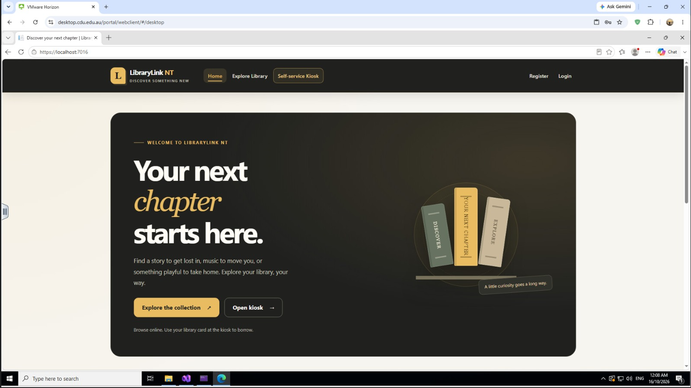
“Successfully started the application in the CDU IT Desktop VM and opened the login page.”
Keep report exports and CSV importing marked not yet verified on the VM unless you tested them. Your earlier PC test results remain valid.

