LibraryLink NT Patron User Guide
Searching the catalogue and borrowing through the self-service kiosk
Prepared by Asraful Hasan Asif for HIT339 Group 11. Version 1.0, 14 October 2026.
Use this guide to find books, music and toys, view your borrowing account, borrow an available item and finish your kiosk session. Screenshots show fictional demonstration records. Item availability, loan totals and return dates may differ when you use the system.

1 Search the library
1. Select Explore Library from the website navigation. You can search without signing in to a staff account.
2. Enter a name, library code or description. Optionally choose a Collection and Availability, then select Search.
3. Read the matching item cards. Each card shows the item name, library code and availability. Select Clear to remove filters.
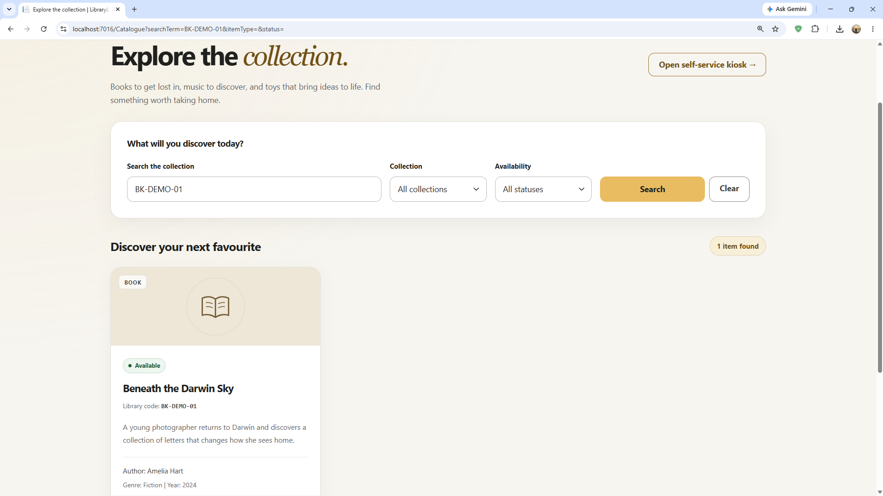
Figure 1 Searching BK-DEMO-01 returns Beneath the Darwin Sky
Available means an item may be borrowed. Borrowing is confirmed only after the kiosk completes the loan. For borrowed, reserved or unavailable items, ask the service desk for help.

2 Open your kiosk account
1. Select Self-service Kiosk from the website, or Open self-service kiosk on the catalogue page.
2. Select the Library card code field. Type the borrower code printed on your card. If a compatible USB barcode scanner is connected and configured, scan your card into this field.
3. Select Open my account. If the code is rejected, check it and try again or ask the service desk.
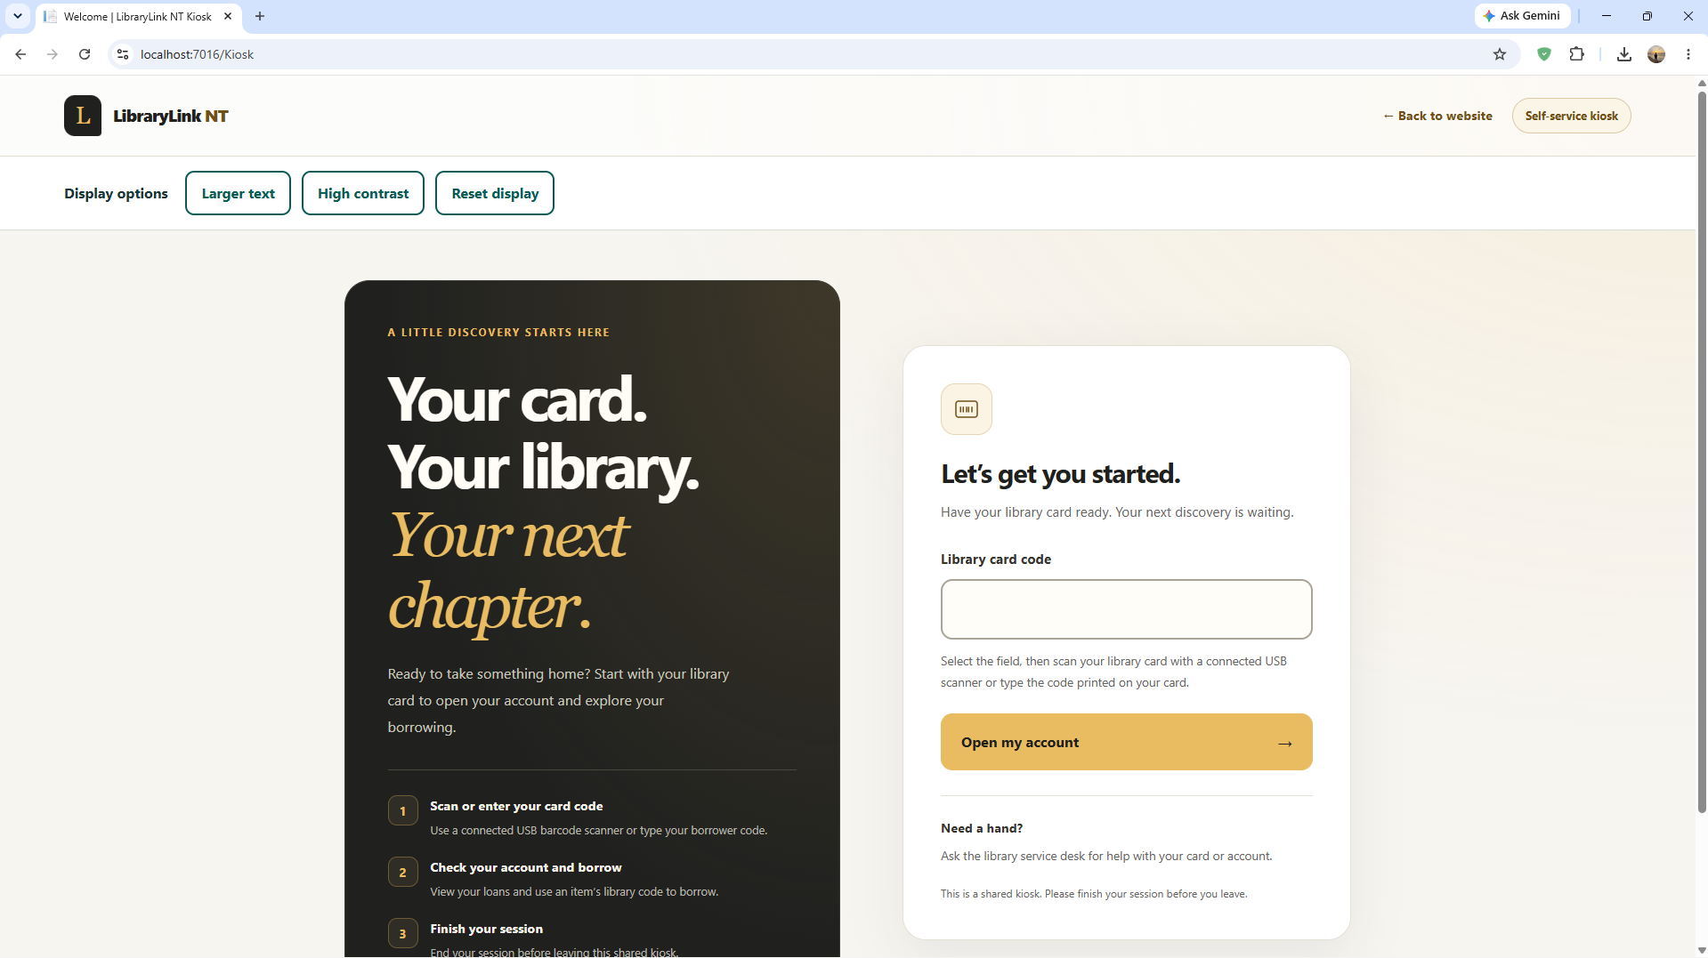
Figure 2 Kiosk welcome screen and library card entry
In this demonstration, BR-DEMO3 opens a sample borrower account. Use your own issued card code in normal operation. The kiosk card code is separate from a staff email and password.

3 Check your borrowing account
1. Check Currently borrowing for your active loan count.
2. Check Unpaid assessed fines for recorded unpaid charges. Further charges may apply when overdue items return. Ask the service desk about payments.
3. Review On your bookshelf for item names, library codes, return dates and overdue labels.
4. Select Borrow an item to begin another loan.
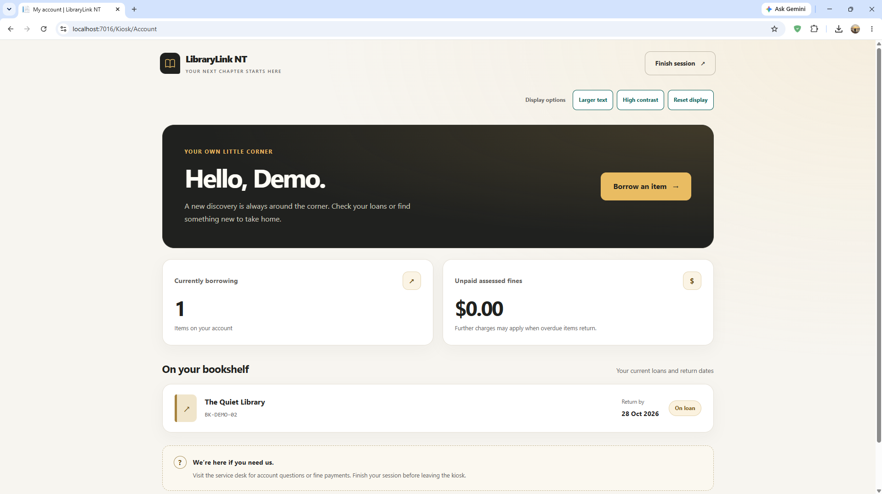
Figure 3 Account summary with one existing loan and its return date
The example shows The Quiet Library due on 28 October 2026. Always follow the return date shown for your own loan.

4 Review an item before borrowing
1. Select Borrow an item from your account.
2. Enter the item library code and select Review this item. Use the library label, not the book ISBN. A connected compatible scanner can enter the code into the selected field.
3. Check the item name, code and return date on the review screen.
4. Select Confirm borrowing to complete the loan, or Choose a different item to return to item entry.
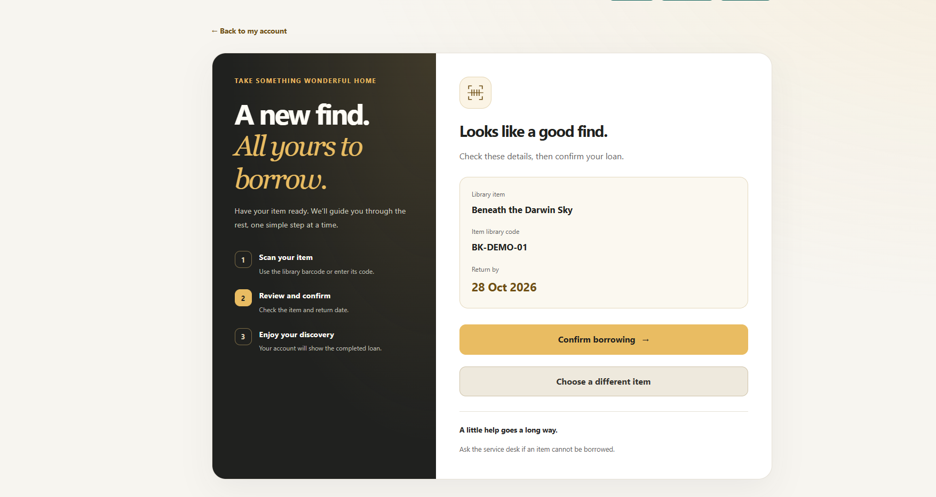
Figure 4 Review the selected item and return date before confirming
If the item is unknown or unavailable, read the error and correct the code or choose another item. Contact the service desk if you need help. Reviewing an item alone does not complete a loan.

5 Check the borrowing confirmation
1. After confirming, read the success message on your account page.
2. Check that Currently borrowing has increased and the new item appears in your current loans. Scroll down if necessary.
3. Note the return date. You may select Borrow an item again for another available item.
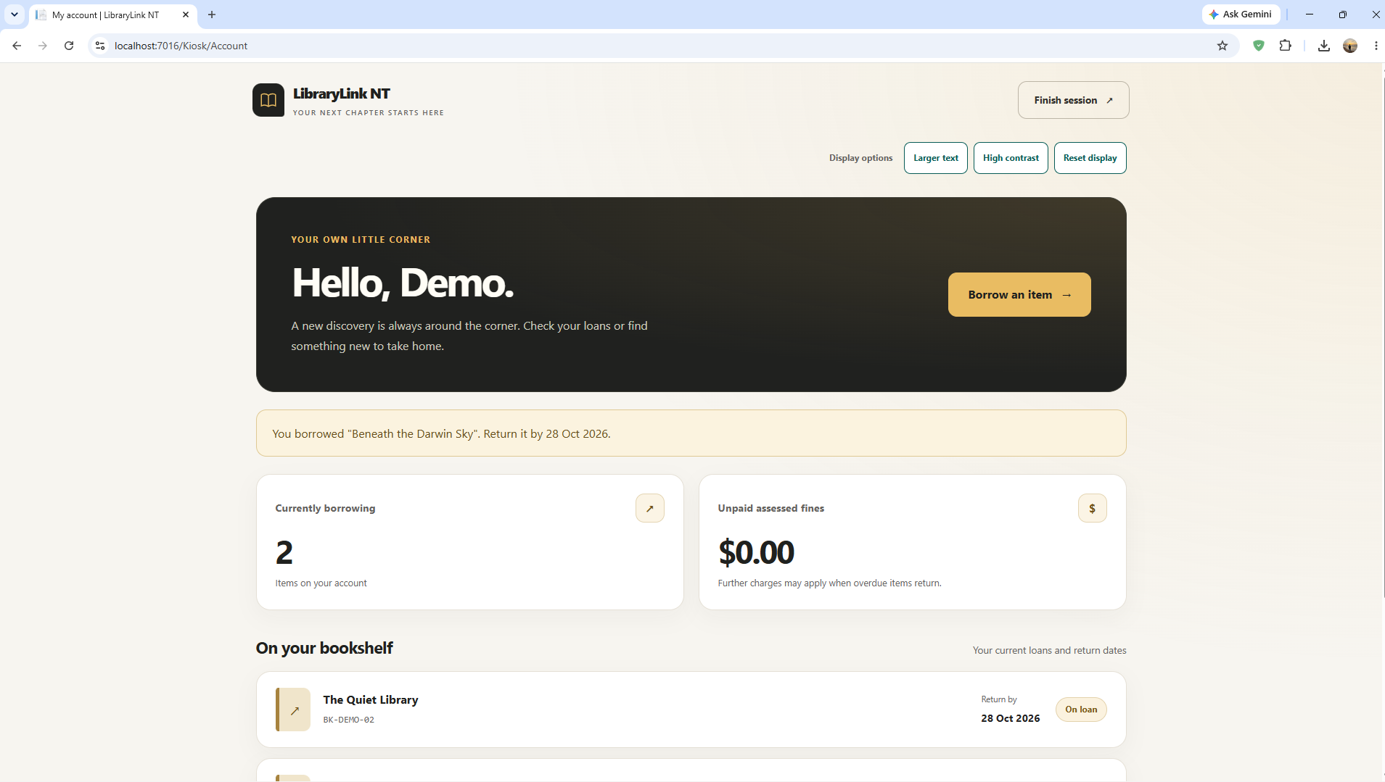
Figure 5 Successful borrowing message and an updated count of two loans
In this example, Beneath the Darwin Sky was borrowed and the account count increased from one to two. If you do not see confirmation, check your account before attempting the same loan again.

6 Finish your session
1. Select Finish session at the top of the account or borrowing page before leaving the kiosk.
2. Check that the welcome screen returns and displays the signed-out confirmation.
3. Do not leave your account open for the next visitor.
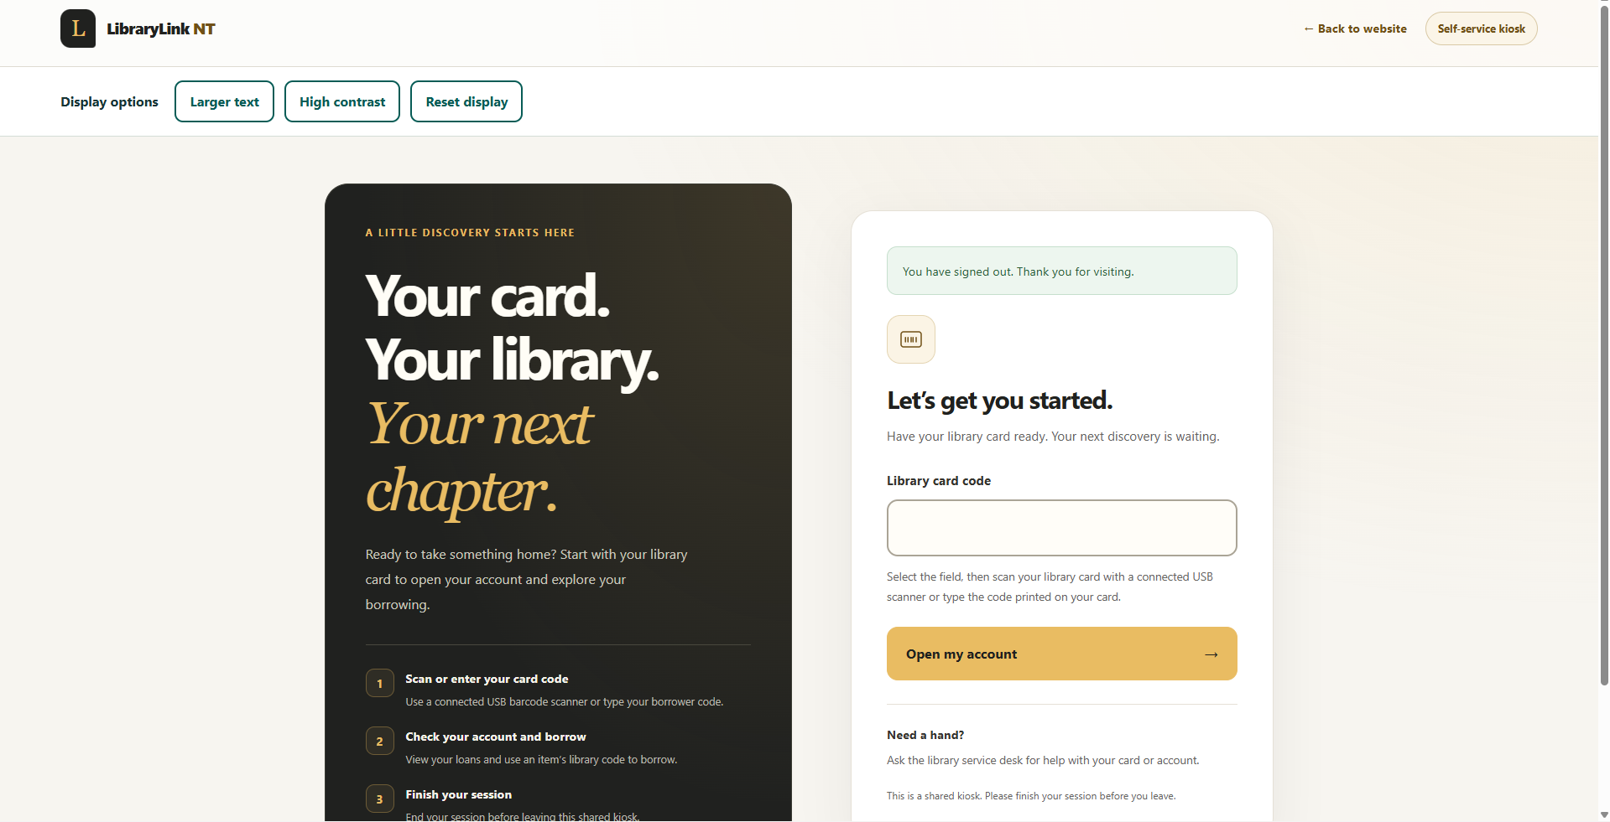
Figure 6 Signed-out confirmation and an empty card entry field
If the inactivity warning appears, choose the option to continue or finish. Continuing from the borrowing page returns to item entry, so you may need to review the item again. If the session has ended, enter your card code again.
Opening the account route without a valid kiosk session returns to the welcome screen. The direct-route check in the supplied evidence showed the message Your session has ended. Please scan your card again.

7 Change the display and get help
1. Select Larger text in Display options to increase text size. Select it again to return to standard text.
2. Select High contrast to use black backgrounds, white text and yellow controls. Select it again to restore standard colours.
3. Select Reset display to turn off both display preferences.
4. Use Tab and Shift plus Tab to move between controls, Enter to activate links or submit a form, and Space to activate a focused button.
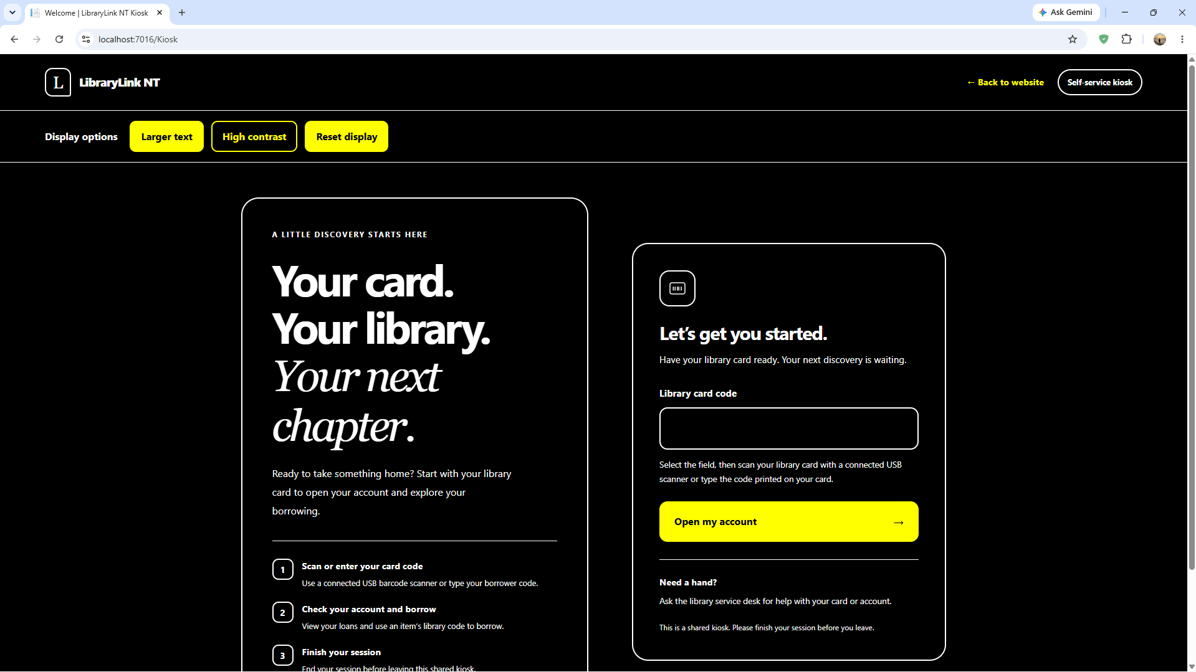
Figure 7 High contrast welcome screen with visible instructions and controls
If a card or item code is not recognised, check the code and try again. If an item is already borrowed or cannot be issued, choose another item or speak with the service desk. Ask staff for help with account questions, fines, returns and reservations.
This guide covers the catalogue and kiosk screens demonstrated. Reservation- and branch-specific instructions should be added after the relevant integrated screens have been verified. Physical scanner operation and full screen-reader compatibility have not been verified by these screenshots.

