Technical Analysis using R
  - Assignment 6 Visualization Phase
Azadvir Singh
BDA400 Data Science Tools and Techniques
Singh_Azadvir_CA_BDA400_A06

Project description
An interactive R Shiny portfolio dashboard displays AAPL, MSFT, and GOOGL using Yahoo Finance data. Users can select dates and daily, weekly, or monthly bars; switch between line, candlestick, and area charts; and independently toggle moving averages, RSI, and MACD. Custom MA periods and optional MACD confirmation control actual crossover events, with buy and sell annotations on the chart.

Repository
https://github.com/azadvirsingh6-cloud/TechnicalAnalysis
Upload location for this assignment
TechnicalAnalysis / Assignment06
https://github.com/azadvirsingh6-cloud/TechnicalAnalysis/tree/main/Assignment06

Run instructions
Extract the package, set Assignment06 as the RStudio working directory, and run source("install_packages.R") once. Open app.R and click Run App, or run shiny::runApp("."). Choose Yahoo Finance live request to fetch data, or use the explicitly labeled 2025 snapshot offline. Keep the data folder with app.R. README.md explains controls and implementation conventions.

Verification and submission
50 automated checks passed. A live quantmod request, Shiny reactive controls, browser chart states, and a 12-row monthly CSV download were verified. Logs and genuine dashboard screenshots are included in evidence. Upload the Assignment06 folder and confirm the public link before submitting this cover page on the LMS. The new assignment folder has not been uploaded by the assistant.
AI assistance: OpenAI Codex helped prepare the implementation, tests, screenshots, and documentation. Trading signals are educational examples; no orders are sent and no investment performance is claimed.

Daily dashboard screenshot
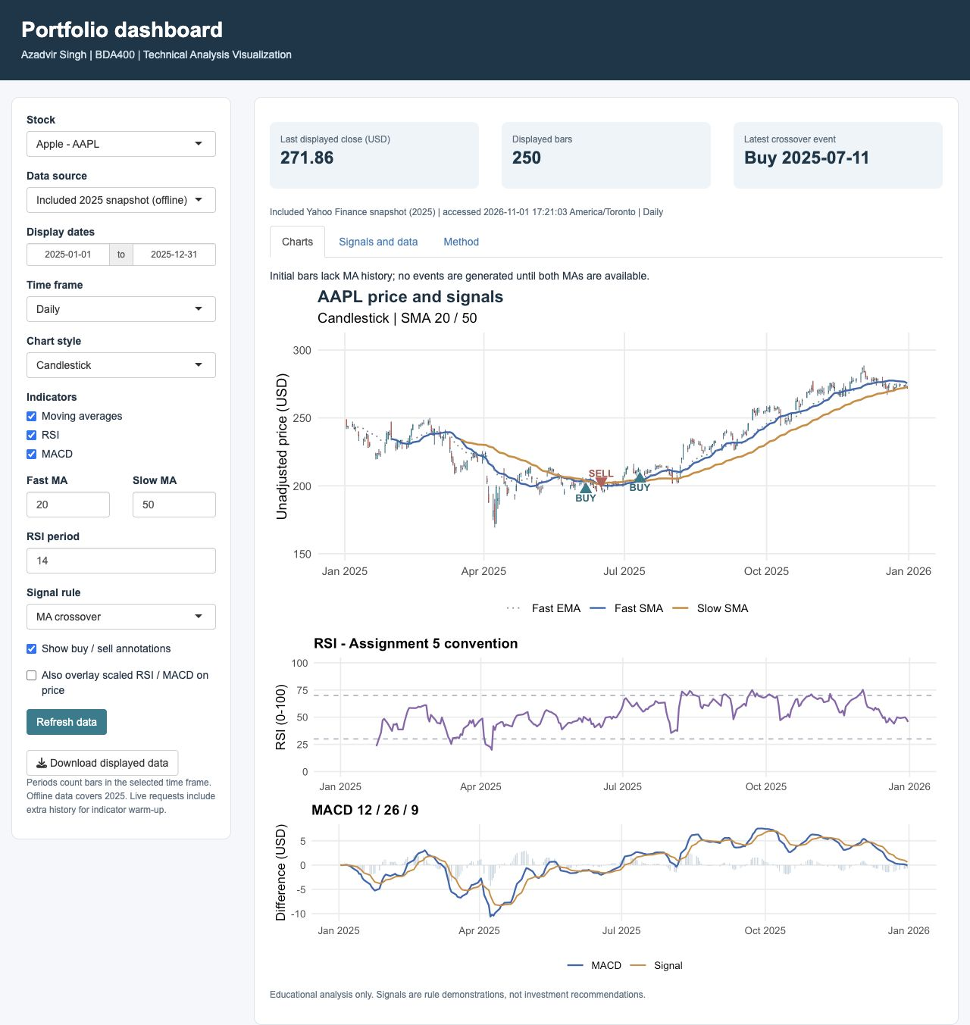
Figure 1. Running Shiny dashboard with daily AAPL candles, SMA/EMA overlays, RSI and MACD panels, and annotated crossover events.

Monthly dashboard screenshot
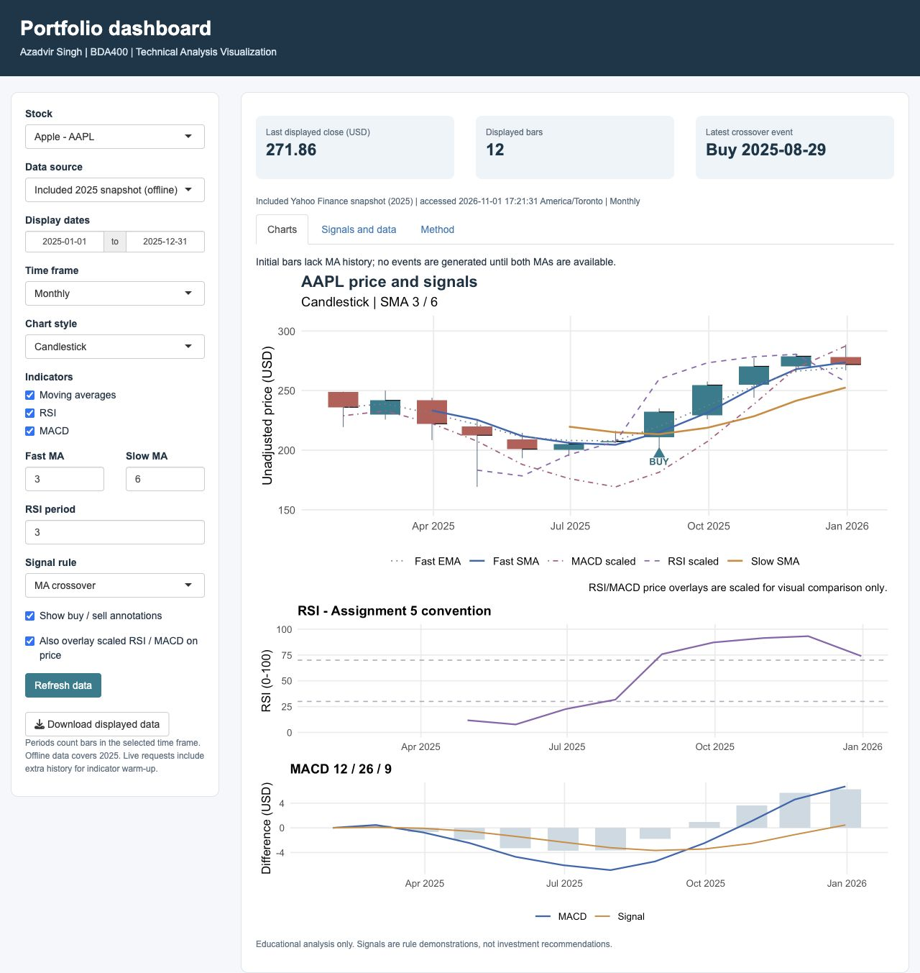
Figure 2. Monthly bars, fast/slow periods of 3 and 6, RSI period 3, and optional scaled RSI/MACD price overlays. The browser download was verified to contain 12 monthly rows.

