I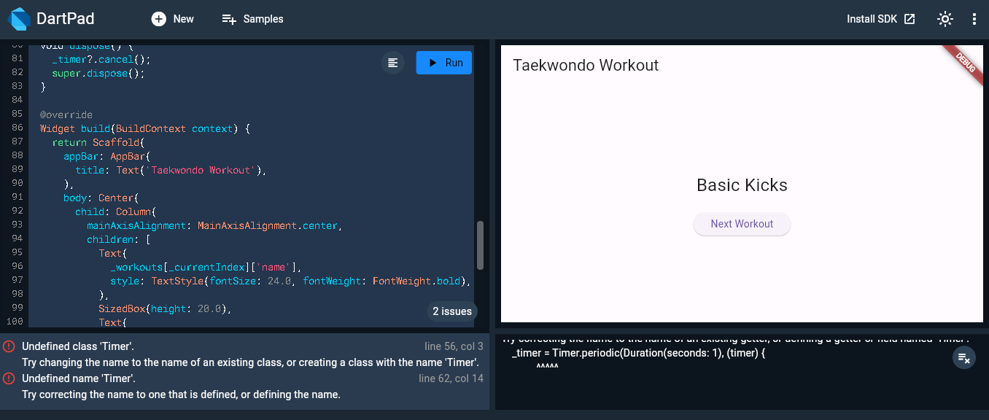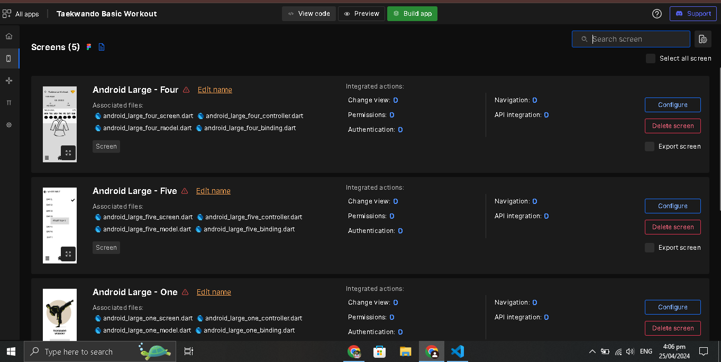

mport 'package:flutter/material.dart';

void main() {

runApp(TaekwondoWorkoutApp());

}

class TaekwondoWorkoutApp extends StatelessWidget {

@override

Widget build(BuildContext context) {

return MaterialApp(

title: 'Taekwondo Workout',

theme: ThemeData(

primarySwatch: Colors.red,

),

home: WorkoutScreen(),

);

}

}

class WorkoutScreen extends StatefulWidget {

@override

_WorkoutScreenState createState() => _WorkoutScreenState();

}

class _WorkoutScreenState extends State<WorkoutScreen> {

final List<Map<String, dynamic>> _workouts = [

{

'name': 'Warm-up',

'description': 'Perform dynamic stretches and light cardio.',

'duration': 10,

},

{

'name': 'Basic Kicks',

'description': 'Practice front kick, side kick, and roundhouse kick.',

'duration': 15,

},

{

'name': 'Blocks',

'description': 'Learn and practice different blocking techniques.',

'duration': 10,

},

{

'name': 'Punches',

'description': 'Practice different punching techniques.',

'duration': 10,

},

{

'name': 'Stretching',

'description': 'Cool down with static stretches.',

'duration': 5,

},

];

int _currentIndex = 0;

int _remainingTime = 0;

Timer _timer;

void _startWorkout() {

setState(() {

_remainingTime = _workouts[_currentIndex]['duration'] * 60;

});

_timer = Timer.periodic(Duration(seconds: 1), (timer) {

setState(() {

_remainingTime--;

if (_remainingTime == 0) {

_timer.cancel();

_nextWorkout();

}

});

});

}

void _nextWorkout() {

setState(() {

_currentIndex = (_currentIndex + 1) % _workouts.length;

});

}

@override

void dispose() {

_timer?.cancel();

super.dispose();

}

@override

Widget build(BuildContext context) {

return Scaffold(

appBar: AppBar(

title: Text('Taekwondo Workout'),

),

body: Center(

child: Column(

mainAxisAlignment: MainAxisAlignment.center,

children: [

Text(

_workouts[_currentIndex]['name'],

style: TextStyle(fontSize: 24.0, fontWeight: FontWeight.bold),

),

SizedBox(height: 20.0),

Text(

_workouts[_currentIndex]['description'],

textAlign: TextAlign.center,

style: TextStyle(fontSize: 18.0),

),

SizedBox(height: 40.0),

Text(

_remainingTime > 0

? Duration(seconds: _remainingTime)

.toString()

.split('.')[0]

.padLeft(8, '0')

: '00:00:00',

style: TextStyle(fontSize: 24.0),

),

SizedBox(height: 40.0),

ElevatedButton(

onPressed: _startWorkout,

child: Text('Start Workout'),

),

],

),

),

);

}

}