Cinema MIS Performance Report

Executive Summary
Period: 2026-03-01 to 2026-03-31
Total Shows: 61
Total Tickets Sold: 716
Total Box Office: $76246
Total Concessions: $23743.86
Total Revenue: $99989.86
Avg Occupancy: 4.27%

Performance Charts
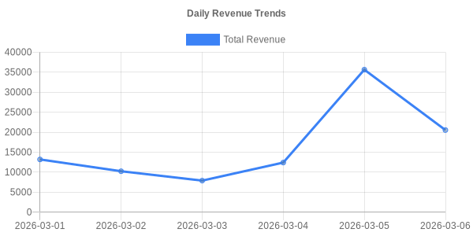
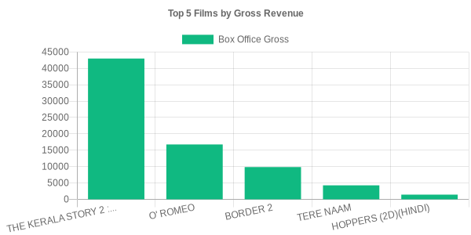

Top Films
Film | Shows | Tickets | Gross Rev
THE KERALA STORY 2 : GOES BEYO | 32 | 401 | 43009
O' ROMEO | 11 | 157 | 16761
BORDER 2 | 6 | 95 | 9863
TERE NAAM | 8 | 45 | 4273
HOPPERS (2D)(HINDI) | 3 | 12 | 1440
SEMI FINAL (INDIA VS ENGLAND) | 1 | 6 | 900

