STUDENT PERFORMANCE AND APTITUDE ANALYSIS

Validating Course Placement Effectiveness at The Key English Course Company



Lead Analyst
Muhammad Azahrul Ramadhan

Project Team
Harry Ramadhana Nasution | Riska Rasyida M Fawwaz Akbar | Salma Nuramalia

Mentor & Supervisor
Hilmi

Data Enthusiast Community
Indonesia
2026

PROJECT OVERVIEW
In the language education industry, the accuracy of level placement (placement testing) is the cornerstone of student success. This project conducts a critical evaluation of the course placement system at The Key English Course Company - Indonesia using an Empirical Statistical Analysis approach.
This analysis moves beyond basic descriptive statistics by implementing a series of rigorous tests:
- Assumptions Testing: Ensuring data meets normality and homogeneity of variance requirements prior to parametric testing.
- One-Way ANOVA: Utilized to test for significant differences in mean performance and aptitude scores across course levels.
- Post-Hoc Analysis: Specifically identifying inter-level differences to mitigate Type I errors.
- Correlation & Effect Size: Measuring the strength of the relationship between aptitude and performance using the Pearson coefficient and calculating Eta-squared ($\eta^2$) to quantify the practical impact of level placement.
The analysis revealed a very strong positive correlation (r = 0.887, p < 0.001) between aptitude scores and final performance. This confirms that the current assessment system possesses high Predictive Validity. Furthermore, the Effect Size for the Performance variable reached $η^{2}=0.744$, indicating that the course level variable accounts for 74.4% of the variance in students' academic achievement.

Research Questions
- Do students with different performance levels enroll in different course levels?
- Are there significant differences in aptitude scores across course levels?
- What is the correlation between aptitude scores and performance?
- What are the implications for course placement and program quality?

Repository Contents
├── README.md # This file
├── assets/
│ └── the_key.png # Company logo
├── Final_Analysis.ipynb # Analysis report
├── Final_Analysis.pdf # Full analysis report (PDF)
├── data/
│ └── student_combined_data.csv # Dataset
└── requirements.txt # Python dependencies

Dataset Description

Sample Characteristics
- Total Students: 150
- Sample Distribution: 50 students per course level
- Sampling Method: Stratified random sampling
- Data Completeness: No missing values

Sample Characteristics
- Total Students: 150
- Sample Distribution: 50 students per course level
- Sampling Method: Stratified random sampling
- Data Completeness: No missing values

Variables
Variable | Type | Description | Range
student_id | Integer | Unique student identifier | 1-150
course_level | Categorical | Course enrollment level | Advanced, Intermediate, Foundation
performance_score | Float | Academic achievement score | 1.55 - 3.80 (4-point scale)
aptitude_score | Integer | Language aptitude test score | 9 - 97 (max 126)

Getting Started

Required Packages
- pandas>=1.3.0
- numpy>=1.21.0
- scipy>=1.7.0
- matplotlib>=3.4.0
- seaborn>=0.11.0
- statsmodels>=0.13.0
- jupyter>=1.0.0

Notebook Structure
The Jupyter notebook (Final_Analysis.ipynb) mirrors the PDF report and includes:
- Chapter 1: Introduction & Data Loading
- Chapter 2: Data Overview & Quality Checks
- Chapter 3: Descriptive Statistics
- Chapter 4: Assumption Testing
- Chapter 5: ANOVA Analysis
- Chapter 6: Post-Hoc Tests
- Chapter 7: Correlation Analysis
- Chapter 8: Effect Sizes
- Chapter 9: Visualizations
- Chapter 10: Summary & Conclusions

Chapter 1: How We Collected and Analyzed Data

The Data: What We Examined

Who Was Included
The researchers employed a Stratified Random Sampling technique to ensure that each course level was equally represented in the analysis. The total population was categorized into three levels, with a fixed sample size of 50 students per level (N=150). This method was selected to eliminate selection bias and ensure that the findings for each specific level are statistically significant. According to the Central Limit Theorem, a sample size of $n ≥30$ per group is generally sufficient for the distribution of the sample means to be approximately normal, making this dataset (n=50) highly reliable for inferential statistical testing.

What We Measured
  - Aptitude Score (Independent Variable)
    - Construct: Evaluates the student's innate cognitive capacity for language learning.
    - Instrument: A standardized psychometric tool assessing four key domains: vocabulary, reading comprehension, logical reasoning, and linguistic problem-solving.
    - Scale: Scores are calculated on a scale of 0–126 points, with the study sample exhibiting a range of 9 to 97.
    - Temporal Context: Administered during the initial placement phase prior to course enrollment.
  - Performance Score (Dependent Variable)
    - Construct: Measures actualized academic achievement and proficiency gains within the program.
    - Assessment: Derived from a weighted average of formal course grades, formative assessments, and comprehensive progress evaluations.
    - Scale: Recorded on a standard 4.0 equivalent scale (Observed range: 1.55–3.80).
    - Temporal Context: Collected cumulatively throughout the instructional period.

Chapter 2: The Data Result

Descriptive Statistics
Level | Performance Mean | Performance SD | Aptitude Mean | Aptitude SD
Advanced | 3.239 | 0.384 | 67.46 | 19.17
Intermediate | 2.518 | 0.392 | 42.74 | 18.28
Foundation | 1.865 | 0.177 | 22.52 | 7.03

Visual Comparison
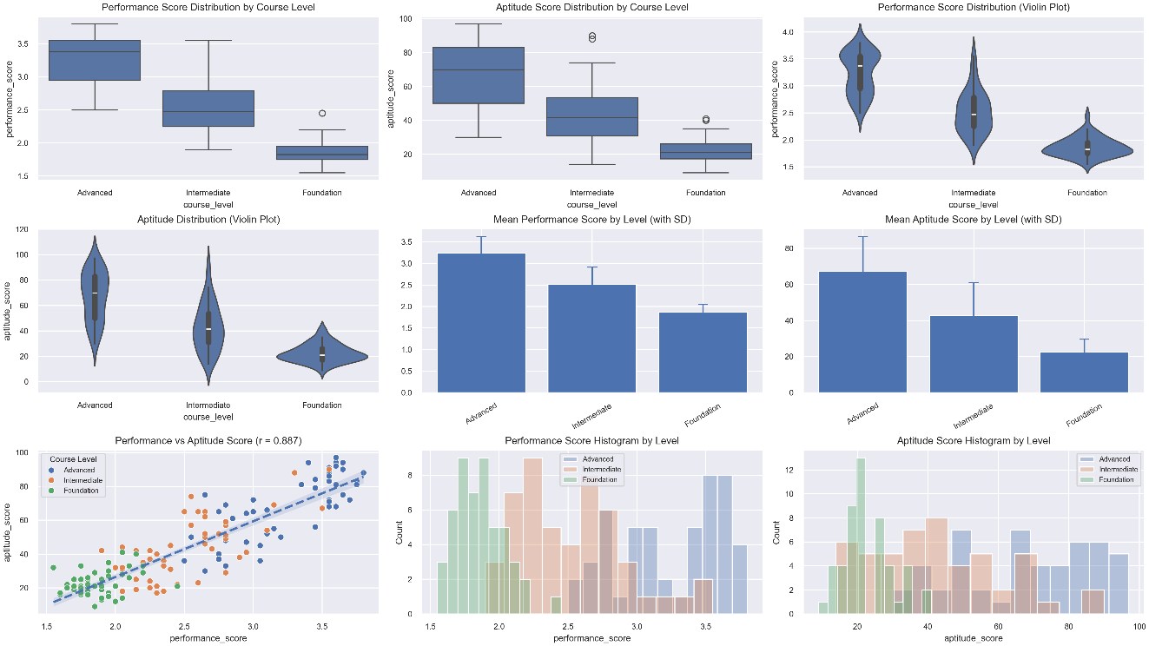
The visualizations confirm distinct differentiation between course levels in both Performance and Aptitude. The clear separation with minimal overlap provides strong visual evidence for the validity of the placement system at The Key English Course.

Box-and-Whisker Plots (Distribution & Variance)
Interquartile Range (IQR): The boxes represent the middle 50% of the data, showcasing where the majority of student scores are concentrated.
Median Line: The horizontal line within each box indicates the central tendency of the scores for that level.
Whiskers & Outliers: Vertical whiskers extend to show the full range of the data, while individual dots represent statistical outliers (unusual scores).
Key Insight: The lack of significant overlap between boxes suggests high inter-group variance, which is a primary indicator of statistically significant differences.

Bar Charts (Comparative Means)
Mean Scores: The height of each bar represents the average score for the respective course level.
Error Bars: These lines indicate the standard deviation or variability within each group.
Key Insight: The steady upward progression from Foundation to Advanced confirms that the curriculum levels are correctly calibrated according to student capability.

Correlation Scatter Plot (Relationship Analysis)
Axes: The horizontal axis (X) represents Aptitude, while the vertical axis (Y) represents Performance.
Regression Line: The red trend line illustrates a strong positive correlation, demonstrating that higher aptitude scores consistently predict higher academic performance.
Color-Coded Stratification: Different colors highlight how students from each level form distinct clusters, proving that the placement system effectively groups students with similar learning profiles.

ANOVA Results
Variable | F-statistic | df | p-value | η² (Effect Size)
Performance | 213.43 | (2, 147) | < 0.001*** | 0.744 (Large)
Aptitude | 101.17 | (2, 147) | < 0.001*** | 0.579 (Large)

Correlation
Relationship | r | p-value | Interpretation
Performance ↔ Aptitude | 0.887 | < 0.001*** | Very Strong Positive

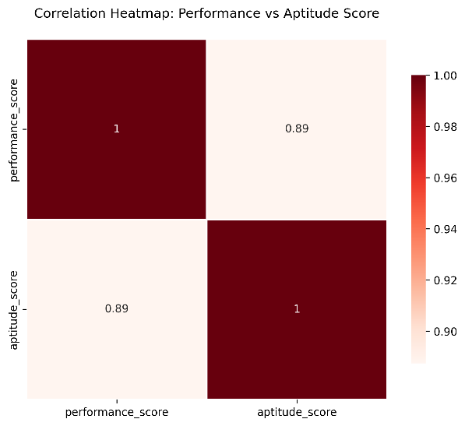

Operational Implications: From Data to Action
The statistical significance found in this study translates directly into pedagogical strategies. Below are the practical applications of our findings for key stakeholders.

Instructional Guidelines for Teachers
The data confirms that the three levels are distinct populations with different learning trajectories. Therefore, instructional pacing and complexity must be tailored accordingly:
- Advanced Level (High-Performance Cohort):
  - Instructional Velocity: Students possess the cognitive aptitude to handle rapid pacing and high-complexity materials.
  - Intervention Strategy: If a student struggles, it is likely due to a specific skill gap (e.g., nuanced grammar) rather than a lack of general ability. Target the specific "bottleneck."
  - Expectations: High-cognitive demand is not only appropriate but necessary to maintain engagement and growth.
- Intermediate Level (Moderate-Aptitude Cohort):
  - Strategic Scaffolding: Students are in the "Zone of Proximal Development." They require a balance of independent work and structured support to bridge the gap to Advanced materials.
  - Collaborative Learning: This level benefits most from mixed-ability peer activities, as the performance range is consistent enough for students to learn from one another.
- Foundation Level (Baseline-Building Cohort):
  - Pedagogical Structure: Instruction should focus on high-frequency fundamentals. Direct, explicit instruction is more effective here than purely discovery-based learning.
  - Growth Mindset: The data shows slower progress is developmentally normal at this stage. Patience and reinforcing "Mastery over Speed" are essential for long-term retention.

Guidance for Students and Parents
The placement system is a tool for optimal learning, not a label of fixed ability. Here is how to interpret a student's placement:
- Advanced Placement:
  - Validation: Your placement indicates you scored in the top tier for both aptitude and performance.
  - The Challenge: Coursework is intentionally rigorous. If you find it difficult, remember that you have the proven potential to succeed here; you may simply need to refine your study habits.
- Intermediate Placement:
  - The "Bridge" Level: This is the most common placement and represents a solid mastery of the basics.
  - Path to Advancement: You are in the optimal environment to build the stamina required for Advanced work. Consistent effort here is the most reliable predictor of future promotion to the next level.
- Foundation Placement:
  - The Power of Fundamentals: Every advanced speaker once started here. This level is designed to ensure there are no "cracks" in your foundation that would cause failure later on.
  - Success Metric: Focus on mastery. A student who masters the Foundation level is statistically more likely to succeed in Advanced levels than a student who rushes through without understanding.

