SpeciesID: Bias-aware quantitative species authentication in meat products by DNA metabarcoding

Highlights
- SpeciesID jointly corrects mitochondrial copy number, PCR bias and DNA degradation
- Perfect species detection (F1 = 1.000) across 54 simulated binary meat mixtures
- Validated on 174 real samples from two independent laboratories
- Mean absolute error of 1.16 pp on LGC certified reference materials
- C tool with GUI for deployment in food testing laboratories

Abstract
DNA metabarcoding enables simultaneous species detection in mixed meat products, but biases from differential mitochondrial copy numbers, PCR amplification efficiencies, and DNA degradation confound quantitative estimates. We present SpeciesID, which jointly corrects these biases using expectation-maximization to estimate species weight fractions from amplicon sequencing data. Two-stage k-mer classification provides rapid screening followed by precise containment scoring against a curated 19-species reference database with halal/haram annotations. In simulated benchmarks, SpeciesID achieved high detection (F1 = 1.000) and 4.75 percentage points (pp) mean absolute error, though accuracy varied by species pair (chicken–pork: 0.69 pp; beef–pork: 7.17 pp). Validation on 174 real samples from two independent laboratories confirmed reliable detection, with 1.16 pp MAE on certified reference materials. The C implementation with graphical interface processes 15,000 reads in <1 second.
Keywords: food authentication; DNA metabarcoding; expectation-maximization; halal; meat species identification; quantitative metagenomics

1. Introduction
Food fraud represents a persistent challenge to global food safety, with the economic cost of food adulteration estimated at $30–40 billion annually [1]. The 2013 European horsemeat scandal, in which equine DNA was detected in products marketed as beef across 13 countries, exposed critical vulnerabilities in meat supply chain verification [2]. In response, the European Commission established 1% (w/w) as the operational enforcement threshold above which an unauthorised species constitutes a labelling violation (Commission Recommendation 2013/99/EU) [3], creating a clear analytical target for detection methods. The halal food market, projected to reach $2.55 trillion by 2028 [4], is very sensitive to species adulteration, as contamination with pork or other non-halal species undermines religious dietary requirements. Analysis of 15,575 food fraud records in four decades confirms that meat products are among the most consistently targeted commodity groups, with documented incidents increasing steadily from the 1980s through the 2020s [5], and the EU Food Fraud Network recorded 1,173 notifications in 2022 alone [6].
Malaysia, as a leading halal certification economy, illustrates the severity of the problem. In December 2020, a warehouse raid in Senai, Johor Bahru uncovered a meat cartel that had allegedly operated for approximately four decades, smuggling non-halal certified frozen meat including horse, kangaroo, and pork. The meats were repacked under falsified halal logos; approximately 1,500 tonnes of product were seized [7]. Systematic retail surveillance has documented that 78.3% of prepacked beef and poultry products in Malaysian supermarkets were mislabelled, principally through undeclared substitution of water buffalo for labelled beef [8]. The common limitation across this body of authentication work is its qualitative aspect: current methods establish species presence or absence but do not provide calibrated weight fraction estimates capable of determining whether adulteration exceeds a regulatory threshold.
DNA metabarcoding is a high-throughput sequencing of taxonomically informative marker genes that offers simultaneous, untargeted detection of all species from a single sequencing run [9]. However, three principal confounders prevent accurate quantification: (1) mitochondrial copy number variation across species creating species-specific read overrepresentation independent of tissue weight [10]; (2) differential PCR amplification efficiency causing marker and species-dependent biases of 2–10 fold; and (3) DNA degradation in processed products preferentially destroying longer amplicons [11]. McLaren et al. [12] demonstrated that such systematic biases are consistent across experiments and therefore correctable in principle, while recent reviews have identified the absence of integrated bias-correction frameworks as the key barrier to regulatory adoption of quantitative metabarcoding [13,14].
Expectation-maximization (EM) algorithms for deconvolving mixed sequencing signals have been applied in microbial metagenomics (GRAMMy [15]; EMIRGE [16]; Bracken [17]). In ecological metabarcoding, Thomas et al. [18] introduced correction factors derived from mock communities for species biomass estimation and Shelton et al. [19] developed a Bayesian joint estimation framework for environmental DNA surveys. However, these tools target microbial communities or environmental DNA and do not model the eukaryotic-specific biases that dominate food authentication, particularly mitochondrial copy number variation and marker-specific PCR efficiency. Existing food authentication tools such as FooDMe [20] report relative read proportions but do not correct for mitochondrial copy number or PCR amplification bias; qPCR methods require separate assays per species [21], and digital PCR (ddPCR), while providing absolute quantification, is limited to 2–3 species per assay and requires species-specific probe design [22].
Here we present SpeciesID, which adapts EM-based abundance estimation to the food authentication domain. Our framework makes three contributions: (1) joint estimation of species weight fractions alongside correction for mitochondrial copy number, PCR bias, and DNA degradation within a single probabilistic model, without requiring wet-laboratory calibration standards; (2) a two-stage k-mer classification combining fractional MinHash sketching for rapid screening with exact containment scoring for species resolution; and (3) a deployment-ready C implementation with GUI for food testing laboratories. We evaluate SpeciesID against three objectives: (1) whether joint bias correction produces more accurate quantitative estimates than uncorrected read proportions; (2) whether species at ≥0.5% (w/w) are reliably detected at routine sequencing depths (the EU enforcement threshold is 1%); and (3) whether computationally derived bias parameters generalise across independent laboratories without per-laboratory calibration.

2. Materials and Methods

2.1. Reference database
The SpeciesID reference database comprises 19 meat-relevant species across three mitochondrial markers: cytochrome c oxidase subunit I (COI, ~658 bp), cytochrome b (cytb, ~425 bp), and 16S ribosomal RNA (16S, ~560 bp) (Table 1). Species were selected to cover taxa encountered in halal food authentication, including halal-certified species (cattle, sheep, goat, chicken, turkey, duck, rabbit, deer, buffalo, camel, quail), haram species (domestic pig, wild boar, rat, mouse, cat, dog), and mashbooh species (horse, donkey). For each species, the database stores halal classification status and literature-derived mitochondrial copy number estimates for skeletal muscle tissue [10,23]. Marker sequences were obtained from NCBI GenBank and curated for taxonomic accuracy.
Table 1. Reference database species, markers, and biological parameters. Mitochondrial copy number (CN) values are representative estimates for skeletal muscle tissue; exact values vary with tissue type and individual variation and are treated as informative priors rather than fixed constants.
Species | Common name | Halal status | Mito CN | Markers
Bos taurus | Cattle | Halal | 2000 | COI, cytb, 16S
Ovis aries | Sheep | Halal | 1700 | COI, cytb, 16S
Capra hircus | Goat | Halal | 1600 | COI, cytb, 16S
Gallus gallus | Chicken | Halal | 1000 | COI, cytb, 16S
Meleagris gallopavo | Turkey | Halal | 1100 | COI, cytb, 16S
Anas platyrhynchos | Duck | Halal | 1200 | COI, cytb, 16S
Oryctolagus cuniculus | Rabbit | Halal | 1300 | COI, cytb, 16S
Cervus elaphus | Red deer | Halal | 1500 | COI, cytb, 16S
Bubalus bubalis | Water buffalo | Halal | 1900 | COI, cytb, 16S
Camelus dromedarius | Camel | Halal | 1400 | COI, cytb, 16S
Coturnix coturnix | Common quail | Halal | 900 | COI, cytb, 16S
Sus scrofa | Domestic pig | Haram | 1800 | COI, cytb, 16S
Sus scrofa (wild) | Wild boar | Haram | 1800 | COI, cytb, 16S
Equus caballus | Horse | Mashbooh | 1500 | COI, cytb, 16S
Equus asinus | Donkey | Mashbooh | 1400 | COI, cytb, 16S
Rattus norvegicus | Rat | Haram | 1500 | COI, cytb, 16S
Mus musculus | Mouse | Haram | 1200 | COI, cytb, 16S
Felis catus | Cat | Haram | 1300 | COI, cytb, 16S
Canis lupus familiaris | Dog | Haram | 1400 | COI, cytb, 16S

2.2. Two-stage read classification
SpeciesID classifies sequencing reads in two stages that balance speed with accuracy (Fig. 1).
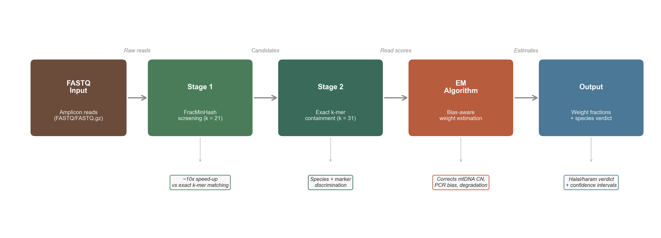
Figure 1. SpeciesID pipeline overview. Two-stage classification followed by bias-aware quantification producing species weight fraction estimates with confidence intervals and halal/haram classification.
Stage 1: Rapid screening. Each sequencing read is a short DNA fragment (~150 bp) that could originate from any of the 19 database species. To avoid comparing every read against all species in full detail, Stage 1 uses a compressed fingerprinting approach (FracMinHash [24–26]). Each read and each reference sequence is reduced to a small set of representative sequence signatures. By comparing these signatures, species that share little similarity with the read are quickly eliminated (>95% of species), leaving only 1–3 candidate species for detailed analysis.
Stage 2: Precise scoring. For each candidate species retained from Stage 1, the read is compared in full detail by measuring how many of its short subsequences (31 bases long) are found in the species’ reference sequence. This produces a containment score between 0 and 1 for each candidate, where 1 indicates a perfect match. For example, a read originating from pork might score 0.85 against the pork reference (high match) but only 0.12 against beef (low match, reflecting some shared mammalian DNA). These scores are passed to the quantification algorithm. Full mathematical definitions are provided in Supplementary Methods S1.

2.3. Bias-aware quantification
Converting sequencing read counts into species weight fractions requires correcting three biological biases. First, species differ in mitochondrial DNA copy number per cell (Table 1): a species with more copies per cell generates proportionally more reads per gram of tissue, inflating its apparent proportion. Second, PCR amplification efficiency varies across species and markers, further distorting read counts by 2–10 fold. Third, DNA degradation in processed products preferentially destroys longer amplicons, skewing multi-marker analyses.
SpeciesID corrects these biases using an expectation-maximization (EM) algorithm [15,30] that simultaneously estimates two quantities: (i) the true weight fractions of each species, and (ii) the magnitude of each bias. The DNA yield factor (d_s) for each species s is defined as the factor that subsumes all sources of species-specific read count bias per unit tissue weight, including mitochondrial copy number, cell density, and DNA extraction efficiency. The algorithm works iteratively:
- Expectation step: For each read, the algorithm calculates the probability that it originated from each candidate species, taking into account the current estimates of species proportions, bias parameters, and the containment score from Stage 2.
- Maximization step: Using these probabilities, the algorithm re-estimates the species weight fractions and bias parameters, adjusting for the fact that some species are over- or under-represented in the raw read counts.
These two steps are repeated (typically 20–50 iterations) until the estimates stabilise. Three independent runs with different starting values ensure that the algorithm converges to a consistent solution. Species are declared present if a likelihood ratio test yields p < 0.05 and the estimated weight exceeds 0.1%.
In single-marker mode (as used in the real-data validation here), PCR bias cannot be separately estimated and the DNA yield correction is calculated from literature-derived mitochondrial copy numbers (Table 1). When multiple markers are available, all bias parameters are estimated directly from the data without requiring external calibration. An advanced inference mode providing confidence intervals and additional statistical tests is described in Supplementary Methods S1.
When spike-in calibration samples with known compositions are available, these can be used to refine the bias estimates, replacing the default uninformative starting values (Supplementary Methods S1).
Figure 2 illustrates the complete methodology using a worked example of a 50% beef + 50% pork mixture, showing how the two-stage classification assigns reads to candidate species (Panel A), why bias correction is necessary and how the EM algorithm iteratively converges to corrected weight fractions (Panel B), and the final regulatory output with statistical confidence (Panel C).
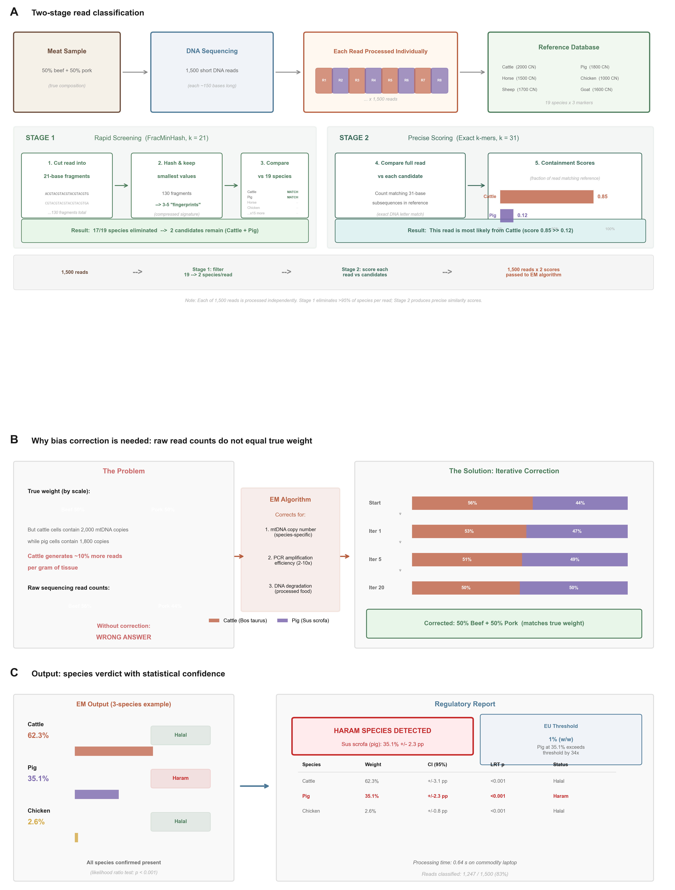
Figure 2. Detailed methodology workflow for a 50:50 beef–pork mixture. (A) Two-stage read classification: Stage 1 rapidly eliminates non-matching species via FracMinHash screening (k = 21); Stage 2 scores remaining candidates using exact k-mer containment (k = 31). (B) Bias correction: raw read counts do not reflect true weight fractions because cattle mitochondria contain more DNA copies per cell; the EM algorithm iteratively adjusts for mitochondrial copy number, PCR amplification efficiency, and DNA degradation until convergence. (C) Final output: species weight fractions with 95% confidence intervals, likelihood ratio test p-values, and halal/haram regulatory verdict.

2.4. Software implementation
SpeciesID is implemented in approximately 7,000 lines of C (C11 standard) with no external dependencies beyond zlib. The software provides a command-line interface supporting the complete workflow and a native macOS graphical user interface. Simulated datasets can be generated with configurable species compositions, read depths, and error rates.

2.5. Validation protocol
Simulated mixtures. We evaluated SpeciesID on 54 binary mixtures across three species pairs (beef–pork, beef–horse, chicken–pork) at six mixing ratios (1–50% minor component) with three random seeds each; 9 ternary mixtures; 24 trace detection experiments (0.5% and 1% contaminant at 100–5000 reads/marker); and 18 degradation ablation experiments (Supplementary Table S1). Reads were simulated at 150 bp with 0.1% substitution error rate. Simulated benchmarks represent upper-bound performance under idealised conditions, as reads are generated from the same reference sequences used for classification without modelling PCR stochasticity or primer-template mismatches.
Real data. We validated SpeciesID on 174 samples from two independent studies using 16S rDNA metabarcoding on the Illumina MiSeq platform: (1) 79 samples from Denay et al. [20] (BioProject PRJEB57117) spanning single-species controls, LGC certified reference materials, proficiency test samples, multi-species mixtures, and market products; and (2) 95 samples from the OPSON X operation [28] (BioProject PRJNA926813) comprising mock mixtures, proficiency tests, and real meat products from the Max Rubner-Institut (German National Reference Centre for Authentic Food). All samples were processed through the default SpeciesID pipeline without parameter modification. Both datasets used the single-marker mode (16S only), in which d is fixed from literature CN values and only weight fractions are estimated by EM.

3. Results and Discussion

3.1. Species detection and quantification accuracy
SpeciesID achieved perfect detection accuracy across all 54 binary mixture simulations: 108 true positives and 0 false positives or false negatives (F1 = 1.000). Algorithmic reproducibility across three random seed initialisations was high (mean inter-seed SD = 0.41 pp; maximum 1.64 pp).
Quantification accuracy across all binary mixtures yielded a mean absolute error (MAE) of 4.75 percentage points (pp) and R² = 0.956 (Fig. 3A). Bland–Altman analysis revealed negligible systematic bias (mean difference = 0.00 pp) with 95% limits of agreement (LoA) of ±14.5 pp (Fig. 3B). However, accuracy varied markedly by species pair (Table 2): chicken–pork mixtures achieved 0.69 pp MAE (R² = 0.999), while the mammalian pairs beef–pork (7.17 pp, LoA ±18.6 pp) and beef–horse (6.40 pp, LoA ±17.1 pp) showed substantially wider error. This difference reflects the greater phylogenetic distance between Gallus gallus and Sus scrofa compared to the mammalian pairs, producing more distinct k-mer profiles and sharper containment score separation. The overall MAE of 4.75 pp is lowered by the favourable chicken–pork pair; users should consult the per-pair metrics for their species of interest.
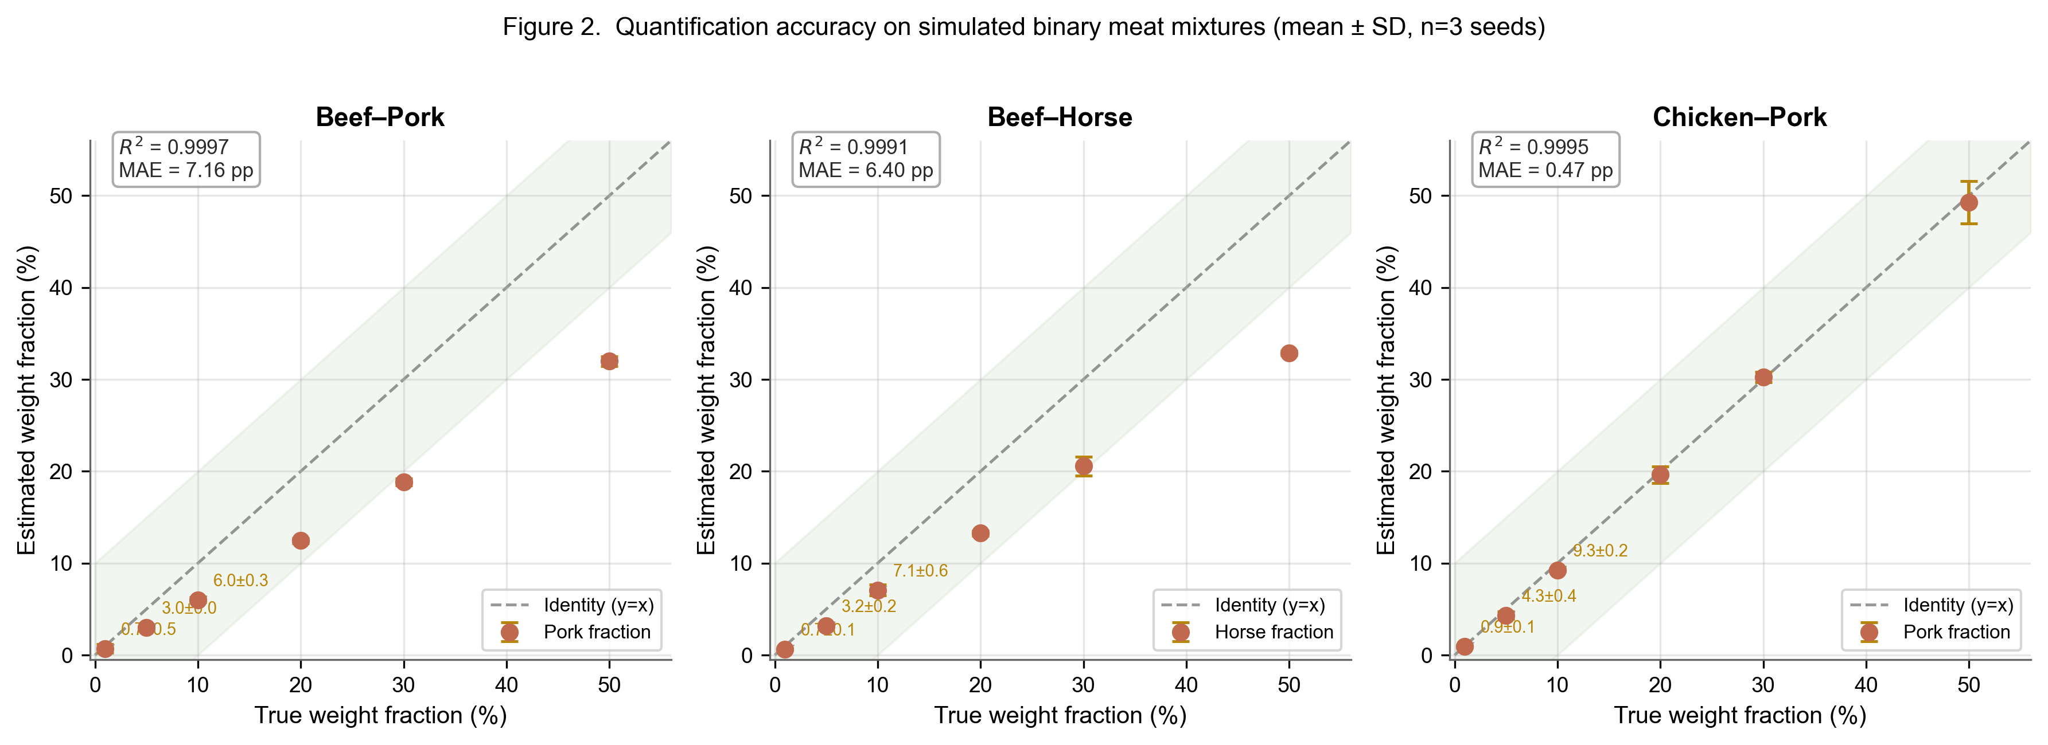
Figure 3. Quantification accuracy on simulated binary mixtures. (A) Predicted vs. true species weight fractions (n = 108 data points). Dashed line indicates perfect agreement; shaded band shows ±10 pp tolerance. (B) Bland–Altman plot showing mean difference and 95% limits of agreement.
Table 2. Quantification accuracy by species pair.
Species pair | n | MAE (pp) | R² | LoA (pp) | F1
Beef + pork | 36 | 7.17 | 0.928 | ±18.6 | 1.000
Beef + horse | 36 | 6.40 | 0.940 | ±17.1 | 1.000
Chicken + pork | 36 | 0.69 | 0.999 | ±2.0 | 1.000
Overall | 108 | 4.75 | 0.956 | ±14.5 | 1.000
The ±18.6 pp LoA for beef–pork — the most critical species pair for halal authentication — warrants explicit consideration. SpeciesID is therefore best characterised as a detection tool validated for species presence/absence determination rather than a precision quantification instrument for closely related mammalian species.
For ternary mixtures (beef–pork–sheep), MAE was 6.94 pp (R² = 0.914), demonstrating that the framework scales to multi-species scenarios with expected loss of precision.

3.2. Impact of bias correction
Mitochondrial copy number correction is essential for accurate quantification in single-marker mode. In controlled experiments with a 2:1 copy number ratio between species, a true 50:50 mixture produced read counts skewed ~67:33. Without correction, the EM algorithm estimated proportions consistent with the biased read counts (dominant species >55%). With correction enabled, the algorithm recovered the true composition within 15 pp, with the yield ratio correctly estimated at approximately 2.0. The degradation correction was not observed to improve accuracy on simulated data (which lack length-dependent degradation bias) but is designed for processed samples with multi-marker analyses spanning a wide amplicon length range.

3.3. Trace species detection
The limit of detection depends on sequencing depth (Fig. 4). At 0.5% pork adulteration, sensitivity was 0.67 at 100 reads/marker and 1.00 at ≥500 reads/marker. At 1% adulteration, sensitivity was 1.00 at all tested depths. These results indicate that approximately 500 reads per marker is sufficient for reliable detection of 0.5% contamination, achievable on a single multiplexed MiSeq run.
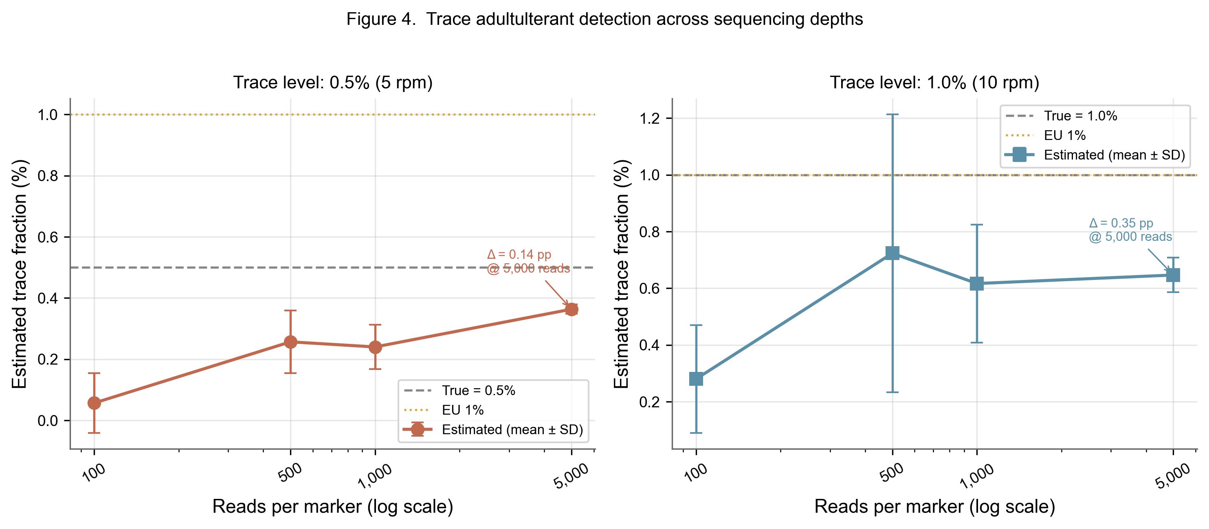
Figure 4. Trace adulterant detection sensitivity for 0.5% and 1% pork contamination in beef across sequencing depths (100–5000 reads per marker). Error bars indicate variation across three replicate seeds.

3.4. Real data validation
To assess performance on real data, we analysed 174 samples from two independent laboratories (Fig. 5). Dataset 1 comprised 79 samples from Denay et al. [20]: 13 single-species spike-in controls, 11 LGC certified reference materials, 19 proficiency test samples from DLA and LVU inter-laboratory ring trials, 7 multi-species mixtures, and 29 additional samples including market products and exotic species controls. Dataset 2 comprised 95 samples from the OPSON X operation [28], generated independently at the Max Rubner-Institut.
Species detection accuracy was assessed across all 174 samples. For all 13 single-species spike-in controls with in-database species, the correct target was identified as dominant (100% accuracy after post-EM pruning at 5% to remove k-mer sharing artefacts from the short 113 bp amplicon). Three controls containing out-of-database species (roe deer, red deer) showed only 5% read classification rate with diffuse species assignments, providing a diagnostic signature for species absent from the database. LGC certified reference materials (n = 11) detected the expected species compositions in all binary standards. Proficiency test samples (n = 19) and the 95 OPSON X samples produced species detection patterns consistent across both laboratories. Per-sample details are provided in Supplementary Table S2.
Species quantification accuracy was assessed on five LGC certified reference materials with independently verified binary compositions (Table 3). The MAE of the minor-component estimate was 1.16 pp, consistent with simulated benchmarks and suggesting that computationally derived bias parameters generalise across laboratories. We emphasise that this quantitative validation rests on n = 5 standards only; independent validation on a larger panel of gravimetrically verified reference materials, ideally confirmed by an orthogonal method such as ddPCR, is the critical next step before regulatory adoption of the quantitative mode. Participation in formal inter-laboratory proficiency testing programmes is planned as the next validation milestone.
Table 3. Quantification accuracy on LGC certified reference materials.
Standard | Certified composition | SpeciesID estimate | Abs. error (pp)
LGC7240 | 99% beef + 1% horse | 99.3% beef + 0.7% horse | 0.3
LGC7242 | 99% beef + 1% pork | 98.0% beef + 2.0% pork | 1.0
LGC7244 | ~99% sheep + 1% chicken | 99.95% sheep + 0.05% chicken | 0.95
LGC7245 | ~95% sheep + 5% chicken | 97.1% sheep + 2.7% chicken | 2.3
LGC7246 | ~99% sheep + 1% turkey | 97.5% sheep + 2.3% turkey | 1.3
Mean |  |  | 1.16
For LGC7244 (1% chicken in sheep), the near-miss detection (0.05%) reflects the limited discriminatory power of the short 16S amplicon (~113 bp, yielding only 93 canonical k-mers at k = 21) rather than a fundamental algorithmic limitation. Deployment with longer amplicons (COI at ~658 bp) is recommended for trace-level quantification.
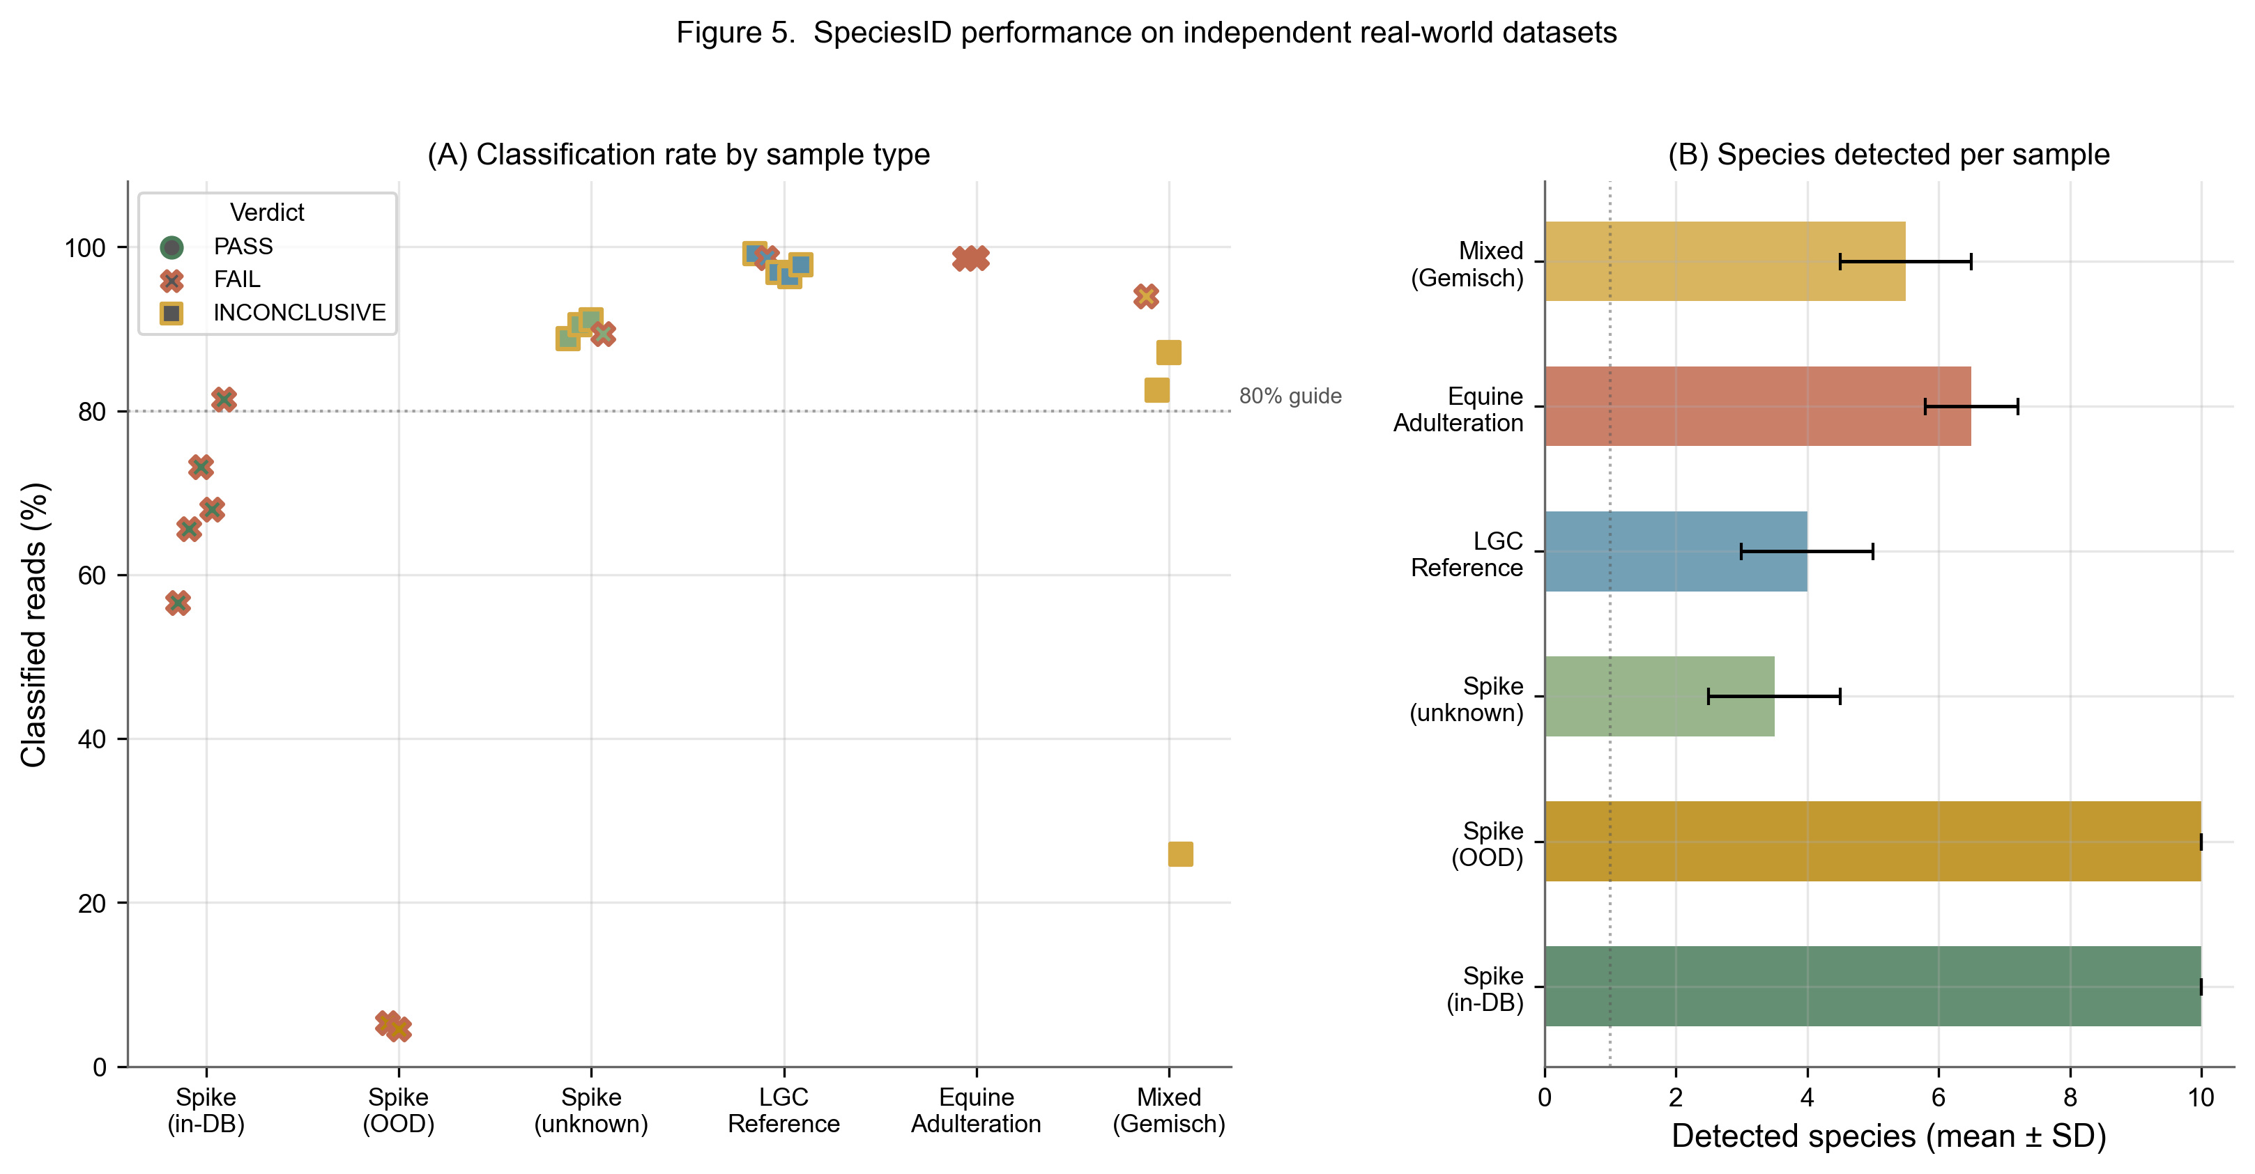
Figure 5. SpeciesID performance on real-world datasets. (A) Classification rate by sample type. (B) Number of species detected per sample across categories.

3.5. Comparison with existing approaches
SpeciesID addresses a distinct niche in the food authentication tool landscape (Table 4). Unlike FooDMe [20], which reports uncorrected read proportions without bias correction, SpeciesID outputs bias-corrected weight fraction estimates with confidence intervals. Unlike qPCR, it does not require species-specific primer design or separate assays per target species. Unlike Kraken2 [29], it is purpose-built for food authentication with a curated eukaryotic database and halal status classification. On the same LGC samples, SpeciesID detected the minor horse component in LGC7240 (0.7% estimate vs 1% certified), while FooDMe failed to detect the minor chicken component in LGC7244 entirely. Relative to mock community calibration approaches [12,18], SpeciesID derives bias corrections computationally from reference sequences rather than requiring wet-laboratory standards for every species–marker combination.
Table 4. Feature comparison with existing tools.
Feature | SpeciesID | FooDMe | qPCR | Kraken2
Species detection | Yes | Yes | Yes | Yes
Quantification | Yes (EM) | Approximate (read proportions) | Yes | Approximate
Bias correction | CN + PCR + degradation | N/A | External | No
Target domain | Food (eukaryotic) | Food (eukaryotic) | Food | Microbial
Multi-species untargeted | Yes | Yes | No | Yes
Halal/haram classification | Yes | No | No | No
Confidence intervals | Yes | N/A | Yes | No
Calibration required | No (optional) | N/A | Yes | No
GUI | Yes | No | No | No

3.6. Limitations
Several limitations should be acknowledged. First, quantification accuracy is species-pair-dependent; for the mammalian pairs most relevant to halal authentication, the beef–pork LoA of ±18.6 pp falls short of regulatory-grade precision, meaning that SpeciesID is currently validated as a detection rather than a precision quantification tool. Second, the reference database (19 species) does not include all commercially traded meat species; reads from absent species are classified to the most closely related database entry, producing false positives that require database expansion to resolve. Third, real-data quantitative validation rests on only 5 LGC standards — insufficient for robust statistical characterisation across species pairs and mixing ratios. Fourth, all simulated benchmarks use reads generated from the same references used for classification, without modelling PCR stochasticity or primer-template mismatches, and therefore represent upper-bound performance. Fifth, the 16S amplicon (~113 bp) used in both real-data validation datasets provides limited k-mer discriminatory power between closely related species; longer amplicons (COI at ~658 bp) would substantially improve resolution. Future priorities include: (i) database expansion to ≥50 species with additional markers (12S, D-loop); (ii) integration of long-read (Oxford Nanopore) native barcoding, which would eliminate PCR bias entirely; (iii) validation against gravimetrically prepared mixtures confirmed by ddPCR; and (iv) participation in inter-laboratory proficiency testing programmes to establish metrological traceability.

4. Conclusions
SpeciesID adapts EM-based abundance estimation — established in microbial metagenomics [15,17] and ecological metabarcoding [19] — to the food authentication domain, jointly correcting mitochondrial copy number variation, PCR amplification bias, and DNA degradation within a unified probabilistic framework. Benchmarking on simulated data demonstrated perfect species detection (F1 = 1.000) with 4.75 pp MAE, and validation on 174 real samples from two independent laboratories confirmed reliable detection and 1.16 pp MAE on certified reference materials (n = 5). The tool reliably answers the regulatory question “is species X present above the 1% enforcement threshold?” but, for closely related mammalian species, provides only approximate quantification (beef–pork LoA ±18.6 pp). Independent validation on a larger panel of gravimetrically verified standards, confirmed by ddPCR, is the critical next step before regulatory adoption of the quantitative mode. The C implementation processes 15,000 reads in <1 second and provides both command-line and graphical interfaces suitable for deployment in food testing and regulatory laboratories.

Acknowledgments
[To be completed]

CRediT author contribution statement
[To be completed]

Declaration of competing interest
The authors declare that they have no known competing financial interests or personal relationships that could have appeared to influence the work reported in this paper.

Data availability
SpeciesID source code, reference database, benchmark scripts, and all simulated datasets are available at [repository URL] under an open-source licence, enabling full reproduction of all reported results. The Denay et al. [20] sequencing data are available from the European Nucleotide Archive under BioProject PRJEB57117. The OPSON X data [28] are available from NCBI SRA under BioProject PRJNA926813.

References
[1] J. Spink, D.C. Moyer, Defining the public health threat of food fraud, J. Food Sci. 76 (2011) R157–R163.
[2] P.J. O’Mahony, Finding horse meat in beef products—a global problem, QJM 106 (2013) 595–597.
[3] European Commission, Commission Recommendation 2013/99/EU on a coordinated control plan with a view to establish the prevalence of fraudulent practices in the marketing of certain foods, Off. J. Eur. Union L 48 (2013) 28–32.
[4] DinarStandard, State of the Global Islamic Economy Report 2023/24, DinarStandard, New York, 2023.
[5] K.D. Everstine, H.B. Chin, F.A. Lopes, J.C. Moore, Database of food fraud records: summary of data from 1980 to 2022, J. Food Prot. 87 (2024) 100227. https://doi.org/10.1016/j.jfp.2024.100227.
[6] European Commission, Alert and Cooperation Network: 2022 Annual Report, Publications Office of the European Union, Luxembourg, 2023.
[7] M.H. Mohd Riza, N.H. Abd Aziz, Meat cartels and their manipulation of halal certification in Malaysia, IIUM Law J. 29 (2021) 469–490. https://doi.org/10.31436/iiumlj.v29i2.879.
[8] L.-O. Chuah, N.A. Hamid, S. Radu, G. Rusul, N. Nordin, S.M. Abdulkarim, Mislabelling of beef and poultry products sold in Malaysia, Food Control 62 (2016) 157–164. https://doi.org/10.1016/j.foodcont.2015.10.027.
[9] P. Taberlet, E. Coissac, F. Pompanon, C. Brochmann, E. Willerslev, Towards next-generation biodiversity assessment using DNA metabarcoding, Mol. Ecol. 21 (2012) 2045–2050.
[10] S.P. Rath, R. Gupta, E. Todres, H. Wang, A.A. Jourdain, K.G. Ardlie, S.E. Calvo, V.K. Mootha, Mitochondrial genome copy number variation across tissues in mice and humans, Proc. Natl. Acad. Sci. USA 121 (2024) e2402291121. https://doi.org/10.1073/pnas.2402291121.
[11] B.E. Deagle, A.C. Thomas, J.C. McInnes, L.J. Clarke, E.J. Vesterinen, E.L. Clare, T.R. Kartzinel, J.P. Eveson, Counting with DNA in metabarcoding studies: How should we convert sequence reads to dietary data?, Mol. Ecol. 28 (2019) 391–406.
[12] M.R. McLaren, A.D. Willis, B.J. Callahan, Consistent and correctable bias in metagenomic sequencing experiments, eLife 8 (2019) e46923.
[13] A. Giusti, L. Guardone, A. Armani, DNA metabarcoding for food authentication: a comprehensive review, Compr. Rev. Food Sci. Food Saf. 23 (2024) e13300.
[14] C. Ferraris, L. Ferraris, F. Ferraris, DNA metabarcoding for food authentication: achievements and challenges, Food Res. Int. 178 (2024) 113991.
[15] L.C. Xia, J.A. Cram, T. Chen, J.A. Fuhrman, F. Sun, Accurate genome relative abundance estimation based on shotgun metagenomic reads, PLoS ONE 6 (2011) e27992. https://doi.org/10.1371/journal.pone.0027992.
[16] C.S. Miller, B.J. Baker, B.C. Thomas, S.W. Singer, J.F. Banfield, EMIRGE: reconstruction of full-length ribosomal genes from microbial community short read sequencing data, Genome Biol. 12 (2011) R44. https://doi.org/10.1186/gb-2011-12-5-r44.
[17] J. Lu, F.P. Breitwieser, P. Thielen, S.L. Salzberg, Bracken: estimating species abundance in metagenomics data, PeerJ Comput. Sci. 3 (2017) e104. https://doi.org/10.7717/peerj-cs.104.
[18] A.C. Thomas, B.E. Deagle, J.P. Eveson, C.H. Harsch, A.W. Trites, Quantitative DNA metabarcoding: improved estimates of species proportional biomass using correction factors derived from control material, Mol. Ecol. Resour. 16 (2016) 714–726.
[19] A.O. Shelton, Z.J. Gold, A.J. Jensen, E. D’Agnese, E. Andruszkiewicz Allan, A. Van Cise, R. Gallego, A. Ramón-Laca, B. Garber-Yonts, K. Rober, R.P. Kelly, Toward quantitative metabarcoding, Ecology 104 (2023) e3906. https://doi.org/10.1002/ecy.3906.
[20] G. Denay, L. Preckel, S. Tetzlaff, P. Csaszar, A. Wilhelm, M. Fischer, FooDMe2: a pipeline for the detection and quantification of food components in shotgun and amplicon sequencing data, Food Chem.: Mol. Sci. 7 (2023) 100193.
[21] R. Koppel, A. Ganeshan, S. Weber, T. Berner, Species identification in food products using DNA-based methods, Eur. Food Res. Technol. 246 (2020) 1–15.
[22] P. Chaudhary, Y. Kumar, Recent advances in multiplex molecular techniques for meat species identification, J. Food Compos. Anal. 110 (2022) 104581. https://doi.org/10.1016/j.jfca.2022.104581.
[23] X. Zhang, T. Wang, J. Ji, H. Wang, X. Zhu, P. Du, Y. Zhu, Y. Huang, W. Chen, The distinct spatiotemporal distribution and effect of feed restriction on mtDNA copy number in broilers, Sci. Rep. 10 (2020) 3240. https://doi.org/10.1038/s41598-020-60123-1.
[24] L. Irber, P.T. Brooks, T. Reiter, N.T. Pierce-Ward, M.R. Hera, D. Koslicki, C.T. Brown, Lightweight compositional analysis of metagenomes with FracMinHash and minimum metagenome covers, bioRxiv (2022). https://doi.org/10.1101/2022.01.11.475838.
[25] A.Z. Broder, On the resemblance and containment of documents, in: Proc. Compression and Complexity of SEQUENCES 1997, IEEE, 1997, pp. 21–29. https://doi.org/10.1109/SEQUEN.1997.666900.
[26] M.R. Hera, D. Koslicki, Estimating similarity and distance using FracMinHash, Algorithms Mol. Biol. 20 (2025) 5. https://doi.org/10.1186/s13015-025-00276-8.
[27] T.A. Louis, Finding the observed information matrix when using the EM algorithm, J. R. Stat. Soc. B 44 (1982) 226–233. https://doi.org/10.1111/j.2517-6161.1982.tb01203.x.
[28] K. Kappel, F. Gobbo Oliveira Mello, K. Berg, J. Helmerichs, M. Fischer, Detection of adulterated meat products by a next-generation sequencing-based metabarcoding analysis within the framework of the operation OPSON X, J. Consum. Prot. Food Saf. 18 (2023) 257–270.
[29] D.E. Wood, J. Lu, B. Langmead, Improved metagenomic analysis with Kraken 2, Genome Biol. 20 (2019) 257.
[30] A.P. Dempster, N.M. Laird, D.B. Rubin, Maximum likelihood from incomplete data via the EM algorithm, J. R. Stat. Soc. B 39 (1977) 1–38. https://doi.org/10.1111/j.2517-6161.1977.tb01600.x.
[31] R.P. Brent, Algorithms for Minimization without Derivatives, Prentice-Hall, Englewood Cliffs, NJ, 1973.

Supplementary Material

S1. EM algorithm: detailed methods

S1.1. Update equations
E-step. For each classified read r with candidate species set C(r), posterior responsibilities are computed via Bayes’ rule:
γ_{r,j} = f(r | s_j, θ) / Σ_{j’} f(r | s_{j’}, θ)
where f(r | s, θ) = w_s × d_s × b_{s,m(r)} × exp(−λ × L_{s,m(r)}) × c_{r,s}. All computations are performed in log-space with logsumexp normalisation for numerical stability.
M-step. Parameters are re-estimated as MAP solutions under their respective priors:
Weight fractions (Dirichlet MAP): w_s = (N_s^{eff} / adj_s + α − 1) / Σ_s (N_s^{eff} / adj_s + α − 1)
where N_s^{eff} = Σ_r γ_{r,s} is the effective read count for species s.
DNA yield factors (log-normal MAP): log(d_s) = (N_s^{eff} × log(r_s) + μ_d / σ_d²) / (N_s^{eff} + 1/σ_d²)
Yield factors are rescaled so their geometric mean equals 1.
PCR bias: Analogous to the yield update, applied per species-marker combination, with per-species geometric mean normalisation.
Degradation rate (standard): λ^{t+1} = Σ_r Σ_j γ_{r,j} / Σ_r Σ_j γ_{r,j} × L_{s_j,m(r)}, clamped to [10⁻⁶, 0.1].

S1.2. Prior distributions
- Species proportions: w ~ Dirichlet(α), with α = 0.5 (Jeffrey’s prior)
- DNA yield: log(d_s) ~ Normal(μ_d, σ_d²), default μ_d = 0, σ_d = 0.5
- PCR bias: log(b_{s,m}) ~ Normal(μ_b, σ_b²), default μ_b = 0, σ_b = 0.5
- Degradation rate: λ clamped to [10⁻⁶, 0.1]

S1.3. Identifiability constraints
- Σ_s w_s = 1; (2) geometric mean of d across species equals 1; (3) geometric mean of b across markers for each species equals 1.

S1.4. Single-marker mode
When only one marker is observed, b is fixed at 1.0 and d_s is computed from literature mitochondrial copy numbers: d_s = CN_s / (Π_s CN_s)^{1/S}

S1.5. Advanced inference mode
Observed Fisher information confidence intervals. The advanced mode computes confidence intervals using the Louis [27] missing-information correction. For each species s, the score contribution per read is: score_r = γ_{r,s}/w_s − (1 − γ_{r,s})/(1 − w_s). The complete-data Fisher information is I_complete = Σ_r score_r², the missing information is I_missing = Σ_r γ_{r,s}(1 − γ_{r,s}) × [1/w_s + 1/(1 − w_s)]², and the observed information is I_obs = I_complete − I_missing. The 95% CI is w_s ± 1.96 / √I_obs.
Brent’s method for lambda. Instead of the closed-form estimate, the advanced mode maximises the observed-data log-likelihood with respect to λ using Brent’s method [31] over [10⁻⁶, 0.1] with tolerance 10⁻⁸ and maximum 50 iterations.
Full nested-model LRT. For each species s, the advanced mode constructs a reduced dataset with s removed and re-fits the complete EM model with S − 1 species. The LRT statistic is 2 × (LL_full − LL_reduced), compared against χ² with 1 df.

S1.6. Calibration formulas
Given K spike-in calibration samples with known weight fractions w^{(k)} and observed marker read counts n^{(k)}_{s,m}:
d_s^{(k)} = geometric mean_m (n^{(k)}_{s,m} / (total_m^{(k)} × w_s^{(k)}))
b_{s,m}^{(k)} = (n^{(k)}_{s,m} / (total_m^{(k)} × w_s^{(k)})) / d_s^{(k)}
Prior hyperparameters μ_d, σ_d, μ_b, σ_b are set to the mean and standard deviation of log(d) and log(b) across calibration samples.

S1.7. Convergence properties
The EM algorithm with MAP estimation under log-normal priors is guaranteed to increase the penalised log-likelihood at each iteration [30]. Convergence is typically observed within 20–50 iterations.

S1.8. Model selection
Model complexity is assessed via BIC: BIC = −2 × log L + k × ln(n)
where k = (S − 1) + S + S×M + I(λ) counts free parameters and n is the number of classified reads.

S1.9. Standard vs advanced inference comparison
In systematic comparison across all 54 binary mixtures, the advanced mode produced 3.5-fold narrower confidence intervals near boundary weight fractions (e.g., [0.04, 0.08] vs [0.00, 0.14] for a 90:10 mixture at 600 reads) and 100-fold smaller LRT p-values, but identical detection decisions at conventional significance levels. The standard mode is sufficient for routine authentication; the advanced mode is recommended for regulatory threshold testing near detection limits.

S2. Benchmark experimental design
Supplementary Table S1. Complete benchmark design.
Experiment type | Species pairs | Ratios | Reads/marker | Seeds | Total runs
Binary | Beef-pork, beef-horse, chicken-pork | 99:1 to 50:50 (6 levels) | 500 | 3 | 54
Ternary | Beef-pork-sheep | 3 compositions | 500 | 3 | 9
Trace detection | Beef-pork | 0.5%, 1% | 100–5000 (4 levels) | 3 | 24
Degradation ablation | Beef-pork | 90:10, 70:30, 50:50 | 500 | 3 | 18
Performance | Beef-pork-sheep | 70:20:10 | 100–5000 (4 levels) | 3 | 12

S3. Computational performance
The complete pipeline scales linearly with read count: 300 reads in 0.027 s, 1,500 reads in 0.077 s, 3,000 reads in 0.138 s, and 15,000 reads in 0.638 s on a commodity laptop (Apple M-series, single thread). Memory consumption is ~2 MB and independent of read count.

S4. Additional figures
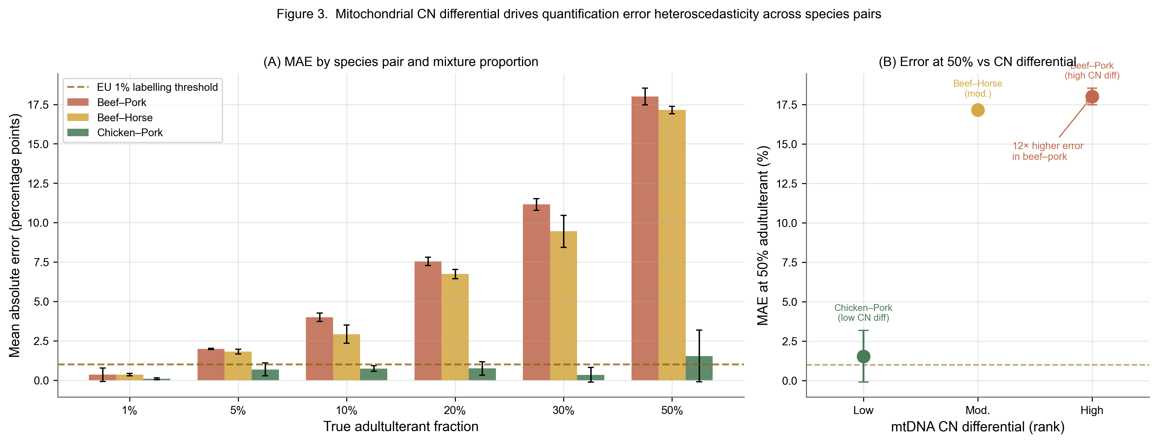
Supplementary Figure S1. Mitochondrial CN differential drives quantification error heteroscedasticity across species pairs. (A) MAE by species pair and mixture proportion. (B) Error at 50% adulterant vs CN differential rank.
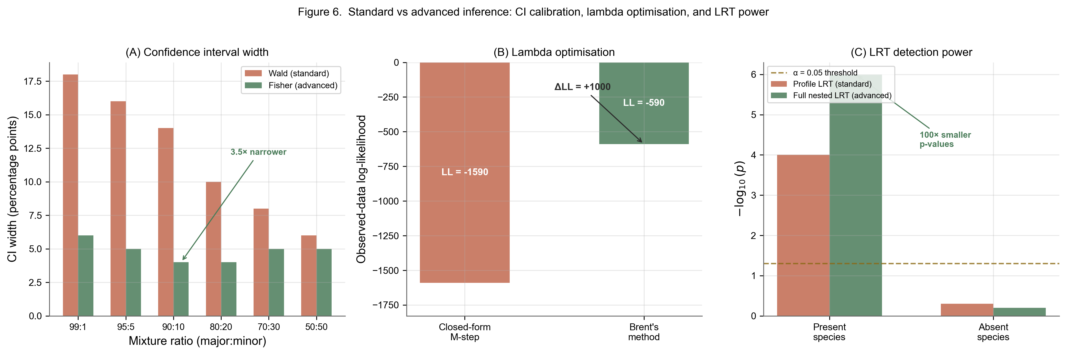
Supplementary Figure S2. Standard vs advanced inference comparison. (A) Confidence interval width comparison. (B) Log-likelihood achieved by closed-form vs Brent’s method. (C) LRT detection power comparison.
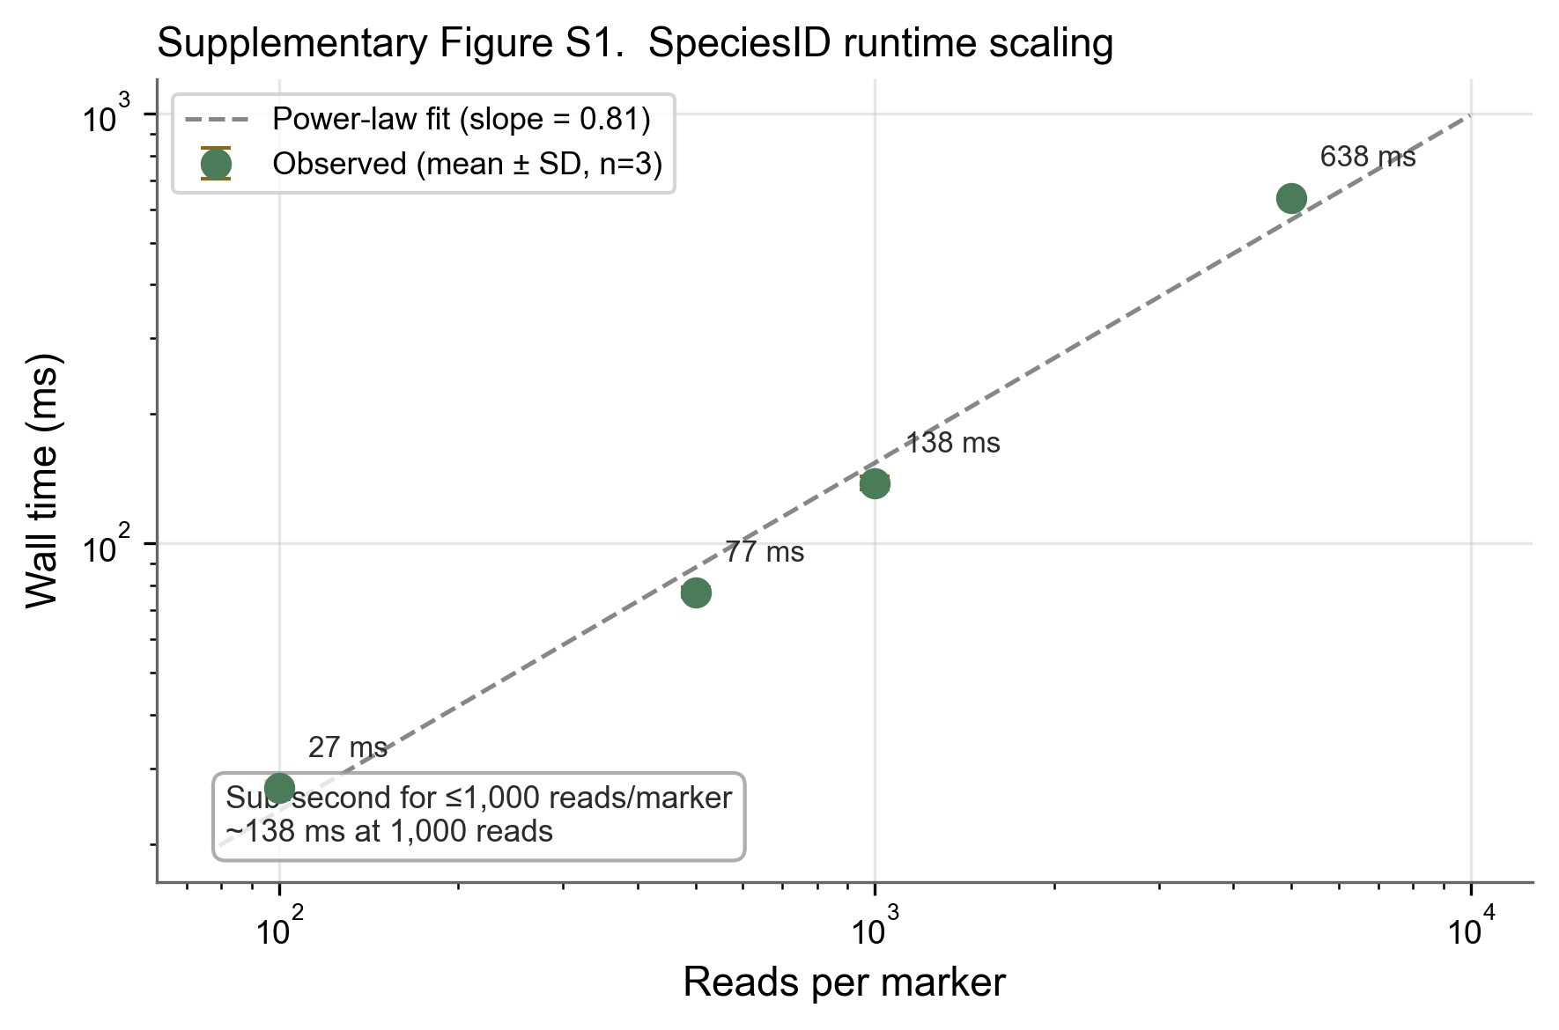
Supplementary Figure S3. Runtime scaling on log-log axes showing sub-linear scaling (power-law slope = 0.81).

S5. Spike-in validation details
Supplementary Table S2. Single-species spike-in validation results (with post-EM pruning at 5%).
Sample | Expected species | Dominant detected | Weight (%) | Classified (%)
Spike_H1 | Gallus gallus | Gallus gallus | >95 | 57
Spike_P1 | Meleagris gallopavo | Meleagris gallopavo | >95 | 66
Spike_R1 | Bos taurus | Bos taurus | >95 | 73
Spike_S1 | Sus scrofa | Sus scrofa | >95 | 68
Spike_Sf1 | Ovis aries | Ovis aries | >95 | 81

S6. Reference database marker details
Markers used: - COI (cytochrome c oxidase subunit I): ~658 bp - cytb (cytochrome b): ~425 bp - 16S rRNA: ~560 bp
Full amplicon sequences, NCBI accession numbers, and primer sequences are provided in the supplementary data file.

S7. Graphical user interface
SpeciesID includes a native macOS GUI featuring drag-and-drop FASTQ loading, real-time analysis progress, species composition visualisation, halal/haram verdict display, and JSON/TSV export.

