Install Flutter window 10

First we need some software for to install flutter

* Git: <https://git-scm.com/downloads>
* Android studio: <https://developer.android.com/studio>
* Vs-Code: <https://code.visualstudio.com/download>
* Flutter: <https://docs.flutter.dev/get-started/install>
* Visual studio (if needed): <https://visualstudio.microsoft.com/downloads/>

1. First of all install git
2. Than install android studio.
3. Enable [VM acceleration](https://developer.android.com/studio/run/emulator-acceleration) on your machine.
4. Launch **Android Studio**, click the **AVD Manager** icon, and select **Create Virtual Device…**
   1. In older versions of Android Studio, you should instead launch **Android Studio > Tools > Android > AVD Manager** and select **Create Virtual Device…**. (The **Android** submenu is only present when inside an Android project.)
   2. If you do not have a project open, you can choose **Configure > AVD Manager** and select **Create Virtual Device…**
5. Choose a device definition and select **Next**.
6. Select one or more system images for the Android versions you want to emulate, and select **Next**. An x86 or x86_64 image is recommended.
7. Under Emulated Performance, select **Hardware - GLES 2.0** to enable [hardware acceleration](https://developer.android.com/studio/run/emulator-acceleration).
8. Verify the AVD configuration is correct, and select **Finish**.
   1. For details on the above steps, see [Managing AVDs](https://developer.android.com/studio/run/managing-avds).
9. In Android Virtual Device Manager, click **Run** in the toolbar. The emulator starts up and displays the default canvas for your selected OS version and device.
10. Than install Vs code
    1. Than install extension of flutter it will also install dart extension as well.
11. The following steps for to install Flutter
12. First go to flutter website: <https://docs.flutter.dev/get-started/install>
13. Select window operating system
14. Download the zip file
15. Extract it to C:\src
16. After that update your **environment variables for your account**
17. **After click on window button and search for (env)**
18. **After that go to environment variable**
19. **Than a new window popup and click on path and edit it**
20. **Add new path and paste the path (C:\src\flutter\bin) here and press ok ok ok**
21. **Now open PowerShell window and write the command “flutter doctor”**
22. **If everything done right than after executing the above command it will show the like the following image**

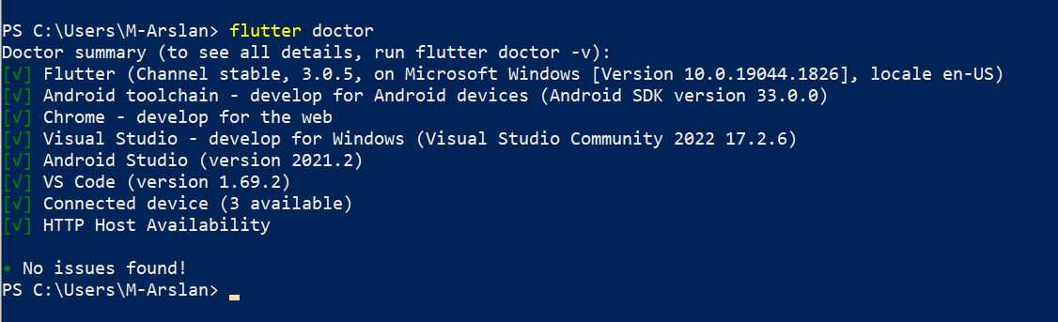

**Create the first App**

1. Invoke **View > Command Palette**.
2. Type “flutter”, and select the **Flutter: New Project**.
3. Select **Application**.
4. Create or select the parent directory for the new project folder.
5. Enter a project name, such as my_app, and press **Enter**.
6. Wait for project creation to complete and the main.dart file to appear.