Deploying an AI Model Locally Without Internet

Offline Deployment of a 27B Cybersecurity-Focused Language Model Using llama.cpp

Detail | Description
Model | Qwen3.8-27B-Uncensored-Cyber (GGUF format)
Inference Engine | llama.cpp (CUDA build)
Environment | Kaggle GPU Runtime — 2 × NVIDIA Tesla T4
Objective | Local / offline inference without an online AI service
Date | September 20, 2026

Author: Azam Abbas

Table of Contents
1. Introduction 3
2. Objectives 3
3. Kaggle Hardware / GPU Specifications 3
4. llama.cpp Setup 4
5. Model Download and Verification 6
6. Dual-GPU Configuration 7
7. Problems Faced and Solutions 8
8. Online Inference 8
9. Offline Inference 9
10. Test Results 11
11. Cloud vs. Local Execution 12
12. Security and Privacy 13
13. What I Learned 13
14. Conclusion 13
15. Screenshots 13

1. Introduction
The purpose of this assignment was to deploy a 27B cybersecurity-focused AI model using llama.cpp and run inference without relying on an online AI service. The model used was Qwen3.8-27B-Uncensored-Cyber, stored in GGUF format.

2. Objectives
- Deploy a large language model using llama.cpp.
- Utilize available GPU resources for inference.
- Load the model from local storage.
- Test the model with cybersecurity-related questions.
- Verify that inference works when Internet access is disabled.
- Understand the difference between cloud infrastructure and local model execution.

3. Kaggle Hardware / GPU Specifications
The deployment was performed in a Kaggle GPU runtime.
Component | Specification
GPUs | 2 × NVIDIA Tesla T4
GPU memory | ~15 GB per GPU
CUDA | 13.0
Driver | 580.159.04
Operating System | Linux x86_64
Compiler | GNU 11.4.0

Both GPUs were successfully detected by the system and made available to llama.cpp.
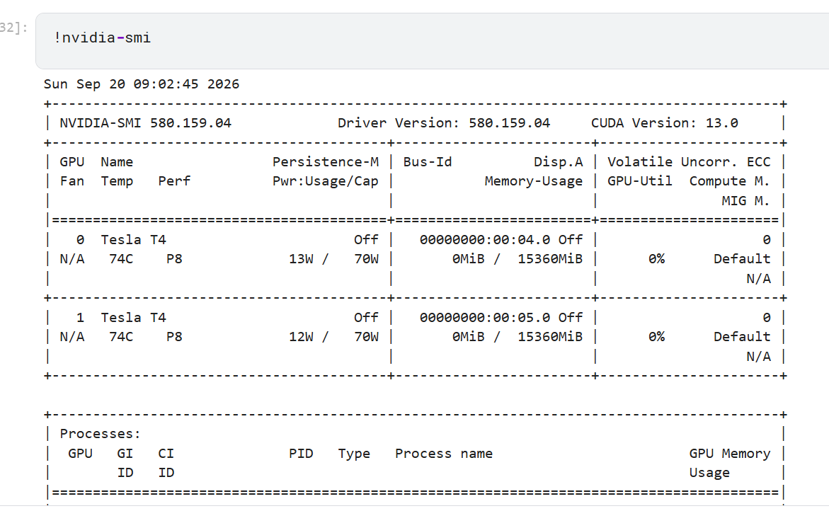
Figure 1: Kaggle environment showing two NVIDIA Tesla T4 GPUs.

4. llama.cpp Setup
llama.cpp was cloned from its GitHub repository and compiled with CUDA support. The build was configured using:
cmake -B build \
-DGGML_CUDA=ON \
-DGGML_CUDA_NO_VMM=ON \
-DCMAKE_CUDA_COMPILER=/usr/local/cuda/bin/nvcc \
-DCUDAToolkit_ROOT=/usr/local/cuda

The resulting version was:
0.4.1-dev
build 11061
commit b23efaa2e

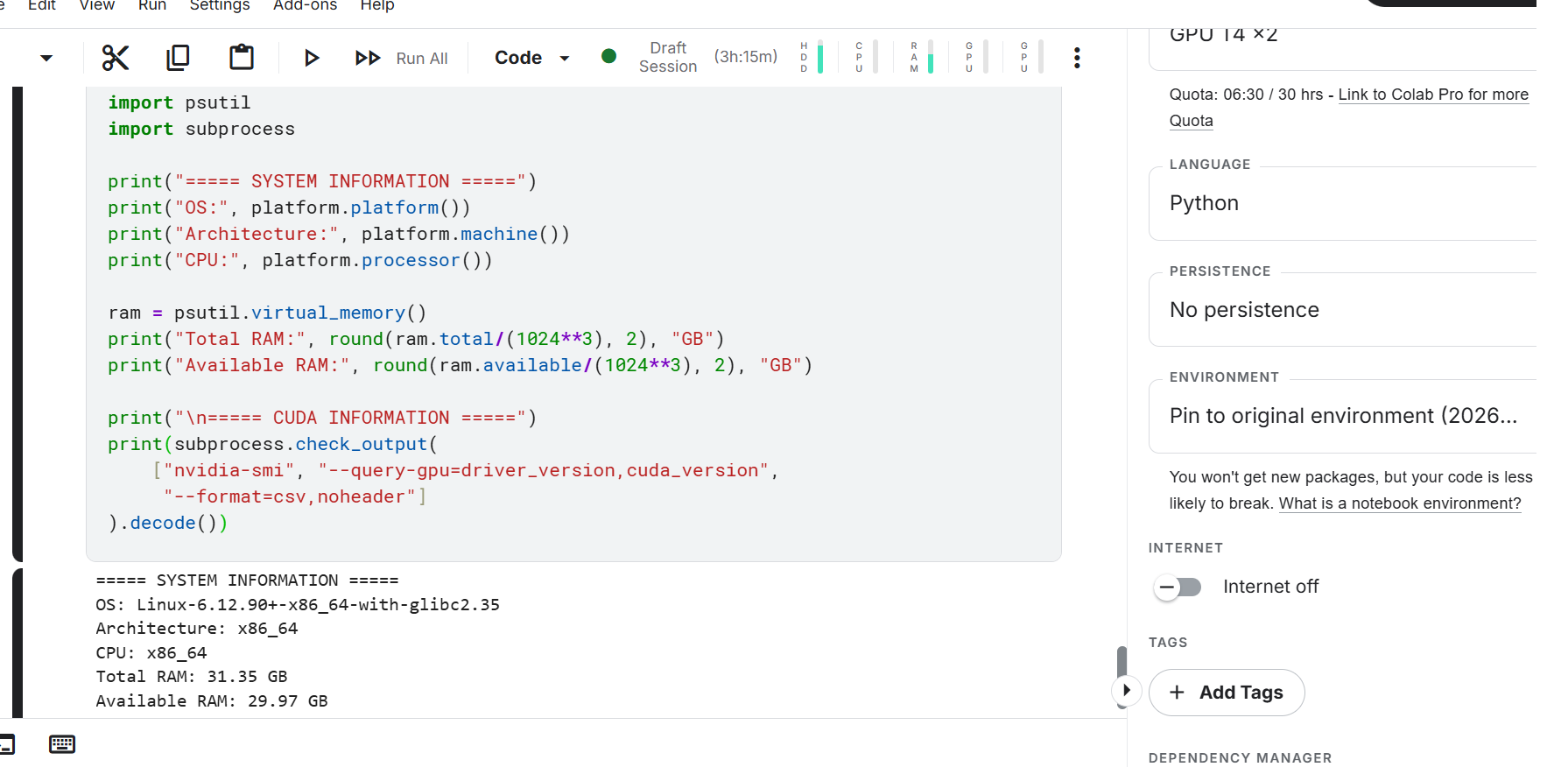
Figure 2: CUDA and system environment verification.
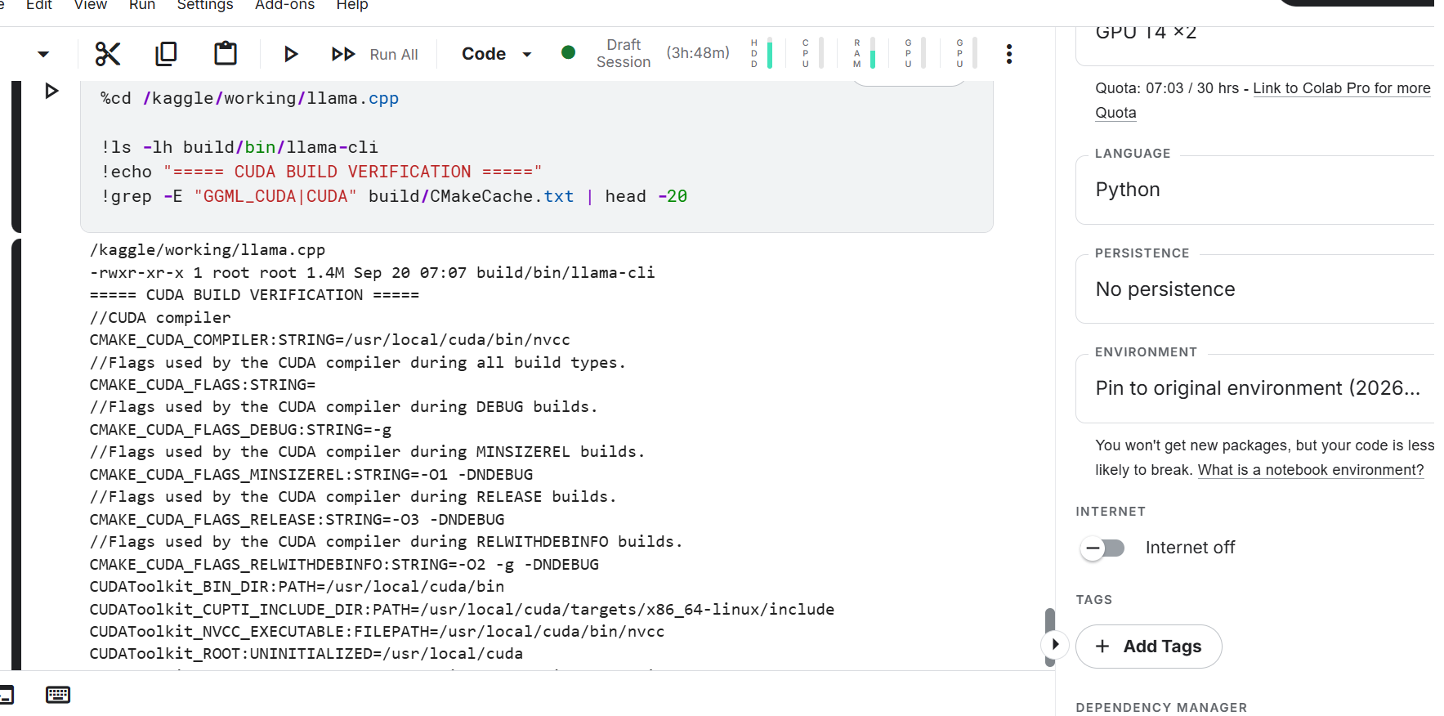
Figure 3: Successful compilation of llama.cpp with CUDA support.
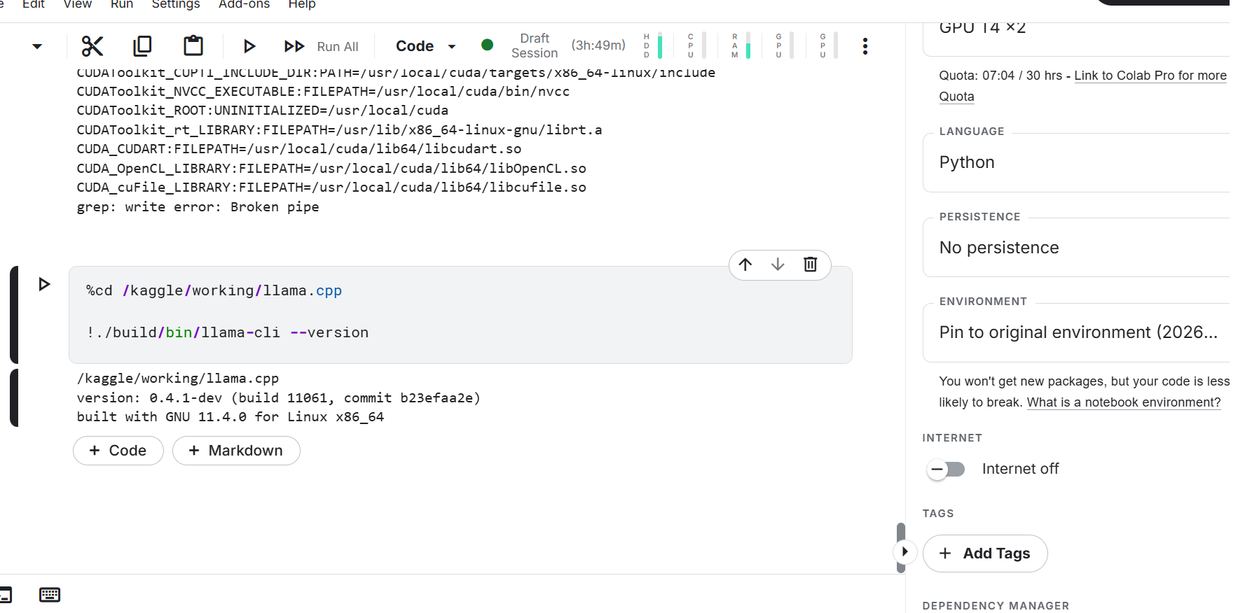
Figure 4: llama.cpp version and build verification.

5. Model Download and Verification
The model was downloaded from the specified Hugging Face repository in GGUF format.

Model
Qwen3.8-27B-Uncensored-Cyber-IQ4_XS-imatrix-fromq8.gguf

Size
14.96 GiB

The model file was successfully verified in:
/kaggle/working/models/

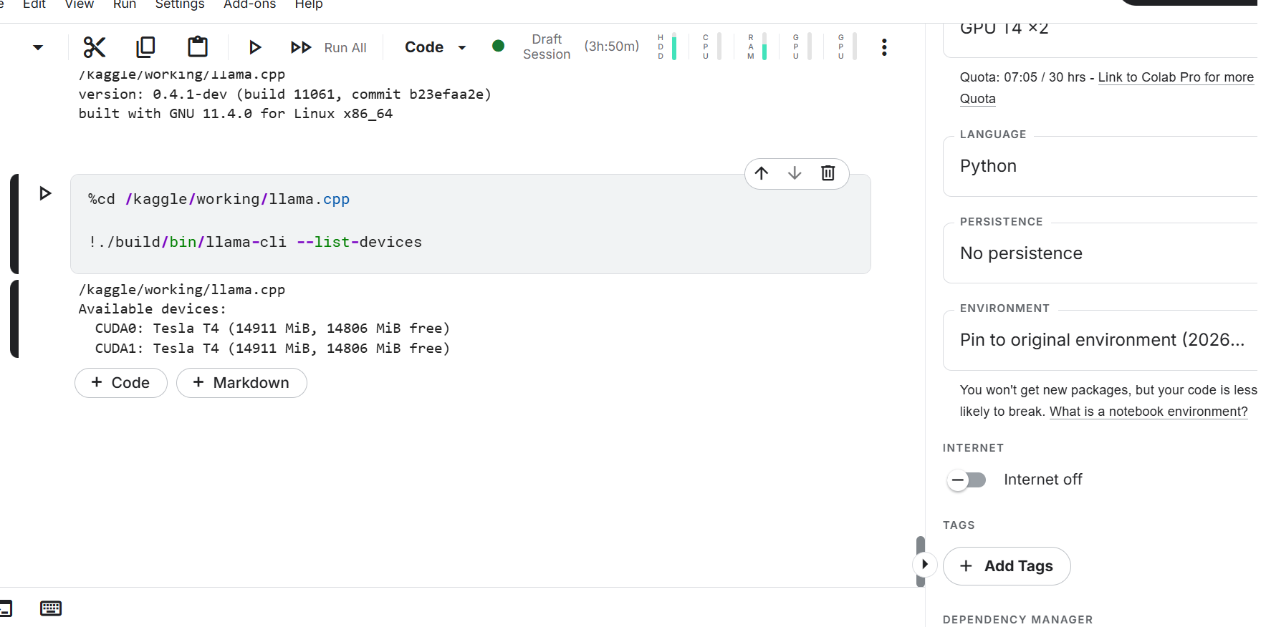
Figure 5: Detection of both Tesla T4 GPUs by llama.cpp.
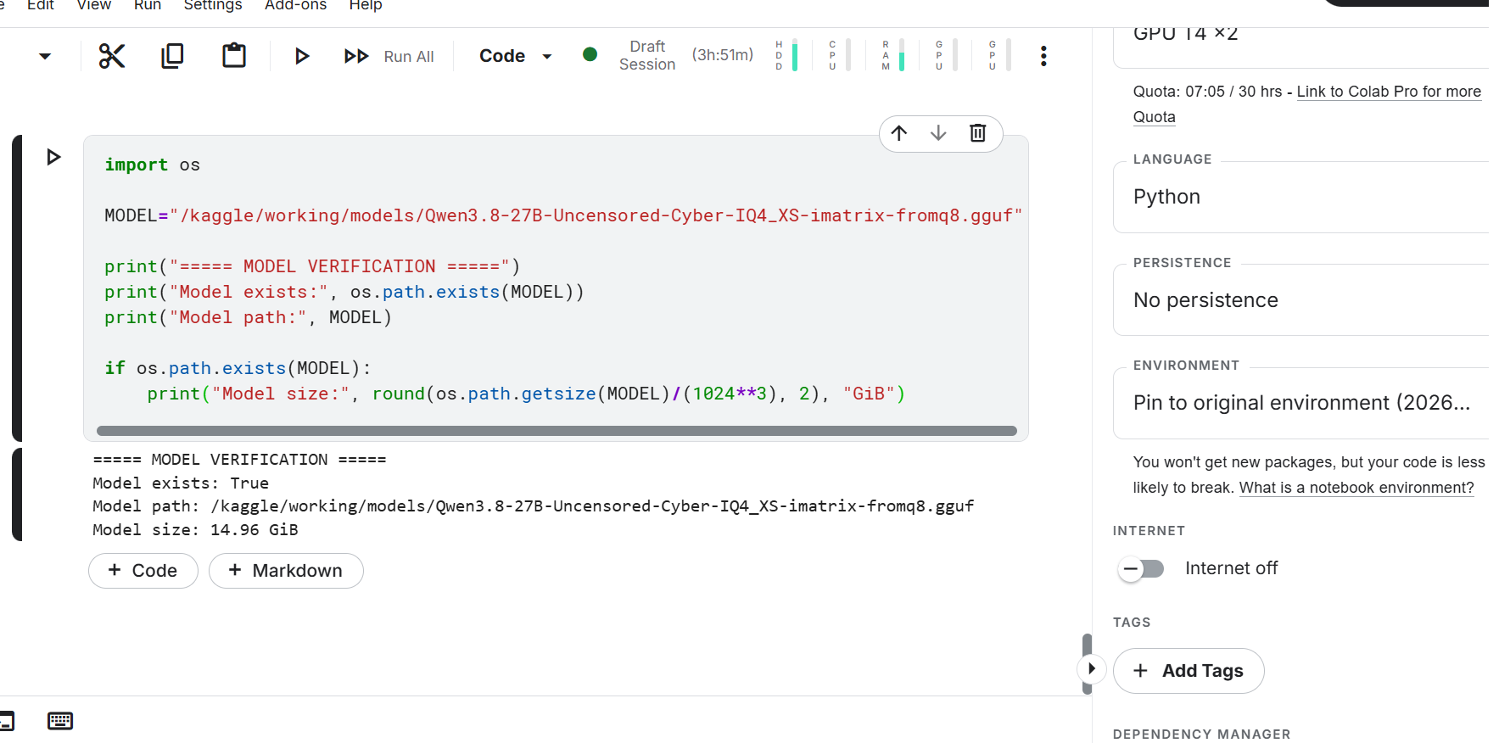
Figure 6: Download and verification of the Qwen3.8-27B GGUF model.

6. Dual-GPU Configuration
Both Tesla T4 GPUs were used for inference. llama.cpp was configured with:
--device CUDA0,CUDA1
--split-mode layer
--tensor-split 1,1
-ngl 99

This allowed the model layers to be distributed across the two available GPUs.

7. Problems Faced and Solutions
- Model filename / 404 error: The initial filename did not match the repository filename. The correct GGUF filename was identified and downloaded.
- Large model size: The 27B model required approximately 15 GB of storage, so storage usage had to be monitored.
- Long generation / waiting: The model uses a reasoning process and can take time to generate an answer. A generation limit of 256 tokens was used for practical testing.
- Interactive prompt: After answering, llama-cli displayed ">", which means it was waiting for another prompt rather than being stuck.
- Offline testing: After disabling Kaggle Internet access, the locally stored model and llama.cpp executable remained available and successfully performed inference.
- Kaggle session not starting: The Kaggle GPU notebook session sometimes failed to start or remained stuck on "Starting session..." because the requested dual-T4 accelerator was busy or the GPU quota was close to its limit. Solution: The session was stopped and restarted, the GPU accelerator was re-selected from Settings, and the notebook was re-run after a short wait. Checking the remaining weekly GPU quota beforehand and retrying during a less busy period resolved the issue.
- Stuck at ">" when generating a response: After typing a prompt into llama-cli's interactive mode, the terminal appeared to freeze at the ">" line with no new output for a while, which looked like the process had hung. Solution: This was not a hang — the 27B model was still processing the prompt and generating tokens in the background. Checking nvidia-smi in a separate cell confirmed GPU-Util was active during this time. Waiting for generation to finish, and setting a token limit (256 tokens) for faster, more predictable responses during testing, resolved the apparent freeze.

8. Online Inference
Before disabling Internet access, the model was successfully tested with a cybersecurity question about the CIA triad.
The model generated an appropriate answer explaining:
- Confidentiality
- Integrity
- Availability

This confirmed that the model and inference engine were functioning correctly.
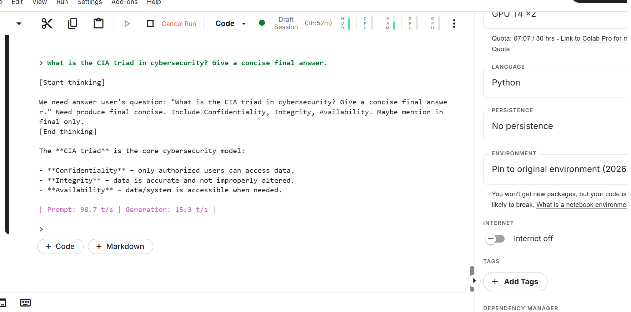
Figure 7: Successful online inference using the cybersecurity model.

9. Offline Inference
The most important test was performed after Kaggle Internet access was disabled. The connectivity test reported:
Internet access: DISABLED/UNREACHABLE

The model was then loaded directly from the local filesystem and successfully answered the CIA triad question. This demonstrated that model inference did not require an active Internet connection or an online AI API.
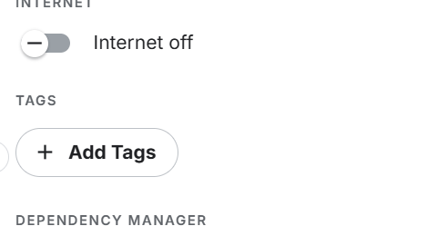
Figure 8: Kaggle Internet access disabled.
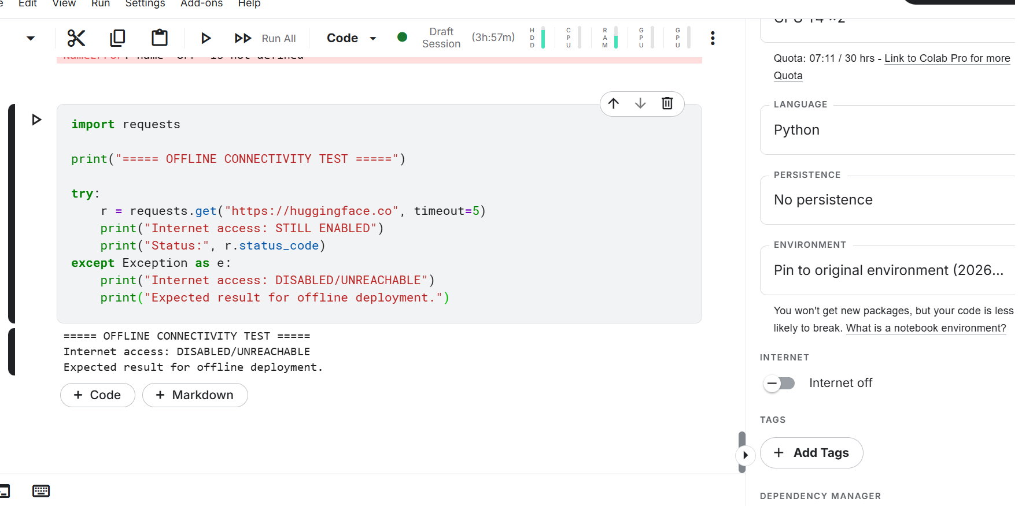
Figure 9: Verification that Internet access was disabled.
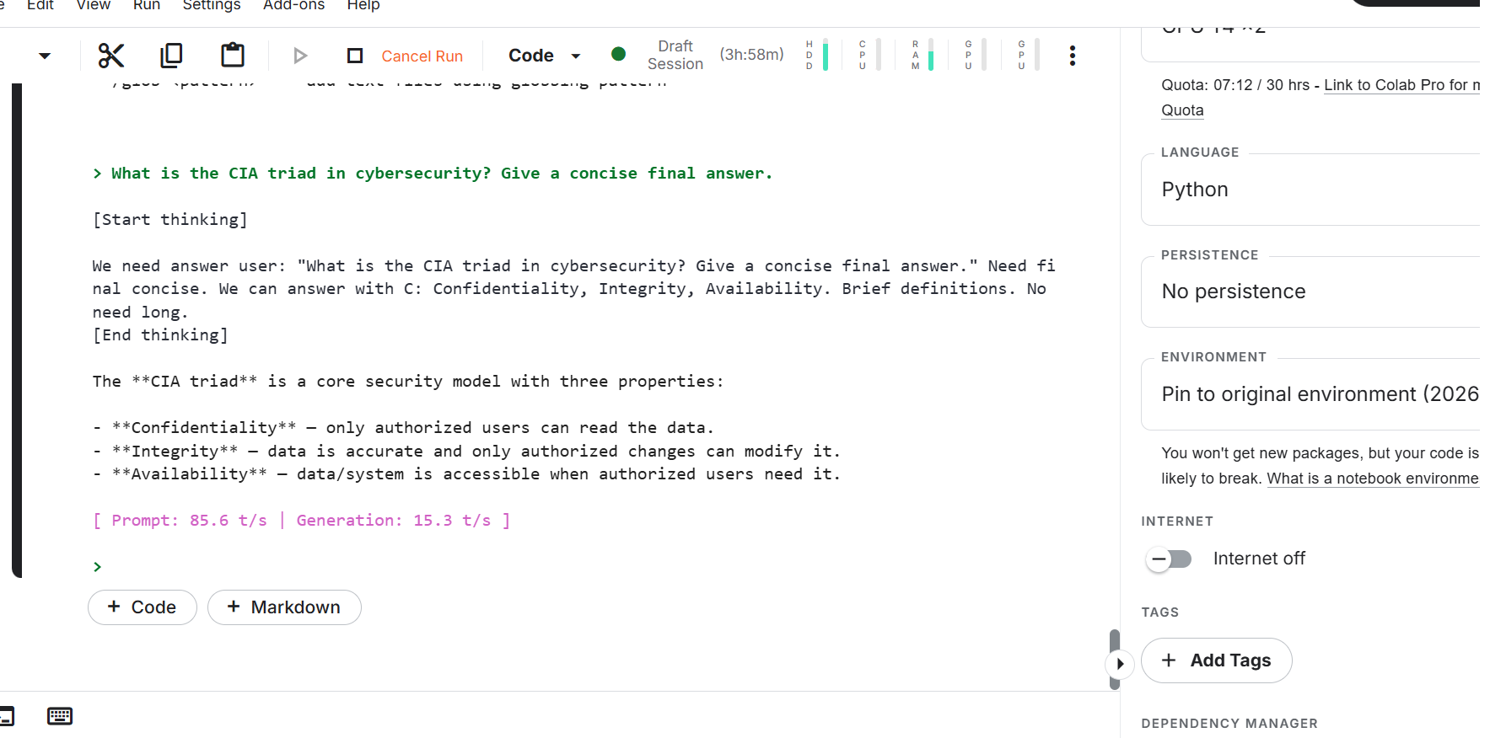
Figure 10: Successful offline inference using the locally stored 27B model.

10. Test Results
The successful offline test produced approximately:
Prompt processing: 94.5 tokens/second
Generation: 15.2 tokens/second

The model successfully answered the following prompt:
“What is the CIA triad in cybersecurity?”
The response correctly described Confidentiality, Integrity, and Availability.
Additional cybersecurity prompts can be used to further demonstrate the model's functionality.
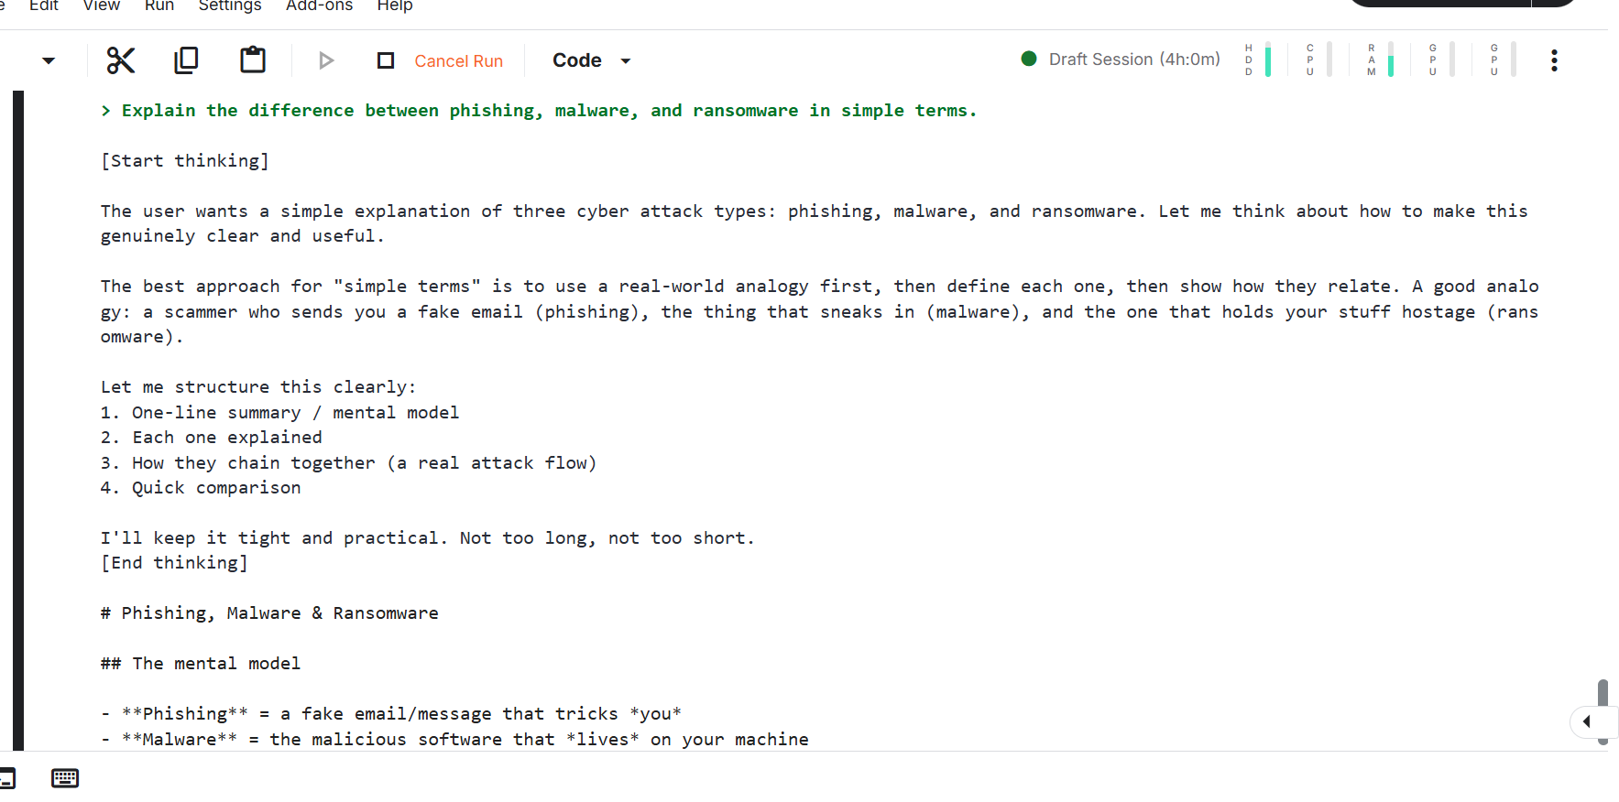
Figure 11: Cybersecurity test prompt and generated response.
Figure 12: Inference performance showing approximately 94.5 tokens/s prompt processing and 15.2 tokens/s generation.

11. Cloud vs. Local Execution
The experiment demonstrates an important distinction between cloud infrastructure and cloud AI services.
Kaggle provided the GPU computing environment, so the physical hardware was cloud-hosted. However, during the final test:
- The model weights were stored in the runtime.
- llama.cpp was executed locally within the runtime.
- No online AI inference API was used.
- Internet access was disabled.

Therefore, the experiment demonstrates local/offline model inference within a cloud-provided compute environment rather than inference on a personal physical laptop.

12. Security and Privacy
Running a model locally/offline can provide privacy advantages because sensitive prompts and data do not need to be sent to an external AI inference service.
For cybersecurity applications, this can be useful when working with:
- Confidential information
- Internal security documentation
- Sensitive logs
- Private organizational data

However, security also depends on protecting the machine, model files, input data, and generated outputs.

13. What I Learned
- How to verify GPU and CUDA availability.
- How to compile llama.cpp with CUDA support.
- How GGUF models are deployed locally.
- How to distribute a large model across multiple GPUs.
- How to troubleshoot model-loading and inference problems.
- How to verify that a model can operate without Internet access.
- The difference between using a cloud AI service and running an AI model locally within a cloud compute environment.

14. Conclusion
The Qwen3.8-27B cybersecurity model was successfully deployed using llama.cpp with two NVIDIA Tesla T4 GPUs. The model was loaded from local storage and successfully generated cybersecurity responses. Most importantly, the model continued to operate after Internet access was disabled, demonstrating that the inference process itself did not depend on an online AI service.

15. Screenshots
Figures 1 through 12, embedded throughout this report, document each stage of the deployment process, from GPU detection and llama.cpp compilation through online inference, disabling Internet access, and the final offline inference test.

