BANK

**?**

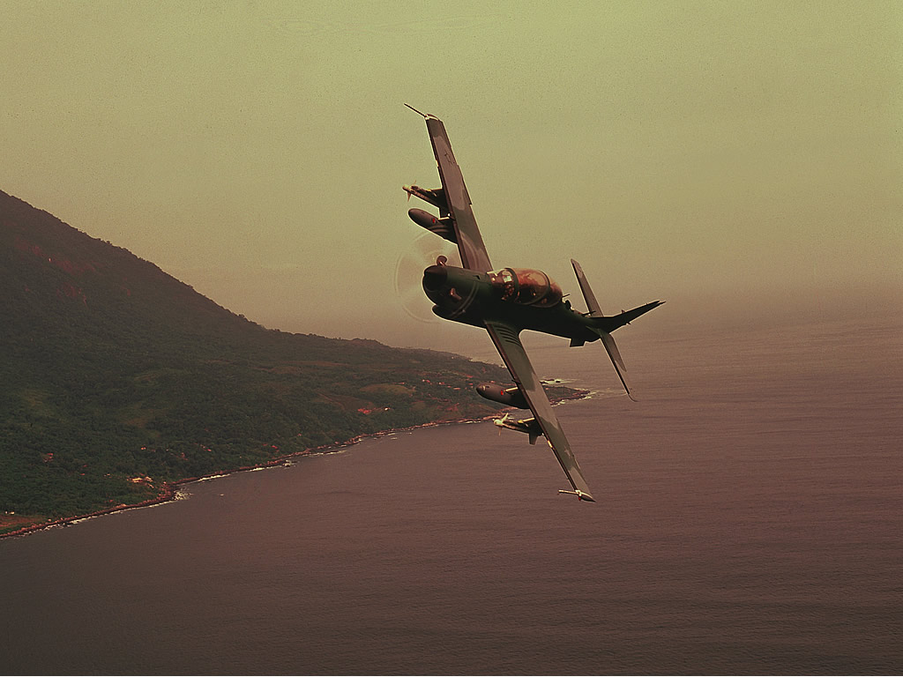 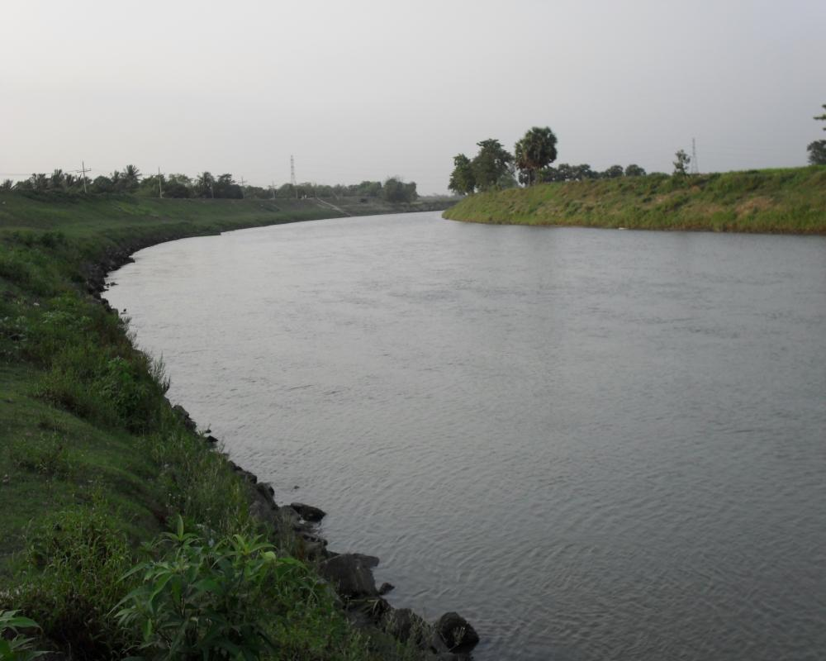 

<http://media.defenceindustrydaily.com/images/AIR_Super_Tucano_Seaside_Bank_lg.jpg>

<http://1.bp.blogspot.com/_jGEuU1zFjq8/S7yLzJZuxfI/AAAAAAAACi8/h7ch0Gsf4kY/s1600/SAM_0367.JPG>

<http://thetrustadvisor.com/wp-content/uploads/2012/07/Bank.jpg>