

2019

**Full-Stack Javascript Developer**

FITNESS

TRAVELS

I'm an Experienced and Expert in Font end web development. I am working more then 2 years with web design I have a good experience in HTML5, CSS3, JavaScript, jQuery, React.Js , Vue.js, Row php, Node.js Responsive web design, etc. Current i am working with React.js, React native and Node.js..

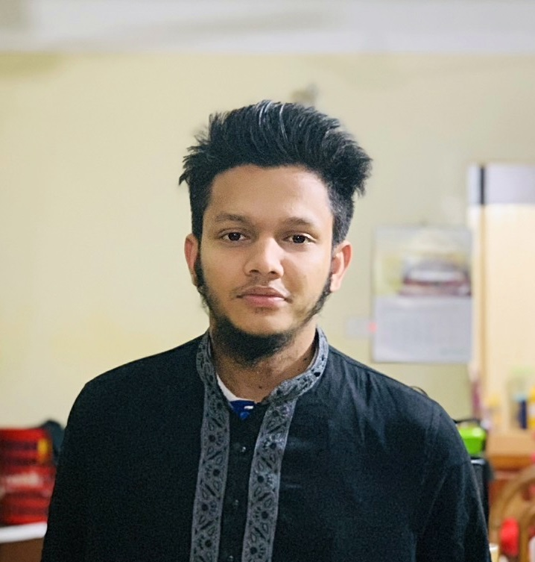

React.js

Vue.js

Node.js

React Native

CSS3

HTML5

PHP

JavaScript

**PROFESSIONAL SKILLS**

IAntooba

**React.js Devoloper**

CodexCoder

https://www.codexcoder.com/

HTML5, CSS3, JavaScrpt, jQuery, Bootstrap, Article Writing

**Front-End Web Developer**

2017 - 2018

**EXPERIENCE**

4.00 out of 5

46/12 middl;e rajation savar, Dhaka 1207

**Golam Rabbi**

+880 1684151985

grabbi96

Savar, Dhaka

www.flexshaper.net

grabbi96@gmail.com

Md Golam Rabbi

CONTACT

**twitter.com/@** **mohiuddin_em**

**dribbble.com/**

**linkedin.com/** mohiuddinem

**facebook.com/**mohiuddin.em

**behance.com**

Skype

Address

Email

Phone

Web

Md Golam Rabbi

17th sep 1196

English / Bangali

Languages

Name

Date of Birth

Relationship

Nationality

Unmarried

Bangladeshi

**MD**

PROFILE

Professional

**Resume**

**EDUCATION**

**HOBBIES AND INTERESTS**

**2014**

Not Finished

St. joseph hight School

Sylhet Polytechnic Institute, Sylhet

City University

S 4.00 out of 5

**SSC**

**HSC**

**BA Honours In English**

BOOKS

GOOD MUSIC

**2015**