| Business Template  **SUBJECT AREAS** |
| --- |
| **Logo / Image** |

**Contents**

1 Business Description 3

1.1 Business background 3

1.2 Problems. Current Situation 3

1.3 The benefits of implementing a database. Project Vision 3

2 Model description 3

2.1 Definitions & Acronyms 3

2.2 Logical Scheme 3

2.3 Objects 3

# 

# Business Description

## Business background

The auction house operates in the art and antiques market, facilitating the sale of valuable items through organized auctions. Sellers submit items for auction, and buyers participate in bidding to purchase these items. Each auction is unique, with specific details such as date, time, location, and theme (e.g., oil paintings from before 1900). After an auction concludes, the auction house records the final sale price, buyer information, and logistics details for shipping the purchased items.

The auction house aims to efficiently manage its operations by tracking sellers, buyers, items, auctions, and transactions. This requires a robust database system to ensure accurate data management, reduce redundancy, and improve operational efficiency.

## Problems. Current Situation

Currently, the auction house relies on manual processes and spreadsheets to manage its operations. This approach presents several challenges:

* Data Redundancy : Information about sellers, buyers, and items is duplicated across multiple spreadsheets.
* Inconsistent Data : Manual entry often leads to errors, such as incorrect pricing or mismatched buyer/seller details.
* Lack of Scalability : As the number of auctions and participants grows, managing data becomes increasingly difficult.
* Limited Reporting : Generating reports on sales, auctions, or item performance is time-consuming and error-prone.
* No Centralized System : There is no unified platform to track all aspects of the business, leading to inefficiencies.

These issues hinder the auction house's ability to operate effectively and make informed decisions.

## The benefits of implementing a database. Project Vision

Implementing a database will address the current challenges and provide numerous benefits:

* Centralized Data Management : All information will be stored in a single, centralized system, reducing redundancy and errors.
* Improved Efficiency : Automated processes will streamline operations, such as assigning lot numbers, recording sales, and managing logistics.
* Scalability : The database can handle increasing volumes of data as the business grows.
* Enhanced Reporting : Customizable reports can be generated quickly to analyze sales trends, auction performance, and customer behavior.
* Data Integrity : Constraints and relationships will ensure accurate and consistent data.

The project vision is to create a modern, scalable database system that empowers the auction house to operate more efficiently, improve customer satisfaction, and drive growth.

# Model description

## Definitions & Acronyms

* PK : Primary Key – A unique identifier for each record in a table.
* FK : Foreign Key – A field used to establish a relationship between two tables.
* 3NF : Third Normal Form – A level of database normalization that eliminates redundancy and ensures data integrity.
* M:N : Many-to-Many Relationship – A relationship where multiple records in one table are associated with multiple records in another table.

## Logical Scheme

The logical data model consists of 10 tables , each representing a key entity in the auction house's operations. The tables are interconnected through primary and foreign keys to enforce relationships and maintain data integrity. Below is a high-level overview of the schema:

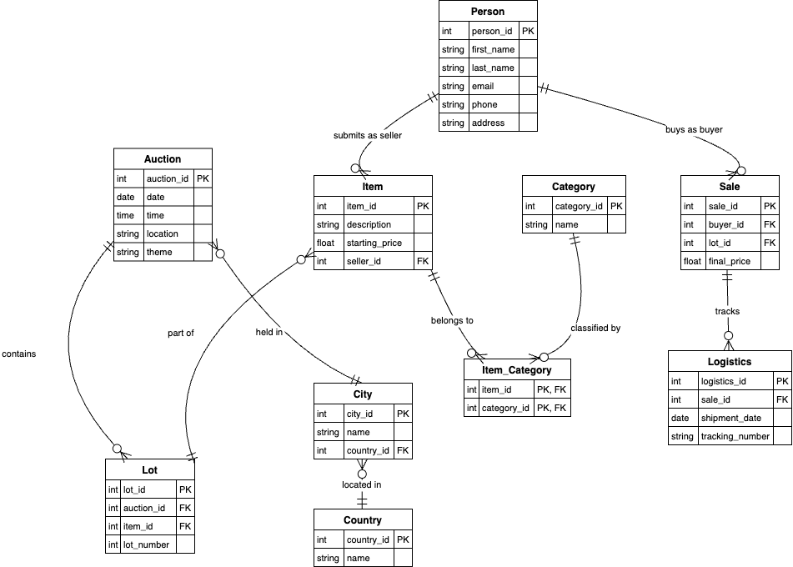

Table 1.1.

## Objects

Table Description

| Table name | Field name | Field Description | Data Type |
| --- | --- | --- | --- |
| Person | person_id | Unique identifier for a person, PK, auto_increment | Int |
| first_name | First name of the person, not null | VARCHAR(50) |
| last_name | Last name of the person, not null | VARCHAR(50) |
| email | Email address of the person, unique | VARCHAR(100) |
| phone | Phone number of the person | VARCHAR(15) |
|  | address | Physical address of the person | TEXT |

| Table Name | Field name | Field Description | Data Type |
| --- | --- | --- | --- |
| Item | item_id | Unique identifier for an item, PK, auto_increment | INT |
| description | Description of the item, not null | Text |
| starting_price | Starting price of the item, not null | DECIMAL(10, 2) |
| seller_id | ID of the seller who submitted the item, FK(Person.person_id) | INT |

| Table Name | Field name | Field Description | Data Type |
| --- | --- | --- | --- |
| Lot | lot_id | unique identifier for a lot, PK, auto_increment | Int |
| auction_id | ID of the auction, FK(Auction.auction_id) | Int |
| item_id | ID of the item in the lot, FK(Item.item_id) | Int |
| lot_number | Lot number assigned to the item, not null | Int |

| Table Name | Field name | Field Description | Data Type |
| --- | --- | --- | --- |
| Auction | auction_id | Unique identifier for an auction, PK | Int |
| date | Date of the auction, not null | Date |
| time | Time of the auction, not null | TIME |
| location | Location of the auction, not null | VARCHAR(100) |
| theme | Theme of the auction | VARCHAR(100) |

| Table Name | Field name | Field Description | Data Type |
| --- | --- | --- | --- |
| Sale | Sale_id | Unique identifier for a sale, PK, auto_increment | Int |
| buyer_id | ID of the buyer, FK(Person.person_id) | Int |
|  | lot_id | ID of the lot sold, FK(Lot.lot_id) | Int |
|  | final_price | Final price paid for the item, not null | DECIMAL(10, 2) |

| Table Name | Field name | Field Description | Data Type |
| --- | --- | --- | --- |
| Country | country_id | Unique identifier for a country, PK, auto_increment | Int |
| name | Name of the country, not null, unique | VARCHAR(50) |

| Table Name | Field name | Field Description | Data Type |
| --- | --- | --- | --- |
| City | city_id | Unique identifier for a city, PK, auto_intrement | Int |
| name | Name of the city, not null | VARCHAR(50) |
| country_id | ID of the country where the city is located, FK(Country.c) | INT |

| Table Name | Field name | Field Description | Data Type |
| --- | --- | --- | --- |
| Category | category_id | Unique identifier for a category, PK, auto_increment | Int |
| name | Name of the category, not null, unique | VARCHAR(50) |

| Table Name | Field name | Field Description | Data Type |
| --- | --- | --- | --- |
| Item_category | item_id | ID of the item, PK/FK(Item.item_id) | Int |
| category_id | ID of the category, PK, FK (Category.category_id) | Int |

| Table Name | Field name | Field Description | Data Type |
| --- | --- | --- | --- |
| Logistics | logistics_id | unique identifier for logistics, PK, auto_increment | Int |
| sale_id | ID of the sale, FK(Sale.sale_id) | Int |
| shipment_date | Date of shipment | Date |
| tracking_number | Tracking number for the shipment, unique | VARCHAR(50) |

Comments on table relationships

* Person ↔ Item : A person can act as both a seller and a buyer. The seller_id in the Item table links sellers to their items, while the buyer_id in the Sale table links buyers to their purchases.
* Item ↔ Lot : Each item is assigned to a specific lot in an auction. The item_id in the Lot table establishes this relationship.
* Auction ↔ Lot : An auction can have multiple lots, and each lot belongs to a single auction. The auction_id in the Lot table enforces this relationship.
* Item ↔ Category : Items can belong to multiple categories, and categories can include multiple items. The Item_Category junction table resolves this many-to-many relationship.
* Sale ↔ Logistics : Each sale is associated with logistics details for shipping. The sale_id in the Logistics table links sales to their logistics records.

Example with data

| Field Name 1 | Field name 2 | Field name 3 | Field name N |
| --- | --- | --- | --- |
| 1 | Azamat | Duisenbekov | azamat_duisenbekov@icloud.com |
| 2 | Bekzat | Duisenbekov | beka034@gmail.com |
| 101 | Gennady Golovkin | 500.0 | 1 |
| 102 | Oil Painting | 1000.0 | 2 |
| 1001 | 1 | 101 | 10 |
| 1002 | 1 | 102 | 20 |