CR-HKGE: Cross-Reference Semantic Enrichment on Heterogeneous Knowledge Graph Embedding for Fragrance Recommendation
Azam Azri Ahmad¹, Raissa Desyandita²
Department / Faculty [VERIFY], Institution [VERIFY]
{author1, author2}@institution [VERIFY]

Abstract—Fragrance recommendation is a challenging cold-start problem because small-scale perfume catalogs often lack historical user-item interactions, while product relevance is expressed through subjective olfactory concepts such as accords, fragrance families, visual notes, and global fragrance references. Existing knowledge graph (KG) recommendation models, including KGAT, commonly rely on user-item interaction matrices and do not explicitly model cross-reference semantics between local perfume products and global fragrance references. This paper proposes CR-HKGE, a Cross-Reference Semantic Enrichment model built on heterogeneous knowledge graph embedding for fragrance recommendation without historical user behavior. CR-HKGE constructs a fragrance-specific heterogeneous KG, propagates global reference semantics through the inspired_by relation, and applies relation-type attention to prioritize informative fragrance relations. Since the Aromatique dataset contains no purchase, rating, or click logs, content-based positive pairs are constructed as surrogate supervision for KGAT-compatible offline training and evaluation in a zero historical interaction setting. Experiments on 340 perfume products, 998 entities, 9,250 triples, and seven relation types show that CR-HKGE outperforms KGAT and other KG/collaborative-filtering baselines across overall Top-K metrics, with the largest gains on enriched products linked to global references. These results indicate that cross-reference semantic enrichment can improve KG-based fragrance recommendation when no interaction history is available.
Keywords—knowledge graph recommendation; heterogeneous knowledge graph; fragrance recommendation; cold-start recommendation; cross-reference enrichment; relation-type attention; KGAT
I. INTRODUCTION
Unlike movie or book recommendation, fragrance recommendation often relies on subjective olfactory descriptors and reference scents rather than explicit ratings or purchase histories. Users typically describe what they want through perceptual concepts such as sweet, woody, amber, or vanilla, and frequently mention a reference perfume whose scent they wish to approximate. For a small local catalog, this perceptual and reference-driven nature makes conventional interaction-based recommendation difficult to apply directly.
Collaborative filtering and many KG-based recommenders require a user-item interaction matrix [1], [3], [9]. In the Aromatique catalog studied here, no historical purchase, rating, or click logs are available. This makes standard collaborative filtering and KGAT-style training [1] infeasible without constructing a surrogate supervision signal, since these models cannot be executed without an interaction source.
Fragrance data are, however, naturally relational. A product is connected to its accords, visual notes, and olfactory family, and an inspired product is additionally connected to a global fragrance reference that carries its own accords and family. The inspired_by relation therefore acts as a semantic bridge from the local product space to a richer global fragrance knowledge space, which is well suited to a knowledge graph formulation [7], [10].
Nevertheless, two gaps remain. First, KGAT applies attentive propagation but does not assign explicit, type-specific priors to domain relations, so a highly informative relation such as inspired_by is treated similarly to a weak relation such as has_visual_note [1], [16]. Second, existing KG recommenders are typically validated on large datasets with abundant user interactions [6], [14], and prior work reports instability on extremely sparse data [14], [15]. A small interaction-free fragrance catalog is an extreme case that these models do not directly address.
To address these gaps, we propose CR-HKGE, a Cross-Reference Heterogeneous Knowledge Graph Embedding model that modifies KGAT for fragrance recommendation. CR-HKGE replaces real interaction supervision with content-based positive pairs and enriches product embeddings with global reference semantics through a dedicated cross-reference propagation mechanism guided by relation-type attention.
The main contributions of this paper are as follows:
• We construct a fragrance-specific heterogeneous KG for the Aromatique catalog, containing 340 products, 998 entities, 9,250 triples, and seven relation types.
• We introduce a cross-reference semantic propagation layer that transfers global fragrance reference semantics to local product embeddings through the inspired_by relation.
• We introduce relation-type attention that differentiates the contribution of heterogeneous fragrance relations during KG propagation.
• We construct content-based positive pairs as surrogate supervision for KGAT-compatible training in a zero historical interaction setting.
• We show that CR-HKGE improves over KGAT, BPRMF, CKE, and CFKG on overall Top-K recommendation metrics, with the largest gains on enriched products.
II. RELATED WORK
A. Collaborative and KG-Based Recommendation
Matrix factorization with Bayesian personalized ranking (BPRMF) is a widely used pairwise ranking baseline [3], [20]. To incorporate side information, collaborative knowledge base embedding (CKE) jointly learns item and KG embeddings [2], while CFKG casts recommendation as KG completion over a unified user-item-entity graph [8]. KGAT integrates these ideas through attentive embedding propagation over a collaborative knowledge graph [1] and is the direct architectural baseline for this work. Graph collaborative filtering further confirms the value of high-order connectivity [9]. CR-HKGE retains the KGAT backbone but adapts it to an interaction-free, domain-specific fragrance setting.
B. Heterogeneous KG and Relation Attention
Heterogeneous KG recommenders model multiple node and edge types [10], [11]. However, several heterogeneous information network models assign uniform weights to different edge types, which limits recommendation quality [16]. Heterogeneous KG attention models such as HKGAT extend attentive propagation but are validated on large datasets and acknowledge the need for cross-domain semantic bridges [17]. HGKR reports instability on sparser datasets and suggests stronger KG reasoning as a remedy [14]. CR-HKGE responds to these observations with learnable relation-type weights and an explicit cross-reference propagation path.
C. Cold-Start and Conversational Fragrance Recommendation
Cold-start recommendation addresses settings with little or no interaction data [13]. Empirically, KGAT-style attention has been reported to struggle with attention allocation on extremely sparse knowledge graphs [15], and content-derived supervision has been used to compensate for missing feedback [18], [19]. Conversational recommender systems motivate Top-K retrieval from natural-language preferences [12]; in this paper, conversational use is the deployment motivation, while evaluation remains offline. The Aromatique catalog represents an extreme zero historical interaction case, for which content-based positive pairs provide surrogate supervision.
III. PROPOSED METHOD
A. Problem Formulation
Let P be the set of perfume products, E the set of entities, R the set of relation types, and T the set of triples. The fragrance KG is G = (E, R, T), where each triple (h, r, t) ∈ T links a head entity h to a tail entity t through relation r. The recommendation task estimates a relevance score
ŷ(u, p) = f(eᵤ, eₚ) (1)
between a content/query profile u and a product p. Here u denotes a content/query profile derived from fragrance attributes, not a real historical user; no purchase, rating, or click logs are used.
B. Fragrance-Specific Heterogeneous KG Construction
The heterogeneous KG contains seven node types—product, accord, note, family, global_ref, global_accord, and global_family—and seven relation types listed in Table I. The inspired_by relation connects a local product to a global fragrance reference, which in turn carries has_global_accord and belongs_to_global_family edges. This design exposes a path from a local product to global semantics, as illustrated in Fig. 2. Products that have an inspired_by edge are termed enriched (243 products); the remaining products are standard (97 products).
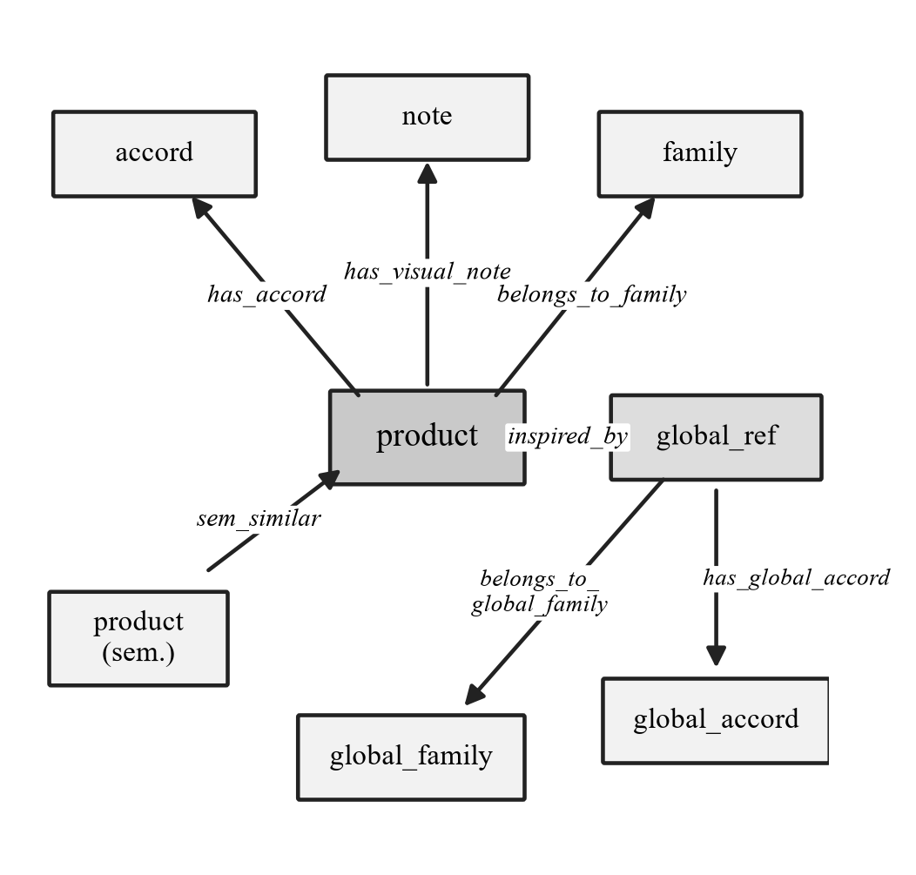
Fig. 2. Fragrance-specific heterogeneous KG schema. The inspired_by relation bridges local products to the global fragrance reference space.
C. Content-Based Positive-Pair Construction
Because Aromatique has no historical interactions, content-based positive pairs are generated as surrogate supervision. Each content/query profile corresponds to one source product, and positive targets are the products with the highest relevance to that source. The relevance score s(pᵢ, pⱼ) aggregates weighted Jaccard and indicator terms over local accords, visual notes, local family, global accords, global family, a global-to-local accord/family bridge, shared global references, and sem_similar neighbors, with an additional bonus when both products are enriched. The eight scoring weights range from 0.20 (enriched bonus) to 3.00 (same global reference), giving the highest priority to cross-reference agreement. For each profile, the top-ranked candidates are split into eight train and four test positive items, yielding 2,720 train and 1,360 test pairs. These train/test files follow the KGAT format but are content-based positive pairs, not user behavior.
D. CR-HKGE Architecture
CR-HKGE preserves the KGAT backbone and adds three novelty components, as shown in Fig. 3.
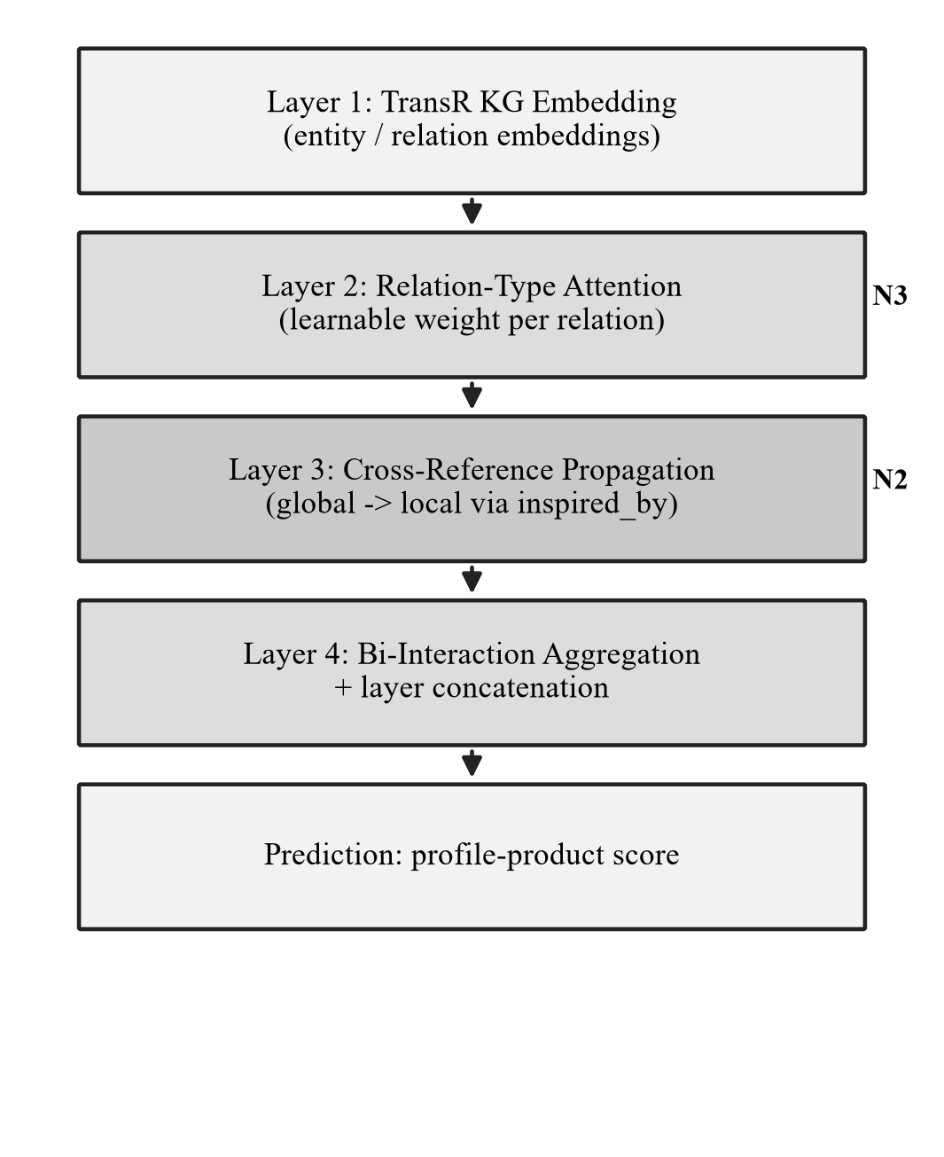
Fig. 3. CR-HKGE architecture. N1 is the fragrance-specific heterogeneous KG input; N2 is cross-reference propagation; N3 is relation-type attention.
1) Layer 1 – TransR KG embedding: Following KGAT [1] and TransR [4], the plausibility of a triple is
g(h, r, t) = ‖ Wᵣ eₕ + eᵣ − Wᵣ eₜ ‖²₂ (2)
and the KG embedding is trained with a pairwise loss over corrupted tails t′:
L_KG = Σ − ln σ( g(h, r, t′) − g(h, r, t) ) (3)
2) Layer 2 – Relation-type attention: KGAT computes attention π(h, r, t) = (Wᵣ eₜ)ᵀ tanh(Wᵣ eₕ + eᵣ). CR-HKGE scales this score by a learnable, type-specific weight:
π_CR(h, r, t) = λ̃ᵣ · (Wᵣ eₜ)ᵀ tanh(Wᵣ eₕ + eᵣ) (4)
λ̃ᵣ = |R| · exp(λᵣ) / Σ exp(λᵣ′) (5)
One scalar λᵣ is learned per semantic relation type and shared between forward and inverse edges. The softmax is rescaled by the number of relation types so that a uniform initialization preserves the original KGAT attention scale, while an optional fragrance prior (relation prior strength 1.0) can bias initialization toward informative relations.
3) Layer 3 – Cross-reference propagation: For an enriched product p, global reference context is aggregated and injected into the product embedding:
c_ref(p) = α · λ̃_ib · W_cr ( e_g + Σ π_CR(g, r, t) eₜ ) (6)
where g is the global reference reached through inspired_by, λ̃_ib is its relation weight, and α controls the propagation strength. For standard products c_ref(p) = 0, enforced by a product mask, so cross-reference enrichment affects only products that actually have an inspired_by edge. The final model uses α = 0.1.
4) Layer 4 – Bi-interaction and prediction: The cross-reference context is added to the aggregated neighbor message m_N(p) and combined through the KGAT bi-interaction update
eₚ⁽ˡ⁾ = σ( W⁽ˡ⁾ ( eₚ⁽ˡ⁻¹⁾ + m_N(p) + c_ref(p) ) ) (7)
Layer outputs are concatenated and scored by inner product:
eₚ* = eₚ⁽⁰⁾ ∥ … ∥ eₚ⁽ᴸ⁾ , ŷ(u, p) = (eᵤ*)ᵀ eₚ* (8)
E. Training Objective
CR-HKGE follows the KGAT alternating schedule. Phase I trains the recommender with a BPR loss over content-based positive pairs:
L_BPR = − Σ ln σ( ŷ(u, i) − ŷ(u, j) ) (9)
Phase II trains the TransR/KG embedding and updates the attentive adjacency. The overall objective is
L = L_BPR + L_KG + β ‖ Θ ‖² (10)
IV. EXPERIMENTAL SETUP
A. Dataset
Experiments use the dataset-aromatique-crhkge-ready dataset, whose key statistics are summarized in Table I. The dataset contains no historical purchase, rating, or click logs; the train/test files are content-based positive pairs used for offline surrogate evaluation in a zero historical interaction setting. The overall pipeline is shown in Fig. 1, which makes explicit that no real user interaction history is used.
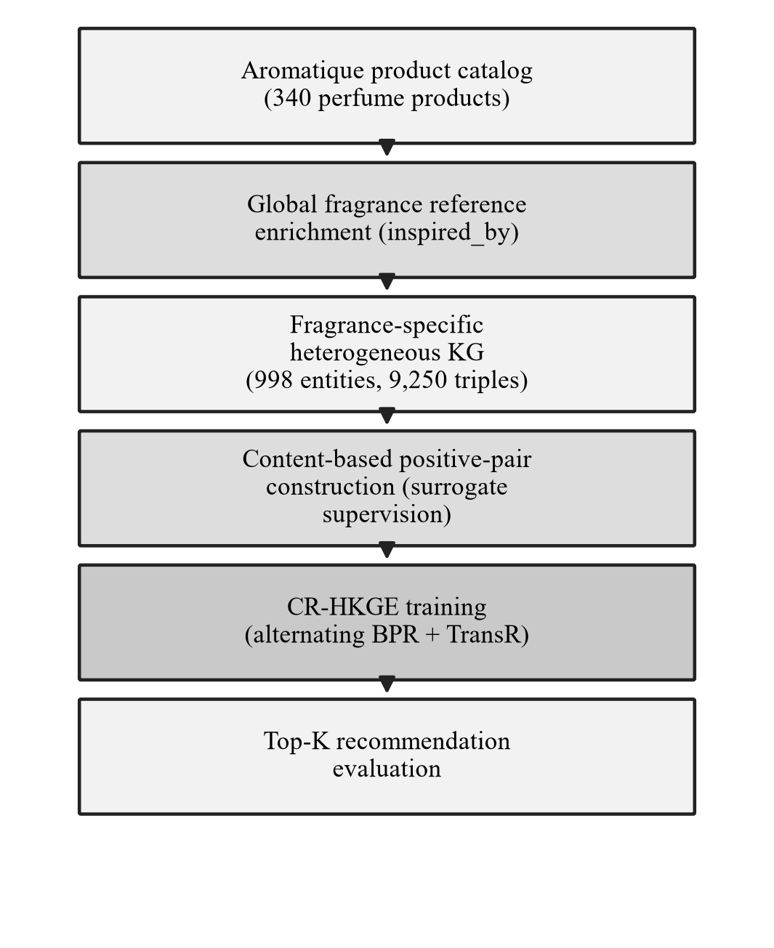
Fig. 1. Overall research pipeline. No real user interaction history is used; supervision comes from content-based positive pairs.
TABLE I
DATASET AND KNOWLEDGE GRAPH STATISTICS
Statistic / Relation | Value
Products | 340
Entities | 998
Relation types | 7
KG triples | 9,250
Enriched products (inspired_by) | 243
Standard products | 97
Content/query profiles | 340
Train positive pairs | 2,720
Test positive pairs | 1,360
inspired_by | 243
has_accord | 1,629
has_visual_note | 680
belongs_to_family | 340
sem_similar | 4,110
has_global_accord | 2,017
belongs_to_global_family | 231

B. Baselines
CR-HKGE is compared with four baselines on the same content-based split: BPRMF, a matrix-factorization ranking baseline [3], [20]; CKE, a collaborative KG embedding baseline [2]; CFKG, a KG-collaborative baseline [8]; and KGAT, the main KG-attention architectural baseline [1]. All models share the same dataset, candidate pool, and evaluation protocol to ensure a fair comparison.
C. Hyperparameters and Metrics
The embedding and KGE sizes are 64, with propagation layers of size [64, 32, 16], learning rate 1×10⁻⁴, batch size 64, node dropout 0.1, message dropout 0.1, and 100 epochs. The CR-HKGE checkpoint is selected by NDCG@3, the final cross-reference strength is α = 0.1, and the relation prior strength is 1.0. Recommendation quality is reported with Precision@K, Recall@K, Hit@K, and NDCG@K for K ∈ {3, 5, 10}, computed over the full non-training candidate pool. Enriched and standard subsets are evaluated by restricting the relevant items to products with or without an inspired_by edge, respectively.
V. RESULTS AND DISCUSSION
A. Overall Performance
TABLE II
OVERALL TOP-K PERFORMANCE ON dataset-aromatique-crhkge-ready
Model | R@3 | P@3 | H@3 | N@3 | R@10 | N@10
CFKG | .0074 | .0098 | .0294 | .0203 | .0309 | .0514
BPRMF | .2110 | .2814 | .6559 | .2809 | .5375 | .5220
CKE | .2265 | .3020 | .6853 | .2987 | .5735 | .5458
KGAT | .2632 | .3510 | .7618 | .3278 | .6912 | .6048
CR-HKGE (α=0.1) | .2949 | .3931 | .8265 | .3663 | .7140 | .6272

Table II reports overall performance. CR-HKGE outperforms all included baselines on every metric. The improvement over KGAT—the strongest baseline—confirms that the added cross-reference propagation and relation-type attention strengthen KGAT-style recommendation. CFKG performs poorly, indicating that simple collaborative KG modeling is insufficient on this small, interaction-free catalog, whereas BPRMF and CKE are stronger than CFKG but remain below the attentive KG models, showing the value of attentive propagation.
Relative to KGAT, CR-HKGE improves Recall@3 by +0.0316 (0.2632→0.2949), Precision@3 by +0.0422, Hit@3 by +0.0647, NDCG@3 by +0.0385, Recall@10 by +0.0228, and NDCG@10 by +0.0223. The largest gains appear at Hit@3 and Precision@3, indicating that CR-HKGE places relevant candidates earlier in the recommendation list, which is desirable for a Top-3 conversational setting.
B. Enriched vs. Standard Products
TABLE III
ENRICHED VS. STANDARD PRODUCT PERFORMANCE
Subset / Model | R@3 | P@3 | H@3 | N@3 | R@10 | N@10
Enr. KGAT | .2598 | .3029 | .6814 | .2993 | .6913 | .5594
Enr. CR-HKGE | .3092 | .3481 | .7640 | .3474 | .7203 | .5912
Std. KGAT | .2921 | .1587 | .4571 | .2219 | .7429 | .4587
Std. CR-HKGE | .2730 | .1492 | .4095 | .2018 | .7413 | .4398

Table III separates enriched products (with inspired_by) from standard products. On enriched products, CR-HKGE improves over KGAT on every metric, directly supporting the usefulness of cross-reference semantic propagation. On standard products, where inspired_by is absent and the cross-reference context is masked to zero, KGAT remains slightly stronger. This behavior is expected, because cross-reference propagation is designed to benefit enriched products; CR-HKGE nevertheless remains competitive on standard products and improves overall recommendation.
C. Sensitivity and Ablation
Varying the cross-reference strength α ∈ {0.25, 0.10, 0.075, 0.05} shows that α = 0.10 gives the best overall NDCG@3 (0.3663) while maintaining strong Recall@10 (0.7140). A larger α over-emphasizes cross-reference paths, whereas a smaller α weakens global reference enrichment; α = 0.10 provides the best balance for early ranking and Top-10 retrieval.
TABLE IV
ABLATION STUDY (OVERALL)
Variant | R@3 | P@3 | H@3 | N@3 | R@10 | N@10
No novelty modules | .2625 | .3500 | .7471 | .3244 | .7015 | .6068
No cross-reference | .2824 | .3765 | .7971 | .3496 | .7140 | .6184
No fragrance prior | .2816 | .3755 | .7618 | .3562 | .6993 | .6211
Full CR-HKGE (α=0.1) | .2949 | .3931 | .8265 | .3663 | .7140 | .6272

Table IV reports an ablation in which novelty components are removed. The full CR-HKGE with α = 0.1 achieves the best overall scores. Removing the cross-reference path or the fragrance prior reduces early-ranking quality (NDCG@3 and Hit@3), and disabling all novelty modules reduces the model to a KGAT-equivalent baseline. These results are consistent with the overall and subset analyses and indicate that the components are complementary.
D. Limitations
Several limitations should be noted. The dataset contains no real historical user interactions, so positive pairs are surrogate content-based relevance labels rather than observed behavior, and evaluation is offline rather than online user testing. The catalog is small (340 products), and the results should be validated on other fragrance catalogs. Accordingly, the claims are scoped to improvement over KGAT and the included KG/CF baselines on this dataset, not to absolute superiority over all possible approaches.
VI. CONCLUSION
This paper proposed CR-HKGE, a cross-reference semantic enrichment model for fragrance recommendation in a zero historical interaction setting. CR-HKGE constructs a fragrance-specific heterogeneous KG, propagates global reference semantics through the inspired_by relation, and applies relation-type attention to prioritize heterogeneous fragrance relations. Because Aromatique contains no purchase, rating, or click logs, content-based positive pairs are used as surrogate supervision for KGAT-compatible training and evaluation. Experiments show that CR-HKGE improves over KGAT, BPRMF, CKE, and CFKG across overall Top-K metrics, with the clearest gains on enriched products linked to global references. Future work will incorporate real user feedback, online conversational evaluation, larger fragrance catalogs, additional relations such as season and occasion, and more robust relation-type calibration.
REFERENCES
[1] X. Wang, X. He, Y. Cao, M. Liu, and T.-S. Chua, “KGAT: Knowledge Graph Attention Network for Recommendation,” in Proc. 25th ACM SIGKDD Int. Conf. Knowledge Discovery & Data Mining (KDD), 2019, pp. 950–958.
[2] F. Zhang, N. J. Yuan, D. Lian, X. Xie, and W.-Y. Ma, “Collaborative Knowledge Base Embedding for Recommender Systems,” in Proc. 22nd ACM SIGKDD Int. Conf. Knowledge Discovery & Data Mining (KDD), 2016, pp. 353–362.
[3] S. Rendle, C. Freudenthaler, Z. Gantner, and L. Schmidt-Thieme, “BPR: Bayesian Personalized Ranking from Implicit Feedback,” in Proc. 25th Conf. Uncertainty in Artificial Intelligence (UAI), 2009, pp. 452–461.
[4] Y. Lin, Z. Liu, M. Sun, Y. Liu, and X. Zhu, “Learning Entity and Relation Embeddings for Knowledge Graph Completion,” in Proc. AAAI Conf. Artificial Intelligence, 2015, pp. 2181–2187.
[5] A. Bordes, N. Usunier, A. Garcia-Durán, J. Weston, and O. Yakhnenko, “Translating Embeddings for Modeling Multi-relational Data,” in Adv. Neural Inf. Process. Syst. (NeurIPS), 2013, pp. 2787–2795.
[6] H. Wang et al., “RippleNet: Propagating User Preferences on the Knowledge Graph for Recommender Systems,” in Proc. 27th ACM Int. Conf. Information and Knowledge Management (CIKM), 2018, pp. 417–426.
[7] H. Wang, M. Zhao, X. Xie, W. Li, and M. Guo, “Knowledge Graph Convolutional Networks for Recommender Systems,” in Proc. World Wide Web Conf. (WWW), 2019, pp. 3307–3313.
[8] Q. Ai, V. Azizi, X. Chen, and Y. Zhang, “Learning Heterogeneous Knowledge Base Embeddings for Explainable Recommendation,” Algorithms, vol. 11, no. 9, p. 137, 2018.
[9] X. Wang, X. He, M. Wang, F. Feng, and T.-S. Chua, “Neural Graph Collaborative Filtering,” in Proc. 42nd Int. ACM SIGIR Conf. Research and Development in Information Retrieval (SIGIR), 2019, pp. 165–174.
[10] Q. Guo et al., “A Survey on Knowledge Graph-Based Recommender Systems,” IEEE Trans. Knowledge and Data Engineering, vol. 34, no. 8, pp. 3549–3568, 2022.
[11] Z. Wu, S. Pan, F. Chen, G. Long, C. Zhang, and P. S. Yu, “A Comprehensive Survey on Graph Neural Networks,” IEEE Trans. Neural Networks and Learning Systems, vol. 32, no. 1, pp. 4–24, 2021.
[12] D. Jannach, A. Manzoor, W. Cai, and L. Chen, “A Survey on Conversational Recommender Systems,” ACM Computing Surveys, vol. 54, no. 5, pp. 1–36, 2021.
[13] A. I. Schein, A. Popescul, L. H. Ungar, and D. M. Pennock, “Methods and Metrics for Cold-Start Recommendations,” in Proc. 25th Int. ACM SIGIR Conf., 2002, pp. 253–260.
[14] Zhang et al., “HGKR,” Scientific Reports, 2023. [VERIFY metadata].
[15] Rong et al., “ML-KDGATMoco,” Scientific Reports, 2024. [VERIFY metadata].
[16] Wan et al., “HN-DKG,” Int. J. Intelligent Systems (Wiley), 2024. [VERIFY metadata].
[17] Zhang et al., “HKGAT,” Applied Intelligence (Springer), 2025. [VERIFY metadata].
[18] Liang et al., “KGCN-UP,” Scientific Reports, 2025. [VERIFY metadata].
[19] Ma et al., “KGBPR,” in Proc. Int. Conf. Computing and Pattern Recognition (ICCPR), 2022. [VERIFY metadata].
[20] Y. Koren, R. Bell, and C. Volinsky, “Matrix Factorization Techniques for Recommender Systems,” Computer, vol. 42, no. 8, pp. 30–37, 2009.

