[University Name]
[College / Department]
Course Project Report
CrowdCloud: A Cloud-Based
Intelligent Queue Management and
Service Load Monitoring System

Course | Cloud Computing & Distributed Systems
Course Code | 3CCN314
Instructor | [Instructor Name]
Submission Date | [Date]

Group Members
Abdulaziz Mohammed Al Mansour | 444101274
Ali Nasrallah Al Makrami | 443102797
Mohammed Omar Bel Eid | 444105743
Abdullah Idris Al Makrami | 444100820
Faris Hussein Al Mansour | 444100688
Hassan Saleh Musfer Al-Yami | 444100615

Abstract
University service counters face sharp demand peaks that produce long physical lines and unpredictable waiting times. CrowdCloud is a cloud-oriented web system that moves the waiting line online: students select one of four campus services, receive a numbered ticket with a live queue position and an estimated waiting time, and see an explicit load status, while staff operate the same queues from a dashboard whose actions are atomic and race-free. The system continuously derives three load levels, NORMAL, BUSY, and HIGH LOAD, from the number of waiting tickets per service and demonstrates the required transitions in a reproducible live scenario.
The application is a Flask service backed by SQLite in WAL mode, served by Gunicorn with four workers and two threads, and packaged as a Docker image with compose files for single-node and load-balanced multi-replica topologies. Performance was measured with an ApacheBench-equivalent tool across a load-level matrix, a worker-scaling experiment, and a gradual stress test up to 800 concurrent clients: 53,610 benchmark requests completed with zero failures, a single-instance read ceiling near 1,000 requests per second, and a graceful, failure-free latency degradation under the single-writer constraint of SQLite. Environmental limits, such as the unavailability of Docker in the test environment, are disclosed explicitly, and the horizontal-scaling strategy for thousands of users is analysed from the measured bottlenecks.
Keywords: queue management; cloud computing; load monitoring; performance testing; scalability; Flask; SQLite; Docker

Table of Contents

1. Introduction and Problem Statement 2
2. Project Objectives and Requirements 2
3. Cloud Computing and Distributed Systems (W1) 3
4. Cloud Service and Deployment Models (W2) 3
5. System Architecture and Data Flow (W3) 3
6. Queue Management and Load-Status Detection 4
7. Virtualization, Isolation, and Docker (W4) 5
8. Implementation and Technologies 6
9. Performance Testing Methodology (W5) 6
10. Actual Performance Results and Analysis 7
10.1 Load-test matrix 7
10.2 Worker scaling 8
11. Scalability and Performance Discussion (W6) 8
12. Limitations, Challenges, and Future Improvements 9
13. Conclusion 10
References 10

Note: this table of contents is generated with field codes. After editing the document, right-click the table and choose Update Field to refresh the page numbers.

1. Introduction and Problem Statement
University service counters such as academic advising, IT support, registration support, and student services regularly face sharp demand peaks. Students arrive in bursts at the start of a term, before examinations, or during registration windows, and the resulting crowding produces long physical lines, unpredictable waiting times, and uneven pressure on staff. Because demand is concentrated in short windows and varies widely between services, a purely manual queue is difficult to manage: nobody knows in advance which counter is about to be overloaded, and customers cannot plan their waiting time. This is exactly the setting of a shared service used simultaneously by many users, in which cloud computing and distributed-systems techniques add value.
CrowdCloud moves the waiting line online. A student selects a service through a web interface, receives a numbered queue ticket, and tracks the live queue position and the current pressure level of the service from any device. Staff call the next customer from a dashboard while the system monitors the number of waiting tickets per service and publishes an explicit load status. The project was commissioned for the course Cloud Computing & Distributed Systems (3CCN314) as a working prototype rather than a design exercise, so every capability claimed in this report was implemented and executed on a running system.

2. Project Objectives and Requirements
The project brief defined a working prototype that allows a user to choose a service, obtain a queue ticket number, and follow the status of the request, while the system manages the current request list, updates it as requests are processed, and makes the pressure level of each service visible in practice, including the transition from NORMAL to BUSY to HIGH LOAD as the number of users grows.
These requirements were translated into concrete objectives: (1) implement four student-facing services with per-service queues and prefixed ticket numbering; (2) enforce a correct, race-free queue under concurrent requests; (3) compute and display three load levels per service from measurable queue metrics; (4) expose the functionality through both a web interface and a REST API so that realistic load testing is possible; (5) package the application as a container with configuration for horizontal scaling; and (6) benchmark the system under different loads, record the results, and analyse the scalability behaviour from tens to hundreds of concurrent users, following the lecture topics W1 to W6.

3. Cloud Computing and Distributed Systems (W1)
A queue-management service for a campus is a strong candidate for cloud computing for three practical reasons. First, demand is highly variable: simultaneous users can move from a handful on a quiet afternoon to thousands during registration week, and a cloud-deployed service can be scaled up for the peak and down afterwards instead of sizing hardware for the worst case; this elasticity argument is central to the cloud literature [1], [2]. Second, the service is naturally distributed: users, staff consoles, and the data store interact over a network, and the request path splits into a stateless application tier and a data tier with well-defined interfaces. Third, availability matters more than raw performance: if the queue server fails during a peak, every waiting ticket is affected, so isolating the application in a restartable, replicable container with a persistent volume improves fault behaviour.
The distributed-systems aspects are visible inside the implementation as well. The application is served by multiple Gunicorn worker processes that access one shared SQLite database, which makes concurrent access control a first-class design concern. The atomic ticket-claim operation described in Section 6 is a small distributed-coordination problem, solved with guarded SQL updates instead of in-process locks precisely because several server processes may try to serve the same queue at the same moment. In the scale-out topology of Section 7, multiple replicas share the same data volume behind an nginx load balancer, which is the standard shared-data cluster pattern and illustrates both its benefit, transparent capacity growth, and its constraint, a single logical writer set.

4. Cloud Service and Deployment Models (W2)
CrowdCloud was designed for the Infrastructure-as-a-Service plus Platform-as-a-Service style of consumption. The application is written in Python/Flask, a platform-level framework, while the execution environment is a standard container image (python:3.12-slim) that can be provisioned on any IaaS virtual machine or managed container platform; a render.yaml blueprint is included so the same image deploys to a managed hosting service in one action. This choice keeps the project close to the suggested toolchain, remains portable across providers, and avoids coupling to proprietary managed services.
The deployment model is a private cloud for development and measurement and a public cloud for hosting. Experiments ran on a controlled local host that acted as a private node, giving full observability of the server during load tests, while the same container runs on public infrastructure behind a reverse proxy for real access. The justification is practical: a university prototype must be reachable from any student device, yet the measurements in Sections 9 to 11 required an environment in which the server configuration was known exactly. Both models use the same artefacts, since the Dockerfile, compose files, and health checks are deployment-agnostic. The storage layer is deliberately simple, a file-backed SQLite database on a mounted volume, so replacing it with a managed database service, the natural step for a multi-node deployment, is a configuration change rather than a redesign.

5. System Architecture and Data Flow (W3)
The system follows a three-tier architecture that maps onto the lecture model of users, application logic, and data. Figure 1 shows the components and request paths. Clients are of three kinds: student browsers that render the service page and poll the REST API every three seconds, staff consoles that call the next ticket and complete or cancel service actions, and load-test clients that exercise the same REST endpoints the browser uses. The application tier is a Flask application served by Gunicorn with four worker processes and two threads per worker; it contains the page routes, the REST API, the queue manager, and the load monitor. The data tier is a single SQLite database file on a Docker volume, so tickets survive container restarts.
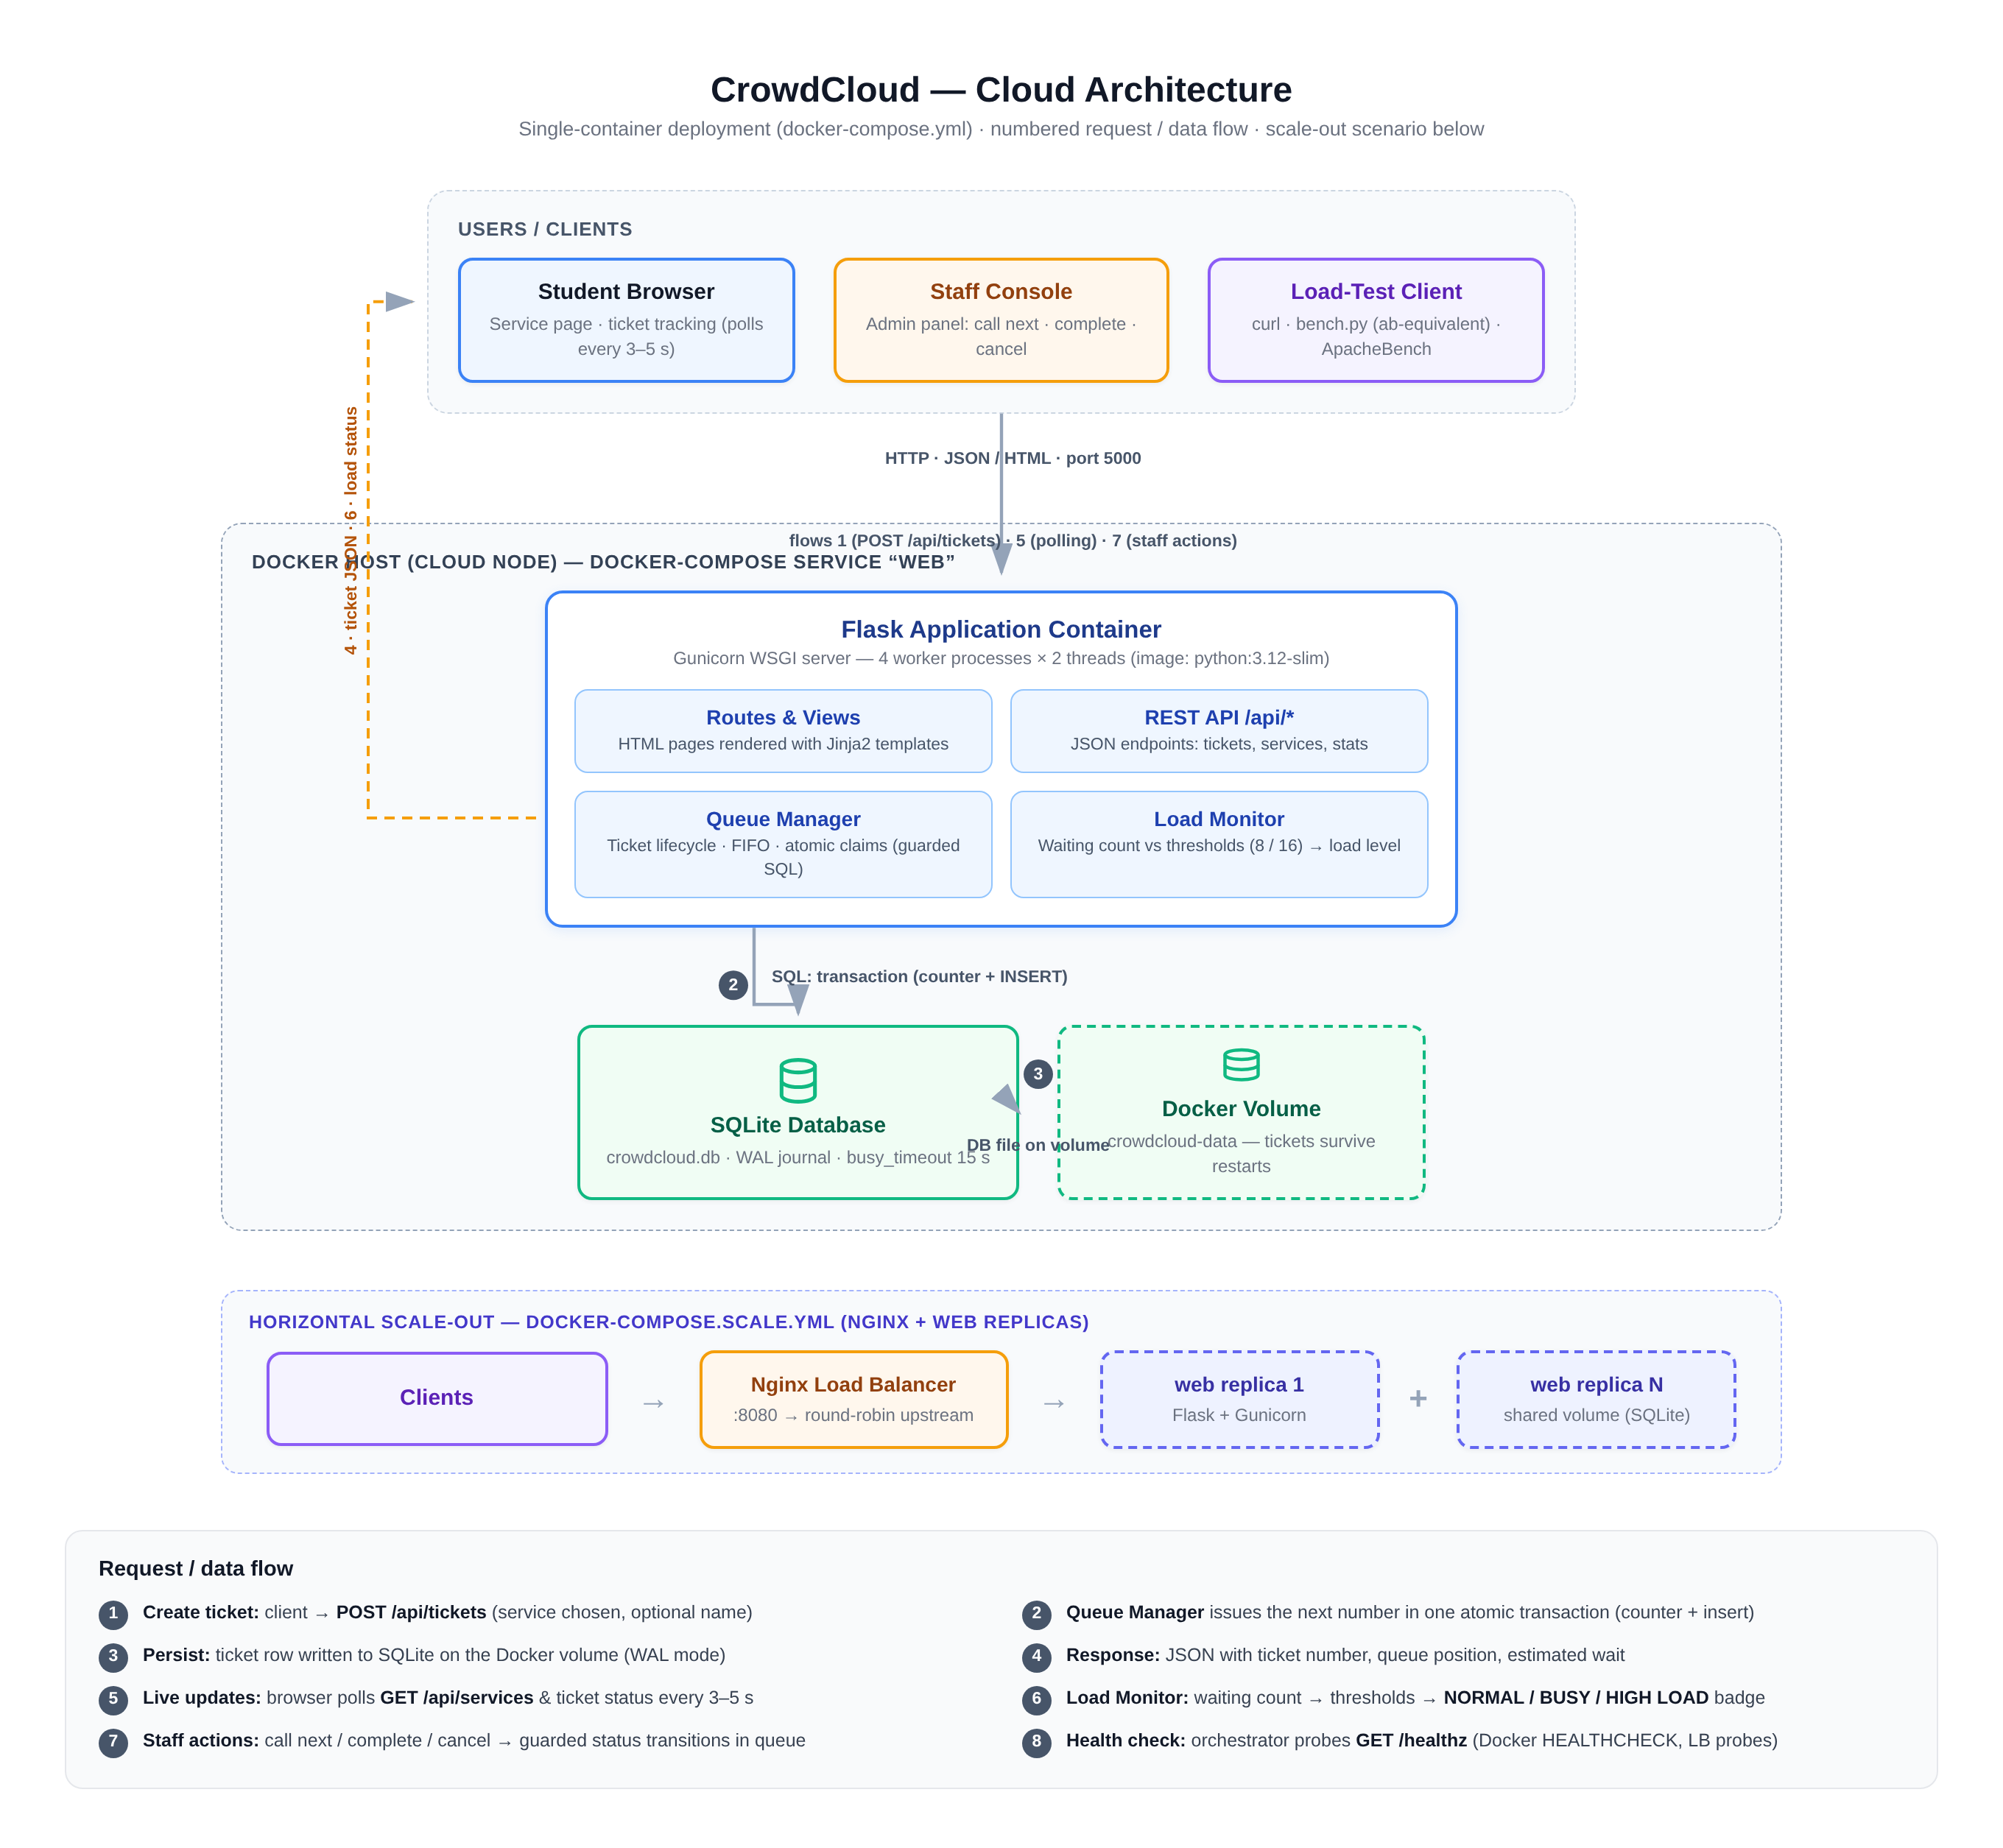
Figure 1: CrowdCloud cloud architecture: clients, containerised application tier, and data tier with the optional nginx scale-out path
The data flow for a ticket request is as follows. The browser sends a POST request to /api/tickets with the chosen service, an optional name, and an optional university ID. The queue manager opens an immediate-mode transaction, increments the per-service counter, and inserts a new ticket row atomically, so two simultaneous requests can never receive the same ticket number; every response is enriched with the live queue position, the estimated waiting time, and the current load level. Staff actions travel the same REST path: calling the next customer performs a guarded update that moves exactly one WAITING ticket to SERVING, and completing a ticket moves it to DONE with a timestamp. Because every mutation is a short SQL transaction on a WAL-journalled database, multiple workers serve reads concurrently while writes are serialised safely. The optional scale-out path places an nginx load balancer in front of several replicas of the same container, all sharing the same data volume.

6. Queue Management and Load-Status Detection
The queue model is deliberately explicit so that the required NORMAL, BUSY, and HIGH LOAD states are observable and reproducible. Each ticket moves through a fixed lifecycle, WAITING, then SERVING when a staff member calls it, then DONE when service is completed, with CANCELLED possible while waiting or being served; all other transitions are rejected by the API with status code 409, which the automated tests verify. Ticket numbers combine a service prefix with a zero-padded sequence, for example IT-004, and the sequence counter is updated inside the same transaction as the ticket insert, so numbering stays unique under concurrency. A student ID, when supplied, may hold only one active ticket per service; a duplicate attempt returns the existing ticket number with a 409 response, and this rule is enforced inside the creation transaction, so it also holds under simultaneous requests.
Load detection is based on the number of WAITING tickets per service compared against two configurable thresholds, and the level is recomputed on every read, so it never needs a background job to stay current. Table 1 defines the rule, and Figure 2 shows a real demonstration run in which the IT Support queue was pushed from three waiting tickets to eight (BUSY) and then sixteen (HIGH LOAD) before three services completed and the level fell back to BUSY; the de-escalation is automatic because the level is a pure function of the current queue length. Each service is monitored independently, and the dashboard reports the most severe level across services as the overall status. Figures 3 and 4 show the English user interface during this run: the service grid with live badges and counters, and an issued ticket with its number, queue position, and student identity.
Table 1: Load-status rule (defaults; configurable via environment variables)
Condition (waiting tickets per service) | Load level | Meaning for users and staff
waiting < 8 | NORMAL | Service is comfortable; join freely.
8 <= waiting < 16 | BUSY | Noticeable pressure; expect a queue.
waiting >= 16 | HIGH LOAD | Heavy pressure; consider another service or time.

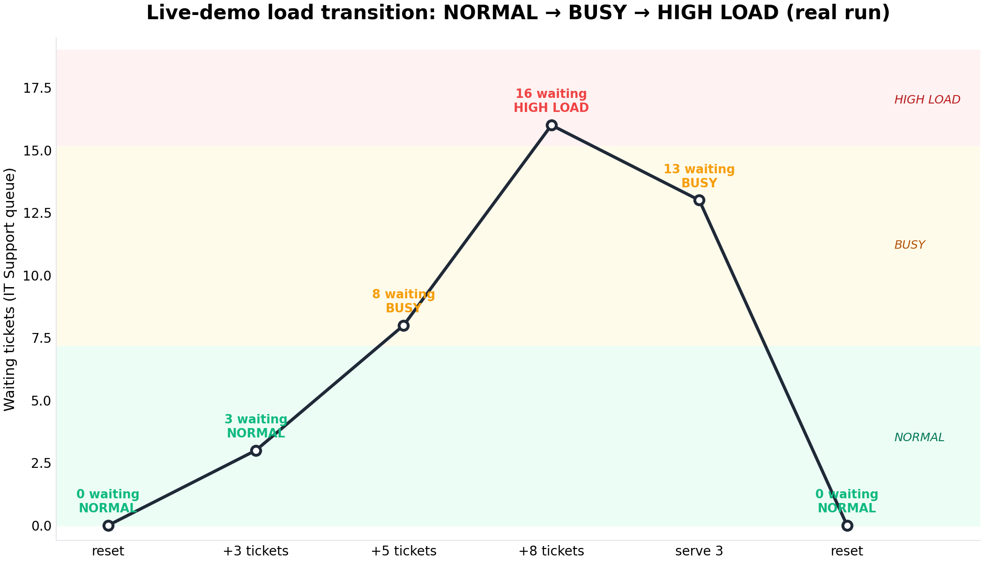
Figure 2: Measured load transition during the live demo: waiting count and resulting level at each step
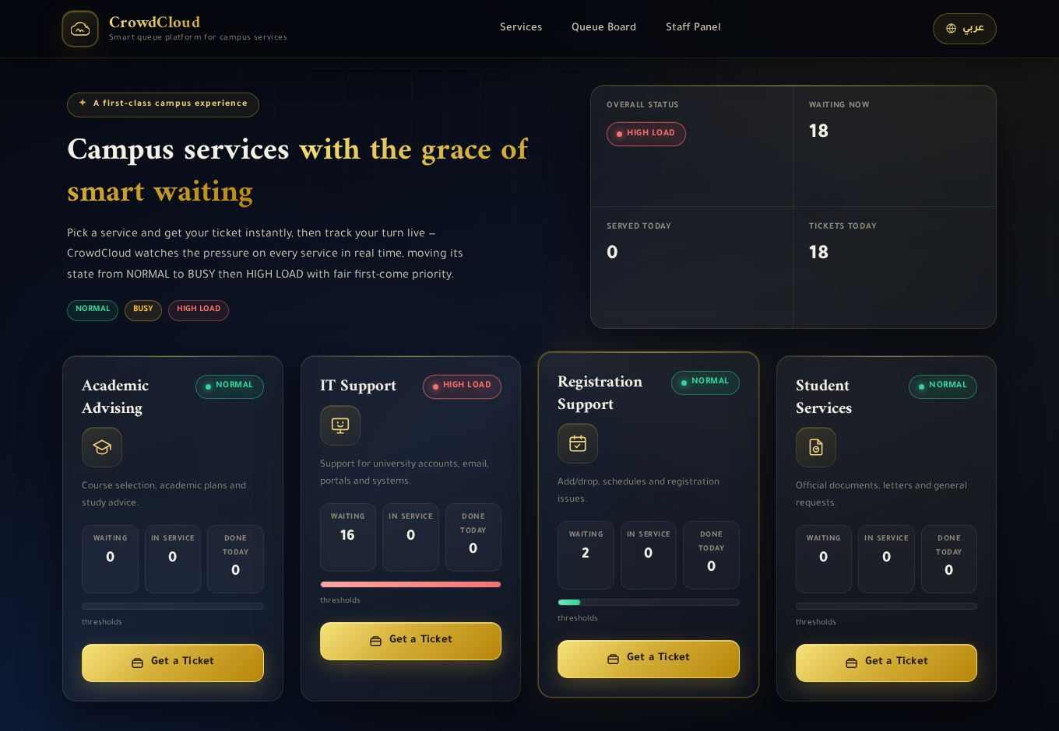
Figure 3: The service grid under load: per-service badges with waiting and in-service counters (real interface, English mode)
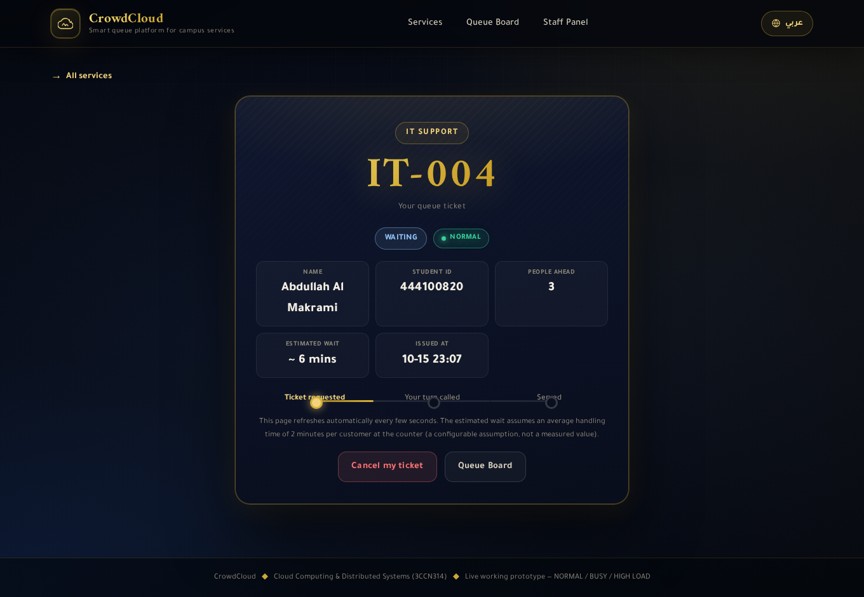
Figure 4: Issued ticket: number, live queue position, estimated wait, and student identity

7. Virtualization, Isolation, and Docker (W4)
Virtualization is what allows the same CrowdCloud artefacts to run identically on a laptop, a university server, or a public cloud host. The application is packaged in a Docker image based on python:3.12-slim that installs the Python dependencies, copies the application code, declares a health check that polls the /healthz endpoint, and starts Gunicorn with four workers and two threads. The container treats the database as a mounted volume, so state survives while the container itself can be replaced, upgraded, or replicated at any time. This is the isolation property that matters for a cloud service: the application tier cannot modify its own environment, its footprint is bounded by the container, and a failure inside the application does not affect the host or neighbouring containers [3], [4].
The project includes two operational topologies built from the same image: the single-node topology (docker-compose.yml) used for development and measurement, and a scale-out topology (docker-compose.scale.yml) that runs a configurable number of replicas behind an nginx load balancer distributing requests round-robin. It must be stated clearly and honestly that Docker was not available in the environment in which this project was developed and measured, so the containers were not started during the tests. Instead, every performance number in Sections 9 to 11 was produced by running the identical application code under Gunicorn with exactly the worker configuration the Dockerfile specifies, which is the same process model a container would run. The compose files, the nginx configuration, and the image are complete and ready to execute, and a continuous-integration workflow re-runs the test suite on every change, but the act of building and starting the containers on a Docker host remains an execution step this report does not claim.

8. Implementation and Technologies
The implementation follows the suggested toolchain: Python with Flask for the web layer, HTML, CSS, and JavaScript for the interface, SQLite for storage, diagrams.net for the architecture diagram, and curl plus a load tool for testing. The server side is organised as an application factory with separate modules for configuration, database access, queue logic, and routes. The REST API exposes the services with their live statistics, ticket creation and lookup, ticket-status changes, per-service call-next, global statistics, the load-level rule, and a demo-reset utility; the HTML pages are rendered from Jinja templates and refreshed by JavaScript that polls the API every three seconds, so the queue board, the ticket page, and the staff panel update without reloading. The interface is bilingual, with Arabic as the default and English selectable, adapting its layout direction accordingly.
The data layer is where correctness was prioritised. Connections run in autocommit mode with explicit transactions for every mutation; write transactions open with BEGIN IMMEDIATE so concurrent writers are serialised by the database engine rather than by application locks, and the WAL journal mode lets readers proceed while a write is in progress. Call-next is a guarded update that can move a ticket from WAITING to SERVING exactly once even if two staff members click at the same moment, and ticket numbering comes from a per-service counter inside the creation transaction. An optional simulator finishes and calls tickets on a timer so the live demonstration shows a moving queue without manual clicking. The test suite covers these guarantees: 33 automated tests verify threshold logic, numbering, first-in-first-out ordering, atomic claims, valid transitions, API behaviour, and the duplicate-active-ticket rule, and all of them pass.

9. Performance Testing Methodology (W5)
The benchmarking follows the course requirement of comparing a small number of requests with a larger number under higher concurrency. Three families of load tests were executed, all against the same REST endpoints the browser interface uses, so the measured path is the real code path rather than a static page. The first family is a measurement matrix of twelve runs combining three endpoints (the home page, GET /api/services, and POST /api/tickets) with three load levels (n=200 at concurrency 1, n=500 at concurrency 10, and n=1000 at concurrency 50), plus a fourth write level (n=2000 at concurrency 100) and two control measurements against /healthz, an endpoint that returns without touching the database; the controls exist to prove that the load generator itself is not the bottleneck. The second family repeats a read workload and a write workload against the server configured with one, two, and four Gunicorn workers, and the third is a gradual stress test raising concurrency from 10 to 800 across fourteen levels, recording throughput and latency percentiles at each level.
Table 2: Test environment (identical for every measurement in this report)
Item | Value
Processor | Intel Xeon, 2 cores (2 vCPU)
Memory | 4.1 GiB
Operating system | Linux 5.10 (x86_64)
Python / Flask / Gunicorn | 3.12.14 / 3.1.3 / 26.2.0
Database | SQLite 3.53.1, WAL journal mode
Server model | Gunicorn, 4 workers x 2 threads (as in the Dockerfile)

One tool substitution must be disclosed. ApacheBench was not available in the development environment, so the project includes an equivalent load generator (benchmarks/bench.py) built with the Python standard library that produces the same measurements ab produces: requests per second, mean and percentile latencies, and failure counts. The repository also records the equivalent ab command lines (benchmarks/ab_commands.txt) so the runs can be repeated with ab on any machine that has it. Load was generated from the same host as the server (loopback), which suits the goal of comparing relative behaviour between load levels but does not measure wide-area network latency, as discussed in Section 12. A separate measurement set was taken through the full deployment chain (reverse proxy to the application) to capture the end-to-end path, and persistence under load was verified directly: after the heaviest write test, the database contained exactly the number of tickets submitted.

10. Actual Performance Results and Analysis

10.1 Load-test matrix
Table 3 lists the twelve matrix measurements; every request succeeded, giving 6,900 requests with zero failures. Throughput rises steeply from one concurrent client to ten, because a single client cannot keep the four workers busy, then flattens between concurrency 10 and 50: GET /api/services reaches 976 and then 1,028 requests per second, and POST /api/tickets reaches 812 and then 806. The flattening means the server is already saturated by roughly ten simultaneous clients; beyond that point, extra concurrency buys no throughput and begins to cost latency, which the mean and p95 columns show directly. Ticket creation degrades first and most, from a mean of 1.53 ms at concurrency 1 to 32 ms at concurrency 50 and 72 ms at concurrency 100 with p95 at 144 ms, because every write must take the single-writer path through SQLite. The control endpoint answers more than 2,400 requests per second, confirming that the generator can offer far more load than the database path absorbs and that the differences between endpoints come from the application, not the measurement tool.
Table 3: Load-test matrix, 12 runs, 6,900 requests, 0 failures (real measurements)
Run | c | n | RPS | mean (ms) | p95 (ms) | failed
GET / (page) L1 | 1 | 200 | 638.22 | 1.56 | 1.70 | 0
GET / (page) L2 | 10 | 500 | 981.21 | 8.07 | 31.74 | 0
GET / (page) L3 | 50 | 1000 | 905.65 | 28.38 | 63.92 | 0
GET /api/services L1 | 1 | 200 | 676.94 | 1.47 | 1.83 | 0
GET /api/services L2 | 10 | 500 | 976.33 | 7.24 | 29.01 | 0
GET /api/services L3 | 50 | 1000 | 1027.82 | 20.82 | 57.81 | 0
POST /api/tickets L1 | 1 | 200 | 651.41 | 1.53 | 1.68 | 0
POST /api/tickets L2 | 10 | 500 | 812.19 | 8.97 | 29.48 | 0
POST /api/tickets L3 | 50 | 1000 | 805.80 | 32.13 | 91.43 | 0
POST /api/tickets L4 | 100 | 2000 | 767.84 | 72.05 | 144.26 | 0
GET /healthz (control) L2 | 10 | 500 | 2083.76 | 2.85 | 7.08 | 0
GET /healthz (control) L3 | 50 | 1000 | 2405.17 | 3.36 | 10.89 | 0

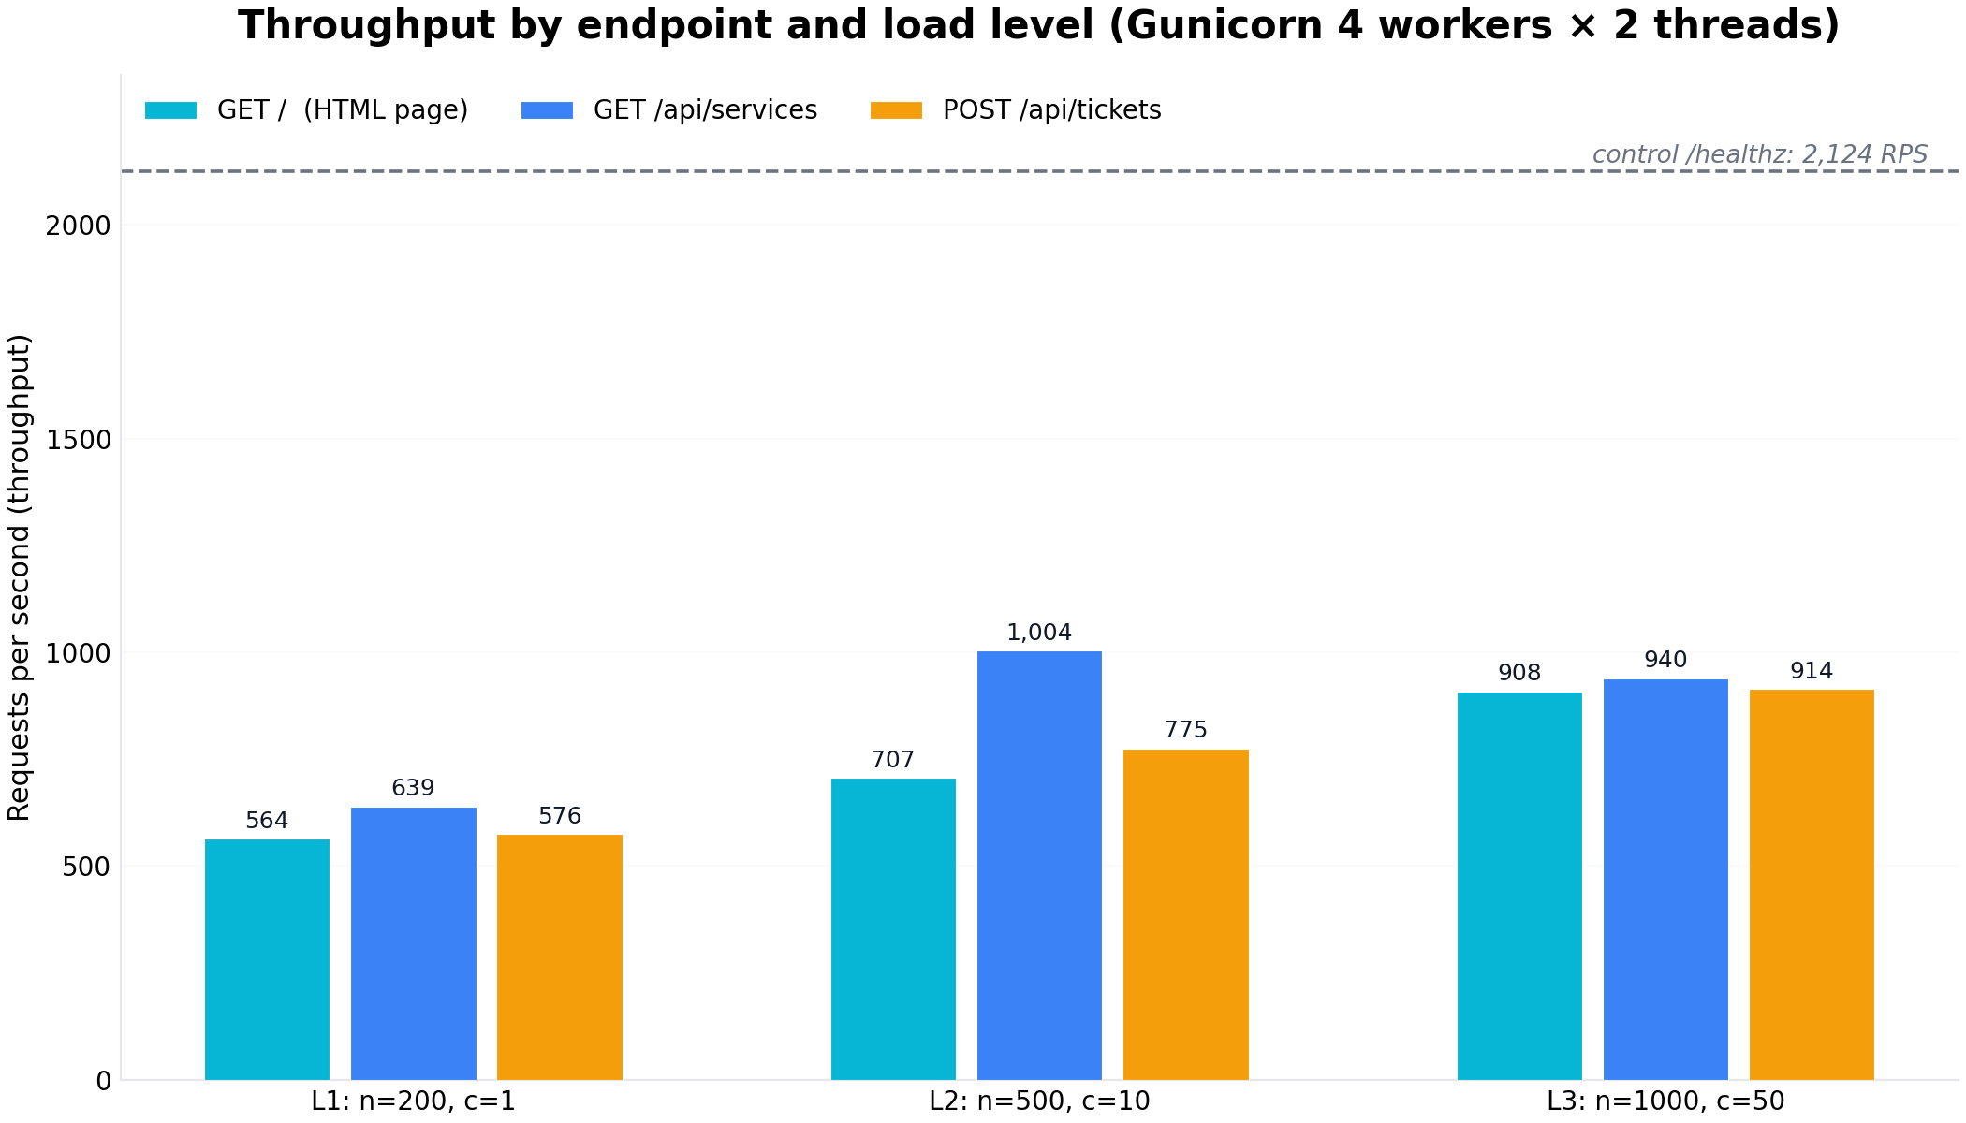
Figure 5: Throughput by endpoint and load level; the dashed line is the control endpoint

10.2 Worker scaling
Table 4 and Figure 6 show the effect of adding Gunicorn workers on the two-core host. Raising the worker count from one to four lifted read throughput from 658 to 1,028 requests per second (about 1.56 times) and write throughput from 538 to 903 requests per second (about 1.68 times), while mean latency fell from 73 to 39 ms for reads and from 44 to 24 ms for writes. The gain is clearly sub-linear: four workers deliver about 1.6 times the throughput of one worker, not four times, because the two virtual CPUs and the serialised write path are shared resources, and the small improvement from two to four workers shows the host is close to saturation. This is a concrete demonstration of vertical-scaling limits: on a fixed machine, parallelism helps until a shared bottleneck, the cores or the single database writer, dominates.
Table 4: Worker scaling, 6 runs, 6,200 requests, 0 failures (real measurements)
Gunicorn workers | Read RPS | Read mean (ms) | Write RPS | Write mean (ms)
1 | 657.65 | 73.08 | 538.31 | 44.48
2 | 932.11 | 49.12 | 758.08 | 30.72
4 | 1027.58 | 38.98 | 903.39 | 24.30

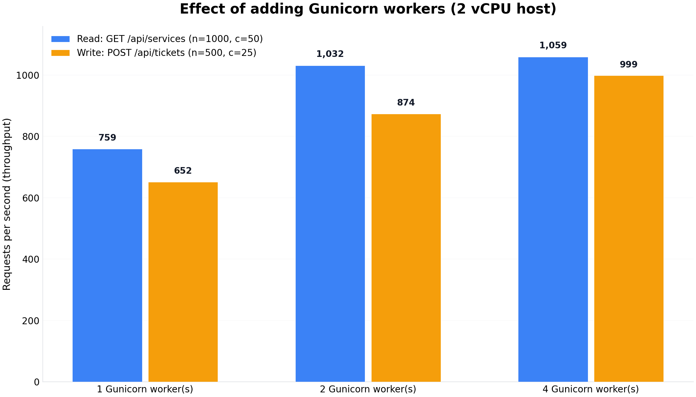
Figure 6: Throughput versus number of Gunicorn workers on the two-core host

11. Scalability and Performance Discussion (W6)
The course asks what happens when a service moves from tens of simultaneous users to thousands, and the gradual stress test answers the first half of that question with measurements rather than speculation. Table 5 summarises the ramp from concurrency 10 to 800 on the single instance: 40,510 requests in total with zero failures at every level. Reading behaviour stays nearly flat at about 1,000 requests per second from concurrency 25 onwards, the signature of a saturated thread pool, with extra clients simply queueing inside the server; the practical degradation knee for reads is at concurrency 400, where p95 jumps from roughly 90 ms to 244 ms. Writing behaves differently: throughput peaks at 716 requests per second at concurrency 10 and declines steadily to 465 at concurrency 800 because SQLite allows only one writer at a time, and by concurrency 800 the write p95 reaches 1.82 seconds. No request is lost at any level, so the failure mode is graceful: latency grows while correctness is preserved.
Table 5: Gradual stress test summary, 40,510 requests, 0 failures (real measurements)
Concurrency | Read RPS | Read p95 (ms) | Write RPS | Write p95 (ms) | failed
10 | 905.25 | 30.53 | 716.44 | 36.60 | 0
25 | 1012.91 | 46.87 | 676.86 | 60.04 | 0
50 | 985.48 | 76.78 | 708.32 | 97.49 | 0
100 | 995.38 | 90.14 | 651.86 | 237.43 | 0
200 | 1009.75 | 82.34 | 649.97 | 282.35 | 0
400 | 968.35 | 243.62 | 582.44 | 804.43 | 0
800 | 975.29 | 200.62 | 464.84 | 1822.06 | 0

From these numbers, the single-instance comfort zone is roughly 100 to 200 concurrent users, the range in which p95 latency stays under about 300 ms. Beyond that, the system needs the horizontal-scaling strategy the repository already prepares: additional application replicas behind the nginx load balancer, which removes the thread-pool ceiling because requests are shared across containers. A further measurement set through the complete deployment chain, the reverse proxy forwarding to the application, confirms the end-to-end path behaves the same way: six runs totalling 3,800 requests with zero failures, throughput between 188 and 231 requests per second, and mean latency between 43 and 252 ms depending on concurrency, as listed in Table 6. Scaling to thousands of users, however, cannot be solved by replicas alone while all of them write to one SQLite file; the write path must move to a client-server database such as PostgreSQL, and the queue itself is a natural candidate for a message broker. The distribution and consistency trade-offs this transition raises are the classical distributed-systems decisions captured by the CAP perspective [5].
Table 6: Measurements through the full deployment chain, 6 runs, 3,800 requests, 0 failures
Run | c | n | RPS | mean (ms) | p95 (ms)
GET / (page) | 10 | 300 | 210.02 | 46.64 | 76.98
GET /api/services | 10 | 500 | 211.38 | 46.55 | 72.71
GET /api/services | 50 | 1000 | 187.92 | 250.76 | 497.94
GET /healthz (control) | 10 | 500 | 230.56 | 42.95 | 78.09
POST /api/tickets | 10 | 500 | 187.88 | 52.54 | 93.36
POST /api/tickets | 50 | 1000 | 188.61 | 252.36 | 296.44

12. Limitations, Challenges, and Future Improvements
The project records its own boundaries, and Table 7 separates what was executed and measured from what was only partially possible in the available environment. The central environmental limitation is that Docker was not installed on the development host, so the containers themselves were never started; the identical Gunicorn process model that the Dockerfile specifies was used for every measurement instead, and the container artefacts plus a continuous-integration workflow are ready to run on any Docker host. Likewise, ApacheBench was unavailable and was replaced by an equivalent tool whose commands are documented for repetition with ab. The load generator and the server shared one machine, which keeps comparisons between load levels fair but excludes network transit time from the numbers. The two-core host caps vertical scaling, which is why the worker experiment tops out at four workers, and the single SQLite file, while adequate for the prototype and instrumental in exposing the read/write contrast, is the known constraint any multi-node deployment must remove first.
Table 7: Execution status of every test family claimed in this report
Test family | Status | Result
Automated tests (pytest, 33 tests) | Executed and re-verified | 33/33 pass
Functional smoke suite (production settings) | Executed (recorded in VERIFICATION.md) | 23/23 pass
Browser UI suite, both languages | Executed and re-verified | 62/62 pass
Load matrix, worker scaling, ramp | Executed on the live server | 53,610 requests, 0 failures
Deployment-chain measurements | Executed through the full proxy path | 3,800 requests, 0 failures
Docker containers | Not executed (Docker unavailable) | Artefacts ready; same server model tested
ApacheBench runs | Not executed (ab unavailable) | Equivalent tool used; ab commands documented

The natural improvements follow directly from the measurements. Moving the write path to PostgreSQL or another client-server database removes the single-writer ceiling and is the prerequisite for the nginx replica topology to deliver its full benefit. Adding Redis or a message queue would make the queue itself horizontally scalable and let the load monitor aggregate across replicas. Authentication, per-student quotas, and an appointment option would turn the prototype into a deployable campus service, and a WebSocket channel could replace the three-second polling to cut the read load that polling generates at high user counts. None of these changes invalidate the current results; they extend a base whose behaviour is now measured and understood.

13. Conclusion
CrowdCloud delivers the required working prototype: students obtain numbered tickets for four services, follow their live queue position, and see an explicit, honestly computed load status, while staff operate the same queues from a dashboard whose every action is atomic and verified. The system is packaged for cloud deployment, its architecture maps the lecture model of users, application, and data onto a containerised three-tier design, and its behaviour under load has been measured rather than assumed: 53,610 benchmark requests and 3,800 deployment-chain requests with zero failures, a measured read ceiling near 1,000 requests per second for a single instance, a write path that degrades gracefully under the single-writer constraint, and a demonstrated comfort zone of roughly 100 to 200 concurrent users per instance before horizontal scaling becomes necessary. The project also demonstrates a discipline the group considers as important as the numbers: every claim in this report is tied either to an executed test or to an explicitly disclosed environmental limitation, so the next steps, a client-server database and replicated containers, are identified not by speculation but by the measured bottlenecks themselves.

References
[1] P. Mell and T. Grance, The NIST Definition of Cloud Computing, NIST Special Publication 800-145, National Institute of Standards and Technology, 2011. https://doi.org/10.6028/NIST.SP.800-145
[2] M. Armbrust, A. Fox, R. Griffith, A. D. Joseph, R. Katz, A. Konwinski, G. Lee, D. Patterson, A. Rabkin, I. Stoica, and M. Zaharia, A view of cloud computing, Communications of the ACM, vol. 53, no. 4, pp. 50-58, 2010. https://doi.org/10.1145/1721654.1721672
[3] D. Bernstein, Containers and cloud: From LXC to Docker to Kubernetes, IEEE Cloud Computing, vol. 1, no. 3, pp. 81-84, 2014. https://doi.org/10.1109/MCC.2014.51
[4] Docker Inc., Docker overview, Docker Documentation. https://docs.docker.com/get-started/docker-overview/ (accessed October 2026)
[5] E. Brewer, CAP twelve years later: How the rules have changed, Computer, vol. 45, no. 2, pp. 23-29, 2012. https://doi.org/10.1109/MC.2012.37
[6] Pallets, Flask documentation (release 3.1.x). https://flask.palletsprojects.com/ (accessed October 2026)
[7] SQLite, Write-Ahead Logging. https://www.sqlite.org/wal.html (accessed October 2026)
[8] Gunicorn, Design notes, Gunicorn Documentation. https://docs.gunicorn.org/en/stable/design.html (accessed October 2026)
[9] The Apache Software Foundation, ab - Apache HTTP server benchmarking tool, Apache HTTP Server Version 2.4 Documentation. https://httpd.apache.org/docs/2.4/programs/ab.html (accessed October 2026)
[10] F5 Inc., nginx documentation. https://nginx.org/en/docs/ (accessed October 2026)

