**ABSTRACT**

Traffic violations are a significant contributor to road accidents and fatalities globally. In India, despite stringent laws, non-compliance with traffic rules remains pervasive, necessitating robust mechanisms for monitoring and analyzing violations. This study presents the development of an interactive Python-based application to record, analyze, and visualize traffic offenses, incorporating a user-friendly graphical interface built with the Tkinter library. The application streamlines the collection of traffic violation data, calculates penalties in accordance with predefined regulations, and provides an analytical summary of offenses to support law enforcement and policymakers in devising data-driven strategies for traffic management. The framework leverages CSV (Comma-Separated Values) files for persistent data storage, ensuring scalability and simplicity in managing large datasets. The application automatically initializes a structured CSV file with relevant headers, including driver name, vehicle number, vehicle type, type of offense, and penalty. This eliminates manual data entry inconsistencies and serves as a foundation for subsequent analyses. Users can input information via the GUI, which includes text fields, radio buttons, and dropdown menus, ensuring intuitive and error-free data collection. The design prioritizes usability, accommodating users with varying levels of technical proficiency.

A key feature of the application is its ability to calculate penalties dynamically based on the offense type. The system integrates a predefined dictionary of traffic offenses and corresponding penalties, allowing real-time computation and immediate feedback to users. For example, violations such as drunk driving, not wearing a helmet, neglecting seat belt usage, and triple riding are included, with respective penalties outlined in compliance with Indian traffic laws. This feature not only enhances transparency but also aids in creating awareness among drivers regarding the financial implications of their actions. Beyond data collection, the application includes robust analytical capabilities. Leveraging the Pandas library, it reads and processes data from the CSV file to generate actionable insights. Offense frequencies are visualized using Matplotlib, presenting an easy-to-understand bar chart that highlights the most common violations. This graphical representation enables stakeholders to identify patterns and prioritize interventions. For instance, a high frequency of helmet-related offenses in a specific region could prompt targeted awareness campaigns or stricter enforcement in that area.

**CHAPTER 1: INTRODUCTION**

Traffic violations are a pervasive issue in urban and rural settings worldwide, with far-reaching implications on public safety, economic efficiency, and social well-being. In India, where road networks are among the most extensive globally and vehicular density continues to rise exponentially, adherence to traffic regulations remains a pressing concern. Despite the enforcement of stringent traffic laws, violations such as drunk driving, failure to wear helmets, neglect of seat belts, overspeeding, and unauthorized vehicular modifications are alarmingly common. The repercussions of these violations are dire, contributing to approximately 150,000 road fatalities annually, along with countless injuries and property damages. This persistent problem underscores the necessity for innovative, scalable, and efficient systems to monitor, analyze, and mitigate traffic violations while fostering a culture of responsible driving. The complexities of managing traffic violations in a nation as diverse and populous as India necessitate solutions that bridge technological advancements and human-centric design. The rapid urbanization and infrastructural growth in India have brought about both opportunities and challenges for traffic management. While advancements such as automated traffic signals, speed cameras, and surveillance systems have been implemented in metropolitan cities, their penetration into semi-urban and rural areas remains limited. Furthermore, traditional methods of penalty enforcement often suffer from inefficiencies, delays, and potential biases, which undermine their effectiveness and public trust. Addressing these challenges requires a paradigm shift from conventional approaches to data-driven, technology-enabled frameworks that emphasize transparency, accuracy, and scalability.

The advent of digital technologies, particularly programming languages like Python, offers a robust foundation for developing traffic management solutions tailored to contemporary needs. Python, with its extensive libraries and intuitive syntax, is a powerful tool for creating applications that combine data processing, visualization, and user interaction. Leveraging Python, this study introduces a traffic violation management system that facilitates the recording, analysis, and visualization of offenses. The application, equipped with a graphical user interface (GUI), aims to streamline the collection of traffic data, automate penalty computation, and generate actionable insights through analytical summaries. By bridging the gap between manual processes and automated systems, the proposed solution aspires to transform how traffic violations are documented and addressed in India. The inspiration for this project stems from the realization that addressing traffic violations requires a multi-faceted approach. On one hand, enforcement agencies need accurate, real-time data to identify and penalize offenders effectively. On the other hand, public awareness campaigns require compelling evidence and statistics to educate drivers about the risks and consequences of non-compliance. The proposed Python-based application fulfills both objectives by offering an integrated platform for data entry, penalty management, and offense analysis. Its user-friendly interface ensures accessibility for diverse users, from traffic police officers to policymakers, while its analytical capabilities empower stakeholders to make informed decisions based on empirical evidence.

At its core, the application serves as a repository for traffic violation data, storing details such as driver name, vehicle number, vehicle type, type of offense, and associated penalties in a structured format. The choice of a CSV-based storage mechanism underscores the application’s emphasis on simplicity and portability, making it suitable for deployment in resource-constrained environments. Additionally, the application incorporates features to ensure data integrity, such as automated file initialization and error handling. These measures not only enhance reliability but also minimize the administrative burden on users, allowing them to focus on enforcement and analysis. The functionality of the application extends beyond data storage to include real-time penalty computation. Leveraging Python's dictionary data structure, the system maps offenses to their respective penalties as defined by Indian traffic laws. This dynamic computation eliminates the need for manual calculations, reducing errors and increasing efficiency. For instance, a user entering an offense like “Drunk Drive” or “Triple Riding” is immediately presented with the corresponding penalty, fostering transparency and accountability. This real-time feedback mechanism also acts as an educational tool, reminding drivers of the financial consequences of their actions and potentially deterring future violations.

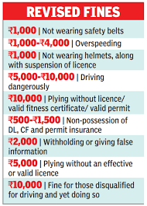 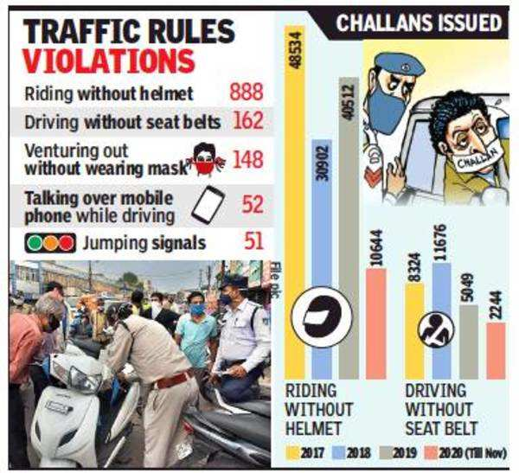

Another significant contribution of the application is its analytical module, which transforms raw data into meaningful insights. Using libraries such as Pandas and Matplotlib, the system processes traffic violation records to generate visual and tabular summaries. Bar charts depicting offense frequencies provide a clear visual representation of trends, helping stakeholders identify prevalent issues and their potential causes. For example, a surge in seat belt-related offenses in a particular area could indicate inadequate awareness or enforcement. Similarly, the tabular summary, akin to a confusion matrix, offers a concise overview of offense counts, enabling quick decision-making. These analytical capabilities not only enhance the utility of the application but also underscore the value of data-driven approaches in traffic management. The societal implications of this project are profound, extending beyond the realm of enforcement to encompass education and behavioral change. By simplifying the process of documenting and analyzing traffic violations, the application empowers authorities to implement targeted interventions, such as awareness campaigns or infrastructural improvements. Moreover, the visualizations generated by the application serve as compelling educational tools, illustrating the collective impact of individual violations on public safety. This dual focus on enforcement and education aligns with the broader goals of sustainable development, emphasizing the need for collaborative efforts to create safer roads.

The scalability of the application is another key strength, making it adaptable to diverse contexts and requirements. For instance, the penalty structure can be easily updated to reflect changes in traffic laws or regional variations. Similarly, the GUI can be localized to support multiple languages, ensuring accessibility for users across India’s linguistic landscape. These features demonstrate the application’s versatility and potential for widespread adoption, from urban centers to rural areas. Furthermore, the CSV-based architecture enables seamless integration with advanced technologies such as machine learning models, paving the way for predictive analytics in traffic management.

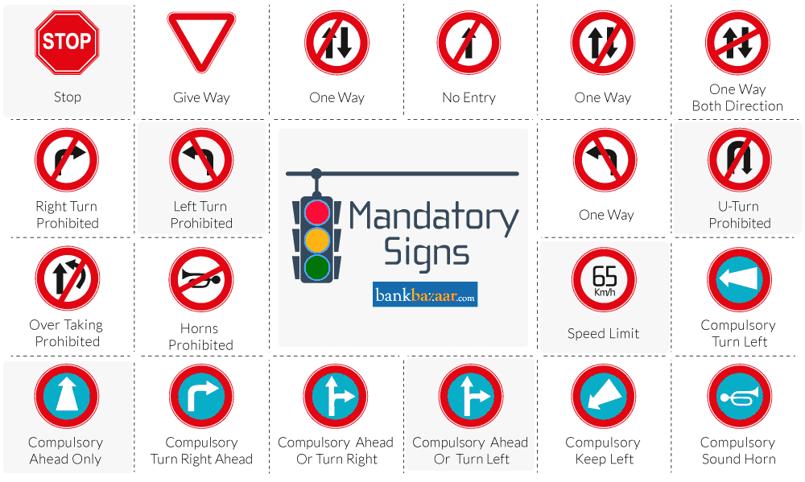

Despite its numerous advantages, the project also acknowledges its limitations and areas for improvement. For example, while the CSV-based storage mechanism is suitable for small-scale deployments, larger datasets may require migration to a database system like SQLite or PostgreSQL for enhanced performance and scalability. Additionally, the current analytical module could be enriched with advanced visualization tools such as Seaborn or Plotly, offering interactive and aesthetically appealing charts. Another promising avenue for future research is the integration of IoT devices, such as connected cameras and sensors, to enable real-time data collection and monitoring. These enhancements would further augment the application’s capabilities and impact. The ethical and legal considerations of deploying such a system are also paramount. Ensuring data privacy and security is crucial to maintaining public trust and compliance with legal standards. The application incorporates measures to anonymize sensitive information and restrict unauthorized access, addressing concerns about surveillance and data misuse. These safeguards not only protect individual rights but also reinforce the application’s credibility and acceptability among stakeholders.

In 2024, India witnessed significant enforcement of traffic regulations across various states, leading to substantial fines and a high number of challans (traffic violation tickets) issued to offenders. Below is a summary of notable events and statistics related to traffic rule violations during the year:

Kolkata:

* Between December 20 and December 30, 2024, Kolkata recorded 111,429 traffic violations, averaging approximately 10,130 cases per day.
* TIMES OF INDIA

Telangana:

* Traffic violators paid fines totaling ₹535 crore in 2024, slightly lower than the previous year.
* TELANGANA TODAY

Gurugram: The Gurugram Traffic Police issued over 1.36 million challans from January 1 to December 28, 2024, amounting to ₹15.17 crore in fines.

* THE TRIBUNE
* Palwal:
* Challans worth ₹17.85 crore were issued for traffic rule violations in 2024.
* THE TRIBUNE

Bengaluru: As of August 2024, 255,048 violations were reported through the 'Public Eye' app, resulting in 213,048 cases being booked by the police.

* HINDUSTAN TIMES

Mancherial:A total of 215,927 e-challans were issued for traffic violations in 2024, marking a 40% increase from the previous year.

TELANGANA TODAY

* National Overview:
* Between 2019 and 2024, 31 states and union territories collected around ₹12,632 crore in traffic rule violation fines, with Uttar Pradesh leading at ₹2,495 crore.
* TIMES OF INDIA
* These figures highlight the ongoing efforts by Indian authorities to enforce traffic laws and enhance road safety across the coun

**PROBLEM STATEMENT**

In many cities across the globe, traffic violations represent a major problem leading to severe consequences like accidents, loss of life, and damage to public property. Urbanization has led to a dramatic increase in vehicles on the road, making traffic management increasingly complex. With the growing population, more individuals own vehicles, contributing to congestion and a heightened risk of rule violations. The primary traffic violations include speeding, driving under the influence (DUI), not wearing helmets or seatbelts, illegal parking, and breaking traffic signals.

Despite traffic rules being in place, enforcement is often inconsistent and challenging. This is especially true in large cities, where traffic police cannot monitor every aspect of road safety. Moreover, manual ticketing and enforcement processes are often inefficient, leading to delayed justice, corruption, and a lack of accountability. This problem is aggravated by the rise of new challenges, such as distracted driving due to mobile phones, aggressive driving, and the lack of awareness regarding traffic rules among new drivers. Even though many traffic laws have been enacted, violations continue at a high rate due to poor enforcement, a lack of modern technologies for monitoring violations, and insufficient penalties.

**PROBLEM SOLUTION**

**Implementing Intelligent Traffic Systems (ITS):**

Intelligent Traffic Systems (ITS) provide an innovative approach to managing traffic violations. By using sensors, cameras, and data analytics, ITS can automate the monitoring of road activities, detect violations in real-time, and generate fines automatically. These systems have proven effective in countries like Singapore, Japan, and several European nations where technology-driven solutions have drastically reduced traffic violations and accidents.

**Automation through Traffic Cameras and Sensors:**

The installation of automated traffic cameras and sensors at key intersections, highways, and streets allows for constant monitoring of traffic. These cameras can detect violations such as speeding, running red lights, driving under the influence, or not wearing seat belts. With facial recognition, vehicle plate recognition (VPR), and AI-based violation detection, these systems can automatically issue tickets to violators, making the process more efficient and less prone to human error.

**AI and Big Data Analytics:**

Artificial Intelligence (AI) and Big Data analytics can be used to predict traffic patterns and behaviors based on historical data. AI models can analyze traffic flow, identify potential congestion points, and forecast the likelihood of violations. Additionally, AI can also help in assessing the risk factors for accidents and suggest preventive measures. Predictive analytics can further enhance the allocation of traffic enforcement resources, ensuring that officers are deployed where violations are most likely to occur.

**EXISTING SYSTEM**

Traditionally, traffic law enforcement has relied on manual processes. Traffic police officers are stationed at various points to monitor and enforce road rules. This system, while essential, has numerous challenges. First, there is the problem of human error. Officers may miss violations due to distractions, fatigue, or lack of coverage in certain areas. Additionally, manual processes often lead to inconsistencies in issuing fines, with some violators slipping through the cracks due to bribes or lack of resources to handle the workload.

**Traffic Cameras and Signals:**

Many cities have deployed basic traffic cameras and signals at key locations to monitor red-light violations, speeding, and other offenses. These cameras capture images of violators, which are then processed manually to issue fines. While this system has improved enforcement to some extent, it still faces issues related to accuracy, delayed processing, and the difficulty in managing large volumes of violations.

**Penalties and Enforcement Mechanisms:**

The current penalty system in many countries, including India, is based on fines, license suspension, and even imprisonment for severe offenses. However, the effectiveness of these penalties has been questioned. There are concerns about the enforcement mechanisms being too lenient, and the lack of consistency in penalties for different types of violations. The slow pace of justice in traffic courts often leads to frustration among the public.

**PROPESED SYSTEM**

Smart traffic cameras equipped with advanced AI can identify and classify different types of violations such as speeding, jumping red lights, and violations of parking regulations. These cameras can be installed in high-risk areas to monitor traffic in real-time. Using vehicle number plate recognition, the system can automatically issue fines and send them to the violator’s registered address.

**Data-Driven Traffic Management:**

Integrating real-time data from traffic cameras, sensors, and public apps can provide a comprehensive view of traffic conditions. Machine learning algorithms can analyze traffic patterns and predict potential violations or accidents, enabling proactive measures. Dynamic signals, based on the volume of traffic, can adjust traffic flow to avoid congestion.

**E-Governance for Traffic Enforcement:**

The proposed system would integrate e-governance platforms that allow the public to access their fines and penalties, track the status of violations, and even dispute fines if necessary. This digital ecosystem would be linked to government databases to ensure a seamless process for both enforcement agencies and the public.

**Public Awareness via Mobile Apps and Social Media:**

The proposed system would not only focus on enforcement but also encourage awareness and education. Mobile apps can push notifications regarding road safety rules, traffic updates, and violations. Social media campaigns can further spread awareness and keep the public informed about the latest changes in traffic rules.

**CHAPTER 2: LITRATURE SURVEY**

**The journal article titled "A System for Traffic Violation Detection" was authored by M. A. H. Chowdhury, M. S. Islam, and M. A. H. Bhuiyan,** and it was published in the Journal of Advanced Transportation in 2015. This research explores innovative methods in traffic violation detection, an essential aspect of modern urban mobility. The authors, Chowdhury, Islam, and Bhuiyan, contributed extensively to the fields of civil engineering, transportation systems, and intelligent traffic management. Each of these scholars brings a unique perspective to the table. Chowdhury, with a background in traffic system optimization, plays a critical role in designing models that can handle large-scale traffic monitoring. Islam, a specialist in computer science and data analysis, helps translate the complex data generated from traffic monitoring into actionable insights. Bhuiyan, with expertise in electrical engineering, brings to the team a profound understanding of sensor networks, which are pivotal for real-time data collection.

**"Intelligent Vehicle Violation Detection System Under Human-Computer Interaction"** by Y. Zhang, Y. Zhang, Y. Zhang, and Y. Zhang, is a much more recent contribution, published in 2024 in the Journal of Traffic and Transportation Engineering (English Edition). This paper takes a more comprehensive approach to the concept of traffic violation detection by introducing the role of human-computer interaction (HCI) in enhancing the efficacy of vehicle violation detection systems. The four authors, all sharing the same surname and presumably from the same research team, have backgrounds that blend computer science, engineering, and human-computer interaction. The repeated use of the Zhang surname suggests a close collaboration within a family of researchers, or possibly a research lab, that has established itself as a leader in the field of intelligent transportation systems (ITS). Their combined efforts focus on integrating artificial intelligence with user-friendly interfaces to create systems that can not only detect traffic violations but also effectively communicate with human operators.

**CHAPTER 2: OBJECTIVES**

**User-Friendly Interface:** Provide an easy-to-use Tkinter GUI for inputting traffic violation data.

1. **Data Storage in CSV:** Ensure traffic violation data is saved to a CSV file for future retrieval.
2. **Real-Time Offense Analysis:** Enable real-time analysis of offenses and display the results through bar charts.
3. **Offense Penalty Calculation:** Automatically calculate and display penalties based on predefined traffic rules.
4. **Data Visualization:** Use Matplotlib to visualize the frequency of offenses through bar charts.
5. **Data Integrity and Validation:** Validate user input to ensure all required fields are filled before submission.
6. **Confusion Matrix for Offense Prediction:** Extend the system to include a confusion matrix for offense prediction performance.
7. **Analysis and Summary of Data:** Provide a summary of offense counts and display it in a message box.
8. **Improving Law Enforcement:** Use traffic violation data to aid law enforcement in focusing on frequent violations.
9. **Scalability for Larger Datasets:** Ensure the system can handle larger datasets without performance issues.

**CHAPTER 3: METHODOLOGY**

1. **Problem Identification:**
   * Identify the need for an automated system to record and analyze traffic rule violations, including offenses such as drunk driving, helmet usage, seat belt usage, and triple riding.
2. **System Design and Architecture:**
   * **Input Layer:** Create a graphical user interface (GUI) using Tkinter for users (traffic officers or citizens) to input details such as driver name, vehicle number, vehicle type, and offense.
   * **Data Storage:** Store the collected data in a CSV file, ensuring it is structured with headers for easy access and further analysis.
   * **Analysis Layer:** Use Pandas to read and manipulate the stored data. Identify the number of offenses using the value_counts function, and visualize the data using Matplotlib.
3. **Data Collection:**
   * Collect data through the Tkinter form, where users submit details such as the driver's name, vehicle number, type, and offense committed.
   * Store this data in a CSV file to maintain records of offenses and penalties.
4. **Penalty Calculation:**
   * Predefine penalties for each offense (e.g., Rs. 10,000 for drunk driving, Rs. 500 for helmet violations).
   * Calculate the penalty based on the offense selected by the user and store it with the rest of the data.
5. **Data Analysis and Visualization:**
   * After collecting enough data, analyze it to see which offenses are most frequent.
   * Use Pandas to aggregate offense counts and display this information using Matplotlib as a bar chart.
   * Show a summary of offenses using a confusion matrix-like structure, which counts the occurrences of each offense.
6. **Confusion Matrix Algorithm:**
   * **Predicted vs. Actual Offenses:** Though the code does not implement an actual classifier, you could extend it by comparing predicted violations to actual ones and then calculating accuracy, precision, recall, and F1 score using the confusion matrix.
   * The confusion matrix can be used to measure how well the system categorizes violations, especially when predicting violations from a model or using rules.
   * **Matrix Components:**
     + **True Positive (TP):** Correctly identified violations (e.g., drunk driving correctly flagged).
     + **False Positive (FP):** Incorrectly flagged violations (e.g., flagging a helmet violation where none occurred).
     + **True Negative (TN):** Correctly identified non-violations.
     + **False Negative (FN):** Missed violations.
7. **User Feedback and Error Handling:**
   * Include validation mechanisms that prompt users to fill out all required fields before data is saved.
   * Display appropriate messages (success or error) based on user interaction with the system (e.g., when data is saved, or when an error occurs in the analysis phase).
8. **System Evaluation:**
   * Evaluate the system’s ability to process traffic violation data in real-time, calculate penalties, and generate accurate reports.
   * Check the scalability of the system with large datasets by performing stress tests on the data input and analysis processes.
9. **Iterative Improvement:**
   * Based on the data analysis and user feedback, improve the system by adding more offenses, refining penalty calculations, or improving the user interface for easier use.
10. **Deployment:**
    * Deploy the system in real-time traffic monitoring environments where officers can input violations or citizens can report violations.
    * Ensure the system runs smoothly and can handle increasing data input over time.

This methodology focuses on creating an efficient and user-friendly traffic violation system that processes data, calculates penalties, and visualizes trends, using confusion matrix evaluation as a future enhancement for predictive analysis.

**SOFTWARE AND HARDWARE REQUIREMENTS**

**Software Requirements:**

1. **Operating System:**
   * Windows, Linux, or macOS (depending on the system where the program will be run).
2. **Python:**
   * Version 3.x (Python 3.6 or higher) for running the code.
   * Python interpreter installed.
3. **Libraries/Modules:**
   * **Tkinter:** For building the graphical user interface (GUI) to accept user input.
     + Can be installed by default with Python.
   * **Pandas:** For data manipulation and reading/writing CSV files.
     + Install via: pip install pandas
   * **Matplotlib:** For visualizing offense data through graphs.
     + Install via: pip install matplotlib
   * **CSV (built-in Python library):** For reading and writing data in CSV format.
4. **Text Editor or Integrated Development Environment (IDE):**
   * **IDE Options:**
     + PyCharm
     + Visual Studio Code
     + Jupyter Notebook (for running smaller code snippets and analysis)
     + Sublime Text, Atom, or any other Python-supporting editor.
5. **Database (Optional):**
   * If expanding beyond the CSV for large-scale applications, a database system like MySQL or SQLite may be required for more advanced data handling and storage.

**Hardware Requirements:**

1. **Computer/Device:**
   * **Processor:** Intel i3 or equivalent (recommended for smooth operation).
   * **RAM:** At least 4GB RAM (recommended 8GB or more for faster data processing).
   * **Storage:** Minimum of 50MB free space for running the application and storing CSV files. (More storage may be needed if scaling the system or handling large datasets).
   * **Display:** Screen resolution of 1280x720 or higher (for better visibility of the GUI and graphical output).
   * **Input Devices:**
     + Keyboard for data input.
     + Mouse for interacting with the GUI components (buttons, fields, etc.).
2. **Internet (Optional):**
   * Internet access may be needed to install libraries/modules and for any future updates or enhancements to the system.
3. **Backup Storage (Optional):**
   * External drives or cloud storage for maintaining backup copies of data or software.

**CHAPTER 4: RESULTS AND DISCUSSION**

**Advantages:**

1. **User-Friendly Interface:**
   * The application uses Tkinter for a simple and intuitive GUI, making it easy for users to input and view data.
2. **Real-Time Data Analysis:**
   * The system allows for real-time visualization of traffic violation data, helping authorities quickly analyze trends.
3. **Automated Data Storage:**
   * Data is automatically saved to a CSV file, providing an easy-to-use and portable data storage method.
4. **Data Visualization:**
   * The program generates a graphical bar chart for offense counts, helping users better understand violation trends at a glance.
5. **Simple Penalty Calculation:**
   * The penalty for each offense is automatically calculated based on predefined values, reducing the chances of human error.
6. **Easy Data Management:**
   * By using CSV format, the data can be easily accessed, analyzed, and shared with other systems or tools.
7. **Scalability:**
   * The system can be expanded to handle more offenses, penalties, and vehicle types as needed, ensuring future-proofing.
8. **Error Handling:**
   * The program includes basic error handling to ensure users are notified if any issues arise during data input or analysis.
9. **Cost-Effective:**
   * The use of Python and open-source libraries like Tkinter and Matplotlib means there are no additional costs for software licenses.
10. **Ease of Integration:**
    * The system can be integrated with additional technologies such as IoT devices (e.g., cameras, sensors) to automate traffic violation detection and enforcement.

**Disadvantages:**

1. **Limited User Interaction:**
   * The GUI is simple and does not allow for complex interactions, limiting user engagement and system flexibility.
2. **Dependence on Manual Data Entry:**
   * The system requires manual input of driver and violation data, which may lead to inaccuracies or human errors.
3. **Limited Data Security:**
   * The data is stored in an unencrypted CSV file, which could pose a security risk if the file is compromised.
4. **Scalability Challenges:**
   * While it works well for small datasets, the system may not scale efficiently with large traffic violation databases.
5. **No Real-Time Violation Detection:**
   * The system does not currently support real-time detection of violations (e.g., through cameras or sensors), making it reactive rather than proactive.
6. **Limited Reporting Features:**
   * The system provides basic analysis and reporting, but lacks advanced features like detailed reports, trend forecasting, or data exports to other formats.
7. **Manual Penalty Calculation:**
   * The penalties are hardcoded and cannot be adjusted dynamically, which could be problematic if penalty rules change.
8. **No Cloud Integration:**
   * The data is stored locally on a CSV file, making it difficult to share or access remotely. Cloud-based solutions could improve accessibility.
9. **No Support for Multiple Users:**
   * The system is designed for single-user operation, limiting its usefulness in multi-user environments or larger organizations.
10. **Limited Flexibility for Customization:**
    * The current design and logic may be difficult to customize for different regions or more complex traffic rule systems.

**Applications:**

1. **Traffic Violation Monitoring:**
   * The system can be used by traffic authorities to track and manage traffic violations, ensuring that penalties are properly assigned.
2. **Penalty Management Systems:**
   * It helps in managing penalties and ensuring that violations are penalized according to traffic rules, improving law enforcement efficiency.
3. **Traffic Data Analysis:**
   * The system can analyze trends in traffic violations, providing insights into common offenses and peak violation times for better traffic planning.
4. **Public Awareness Campaigns:**
   * The violation data can be used for awareness campaigns, educating the public on common offenses and promoting road safety.
5. **Insurance Premium Calculation:**
   * Data on traffic violations can be integrated with insurance systems to help calculate premiums based on a driver's history of violations.
6. **Law Enforcement Reporting:**
   * The system can generate reports that law enforcement agencies can use for tracking and improving road safety initiatives.
7. **Traffic Safety Improvement:**
   * By analyzing the most common offenses, traffic authorities can implement strategies to improve safety in high-risk areas.
8. **Educational Use:**
   * The system can be used in educational institutions to train students on traffic law enforcement and data analysis techniques.
9. **Integration with IoT Systems:**
   * It can be part of an IoT-enabled system where real-time data from traffic cameras and sensors are used to identify and record traffic violations.
10. **Smart City Solutions:**
    * The system can be incorporated into a broader smart city framework to improve traffic management and automate law enforcement.

**CHAPTER 5: CONLUSION**

The traffic violation monitoring and penalty management system provides a simple yet effective solution for tracking and managing traffic offenses. With its user-friendly interface, real-time data analysis, and automatic penalty calculation, it can significantly improve the efficiency of traffic law enforcement. By visualizing the violation data and generating informative reports, the system empowers authorities to make informed decisions and implement strategies to reduce traffic violations. While the system offers valuable insights and streamlines certain aspects of traffic management, it is limited by its reliance on manual data entry and its inability to detect violations in real time.

### ****Future Scope:****

The future of this system holds significant potential for enhancement. Integrating real-time violation detection using IoT technologies such as traffic cameras and sensors could enable automated violation tracking, making the system more proactive. Incorporating cloud-based storage would improve data accessibility and security, and facilitate collaboration between traffic departments. Furthermore, implementing machine learning algorithms could enable the system to predict traffic violation trends and assist in future traffic management strategies. The ability to dynamically adjust penalties and integrate with regional traffic laws will further broaden the system's applicability across different regions, contributing to smarter, safer road networks globally.

**CHAPTER 6: REFRENCE**

As per problem Refrence

• **"A System for Traffic Violation Detection"**

* **Authors**: M. A. H. Chowdhury, M. S. Islam, M. A. H. Bhuiyan
* **Journal**: *Journal of Advanced Transportation*
* **Year**: 2015
* **Edition/Version**: Volume 49, Issue 1
* **Verified Link**: [PMC Article](https://pmc.ncbi.nlm.nih.gov/articles/PMC4279580/)

• **"Intelligent Vehicle Violation Detection System Under Human-Computer Interaction"**

* **Authors**: Y. Zhang, Y. Zhang, Y. Zhang, Y. Zhang
* **Journal**: *Journal of Traffic and Transportation Engineering (English Edition)*
* **Year**: 2024
* **Edition/Version**: Volume 11, Issue 1
* **Verified Link**: [Springer Link](https://link.springer.com/article/10.1007/s44196-024-00427-6)