This documentation describes the Application functionality and steps to run the application

Following are the steps to run the application:

1. Install node packages:

Open the terminal and run the following command

Command: npm install

1. Build the application:

Command: ng serve

1. Open the browser and access the Application:

Link: <http://localhost:4200/>

Below are the modules of the Application:

1. List of users:

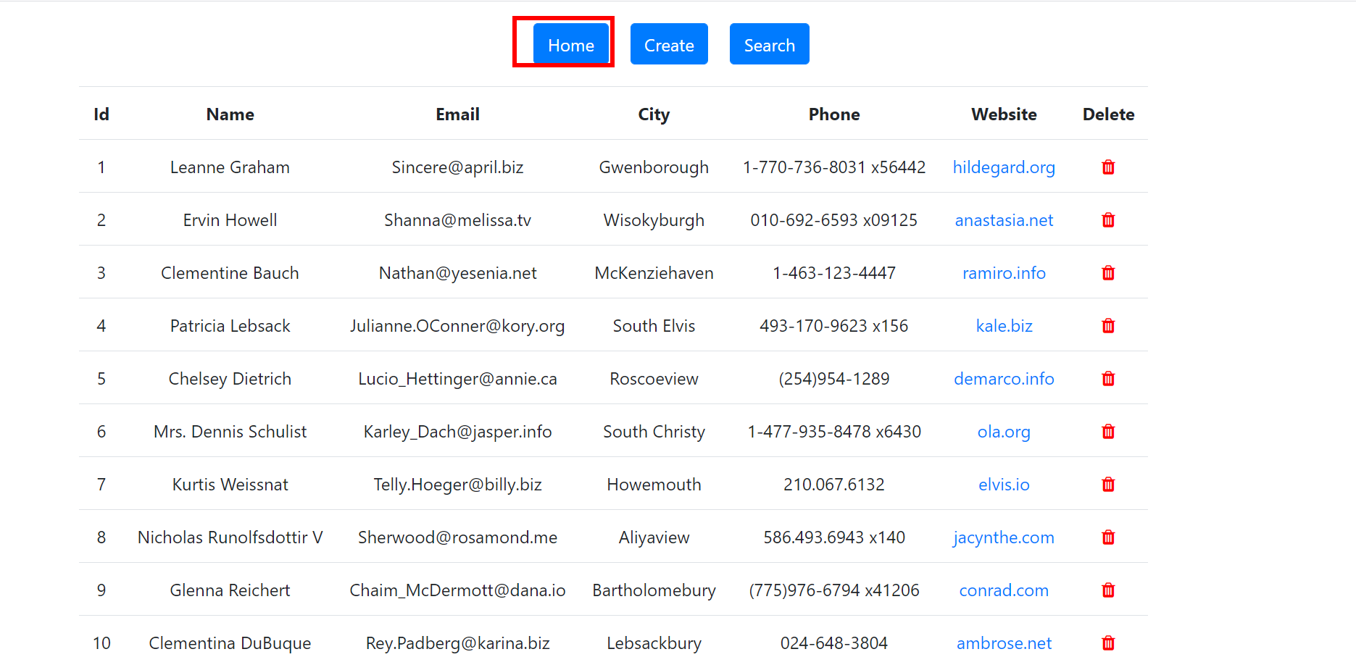

1. Create an User:

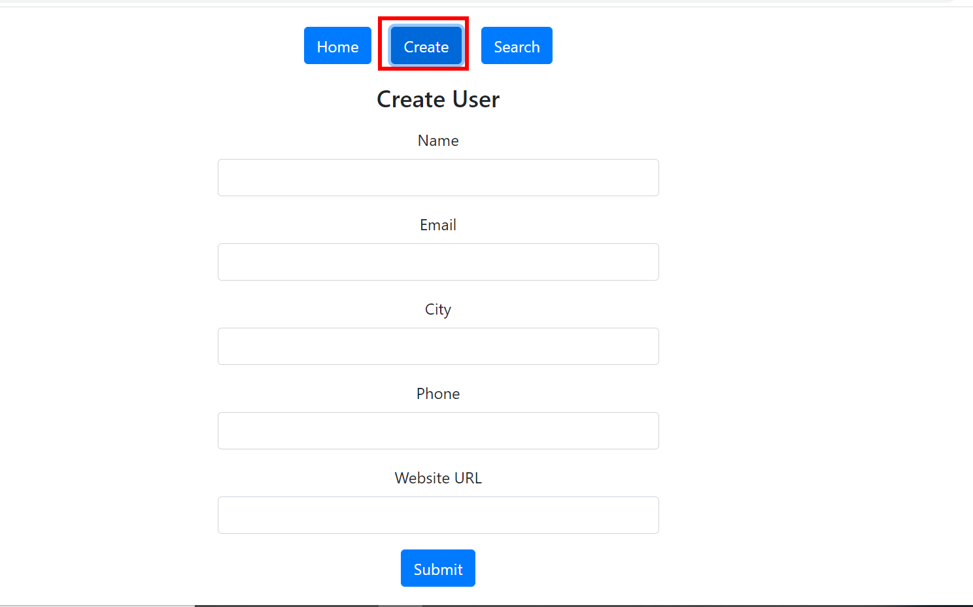

1. Delete an User:

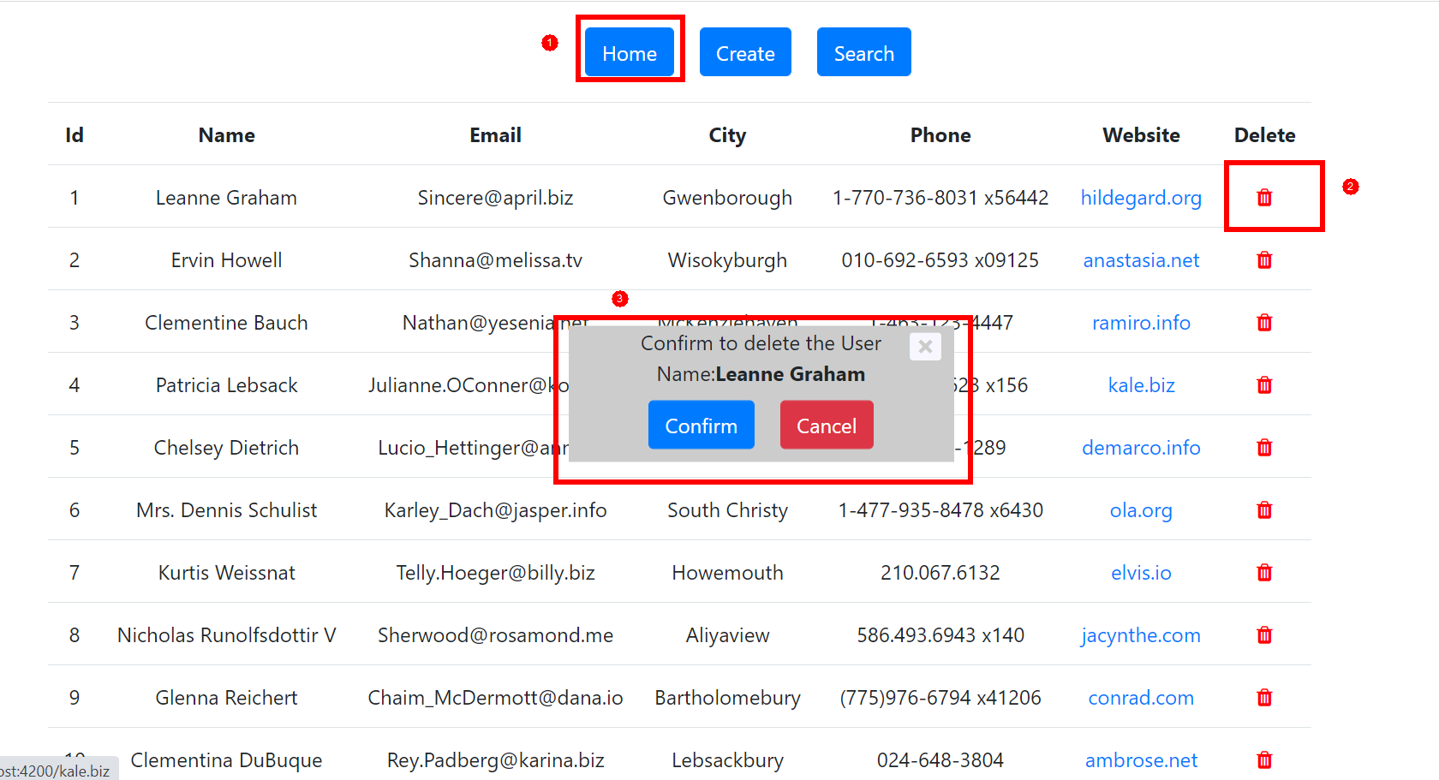

1. Search for User:

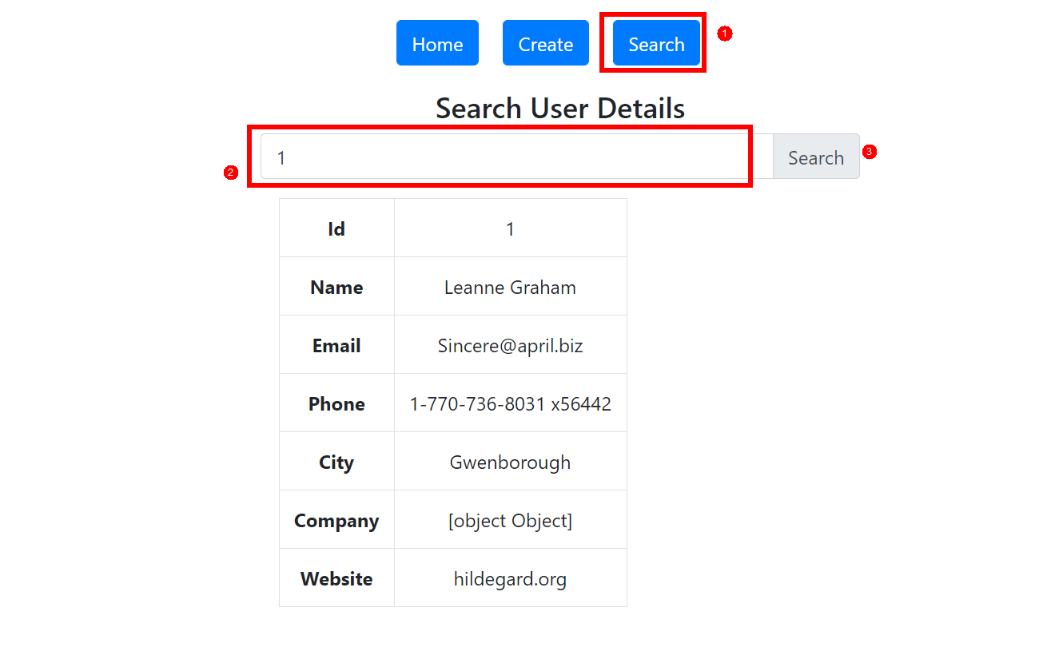

Key Features implemented:

Data Source:

API endpoint: <https://jsonplaceholder.typicode.com/users>

1. validation of form where user cant submit the input field with WhiteSpaces
2. User can enter the id (ex:1) to get the details of the user
3. There is an option under each row to delete the data from the table