MBTA Capstone

Lyla Fadden  Harvard University  lylafadden@g.harvard.edu | Micah Lanier  Harvard University  micahlanier@g.harvard.edu | Fil Piasevoli  Harvard University  fpiasevoli@g.harvard.edu | Aaron Zampaglione  Harvard University  azampaglione@g.harvard.edu
 | Pavlos Protopapas  Harvard University  pavlos@seas.harvard.edu | Robert Adolf  Harvard University  rdadolf@seas.harvard.edu

ABSTRACT
In this paper, we will present the models and findings developed by the aforementioned authors during the semester-long AC 297r Capstone course of the Harvard IACS Department. We worked closely with Dominick Tribone of the MBTA and under the guidance of Pavlos Protopapas and Bob Adolf of Harvard University.

INTRODUCTION
The MBTA serves 4.8 million people throughout the Boston metro area and facilitates approximately 1.3 million trips each weekday. Aggregated entry and exit data is collected for each rail station at 15-minute intervals. Since commuting is one of the most habitual acts a metropolitan citizen performs, this data provides excellent means to predict ridership throughout the week. Even with this huge amount of data, many of the daily operational decisions have been driven by gut instinct and industry-specific knowledge.
Using data from the MBTA’s fare collection system, we found that the habitual nature of mass-transit and commuting makes it relatively easy to compute a point-estimate of consumer demand at any station at any time of day. Thus, our research focused on exploring the more nuanced aspects of how Bostonians ride the T and using the insights of the exploration to make a better prediction than simple historical models. The avenues of our research include:
- Identifying similar rail stations according to some measure beyond what color rail line they are a part of.
- Examining the effects of weather on rider demand and identifying severity levels that correspond to decreased ridership.
- Observing ridership distributions during sporting events and how they might guide MBTA decision-making.
- Predicting ridership for any station a few days in advance.

Following the insights gleaned from these areas, we incorporated daily weather data and schedules of sporting events along with the historical records of entries at a given station into a more comprehensive model of ridership.

About the Data
We received a little over two years of ridership data across all MBTA stations where each row contained the date, time, station, and entries/exits aggregated over 15-minute time intervals. Thus the data itself is relatively lean in terms of features, even though it totals over 5 million rows. While we do have numerical values for the number of exits, the data is not reliable as many stations have exit gates that do not record the number of people exiting.
The snowfall data we used was from the NOAA API [1]. The game schedules for the Boston Red Sox, Celtics, and Bruins was scraped from the Red Sox official website and ESPN [2].

GENERAL RIDERSHIP
A nontrivial amount of variation in daily MBTA ridership can be explained by simple running averages of demand for each day of the week. Accordingly, planners have successfully relied upon learned intuition to accurately predict upcoming ridership in the past. Below is a plot of ridership data for South Station on a Monday. The red line represents the mean entries at the specific time interval across all Mondays in our dataset, and the blue shading represents one standard deviation for the same fixed criteria.
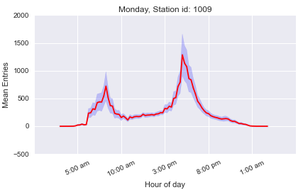
Figure 1: South Station Monday Ridership
Note how small the variation is for any given time interval. Upon seeing how accurate a point-estimate we could derive from historical trends alone, we directed our efforts towards improving predictive capabilities in atypical circumstances.

SIMILAR STATIONS
Part of our initial exploration of the data dealt with the identification of similar stations. One existing measure of similarity is the line color. MBTA stations along the same route are colored Red, Orange, Green, or Blue. This grouping is helpful when looking at a map and planning a trip, but this relationship has nothing to do with the ridership patterns of the stations.

Correlation Between Stations
For each time interval during the day, we computed the mean number of entries at that time for each station. Together, the average entries at each interval form a time series of mean weekday ridership for one station. For simplicity, we only considered weekdays in our dataset as those patterns are much more stable than weekend ridership patterns. One issue when comparing stations is that some have ridership figures that are more than an order of magnitude larger than others. We standardized the data so that each series had a mean of zero with unit variance. The reason we scaled the series was because we felt that similarity is defined in terms of the shape of ridership rather than the raw number of people.
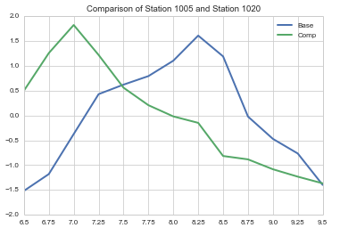
Figure 2: Two Dissimilar Ridership Patterns
Once all stations’ series are scaled to a level playing field, the correlation between two stations tells us how similarly shaped their ridership patterns are. In the two-sample univariate case, recall:
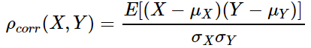
The correlation of two univariate samples ranges from -1 to 1. When extended to compare two time series, the correlation coefficient is defined in terms of the cross-correlation below, where T is the set of all time intervals, f* denotes the complex conjugate of f, and n is the lag. In our case n=0.
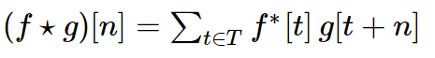
This value can range from –m to m where m is the number of intervals in each time series. We standardized the coefficient by dividing by m to keep the interpretation of correlation the same as the traditional sense. Figure 2 shows ridership during the morning rush hour for two stations with a correlation below 0.45, suggesting that their riderships are somewhat similar. While both series have increasing ridership from 6:30 a.m. to 7 a.m. and pronounced peaks, one peak occurs much earlier than the other. Similar stations would have peaks in ridership at the same time with comparable peak shapes and similar periods of low ridership.

The Similarity Matrix
Correlation coefficients are a good way to quantify pair-wise comparisons between stations, but we needed a way to visualize every comparison between all stations. Similarity matrices use red to denote positive correlation and blue for negative correlation between the stations in the corresponding row and column. Figure 3 shows an example of the unordered similarity matrix for all stations on the red line. While it's easy to compare any two stations by identifying the correct row and column, it's difficult to name groups of similar stations at first sight.
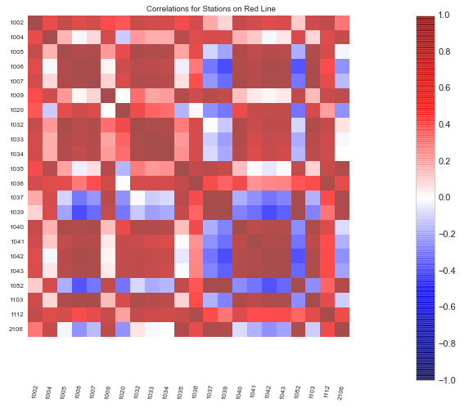
Figure 3: Unordered Similarity Matrix
A row of correlation scores represents the relationship of one station with a collection of other stations. The correlations are a measurement on a specific pairing of stations so they cannot be compared, ordered, or easily generalized upon. One way to order the similarity matrix is to identify groups of similar stations through another method and rearrange the rows according to this grouping.
As mentioned in Section 3.1, we computed average entries at 15-minute intervals, resulting in 59 measurements for each station between 5:15 a.m. and midnight. These 59 measurements can be considered a point in a 59-dimensional span of real numbers.
Using Principal Component Analysis, we can map our data from a high-dimension space down to a lower-dimensional space while preserving the variation that makes stations similar to one another. We were able to preserve 90% of the variation in the dataset using only two dimensions, making the mapping very convenient to visualize in Figure 4, where each point represents one station.

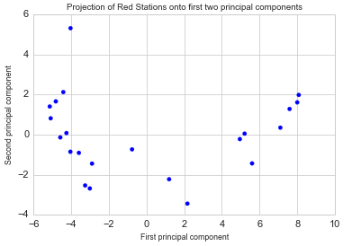
Figure 4: Projection onto First Two Principal Components

After mapping the points down to two dimensions, we applied the k-means clustering algorithm. We reduce the dimensionality of the data first, because k-means is more easily able to cluster similar stations in low-dimensional spaces. Figure 5 shows the coloring of points by their assigned cluster after applying k-means clustering with k=3. The reason we chose k=3 is because the points in Figure 4 seem to be organized in 3 groups. Figure 6 is the ordered similarity matrix of the data from Figure 3 with the rows reordered according to the k-means labels.
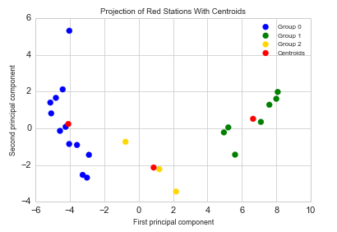
Figure 5: Projection with Cluster Coloring
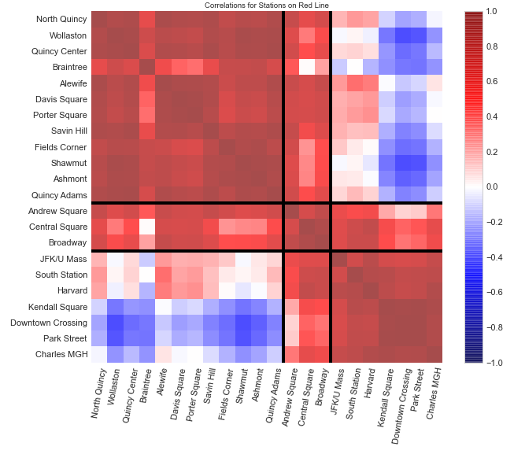
Figure 6: Re-ordered Similarity Matrix

Groupings Across the Whole System
Performing the PCA/k-means on all MBTA stations, we derive the 3 groups of stations with similar ridership patterns (see appendix for the similarity matrix). Figure 7 is a map of the MBTA with the stations colored by our groupings. Using Government Center as the unofficial middle of the city, it seems that ridership patterns are heavily dictated by a station’s distance from the city center.
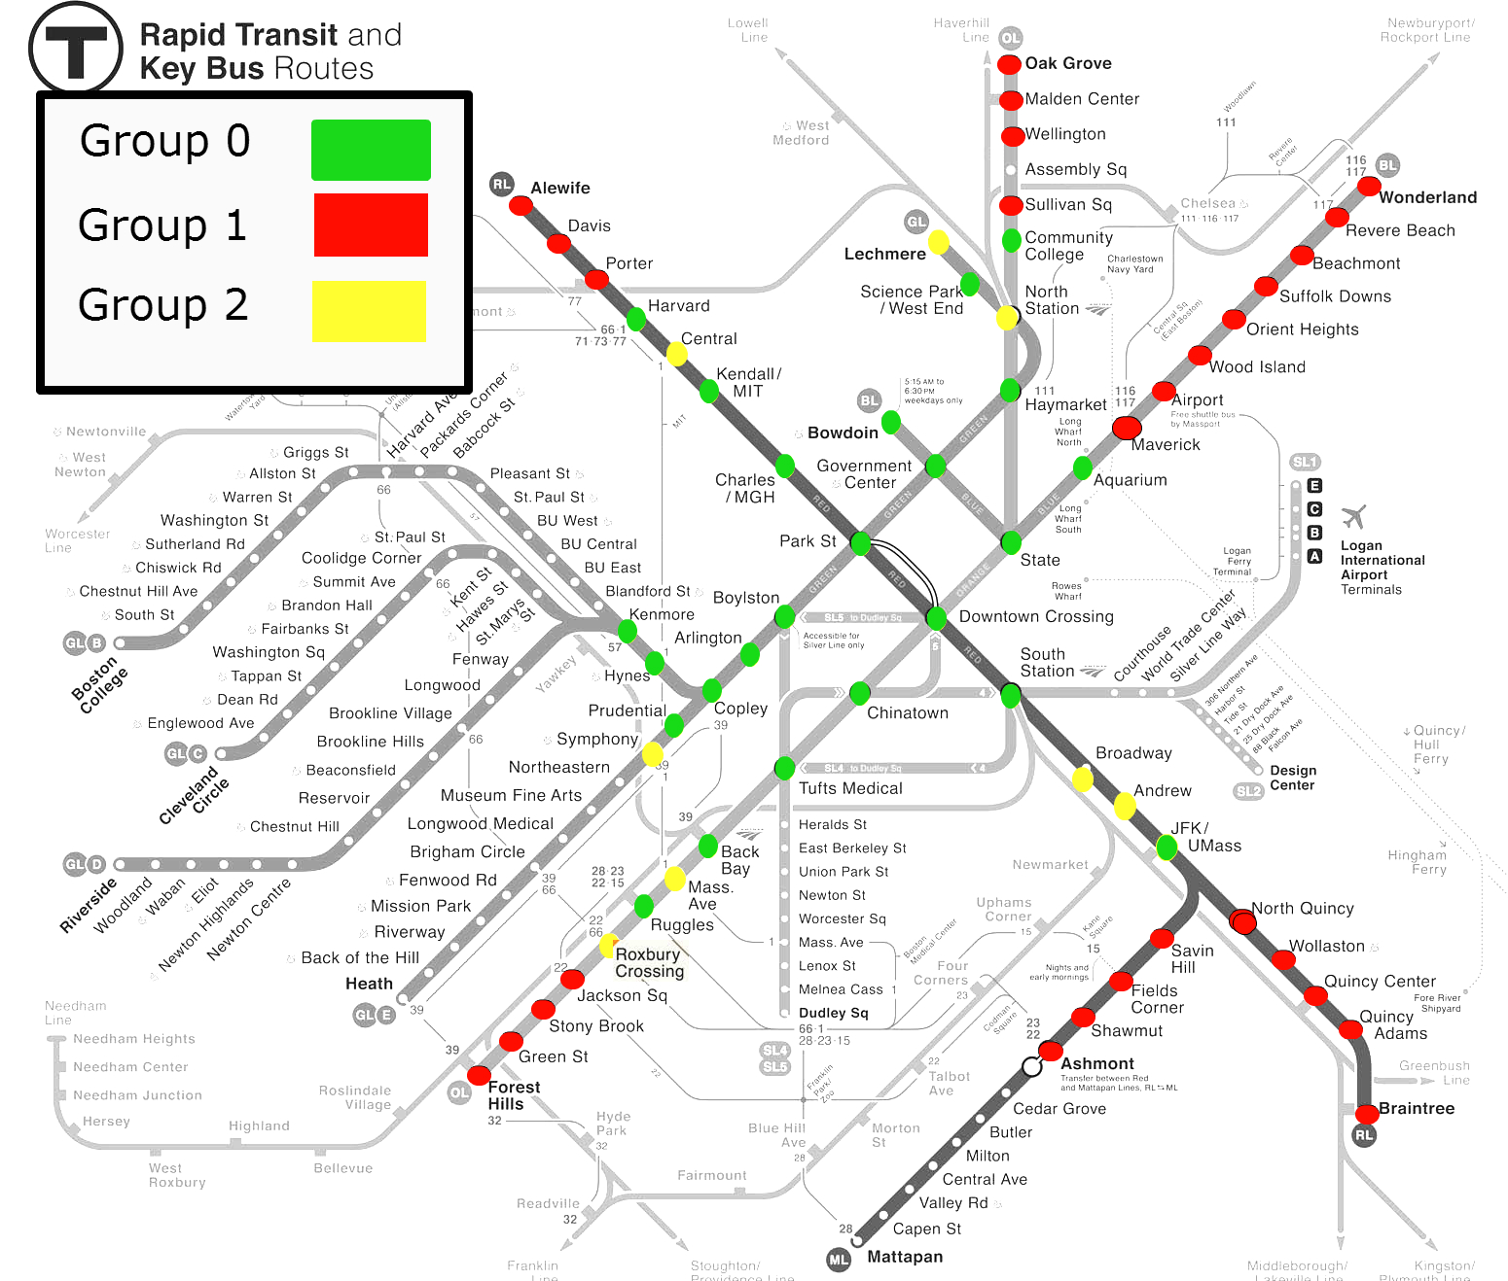
Figure 7: MBTA Map Colored by Groupings
Keep in mind that we derived these relationships only using average ridership figures, not distance metrics. Common intuition surrounding public transportation reflects the difference in ridership between stations near and far from the city as they experience the most traffic at opposing parts of the day. The intermediary stations, however, are much more nuanced. Stations in Group 2, like JFK/UMass and Central, are what the MBTA refers to as peak-load points. In the morning, inbound trains accumulate riders at preceding stations with practically no riders disembarking until the trains reach these peak-load points. After these points, riders disembark en masse as trains reach the city center. The phenomenon occurs in the opposite direction when commuters return home in the evening.

SNOW AND RIDERSHIP
The 2015 winter storms brought unprecedented levels of snow to Boston. As expected, it caused a transportation nightmare between the congestion, delays, and cancelations. It was so chaotic that the Boston MBTA chief decided to step down due to public pressure. With such a rare opportunity, we decided to concentrate on the affects of snow on ridership.

Weather Data
The weather data was obtained by scraping the Wunderground API. The feature of interest was the "snow_fall" column, which was the recorded snowfall for a particular day, in inches. From the recorded snowfall, we also generated a “snow accumulation” feature, which approximated the current snow on the ground for a particular day. The snow accumulation was generated by a polynomial decay of the snowfall that occurred for the previous two weeks.

Interactive Visualizations
We decided that interactive visualizations would be an effective exploratory tool for determining the effect of snow on ridership. Using d3.js, a popular interactive JavaScript framework, we developed interactive plots and maps that helped investigate how ridership changes at any station for varying weather conditions [4]. Information that we discovered after building the visualization were:
- Snowfall only starts to considerably decrease ridership at 4+ inches.
- Particular stations, such as Suffolk Downs, are more effected by weather than others.
- Snow and rain effect ridership patterns more so on weekends than weekdays.

Snowfall and Ridership Trends
Further analysis focused on modeling the relationship between snowfall as the dependent variable and the fraction of normal ridership at the station as the response variable.
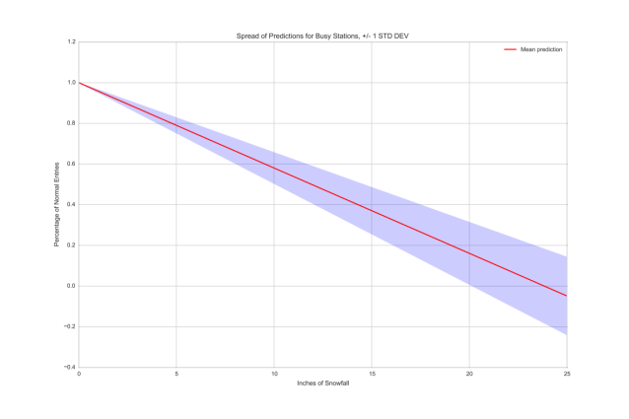
Figure 8: Ridership Percentage as a Function of Snowfall
After exploratory analysis, it was clear that snowfall had an adverse effect on ridership. However, it is important to note that the variance beyond 15 inches was extremely high; there were too few data points to formulate any concrete conclusions about the effects on ridership at this level.

Snow Features for Prediction
Changes in the accuracy of entry predictions are one way of determining the importance of snow to the MBTA. To do so, we can add snow "features" to a basic model (Linear Regression) and check the prediction accuracy for each station.
The baseline model features consist of only the number of entries on the same day for the past two weeks. For example, if we were predicting the entries for Andrew Square on 2015-02-21, we would build a regression model using only the known entries on 2015-02-14 and 2015-02-07 as features.
The snow model consists of the same features as the baseline model, plus the snow features (snow fall and snow accumulation).
Once both of the models were generated using the same training days, we attempted to predict daily ridership entries using multiple test sets. The following figure shows the averaged test set results for a subset of the stations.
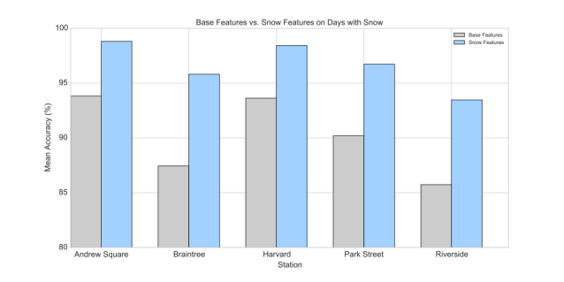
Figure 9: Accuracy Improvements for Select Stations Using Snow Features
The chart clearly shows that the snow feature set was superior to the baseline feature set, in terms of prediction accuracy. For all stations, the average accuracy using the baseline model on days with snow was 92.62%. For the snow feature model, the average accuracy was 97.84% – an approximate 5% increase in accuracy on days where snow occurred.

SPORTING EVENTS
Major public events like concerts and sporting events often cause sudden spikes in demand for transportation services, both before they start and after they end. Transportation demand often increases across the system, perhaps with characteristic patterns along different lines and at specific stations. Postgame entries spike at stations in the immediate vicinity of the venue as people exit. We measure this effect in terms of “lift”—T entries in excess of those expected at a particular weekday/time around the same time of year.
To begin to understand these effects, we focused our analysis on Boston Bruins, Celtics, and Red Sox games. Only home games were considered. Game day traffic is compared to same weekday and time traffic on game-less days (e.g., Friday evening Celtics games are compared to in-season Friday evenings). We excluded several days from both the set of game days and game-less days, including holidays and service interruptions. Our reasoning: we are seeking the effect of games on traffic, and should not consider days with unique traffic patterns that we are reasonably sure have no link to a game.

Sporting Event Data
We obtained sports schedules by manually retrieving them from espn.com and redsox.com. Time frames for each team’s schedule matches the MBTA data that we have available—they start in early 2013 and run until early 2015. This constitutes two entire seasons for the Red Sox, and three full or partial seasons for the Bruins and Celtics.

Pregame Demand Lift
As Boston sports fans live throughout urban Boston and the metropolitan area more generally, we analyzed entry lift throughout the system before games to gauge the effect of sporting events on ridership demand. Line-by-line trends for each team appear in Figure 10.
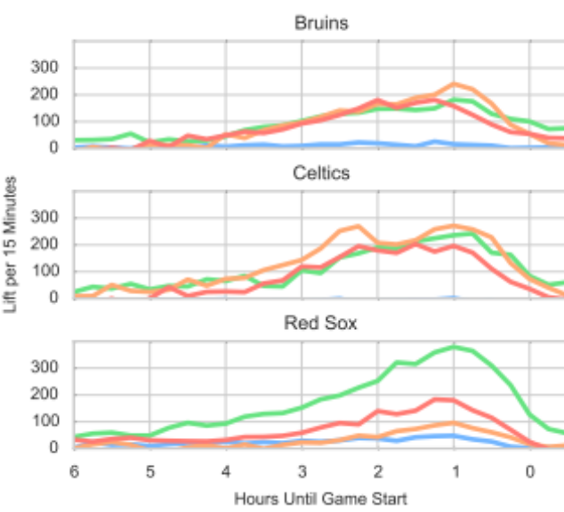
Figure 10: Pregame Entry Lift by Line for Sports
Each team shows a long “ramp-up”, starting several hours before game time and peaking around one hour before the start of the game. The Bruins and Celtics show comparable lift among non-Blue Line routes; Red Sox fans show a distinct preference for the Green Line, followed by the Red and Orange. The Blue Line shows little lift relative to the others, particularly before Celtics games, where Blue Line lift appears negative at times where other lines are reaching their peaks.
Turning our attention to specific stations: all teams show significant lift along inner-city train routes before games—particularly at Green Line stations between Kenmore and North Station. But each sport displays several characteristic patterns. Before Bruins games, several northern Orange Line stations (Sullivan, Wellington, and Oak Grove) show significant entry lift. Celtics games show similar patterns, but with the biggest spikes further south along the Orange Line (Back Bay and Ruggles). Many Bruins fans also commute from either end of the Red Line (Alewife, Braintree, and Quincy Adams), while Celtics fans are more likely to come in from Forest Hills. Interestingly, both teams also show significant lift at JFK/UMass along the Red Line—an effect that Red Sox games do not show.
In addition to inner-city demand spikes, Red Sox fans show a pronounced pattern of commuting from the far reaches of the T system for games. Riverside and Alewife (the ends of the Red and Green Line “D” routes) are among the most popular pregame stations; Oak Grove, Sullivan Square, Quincy Adams, Braintree, and Wonderland (outlying stations along the Orange, Red, and Blue Lines) also appear among the most-trafficked stations. In this regard, the Red Sox show the most distinctly “suburban” traffic pattern of the three teams; the Celtics show the least.

Postgame Demand Lift
Postgame entry lift follows a pattern completely distinct from pregame lift, featuring a large swell in entries around each sporting venue, rather than an aggregate increase in entries across the entire system. Postgame spikes naturally affect the rest of the system—people enter stations to go to others, after all—but we can only observe effects at entry points.
For the Bruins and Celtics, we analyzed entry lift at North Station (nearest to TD Garden); Red Sox entries are focused on Kenmore Square and Hynes. Figure 11 shows postgame lift (from game start until several hours after game end) at these stations. Typical game length roughly corresponds to the peak for each team: basketball/hockey games last (on average) just over two hours; baseball games, slightly more than three.
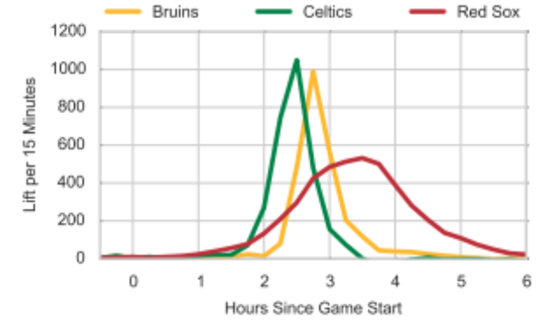
Figure 11: Postgame Entry Lift by Sport (Nearby Stations)
As we see, the Bruins/Celtics show a characteristically different pattern from the Red Sox. In the former case, fans appear to immediately exit games (which we theorize to be of relatively uniform time length) and board public transportation. TD Garden holds relatively few fans, but post-game peak lift is larger than any time following a typical Red Sox game.
The Red Sox show a much different pattern: lift around Fenway Park gradually increases starting late in the game, and fans continue to enter the T long after the game ends. This pattern holds for individual games, suggesting that it is not an artifact of increased variance in game length; rather, many people both leave a typical baseball game early and remain in the neighborhood longer.
Intuitively, much of the observed postgame lift is likely return traffic to the same key stations that we identify for pregame traffic. It is difficult to rigorously analyze transfers and station exits with the data that we have available. It should simply be noted that although postgame entries spike at the observed stations, ridership increases across the system (with the possible exception of the Blue Line for certain sports/games).

PREDICTION
To provide the most accurate prediction of daily ridership (number of entries) per station, it is crucial to come up with the right set of features and methods for model selection. Intuitively, we know that the recent past goes a long way toward predicting the near future. We augmented that insight with data about weather patterns and sporting events in hopes of capturing their variability in our models and determining the incremental benefit each of these provide. Python’s toolset allows us to easily fit and tune multiple regression models. This permits us to select the best model for each T station that predicts entries for each day, when evaluated against held-out testing data.
To provide final evaluation of our models, we compared them to “naïve” predictions of ridership based on unweighted averages of recent weeks’ ridership. This demonstrates the value that machine learning techniques add above simple intuition.

6.1 Feature Extraction And Selection
When selecting a subset of relevant features for the construction of the prediction model, we incorporated the central insights from the exploration of the data and analysis of weather and events.
Since the raw data collected by MBTA provides a scarce set of attributes, our first objective was to extract informative and discriminating features based on the conclusions derived in our analysis. The first observation is that ridership trends are highly periodic and seasonal. We built this into our model in two ways. First, we took the time series trends into account in the regression model by expanding the service date into a set of categorical features using 1-of-K encoding. This makes it possible to identify linear dependencies on periodic events during typical seasonal cycles. The features extracted from the date are day of the week, day of the month, and month of the year. Second, we included average entries from the three previous weeks. When trying to predict ridership, we know that weekend and weekday trends are different. Similarly, each weekday exhibits a different pattern. Hence, when trying to predict daily entries for a Monday for a particular station, we are interested in looking at the historical entries for that station 1, 2, and 3 weeks ago on the same day of the week.
The supplemental observations from the weather and public event analysis were also encoded as features for prediction. As previously discovered, snowfall and snow accumulation have an effect on entries. Sports games contribute a significant lift in ridership at particular stations where the event occurred. Station groupings based on similar AM/PM ridership patterns were also considered.
The resulting feature matrix included 32 features, which were classified into groups for comparison as seen below. The baseline for comparison includes a single feature of historical entries from the previous week.
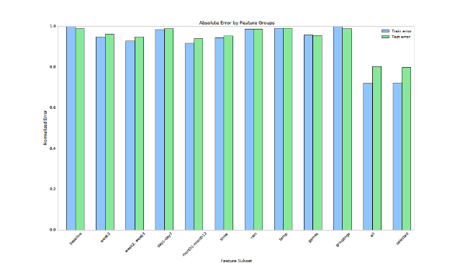
Figure 12: Prediction Accuracy
The distribution of the predictive error by station shows the added benefit of each feature subset compared to the baseline. Historical entries, snow data, and game data have a significant impact on prediction. The distribution of the prediction error using the optimal selection of features compared to the baseline can be seen below. Overall, stations shift left exhibiting a lower prediction error. The gap between the average error and the baseline is widest using the optimal feature subset for prediction.

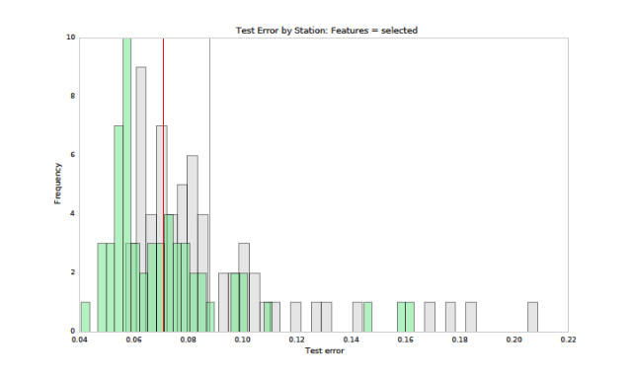
Figure 13: Prediction Error Comparison

Regression Model Comparison
Once an optimal feature subset was determined, the next step was to find the best model for regression. The initial prediction of entries and comparison with the baseline was performed using a simple linear regression model. Linear regression fits a linear model with coefficients to minimize the residual sum of squares between the number of entries in the dataset and the entries predicted by the linear approximation. To attempt to correct for possible correlation in the model terms, a Ridge regression model was also considered. This model imposes a penalty on the size of coefficients making predictions more robust to collinearity, and therefore less sensitive to random errors in the recorded entries. Similarly, a Bayesian regression model was also considered where the regularization parameter is learned based on the data using semi-informative priors over the parameters of the model.
Each regression model was tuned and applied to every station. The average of 50 trials was obtained calculating the error proportional to the ridership volume of the station. Out of the 61 stations being considered, about one third performed better using Ridge, Random Forest, and Bayesian regression models respectively. An ensemble averaging method using a combination of these learners was employed to improve predictions. The results are summarized below.

Method | Test Error
Ordinary Least Squares | 0.076
Ridge Regression | 0.070
Random Forest | 0.069
Bayesian Regression | 0.071
Ensemble Method | 0.067
Figure 14: Method Comparison
As can be surmised, the best predictive results are achieved with the ensemble method resulting in 94% predictive accuracy.

Prediction Results and Outliers
Overall, 30 stations have a very high predictive accuracy (>95%). Most of these higher ranking stations are on the red and orange line with a station count of 14 and 8, respectively. On the other hand, stations with the lowest predictive accuracy (<90%) are Science Park, Community College, Suffolk Downs, and Riverside.

CONCLUSION
dfdf

ACKNOWLEDGMENTS
Our thanks to Dominick Tribone for facilitating our relationship with the MBTA. Are thanks also go to Robert Adolf and Pavlos Protopapas for advising our research.

REFERENCES
- USA.gov. NOAA Climate Data Online. 15 February 2015 <http://www.ncdc.noaa.gov/cdo-web/>.
- MLB Advanced Media. 2013 Downloadable Schedule. 30 June 2014. 1 February 2015 <http://boston.redsox.mlb.com/schedule/downloadable.jsp?c_id=bos&year=2013>.
- NBA Media Ventures. Celtics Downloadable Schedule. 1 February 2015 <http://www.nba.com/celtics/schedule/2012-13-downloadable-schedule.html>.
- Aaron Zampaglione, Fil Piasevoli, Dave Brown. Weather and the MBTA. <http://azampagl.github.io/mbta-weather/>
- Lyla Fadden, Micah Lanier. MBTA Gameday. <http://micahlanier.github.io/cs171-gameday/>

Appendix:
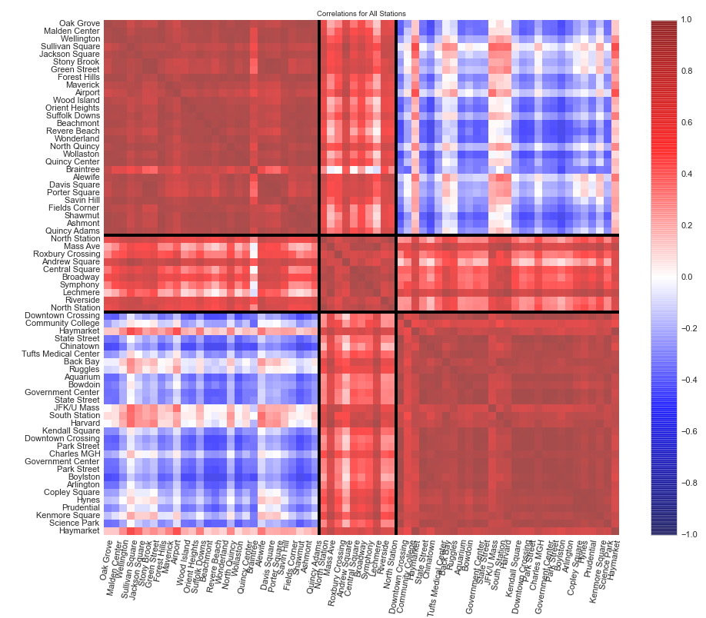
Similarity matrix across all stations

Exact line-by-line lift depends in part on allocation of entries at stations that service two lines. Where appropriate, we have allocated all lift to lines that directly service sporting venues.
We considered other nearby stations but found no appreciable postgame spike in demand at any. Also, we cannot observe entries at the aboveground Fenway Green Line stop. That station features a non-trivial spike in entries, but it is one that we cannot observe.

