





About Us

Custom Market Insights is a market research and advisory company delivering business insights and market research reports to large, small, and medium-scale enterprises. We assist clients with strategies and business policies and regularly work towards achieving sustainable growth in their respective domains.

Custom Market Insights provides a one-stop solution for data collection to investment advice. The expert analysis of our company digs out essential factors that help to understand the significance and impact of market dynamics. The professional experts apply clients inside on the aspects such as strategies for future estimation fall, forecasting or opportunity to grow, and consumer survey.

**OUR SERVICES**









**Copyright © 2023 Custom Market Insight**

All Rights Reserved. This document contains highly confidential information and is the sole property of CMI. No part of it may be circulated, copied, quoted, or otherwise reproduced without the approval of CMI

INTRODUCTION

**OBJECTIVES OF THE STUDY**

* To define, describe, and forecast the {Keyword} market by Sales channel, Application, and Region
* Total Addressable Market and Market sizing in terms of Value (USD Million) and Volume (Kilo Tons)
* To provide detailed information regarding the factors influencing the growth of the Market (such as drivers, restraints, opportunities, and challenges)
* To strategically analyze micro Markets with respect to individual growth trends, prospects, and contributions to the {Keyword}market
* To analyze Market opportunities for all the stakeholders and provide details of the competitive landscape for Market leaders
* To forecast the size of the Market segments in North America, Europe, the Asia Pacific, Latin America, and Middle East & Africa (MEA)
* To profile key operating players and comprehensively analyze their product portfolios, Market positions, Market shares, and core competencies
* To track and analyze competitive developments, such as product launches, expansions, collaborations, agreements, and acquisitions in the {Keyword}market
* Supply and demand analysis of the {Keyword}market across the globe and region – wise

**MARKET DEFINITION**

{Keyword} are used for image acquisition and to examine the heart rate and movement of a fetus to enable the detection of congenital anomalies and abnormalities in fetal growth. These systems are also used to examine the pulse rate and uterine contractions of a mother during labor.

{Keyword} systems help enhance prenatal care quality, prevent maternal mortalities in cases of high-risk pregnancies, and diagnose congenital disabilities in a fetus.

**YEARS CONSIDERED FOR THE STUDY**

| **2016-2021** | **2022** | **2022-e** | **2022-2030** |
| --- | --- | --- | --- |
|  |  |  |  |
| **HISTORICAL YEARS** | **BASE YEAR** | **ESTIMATED YEAR** | **PROJECTED YEARS** |

**CURRENCY**

* The currency used in this report is the United States Dollar (USD), with the Market size indicated in terms of USD million/billion and volume (Kilo Tons)
* For companies reporting their revenues in USD, the revenues were picked from their annual reports
* For companies that reported their revenues in other currencies, the average annual currency conversion rate was used for the particular year to convert the value to USD

**STAKEHOLDERS**

* {Keyword} Manufacturers
* {Keyword} Associations
* {Keyword} Research Institutes
* Research and Consulting Firms
* {Keyword} Distributors
* Group Purchasing Organizations (GPOs)
* {Keyword} Raw Material Suppliers
* {Keyword} Development Institutes and Organizations
* Government Organizations
* End-User Industry Players
* Students, Professors, etc.
* Others

**SUMMARY OF CHANGES**

Changes in the Market scope: The new edition of the report provides Market size and forecast for each region and their countries. In this edition of the report, North America has been segmented into the U.S. and Canada. Europe has been segmented into the UK, France, Germany, Italy, Spain, and the Rest of Europe. Similarly, the Asia Pacific region has been segmented into Japan, China, India, Australia, South Korea, ASEAN, and the Rest of the Asia Pacific. Latin America has been segmented into the Mexico, Brazil, and Rest of Latin America. Middle East & Africa (MEA) has been segmented into the GCC countries, South Africa, and Rest of MEA.

* **New and Improved Representation of Financial Information:** The new edition of the report provides updated financial information till 2020 (depending on the availability) for each listed company in a graphical representation in a single diagram (instead of multiple tables). This would help in the easy analysis of profiled companies' present status regarding their financial strength, profitability, key revenue-generating country/region, and business segment focus in terms of the highest revenue-generating segment.
* **Recent Market Developments:** Recent developments are helpful to know the Market trends and growth strategies adopted by players in the Market.
* **Latest Product Portfolio:** The new edition of the report provides an updated product portfolio of the companies profiled in the report.
* **COVID-19 Impacts:** The current edition of the report covers the COVID-19 impacts on the {Keyword}. Quantitative and qualitative analysis of COVID-19 pandemic impacts in the long-term, mid-term, and short-term scenarios. Additional points in the Market overview section have been added, keeping in mind the impact of COVID-19 on the Market.
* **Company Profiles:** A total of upto 20 companies can be profiled, free of cost. If required, customized list of companies can be profiled in the final deliverable as per your specific choice.
* **Competitive Leadership Mapping:** The Vendor Dive Matrix has been added in this version of the report, covering a comprehensive study of the key vendors offering {Keyword} products. The top vendors operating in the {Keyword} have been evaluated in this section. Competitive Leadership mapping is also done for start-ups/SMEs.
* **Additional Information:** The current edition of the report covers pricing analysis, value chain analysis, supply chain analysis, ecosystem analysis, trade analysis, regulatory landscape, patent analysis, technology analysis, Porter’s Five Forces analysis, PESTLE analysis, SWOT analysis under the Market overview chapter. This edition also covers company product and geographical footprint for key players under the competitive landscape chapter.

**LIMITATIONS**

* Some of the companies in this Market are privately owned, and their revenues are not available in the public domain. Hence, the revenues for those companies are estimated based on paid primary interviews and surveys along with paid external third-party databases.
* Company developments not reported in the public domain are not included in the report.
* Inflation is not a part of pricing analysis and revenue calculations in this report. Prices of {Keyword} and its derivatives vary in each region and hence similar revenue ratio does not follow for each individual region.
* The weighted average price for each product category has been considered while estimating and forecasting Market revenue on a basis.
* Regional weighted average prices have been considered while breaking down this Market by type, application and end-user in each region.

RESEARCH REPORT – PRODUCTION COSTS & RESOURCES

**RESEARCH DATA**

|  |  |  |
| --- | --- | --- |
| **Primary research** | **Secondary research** | **Manpower resources** |

{%Image}

Table of Content

**Chapter No. 1 :** **Introduction 12**

**1.1.** **Report Description 12**

1.1.1. Purpose of the Report 12

1.1.2. USP & Key Offerings 12

**1.2.** **Key Benefits for Stakeholders 12**

**1.3.** **Target Audience 13**

**1.4.** **Report Scope 13**

**Chapter No. 2 :** **Executive Summary 15**

**2.1.** **Key Findings 15**

2.1.1. Top Investment Pockets 15

2.1.1.1. {Keyword}Market Attractiveness Analysis, By Type 15

2.1.1.2. {Keyword}Market Attractiveness Analysis, By Application 15

2.1.1.3. {Keyword}Market Attractiveness Analysis, By End Use Industry 16

2.1.1.4. {Keyword}Market Attractiveness Analysis, By Region 16

**2.2.** **{Keyword}Market Snapshot 17**

**2.3.** **Global {Keyword}Market, {FromYear} – {ToYear} ({Revenue}) 19**

**Chapter No. 3 :** **COVID 19 Impact Analysis 20**

**3.1.** **Impact Assessment of COVID-19 Pandemic, By Region 20**

3.1.1. North America: Impact of COVID-19 Pandemic 20

3.1.2. Europe: Impact of COVID-19 Pandemic 20

3.1.3. Asia Pacific: Impact of COVID-19 Pandemic 20

3.1.4. Latin America: Impact of COVID-19 Pandemic 20

3.1.5. The Middle-East and Africa: Impact of COVID-19 Pandemic 20

**3.2.** **Quarterly Market Revenue by Region 2020 & 2021 21**

**3.3.** **Pre COVID-19 Market Revenue, By Region, 2016-2019 ({Revenue}) 22**

**3.4.** **Post COVID-19 Market Revenue, By Region, 2020-2030 ({Revenue}) 22**

**3.5.** **Short Term Dynamics 23**

**3.6.** **Long Term Dynamics 23**

**Chapter No. 4 :** **{Keyword}Market – By Type Segment Analysis 24**

**4.1.** **{Keyword}Market Overview, by Type Segment 24**

4.1.1. {Keyword}Market Revenue Share, By Type, 2021 & 2030 24

**4.2.** **Polyether {Keyword} 25**

**4.3.** **Polyester {Keyword} 26**

**Chapter No. 5 :** **{Keyword}Market – By Application Segment Analysis 27**

**5.1.** **{Keyword}Market Overview, by Application Segment 27**

5.1.1. {Keyword}Market Revenue Share, By Application, 2021 & 2030 27

**5.2.** **Flexible Polyurethane Foam 28**

**5.3.** **Rigid Polyurethane Foam 29**

**5.4.** **CASE 30**

**Chapter No. 6 :** **{Keyword}Market – By End Use Industry Segment Analysis 31**

**6.1.** **{Keyword}Market Overview, by End Use Segment 31**

6.1.1. {Keyword}Market Revenue Share, By End Use Industry, 2021 & 2030 31

**6.2.** **Carpet backing 32**

**6.3.** **Packaging 33**

**6.4.** **Furniture 34**

**6.5.** **Automotive 35**

**6.6.** **Building & Construction 36**

**6.7.** **Footwear 37**

**6.8.** **Electronics 38**

**6.9.** **Others 39**

**Chapter No. 7 :** **{Keyword}Market – Regional Analysis 40**

**7.1.** **{Keyword}Market Overview, by Region Segment 40**

7.1.1. Global {Keyword}Market Revenue Share, By Region, 2021 & 2030 40

7.1.2. Global {Keyword}Market Revenue, By Region, {FromYear} – {ToYear} ({Revenue}) 41

**7.2.** **North America 42**

7.2.1. North America {Keyword}Market Revenue, By Country, {FromYear} – {ToYear} ({Revenue}) 43

7.2.2. North America {Keyword}Market Revenue, By Type, {FromYear} – {ToYear} 44

7.2.3. North America {Keyword}Market Revenue, By Application, {FromYear} – {ToYear} 45

7.2.4. North America {Keyword}Market Revenue, By End Use Industry, {FromYear} – {ToYear} 46

7.2.5. U.S. {Keyword}Market Revenue, 2016 - 2030 ({Revenue}) 47

7.2.6. Canada {Keyword}Market Revenue, 2016 - 2030 ({Revenue}) 48

7.2.7. Mexico {Keyword}Market Revenue, 2016 - 2030 ({Revenue}) 49

**7.3.** **Europe 50**

7.3.1. Europe {Keyword}Market Revenue, By Country, {FromYear} – {ToYear} ({Revenue}) 51

7.3.2. Europe {Keyword}Market Revenue, By Type, {FromYear} – {ToYear} 52

7.3.3. Europe {Keyword}Market Revenue, By Application, {FromYear} – {ToYear} 53

7.3.4. Europe {Keyword}Market Revenue, By End Use Industry, {FromYear} – {ToYear} 54

7.3.5. Germany {Keyword}Market Revenue, 2016 - 2030 ({Revenue}) 55

7.3.6. France {Keyword}Market Revenue, 2016 - 2030 ({Revenue}) 56

7.3.7. U.K. {Keyword}Market Revenue, 2016 - 2030 ({Revenue}) 57

7.3.8. Italy {Keyword}Market Revenue, 2016 - 2030 ({Revenue}) 58

7.3.9. Spain {Keyword}Market Revenue, 2016 - 2030 ({Revenue}) 59

7.3.10. Rest of Europe {Keyword}Market Revenue, 2016 - 2030 ({Revenue}) 60

**7.4.** **Asia Pacific 61**

7.4.1. Asia Pacific {Keyword}Market Revenue, By Country, {FromYear} – {ToYear} ({Revenue}) 62

7.4.2. Asia Pacific {Keyword}Market Revenue, By Type, {FromYear} – {ToYear} 63

7.4.3. Asia Pacific {Keyword}Market Revenue, By Application, {FromYear} – {ToYear} 64

7.4.4. Asia Pacific {Keyword}Market Revenue, By End Use Industry, {FromYear} – {ToYear} 65

7.4.5. China {Keyword}Market Revenue, 2016 - 2030 ({Revenue}) 66

7.4.6. Japan {Keyword}Market Revenue, 2016 - 2030 ({Revenue}) 67

7.4.7. India {Keyword}Market Revenue, 2016 - 2030 ({Revenue}) 68

7.4.8. South Korea {Keyword}Market Revenue, 2016 - 2030 ({Revenue}) 69

7.4.9. South-East Asia {Keyword}Market Revenue, 2016 - 2030 ({Revenue}) 70

7.4.10. Rest of Asia Pacific {Keyword}Market Revenue, 2016 - 2030 ({Revenue}) 71

**7.5.** **Latin America 72**

7.5.1. Latin America {Keyword}Market Revenue, By Country, {FromYear} – {ToYear} ({Revenue}) 73

7.5.2. Latin America {Keyword}Market Revenue, By Type, {FromYear} – {ToYear} 74

7.5.3. Latin America {Keyword}Market Revenue, By Application, {FromYear} – {ToYear} 75

7.5.4. Latin America {Keyword}Market Revenue, By End Use Industry, {FromYear} – {ToYear} 76

7.5.5. Brazil {Keyword}Market Revenue, 2016 - 2030 ({Revenue}) 77

7.5.6. Argentina {Keyword}Market Revenue, 2016 - 2030 ({Revenue}) 78

7.5.7. Rest of Latin America {Keyword}Market Revenue, 2016 - 2030 ({Revenue}) 79

**7.6.** **The Middle-East and Africa 80**

7.6.1. The Middle-East and Africa {Keyword}Market Revenue, By Country, {FromYear} – {ToYear} ({Revenue}) 80

7.6.2. The Middle-East and Africa {Keyword} Revenue, By Type, {FromYear} – {ToYear} 81

7.6.3. The Middle-East and Africa {Keyword}Market Revenue, By Application, {FromYear} – {ToYear} 82

7.6.4. The Middle-East and Africa {Keyword}Market Revenue, By End Use Industry, {FromYear} – {ToYear} 83

7.6.5. GCC Countries {Keyword}Market Revenue, 2016 - 2030 ({Revenue}) 84

7.6.6. South Africa {Keyword}Market Revenue, 2016 - 2030 ({Revenue}) 85

7.6.7. Rest of Middle-East Africa {Keyword}Market Revenue, 2016 - 2030 ({Revenue}) 86

**Chapter No. 8 :** **{Keyword}Market – Industry Analysis 87**

**8.1.** **Introduction 87**

**8.2.** **Market Drivers 87**

8.2.1. Driving Factor 1 Analysis 87

8.2.2. Driving Factor 2 Analysis 88

**8.3.** **Market Restraints 88**

8.3.1. Restraining Factor Analysis 88

**8.4.** **Market Opportunities 89**

8.4.1. Market Opportunity Analysis 89

**8.5.** **Porter’s Five Forces Analysis 89**

**8.6.** **PEST Analysis 90**

**8.7.** **Regulatory Landscape 91**

**8.8.** **Technology Landscape 91**

**8.9.** **Value Chain Analysis 92**

**Chapter No. 9 :** **Competitive Landscape 93**

**9.1.** **Company Market Share Analysis – 2021 93**

9.1.1. Global {Keyword}Market: Company Market Share, 2021 93

**9.2.** **Strategic Developments 94**

9.2.1. Acquisitions & Mergers 94

9.2.2. New Product Launch 94

9.2.3. Regional Expansion 94

**9.3.** **Company Strategic Developments – Heat Map Analysis 94**

**Chapter No. 10 :** **Company Profiles 95**

**10.1.** **BASF SE 95**

10.1.1. Company Overview 95

10.1.2. Key Executives 95

10.1.3. Product Portfolio 95

10.1.4. Financial Overview 95

10.1.5. Operating Business Segments 96

10.1.6. Business Performance 96

10.1.7. Recent Developments 97

**10.2.** **Covestro AG 97**

**10.3.** **Royal Dutch Shell Plc 97**

**10.4.** **The Dow Chemical Company 97**

**10.5.** **Mitsui Chemicals 97**

**10.6.** **Wanhua Chemicals Group 97**

**10.7.** **LANXESS AG 97**

**10.8.** **Huntsman Corporation 97**

**10.9.** **Stepan Company 97**

**10.10.** **Repsol SA 97**

**Chapter No. 11 :** **Marketing Strategy Analysis 98**

**11.1.** **Marketing Channel 98**

**11.2.** **Direct Marketing 98**

**11.3.** **Indirect Marketing 98**

**11.4.** **Marketing Channel Development Trends 98**

**Chapter No. 12 :** **Research Methodology 100**

**12.1.** **Research Methodology 100**

**12.2.** **Phase I - Secondary Research 101**

**12.3.** **Phase II - Data Modeling 101**

12.3.1. Company Share Analysis Model 102

12.3.2. Revenue Based Modeling 102

**12.4.** **Phase III - Primary Research 103**

**12.5.** **Research Limitations 104**

12.5.1. Assumptions 104

List of Figures

FIG NO. 1. Market Attractiveness Analysis, By Type 15

FIG NO. 2. Market Attractiveness Analysis, By Application 15

FIG NO. 3. Market Attractiveness Analysis, By End Use Industry 16

FIG NO. 4. Market Attractiveness Analysis, By Region 16

FIG NO. 5. Global {Keyword}Market Revenue, {FromYear} – {ToYear} ({Revenue}) 19

FIG NO. 6. Impact of COVID-19 Pandemic in North America Countries 20

FIG NO. 7. {Keyword}Market Revenue Share, By Type, 2021 & 2030 24

FIG NO. 8. Global {Keyword}Market for Polyether {Keyword} , Revenue ({Revenue}) {FromYear} – {ToYear} 25

FIG NO. 9. Global {Keyword}Market for Polyester {Keyword} , Revenue ({Revenue}) {FromYear} – {ToYear} 26

FIG NO. 10. {Keyword}Market Revenue Share, By Application, 2021 & 2030 27

FIG NO. 11. Global {Keyword}Market for Flexible Polyurethane Foam, Revenue ({Revenue}) {FromYear} – {ToYear} 28

FIG NO. 12. Global {Keyword}Market for Rigid Polyurethane Foam, Revenue ({Revenue}) {FromYear} – {ToYear} 29

FIG NO. 13. Global {Keyword}Market for CASE, Revenue ({Revenue}) {FromYear} – {ToYear} 30

FIG NO. 14. {Keyword}Market Revenue Share, By End Use Industry, 2021 & 2030 31

FIG NO. 15. Global {Keyword}Market for Carpet backing, Revenue ({Revenue}) {FromYear} – {ToYear} 32

FIG NO. 16. Global {Keyword}Market for Packaging, Revenue ({Revenue}) {FromYear} – {ToYear} 33

FIG NO. 17. Global {Keyword}Market for Furniture, Revenue ({Revenue}) {FromYear} – {ToYear} 34

FIG NO. 18. Global {Keyword}Market for Automotive, Revenue ({Revenue}) {FromYear} – {ToYear} 35

FIG NO. 19. Global {Keyword}Market for Building & Construction, Revenue ({Revenue}) {FromYear} – {ToYear} 36

FIG NO. 20. Global {Keyword}Market for Footwear, Revenue ({Revenue}) {FromYear} – {ToYear} 37

FIG NO. 21. Global {Keyword}Market for Electronics, Revenue ({Revenue}) {FromYear} – {ToYear} 38

FIG NO. 22. Global {Keyword}Market for Others, Revenue ({Revenue}) {FromYear} – {ToYear} 39

FIG NO. 23. Global {Keyword}Market Revenue Share, By Region, 2021 & 2030 40

FIG NO. 24. North America {Keyword}Market Revenue, 2016 - 2030 ({Revenue}) 42

FIG NO. 25. U.S. {Keyword}Market Revenue, 2016 - 2030 ({Revenue}) 47

FIG NO. 26. Canada {Keyword}Market Revenue, 2016 - 2030 ({Revenue}) 48

FIG NO. 27. Mexico {Keyword}Market Revenue, 2016 - 2030 ({Revenue}) 49

FIG NO. 28. Europe {Keyword}Market Revenue, 2016 - 2030 ({Revenue}) 50

FIG NO. 29. Germany {Keyword}Market Revenue, 2016 - 2030 ({Revenue}) 55

FIG NO. 30. France {Keyword}Market Revenue, 2016 - 2030 ({Revenue}) 56

FIG NO. 31. U.K. {Keyword}Market Revenue, 2016 - 2030 ({Revenue}) 57

FIG NO. 32. Italy {Keyword}Market Revenue, 2016 - 2030 ({Revenue}) 58

FIG NO. 33. Spain {Keyword}Market Revenue, 2016 - 2030 ({Revenue}) 59

FIG NO. 34. Rest of Europe {Keyword}Market Revenue, 2016 - 2030 ({Revenue}) 60

FIG NO. 35. Asia Pacific {Keyword}Market Revenue, 2016 - 2030 ({Revenue}) 61

FIG NO. 36. China {Keyword}Market Revenue, 2016 - 2030 ({Revenue}) 66

FIG NO. 37. Japan {Keyword}Market Revenue, 2016 - 2030 ({Revenue}) 67

FIG NO. 38. India {Keyword}Market Revenue, 2016 - 2030 ({Revenue}) 68

FIG NO. 39. South Korea {Keyword}Market Revenue, 2016 - 2030 ({Revenue}) 69

FIG NO. 40. South-East Asia {Keyword}Market Revenue, 2016 - 2030 ({Revenue}) 70

FIG NO. 41. Rest of Asia Pacific {Keyword}Market Revenue, 2016 - 2030 ({Revenue}) 71

FIG NO. 42. Latin America {Keyword}Market Revenue, 2016 - 2030 ({Revenue}) 72

FIG NO. 43. Brazil {Keyword}Market Revenue, 2016 - 2030 ({Revenue}) 77

FIG NO. 44. Argentina {Keyword}Market Revenue, 2016 - 2030 ({Revenue}) 78

FIG NO. 45. Rest of Latin America {Keyword}Market Revenue, 2016 - 2030 ({Revenue}) 79

FIG NO. 46. GCC Countries {Keyword}Market Revenue, 2016 - 2030 ({Revenue}) 84

FIG NO. 47. South Africa {Keyword}Market Revenue, 2016 - 2030 ({Revenue}) 85

FIG NO. 48. Rest of Middle-East Africa {Keyword}Market Revenue, 2016 - 2030 ({Revenue}) 86

FIG NO. 49. Porter’s Five Forces Analysis for Global {Keyword}Market 89

FIG NO. 50. PEST Analysis for Global {Keyword}Market 90

FIG NO. 51. Value Chain Analysis for Global {Keyword}Market 92

FIG NO. 52. Company Share Analysis, 2021 93

FIG NO. 53. Company Strategic Developments – Heat Map Analysis 94

FIG NO. 54. BASF SE Business Segment Revenue Share, 2021 (%) 96

FIG NO. 55. BASF SE Geographical Segment Revenue Share, 2021 (%) 96

FIG NO. 56. Market Channels 98

FIG NO. 57. Marketing Channel Development Trend 99

FIG NO. 58. Research Methodology – Detailed View 100

FIG NO. 59. Research Methodology 101

List of Tables

TABLE NO. 1. : Global {Keyword}Market: Snapshot 17

TABLE NO. 2. : Quarterly {Keyword}Market Revenue by Region, 2020 21

TABLE NO. 3. : Quarterly {Keyword}Market Revenue by Region, 2021 21

TABLE NO. 4. : Pre COVID-19 Market Revenue, By Region, 2016-2019 ({Revenue}) 22

TABLE NO. 5. : Post COVID-19 Market Revenue, By Region, 2020-2030 ({Revenue}) 22

TABLE NO. 6. : Global {Keyword}Market, By Region, 2016 – 2021 (USD Million) 41

TABLE NO. 7. : Global {Keyword}Market Revenue, By Region, 2022 – 2030 ({Revenue}) 41

TABLE NO. 8. : North America {Keyword}Market Revenue, By Country, 2016 – 2021 ({Revenue}) 43

TABLE NO. 9. : North America {Keyword}Market Revenue, By Country, 2022 – 2030 ({Revenue}) 43

TABLE NO. 10.North America {Keyword}Market Revenue, By Type, 2016 – 2021 ({Revenue}) 44

TABLE NO. 11. North America {Keyword}Market Revenue, By Type, 2022 – 2030 ({Revenue}) 44

TABLE NO. 12. North America {Keyword}Market Revenue, By Application, 2016 – 2021 ({Revenue}) 45

TABLE NO. 13. North America {Keyword}Market Revenue, By Application, 2022 – 2030 ({Revenue}) 45

TABLE NO. 14. North America {Keyword}Market Revenue, By End Use Industry, 2016 – 2021 ({Revenue}) 46

TABLE NO. 15. North America {Keyword}Market Revenue, By End Use Industry, 2022 – 2030 ({Revenue}) 46

TABLE NO. 16. Europe {Keyword}Market Revenue, By Country, 2016 – 2021 ({Revenue}) 51

TABLE NO. 17. Europe {Keyword}Market Revenue, By Country, 2022 – 2030 ({Revenue}) 51

TABLE NO. 18. Europe {Keyword}Market Revenue, By Type, 2016 – 2021 ({Revenue}) 52

TABLE NO. 19. Europe {Keyword}Market Revenue, By Type, 2022 – 2030 ({Revenue}) 52

TABLE NO. 20. Europe {Keyword}Market Revenue, By Application, 2016 – 2021 ({Revenue}) 53

TABLE NO. 21. Europe {Keyword}Market Revenue, By Application, 2022 – 2030 ({Revenue}) 53

TABLE NO. 22. Europe {Keyword}Market Revenue, By End Use Industry, 2016 – 2021 ({Revenue}) 54

TABLE NO. 23. Europe {Keyword}Market Revenue, By End Use Industry, 2022 – 2030 ({Revenue}) 54

TABLE NO. 24. Asia Pacific {Keyword}Market Revenue, By Country, 2016 – 2021 ({Revenue}) 62

TABLE NO. 25. Asia Pacific {Keyword}Market Revenue, By Country, 2022 – 2030 ({Revenue}) 62

TABLE NO. 26. Asia Pacific {Keyword}Market Revenue, By Type, 2016 – 2021 ({Revenue}) 63

TABLE NO. 27. Asia Pacific {Keyword}Market Revenue, By Type, 2022 – 2030 ({Revenue}) 63

TABLE NO. 28. Asia Pacific {Keyword}Market Revenue, By Application, 2016 – 2021 ({Revenue}) 64

TABLE NO. 29. Asia Pacific {Keyword}Market Revenue, By Application, 2022 – 2030 ({Revenue}) 64

TABLE NO. 30. Asia Pacific {Keyword}Market Revenue, By End Use Industry, 2016 – 2021 ({Revenue}) 65

TABLE NO. 31. Asia Pacific {Keyword}Market Revenue, By End Use Industry, 2022 – 2030 ({Revenue}) 65

TABLE NO. 32. Latin America {Keyword}Market Revenue, By Country, 2016 – 2021 ({Revenue}) 73

TABLE NO. 33. Latin America {Keyword}Market Revenue, By Country, 2022 – 2030 ({Revenue}) 73

TABLE NO. 34. Latin America {Keyword}Market Revenue, By Type, 2016 – 2021 ({Revenue}) 74

TABLE NO. 35. Latin America {Keyword}Market Revenue, By Type, 2022 – 2030 ({Revenue}) 74

TABLE NO. 36. Latin America {Keyword}Market Revenue, By Application, 2016 – 2021 ({Revenue}) 75

TABLE NO. 37. Latin America {Keyword}Market Revenue, By Application, 2022 – 2030 ({Revenue}) 75

TABLE NO. 38. Latin America {Keyword}Market Revenue, By End Use Industry, 2016 – 2021 ({Revenue}) 76

TABLE NO. 39. Latin America {Keyword}Market Revenue, By End Use Industry, 2022 – 2030 ({Revenue}) 76

TABLE NO. 40. The Middle-East and Africa {Keyword}Market Revenue, By Country, 2016 – 2021 ({Revenue}) 80

TABLE NO. 41. The Middle-East and Africa {Keyword}Market Revenue, By Country, 2022 – 2030 ({Revenue}) 80

TABLE NO. 42. The Middle-East and Africa {Keyword}Market Revenue, By Type, 2016 – 2021 ({Revenue}) 81

TABLE NO. 43. The Middle-East and Africa {Keyword}Market Revenue, By Type, 2022 – 2030 ({Revenue}) 81

TABLE NO. 44. The Middle-East and Africa {Keyword}Market Revenue, By Application, 2016 – 2021 ({Revenue}) 82

TABLE NO. 45. The Middle-East and Africa {Keyword}Market Revenue, By Application, 2022 – 2030 ({Revenue}) 82

TABLE NO. 46. The Middle-East and Africa {Keyword}Market Revenue, By End Use Industry, 2016 – 2021 ({Revenue}) 83

TABLE NO. 47. The Middle-East and Africa {Keyword}Market Revenue, By End Use Industry, 2022 – 2030 ({Revenue}) 83

TABLE NO. 48. Drivers for the {Keyword}Market: Impact Analysis 87

TABLE NO. 49. Restraints for the {Keyword}Market: Impact Analysis 88

# Introduction

## Report Description

### Purpose of the Report

* The purpose of the strategic research study titled “{Keyword}market 2022 – 2030 - Industry Perspective Comprehensive Analysis and Forecast 2022 - 2030” is to offer industry investors, company executives, and industry participants with in-depth analysis to enable them make informed strategic decisions related to the opportunities in the industry.

### USP & Key Offerings

* Market Size in terms of Revenue ({Revenue}) from 2016 to 2030
* Historical & Descriptive Analysis from 2016 to 2021
* Forecasts & Predictive Analysis from 2022 to 2030
* Market Drivers, Restraints, Opportunities, & Regional Market Trends
* Market Attractiveness Analysis
* Segment Analysis by Region and Country
* Competitive Landscape and Company Market Share Analysis
* Porter’s Five Forces Analysis
* Value Chain Analysis
* PEST Analysis
* Regulatory Landscape
* Technology Landscape
* COVID-19 Impact Analysis

## Key Benefits for Stakeholders

* The report covers forecast and analysis for the {Keyword}market 2022 – 2030 on and regional level.
* The study provides historic data from 2016 to 2021 along with a forecast from 2022 to 2030 based on revenue ({Revenue}) to determine the market potential.
* The study includes drivers and restraints of the market along with the impact they have on the demand over the forecast period.
* The report includes the study of potential growth opportunities available in the {Keyword}market 2022 – 2030 on a level.
* Porter’s five forces analysis illustrates the degree of competition along with the potency of buyers and suppliers operating in the industry.

## Target Audience

* Industry Investors
* Developers
* Service Providers
* End Users

## Report Scope

This report segments the global {Keyword}Market as follows:

**{#Segment}**

**By {SegmentName} Analysis**

{#SubSegment}

* {SubSegmentName}

{/SubSegment}

{/Segment}

**Regional Segment Analysis**

{#RC}

* {RegionName}

{#Country}

* + {CountryName}

{/Country}

{/RC}

# Executive Summary

## Key Findings

### Top Investment Pockets

#### {#Segment}

#### {Keyword}Market Attractiveness Analysis, By {SegmentName}

1. **Market Attractiveness Analysis, By {SegmentName}**

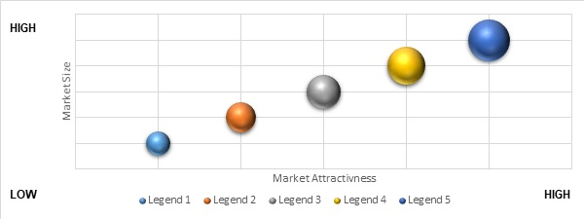

Source: Custom Market Insights Analysis 2023

#### {/Segment}

## {Keyword}Market Snapshot

The demand for the {Keyword} Market 2022 – 2030 was valued at USD XX Million in 2021 is expected to reach USD XX Million in 2030 growing at a CAGR of XX% between 2022 and 2030.

1. **Global {Keyword}Market: Snapshot**

| **PARAMETER** | **2021** | **2030** |
| --- | --- | --- |
| **Global Revenue ({Revenue})** | XX | XX |
| **Global CAGR (%) 2022 - 2030** | Global CAGR: XX% | |
| **{#Segment}By {SegmentName} Segment Share (% revenue basis)** | {#SubSegment}  {SubSegmentName}: XX% {/SubSegment} | {#SubSegment}  {SubSegmentName}: XX% {/SubSegment} |
| **By {SegmentName} Segment CAGR (%) 2022 - 2030** | {#SubSegment}  {SubSegmentName}: XX% {/SubSegment} {/Segment} | |
| **Geography Share (% revenue basis)** | {#RC}  {RegionName}: XX%  {/RC} | {#RC}  {RegionName}: XX%  {/RC} |
| **Geography CAGR (%) 2022 - 2030** | {#RC}  {RegionName}: XX%  {/RC} | |
| **Key Participant Share, 2021 (%)** | {#Company}  {CompanyName}: XX%  {/Company}  Others: XX% | |
| **Drivers** | Driving Factor 1  Driving Factor 2 | |
| **Restraint** | Restraining Factors | |

## Global {Keyword}Market, {FromYear} – {ToYear} ({Revenue})

1. **Global {Keyword}Market Revenue, {FromYear} – {ToYear} ({Revenue})**

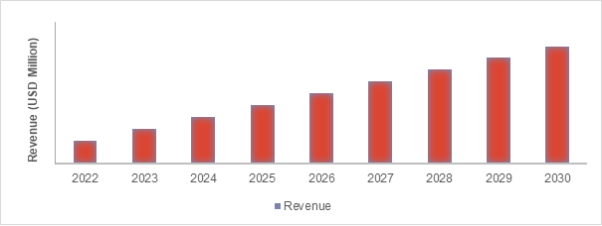

Source: Primary Interviews, Custom Market Insights, 2023

## Insights from Primary Respondents

 

# COVID 19 Impact Analysis

## Impact Assessment of COVID-19 Pandemic, By Region

This updated and latest version of the report would be considering the impact of COVID-19 on the {Keyword} Market 2022 – 2030 across the globe as well as on different regions and individual countries. The effects of the COVID-19 pandemic will be analyzed on the overall industry including both the demand side and supply side perspectives.

The effects of the pandemic would be studied and analyzed for short-term, mid-term, and long-term scenarios. This would assist to formulate business strategies for the period during the pandemic as well as the post-pandemic period for all stakeholders involved in the {Keyword} Market 2022 – 2030 industry including suppliers, manufacturers, vendors, distributors, and end-users.

{#RC}

### {RegionName}: Impact of COVID-19 Pandemic

1. **Impact of COVID-19 Pandemic in {RegionName} Countries**

| **Country** |  | **Low** |  | **Moderate** |  | **High** |
| --- | --- | --- | --- | --- | --- | --- |
| **{#Country}{CountryName}** |  |  |  |  |  | **{/Country}** |

Source: Primary Interviews, Custom Market Insights, 2023

{/RC}

## Key Strategies Undertaken by Companies to Tackle COVID-19

## 

## Quarterly Market Revenue by Region 2020 & 2021

1. **Quarterly {Keyword}Market Revenue by Region, 2020**

| **Region** | **2021 Q1** | **2021 Q2** | **2021 Q3** | **2021 Q4** |
| --- | --- | --- | --- | --- |
| North America | XX | XX | XX | XX |
| Europe | XX | XX | XX | XX |
| Asia Pacific | XX | XX | XX | XX |
| Latin America | XX | XX | XX | XX |
| The Middle-East and Africa | XX | XX | XX | XX |
| Total | XX | XX | XX | XX |

Source: Primary Interviews, Custom Market Insights, 2023

1. **Quarterly {Keyword}Market Revenue by Region, 2021**

| **Region** | **2022 Q1** | **2022 Q2** | **2022 Q3** | **2022 Q4** |
| --- | --- | --- | --- | --- |
| North America | XX | XX | XX | XX |
| Europe | XX | XX | XX | XX |
| Asia Pacific | XX | XX | XX | XX |
| Latin America | XX | XX | XX | XX |
| The Middle-East and Africa | XX | XX | XX | XX |
| Total | XX | XX | XX | XX |

Source: Primary Interviews, Custom Market Insights, 2023

## Pre COVID-19 Market Revenue, By Region, 2016-2019 ({Revenue})

1. **Pre COVID-19 Market Revenue, By Region, 2016-2019 ({Revenue})**

| Region | 2016 | 2017 | 2018 | 2019 |
| --- | --- | --- | --- | --- |
| North America | XX | XX | XX | XX |
| Europe | XX | XX | XX | XX |
| Asia Pacific | XX | XX | XX | XX |
| Latin America | XX | XX | XX | XX |
| The Middle-East and Africa | XX | XX | XX | XX |
| **Total** | **XX** | **XX** | **XX** | **XX** |

Source: Primary Interviews, Custom Market Insights, 2023

## Post COVID-19 Market Revenue, By Region, 2020-2030 ({Revenue})

1. **Post COVID-19 Market Revenue, By Region, 2020-2030 ({Revenue})**

| Region | 2020 | 2021 | 2022 | 2023 | 2024 | 2025 | 2026 | 2027 | 2028 | 2029 | 2030 | CAGR (%) 2022 -2030 |
| --- | --- | --- | --- | --- | --- | --- | --- | --- | --- | --- | --- | --- |
| North America | XX | XX | XX | XX | XX | XX | XX | XX | XX | XX | XX | XX% |
| Europe | XX | XX | XX | XX | XX | XX | XX | XX | XX | XX | XX | XX% |
| Asia Pacific | XX | XX | XX | XX | XX | XX | XX | XX | XX | XX | XX | XX% |
| Latin America | XX | XX | XX | XX | XX | XX | XX | XX | XX | XX | XX | XX% |
| The Middle-East and Africa | XX | XX | XX | XX | XX | XX | XX | XX | XX | XX | XX | XX% |
| **Total** | **XX** | **XX** | **XX** | **XX** | **XX** | **XX** | **XX** | **XX** | **XX** | **XX** | **XX** | **XX%** |

Source: Primary Interviews, Custom Market Insights, 2023

## Short Term Dynamics



## Long Term Dynamics



{#Segment}

{@pageBreak}

# {Keyword}Market – By {SegmentName} Segment Analysis

## {Keyword}Market Overview, by {SegmentName} Segment



### {Keyword}Market Revenue Share, By {SegmentName}, 2021 & 2030

1. **{Keyword}Market Revenue Share, By {SegmentName}, 2021 & 2030**

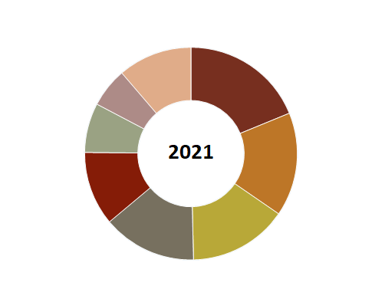 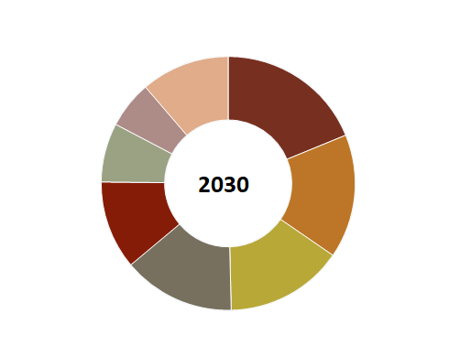

Source: Primary Interviews, Custom Market Insights, 2023

## {#SubSegment}

## {SubSegmentName}

1. **Global {Keyword} Market for {SubSegmentName}, Revenue ({Revenue}) {FromYear} – {ToYear}**

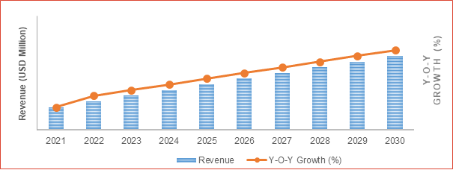

Source: Custom Market Insights Analysis 2023

### {Keyword} Share Forecast, By Region ({Revenue})

1. **{Keyword} Market, By Region, 2016 – 2021 ({Revenue})**

| Region | 2016 | 2017 | 2018 | 2019 | 2020 | 2021 |
| --- | --- | --- | --- | --- | --- | --- |
| {#RC}{RegionName} | XX | XX | XX | XX | XX | XX{/RC} |
| **Total** | **XX** | **XX** | **XX** | **XX** | **XX** | **XX** |

Source: Primary Interviews, Custom Market Insights, 2023

1. **{Keyword} Market Revenue, By Region, 2022 – 2030 ({Revenue})**

| Region | 2022 | 2023 | 2024 | 2025 | 2026 | 2027 | 2028 | 2029 | 2030 | CAGR |
| --- | --- | --- | --- | --- | --- | --- | --- | --- | --- | --- |
| {#RC}{RegionName} | XX | XX | XX | XX | XX | XX | XX | XX | XX | XX%{/RC} |
| **Total** | **XX** | **XX** | **XX** | **XX** | **XX** | **XX** | **XX** | **XX** | **XX** | **XX%** |

Source: Primary Interviews, Custom Market Insights, 2023

### Comparative Revenue Analysis, By Country, 2021 & 2030

1. **Comparative Revenue Analysis of {Keyword} Market for {SubSegmentName}, by Country Revenue ({Revenue}) {FromYear} – {ToYear}**

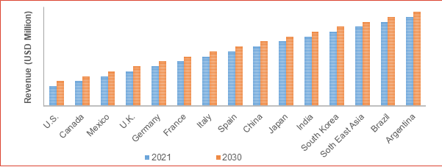

Source: Custom Market Insights Analysis 2023

### Key Market Trends, Growth Factors, & Opportunities



{/SubSegment}

{/Segment}

# {Keyword}Market – Regional Analysis

## {Keyword}Market Overview, by Region Segment

Regionally, the Market for {Keyword} is fragmented into North America, Latin America, Asia-Pacific, Europe, and Middle East & Africa.



### Global {Keyword}Market Revenue Share, By Region, 2021 & 2030

1. **Global {Keyword}Market Revenue Share, By Region, 2021 & 2030**

 

Source: Primary Interviews, Custom Market Insights, 2023

### Global {Keyword}Market Revenue, By Region, {FromYear} – {ToYear} ({Revenue})

1. **Global {Keyword} Market Revenue, By Region, 2016 – 2021 ({Revenue})**

| Region | 2016 | 2017 | 2018 | 2019 | 2020 | 2021 |
| --- | --- | --- | --- | --- | --- | --- |
| {#RC}{RegionName} | XX | XX | XX | XX | XX | XX{/RC} |
| **Total** | **XX** | **XX** | **XX** | **XX** | **XX** | **XX** |

Source: Primary Interviews, Custom Market Insights, 2023

1. **Global {Keyword}Market Revenue, By Region, 2022 – 2030 ({Revenue})**

| Region | 2022 | 2023 | 2024 | 2025 | 2026 | 2027 | 2028 | 2029 | 2030 | CAGR |
| --- | --- | --- | --- | --- | --- | --- | --- | --- | --- | --- |
| {#RC}{RegionName} | XX | XX | XX | XX | XX | XX | XX | XX | XX | XX%{/RC} |
| **Total** | **XX** | **XX** | **XX** | **XX** | **XX** | **XX** | **XX** | **XX** | **XX** | **XX%** |

Source: Primary Interviews, Custom Market Insights, 2023

### {#Segment}

### Global {Keyword}Market Revenue, By {SegmentName}, {FromYear} – {ToYear}

1. **Global {Keyword}Market Revenue, By {SegmentName}, 2016 – 2021 ({Revenue})**

| By {SegmentName} | 2016 | 2017 | 2018 | 2019 | 2020 | 2021 |
| --- | --- | --- | --- | --- | --- | --- |
| {#SubSegment}{SubSegmentName} | XX | XX | XX | XX | XX | XX{/SubSegment} |
| **Total** | **XX** | **XX** | **XX** | **XX** | **XX** | **XX** |

Source: Primary Interviews, Custom Market Insights, 2023

1. **Global {Keyword}Market Revenue, By {SegmentName}, 2022 – 2030 ({Revenue})**

| By {SegmentName} | 2022 | 2023 | 2024 | 2025 | 2026 | 2027 | 2028 | 2029 | 2030 | CAGR |
| --- | --- | --- | --- | --- | --- | --- | --- | --- | --- | --- |
| {#SubSegment}{SubSegmentName} | XX | XX | XX | XX | XX | XX | XX | XX | XX | XX%{/SubSegment} |
| **Total** | **XX** | **XX** | **XX** | **XX** | **XX** | **XX** | **XX** | **XX** | **XX** | **XX%** |

Source: Primary Interviews, Custom Market Insights, 2023

{/Segment}

## {#RC}

## {RegionName}

1. **{RegionName} {Keyword}Market Revenue, 2016 - 2030 ({Revenue})**



Source: Primary Interviews, Custom Market Insights, 2023

### {RegionName} {Keyword}Market Revenue, By Country, {FromYear} – {ToYear} ({Revenue})

1. **{RegionName} {Keyword}Market Revenue, By Country, 2016 – 2021 ({Revenue})**

| Country | 2016 | 2017 | 2018 | 2019 | 2020 | 2021 |
| --- | --- | --- | --- | --- | --- | --- |
| {#Country}{CountryName} | XX | XX | XX | XX | XX | XX{/Country} |
| **Total** | **XX** | **XX** | **XX** | **XX** | **XX** | **XX** |

Source: Primary Interviews, Custom Market Insights, 2023

1. **{RegionName} {Keyword}Market Revenue, By Country, 2022 – 2030 ({Revenue})**

| Country | 2022 | 2023 | 2024 | 2025 | 2026 | 2027 | 2028 | 2029 | 2030 | CAGR |
| --- | --- | --- | --- | --- | --- | --- | --- | --- | --- | --- |
| {#Country}{CountryName} | XX | XX | XX | XX | XX | XX | XX | XX | XX | XX%{/Country} |
| **Total** | **XX** | **XX** | **XX** | **XX** | **XX** | **XX** | **XX** | **XX** | **XX** | **XX%** |

Source: Primary Interviews, Custom Market Insights, 2023

### {#Segment}

### {RegionName} {Keyword}Market Revenue, By {SegmentName}, {FromYear} – {ToYear}

1. **{RegionName} {Keyword}Market Revenue, By {SegmentName}, 2016 – 2021 ({Revenue})**

| By {SegmentName} | 2016 | 2017 | 2018 | 2019 | 2020 | 2021 |
| --- | --- | --- | --- | --- | --- | --- |
| {#SubSegment}{SubSegmentName} | XX | XX | XX | XX | XX | XX{/SubSegment} |
| **Total** | **XX** | **XX** | **XX** | **XX** | **XX** | **XX** |

Source: Primary Interviews, Custom Market Insights, 2023

1. **{RegionName} {Keyword}Market Revenue, By {SegmentName}, 2022 – 2030 ({Revenue})**

| By {SegmentName} | 2022 | 2023 | 2024 | 2025 | 2026 | 2027 | 2028 | 2029 | 2030 | CAGR |
| --- | --- | --- | --- | --- | --- | --- | --- | --- | --- | --- |
| {#SubSegment}{SubSegmentName} | XX | XX | XX | XX | XX | XX | XX | XX | XX | XX%{/SubSegment} |
| **Total** | **XX** | **XX** | **XX** | **XX** | **XX** | **XX** | **XX** | **XX** | **XX** | **XX%** |

Source: Primary Interviews, Custom Market Insights, 2023

{/Segment}

{#Country}

### {CountryName} {Keyword}Market Revenue, 2016 - 2030 ({Revenue})

{#Segment}

1. **{CountryName} {Keyword}Market Revenue, By {SegmentName}, 2016 – 2021 ({Revenue})**

| By {SegmentName} | 2016 | 2017 | 2018 | 2019 | 2020 | 2021 |
| --- | --- | --- | --- | --- | --- | --- |
| {#SubSegment}{SubSegmentName} | XX | XX | XX | XX | XX | XX{/SubSegment} |
| **Total** | **XX** | **XX** | **XX** | **XX** | **XX** | **XX** |

Source: Primary Interviews, Custom Market Insights, 2023

1. **{CountryName} {Keyword}Market Revenue, By {SegmentName}, 2022 – 2030 ({Revenue})**

| By {SegmentName} | 2022 | 2023 | 2024 | 2025 | 2026 | 2027 | 2028 | 2029 | 2030 | CAGR |
| --- | --- | --- | --- | --- | --- | --- | --- | --- | --- | --- |
| {#SubSegment}{SubSegmentName} | XX | XX | XX | XX | XX | XX | XX | XX | XX | XX%{/SubSegment} |
| **Total** | **XX** | **XX** | **XX** | **XX** | **XX** | **XX** | **XX** | **XX** | **XX** | **XX%** |

Source: Primary Interviews, Custom Market Insights, 2023

{/Segment}

{/Country}

{/RC}

# {Keyword}Market – Industry Analysis

## Introduction



## Market Drivers

1. **Drivers for the {Keyword}Market: Impact Analysis**

| **Market Drivers** | **2016-19** | **2020-23** | **2024-30** |
| --- | --- | --- | --- |
| **Impact** | | |
| **Market Driver 1** | XX | XX | XX |
| **Market Driver 2** | XX | XX | XX |

Source: Primary Interviews, Custom Market Insights, 2023

### Driving Factor 1 Analysis





### Driving Factor 2 Analysis





## Market Restraints

1. **Restraints for the {Keyword}Market: Impact Analysis**

| **Market Drivers** | **2016-19** | **2020-23** | **2024-30** |
| --- | --- | --- | --- |
| **Impact** | | |
| **Market Restraints 1** | XX | XX | XX |
| **Market Restraints 2** | XX | XX | XX |

### Restraining Factor Analysis



## Market Opportunities

### Market Opportunity Analysis



## Porter’s Five Forces Analysis

|  |  |  |  |  |
| --- | --- | --- | --- | --- |
| **DEGREE OF COMPITITION** | **SUPPLIER’S POWER** | **BUYER’S POWER** | **TRHEAT OF SUBSTITUTE** | **TRHEAT OF**  **NEW ENTRANTS** |
| * List * List | * List | * List | * List | * List |

Source: Custom Market Insight Analysis 2023

## PEST Analysis

|  | * List |
| --- | --- |
|  | * List |
|  | * List |
|  | * List |
|  | * List |
|  | * list |

Source: Custom Market Insight Analysis 2023

## Regulatory Landscape



## Technology Landscape



## Regional Market Trends

### North America

### 

### Europe



### Asia Pacific



### Latin America



### The Middle-East and Africa



## Downstream Buyers

1. **Distributors/Traders List of {Keyword} Market**

| **MAJOR BUYER** | **MAJOR BUYER** | **LOCATION** |
| --- | --- | --- |
| **{#Company}** | **XX** | **XX {/Company}** |

Source: Custom Market Insights Analysis 2023

## Distributors/Traders List

1. **Distributors/Traders List of {Keyword} Market**

| **REGION** | **DISTRIBUTORS/TRADERS** | **CONTACT INFORMATION** |
| --- | --- | --- |
| **{#RC}** | **XX** | **XX** |
| **XX** | **XX{/RC}** |

Source: Custom Market Insights Analysis 2023

## Value Chain Analysis

|  | **RAW MATERIAL / COMPONENT SUPPLIERS** | |  |
| --- | --- | --- | --- |
| **Key {SegmentName1}s:** | | **Key Manufacturers/ Assemblers/OEMs** | |
| * **List** | | * List | |
|  | | | |
|  | **MANUFACTURERS / ASSEMBLERS / OEMS** | |  |
| **Key {SegmentName1}s:** | | **Key Manufacturers/ Assemblers/OEMs** | |
| * **List** | | * List | |
|  | | | |
|  | **DISTRIBUTORS** | |  |
| **Key {SegmentName1}s:** | | **Key Manufacturers/ Assemblers/OEMs** | |
| * **List** | | * List | |
|  | | | |
|  | **RETAILERS AND  ONLINE SALES** | | **------** |
| **Key {SegmentName1}s:** | | **Key Manufacturers/ Assemblers/OEMs** | |
| * **List** | | * List | |
|  | | | |
|  | **END-USERS** | |  |
| **Key {SegmentName1}s:** | | **Key Manufacturers/ Assemblers/OEMs** | |
| * **List** | | * List | |
| Source: Custom Market Insight Analysis 2023 | | | |

# Competitive Landscape

## Company Market Share Analysis – 2021

### Global {Keyword}Market: Company Market Share, 2021

1. **Company Share Analysis, 2021**

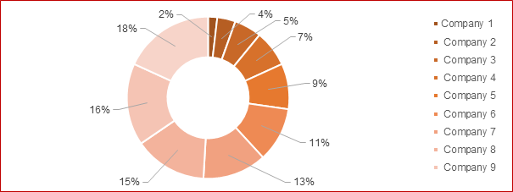

Source: Primary Interviews, Custom Market Insights, 2023

## Global {Keyword} Market Company Market Share, 2021

1. **{Keyword} Market – Company Market Share**

| **Company Name** | **Market Revenue (USD Million)** | **Market Share (%)** |
| --- | --- | --- |
| **{#Company}** | **XX** | **XX{/Company}** |

## Strategic Developments

### Acquisitions & Mergers

| **Date** | **Company** | **Development** |
| --- | --- | --- |
| March, 2017 | XXXXX | XXXXX |
| April, 2018 | XXXXX | XXXXX |
| September, 2018 | XXXXX | XXXXX |

Source: Primary Interviews, Custom Market Insights, 2023

### New Product Launch

| **Date** | **Company** | **Development** |
| --- | --- | --- |
| January, 2020 | XXXXX | XXXXX |
| August, 2019 | XXXXX | XXXXX |
| December, 2018 | XXXXX | XXXXX |

Source: Primary Interviews, Custom Market Insights, 2023

### Regional Expansion

| **Date** | **Company** | **Development** |
| --- | --- | --- |
| May, 2019 | XXXXX | XXXXX |
| April, 2017 | XXXXX | XXXXX |
| October, 2016 | XXXXX | XXXXX |

Source: Primary Interviews, Custom Market Insights, 2023

## Company Strategic Developments – Heat Map Analysis

1. **Company Strategic Developments – Heat Map Analysis**

| **Company Name** | **Acquisitions & Mergers** | **New Product Launch** | **Regional Expansion** | **Partnership / Collaborations** |
| --- | --- | --- | --- | --- |
|  |  |  |  |  |
|  |  |  |  |  |
|  |  |  |  |  |
|  |  |  |  |  |
|  |  |  |  |  |
|  |  |  |  |  |
|  |  |  |  |  |
|  |  |  |  |  |
|  |  |  |  |  |
|  |  |  |  |  |
| |  | Depicts High | | --- | --- | |  | Depicts Moderate | |  | Depicts Low | | | | | |

Source: Custom Market Insights Analysis 2023

# Company Profiles

## {#Company}

## {CompanyName}

| **Address:** | Xx |
| --- | --- |
| **Contact No.:** | Xx |
| **Website:** | Xx |

### Company Overview

xxx

### Key Executives

| **Name** | **Designation** |
| --- | --- |
| XX | CEO |
| XX | President |
| XX | XX |

### Product Portfolio

| **Product** | **Information** |
| --- | --- |
| **XX** | **XXX** |
| **XX** | **XXX** |

Source: Primary Interviews, Custom Market Insights, 2023

### Financial Overview

| **Year** | **2019** | **20202** | **2021** |
| --- | --- | --- | --- |
| Revenue ({Revenue}) | XX | XX | XX |
| R&D Expenditure ({Revenue}) | XX | XX | XX |
| Gross Margin | XX | XX | XX |
| Operating Income | XX | XX | XX |

Source: Primary Interviews, Custom Market Insights, 2023

### Operating Business Segments

| **Segment** | **Description** |
| --- | --- |
| **XX** | **XXX** |
| **XX** | **XXX** |

Source: Primary Interviews, Custom Market Insights, 2023

### Business Performance

1. **{CompanyName} Business Segment Revenue Share, 2021 (%)**

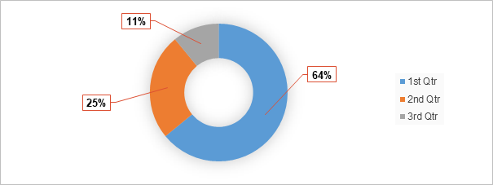

Source: Primary Interviews, Custom Market Insights, 2023

1. **{CompanyName} Geographical Segment Revenue Share, 2021 (%)**

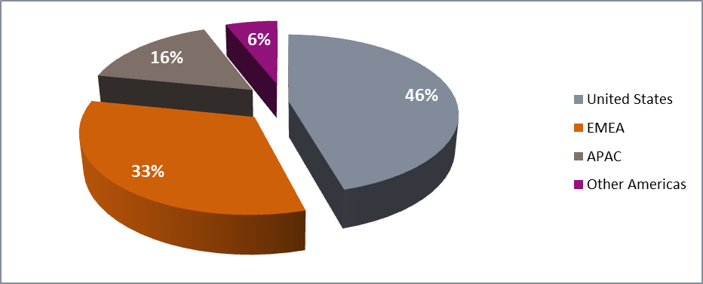

Source: Primary Interviews, Custom Market Insights, 2023

### Recent Developments

| **Date** | **Development** |
| --- | --- |
| **February, 2021** | **XXX** |
| **February, 2021** | **XXX** |
| **October, 2021** | **XXX** |

Source: Primary Interviews, Custom Market Insights, 2023

## {/Company}

# Research Methodology

## Research Methodology

* The research methodology at CMI is iterative in nature is usually conducted in three phases:
* Secondary Research
* Data Modeling
* Primary Research

1. **Research Methodology – Detailed View**

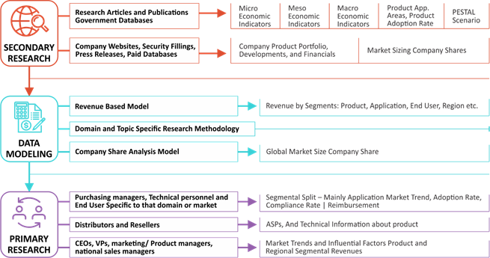

Source: Primary Interviews, Custom Market Insights, 2023

## Phase I - Secondary Research

Understanding the scope, we commenced our study with in-depth and extensive secondary research. Data for secondary research is procured from public and paid sources. The secondary research sources that are typically referred to include, but are not limited to:

* Company websites, annual reports, financial reports, broker reports, investor presentations, and SEC filings
* Internal and external proprietary databases, relevant patent and regulatory databases
* National government documents, statistical databases, and market reports
* News articles, press releases and web-casts specific to the companies operating in the market

Some sources for paid secondary research include, but are not limited to: Factiva, Hoovers, and Statista

1. **Research Methodology**
2. 

Source: Primary Interviews, Custom Market Insights, 2023

## Phase II - Data Modeling

Data procured from secondary sources is then used across different market sizing models and estimates are derived in order to produce comprehensive data sets. A rigorous methodology is adopted in which the available hard data is cross referenced with the following data types to produce estimates:

* Demographic data: Population split
* Macro-economic indicators: GDP
* Industry indicators: Expenditure, product stage & infrastructure, sector growth and facilities.

Data is then cross checked by the expert panel.

### Company Share Analysis Model

Company share analysis is used to derive the size of global Market. As well as study of revenues of companies for last three to five years also provide the base for forecasting the Market size and its growth rate. This model is built in following steps: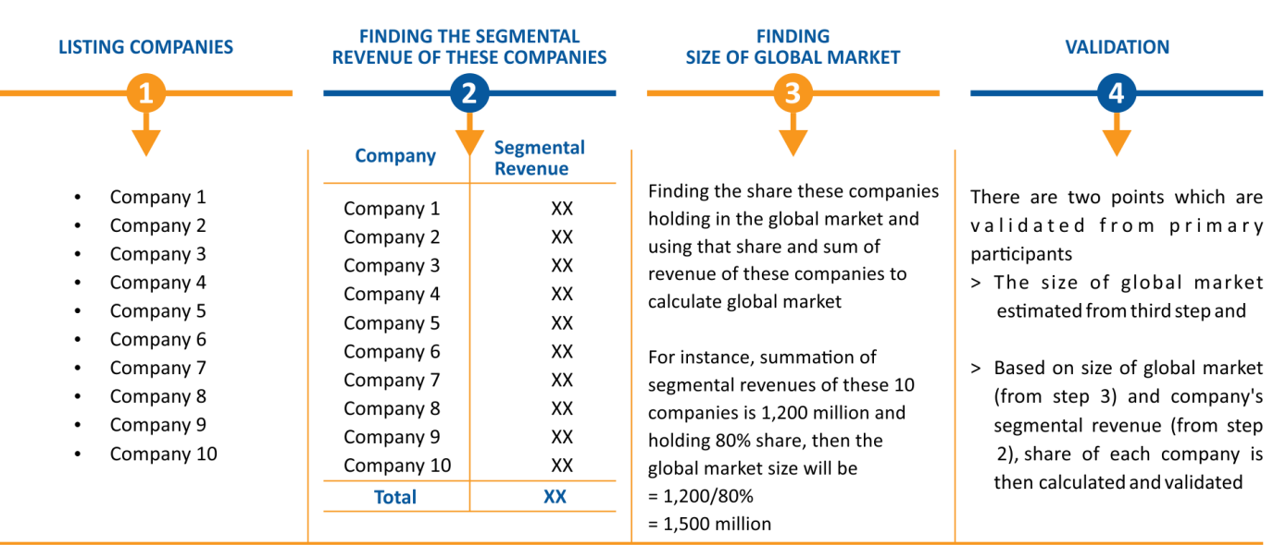

### Revenue Based Modeling

Revenue based models can be built in two ways – Top-Down or Bottom-Up irrespective of industry. Market size estimated from company share analysis acts as a validation point for bottom-up approach whereas it acts as a starting point for top-down approach.

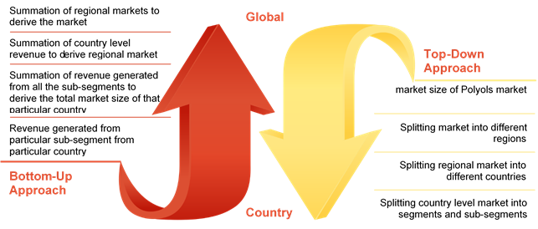

## Phase III - Primary Research

Information from secondary is used to build data models. The results obtained from data models are then validated from primary participants. Then cycle repeats where, according to inputs from primary participants, additional secondary research is done and new information is again incorporated into the data model. The process continues till the desired level of information is generated.

We conduct primary interviews on an ongoing basis with industry participants and commentators in order to validate data and analysis. A typical research interview fulfills the following functions:

* It provides first-hand information on the market size, market trends, growth trends, competitive landscape, and future outlook.
* Helps in validating and strengthening the secondary research findings
* Further develops the analysis team’s expertise and market understanding
* Primary research involves E-mail interactions, telephonic interviews as well as face-to-face interviews for each market, category, segment, and sub-segment across geographies

The participants who typically take part in such a process include, but are not limited to:

* Industry participants: CEOs, VPs, marketing/ product managers, market intelligence managers, and national sales managers
* Purchasing managers, technical personnel, distributors and resellers
* Outside experts: Investors, valuation experts, research analysts specializing in specific markets
* Key opinion leaders specializing in different areas corresponding to different industry verticals

## Research Limitations

Inflation is not a part of pricing in this report. Prices of {Keyword} and its derivatives vary in each region and hence similar revenue ratio does not follow for each individual region. The same price for each type has been taken into account while estimating and forecasting Market revenue on a global basis. The regional average price has been considered while breaking down this Market by applications in each region.

This report provides Market size of {Keyword} for the past four years and forecasts for the next seven years. The global {Keyword}Market size is given in terms of revenue. Market revenue is defined in USD Million. Market numbers are given on the basis of different {Keyword} . Market size and forecasts for each major distribution channel is provided in the context of global as well as the regional Market.

The numbers provided in this report are derived on the basis of demand for {Keyword} from different applications in different regions.

### Assumptions

| **FACTORS** | **ASSUMPTIONS** |
| --- | --- |
| **Exchange Rates** | We have assumed that U.S. dollar fluctuations will not be severe enough to affect the forecasts to a significant extent. |
| **Political Unrest** | We have assumed political stability in the regions covered and any instability will not hamper the economic growth to the level which will affect our forecasts. |
| **Government Spending** | A stable government spending pattern is considered during the forecast period. |

Disclaimer

Any part of this report cannot be reproduced, kept in a retrieval system or transmitted in any kind by any means, electronic, mechanical, photocopying, recording or otherwise, without the prior permission of the publisher, **Custom Market Insight**.

The information and opinions in this report were prepared by **Custom Market Insight**. The information herein is believed to be reliable and has been obtained from public source believed to be reliable. All info provided in this report is provided for information purposes solely.

The facts of this report are believed to be correct at the time of publication however cannot be assured. Please note that the judgments, conclusions and recommendations that **Custom Market Insight** delivers can be based on information gathered in good faith from each primary and secondary sources, we have a tendency to be always in a position to ensure.

Research can initiate, update and cease coverage alone at the discretion of **Custom Market Insight**.

**Custom Market Insight** has no obligation to notify a recipient thereof within the event that any estimation, forecast, changes or subsequently becomes inaccurate.

As such **Custom Market Insight** will accept no liability whatever for actions taken based mostly on any information that could subsequently prove to be incorrect.

**Asia Pacific Office**

CMI Market Research Pvt Ltd.

B 701, Basileo,

MS Kate Chowk, Pimple Gurav,

Pune 411061 India

Office No. 020 46022736

sales, support & inquiry

support@custommarketinsights.com

**Corporate Office**

CMI Consulting LLC,

1333, 701 Tillery Street Unit 12,

Austin, TX, Travis, US, 78702

Phone No +1 801 639 9061

sales, support & inquiry

support@custommarketinsights.com