FAST NATIONAL UNIVERSITY
Department of Computer Science

Fundamentals of Software Engineering
Spring 2026

PROJECT:
LogHorizon
Modernized Full-Stack Content Indexing Platform

Deliverable: | D1 — Sprint 1 Report
Date: | 24 March 2026
Iteration: | Sprint 1

Group Members

Name | Roll No. | Role
Azan Wasty | 24L-2557 | Lead Architect
Mahareb Ammar | 24L-2540 | Frontend Developer
Ali Naveed | 24L-2579 | Tester

1. Project Title and Introduction

1.1 Project Title
LogHorizon: Modernized Full-Stack Content Indexing Platform

1.2 Introduction
LogHorizon is a comprehensive, full-stack content management and discovery platform designed to serve as a centralized hub for tracking and exploring diverse media types including Anime, Manga, Movies, TV Series, and Books. The platform is developed as part of the Fundamentals of Software Engineering course at FAST-NUCES, Spring 2026.

The motivation behind LogHorizon is to replace fragmented, manually maintained content lists with an intelligent, automated system that fetches metadata from industry-standard APIs (Jikan, TMDB, Google Books), stores it in a structured relational database, and presents it through a polished, modern interface.

Sprint 1 focuses on establishing the foundational architecture: a secure, layered backend using Node.js and Express with Prisma ORM connected to Microsoft SQL Server, a React-based frontend styled with the "Void Codex" Electric Purple dark-mode design system, and automated ingestion pipelines that populate the platform with rich content metadata.

Key goals of Sprint 1:
- Deliver a secure authentication system with JWT and Role-Based Access Control (RBAC).
- Build an automated metadata ingestion pipeline covering all five content types.
- Implement the Void Codex UI — a premium dark-mode interface with Framer Motion animations.
- Establish an admin panel for user management, content moderation, and tag administration.
- Introduce the Neural Nodes preference system as a foundation for future recommendations.

2. User Stories
The following user stories represent the functional requirements identified for Sprint 1 of LogHorizon. Each story follows the standard template: Story ID, Title, Priority, Estimated Hours, User Story statement, Description, Sub User Stories, and Acceptance Criteria.

US-01: User Registration and Authentication
Story ID: US-01 Story Title: User Registration & Authentication | Priority: High  Estimated Hours: 8
User Story:
As a user, I want to register and log in securely so that I can access my personalized content dashboard.
Description:
This story covers the complete authentication lifecycle including user registration with validation, secure login with JWT token issuance, and role-based access enforcement throughout the application.
Sub User Stories:
- As a new user, I want to register with my email and password.
- As a registered user, I want to log in and receive a secure token.
- As an admin, I want certain routes to be restricted to authorized roles only.
- As a user, I want my session to persist across page refreshes.
Acceptance Criteria:
- Registration must validate email format and enforce minimum password length.
- Login must return a signed JWT token on success.
- Protected routes must reject requests without a valid token.
- Role-based middleware must block unauthorized access with HTTP 403.

US-02: Automated Content Ingestion
Story ID: US-02 Story Title: Automated Content Ingestion | Priority: High  Estimated Hours: 12
User Story:
As an admin, I want the system to automatically fetch and store metadata for Anime, Manga, Movies, TV, and Books so that the platform is populated without manual data entry.
Description:
This story involves building ingestion pipelines that connect to third-party APIs (Jikan for Anime/Manga, TMDB for Movies/TV, Google Books API for Books), transform the returned data to match the internal schema, and persist it in the SQL Server database via Prisma ORM.
Sub User Stories:
- As an admin, I want to trigger ingestion for Anime from the Jikan API.
- As an admin, I want to trigger ingestion for Movies and TV from TMDB.
- As an admin, I want to trigger ingestion for Books from Google Books API.
- As an admin, I want the system to handle duplicate entries gracefully.
Acceptance Criteria:
- Ingestion endpoint must successfully fetch and store at least 20 records per content type.
- Duplicate detection must prevent re-inserting existing records.
- Failed API calls must be logged without crashing the pipeline.
- Ingested records must include title, description, cover image URL, and genre/tags.

US-03: Admin Panel – Member & Content Management
Story ID: US-03 Story Title: Admin Panel – Member & Content Management | Priority: High  Estimated Hours: 10
User Story:
As an admin, I want a unified panel to manage users, promote members, and moderate content and tags so that I can maintain platform quality.
Description:
This story covers the administrative interface that allows super-users to view all registered members, change user roles (e.g., promote to moderator), manage content entries (edit or remove), and administer the tag taxonomy used to categorize content.
Sub User Stories:
- As an admin, I want to view a list of all registered users.
- As an admin, I want to promote a regular user to moderator role.
- As an admin, I want to edit or delete any content entry.
- As an admin, I want to create, rename, or delete content tags.
Acceptance Criteria:
- Admin panel must be accessible only to users with the 'admin' role.
- User role changes must persist immediately in the database.
- Content edits must update all associated metadata fields.
- Tag deletion must cascade gracefully without breaking existing content entries.

US-04: Void Codex UI – Dark Mode Interface
Story ID: US-04 Story Title: Void Codex UI – Dark Mode Interface | Priority: High  Estimated Hours: 9
User Story:
As a user, I want a premium dark-mode interface with smooth animations so that my browsing experience is visually engaging and comfortable.
Description:
This story involves implementing the complete Void Codex design system — an Electric Purple dark-mode UI built with Tailwind CSS v4, Lucide Icons, and Framer Motion. All components must consistently apply the design tokens and support fluid page transitions.
Sub User Stories:
- As a user, I want the app to render in dark mode by default.
- As a user, I want smooth animated transitions between pages.
- As a user, I want interactive elements to have hover and focus states.
- As a user, I want the UI to be visually consistent across all pages.
Acceptance Criteria:
- All pages must render with the Electric Purple dark-mode color palette.
- Page transitions must use Framer Motion with sub-300ms duration.
- All interactive elements must have clearly visible hover/focus states.
- The design must be responsive on desktop and tablet screen sizes.

US-05: Neural Nodes – User Preference System
Story ID: US-05 Story Title: Neural Nodes – User Preference System | Priority: Medium  Estimated Hours: 6
User Story:
As a user, I want to select my preferred moods, themes, and genres so that the platform can provide personalized content recommendations in the future.
Description:
This story implements the preference selection UI (Neural Nodes) which allows users to tag themselves with mood descriptors, thematic interests, and genre preferences. These selections are stored per-user and will feed into the recommendation engine in future sprints.
Sub User Stories:
- As a user, I want to see a selection screen for moods, themes, and genres.
- As a user, I want to select and deselect multiple preferences.
- As a user, I want my preferences to be saved to my profile.
- As a user, I want to update my preferences at any time.
Acceptance Criteria:
- Preference screen must display at least 10 options per category (Mood, Theme, Genre).
- Selected preferences must be highlighted visually.
- Preferences must persist to the database and be retrievable on next login.
- Updating preferences must reflect changes within the same session.

US-06: Content Search and Discovery
Story ID: US-06 Story Title: Content Search and Discovery | Priority: Medium  Estimated Hours: 7
User Story:
As a user, I want to search and filter content by title, type, or genre so that I can quickly find items I am interested in.
Description:
This story covers the search and filter functionality on the main content listing page. Users can type a search query and optionally filter by content type (Anime, Movie, Book, etc.) and genre tags. Results are returned in real time or near-real time from the backend.
Sub User Stories:
- As a user, I want to search content by title using a search bar.
- As a user, I want to filter results by content type (Anime, Movie, Book, etc.).
- As a user, I want to filter results by genre or tag.
- As a user, I want search results to update without a full page reload.
Acceptance Criteria:
- Search must return results within 500ms for queries against the local database.
- Filters must be combinable (e.g., type + genre simultaneously).
- An empty result state must display a friendly message.
- Search must be case-insensitive and support partial matches.

3. Structured Specifications
The following structured specifications provide formal use-case style definitions for each user story, detailing actors, pre-conditions, main flow, alternative flows, and post-conditions.

US-01 – User Registration and Authentication
Actor | Unregistered Visitor / Registered User
Action | Register a new account or log in to an existing account
Benefit | Gain secure, personalized access to the LogHorizon platform
Pre-conditions | - Application server is running  - Database connection is active  - User is on the login/register page
Main Flow | - User navigates to the Registration page.  - User enters full name, email address, and password.  - System validates input format and checks for duplicate email.  - System hashes the password and stores the user record.  - System issues a signed JWT token and redirects to the dashboard.  - For login: user enters credentials, system validates, issues new token.
Alternative Flow | - Email already exists: system returns HTTP 409 with an appropriate error message.  - Invalid credentials: system returns HTTP 401 and prompts the user to retry.  - Token expiry: system redirects user to the login page with a session-expired message.
Post-conditions | - User record is persisted in the database  - JWT token is issued and stored client-side  - User is redirected to the main dashboard

US-02 – Automated Content Ingestion
Actor | Admin User / System Cron Job
Action | Trigger ingestion of metadata from external APIs
Benefit | Populate the platform with rich, accurate content metadata automatically
Pre-conditions | - Admin is authenticated with admin role  - External API keys (TMDB, Jikan, Google Books) are configured in .env  - Database schema is migrated and ready
Main Flow | - Admin navigates to the Ingestion Panel in the Admin dashboard.  - Admin selects the content type to ingest (Anime, Movie, Book, etc.).  - System calls the relevant external API with appropriate query parameters.  - System receives the response and maps fields to the internal schema.  - System checks for duplicate records before inserting.  - System persists new records to the database and returns a summary report.
Alternative Flow | - API rate limit exceeded: system waits and retries after a cooldown period.  - Network timeout: system logs the error and marks the ingestion as partially complete.  - Schema mismatch: system skips the malformed record and logs a warning.
Post-conditions | - New content records are stored in the database  - Ingestion log entry is created with timestamp and record count  - Admin receives a success/failure summary

US-03 – Admin Panel – Member & Content Management
Actor | Admin User
Action | Manage users, roles, content entries, and tags through the admin panel
Benefit | Maintain platform quality and user governance from a centralized interface
Pre-conditions | - Admin is authenticated with the 'admin' role  - Admin panel route is accessible  - User and content records exist in the database
Main Flow | - Admin navigates to the Admin Panel page.  - Admin selects the 'Members' tab to view all registered users.  - Admin selects a user and chooses 'Promote to Moderator'.  - System updates the user's role in the database.  - Admin navigates to 'Content' tab and selects a content entry to edit or delete.  - Admin navigates to 'Tags' tab to create, rename, or delete tags.
Alternative Flow | - Attempt to demote the only admin: system prevents the action with an error.  - Deleting a tag with associated content: system warns admin before cascading removal.  - Editing content with invalid data: system returns validation errors without saving.
Post-conditions | - User role changes are reflected immediately  - Content edits are saved to the database  - Tag changes propagate across all associated content

US-04 – Void Codex UI – Dark Mode Interface
Actor | Any User
Action | Experience the platform through a premium, animated dark-mode interface
Benefit | Enjoy a visually engaging, comfortable, and consistent browsing experience
Pre-conditions | - Frontend application is running  - Tailwind CSS v4 and Framer Motion are installed  - Design tokens are configured in the Tailwind config
Main Flow | - User opens the application in a browser.  - Application renders in dark mode with the Electric Purple palette by default.  - User navigates between pages; Framer Motion handles animated transitions.  - User interacts with buttons, cards, and inputs; hover/focus states are visible.  - All UI components reflect the Void Codex design system consistently.
Alternative Flow | - Reduced motion preference detected: system disables animations for accessibility.  - Missing design token: component falls back to the nearest defined style.
Post-conditions | - All pages render consistently in the Void Codex design system  - Animations complete within 300ms  - User can navigate the full app without visual inconsistencies

US-05 – Neural Nodes – User Preference System
Actor | Authenticated User
Action | Select and save mood, theme, and genre preferences
Benefit | Enable future personalized content recommendations
Pre-conditions | - User is authenticated  - Preference options are seeded in the database  - User preference table exists in the schema
Main Flow | - User navigates to the Preferences page from their profile.  - System displays categorized preference chips (Mood, Theme, Genre).  - User clicks to select one or more preferences from each category.  - Selected chips are highlighted with the Electric Purple accent.  - User clicks 'Save Preferences'.  - System sends the selection to the backend and updates the user's preference record.
Alternative Flow | - User saves with no preferences selected: system accepts and stores an empty preference set.  - Network error during save: system displays a retry prompt without losing selections.
Post-conditions | - User preference record is updated in the database  - Confirmation message is displayed  - Preferences are retrievable on next login

US-06 – Content Search and Discovery
Actor | Any User (authenticated or guest)
Action | Search and filter content by title, type, and genre
Benefit | Quickly find specific or related content of interest
Pre-conditions | - Frontend search component is rendered  - Backend search endpoint is available  - Content records exist in the database
Main Flow | - User types a query in the search bar on the content listing page.  - Frontend sends a debounced request to the backend search endpoint.  - Backend queries the database with case-insensitive partial matching.  - Results are returned and rendered as content cards.  - User optionally selects a content type filter (Anime, Movie, etc.).  - User optionally selects one or more genre/tag filters.  - Backend applies combined filters and returns the filtered result set.
Alternative Flow | - No results found: system displays an empty state message with a suggestion to broaden the search.  - Search query too short (< 2 chars): system waits for more input before querying.  - Backend error: system displays a friendly error message.
Post-conditions | - Matching content records are displayed to the user  - Applied filters are visually indicated  - Result set updates without full page reload

4. Scrum Board
The Scrum board below represents the state of the Sprint 1 backlog as of the deliverable submission date. Tasks are categorized into Backlog, In Progress, In Review, and Done.

📋 Backlog | 🔄 In Progress | 🔍 In Review | ✅ Done
- User Registration & Login
- JWT Auth + RBAC
- Admin Panel Setup
- Ingestion Pipeline (Anime)
- Ingestion Pipeline (Movies)
- Ingestion Pipeline (Books)
- Ingestion Pipeline (Manga/TV)
- Dark Mode UI Design
- Neural Nodes (Preferences)
- Tag Management
- Content Search
- User Profile Page

📋 Backlog | 🔄 In Progress | 🔍 In Review | ✅ Done
- User Registration & Login  - JWT Auth + RBAC  - Admin Panel Setup  - Ingestion Pipeline (Anime)  - Ingestion Pipeline (Movies)  - Ingestion Pipeline (Books)  - Ingestion Pipeline (Manga/TV)  - Dark Mode UI Design  - Neural Nodes (Preferences)  - Tag Management  - Content Search  - User Profile Page | - Void Codex UI (Sprint 1)  - Member Promotion (Admin)  - Metadata Ingestion API  - Preference Selection System | - JWT Auth Implementation  - DB Schema (Prisma + MSSQL)  - Express Layered Architecture | - Project Scaffolding  - Backend Setup (Express)  - DB Connection (Prisma)  - Frontend Setup (React+Vite)  - Tailwind v4 Integration  - Git Repository Setup

📋 Backlog | 🔄 In Progress | 🔍 In Review | ✅ Done
- User Registration & Login  - JWT Auth + RBAC  - Admin Panel Setup  - Ingestion Pipeline (Anime)  - Ingestion Pipeline (Movies)  - Ingestion Pipeline (Books)  - Ingestion Pipeline (Manga/TV)  - Dark Mode UI Design  - Neural Nodes (Preferences)  - Tag Management  - Content Search  - User Profile Page |  |  | - Project Scaffolding  - Backend Setup (Express)  - DB Connection (Prisma)  - Frontend Setup (React+Vite)  - Tailwind v4 Integration  - Git Repository Setup  - JWT Auth Implementation  - DB Schema (Prisma + MSSQL)  - Express Layered Architecture  - Void Codex UI (Sprint 1)  - Member Promotion (Admin)  - Metadata Ingestion API  - Preference Selection System

5. NFR Specification (Natural Language)
Non-Functional Requirements (NFRs) define the quality attributes that LogHorizon must satisfy beyond its functional behaviour. These are specified using natural language and are accompanied by measurable targets where applicable.

5.1 Performance
The system shall respond to API requests for content listing and search within 500 milliseconds under normal load conditions (up to 50 concurrent users). Page transitions animated by Framer Motion shall complete within 300 milliseconds to ensure a fluid user experience. The ingestion pipeline shall be capable of processing a minimum of 100 records per minute per content type.

5.2 Security
All user passwords shall be hashed using bcrypt with a minimum cost factor of 10 before storage. Authentication tokens shall be JSON Web Tokens (JWT) signed with a secret key, with an expiry of 24 hours. All administrative routes shall enforce Role-Based Access Control (RBAC), rejecting unauthorized requests with HTTP 403. Environment variables containing API keys and database credentials shall never be committed to version control.

5.3 Usability
The interface shall adhere to the Void Codex design system with a consistent color palette, typography, and component styling throughout all pages. All interactive elements (buttons, links, inputs) shall have clearly distinguishable hover and focus states to support keyboard navigation. Error messages shall be presented in plain English with actionable guidance for the user. The preference selection (Neural Nodes) screen shall be completable by a new user within two minutes.

5.4 Reliability
The backend server shall handle unexpected errors gracefully using centralized error handling middleware, ensuring the server does not crash on unhandled exceptions. The ingestion pipeline shall implement retry logic for failed API calls (up to 3 retries with exponential backoff). The system shall maintain data integrity by using Prisma ORM transactions for multi-step database operations.

5.5 Maintainability
The backend shall follow a layered architecture separating Routes, Controllers, and Services to ensure separation of concerns and ease of future modifications. All database schema changes shall be managed through Prisma migrations to maintain a version-controlled schema history. Frontend components shall be modular and reusable, each responsible for a single UI concern.

5.6 Scalability
The database schema shall be designed to accommodate additional content types beyond the initial five (Anime, Manga, Movies, TV, Books) without requiring structural changes to existing tables. The ingestion pipeline architecture shall be extensible to support new third-party API sources through the addition of new service modules without modifying existing pipeline logic.

5.7 NFR Summary Table

# | Category | NFR Statement | Metric / Target | Priority
1 | Performance | API responses shall complete under normal load | < 500ms @ 50 concurrent users | High
2 | Performance | Page transitions shall complete smoothly | < 300ms (Framer Motion) | High
3 | Performance | Ingestion pipeline throughput | >= 100 records/min per type | Medium
4 | Security | Passwords shall be hashed before storage | bcrypt, cost factor >= 10 | Critical
5 | Security | Auth tokens shall have a limited lifespan | JWT, 24-hour expiry | Critical
6 | Security | Admin routes shall enforce RBAC | HTTP 403 on unauthorized access | Critical
7 | Usability | UI shall follow the Void Codex design system | 100% component coverage | High
8 | Usability | Preference screen completable by new user | <= 2 minutes | Medium
9 | Reliability | Server shall not crash on unhandled exceptions | Centralized error middleware | High
10 | Reliability | Ingestion shall retry on API failure | Up to 3 retries w/ backoff | Medium
11 | Maintainability | Backend shall use layered architecture | Routes / Controllers / Services | High
12 | Scalability | Schema shall support new content types | No structural changes required | Medium

6. Iteration 1 Implementation Screenshots
The following screenshots illustrate the key features delivered in Sprint 1 of LogHorizon. Please replace the placeholders below with actual screenshots from the running application.

6.1 User Registration & Login Page
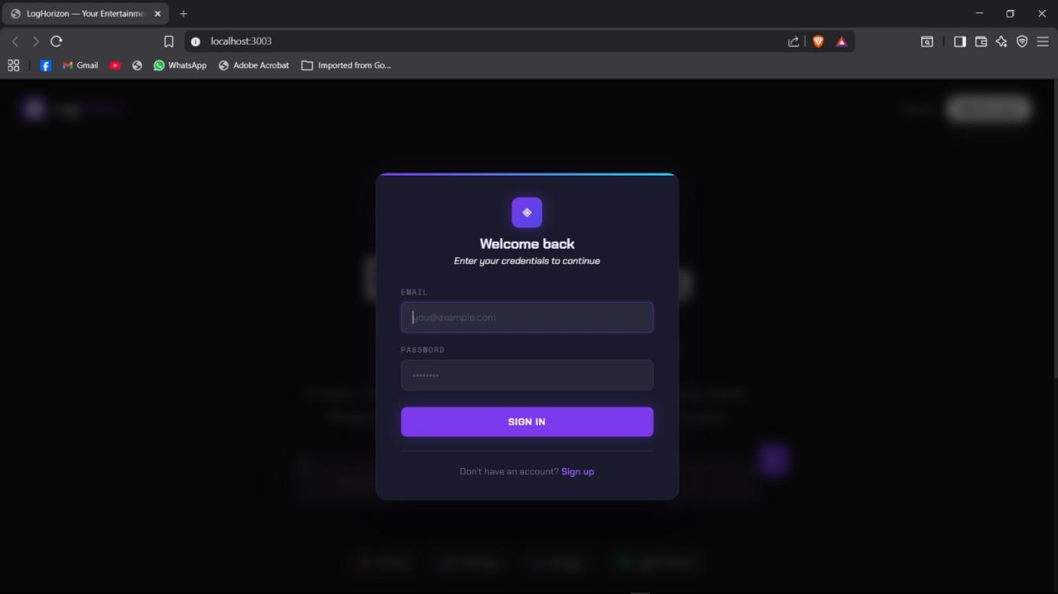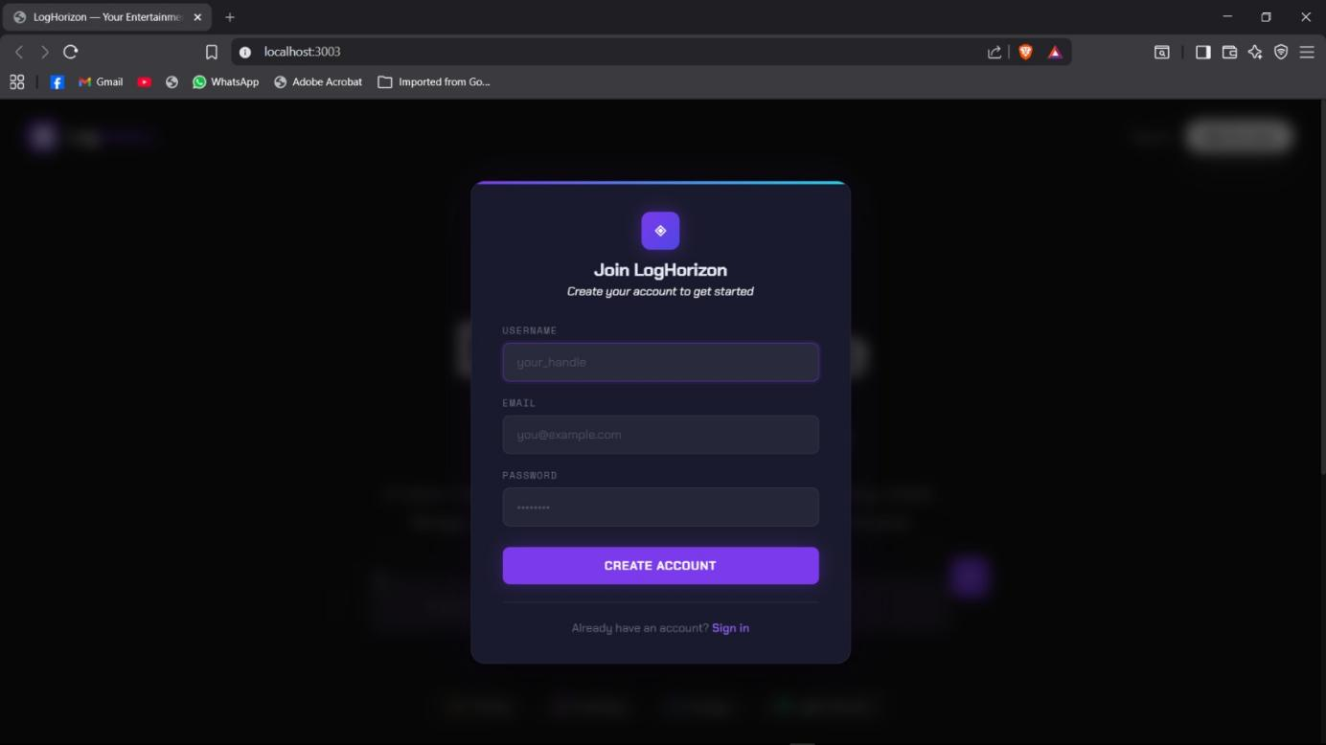

6.2 Main Dashboard / Home Page
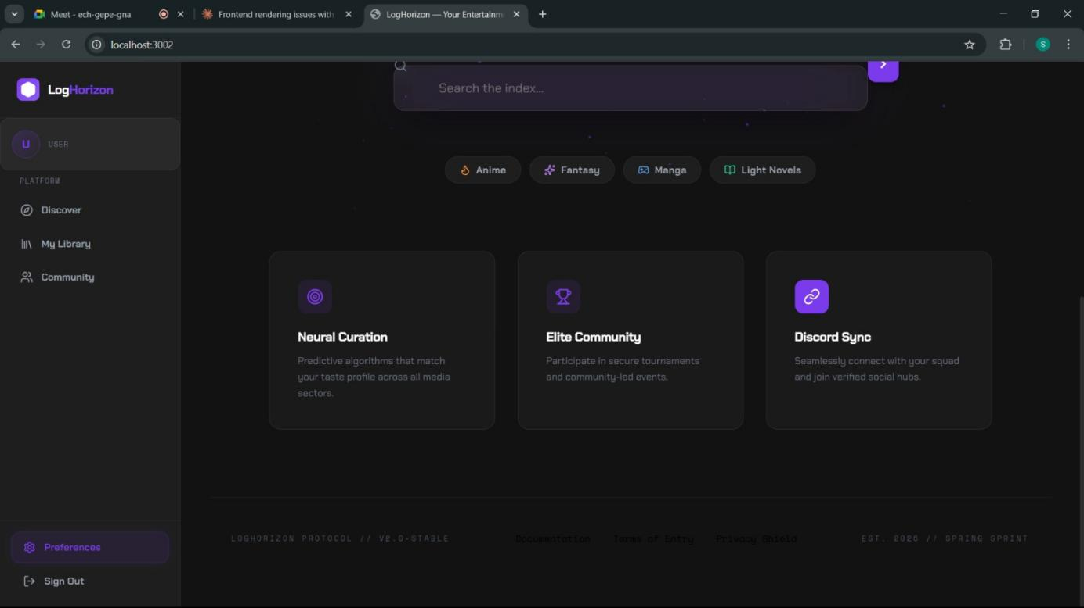I

6.3 Content Listing Page
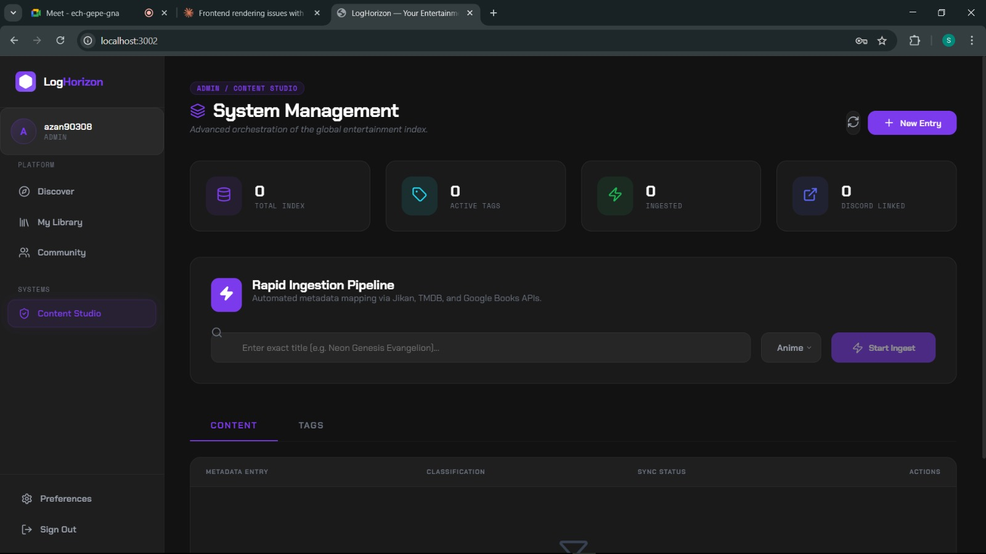

6.4 Admin Panel – Member Management


6.5 Admin Panel – Content & Tag Management
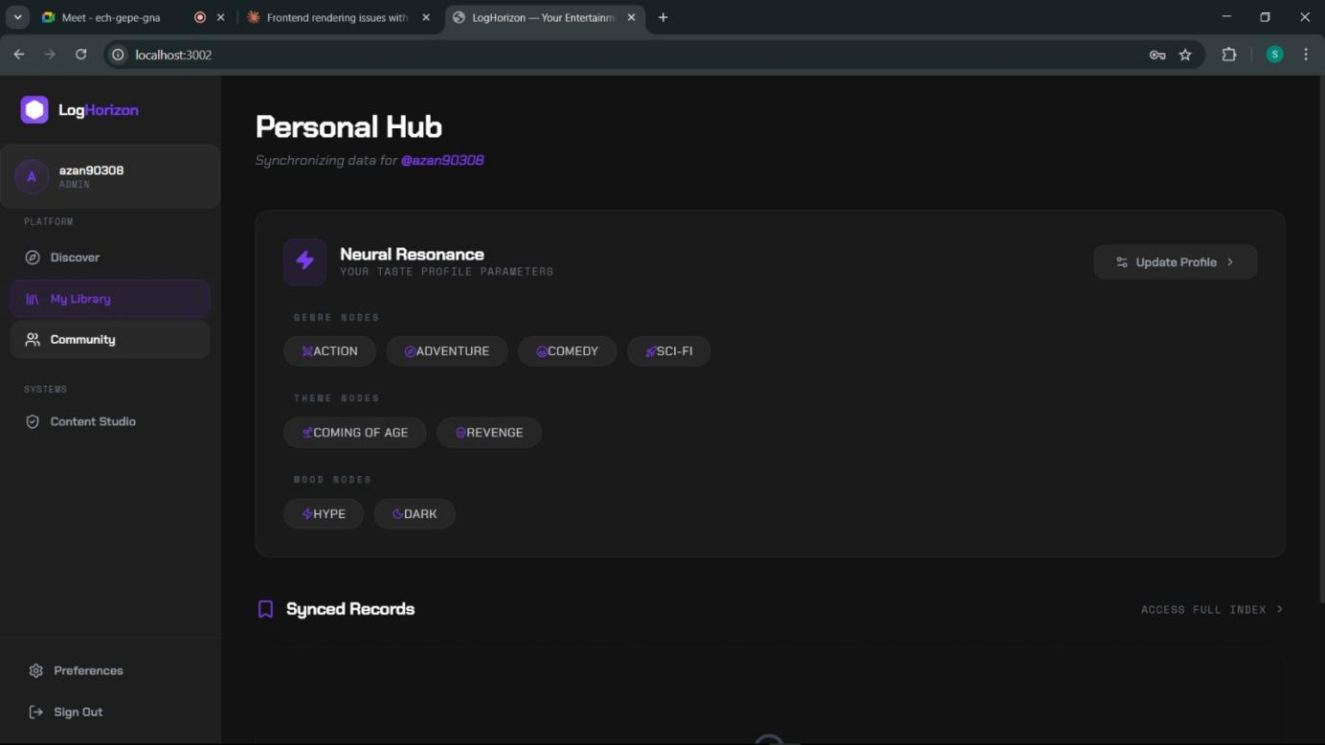

6.6 Neural Nodes – Preference Selection
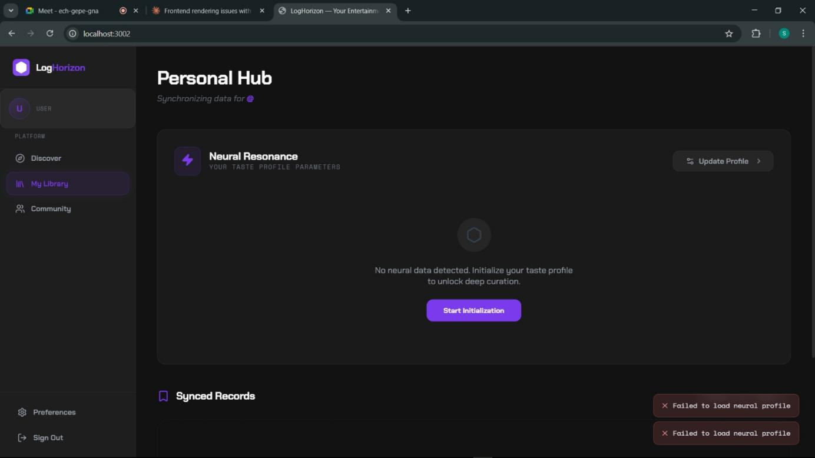

6.7 Content Search & Filter
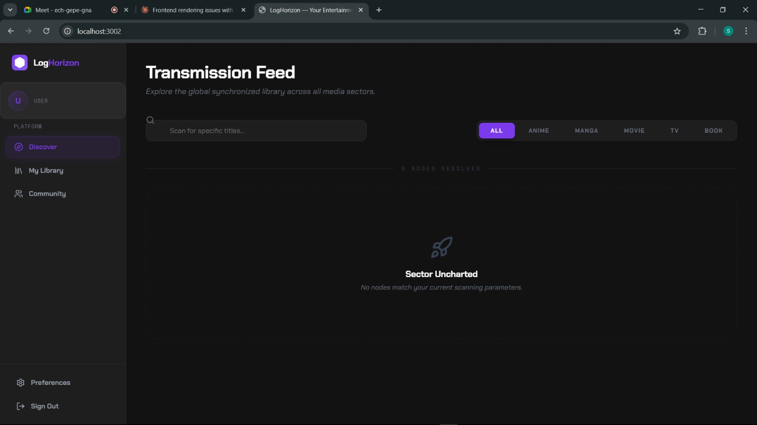

7. Work Division
The following table outlines the contribution of each team member during Sprint 1 of LogHorizon. Hours are estimates based on actual time spent during the sprint.

Member | Role | Responsibilities | Hours
Azan Wasty  24L-2557 | Lead Architect | Backend architecture, Express API design, Prisma schema, JWT auth, ingestion pipeline coordination, project management | 30
Mahareb Ammar  24L-2540 | Frontend Developer | React UI components, Tailwind CSS v4 styling, Void Codex dark mode design, Framer Motion animations, frontend routing | 20
Ali Naveed  24L-2579 | Tester | Test case design, manual testing, bug reporting, API endpoint testing, integration testing, documentation review | 20

7.1 Division Details

Azan Wasty — Lead Architect (24L-2557)
- Designed and implemented the full backend architecture using Express.js with a layered Services/Controllers pattern.
- Authored the Prisma schema targeting Microsoft SQL Server and managed all database migrations.
- Implemented JWT-based authentication and RBAC middleware.
- Built the metadata ingestion service coordinating Jikan, TMDB, and Google Books API calls.
- Managed the Git repository, code reviews, and sprint planning on the Scrum board.
- Authored the API Reference documentation.

Mahareb Ammar — Frontend Developer (24L-2540)
- Implemented the complete Void Codex UI design system using Tailwind CSS v4 and Lucide Icons.
- Built all React components including the dashboard, content listing, admin panel, and Neural Nodes preference screen.
- Integrated Framer Motion for animated page transitions and interactive component states.
- Connected frontend components to backend API endpoints using Axios/Fetch.
- Ensured responsive layout across desktop and tablet screen sizes.

Ali Naveed — Tester (24L-2579)
- Designed and executed manual test cases covering all Sprint 1 user stories.
- Performed API endpoint testing using Postman, verifying request/response schemas.
- Conducted integration testing between the frontend and backend.
- Documented bugs and edge cases in the project issue tracker.
- Reviewed and provided feedback on the D1 report documentation.

Team Member | Estimated Hours
Azan Wasty (24L-2557) | 30
Mahareb Ammar (24L-2540) | 20
Ali Naveed (24L-2579) | 20
TOTAL | 70

