PICKLE CORP™ • COMMERCIAL PREPRESS SPECIFICATION
Official Business Card & Barter Marker
Commercial Print Shop Production Order Document & Prepress Proof
Founders: Azan Abdullah & Thanvi (Age 14) • Marketing: Viren • Studio: Pickle Corp™ • Favors over Fiat ($0.00)
1. Visual Prepress Proofs (Front & Back)
Below are the 300 DPI high-resolution visual proofs for Side A (Front) and Side B (Back). High-res PNG asset files ('business-card-front.png' and 'business-card-back.png') are included in the job folder.
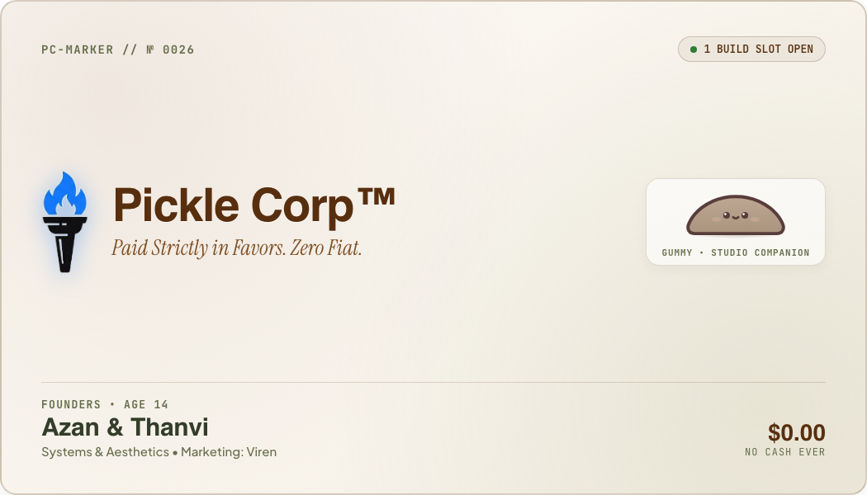
Side A (Front Face) — The Studio Credential (3.5″ × 2.0″ Trim)
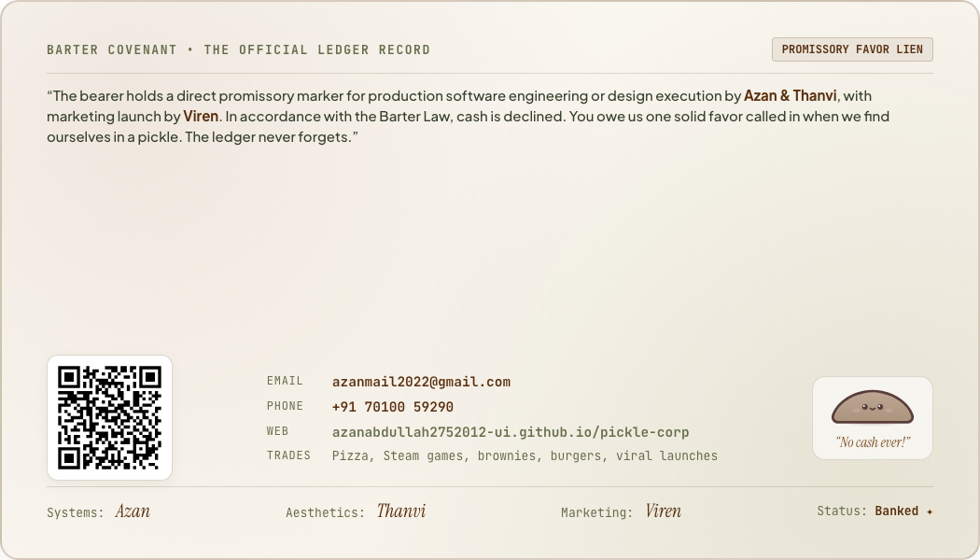
Side B (Back Face) — Barter Covenant & Scannable QR Dispatch (3.5″ × 2.0″ Trim)
2. Technical Print Specifications
Specification Parameter | Production Requirement & Details
Finished Trim Size | 3.5 in × 2.0 in (88.9 mm × 50.8 mm) — Standard Business Card
Full Bleed Canvas | 3.75 in × 2.25 in (95.25 mm × 57.15 mm) [0.125 in / 3.175 mm bleed]
Safe Zone | 3.25 in × 1.75 in (82.55 mm × 44.45 mm) [Keep all critical copy inside]
Orientation | Horizontal / Landscape
Sides / Printing | 2-Sided Full Color Process (4/4 CMYK)
Recommended Stock | 350gsm – 450gsm Premium Cotton Uncoated Matte (Warm Bone / Natural Off-White)
Special Finishes | Front: Blind Deboss on 'Pickle Corp™' title and Torch Mark.  Optional: Warm Gold / Bronze Foil stamping on Torch flame.
Corner Cutting | Standard 90° Clean Square Trim (or 3.5mm rounded radius)
Resolution | 300+ DPI (Vector preferred for text & line art)
Recommended Quantity | 100 / 250 / 500 Cards

3. Exact Word-for-Word Copy Breakdown
SIDE A (FRONT) COPY:
• Top Left Telemetry: PC-MARKER // № 0026
• Top Right Status: ● 1 BUILD SLOT OPEN
• Central Graphic: Pickle Corp Torch Logo (logo-torch.png)
• Main Title: Pickle Corp™ (Cabinet Grotesk 900)
• Sub-Motto: Paid Strictly in Favors. Zero Fiat. (Instrument Serif Italic)
• Identity Tag: Founders • Age 14
• Founder Names: Azan & Thanvi
• Focus: Systems & Aesthetics • Marketing: Viren
• Bottom Right: $0.00 / No Cash Ever
SIDE B (BACK) COPY:
• Header: BARTER COVENANT • THE OFFICIAL LEDGER RECORD (PROMISSORY FAVOR LIEN)
• Covenant Text: “The bearer holds a direct promissory marker for production software engineering or design execution by Azan & Thanvi, with marketing launch by Viren. In accordance with the Barter Law, cash is declined. You owe us one solid favor called in when we find ourselves in a pickle. The ledger never forgets.”
• Graphic: Scannable Vector QR Code pointing to https://azanabdullah2752012-ui.github.io/pickle-corp/
• Direct Email: azanmail2022@gmail.com
• Direct Phone / Hotline: +91 70100 59290
• Website: azanabdullah2752012-ui.github.io/pickle-corp
• Accepted Trades: Pizza, Steam games, brownies, burgers, viral launches
• Signatures: Systems: Azan | Aesthetics: Thanvi | Marketing: Viren | Status: Banked ✦
4. Brand Color Specifications
Color Name | HEX Code | CMYK Values | Usage on Card
Warm Bone / Cream | #FCFBFA | C:1 M:1 Y:2 K:0 | Card Background / Cotton Paper
Deep Espresso Ink | #333D29 | C:45 M:65 Y:85 K:55 | Primary Text, QR Code, Lines
Caramel Accent | #7F4F24 | C:25 M:60 Y:85 K:15 | Motto Italics, Badges, Foil
Olive Forest | #656D4A | C:48 M:32 Y:70 K:22 | Telemetry, Subtitles, Rules

5. Prepress Contact & Approval
Please submit digital prepress PDF proofs prior to plating/printing to:
• Primary Contact: Azan Abdullah & Thanvi (Founders) • Viren (Marketing)
• Email: azanmail2022@gmail.com
• Phone / WhatsApp: +91 70100 59290
• Live Web Proof: https://azanabdullah2752012-ui.github.io/pickle-corp/#card

