# COMPUTER NETWORKING LAB

# WEEK 10

**Muhammad Azan Afzal**

**22i-1741**

**CY-B**

# TASK1 SCREENSHOTS:

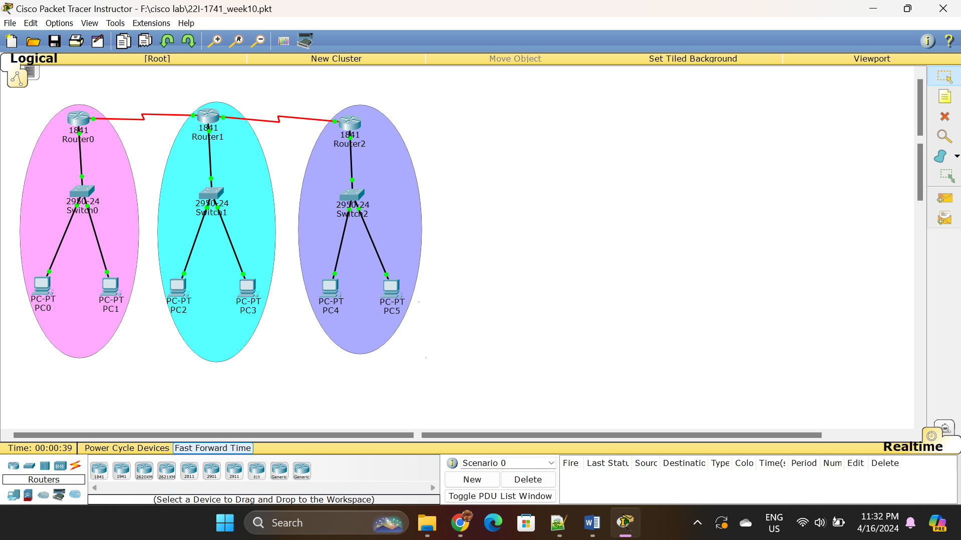

Figure TYPOLOGY

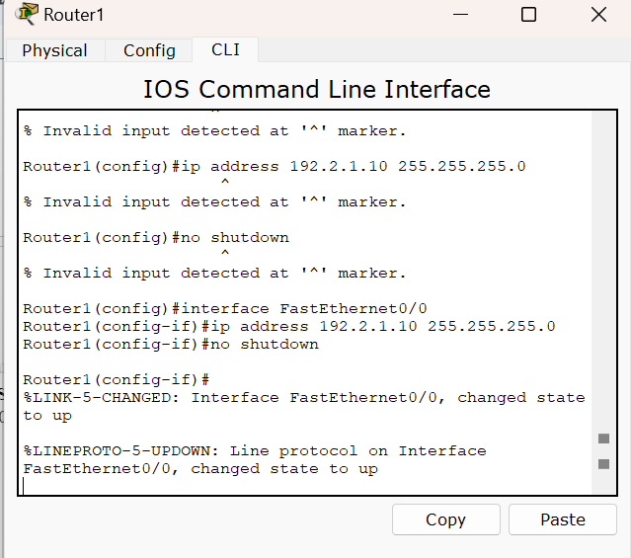

Figure SETTING ROUTER1

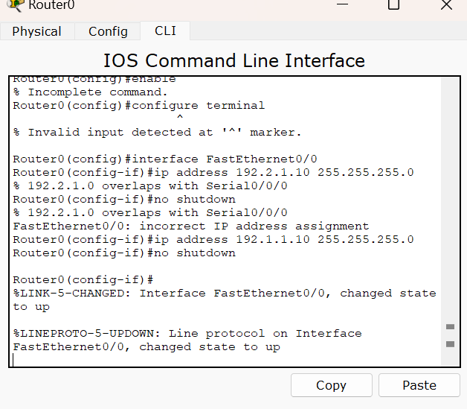

Figure SETTING ROUTER0

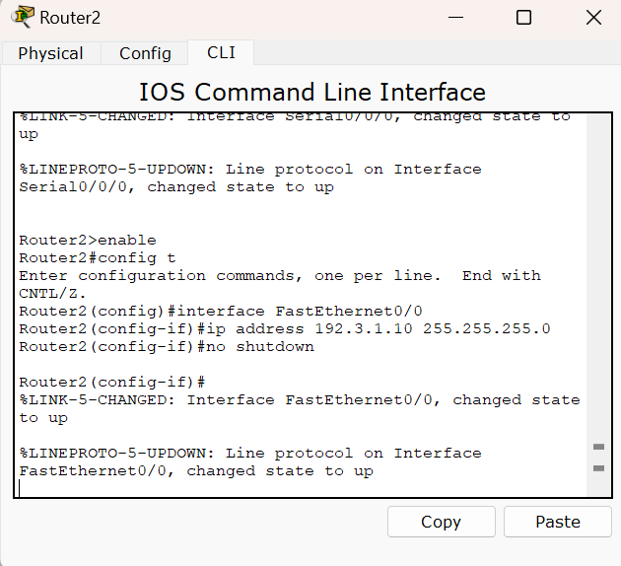

Figure SETTING ROUTER 2

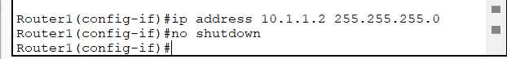

Figure CHANGING IP OF ROUTER 1

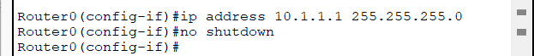

Figure CHANGING IP OF ROUTER 0

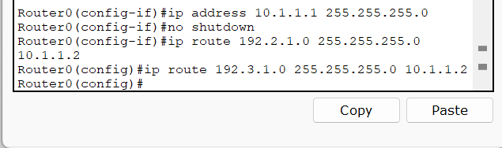

Figure STATIC ROUTING OF ROUTER 0

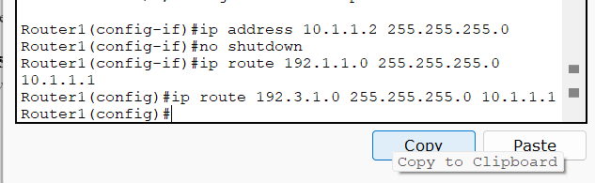

Figure STATIC ROUTING OF ROUTER 1