**COMSATS UNIVERSITY ISLAMABAD (LAHORE**

**CAMPUS)**

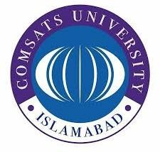

**DEPARTMENT OF MANGEMET SCIENCE (BBA)**

**Exercise 1**

**SUBMITTED BY:**

Azan Ali (FA24-BBA-066)

**SUBMITTED TO:**

Maam Mufeeza Manzoor

**Course Name:**

Programming Languages

**DATE:**

19-10-2025

**Exercise 1**

**Inputs:**

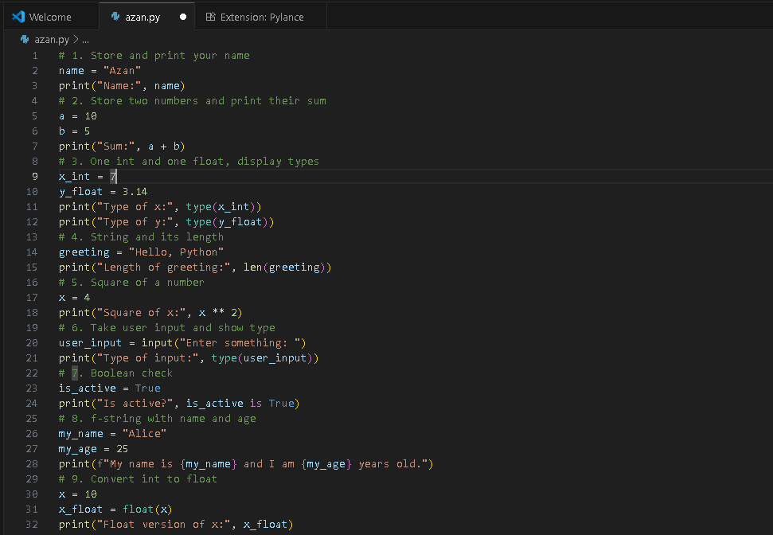

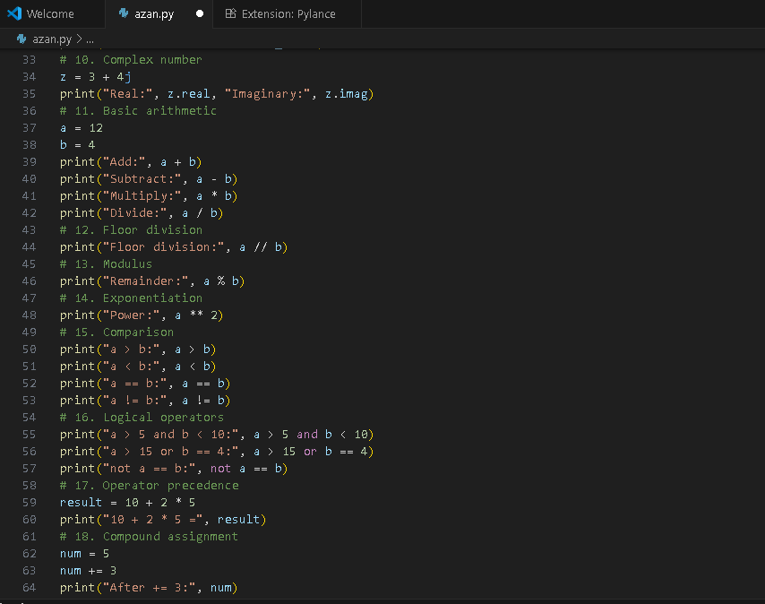

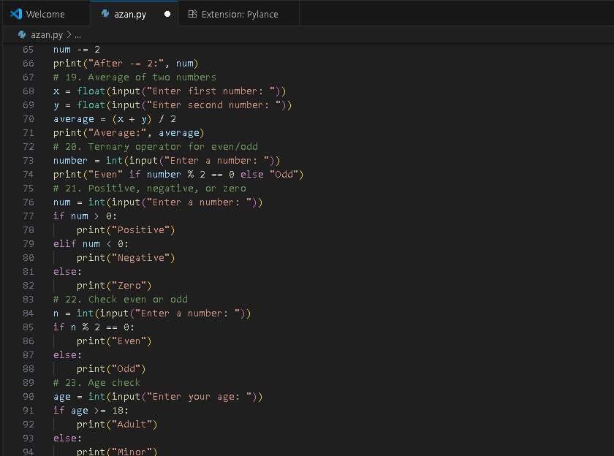

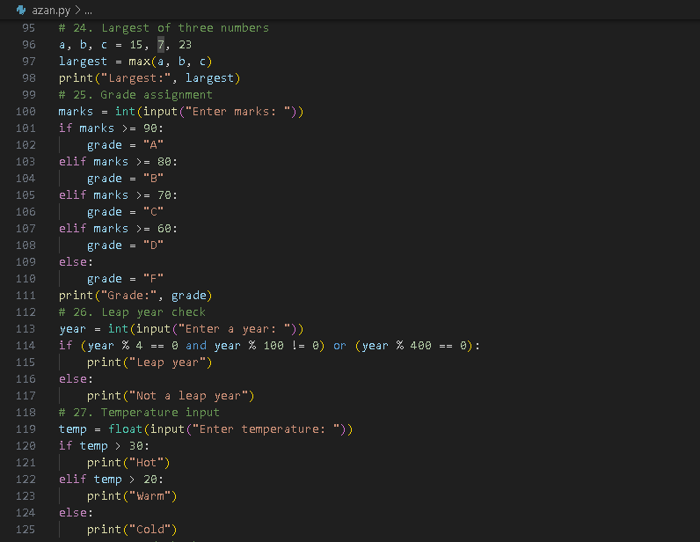

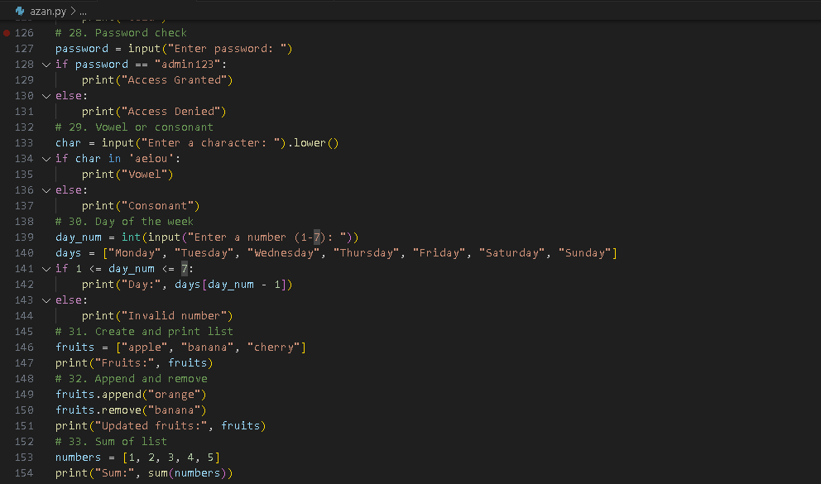

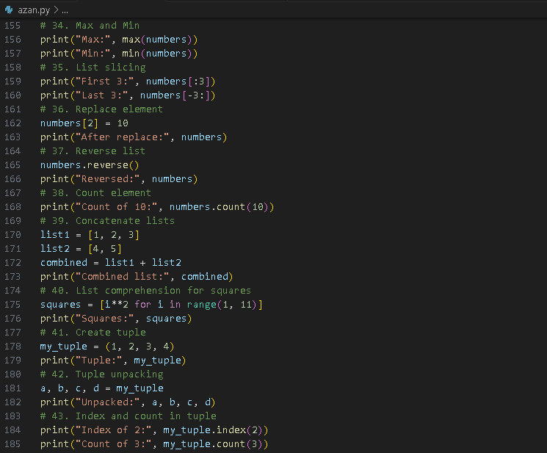

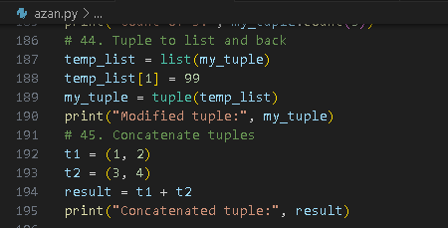

**Outputs:**

