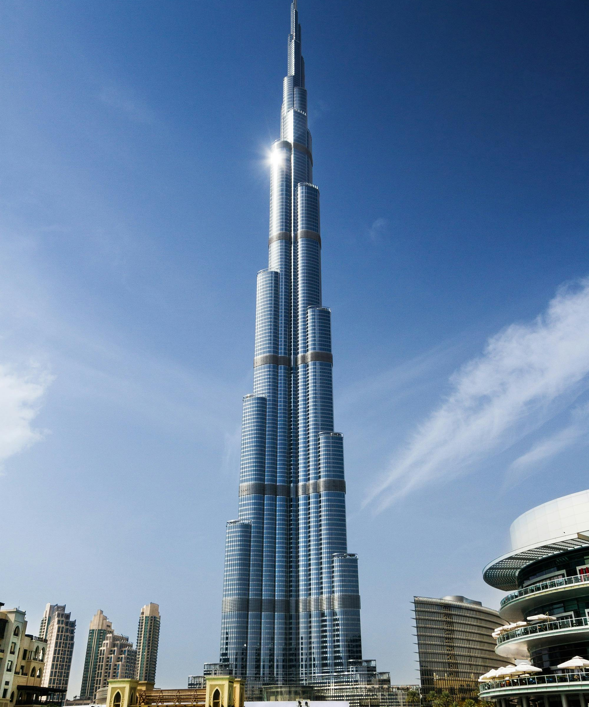

Burj Khalifa
The Burj Khalifa, located in Dubai, United Arab Emirates, is the tallest building in the world.
It stands at a remarkable height of 828 meters (2,717 feet) and has been a global symbol of modern
engineering and architectural innovation since its completion in 2010.
Designed by architect Adrian Smith of Skidmore, Owings & Merrill, the Burj Khalifa’s design was inspired
by the shape of the Hymenocallis flower, featuring a triple-lobed footprint. The structure uses
reinforced concrete and a cladding system made of reflective glazing and aluminum, designed to
withstand the extreme heat of the desert.
The tower has 163 floors above ground and includes a mix of residential apartments, corporate suites,
the luxurious Armani Hotel, and several observation decks that offer panoramic views of Dubai’s skyline.
One of the most popular attractions is the “At the Top” observation deck on the 148th floor, which provides
visitors with breathtaking views across the city and beyond.
The Burj Khalifa also features a state-of-the-art lighting system, which illuminates the tower for
special events and celebrations. It has become a global landmark representing Dubai’s ambition,
innovation, and rapid development.
Beyond being a marvel of modern engineering, the Burj Khalifa is a powerful symbol of human achievement
and a centerpiece of Dubai’s vision for the future.

