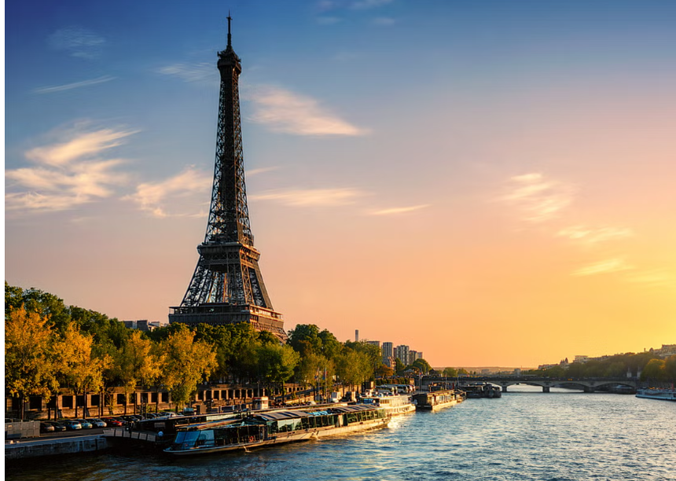

Eiffel Tower
The Eiffel Tower, located in Paris, France, is one of the most recognizable structures in the world.
It was designed by the French engineer Gustave Eiffel and constructed between 1887 and 1889
as the entrance arch for the 1889 Exposition Universelle (World's Fair), held to celebrate the 100th
anniversary of the French Revolution.
Standing at 330 meters (1,083 feet) tall, the Eiffel Tower was the tallest man-made structure in the
world for over 40 years until the completion of the Chrysler Building in New York City in 1930.
The tower is made of wrought iron and consists of three levels accessible to visitors. The first two
levels have restaurants and shops, while the third level offers panoramic views of the city of Paris.
Originally criticized by some of France’s leading artists and intellectuals for its design, the Eiffel Tower
has since become a global cultural icon of France and one of the most visited monuments in the world.
It attracts nearly 7 million visitors each year.
At night, the tower sparkles with 20,000 twinkling lights for five minutes every hour on the hour,
making it an unforgettable sight. The Eiffel Tower stands today as a symbol of innovation, artistry,
and the enduring spirit of Paris.

