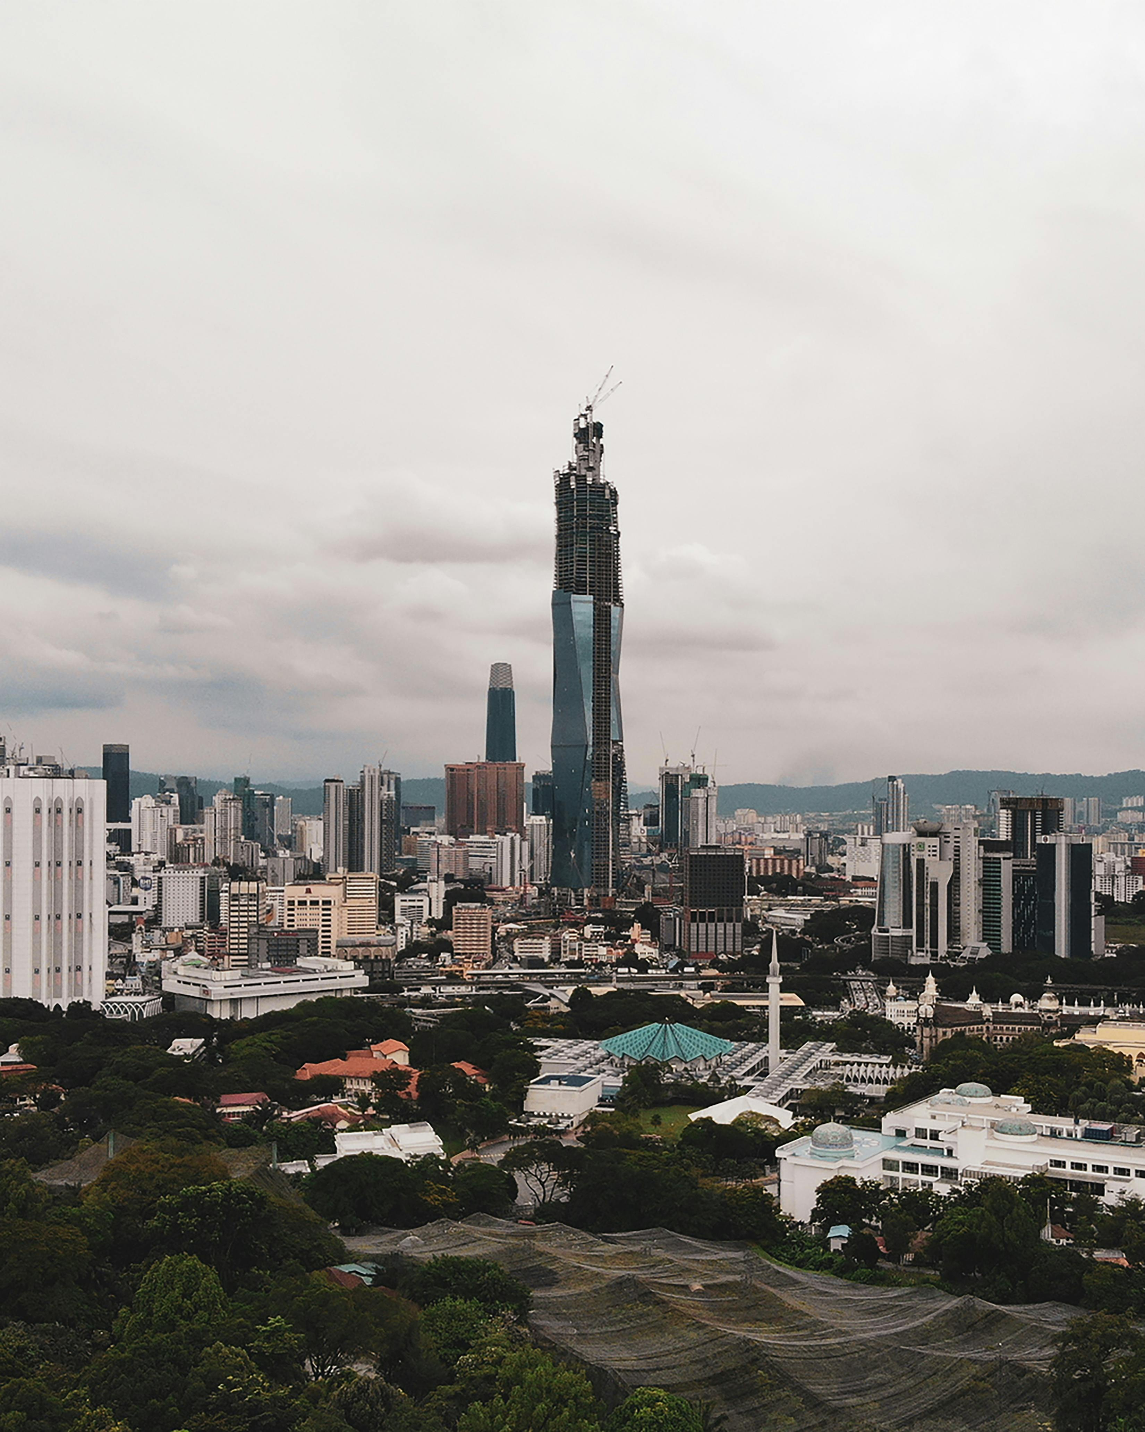

Merdeka 118
Merdeka 118, located in Kuala Lumpur, Malaysia, is the tallest building in Southeast Asia and the second tallest
building in the world as of its completion. Standing at a height of 678.9 meters (2,227 feet) with 118 stories,
it has become a symbol of Malaysia’s progress, unity, and innovation.
The tower was designed by the Australian architecture firm Fender Katsalidis and developed by PNB Merdeka Ventures
Sdn Bhd. Its design was inspired by the outstretched hand gesture made by Malaysia’s first Prime Minister,
Tunku Abdul Rahman, during the declaration of independence in 1957 at the nearby Stadium Merdeka — a site that
holds deep national significance.
Merdeka 118 features a combination of office spaces, a luxury hotel, residential areas, and observation decks.
The building’s façade is made up of triangular glass panels that reflect the city’s skyline and create a
sparkling diamond-like appearance.
One of the tower’s main attractions is its observation deck, “The View at 118,” which offers breathtaking views
of Kuala Lumpur and beyond. The tower also includes the Park Hyatt Kuala Lumpur Hotel and retail spaces that
add to its role as a commercial and cultural hub.
Completed in 2023, Merdeka 118 is a landmark of modern Malaysia, representing the nation’s architectural ambition,
technological advancement, and enduring spirit of independence.

