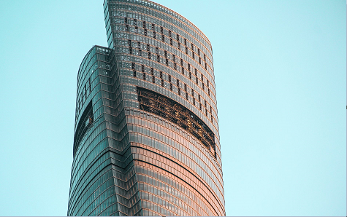

Shanghai Tower
The Shanghai Tower, located in the Lujiazui area of Shanghai, China, is the world’s second tallest building
and the tallest in China. Standing at a height of 632 meters (2,073 feet) with 128 stories, it is a
masterpiece of modern architecture and engineering that symbolizes China’s rapid urban and economic growth.
Designed by the architectural firm Gensler, the tower’s unique twisting design reduces wind loads by
24% and makes it one of the most energy-efficient supertall skyscrapers in the world. Its elegant spiral
form represents the dynamic emergence of modern Shanghai as a global financial hub.
The building features mixed-use spaces, including offices, hotels, retail areas, cultural venues, and
observation decks. The Shanghai Tower’s observation deck, located on the 118th floor, offers panoramic
views of the city and the Huangpu River, making it one of the most visited attractions in Shanghai.
The tower is also a model of sustainable architecture — it incorporates double-glass facades for
insulation, wind turbines for on-site power generation, and a rainwater collection system to minimize
environmental impact.
Completed in 2015, the Shanghai Tower stands alongside the Jin Mao Tower and the Shanghai World
Financial Center, forming the iconic “Shanghai Trio.” Together, they represent China’s architectural
ambition, innovation, and forward-thinking vision for the future.

