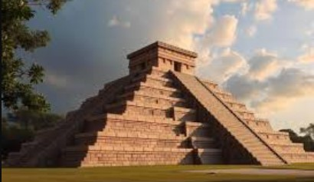

Ziggurat
The Ziggurat is one of the most remarkable architectural achievements of ancient Mesopotamia, representing both the religious devotion and the engineering skills of early civilizations. Built between 2200 and 500 BCE, ziggurats were massive, terraced structures made mainly of sun-dried and baked mud bricks. They were not tombs or palaces, but temple towers that served as sacred places for worshipping the gods. Each major Mesopotamian city, such as Ur, Babylon, and Uruk, had its own ziggurat dedicated to its patron deity. For example, the Great Ziggurat of Ur was built in honor of the moon god Nanna (Sin). The word “ziggurat” comes from the Akkadian word ziqqurratu, which means “to rise high” or “to build on a raised area,” symbolizing the connection between the heavens and the earth.
The structure of a ziggurat typically consisted of several levels or terraces, each smaller than the one below, creating a step-like pyramid shape. The base was large and rectangular, while the top platform often held a shrine or temple where priests would perform rituals and offer sacrifices to the gods. Because the ziggurat was believed to be the dwelling place of the gods, ordinary people were not allowed to climb it; only priests and high officials could access the upper levels. The Mesopotamians believed that building tall structures brought them closer to the divine realm. The ziggurat’s design reflected this belief, as it seemed to bridge the gap between earth and heaven, allowing communication between humans and deities.
One of the best-preserved examples is the Ziggurat of Ur, built around 2100 BCE by King Ur-Nammu of the Third Dynasty of Ur. It originally stood about 30 meters high and was surrounded by a large courtyard. The ziggurat was made with mud bricks for the core and baked bricks on the outer layer to protect it from rain and erosion. The bricks were often inscribed with the names of kings or dedications to the gods. Wide staircases and ramps led to the upper platforms, giving the structure an impressive and majestic appearance. At the top, the temple was likely decorated with bright colors and statues of the gods.
Ziggurats were not just religious centers; they were also symbols of power and pride for the cities that built them. Each ziggurat showed the wealth, organization, and devotion of its people. It took hundreds of workers, craftsmen, and architects to build one, often over many years. The construction also demonstrated the advanced knowledge of engineering and architecture that the Mesopotamians possessed long before modern tools or machinery.
In addition to Ur, other famous ziggurats include the Etemenanki in Babylon, believed to have inspired the biblical story of the Tower of Babel, and the ziggurat of Chogha Zanbil in ancient Elam (modern-day Iran), which is one of the few that still stands mostly intact today. Over time, many ziggurats were destroyed or buried by the sands of time, but their remains still reveal how advanced and spiritual Mesopotamian society was.

