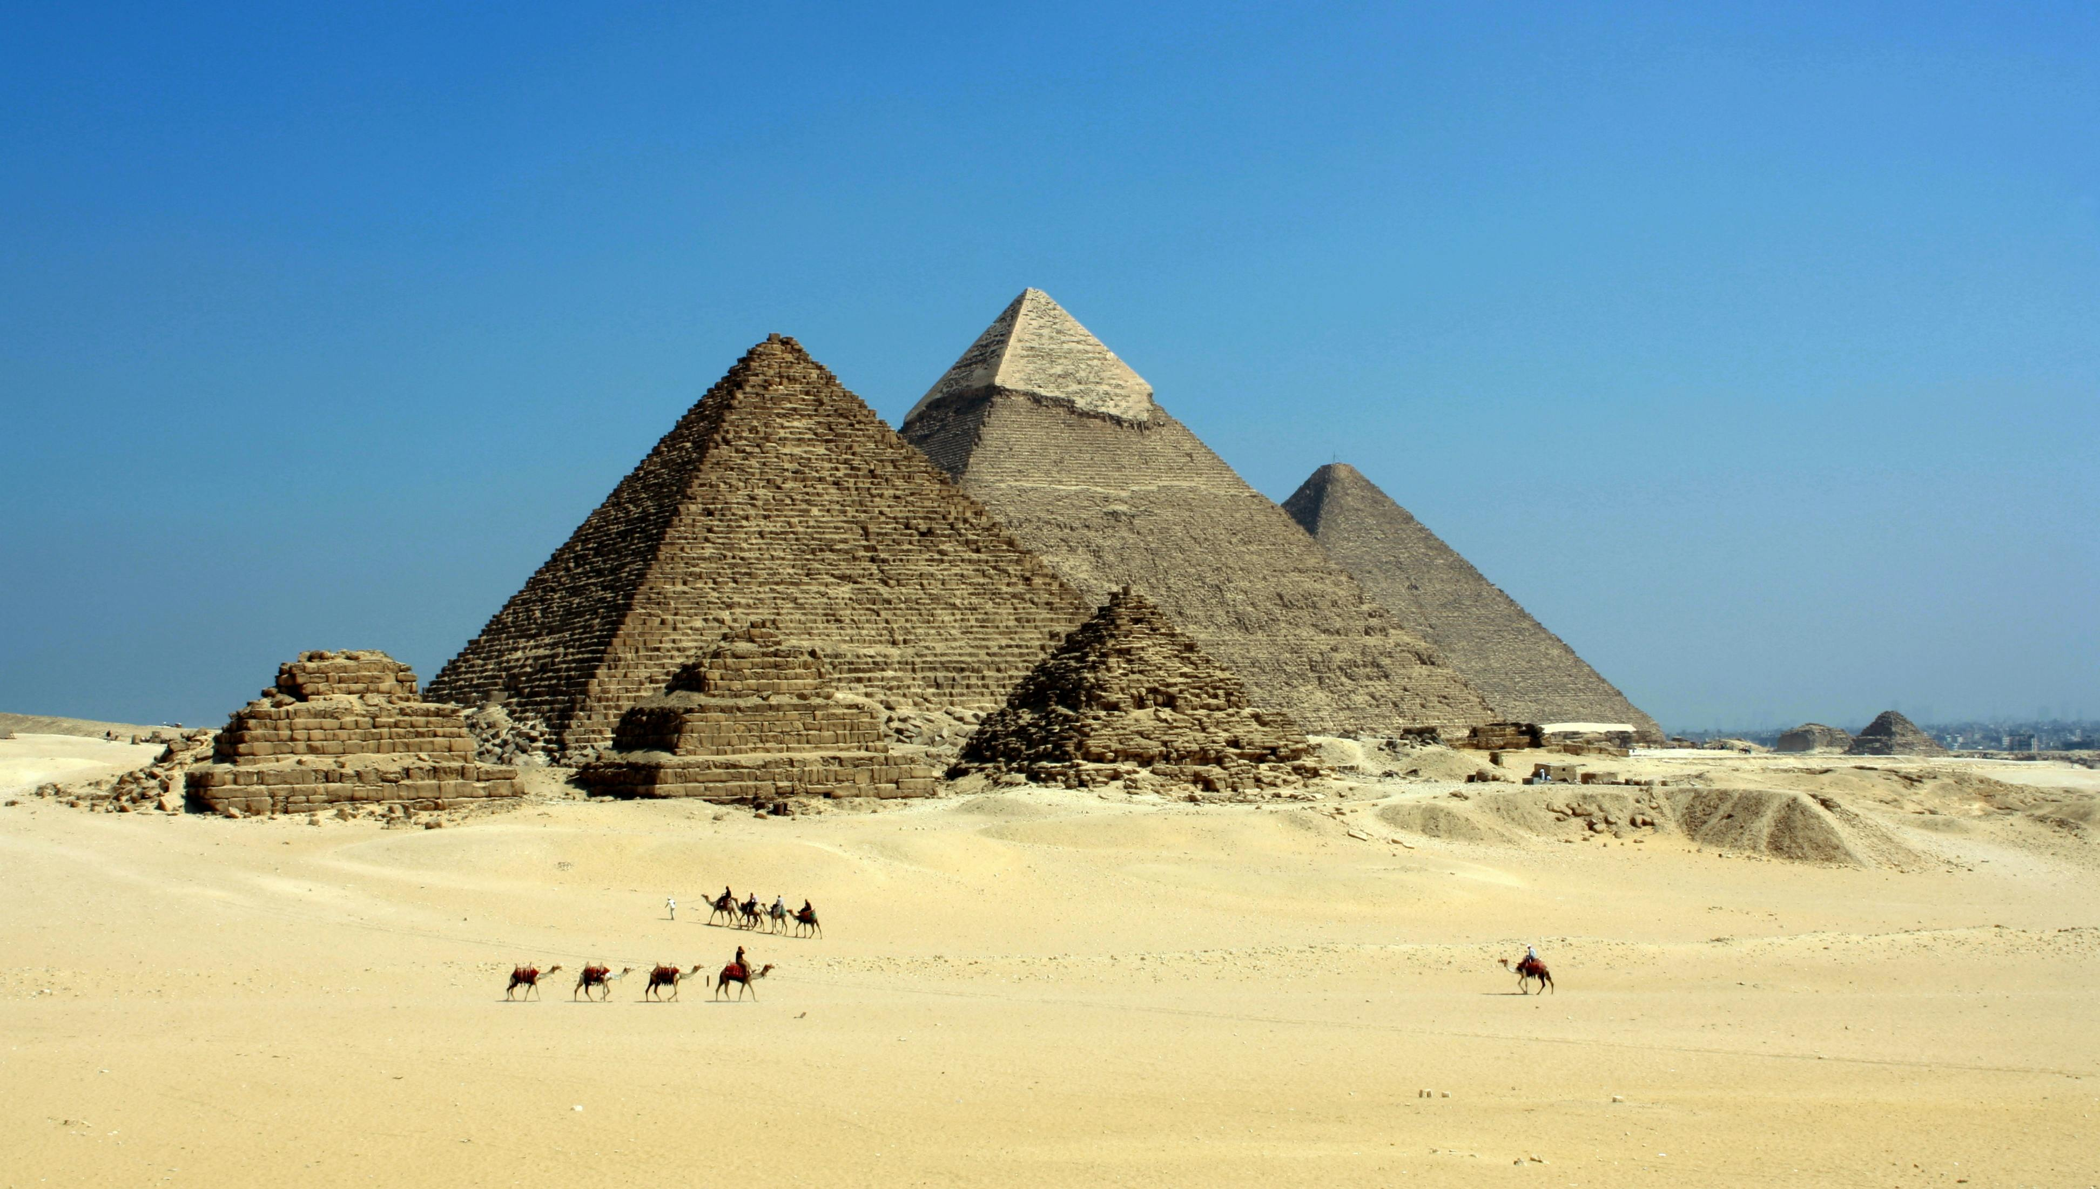

Pyramids Of Giza
The Pyramids of Giza, located on the Giza Plateau near Cairo, Egypt, are among the most remarkable and enduring architectural achievements in human history. Built more than 4,500 years ago, these ancient monuments continue to amaze historians, archaeologists, and travelers from around the world.
The Giza complex consists of three main pyramids: the Great Pyramid of Khufu (Cheops), the Pyramid of Khafre, and the Pyramid of Menkaure. The Great Pyramid, originally standing at 146.6 meters (481 feet), was the tallest man-made structure in the world for over 3,800 years. Its precise alignment with the stars and the remarkable accuracy of its construction demonstrate the advanced engineering skills of the ancient Egyptians.
The pyramids served as royal tombs for the pharaohs, who were believed to become gods in the afterlife. Each pyramid was part of a larger complex that included temples, causeways, and smaller tombs for nobles. The structures were built using millions of limestone and granite blocks, transported and assembled with incredible precision.
Guarding the pyramids is the Great Sphinx — a colossal limestone statue with the body of a lion and the head of a pharaoh, symbolizing strength and wisdom.
Today, the Pyramids of Giza stand as a UNESCO World Heritage Site and one of the Seven Wonders of the Ancient World — the only one still largely intact. They remain a powerful testament to the ingenuity, faith, and ambition of ancient Egyptian civilization.

