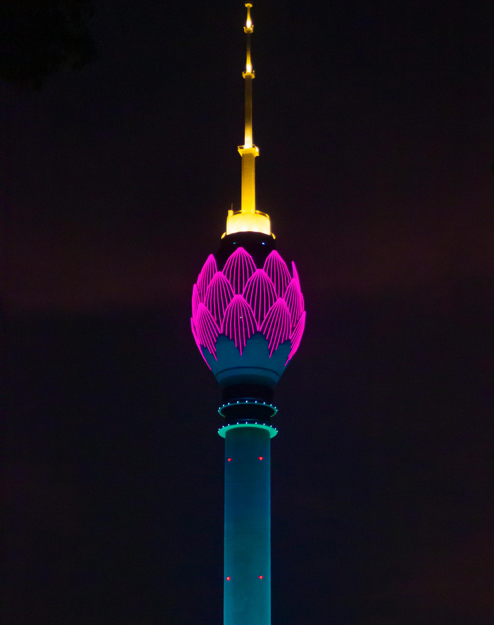

Lotus Tower

The Lotus Tower, located in Colombo, Sri Lanka, is the tallest structure in South Asia and one of the most iconic landmarks in the country. Standing at 356 meters (1,168 feet), it symbolizes Sri Lanka’s development and modernization while reflecting the nation’s cultural identity through its elegant lotus-shaped design.
The design of the tower is inspired by the lotus flower — a symbol of purity, enlightenment, and prosperity in Sri Lankan culture. Its purple and green colors represent the blooming lotus rising from its green stem, creating a beautiful and unique feature on Colombo’s skyline.
Construction of the Lotus Tower began in 2012 and was completed in 2019. It was developed by the Telecommunications Regulatory Commission of Sri Lanka (TRCSL). The tower mainly serves as a communication and broadcasting hub but also functions as a tourist attraction, offering observation decks, restaurants, and event spaces.
Visitors can enjoy panoramic views of Colombo city and the Indian Ocean from the top. At night, the tower is illuminated with colorful LED lights that make it visible from far away, giving it a stunning appearance.
The Lotus Tower stands as a symbol of progress, innovation, and unity for Sri Lanka, representing the country’s blend of tradition and modern architecture.

