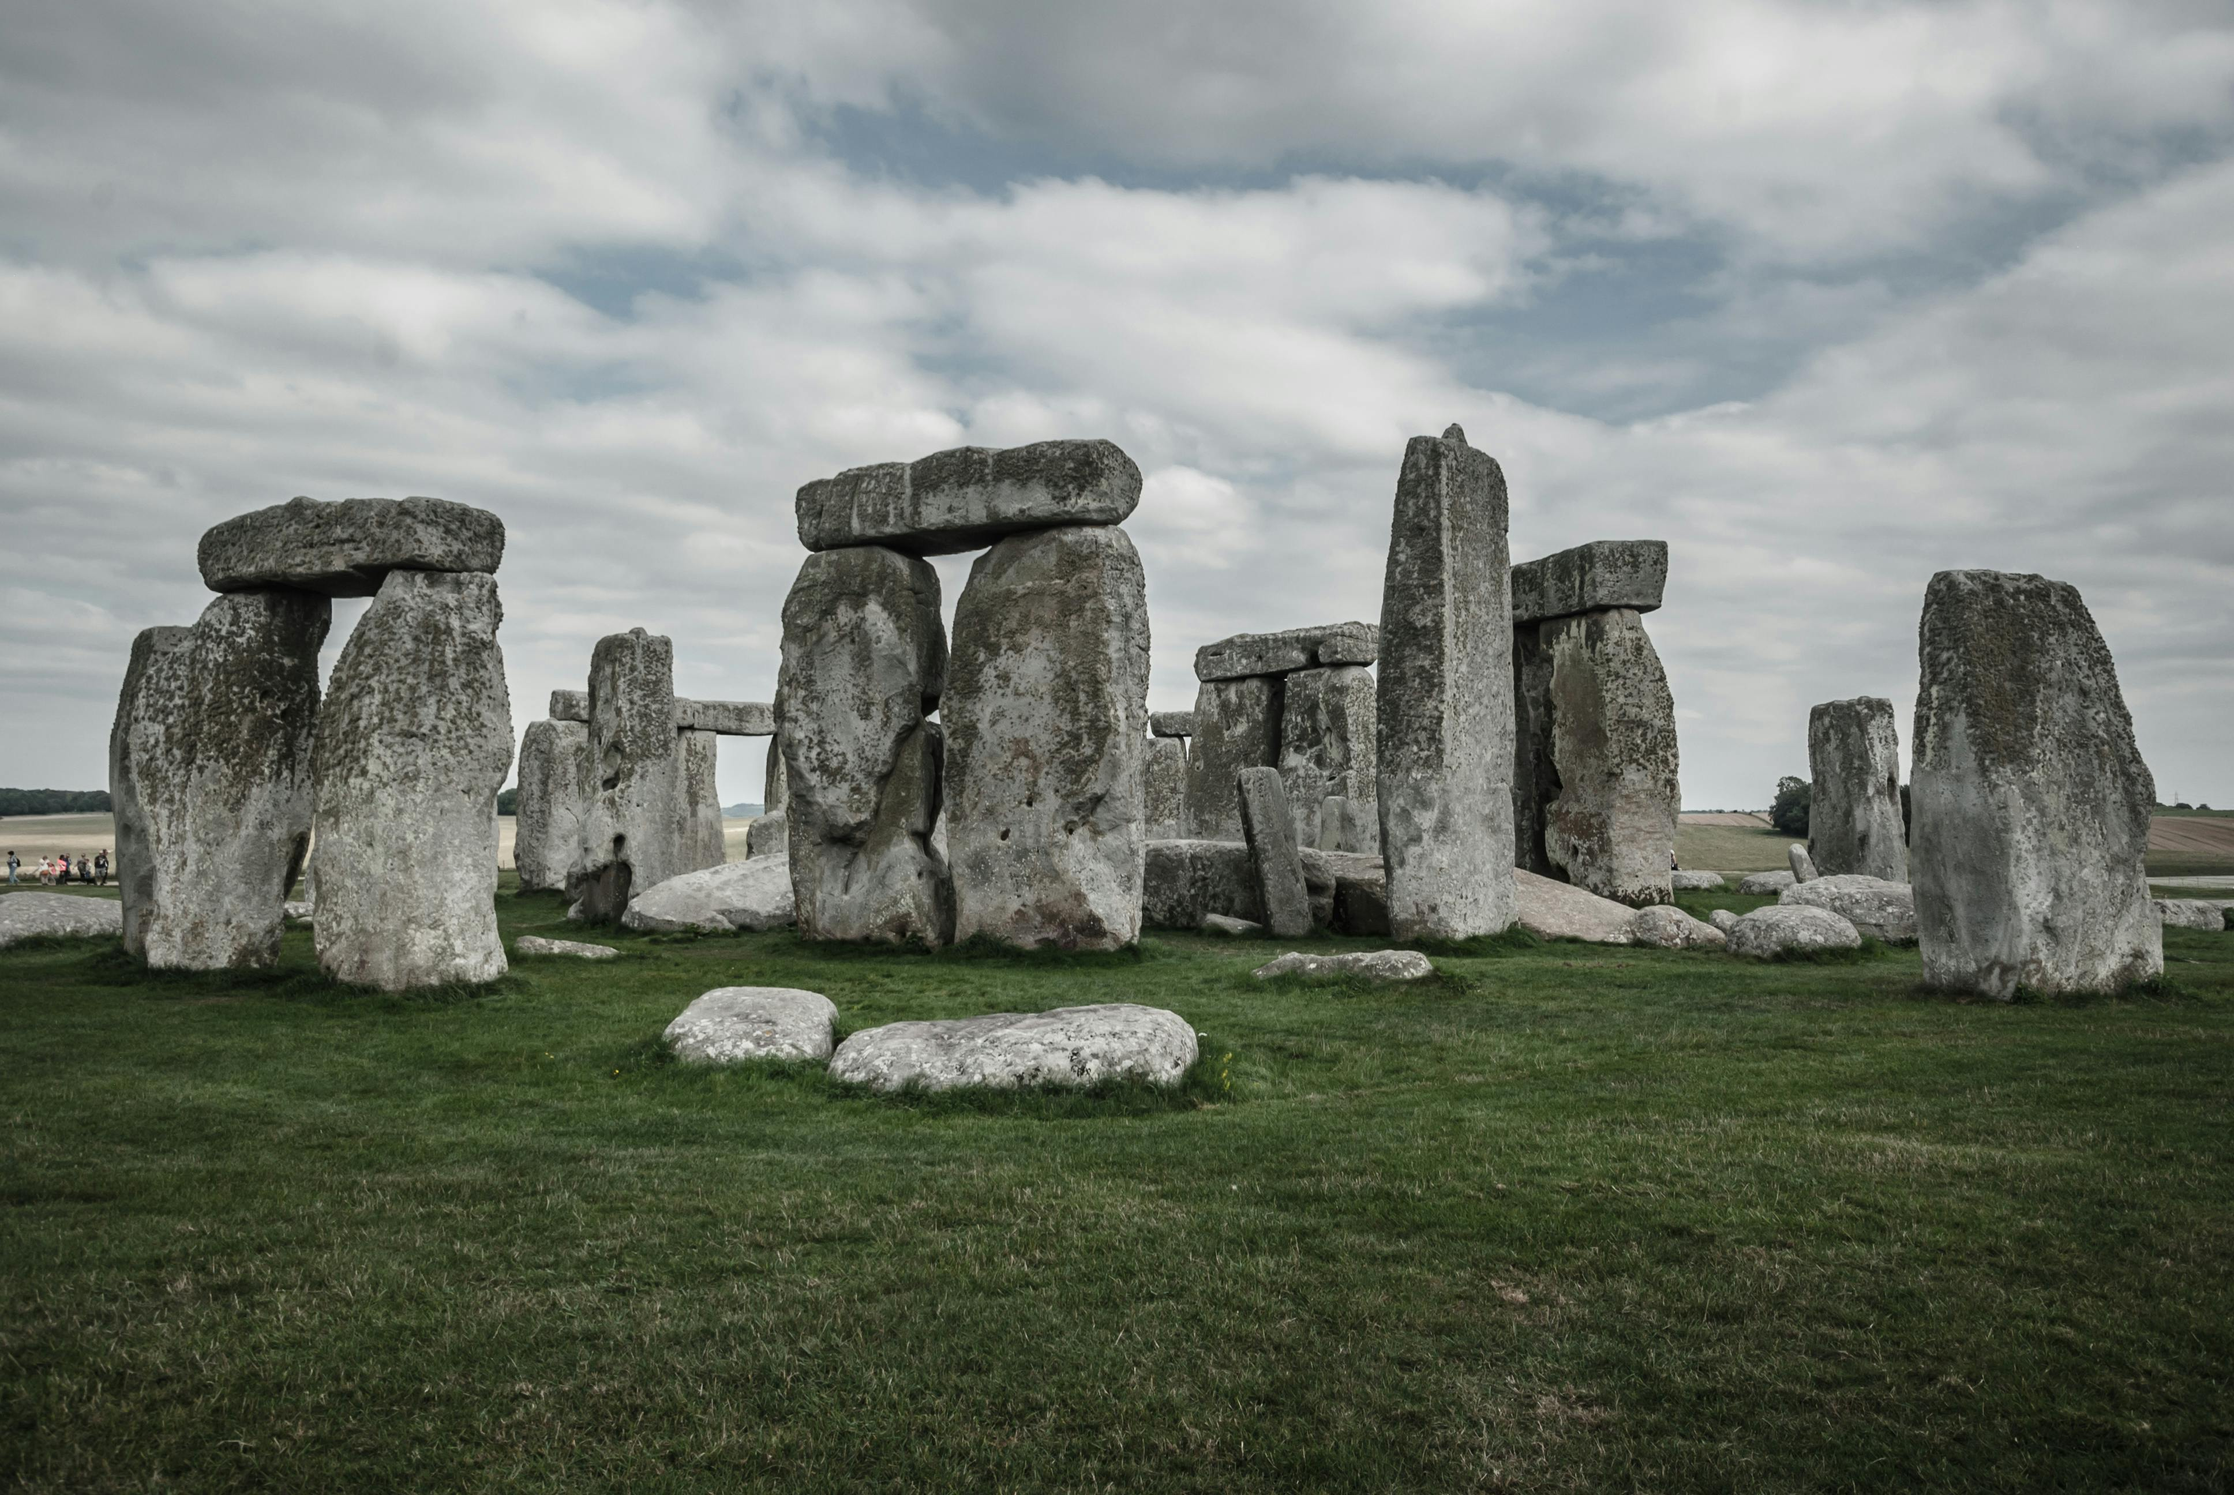

Stonehenge
Stonehenge is one of the most mysterious and iconic prehistoric monuments in the world, located on Salisbury Plain in Wiltshire, England. Believed to have been constructed between 3000 BC and 2000 BC, it continues to fascinate archaeologists, historians, and visitors with its massive stone circle and enigmatic origins.
The monument consists of a ring of standing stones, each around 13 feet (4 meters) high and weighing up to 25 tons. These stones are arranged in a circular layout and surrounded by earthworks that mark an ancient ceremonial site. The larger sarsen stones and the smaller bluestones were transported from long distances — some from over 150 miles away in Wales — an astonishing feat for prehistoric builders.
While the exact purpose of Stonehenge remains uncertain, it is widely believed to have served as a ceremonial, religious, or astronomical site. The stones are aligned with the sunrise on the summer solstice and the sunset on the winter solstice, suggesting that it may have been used to mark seasonal events and agricultural cycles.
Over the centuries, Stonehenge has become a symbol of mystery, spirituality, and ancient human ingenuity. It is now protected as a UNESCO World Heritage Site and attracts millions of visitors every year who come to marvel at its timeless presence and contemplate its secrets.

