Q.1. Explain what is a cluster and what is a hadoop cluster

Hadoop cluster is a special type of computational cluster designed for storing and analyzing vast amount of unstructured data in a distributed computing environment. These clusters run on low cost commodity computers.

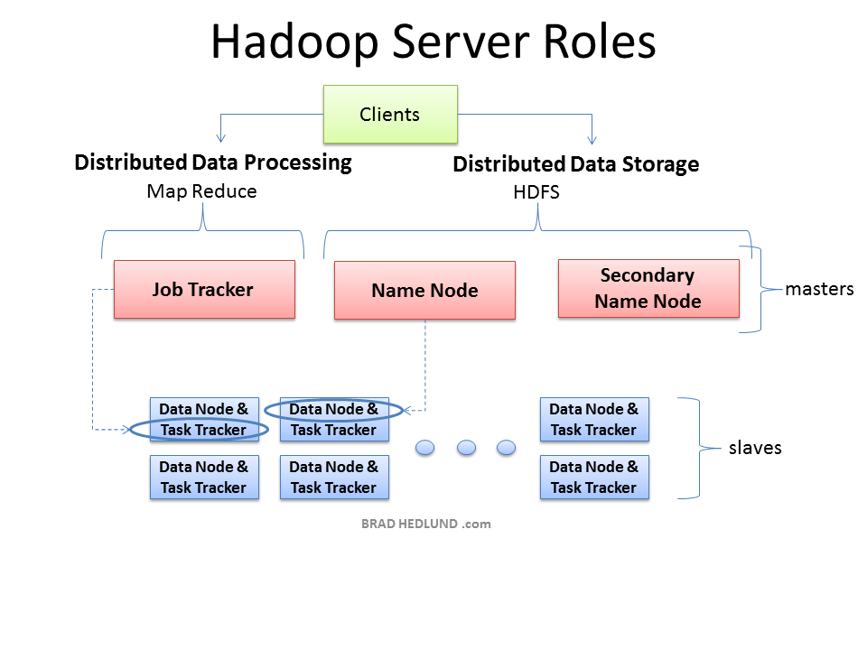

The three major categories of machine roles in a Hadoop deployment are Client machines, Masters Nodes, and Slave nodes. The Master nodes oversee the two key functional pieces that make up Hadoop: storing lots of data (HDFS), and running parallel computations on all that data (Map Reduce). The Name Node oversees and coordinates the data storage function (HDFS), while the Job Tracker oversees and coordinates the parallel processing of data using Map Reduce. Slave Nodes make up the vast majority of machines and do all the dirty work of storing the data and running the computations. Each slave runs both a Data Node and Task Tracker daemon that communicate with and receive instructions from their master nodes. The Task Tracker daemon is a slave to the Job Tracker, the Data Node daemon a slave to the Name Node.

Client machines have Hadoop installed with all the cluster settings, but are neither a Master nor a Slave. Instead, the role of the Client machine is to load data into the cluster, submit Map Reduce jobs describing how that data should be processed, and then retrieve or view the results of the job when it’s finished. In smaller clusters (~40 nodes) you may have a single physical server playing multiple roles, such as both Job Tracker and Name Node. With medium to large clusters you will often have each role operating on a single server machine.

Q.2. What is meant by a Rack and explain the rack arrangement in a hadoop cluster.

Hadoop components are rack-aware. For example, HDFS block placement will use rack awareness for fault tolerance by placing one block replica on a different rack. This provides data availability in the event of a network switch failure or partition within the cluster.

Hadoop master daemons obtain the rack id of the cluster slaves by invoking either an external script or java class as specified by configuration files. Using either the java class or external script for topology, output must adhere to the java org.apache.hadoop.net.DNSToSwitchMapping interface. The interface expects a one-to-one correspondence to be maintained and the topology information in the format of ‘/myrack/myhost’, where ‘/’ is the topology delimiter, ‘myrack’ is the rack identifier, and ‘myhost’ is the individual host. Assuming a single /24 subnet per rack, one could use the format of ‘/192.168.100.0/192.168.100.5’ as a unique rack-host topology mapping.

To use the java class for topology mapping, the class name is specified by the topology.node.switch.mapping.impl parameter in the configuration file. An example, NetworkTopology.java, is included with the hadoop distribution and can be customized by the Hadoop administrator. Using a Java class instead of an external script has a performance benefit in that Hadoop doesn’t need to fork an external process when a new slave node registers itself.

If implementing an external script, it will be specified with the topology.script.file.name parameter in the configuration files. Unlike the java class, the external topology script is not included with the Hadoop distribution and is provided by the administrator. Hadoop will send multiple IP addresses to ARGV when forking the topology script. The number of IP addresses sent to the topology script is controlled with net.topology.script.number.args and defaults to 100. If net.topology.script.number.args was changed to 1, a topology script would get forked for each IP submitted by DataNodes and/or NodeManagers.

If topology.script.file.name or topology.node.switch.mapping.impl is not set, the rack id ‘/default-rack’ is returned for any passed IP address. While this behavior appears desirable, it can cause issues with HDFS block replication as default behavior is to write one replicated block off rack and is unable to do so as there is only a single rack named ‘/default-rack’.

An additional configuration setting is mapreduce.jobtracker.taskcache.levels which determines the number of levels (in the network topology) of caches MapReduce will use. So, for example, if it is the default value of 2, two levels of caches will be constructed - one for hosts (host -> task mapping) and another for racks (rack -> task mapping). Giving us our one-to-one mapping of ‘/myrack/myhost’.

+----------+ +--------+

|jobtracker| |datanode|

+----------+ +--------+

\ /

+--------+ +--------+ +--------+

|datanode|--| switch |--|datanode|

+--------+ +--------+ +--------+

/ \

+--------+ +--------+

|datanode| |namenode|

+--------+ +--------+

We are aware of the fact that hadoop divides the data into multiple file blocks and stores them on different machines. If Rack Awareness is not configured, there may be a possibility that hadoop will place all the copies of the block in same rack which results in loss of data when that rack fails.

Although rare, as rack failure is not as frequent as node failure, this can be avoided by explicitly configuring the Rack Awareness in conf-site.xml.

Rack awareness is configured using the property “topology.script.file.name” in the core-site.xml.