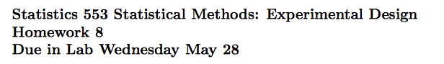

**Mandana Hamidi**

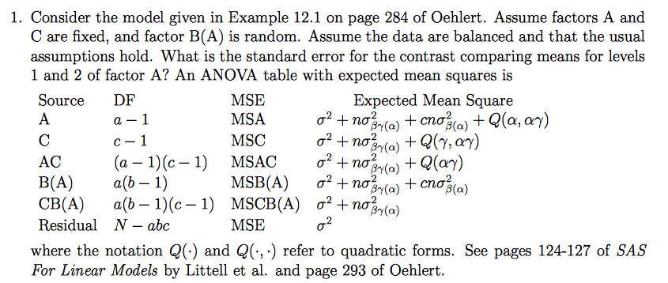

Macintosh HD:Users:Mandana:Desktop:Screen Shot 2014-05-22 at 7.56.29 PM.png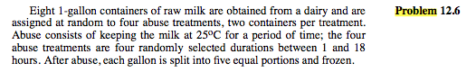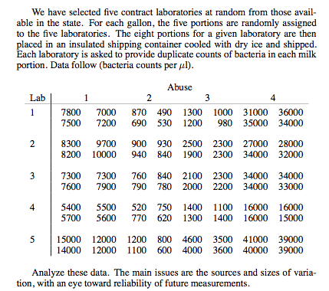

Macintosh HD:Users:Mandana:Desktop:Screen Shot 2014-05-22 at 7.56.36 PM.png