

Name : Azaria Cindy Sahasika

Number Id : 2341760169 / 07

Class : 1G – Business Information System

Lesson : Algorithm and Data Structure

Material : Jobsheet 1

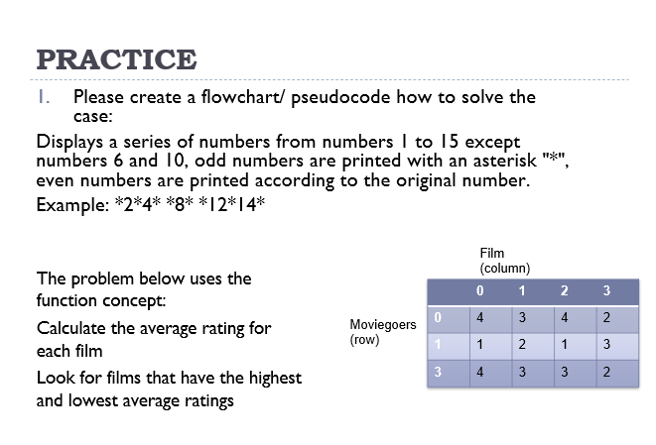

Start

// Part 1: Displaying Series of Numbers

FOR each number FROM 1 TO 15 DO

IF number EQUALS 6 OR number EQUALS 10 THEN

// Skip numbers 6 and 10

Continue to the next iteration

ELSE

IF number IS odd THEN

// Print odd numbers with asterisk

Print "\* "

ELSE

// Print even numbers

Print number + " "

ENDIF

ENDIF

END FOR

Print a new line // Move to the next line for clarity

// Part 2: Function to Calculate Average Rating

Function calculateAverageRating(ratings: Array) RETURNS float

totalRating = 0

FOR EACH rating IN ratings DO

totalRating += rating

END FOR

averageRating = totalRating / length of ratings

RETURN averageRating

End Function

// Part 3: Finding Movies with Highest and Lowest Average Ratings

movies = Array of movies with ratings

highestRating = 0

lowestRating = infinity

FOR EACH movie IN movies DO

ratings = getRatings(movie) // Assume getRatings function retrieves ratings for a movie

averageRating = calculateAverageRating(ratings)

IF averageRating > highestRating THEN

highestRating = averageRating

bestMovie = movie

END IF

IF averageRating < lowestRating THEN

lowestRating = averageRating

worstMovie = movie

END IF

END FOR

// Part 4: Displaying Results

Print "Series of Numbers: " // Displaying the series of numbers

// (Note: Displaying the series can be repeated from Part 1 if needed)

Print "Movie with the highest average rating: " + bestMovie

Print "Movie with the lowest average rating: " + worstMovie

End