

Name : Azaria Cindy Sahasika

Number Id : 2341760169 / 07

Class : 1G – Business Information System

Lesson : Algorithm and Data Structure

Material : Practice 2

Github Link : https://github.com/azariacindy/algorithm-ds

1. Define an object around you, and specify the attributes (at least 4) and methods (at least 3) that the object has!

* Object: Mouse

1. Attributes:

* Brand(String): Logitech
* Battery(String): 1X AA
* Color(String): Merah Jambu
* Button(Int): 4

1. Methods:

* Turn On/Off: turns the mouse on or off.
* Click: Pressing and releasing the primary mouse button (usually the left button).
* Scroll: Rotating the scroll wheel up or down.

1. In the JTI Classroom Loan Management Information System, determine what the objects are!

* Object: Classroom
* Object: Borrower
* Object: Admin

1. There is a class called BangunRuang, with two objects PrismaSegitiga and Balok as shown below. Draw a class diagram of BangunRuang!

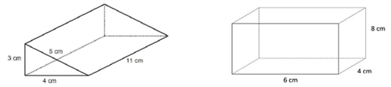

a=4 t=3

|  |
| --- |
| Bangun |
| Bangun: String  Long(t): Int  Width(a): Int  Height: Int |
| Jenis Bangun(c: boolean): void  hitungVolume(): void  hitungLuas(): void |
| Jenis Bangun(c: boolean): void  hitungVolume(): void  hitungLuas(): void |