  
Name : Azaria Cindy Sahasika

Number Id : 2341760169 / 06

Class : 1G – Business Information System

Lesson : Algorithm and Data Structure

Material : Material 6

Github Link : <https://github.com/azariacindy/algorithm-ds>

1. Buatlah flowchart dari algoritma binary search!

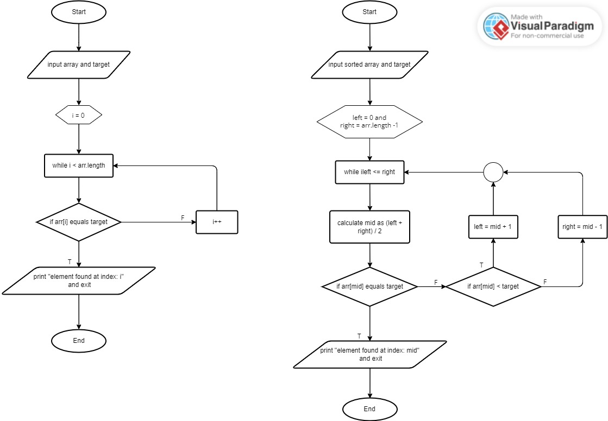

1. Buatlah flowchart dari algoritma sequential search!



|  |  |  |  |  |  |  |  |
| --- | --- | --- | --- | --- | --- | --- | --- |
| **Index** | **0** | **1** | **2** | **3** | **4** | **5** | **6** |
| Array | 78 | 13 | 24 | 9 | 30 | 22 | 41 |

1. Diketahui array sebagai berikut

Jika nilai yang dicari adalah 9, maka:

Gambarkan proses penyelesaian kasus pencarian dengan binary seach (urutkan dahulu array nya dengan algoritma sorting)!

1. a) Sort an array using bubble sort
2. b) Determines the values 'left = 0' and 'right = 6'
3. c) Calculated the 'middle' value with '(left + right) / 2 = (0 + 6) / 2 = 3'
4. d) Compared the value of 'arr[mid]' with the sought/target value (9). Since 'arr[mid]' (value 24) is greater than the target value (9), change 'right' to 'middle - 1 = 2'.
5. e) Recalculate the value of 'middle' with '(left + right) / 2 = (0 + 2) / 2 = 1'.
6. f) Compared the 'arr[mid]' value (value 13) with the searched value (9) again. Since '(value 13) is greater than the value (9)', change 'right' to 'middle - 1 = 1'.
7. g) Recalculate the value of 'middle' with '(left + right) / 2 = (0 + 0) / 2 = 0'.
8. h) Now, 'left' is equal to 'right' so the loop has stopped. Then the value 9 is found at index 0.

