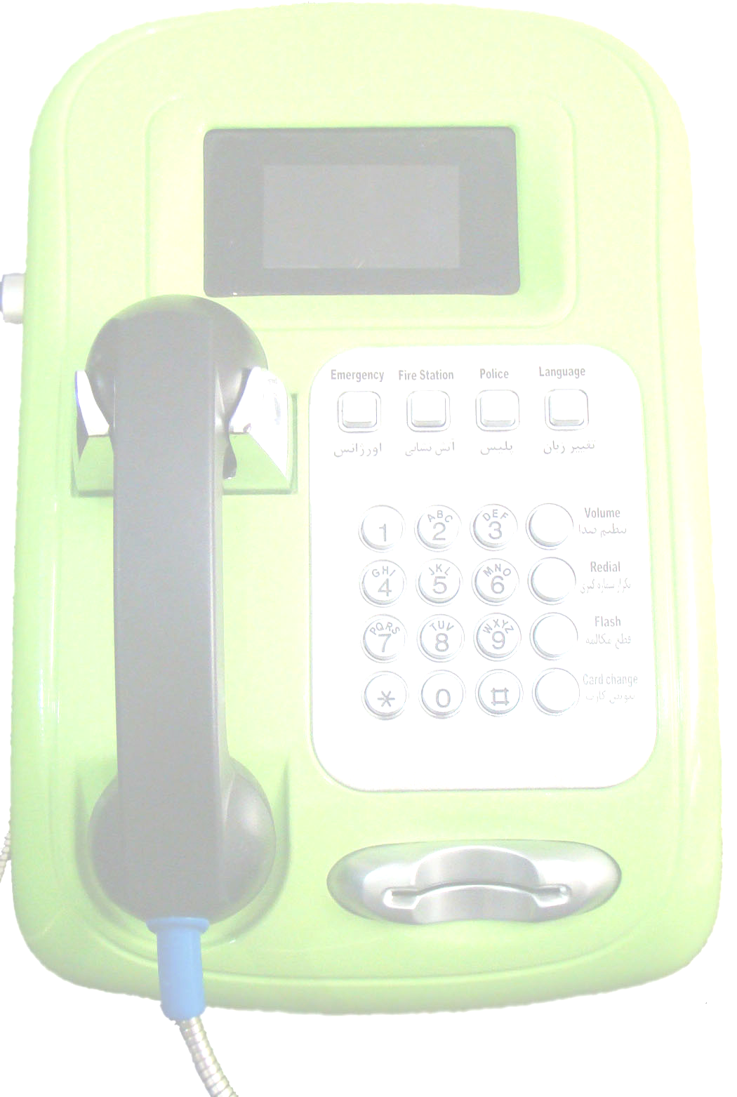
Smartcard Payphone FP110-S

Hardware Features of FP110
- Event Detectors
- Phone line cut detection
- Case Door open Detection
- Handset fault Detection
- Ring Detection
- Mother board obstacle test
- RTC back up battery voltage Detection
- Using RTC Module to Apply time and date
- Using 4 SAM Reader to support 3rd Generation of SAM modules
- Supports ISO 7816 standard of smart card protocol
- Supports AFNOR standard of card protocol
- Using Anti tearing Routine for bad cluster in card memory
- Modular Hardware Design to Achieve Auto fault detection and fault correction
- Using commercial components to Reduce time and cost of repairing
- Using smart Anti tapping module
- Support V.22 modem protocol to connect payphone management system
- Using CRC- 16 standard in Data transfer Routine
- Using a secure process to hand shake between pay phone and PMS
- Both tone & pulse dialing protocols
- Support wide kind of charging Routines

Software features of FP110
- Payphone software upgrade ability with ISP technology
- Via PMS
- Via maintenance card
- Via external programmer
- Synchronization ability to give time & date from PMS
- Payphone Work state Settings
- Dialing wait time
- Card change wait time
- Call answer wait time selectable pre charge and post charge
- Selectable the base language
- Selectable incoming call routine
- LCD back light timer
- Selectable tone / pulse dialing
- Adjustable time & date
- Adjustable charging pulse price
- Selectable black / white rejection
- Adjustable CDR timing
- Charging type
- Charging routine
- Dialing limitation
- Payphone activity level
- Select incoming ringer routine
- Ability to selected each event as an emergency event to report PMS
- User friendly menus, messages and alarms
- Advanced maintenance users menus
- Adjustable speaker volume level
- Selectable payphone language from Arabic ,English , Persian , German
- Manageable Emergency call keys
- Free call support
- Variable reports to send PMS
- Outgoing call reports
- Incoming call reports
- Event reports
- Emergency reports

Payphone management system
- Several Administration Access level
- Variant tables to keep users data
- Free calls table
- White and black list table
- Tariff table
- Tariff timing table
- Day type table
- Message table
- PMS Number table
- Payphones table
- Daily Report timing settings
- Activity level of pay phone settings
- Dialing routine setting
- Dialing limitation setting
- Payphone Ringer setting
- SAM pin code setting
- Charging type and Charging routine setting

