Nottingham Trent University
School of Science and Technology

MSc Major Project COMP40311

Quantum Key Distribution Framework for Secure UAV Swarms
By
Azaruddin Mohammad
In
August 2026
Project report in part fulfilment of the requirements for the degree of
Master of Science
In
CYBER SECUTIY
I hereby declare that I am the sole author of this report. I authorize the Nottingham Trent University to lend this report to other institutions or individuals for the purpose of scholarly research.
I also authorize the Nottingham Trent University to reproduce this report by photocopying or by other means, in total or in part, at the request of other institutions or individuals for the purpose of scholarly research.

Signature
Azaruddin Mohammad

Abstract
If not properly encrypted, authenticated, and protected from replay attacks, UAV communication through MAVLink may be vulnerable to cyber-attacks. In this research, a secure UAV communication system consists of a software implementation of a BB84-inspired Quantum Key Distribution (QKD) mechanism and AES-256-GCM authenticated encryption is designed, implemented and evaluated. The framework was used with PX4 Software-In-The-Loop (SITL), Gazebo, QGroundControl, Python-based Alice and Bob security gateways and Wireshark.
The unsecured and secured MAVLink communication through known Man-in-the-Middle (MITM) and Replay attacks were compared for the evaluation of the framework. The experiments showed that successful manipulations and previously captured packet retransmissions were possible, in the unsecured case. Encrypted packets being processed were inauthentic, sent to the wrong recipient, or replayed and were successfully refused by both AES-GCM authentication and replayed-packet detection using sequence numbers.
The assessment of the performance was done with over 1,000 MAVLink packets. The mean difference in the packet processing delay between the unsecured case and QKD + AES-256-GCM protection was 0.207908 ms/packet or 0.220736 ms. The mean difference between the unsecured case and QKD + AES-256-GCM case was 0.207908 ms/packet or 0.220736 ms.
This research concludes that the proposed framework is able to reliably enhance MAVLink communications against the scenario of MITM modification/replay attack presented in this work, with low average packet processing overhead in the simulated environment. The proposed framework can be expanded to physical UAV platforms, physical ground-based QKD infrastructure, and multi-UAV swarms in the future.
This Example introduces the concepts of UAV Security, MAVLink, Quantum Key Distribution, BB84, AES-256-GCM, MITM Attack, Replay Attack and PX4.

Acknowledgements

I would like to thank Dr. Adnan Kiani, Senior Lecturer, for the tremendous guidance, constant encouragement and constructive criticisms given during this major project. He has provided me with invaluable guidance and advice throughout this dissertation, affecting both its technical development and the rigorous standard set by its academic content. Under his guidance, I was able to face and challenge the technical problems and accomplish the research objectives. In addition, I would like to thank Nottingham Trent University School of Science and Technology for offering a superb Laboratory, Computing facilities and Academic climate which helped and assisted with this research. I extend my sincere appreciation to my parents and my family for their love, encouragement, patience and sacrifices in my pursuit of my degree. They have been such variables to me and have never wavered their trust in me, giving me the motivation and strength to be me. Last but not least, I would like to thank all the academic staff, colleagues, and friends that have given me valuable suggestions, encouragement, and support in the completion of this project.

Table Of content
Contents
Abstract 2
Acknowledgements 3
Table Of content 4
CHAPTER 1 6
Introduction 6
1.1 Introduction 6
1.2 Background of the study 6
1.3 Problem Statement 6
1.4 Aim of the Project 7
1.5 Objectives of the Project 8
1.6 Scope of the Project 9
1.7 Research Questions 10
1.8 Dissertation Structure 11
Chapter 2 12
Literature Review 12
2.1 Introduction 12
2.2 UAV Swarm Communication 14
2.3 MAVLink Communication Protocol 15
2.4 Cybersecurity Threats in UAV Communication 16
2.5 Quantum Key Distribution (BB84 Protocol) 17
2.6 AES-256-GCM Encryption 18
2.7 Existing Secure UAV Communication Frameworks 19
2.8 Chapter Summary 20
Chapter 3 20
NEW IDEAS & APPROACH 20
3.1 Introduction 20
3.2 Research Methodology 21
3.3 System Architecture 21
3.4 Secure Communication Workflow 23
3.5 Experimental Setup 24
3.6 Experimental Procedure 26
3.7 Professional, Social, Ethical and Legal Considerations 26
3.8 Chapter Summary 27
Chapter 4 27
Implementation 27
4.1 Introduction 27
4.2 PX4 SITL and Gazebo Environment Setup 28
4.3 QGroundControl and MAVLink Communication Setup 29
4.4 QKD Key Establishment Implementation 30
4.5 AES-256-GCM Secure Gateway Implementation 31
4.6 Replay Protection Implementation 32
4.7 Network Traffic Capture and Wireshark Integration 32
4.8 Chapter Summary 33
Chapter 5 34
Results and Evaluation 34
5.1 Introduction 34
5.2 Baseline Unsecured MAVLink Communication 34
5.3 MITM Attack on Unsecured MAVLink 35
5.4 Replay Attack on Unsecured MAVLink 37
5.5 Secured MAVLink Communication with QKD + AES-256-GCM 38
5.6 Secured MAVLink Traffic Analysis 39
5.7 Security Comparison Before and After Protection 39
5.8 MITM Attack on QKD + AES-256-GCM Protected MAVLink 40
5.9 Replay Attack on QKD + AES-256-GCM Protected MAVLink 42
5.10 Communication Delay and Performance Analysis 44
5.11 Overall Security Evaluation and Discussion 47
5.12 Chapter Summary 47
CHAPTER 6 48
Conclusion and Future Work 48
6.1 Introduction 48
6.2 Summary of Research Findings 49
6.3 Achievement of Research Objectives 49
6.4 Limitations of the Research 49
6.5 Future Work 50
6.6 Final Conclusion 50

CHAPTER 1

Introduction

1.1 Introduction
Unmanned Aerial Vehicles (UAVs) have revolutionised various industries such as environmental surveillance, environmental management, military surveillance, precision agriculture, intelligent transportation and commercial logistics. UAV swarms – a group of autonomous drones working in a coordinated manner – are currently receiving plenty of attention for the potential they offer to complete more complex missions than one UAV. UAV swarms offer increased scalability, fault tolerance, operational coverage and mission effectiveness by sharing information and synching their actions in real-time.
A successful completion of a mission using a swarm of UAVs will depend on their reliable communication and exchange of information with the Ground Control Station (GCS). For most of its communication, UAVs use the MAVLink protocol widely used due to its lightweight characteristics and compatibility with popular flight control platforms like QGroundControl and PX4. But the conventional MAVLink protocol is not robust enough in the face of current threats from the outside world. In wireless telemetry and control, it is possible for attacks to occur in order to intercept, alter, replay, or sabotage data being sent on the network. These attacks can adversely affect mission integrity, jeopardize flight safety, and even result in loss of UAV control. New advancements in this UAV technology will lead to an increased need for security in unmanned air vehicles (UAVs). The manner in which traditional encryption mechanisms such as the Advanced Encryption Standard (AES) protect against classical computing-based attacks remains strong.
The advent of quantum computing, however, brings with it a major problem for future cryptography systems. Progressions in quantum algorithms suggest that numerous currently prevalent methods of data forgery could become more vulnerable and need to build stronger, more secure defenses to safeguard the communications networks of future UAVs. Quantum Key Distribution (QKD) has emerged as an emerging future ideal candidate for a secure communication for next millennium.
QKD employs the secrets of quantum mechanics to production cryptographic keys and also offers the possibility to discover the attempt to eavesdrop throughout the very same technique of key distribution. With the combination of symmetric encryption algorithms, like AES-256 in Galois/Counter Mode (GCM), QKD is completely compatible with current industry trends, while offering not only secure key establishment but also efficient encryption and message authentication. This combination provides a level of confidentiality, integrity and authenticity while also providing a lowered risk of any successful cyberattacks on the UAV communication systems. The goal of this project is to design a Quantum Key Distribution Framework for Secure UAV Swarms, which will combine the simulated BB84 Quantum Key Distribution mechanism and AES-256-GCM encryption with the MAVLink communication architecture. A realistic UAV communication platform is realized via the PX4 Software-In-The-Loop (SITL) simulator, Gazebo simulation environment and QGroundControl. Gateway proxies ensure MAVLink messages are encrypted, authenticated and verified before transmission between the Ground Control Station and UAV.

1.2 Background of the study
The use of civilian and military Unmanned Aerial Vehicles (UAVs) for a variety of tasks such as environmental monitoring, precision agriculture, inspection of infrastructure, disaster response, surveillance and logistics is gaining ground. Recent developments in autonomy, AI, and communications have also enabled the ability to use multiple UAVs as fleets or swarms. Ongoing and successful communication is vital for the exchange of telemetry, navigational data, mission orders, and system status data in these systems.
MAVLink (Micro Air Vehicle Link) is a protocol commonly adopted for communication between the Ground Control Station (GCS) and the UAV flight controller, as is found in platforms like PX4, ArduPilot and QGroundControl. It is light and can be used in real-time UAV communication. But with insufficient encryption, authentication and replay protection, unsecured MAVLink communication is vulnerable to cybersecurity risks.
In this research, two significant threats are taken into account namely (Man in the Middle), MITM attack and Replay attack. Interceptors can Replay or intercept previously valid packets or a MITM attacker can intercept and modify communication between trusted endpoints. These can impact the UAV communication's confidentiality, integrity, correctness, and reliability.
AES-256-GCM is a version of AES algorithm secured with authenticated encryption that includes the improvements of integrally and authentically secured AES-256.AES-256-GCM is a version of AES that secures authenticated encryption, which has improved from the integrity and authentication-encrypted AES-256. Secure communication also requires appropriate cryptographic key establishment, however. It is shown that another way to establish a key using quantum communication principles is the Quantum Key Distribution (QKD) method. One of the most widely known QKD solutions is BB84, the base for studying the quantum inspired security mechanisms.
This research thus explores a combination scheme between a simulated BB84-inspired QKD mechanism and AES-256-GCM authenticated encryption for MAVLink communication. PX4 SITL, Gazebo, QGroundControl, Python-based security gateways and Wireshark are used to test the framework. Unsecured and secured communication are compared using controlled MITM and Replay experiments to test the security offered by proposed approach.

1.3 Problem Statement
UAV systems require strong connectivity to the Ground Control Station (GCS) and flight controller to communicate with each other for telemetry control, navigation and mission instructions. Generally, the communication is done using the MAVLink protocol, but the communication can be vulnerable to packet injection, unauthorised packet injection, retransmission of previously sniffed packets, modification of the packets and interception.
Two threats are relevant particularly are Man-in-the-Middle (MITM) and Replay attacks. A MITM attacker can be able to intercept and alter the flow of messages between valid users and endpoints, whereas a Replay attacker can be able to re-play packets that he captured but they were valid. If these attacks are not properly authenticated, secured, and time controlled, they may compromise the reliability, security of the UAV communication.
AES is very powerful to provide symmetric encryption; secure communication also must rely on proper key establishment and authenticating the message. In combination, this demonstrates a need to explore architectures that provide secure key establishment, combined with authenticated encryption, with acceptable communication performance.
In this research work, the problem has been targeted by designing and examining a BB84-inspired quantum key distribution mechanism along with a combination of AES-256-GCM authenticated encryption and replay protection using sequence numbers. The framework is executed in a PX4 SITL and Gazebo environment, and validated with controlled MITM and Replay attacks scenarios against unsecured and protected communication of MAVLink.

1.4 Aim of the Project
This project will focus on the design, development and analysis of a secure communication system for Unmanned Aerial Vehicle (UAV) systems, where the communication will be implemented based on MAVLink authenticated encryption using AES-256-GCM, and the security framework will employ a simulated Quantum Key Distribution (QKD) method inspired by the BB84 protocol. The proposed approach for strengthening the confidentiality, integrity, authenticity and resilience of the simulated UAV environment communication with Ground Control Station (GCS).
This framework can add security gateways named Bob and Alice to the MAVLink communication path using the Python language. These gateways support encrypted packets with authenticated AES-256-GCM using shared session-key and include packet authentication and replay protection with sequence numbers. This allows security mechanisms to be tested without changing the actual PX4 flight-control software and MAVLink protocol.
Another goal is to test the framework and validate it using a series of experiments performed on the PX4 SITL simulator and Gazebo simulator. After adding security protection, it is possible to determine whether packet modification and retransmission could be detected and rejected through Controlled Man-in-the-Middle (MITM) and Replay attacks. In the design of the project, the packet-processing delay introduced by the security mechanisms is also taken into account, to evaluate security mechanism performance within the simulated environment.
In summary, the research objective is to practically demonstrate how authenticated encryption, replay protection, and key establishment—based on QKD—can be used together to increase the level of security for the MAVLink communication with a still viable processing performance in the considered experimental setting.

1.5 Objectives of the Project
The following objectives are set for this research project to fulfil the overall goal of this research:
- The aim of exploring the contemporary security requirements and cyber threats to the information exchange and communication between unmanned aircrafts (UAVs) in swarms, a comprehensive literature review has been conducted of recent academic research focusing on vulnerabilities in the MAVLink communication protocol.
- Provide a secure communication design for ground control station and UAV to protect MAVLink communication by integrating with a simulated BB84 Quantum Key Distribution (QKD) mechanism and AES-256-GCM authenticated encryption.

- To build and use the proposed framework in the PX4 Software-In-The-Loop (SITL) simulator, Gazebo simulation environment, QGroundControl, Python-based secure gateway proxies and Wireshark for network traffic analysis.
- To deploy a secure gateway proxy supporting generation of (session) keys as well as encrypting MAVLink packets, authenticating communicated packets, validating packet integrity and detecting replayed packets.
- To emulate and analyse Man-in-the-Middle (MITM) and Replay attacks in an unsecured UAV Communication environment to prove the weakness of the standard MAVLink protocol.
- To test the proposed QKD-AES framework by finding out the behaviour whether a message is sent in unsecured communication or it is sent in secured communication with the same attack scenario through experimental values obtained from simulated environment.
- To evaluate the proposed framework with regards to preserving the confidentiality, integrity, authenticity and resilience of the communication between UbE and the applications executing the swarm and to ensuring reliable real-time communication services.
- To offer suggestions for future studies and for implementation of a quantum-safe communication mode in an autonomous and autonomous flying drones cluster system.
SMART Analysis
The goals are considered Specific to the development and evaluation of a secure MAVLink framework to be developed as part of the Major Project, Measurable in the outcome of attacks, attack packet-processing and the result of the development, Achievable using the selected environment of PX4 and Gazebo (we actually have full workability for it, although it initially required planned outage for some work on it), Relevant in that it relates to the UAV communication security domain in which the project will be applied, and Time-bound for the duration of the project and the scope of its work program.

1.6 Scope of the Project
This project involves the design, simulation and analysis of a secure communication system architecture for UAV systems using a simulated, software-based environment. The study focuses on the use of the Ground Control Station and PX4 flight controller for MAVLink communication, along with authentication encryption based on AES-256-GCM and Replay protection based on sequence-numbered packets to implement a simulated BB84-inspired QKD mechanism.
PX4 Software-In-The-Loop (SITL), Gazebo, QGroundControl, Python-based Alice and Bob security gateways and Wireshark are used for the experimental environment. The gateways use shared session-key material, authenticated encryption, packet authentication and sequence-number validation all to protect MAVLink communication. Both unsecured and secured modes are tested in order to take account of the impact of the proposed protection mechanisms.
The security evaluation is restricted to attack scenarios related to cyber security: Man-in-the-Middle (MITM) and Replay attacks. These attacks were carefully chosen so that the packet modification and retransmission behaviour could be fairly examined before and after implementing the proposed security framework. In addition, packet-processing delay is measured to evaluate the performance penalty due to the extra security processing.
This does not use physical UAVs, actual optical quantum communication device(s) and true physical QKD infrastructure. The BB84 mechanism is simulated in software as an emplacement of session keys. Other aspects like GPS spoofing, DoS attack, wireless jamming, malware, autonomous navigation, swarm intelligence, energy efficiency and hardware security are not experimented.

1.7 Research Questions
Based on the identified problems and goals/kerning measures for security, this study aims to address the following research questions:
RQ1: What is the main threat of the MAVLink communication protocol in a UAV swarm communication system?
This research question aims at analysing the security deficiencies of the MAVLink communication system which include but are not limited to the lack of secure key exchange system, encryption, authentication, and replay protection.
RQ2: Is it possible to implement a Quantum Key Distribution (QKD) protocol in a PX4 Software-In-The-Loop (SITL) UAV simulation environment and use it as an authenticated encryption scheme with AES256-GCM encryption?
In this question, you will investigate whether it is feasible to combine quantum inspired secure key establishment with authenticated encryption (AE) using the current common open-source UAV simulation tools.
RQ3: Whereas secure communication by traditional MAVLink protocol is not effective in protection against Man-in-the-Middle (MITM) attacks, how well the proposed QKD-AES safe communication can protect against MITM attack?
The aim of this question is to assess if the recommended approach would be effective in detecting and preventing packet modification, unauthorised message injection, or interception of communication in real-life MITM attack scenarios.
RQ4: What the efficacy of the proposed mechanism towards detection and defence of Replay attacks using authenticated encryption and sequence number checks?
The following question is asking whether or not replayed packets are properly detected and denied without disrupting the legitimate UAV communication.

1.8 Dissertation Structure
This dissertation consists of six chapters, each of which discusses a particular phase of the research, starting from identifying a component of the research problem through to its evaluation and conclusions.
Chapter 1 – Introduction introduces the background of the research, the cybersecurity issues of UAV swarm communication, project aim and objectives, project scope and focuses the research questions to be answered in the remaining chapters.
The second chapter is a literature review that critically examines academic work related to communication security with UAVs, the Quantum Key Distribution (QKD) system, authenticated encryption, communication as MAVLink and cybersecurity threats for autonomous aerial systems. The chapter introduces the limit of fundamental methods, points out the insufficiency of research and highlights the need for the suggested secure communication system architecture.
In Chapter 3 – New Ideas and Approach, the proposed secure communication framework of QKD-AES created by this research work is explained. Describes the chosen research methodology, system—architecture, software tools, implementation strategy, experimental design, and the professional, social, ethical, and legal issues involved in the project.
Chapter 4 – Implementation details how the proposed framework was implemented using PX4 Software-In-The-Loop (SITL), Gazebo, QGroundControl, Python-based secure gateway proxies and Wireshark. The chapter describes the setting up, software design, communication layout, secure gateway operating, and inclusion of the BB84 Quantum Key Distribution simulation in the AES-256-GCM authenticated encryption. Technical evidence for implementation is provided with figures, screenshots and implementation results.
Chapter 5 – Evaluation presents results of the successful application of the proposed solution to real world scenarios in cybersecurity experiments. Chapter analyses the performance of the results from unsecured and secured communication scenarios through Man in the Middle (MITM) and Replay attacks. The results of the experiment are outlined in the context of the project aims, research questions and literature examined and the project's strengths and weaknesses discussed.
Chapter 6 – Conclusions and Future Work summarizes all the results of the project and the criteria of the research aim, objectives, and research questions met. It also provides an overview of the scope and restrictions of this current research and suggests areas of future research such as physical UAV platforms, physical QKD networks, multi-UAV swarms, and more attack scenarios in cyber security.

Chapter 2

Literature Review

2.1 Introduction
Unmanned Aerial Vehicle (UAV) technology has rapidly evolved and has revolutionized many industries by allowing for the complex, autonomous, and intelligent use of air vehicles. The applications of UAV (Unmanned Aircraft Systems) including environmental monitoring, disaster response, military reconnaissance, precision agriculture, border control, smart city management and infrastructure inspection are perceived as the potential areas where UAV force can be deployed by using multiple drones in an organized format, called 'UAV swarms'. UAV swarms increase the scalability, fault-tolerant system, coverage compared to single drone systems, and the mission effectiveness when using cooperative communication or distributed decision making.
For communication between UAVs and Ground Control Stations (GCS) the Master Air Vehicle Link (MAVLink) protocol is generally used. Low latency and light weight messaging for UAV systems, and is used by many open-source flight controller software programs like PX4 and ArduPilot. Ground control software like QGroundControl talks to UAVs via MAVLink to provide and receive telemetry data, flight commands and navigation data in real-time. While MAVLink provides efficient communication, its initial design aimed to achieve performance and interoperability not for the sake of robust security. As a result, standard communication through the MAVLink does not offer built in encryption or authentication, nor do it provide any protection against advanced cyber-attacks.
As UAV swarms are further integrated into a variety of safety and mission critical applications, their attack surface has grown considerably. There are various attacks that can be carried out by adversaries using communication channels that have not been secured, such as Man-in-the-Middle (MITM), replay attacks, message injection, spoofing, and denial-of-service (DoS). Such attacks can cause the completion of the Mission, loss of mission integrity (as legitimate communication packets may be intercepted, altered or retransmitted), or damage to the public welfare possibilities.
Under the current computational power, data integrity and confidentiality could be well provided by traditional cryptographic techniques like Advanced Encryption Standard (AES). However, the advent of quantum computers poses a considerable problem to traditional approaches to cryptographic key management, especially those based on public-key cryptographic algorithms for secure key exchange. With the emergence and advancement of quantum computing, researchers are exploring protocols that are "quantum resistant" and are expected to deliver long-term security guarantees for APNs.
The technology of quantum key distribution (QKD) has become one of the most promising technologies for realizing secure quantum communications. Classical key exchange techniques rely on the security of transmitting a wide range of information, including public keys, in order to securely generate and distribute a symmetric encryption key. QKD takes a different approach by using the basic laws of quantum mechanics to securely generate and distribute a symmetric encryption key. BB84 protocol proposed by Bennett and Brassard in 1984 is the most extensively studied and practically implemented protocol of QKD. If a third-party tries to intercept a quantum key transmission, it causes measurable disturbances, and allows the participants to confirm if key-discrimination is being carried out prior to establishing the secure communications channel.

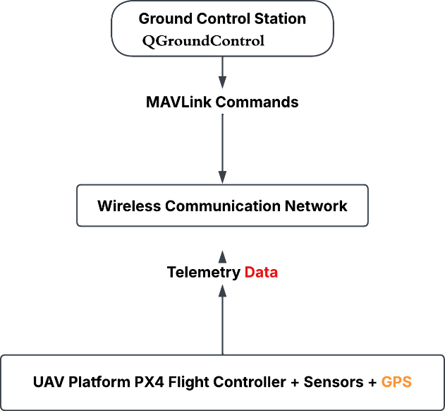
Figure 2.1 General UAV Communication Architecture

2.2 UAV Swarm Communication
Unmanned Aerial Vehicle (UAV) swarm communication is a group of multiple autonomous or semi-autonomous drones for achieving a set of mission goals that is coordinated by the group. When several UAVs are working together in a swarm joint flights will be coordinated with each other, joint computation will be distributed and information will be shared continuously based on communication between the aircraft in this case. The synergistic interaction ensures operational efficiency, boosts the reliability of the mission and offers better operability for large-scale applications.
The use of UAV swarms has been greatly ramped up by recent advances in autonomous systems, artificial intelligence, and wireless communication technologies, especially in the civilian and civilian-military domains. The other uses are in civilian control such as precision agriculture, environment monitoring, disaster management, search and rescue, infrastructure inspection, and smart city surveillance. Military uses include intelligence, military border crossings, reconnaissance, electronic warfare and coordinated military missions. Having several UAVs working at once enables a complex task to be achieved more efficiently than by one UAV alone.
A typical UAV swarm can include a number of interconnected components such as a Ground Control Station (GCS), UAVs (aircraft) with on-board flight controllers, communication links, navigation sensors and mission planning software. The Ground Control Station will be in charge of sending commands to mission, gathering telemetry, visualising mission status, and coordinating mission progress. The Ground Control Station and UAV typically communicate with each other via wireless mechanisms such as radio frequency (RF), Wi-Fi, LTE/5G networks or via satellite communication as required for particular missions.
Many research and industrial platforms have quickly adopted MAVLink as a communication protocol to exchanged various telemetry data, navigation instructions, mission information and vehicle status between the UAVs and the Ground Control Stations. The MAVLink protocol is light, efficient and optimized for real-time application and is especially well suited for autonomous air systems. PX4 and ArduPilot (both open-source flight control software approaches) heavily make use of MAVLink to communicate with Ground Control Stations such as QGroundControl.

2.3 MAVLink Communication Protocol
Micro Air Vehicle Link (MAVLink) is a very simple protocol in UAV communications to communicate between various elements of systems, including GCS, flight controllers, sensors and companion computers. Because of its low bandwidth and real-time performance, MAVLink is the default protocol for open-source autopilots like PX4 and ArduPilot.
MAVLink includes structured data packets to send telemetry, navigation commands, GPS info, battery information, attitude, and mission updates. The research in this work involves sending and receiving MAVLink messages between QGroundControl and the PX4 Software-in-the-Loop (SITL) simulator. The protocol supports the ability to communicate with the UAV and with the operator at all times, permitting the operator to 'see' the UAV and fly it in real time.
Although efficient, MAVLink wasn't originally designed to be as secure as it now is. The standard MAVLink messages are not encrypted or authenticated and can be easily affected by a cyberattack. A malicious entity gaining access to the communication channel can intercept, alter and replicate the packets; this can impact UAV behaviour and mission execution.
There are two critical threats, Man-in-the-Middle (MITM) and Replay attacks. MitM is an attack in which the attacker listens to the communication packets exchanged between the Ground Control Station and UAV, and manipulates them before sending them to the Ground Control Station. In the MAVLink setup studied in this research there was no special protection that uses sequence numbers to stop replay attacks. This meant that packets that had been recorded before could be sent again during the replay attack test.
These drawbacks are addressed with the presented secure communication protocol in this dissertation which is based on Quantum Key Distribution (QKD) with the originality of BB84 and AES-256-GCM for authenticated encryption. Alice and Bob are gateway proxies that both encrypt and decrypt MAVLink packets on their connection with the vehicle, boosting the security of MAVLink packets – protecting against MITM and replay attacks, improving the confidentiality and integrity of messages without compromising PX4 and QGroundControl compatibility. Such vulnerabilities demonstrate the security risks associated with insufficiently protected UAV communication and highlight the importance of authentication and integrity mechanisms (Amrin et al., 2018).
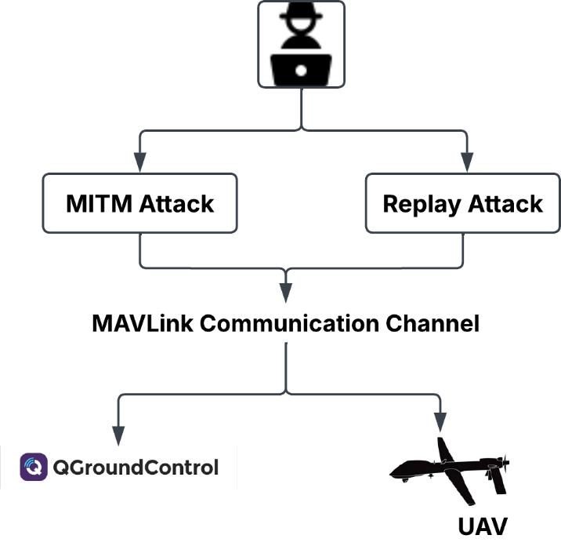
Figure 2.2 Cyber Threat Model

2.4 Cybersecurity Threats in UAV Communication
As the use of UAVs has been trending towards critical applications, secure communications is of great research interest. Problem 1: Because UAVs use wireless networks, they are susceptible to attacks that could affect mission safety, data confidentiality and system reliability. It is a possibility that attackers take advantage of the communication channel to intercept or modify, or inject malicious packets.
A man-in-the-middle attack is the most popular attack. During this attack, the communicator between the Ground Control Station and UAV is corrupted by an enemy. The attacker may alter the commands and/or telemetry before they are sent on, thereby making it appear as though the communication originated from its intended target and changing mission behaviour.
Another significant one is the Replay Attack in which an attacker intercepts the valid communication packet and then replays it. Due to the lack of replay protection in the conventional MAVLink communication, duplicated packets can be received by the UAV platform, opening a possibility of repeating action of commands or triggering false behaviour of operation systems inside the UAV.
Additional attacks include GPS spoofing, message spoofing (sending fake MAVLink packets into the communication channel) and Denial-of-Service (DoS) (saturating the communication channel). The attacks could impair the effectiveness of the missions, possibly causing total loss of UAV control.
The vulnerabilities put forward have led to the development of secure communication methods, such as encryption, authentication, intruding detection systems, security based on blockchain, and quantum cryptography. This dissertation proposes an AES-256-GCM-based Quantum Key Distribution (QKD) protocol, which is derived from BB84, to provide secure key exchange, data confidentiality, data authentication, and against MITM and replay attacks.

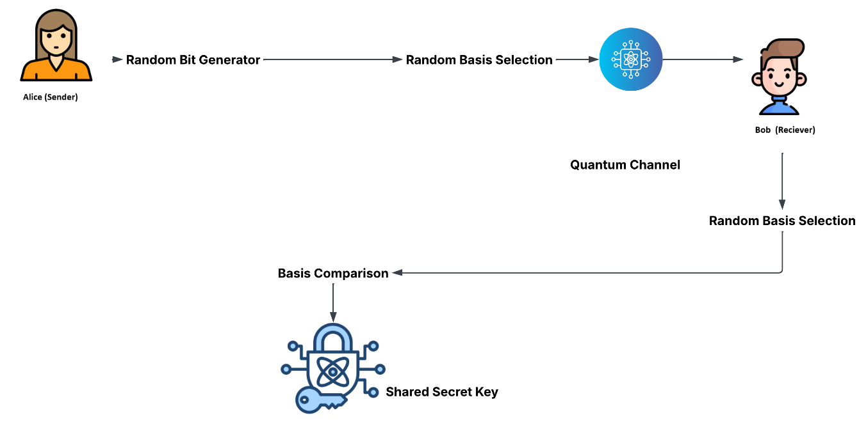
Figure 2.3(a) BB84 Quantum Key Distribution

2.5 Quantum Key Distribution (BB84 Protocol)

Quantum Key Distribution (QKD) is a key establishment technique using properties of quantum states for two legitimate communicating parties to establish secret key material that is suitable to be used in cryptographic applications. QKD is not like traditional public-key key-exchange techniques, which rely exclusively on the presumed difficulty in solving a mathematical problem to make it secure. On the contrary, it sets entirely upon the quantum aspects of the way quantum states were prepared, measured, and ruined. One of the most popular approaches to quantum key distribution is the BB84 protocol by Bennett et al (1984) which is the begin protocol.

The communicating persons are usually labelled Alice (transmitter) and Bob (receiver) in the BB84 protocol. Alice first creates a random sequence of classical bits (0s and 1s). Alice randomly chooses one of two different quantum encoding bases for every bit. The following are often referred to as the rectilinear basis (+) and the diagonal basis (×): It is important to note that the basis of representation, which is used to represent the corresponding classical bit, is a choice.

In the representation using concepts from the polarisation, for instance, the basis of the diagonal could use two photon polarization states in the diagonal, while the basis of the rectilinear uses two photon polarization states in the horizontal and vertical. The key thing is that the states that are created based on one set of basis cannot be reliably measured based on the other set of basis. Assuming Alice and Bob have chosen the same basis upon which to measure the state, the desired bit can hopefully be retrieved. The result is basically unpredictable if Bob takes an incorrect way (basis).
The BB84 process can be described through the following stages.
1. Random bit generation:
Alice creates a random 2 sequence. This string is a raw output value that could potentially make up the final cryptographic key. For example, Alice may generate a sequence such as 1, 0, 1, 1, 0, 0, 1, 0.
2. Random basis selection:
Alice selects independently the encoding basis for each bit generated. Thus, every bit is located with a binary value and a basis. For an observer who is not authorised, it is essential that the basis of the measurement is random, in order to prevent this person from knowing in advance which basis to use in measuring the contents of the box.
3. Quantum-state preparation and transmission:
Alice encodes each bit as a quantum state using the basis she has chosen and sends the sequence through the quantum channel to Bob. Alice creates a quantum state corresponding to each bit using the basis she has selected and sends the sequence of the bits through the quantum channel to Bob. In a physical BB84 system, the states can be encoded on properties of photons as polarisation. Hence, in normal circumstances, QKD necessitates a quantum communication channel to carry the quantum states to be transmitted and a classical communication channel to carry the other operations of the protocol.
4. Bob’s random measurement-basis selection:
At the start of the game, Bob doesn't know which bases Alice has chosen. He engages in a separate measurement basis selection for each received quantum state. If Bob somehow happens to choose the same basis as Alice, then his measurement will create the original bit under optimum conditions. If the bases are different, the measurement will not accurately allow you to determine Alice's original bit.
5. Basis reconciliation and key sifting:
Once the quantum transmission is finished, Alice and Bob send each other along an authenticated classical channel. Publicly share their bases but will not share their secret bit values. They make a comparison of their basis choices and remove from consideration all positions where the base choices differed. The rest of the positions (Alice and Bob used identical keys) are part of the sifted key.
For instance, suppose that they used the same basis in about half of the transmitted states: only the states with the same basis would be kept. So, the sifted key will typically be shorter than Alice's original random bit sequence.
6. Eavesdropping detection and error estimation:
One of the many properties of BB84 is that it will disclose the perturbation made by the measurement of quantum states. Let us imagine an attacker Eve tries an "intercept-and-resend" attack. Suppose an attacker Eve tries an "intercept-and-resend" attack. Eve is not aware of which bases Alice used and has to guess a basis of measurement. If her choice of basis is incorrect, she can disturb the transmitted quantum state when making the measurement. Therefore, Alice could send a state based on that wrong measurement, but Bob might get states different to the ones that Alice delivered.
Alice and Bob can measure QBER by performing a comparison of a subset of the key values they have sifted along the authenticated classical channel. Errors rates beyond an acceptable threshold for security may result from excessive channel disturbance, implementation issues or possible eavesdropping. Under these conditions, it is possible to end up using potentially compromised key material or abort the key-establishment process.
7. Error correction:
If there is no attacker, there are some noises in the channel, imperfect optical components, errors in the detectors, or other effects of the implementation system that can make up errors in physical quantum communication. In order to get Alice and Bob the strings in the same hash, and minimize the amount of information they disclose to each other during the information-reconciliation/ classical error-correction, Practical QKD incorporates classical error-correction or information-reconciliation procedures.
8. Privacy amplification:

The adversary might have some information about the key after error correction. It is theoretically possible for an adversary to have partial information about the reconciled key after error correction. Privacy amplification is used to decrease this information by converting a longer reconciled key into a shorter secret key. The idea is to lower the information that is available to an eavesdropping enemy to a minimal level. The resulted stuff can then be used as a common secret cryptographic key.
Another requirement is that the classical communication to maintain reconciliations, error estimates, and to complete the post-processing must be authenticated. An attacker might mimic Alice or Bob and perform a classical Man-in-the-Middle attack on the QKD protocol, without authentication. So, QKD alone cannot replace the use of authenticated classical communication.
This principle of BB84 secure communication can thus be stated as: no one knows what the basic value is, the unknown value cannot be measured at will without altering it, and no receiver with a measurement basis different from the sender can reproduce the original value sent by the sender with efficiency. With this, they can rely on the observed mistakes to make their conclusions about the appropriateness of the key material they make for secure communication.
Application of BB84 in the Proposal Framework
This dissertation's implementation is a software implementation of a BB84-inspired simulation and not an actual QKD test bed. There will be no photons involved or any optical quantum channels, single photon detectors or any physical communication devices. Programmatically, with BB84 cryptographic functions that include random bit generation, random basis selection, basis comparison, and derivation of common basis keys, the major logical steps of BB84 are illustrated instead.
It results in the generating of a shared key material that is then utilized to produce a session key for the AES-256-GCM security level performing the communication between the Alice and Bob gateway proxies, which is 32-bytes (256-bits). AES-256-GCM is then used for the security of the actual MAVLink data and the BB84 inspired component is used for the security of the session key. In this respect, the two mechanisms have different, but complementary roles within the framework: The QKD mechanism is used to gather cryptographic key material, the AES-256-GCM is to provide authenticated encryption of MAVLink packets.
This is key to keep in mind as it is not a physical security guarantee as it would be in an optical BB84 deployment. However, it gives a softwarized POC to explore the possibility of key establishment based on BB84 ideas being wrapped into an existing UAV communication architecture, while simultaneously using authenticated encryption.
As illustrated in Figure 2.3(b) the BB84 inspired process (i.e. random bit generation, random basis selection, basis comparison, and generation of shared session-key material) is followed in the proposed framework.

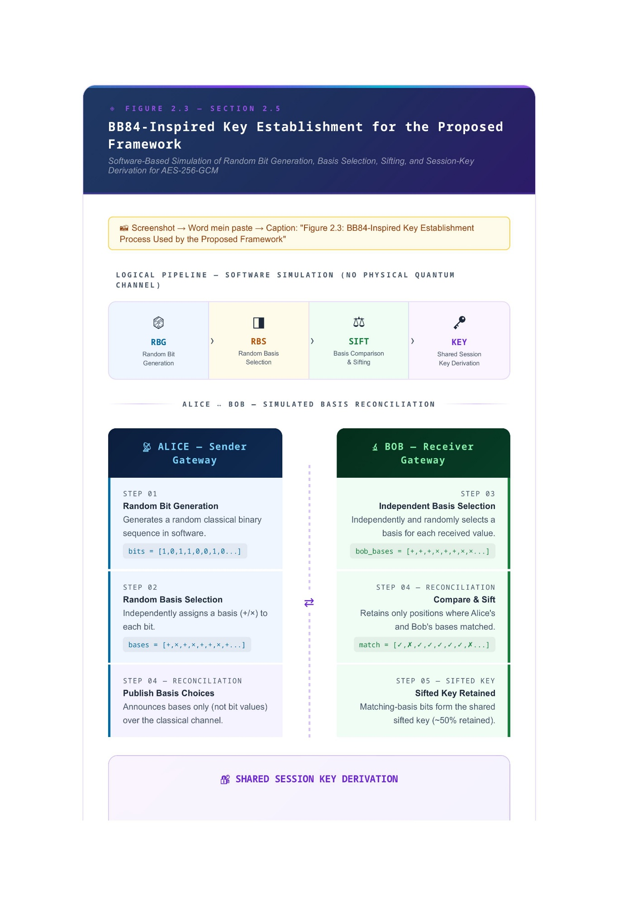
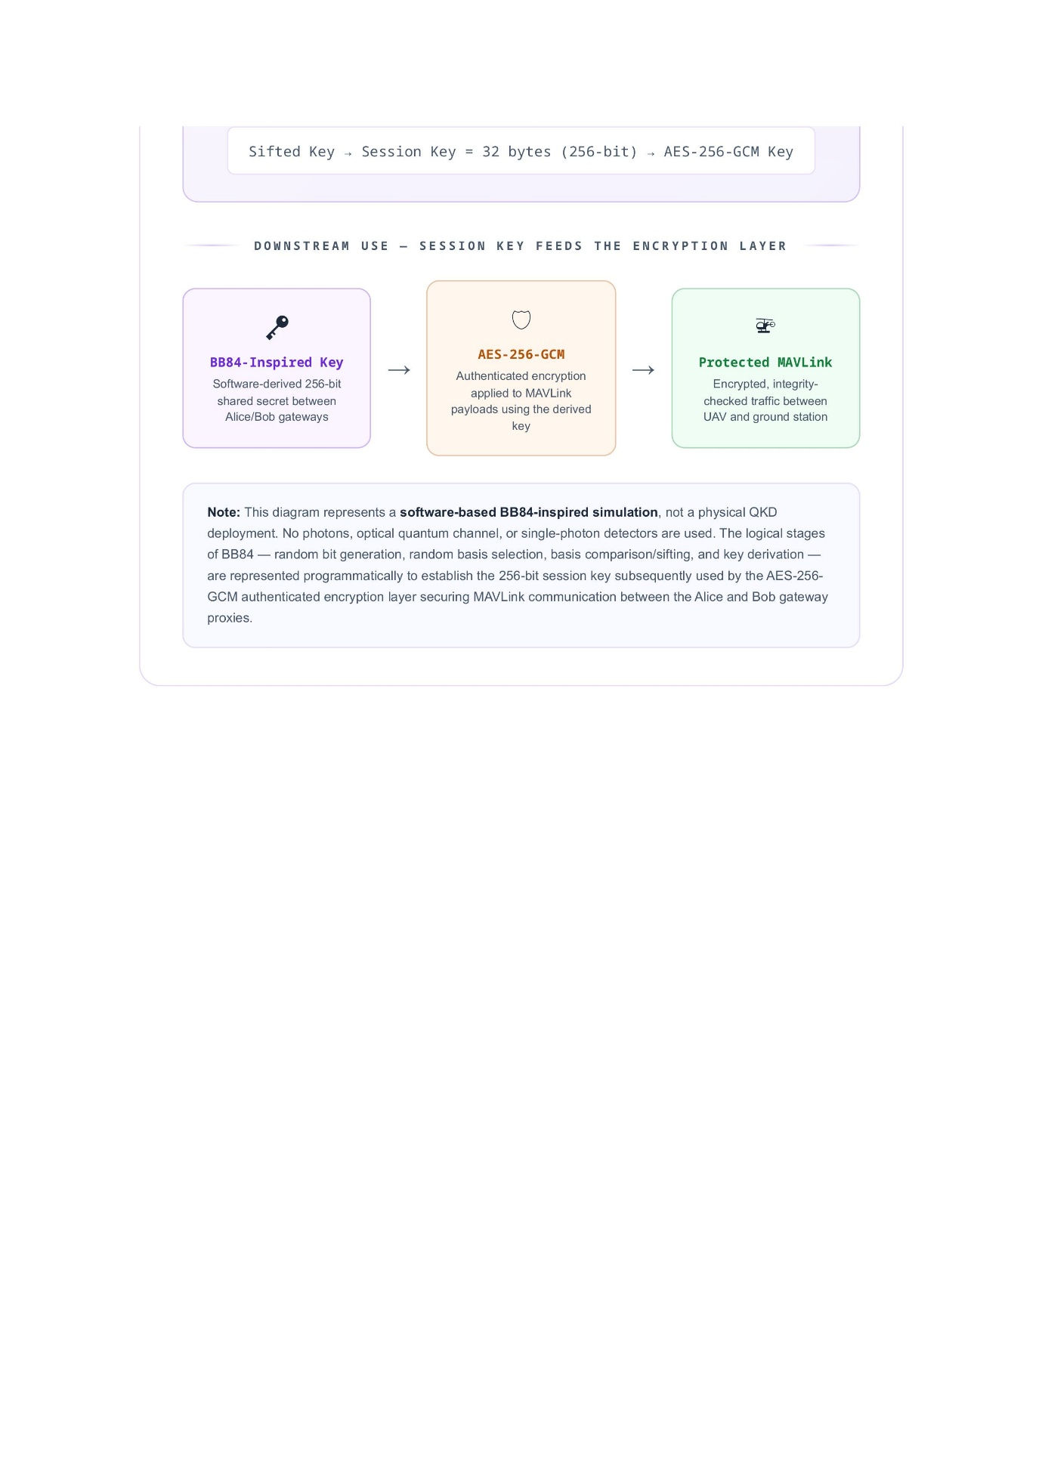
Figure 2.3(b)BB84 Quantum Key Distribution and Session-Key Establishment Process

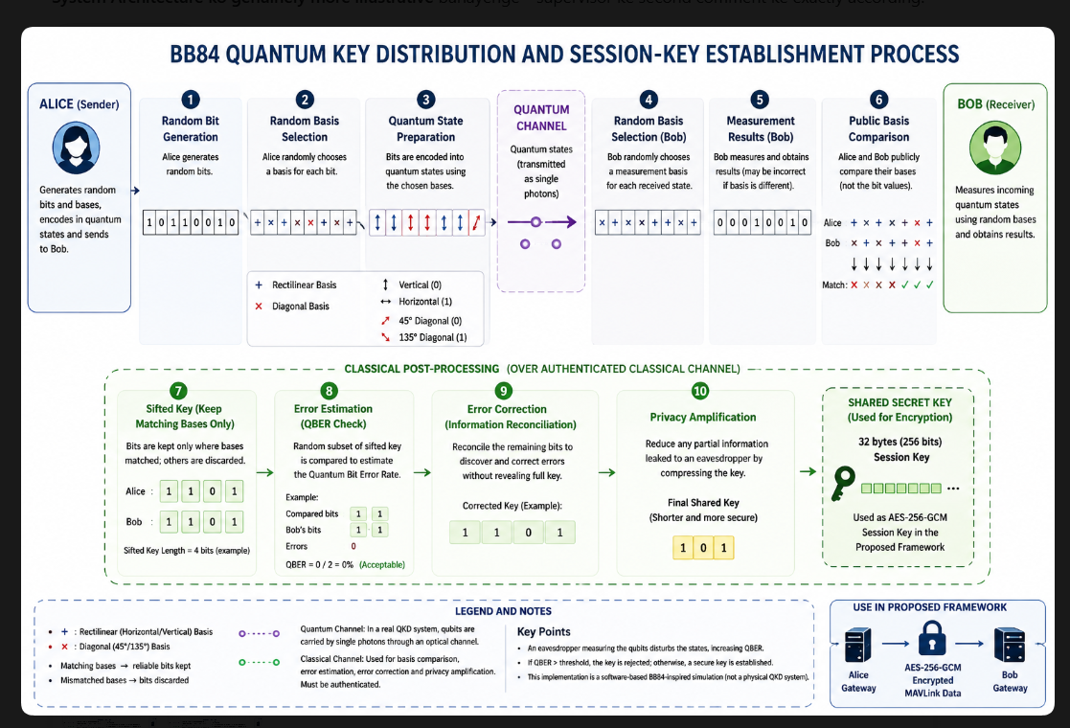
Figure 2.3(c) BB84 Quantum Key Distribution and Session-Key Establishment Process

2.6 AES-256-GCM Encryption
Advanced Encryption Standard (AES) is a symmetric encryption method that is widely used for the encryption of digital communication. It offers robust security, high performance, and is widely used in cloud systems and government applications as well as industry systems. AES has key lengths of 128 bits, 192 bits, and 256 bits, the Security Level 256 being the highest level of security.
This research uses AES-256-GCM (Galois/Counter Mode) to protect MAVLink communication. GCM also offers encryption and authentication, unlike the conventional AES modes. It guarantees the confidentiality of transmitted information and also assures the integrity of the packages during transmission. As the attacker might have changed an encrypted packet, the authentication procedure fails and the packet is refused.
Alice gateway encrypts MAVLink packets based on generated session key using QKD protocol inspired by BB84 within the proposed scheme. The Bob gateway does an important job. It checks the packets that are sent to it. Makes sure they are safe. The Bob gateway uses a key that it shares with other systems to unlock the packets. The Bob gateway then looks at the packets. Only sends the ones that are valid, to where they need to go. The Bob gateway only forwards the MAVLink packets that it knows are okay. This method will prevent mistaken modification of the packet or an increase in the level of communication integrity.
The proposed framework not only introduces secure communication of BB84-based key generation and {AES-256-GCM} but does not affect the current MAVLink protocol, enabling secure communication while maintaining standardized procedures.

2.7 Existing Secure UAV Communication Frameworks
These include symmetric encryption, public-key cryptography, blockchain-based authentication, intrusion detection systems (IDS), and machine learning-based threat detection. These techniques help to make the communication secure, but generally add to the complexity of computation or communication delay or energy consumption.
Most of symmetric encryption algorithms are used widely because they offer fast and efficient data protection, one such example is AES. Their security depends on secure key distribution, however. Key exchange can be solved by public-key cryptography, but may be compromised if quantum computers become available.
These limitations have been researched by using Quantum Key Distribution (QKD). During the key generation process, QKD allows for the detection of eavesdropping, thereby making the transmission of the key secure. While deployment of the systems in practical UAV network may come with limitations in terms of hardware technologies, quantum-inspired technologies succeeded in the simulation environment.
Both the security exchange of keys and secure communication are primarily emphasized in the existing frameworks. Research on using BB84-inspired QKD and AES-256-GCM authenticated encryption and MAVLink communication for a UAV security framework is not very common. To fill this gap, this work combines these technologies in a secure gateway architecture that is additionally compatible with existing PX4 and QGroundControl systems, that enhances the security of telemetry communication.

2.8 Chapter Summary
The readers of this chapter were exposed to the literature covering the communication system of UAV swarms, MAVLink protocol, cybersecurity threats, Quantum Key Distribution and AES256-GCM encryption. Previous studies have shown that ensuring UAV communication is a significant problem, because wireless networks security is not always sufficiently high to support communications, and traditional key exchange techniques are not always secure.
The review found that there is a missing area of research regarding the interweaving of BB84-based QKD, authenticated encryption AES-256-GCM, and MAVLink communication in one package. Avoiding this gap, the proposed system works on communication security by increasing the level of security regarding confidentiality, integrity and authentication of communication and preventing adversarial MITM and replay attack. Chapter 2 discusses the methodology and system design of the proposed secure communication system.

Chapter 3

NEW IDEAS & APPROACH

3.1 Introduction
This chapter documents the design methodology and approach which will be adopted to develop the proposed secure communication framework for UAV system. The research gap from Chapter 2 inspired the approach, and it focused on the lack of integration of the aforementioned aspects of MAVLink security testing in PX4 with a single approach.
The proposed solution consisted in using AES-256-GCM authenticated encryption and Quantum Key Distribution (QKD) inspired with the BB84 protocol for securing MAVLink communication. Alice and Bob software gateways are located in a communication channel between the UAV system and Ground Control Station. Alice encrypts MAVLink packets with the shared session key and Bob decrypts packets received and authenticates them before passing on the communication. The sequence number validation also recognizes replayed packets.
The framework is tested in a controlled simulation environment made up of PX4 Software-In-The-Loop (SITL), Gazebo, QGroundControl, Python-based gateway programs and Wireshark. Experimental method compares communication BEFORE and AFTER application of the proposed security methodology, with particular focus on communication delay, attack outcomes and packets behaviour. To evaluate the effectiveness of the proposed approach, two controlled test scenarios are implemented such as Man-in-the-Middle and Replay attacks.

3.2 Research Methodology
This research employs experimental and comparative approach for studying the effectiveness of the proposed secure UAV communications architecture. The communication environment applies MAVLink communication to the same UAV platform in an environment that can be controlled for two different scenarios, unsecured and secured, so that the comms can be observed.
The experimentation can be categorized into two aspects. The first phase is for the evaluation of standard MAVLink communication with no QKD and AES protection for baseline. Network traffic is captured and analysed by using Wireshark and controlled Man-in-the-Middle (MITM) and Replay attacks are run.
In the second phase, the proposed security framework is implemented by adding the Alice and Bob secure gateways in the communication path. The shared session key is derived from a BB84-inspired QKD mechanism and AES-256-GCM is employed for the encryption and authentication of MAVLink packets. These MITM and Replay attack scenarios are then repeated. Packets that have been modified should not pass authentication and packets that have been captured should be recognised via sequence-number-based replay protection.
For comparison, packet captures are analysed in both phases to determine the packet transmission behaviour, packet size, timestamp in the captured packets, and communication delays. Traffic is analyzed in WireShark to see if any additional overhead is added to the communications due to encryption, authentication and replay protection. The outcome of the attacks is also compared to those outcomes, to test for improvement in the confidentiality and integrity of MAVLink communication as shouted for in the proposed framework.
Having identical PX4, Gazebo, QGroundControl and the network environment running in both phases ensures that the proposed framework can be securely and reliably assessed with respect to its security and performance impact.

3.3 System Architecture
The proposed system architecture includes an additional secure communication layer between a UAV platform and Ground Control Station, and maintains the current MAVLink communication conventional. The experimental setup includes 2 security gateways, Alice and Bob, both based on Python, along with PX4 SITL, Gazebo and QGroundControl.
For the proposed architecture, MAVLink packets created by PX4 are first sent to the Alice gateway. Alice now encrypts the protected packets using the random session key he has generated with the BB84-inspired QKD protocol, and sends the encrypted packets over a secure communication path. The encrypted packets are then received by the Bob gateway where the authentication tag is checked for validity and decryption takes place. Packets which pass the authentication are passed to their final destination while tampered-authorized packets are rejected.
The framework also includes sequence number validation to offer replay protection. There is a sequence value associated with each protected packet, so Bob can determine if a packet was already processed. As a result, packets that are previously received and relayed can also be discarded instead of accepted as valid communication.
The architecture of a gateway was chosen to allow security features could be properly evaluated without changing the underlying MAVLink protocol or PX4 flight-control software. It also offers visibility at clear points that are good for packet captures and attacks under controlled circumstances, so that the downward leg of the comm path can be captured with and without the security.
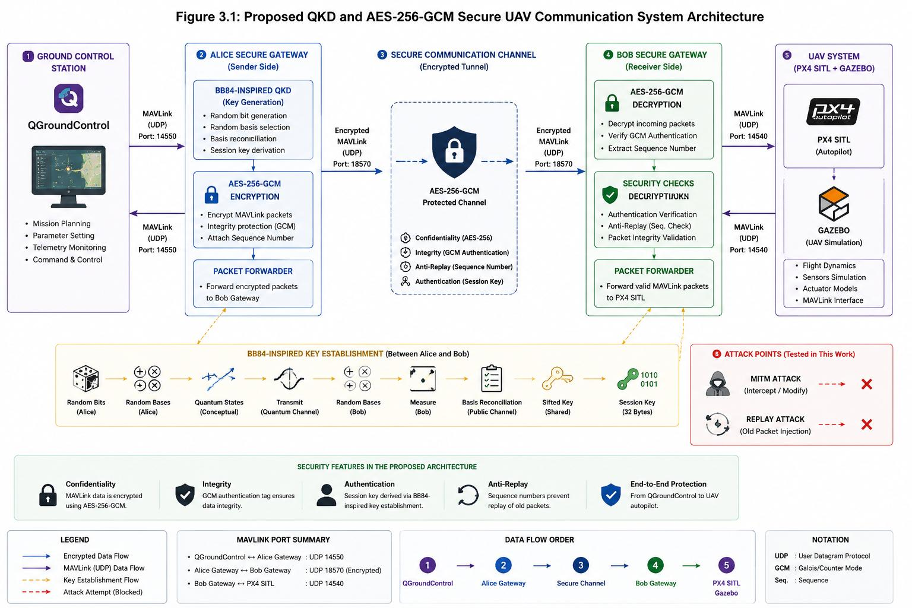
Figure 3.1 Proposed Secure UAV Communication Framework
Figure 3.1 illustrates the proposed architecture and the integration of BB84-inspired key generation and AES-256-GCM authenticated encryption within the MAVLink communication path.

3.3.1 Proposed QKD and AES-256-GCM Secure UAV Communication Framework
The aim of the proposed framework was to create a secure communication layer between UAV and Ground Control Station (GCS). The experimental architecture uses PX4 SITL and Gazebo for UAV simulation, Alice and Bob (both based on Python) for security gateways, and QGroundControl as the GCS. The security gateways are used for the communication between the UAV and the QGroundControl, rather than straight from the UAV to the QGroundControl as in the case of MAVLink telemetry.
Communication starts by the PX4 generating MAVLink telemetry in the Gazebo simulation environment. The plaintext MAVLink packets are received by the Alice gateway. Alice is the user that uses the shared session-key material generated within the QKD portion of the framework and AES-256-GCM authenticated encryption is used to encrypt the MAVLink. A sequence number is also linked to the protected packet to aid freshness check and Replay attack detection. The packet is then encrypted and authenticated and sent by Alice to the Bob gateway.
Bob performs the AES-GCM authentication and decryption with the same session key used during encryption. An encrypted packet is rejected if the packet has been altered while it was being transmitted. This was utilized to determine whether any packet manipulation occurs during the secured MITM experiment.
Bob also does sequence-number validation prior to accepting a decrypted MAVLINK packet. Rejected: Any sequence number used that is either an older play or a previously used number. If the authentication and sequence validation is successful, the packet is forwarded to QGroundControl.
Consequently, the entire fail-safe communication chain is:
PX4/Gazebo → Alice Gateway → AES-256-GCM Protected Channel → Bob Gateway → QGroundControl
This design offers protection for. Telemetry, by keeping it private and ensuring it is not changed. It also checks that each packet is new to stop replay attacks as studied in this research. The way these parts are built and tested is shown in the chapters.

3.4 Secure Communication Workflow
The secure communication workflow specifies the way MAVLink packets are secured during the transportation of them from the UAV environment and Ground Control Station. Alice and Bob gateways first use the BB84-inspired QKD mechanism to distil a shared session key before the secure communication starts. This session key is then employed in an authenticated encryption with AES-256-GCM.
Alice receives a MAVLink packet, adds sequence info and then encrypts it with AES-256-GCM and forwards it on to the secure gateway. The resulting protected packet is then sent to Bob via the secure channel. Prior to accepting a packet, Bob checks the authentication information and the packet sequence. If authentication was successful, the sequence number is also valid and the original MAVLink packet can be decrypted and will be forwarded to the intended recipient.
If the attacker changes the contents of the encrypted packet, AES-GCM authentication will fail when they are trying to form a MITM attack, and Bob will refuse the packet. On the other hand, if a new attack tries to retransmit an old, already captured packet in the encryption, the sequence-number validation mechanism compares the received sequence number with previously accepted sequence values and rejects packets identified as previously processed or outdated. These controls ensure confidentiality, integrity, authentication and replay protection for underlying MAVLink communication without changes.
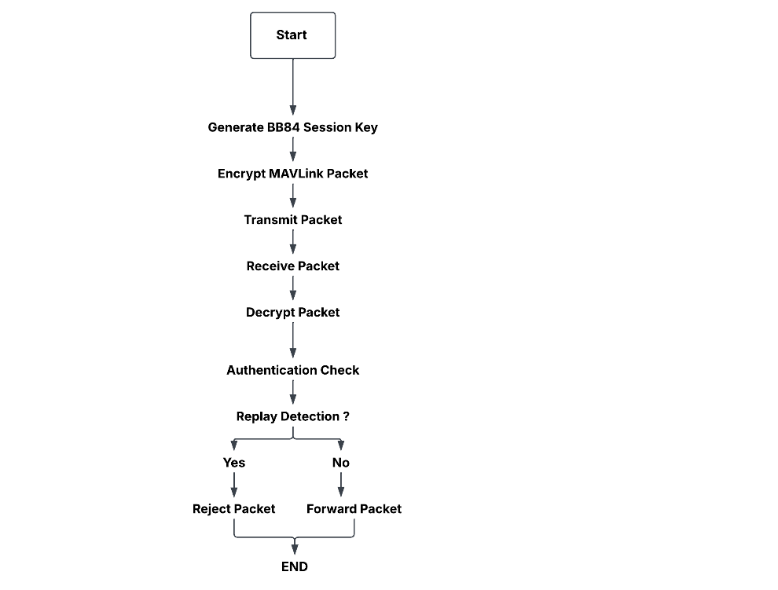
Figure 3.2 Secure Communication Workflow
Figure 3.2 illustrates the complete secure packet-processing workflow, from session-key establishment and MAVLink encryption to authentication, replay validation, decryption, and packet forwarding.

3.5 Experimental Setup
Proposed framework was simulated and tested in a controlled UAV environment. The flight-control platform used was PX4 Software-in-the-Loop (SITL) and the virtual UAV environment was Gazebo. The Ground Control Station (GCS) used was QGroundControl which was used to monitor MAVLink telemetry and communication with the simulated UAV.
Security was set up using gateway proxies Alice and Bob in python. Alice got some plaintext MAVLink packets from the PX4 communication path. She wanted to keep these packets safe. So, Alice used a key that she shared with someone else and a kind of protection called AES-256-GCM authenticated encryption to lock these MAVLink packets. This way Alice made sure that the MAVLink packets, from the PX4 communication path were protected. Bob got the secured packets, authenticated, decrypted them, replay protected with sequence validation and passed on the MAVLink packets that he could declassify.
A series of wire-shark and packet-capture applications were used to monitor packet communication within the network, and to gather experimental evidence. All tests were performed in two configurations: unsecured (no proposed protection) and secured (communication through the QKD and AES-256-GCM protection). Both simulations were conducted in the same simulation environment, so as to have a rough consistent basis to compare.
Both configurations were then subjected to a controlled MITM and Replay attacks. The practical aspects such as packet delays, size of packets, and outcome of attacks have been determined and the security effectiveness and the performance requirements of the proposed framework have been assessed through packet captures.

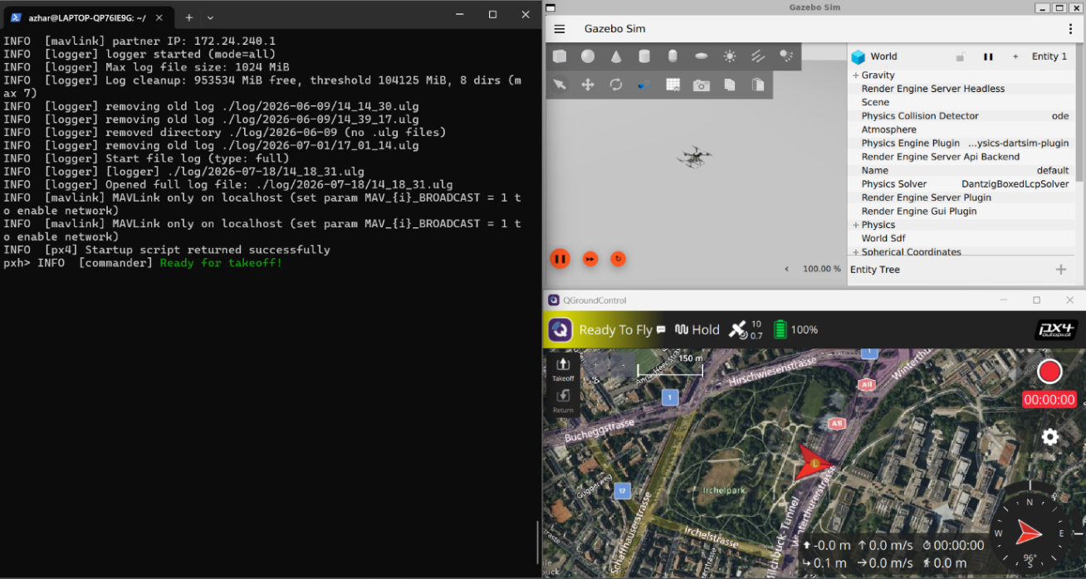
Figure 3.3 Experimental UAV Simulation Environment
Figure 3.3 illustrates the proposed architecture and the integration of BB84-inspired key generation and AES-256-GCM authenticated encryption within the MAVLink communication path.

3.6 Experimental Procedure
The entire process employed was developed to verify how applications of MAVLink communications work before and after implementing the security framework in the same configuration. In order to assess the security effectiveness and communication overhead of the proposed approach, the testing process was organized into two stages.
In this phase (Unsecured Communication) PX4 SITL, Gazebo, and QGroundControl were all running with the regular MAVLink communication without AES encryption or QKD. Common traffic on the network was recorded with Wireshark to get baseline packet behaviour. Simply, controlled MITM and Replay attacks were performed to check if the MAVLink traffic can be successfully compromised: recorded, altered and played back.
In Phases B – Secured Communication, the Alice and Bob gateways were added to the communication path. The BB84-inspired session-key mechanism was used for protecting MAVLink packets against compromise and authenticated encryption is used with AES-256-GCM. The above MITM and Replay scenarios were then repeated. The modified encrypted packets were tested by authentication verification, and duplicated packets were tested by using the sequence number replay detection method.
In both phases, network evidence was gathered for comparison of packet transmissions, packet size, timestamps, attack success, and communication delay. The secured results and the unsecured results have then been compared to find out if the added cryptographic security was sufficient to thwart the tests and to understand if there were any performance limitations due to increased key generation and AES-256-GCM computation induced by the QKD process.

3.7 Professional, Social, Ethical and Legal Considerations
Elaboration and assessment of the proposed UAV security system must be taken into account the professional, ethical, social and legal aspects. A critical security requirement when creating security mechanisms for UAV communication systems is confidentiality, integrity, and authorised access, as it is with the other important telemetry and operational data used in these systems.
In terms of ethics and professional ethics, all experiments of MITM and Replay attack have been performed in this paper, in the controlled simulated environment of PX4 SITL and Gazebo. The experiments have only been carried out to test the security for the proposed framework and not real UAVs, external network nor third party systems. This controlled method minimised potential disruption or unauthorised access.
In terms of social aspects, making communication more secure for UAVs can help to ensure safer implementation of UAV technologies in areas where acceptable communication is a vital relevance. The protection of the telemetry system from interception, modification and a replay would minimize the risks of unauthorized manipulation of the communications between telemetry and UAVs.
Regrettably, the legal aspects of the experimental activities meant that the systems and software were set up specifically for this research. There were no unauthorised attacks on the network or infrastructure. Moreover, the development was not collecting and processing personal data of its participants. Thus, the work was dedicated to the technical aspect of cybersecurity experiments, with responsible and controlled research practices.

3.8 Chapter Summary
In this chapter, the methodology and design of the proposed UAV communication approach to secure communication was presented. The proposed method is based on the QKD mechanism inspired by BB84 and AES-256-GCM authenticated encryption for the protection of MAVLink communication between the simulated UAV environment and Ground Control Station. Alice and Bob secure gateways, secure communication workflow, authentication mechanism, replay protection using sequence numbers and system architecture were discussed in details. In addition, the experimental procedure was clearly outlined to facilitate consistency of comparison of both unsecured and secured MAVLink communication with the MITM attack scenario and Replay attack scenario. Furthermore, the performance measures of packet characteristic and communication delay were identified for evaluating the overhead of proposed security framework. The next chapter offers a practical implementation of the framework and a description of the experimental environment.

Chapter 4

Implementation

4.1 Introduction
This chapter discusses practical implementation of the proposed secure UAV communication framework discussed in Chapter 3. It has been implemented in a simulated UAV environment, with PX4 Software-in-the-Loop System (SITL), Gazebo, QGroundControl, Python-based security gateways and network analysis tools. The goal was to build a viable MAVLink communication environment and later add the MAVLink key generation mechanism based on the principles of QKD, and the AES-256-GCM authenticated encryption mechanism.
The implementation took place in incremental stages. First, the PX4 SITL and Gazebo environment was set-up to offer the simulated UAV platform. QGroundControl was then integrated to support MAVLink telemetry monitoring and functionality as Ground Control Station. After verifying communication at the baseline, the security gateways Alice and Bob were added to the communication path to offer protection for data being encrypted, authenticated, decrypted, and protected from replay attacks. Wireshark was then used to see how the packages are transmitted and it helped to make the experimental evaluation as explained in next chapter.
The approach to implementation allowed the security mechanisms to be put in place without changing the PX4 flight-control software or MAVLink protocol. This was done to get a controlled environment which allowed a comparison between the unsecured and secured UAV communications.

4.2 PX4 SITL and Gazebo Environment Setup
The implementation started with the setting up of the PX4 Software-in-the-Loop (SITL) and the Gazebo simulation environment. PX4 SITL utilized to run the UAV flight-control software (without the need of physical UAV), Gazebo in the virtual environment for the simulated UAV to operate. The PX4 environment was tuned with the gz_x500 vehicle model. Successful launch of the simulation, the PX4 terminal gave flight-controller status information and the simulated environment, Gazebo, showed UAV models. This created the simulation environment necessary for further MAVLink communication and security testing. Initially, before adding the security gateways, the simulation environment was tested to make sure the UAV model and flight-control components were functioning properly. It was especially significant to create an environment for PX4 and Gazebo to be stable since all of the unsecured and secured experiments would be conducted with the same simulated platform.

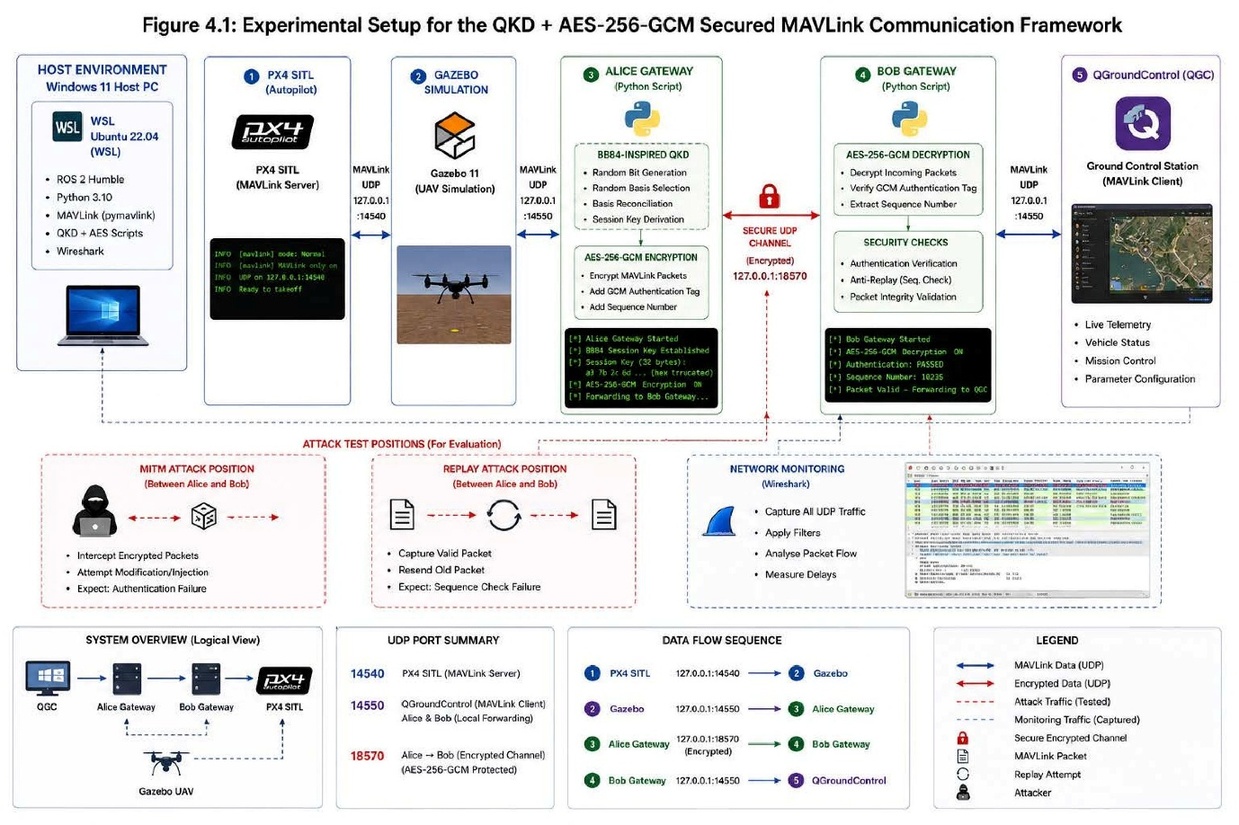
Figure 4.1(a) Experimental Setup for the QKD + AES-256-GCM Secured MAVLink Communication Framework
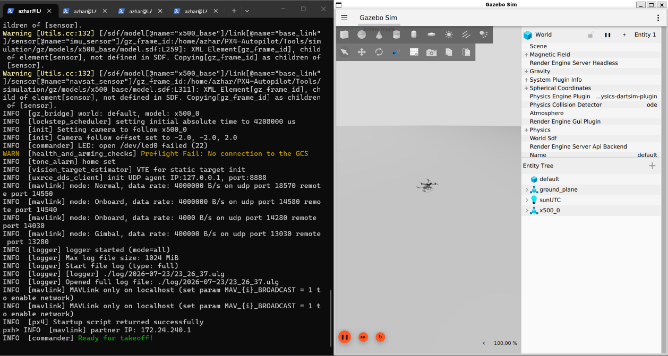
Figure 4.1(b) PX4 SITL and Gazebo UAV Simulation Environment

4.3 QGroundControl and MAVLink Communication Setup
After successfully running the PX4 SITL and Gazebo environment, QGroundControl (QGC) was setup as the Ground Station for monitoring and interacting with the simulated UAV. MAVLink for Transmission of UAV telemetry / flight status data from the Ground Control Station was used to communicate with PX4 via UDP. This was tested by putting the simulated vehicle into the flight path, and seeing it appear in QGroundControl and then receiving updated telemetry information continually. This communication was intended to provide the baseline connectivity that was necessary to integrate security into the rest of the connectivity. In the secured implementation, MAVLink communication path was redirected via the Alice and Bob security gateways, which were capable of protecting packets before they would be sent to their intended target. The first step of a working PX4-QGroundControl link was critical since it gave the means to test the secured communication framework behaviour in comparison to the “unsecured” link.
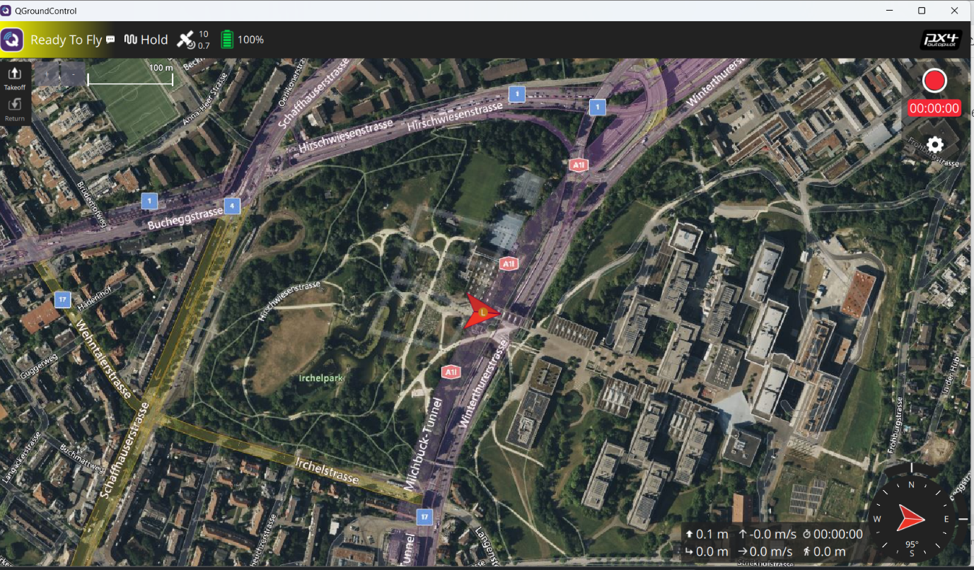
Figure 3.2 QGroundControl Successfully Connected to the PX4 SITL Vehicle
Figure 4.2 confirms successful MAVLink communication between PX4 SITL and QGroundControl, with the simulated vehicle recognised by the Ground Control Station and reported as ready to fly.

4.4 QKD Key Establishment Implementation
The proposed scheme employs the QKD idea developed from BB84 to achieve a common set of key material between Alice and Bob's gateways for the purpose of communication. This stage is for providing the same key material in advance of starting packet encryption on MAVLink, so that both gateways have access to this information to perform the encryption. The session key is saved and then provided to the gateways as needed for further cryptographic operations.
For the implemented framework, a 32-byte (256-bit) session key is used with AES-256-GCM. Alice and Bob load the same 32-byte session key before secure MAVLink packet transmission begins. This helps to make sure that packets that are encrypted by Alice can be successfully authenticated and decrypted by Bob. A separation of key establishment from packet encryption also helps to structure a fit-for-purpose security framework assessment.
There is no unique key that is sent along with each MAVLink packet. It is rather used as the cryptographic foundation for the secured communication phase in which AES-256-GCM offers confidentiality and authentication.

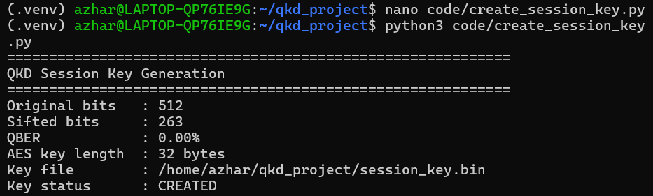
Figure 4.3 BB84-Inspired QKD Session Key Establishment

4.5 AES-256-GCM Secure Gateway Implementation
AES-256-GCM authenticated encryption was included in the security gateways, Alice and Bob. Alice is the encryption gateway as she receives plain text MAVLink packets and safeguards with the 32-byte session key. The encrypted packet is then sent towards Bob via a secure communication channel.
Bob is a receiving security gateway. Before decrypting, it checks the authentication data of each encrypted packet. Successfully authenticated packets are retrieved as MAVLink plaintext and sent down the communication chain. If an encryption packet is modified during transmission, AES-GCM authentication fails and the packet is rejected rather than being accepted as legitimate MAVLink traffic.
There is also sequence number validation within the gateway to provide replay protection. This enables those packets to be identified as previously processed and not transmitted if they are retransmitted. Thus, a combination of confidentiality, integrity, authentication and replay accordingly will be used in a general secure communication framework.
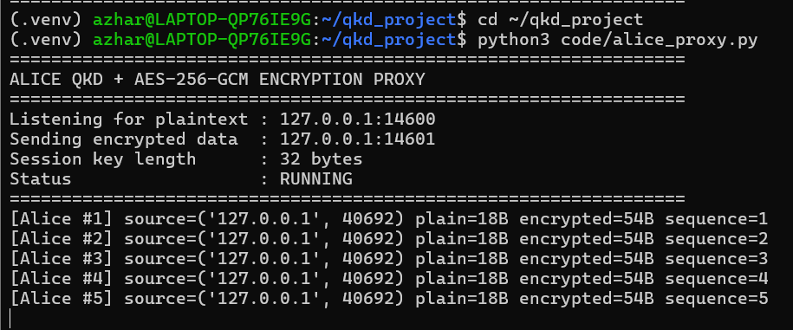
Figure 4.4 Alice Proxy Encrypting MAVLink Packets Using AES-256-GCM
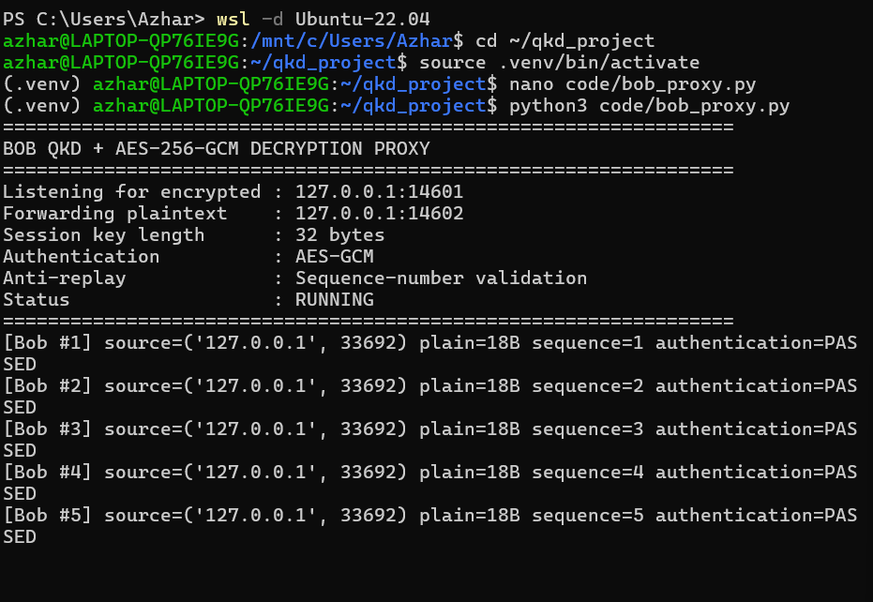
Figure 4.5 Bob Proxy Decrypting and Authenticating MAVLink Packets Using AES-256-GCM

4.6 Replay Protection Implementation
The proposed model includes sequence-number based replay protection as well as encryption and authentication. The Alice gateway is used to assign each message a unique sequence number which is sent with the protected packet. Bob keeps the sequence number of the last packet he accepted successfully and checks the packets as they come into his system to see if they are already validated or need to be.
If Bob receives a legitimate packet and it contains a new sequence number, then Bob authenticates the packet using AES-256-GCM and processes it normally. In contrast, when the previous capture of a packet is repeated, the sequence number is smaller or equal to the highest sequence number already received by Bob. In such a case, the packet is considered a Replay and not as a legitimate MAVLink message. Bob thus recognizes that the packet is a replay, and returns it to the sender before it is accepted as a valid MAVLink message. This mechanism is complementary to the AES-256-GCM authentication mechanism and facilitates reusing previously valid encrypted packets.

4.7 Network Traffic Capture and Wireshark Integration
In order to gain insights into the transmission of MAVLink packets, the network traffic analysis was added to the implementation and the resulting packets observed during the experiments were used for the experimental evaluation at packet level. The UDP traffic created in the PX4, QGroundControl and secure gateway communication environment was captured in Wireshark.
Packet captures were taken of unsecured and secured communication setups. With the unsecured setup it was possible to observe and analyse MAVLink packets directly and as basic network traffic. In the case of the secured environment, the network traffic traversing between the gateways of Alice and Bob constituted the protected channel of communication where the variations in packets could be observed.
The controlled MITM and Replay experiments were performed using Wireshark captures. The captures were used to provide supporting network evidence in addition to the terminal/standard output from the attack scripts and security gateways. The communication delays in unsecured and QKD + AES-256-GCM protected configuration were then compared with the help of packet timestamps.
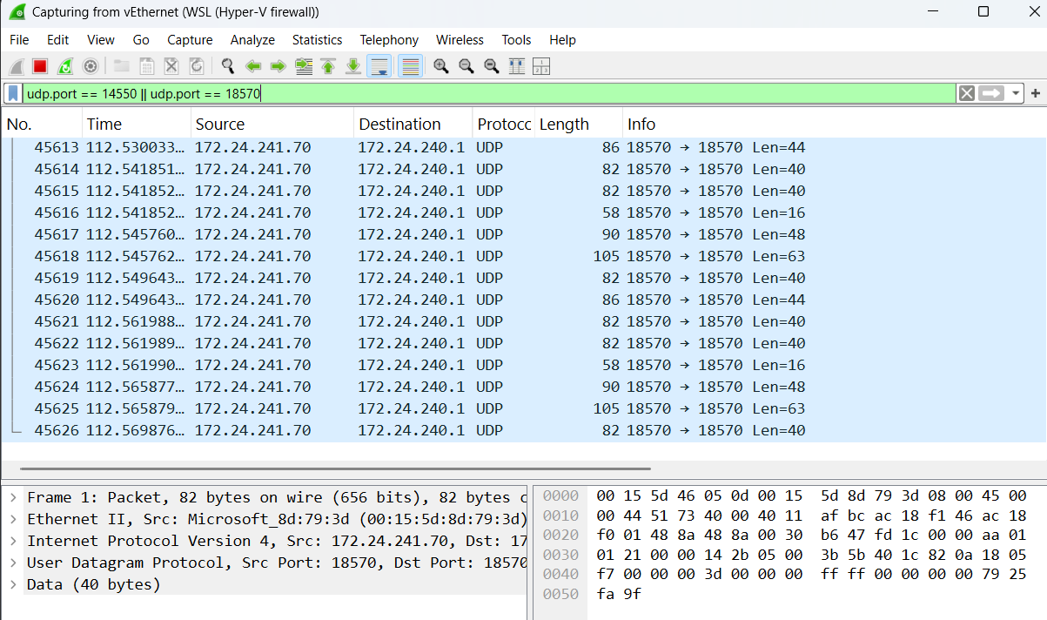
Figure 4.6 Wireshark Capture of UDP Traffic in the UAV Communication Environment

4.8 Chapter Summary
The feasibility of the proposed secure UAV communication scheme has been discussed in this chapter. MAVLink communication was set up with the PX4 SITL environment and Gazebo environment that were set up and integrated with QGroundControl. Alice and Bob gateways were used to implement the BB84-inspired QKD mechanism for generating cryptographic key material and the AES-256-GCM to provide packet encryption, authentication and integrity protection. To enable replay protection, additional sequence-number validation was added. Finally, the improvement of the experimental environment by integrating the Wireshark for traffic reception and performing the packet-level and timing-analysis. Security and performance of the QKD + AES-256-GCM protocol implementation are assessed in the following chapter via MITM and Replay attack simulations and packet processing delay measurements.

Chapter 5

Results and Evaluation

5.1 Introduction
In this chapter the experimental results of the evaluation of the proposed secure UAV communication framework is presented. This analysis performs two types of comparisons: The first comparison considers standard unsecured MAVLink communication while using the communication protected by the BB84-inspired QKD mechanism and authenticated encryption with AES-256-GCM. The goal is to see if the framework will be suitable at limiting the possibility of Man-in-the-Middle (MITM) Attack and Replay Attack on MAVlink information without compromising the functionality of the UAV communication system.
Evaluation was done with the same PX4 SITL, Gazebo and QGroundControl environment from the previous chapters. The experiments were conducted on two test setups: Unsecured MAVLink communication and Secured QKD + AES-256-GCM communication. The analyses conducted considered the packet transmissions, the attack behaviour, the authentication results and the communication performance aspects of the packet transmissions and the attack behaviour, determined using Wireshark captures and terminal outputs as evidence.
The results are shown in the sequence so presented, starting from the baseline unsecured MAVLink traffic, and then coming to MITM and Replay attacks from the unsecured configuration. Then, the same attacks are assessed by the secured framework. Lastly, the security performance and the delay in communication is compared with each other to evaluate the effectiveness of the proposed approach to and its impact on the security performance.

5.2 Baseline Unsecured MAVLink Communication
Prior to implementing the proposed security framework, the existing MAVLink implementations for communication were tested to provide a baseline for comparison. Time synchronization was performed using PX4 SITL, which transmitted UAV telemetry data in the form of MAVLink over UDP without any extra encryption/authn. The following communication condition was used for testing the secured QKD + AES-256-GCM framework.
Network traffic was captured using Wireshark for an unsecured network. There was a continuous stream of packets transmitted over UDP with lengths varying from packet to packet as seen in the capture, effectively representing MAVLink telemetry data exchanges in the simulation environment. No further cryptographic security of the packets at this time, so the packets were sent without the security and integrity capabilities of the secure gateways.
Figure 5.1(a) Wireshark Capture of Unsecured MAVLink Traffic
Figure 5.1a shows the baseline UDP traffic captured before enabling the QKD + AES-256-GCM framework. The capture provides packet timestamps, source and destination information, and varying packet lengths that are used as a reference for comparison with the secured communication results.

5.3 MITM Attack on Unsecured MAVLink
The first security experiment focused on MAVLink basic communication protocol exposed to a Man-in-the-Middle (MITM) attack. In this experiment, the attacker inserted himself in the communication link to receive the MAVLink packets without the use of protection of QKD or AES-256-GCM.
It was shown that the experiment could be done by putting the unsecured MAVLink packets over the attacker, where cryptographic authentication doesn't block the manipulation. This example illustrates how vulnerable they are to unprotected MAVLink communication, because the receiving system does not have anything equivalent to AES-GCM to check that the packet content hasn't been tampered with during transmission.
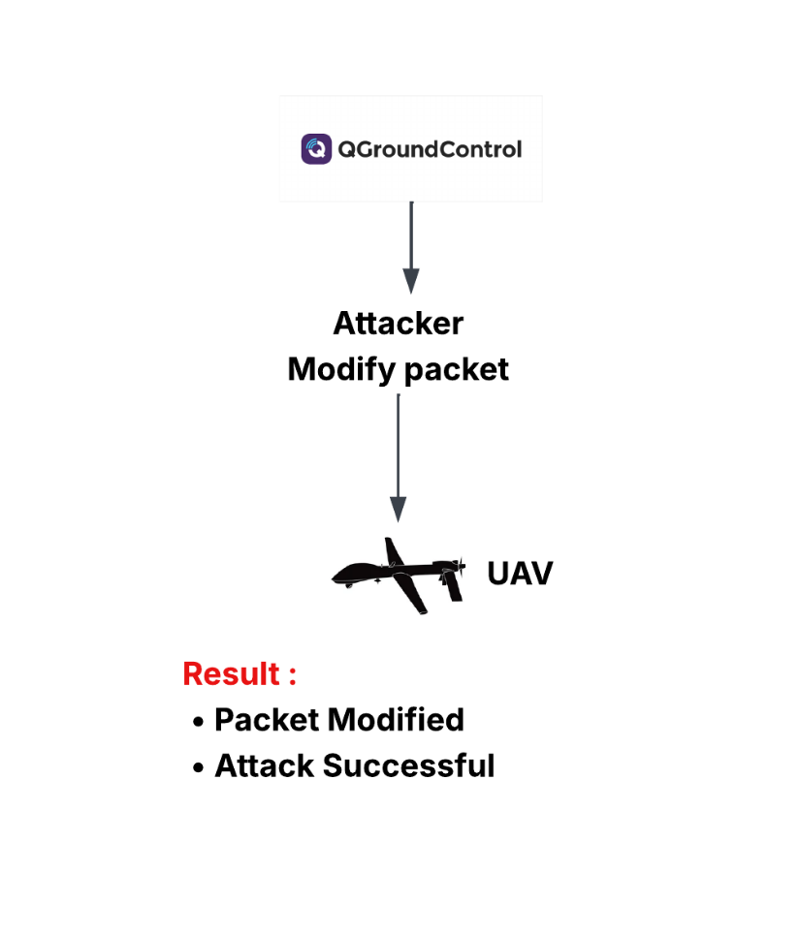
Figure 5.1(b) Conceptual Flow of the MITM Attack on Unsecured MAVLink Communication
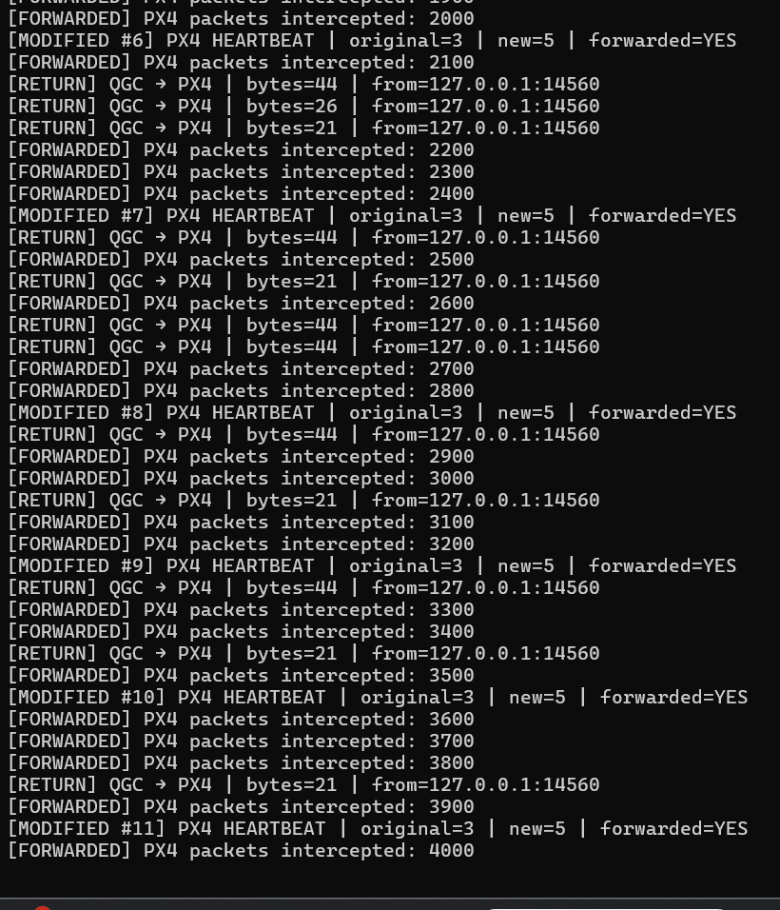
Figure 5.2 Successful MITM Attack on Unsecured MAVLink Communication
Figure 5.2 demonstrates the successful interception of unsecured MAVLink traffic during the MITM experiment. The result establishes the baseline attack condition for comparison with the secured MITM experiment presented later in this chapter.

5.4 Replay Attack on Unsecured MAVLink
The second security experiment examined the possibility to use MAVLink communication without any security measures to lead to a Replay attack. In this experiment, the communication channel packet having an MAVlink protocol was captured and then re-transmitted on the same channel without application of QKD, encryption, authentication or a sequence-number-based replay protection.
The experimental results showed that previous MAVLink packets were able to be replayed in the unsecured environment as there was no specific cryptographic mechanism provided to differentiate new MAVLink packet from a MAVLink packet replayed from a previous capture. This behaviour highlights the need to include freshness checking into the process of communicating with UAVs, especially when messages that have been valid can be used again by an attacker.
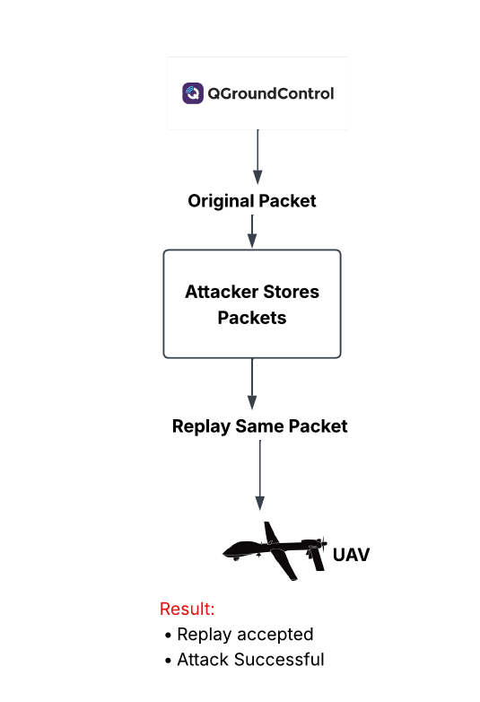
Figure 4.3(a) Conceptual Flow of the Replay Attack on Unsecured MAVLink Communication
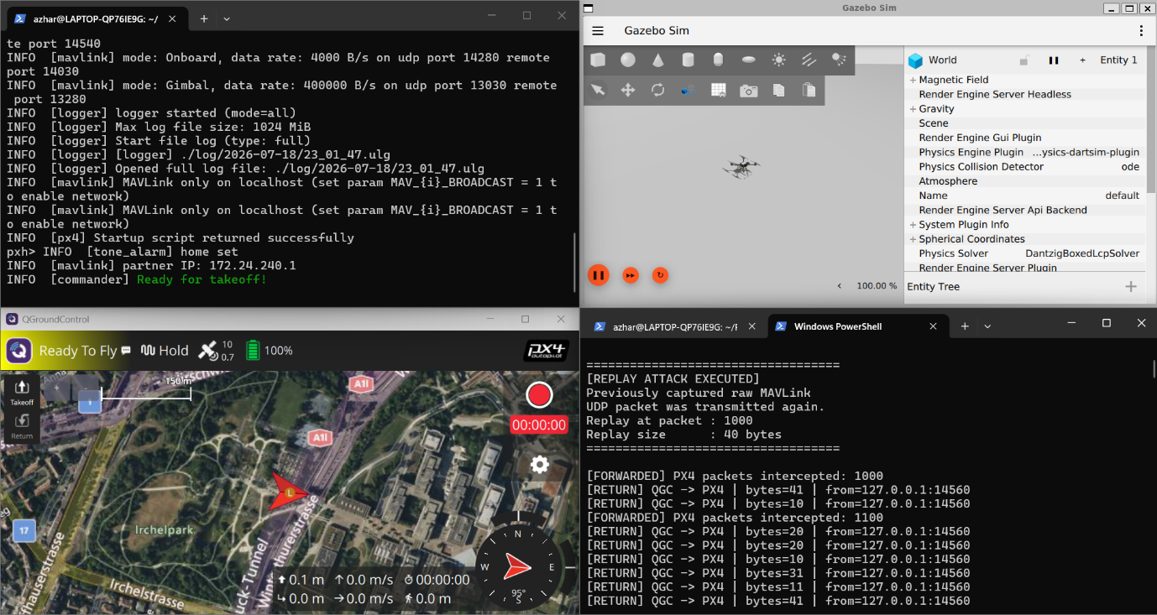
Figure 5.3(b) Successful Replay Attack on Unsecured MAVLink Communication Gazebo + PX4 environment

Figure 5.3b shows how MAVLink traffic is caught and sent again during the Replay experiment. This successful replay gives us something to compare with the sequence-number-based replay protection that is used in the QKD + AES-256-GCM framework. We are using QKD + AES-256-GCM framework, for this. The MAVLink traffic is important here.

5.5 Secured MAVLink Communication with QKD + AES-256-GCM
After the unsecured experiments, the suggested security architecture was activated and the secure situation between MAVLink communication was handled. The communication channel was implemented with the Alice and Bob secure gateways and the shared 32-byte session key was used to encrypt the messages with security of AES authenticated encryption, with the GCM mode used for authenticated encryption. Alice was able to encrypt the MAVLink packets before they went into the secure channel, and Bob was able to decrypt the packets after he authenticated them before handing them off to the flight computer, which considered them to be legitimate. In normal secured communications, the Alice Gateway is constantly able to process the MAVLink packets and create encrypted packets and sequence numbers. On the receiving end, Bob was able to successfully authenticate the protected packets before decrypting them. Also validated to ensure replay protection are the corresponding sequence values.
The successful authentication showed that the correct packets were unaffected while passing through the secured communication channel. When compared to unsecured packets, the secured packets had additional information needed to encrypt, to verify them and to prevent replay. This caused a increase in the packet's size that was transmitted, and added processing overhead, as quantified in the subsequent performance comparison.

5.6 Secured MAVLink Traffic Analysis
Once the QKD + AES-256-GCM framework was turned on, the MAVLink was passed through the secure gateways of Alice and Bob. Alice had used the common 32-byte session key to encrypt the plaintext MAVLink packets; Bob authenticated and decrypted the protected packets in order to pass valid traffic. The packets had cryptographic information added to them when they were secured, such as sequence number, nonce, and authentication tag, compared with the baseline packets which were not secured. This resulted in larger packets being transmitted but ensured confidentiality, integrity, authentication and replay protection. The secured traffic was found to be different from the baseline traffic in terms of payload visibility, length of the packets and processing behaviour.
The secured UDP traffic was captured by Wireshark and compared with the unsecured MAVLink traffic. The captured traffic on the secured Alice-to-Bob path was not directly readable MAVLink payloads anymore, but rather traffic. This was a demonstration at the packet level that the proposed security layer is indeed offering some protection in the communication prior to Bob authenticating and decrypting the packets.

5.7 Security Comparison Before and After Protection
As shown in the experimental results, the difference between the unsecured MAVLink communication and the communication secured by the proposed QKD + AES-256-GCM framework is evident. With the unsecured setting, MITM test showed that MAVLink data could be manipulated without an authenticated-encryption mechanism being able to detect it. Likewise, the Replay experiment could repeat previously captured traffic as there was no dedicated freshness validation. The AES-256-GCM with sequence-number validation method was applied to the MAVLink packets after enabling the proposed framework. After enabling the proposed framework, the MAVLink packets were authenticated using AES-256-GCM with sequence-number validation. In the secured MITM experiment, packet modification during the experiment resulted in packet being rejected for authentication, and previous packets that were accepted were identified by sequence number validation during retransmission. These mechanisms thus brought integrity and replay protection which were not in the baseline configuration.

5.8 MITM Attack on QKD + AES-256-GCM Protected MAVLink
The MITM attack was repeated after enabling the proposed QKD+AES-256-GCM security framework. For this experiment, the attacker catches the encrypted MAVLink packets sent by the Alice side and changes the packed MAVLink messages in the communication channel before re-sending packets towards Bob gateway. For the modified packets, the experiment was not accepted as legitimate communication as it was in an unsecured experiment. Bob gateway had done AES-256-GCM authentication before processing data received. Authenticating the modified ciphertext failed due to a modification of the ciphertext generating the MAC check failed response. Therefore, the spoofed packets were not accepted and/or forwarded as a valid MAVLink packet. The result proves the integrity, and confirms the authentication of AES-256-GCM. The attacker could intercept and modify traffic; however, having possession of the encrypted packet was not enough to generate a valid modified message because they were unable to successfully attempt to verify the authentication information with the recipient

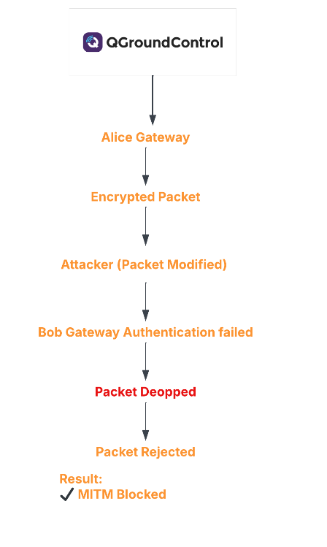
Figure 5.4(a) MITM Attack Detection and Packet Rejection in the QKD + AES-256-GCM Framework
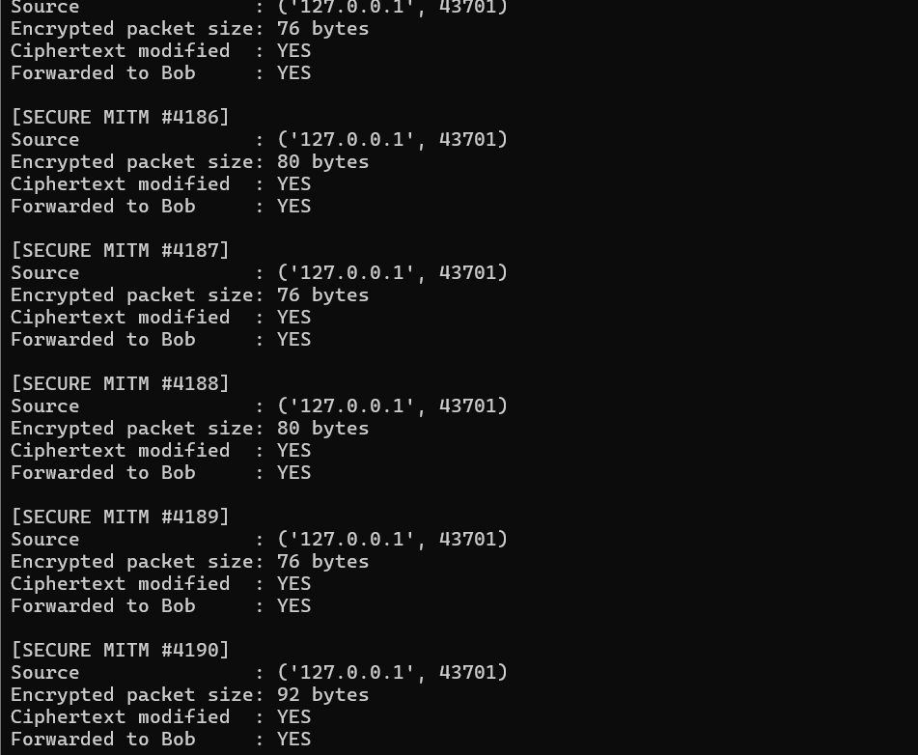
Figure 5.4(b): MITM Modification of AES-256-GCM Protected MAVLink Traffic
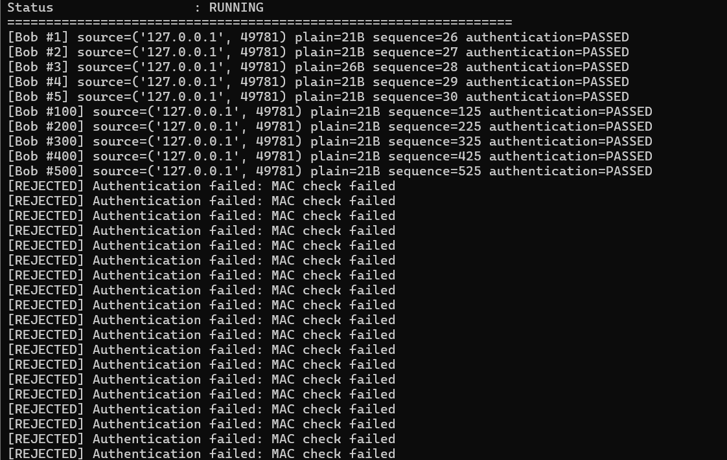
Figure 5.4(c): Rejection of Modified MAVLink Packets Following AES-GCM Authentication Failure
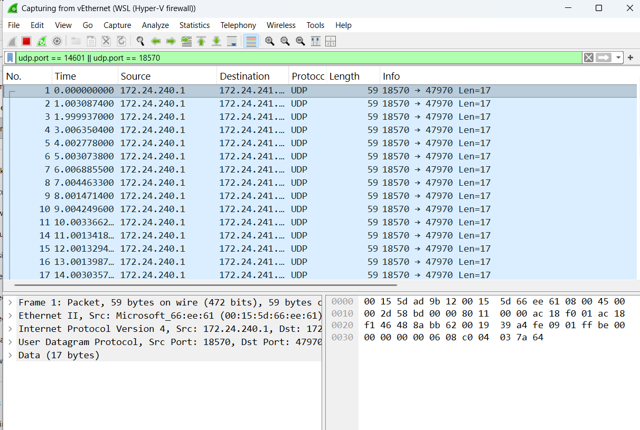
Figure 5.4(d): Wireshark Capture of UDP Traffic During the Secured MITM Experiment
The secured MITM experiment is demonstrated in Figures 5.4(b)–5.4(d). Figure 5.4(b) shows the intercepted and modified protected ciphertext. Figure 5.4(c) shows the legitimate packets passed authentication in the first place and the modified packets were rejected with MAC check failed response. Figure 5.4(d) shows the packet level evidence of the UDP traffic captured during the experiment.

5.9 Replay Attack on QKD + AES-256-GCM Protected MAVLink
The Replay attack was repeated after enabling the QKD + AES-256-GCM security framework. The aim of this experiment is to capture the packets transmitted earlier when it was in encrypted mode and later retransmitting it towards the receiving gateway. These packets were in good condition, but the fact they were re-used indicated that they were being reintroduced into the system with communication that had been previously accepted.
To guard against this attack, the secure one included sequence-number validation at the recipient gateway. Bob kept the largest number of packets successfully processed. If a packet received had a processed sequence number, the packet was rejected as a replay and not treated as a legitimate MAVLink packet.
This is an important difference between authentication and freshness: AES-256-GCM is used to ensure that the packets are authentic and they are not altered or lost. The extra sequence-number mechanism is used for the determination that if the packet were otherwise valid, then it has already been received. These mechanisms work together to keep the channel from being corrupted from packet insertion or from retransmitting previously good packets.
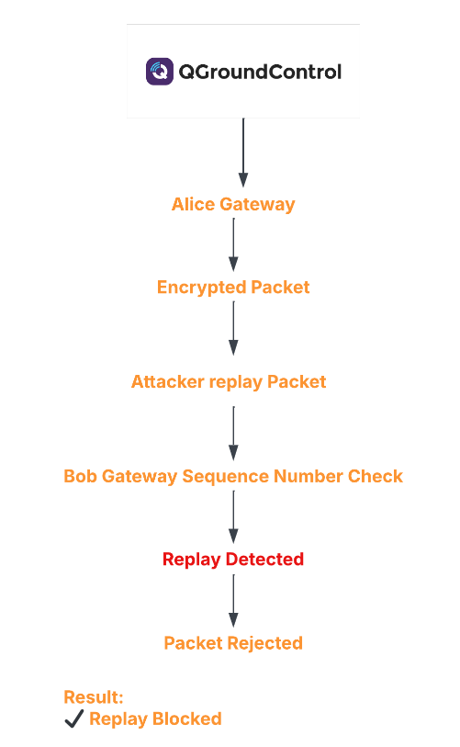
Figure 5.5(a) Replay Attack Detection and Packet Rejection Using Sequence-Number Validation
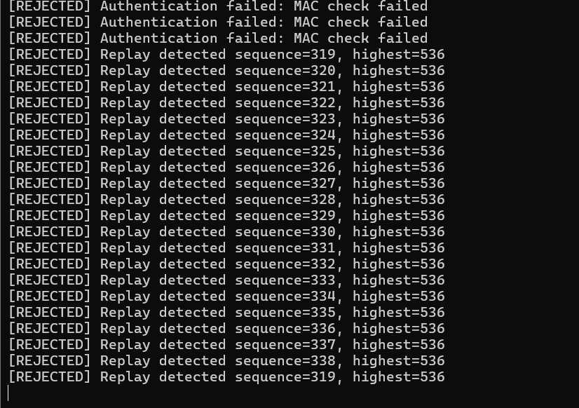
Figure 5.5(b) Replay Attack Blocked through Sequence-Number Validation in the Secured MAVLink Framework
Figure 5.5b. Rejection of replayed encrypted packets based on sequence-number validation. The receiving gateway had already processed packets up to sequence 536, while the replayed packets had earlier sequence values starting from 319. These packets were therefore categorized as already processed traffic and rejected, which illustrates the efficiency of the anti-replay mechanism.

5.10 Communication Delay and Performance Analysis
It was also verified that the proposed QKD + AES-256-GCM framework can introduce negligible latency to the packet transmission process as compared to that in case of unsecured transmission channels. This analysis was to find out if there was any measurable communication overhead in the extra “steps” taken to encrypt, authenticate, decrypt and validate the sequences that these attacks require. The unsecured MAVLink configuration was considered as baseline, and the secured configuration would then refer to the communication via the QKD obtained session key and AES-256-GCM security gateways. The experiments were used to find the difference between the two configurations by obtaining packet timestamps.

5.10.1 Packet Processing Delay Analysis
The computational overhead introduced by the proposed security framework is evaluated by measuring the packet processing delay for unsecured MAVLink communication and secured communication using QKD derived key material with AES-256-GCM. For both experiments 1,000 MAVLink packets were analyzed in PX4 and Gazebo simulation environment.
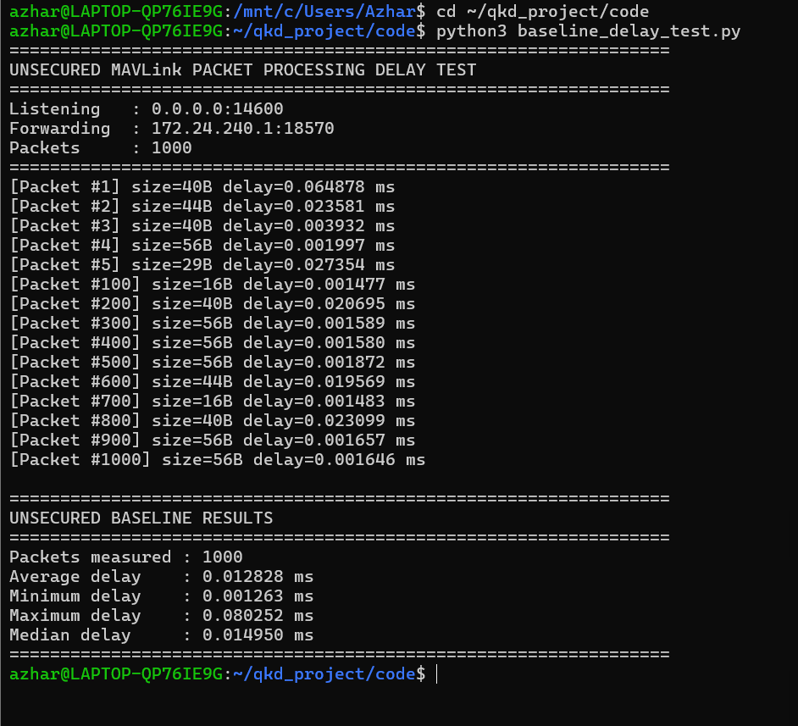
Figure 5.6(a): Packet Processing Delay for Unsecured MAVLink Communication over 1,000 Packets
The average, minimum, maximum, and median packet-processing delays for the unsecured MAVLink experiment were 0.012828 ms, 0.001263 ms, 0.080252 ms, and 0.014950 ms, respectively. Without cryptographic protection, the packets were forwarded for these measurements, and convey the baseline processing cost.
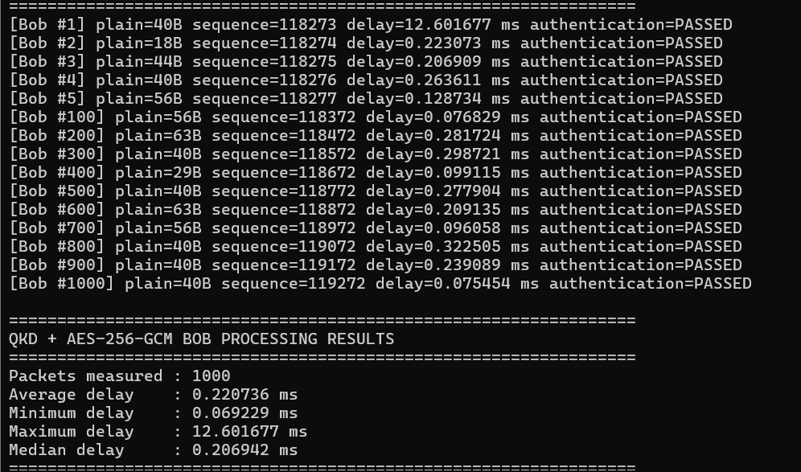
Figure 5.6(b): Packet Processing Delay with QKD and AES-256-GCM Security over 1,000 MAVLink Packets
The average delay for processing frames was increased to 0.220736 ms after applying the suggested security structure. The minimum, maximum and median delays were 0.069229 ms, 12.601677 ms, and 0.206942 ms, respectively. In the experiment, the authenticated packets went through the secured communication via MAVLink telemetry, and the Bob authentication succeeded with AES-256-GCM for the packets.
Performance Metric | Unsecured MAVLink | QKD+AES-256 GCM
Packet measured | 1,000 | 1,000
Average delay | 0.0128128 ms | 0.220736 ms
Minimum delay | 0.001263 ms | 0.069229 ms
Maximum delay | 0.080252 ms | 12.601677 ms
Median delay | 0.014950 ms | 0.206942 ms
Additional average overhead | - | 0.207908 ms
Table-1
The keying improvement introduces with the introduction of QKD based keying and AES-256-GCM, thus, yielded an additional average of 0.207908ms per packet of processing delay. While this is a large relative difference over the very small relative unsecured baseline, it was still less than a millisecond per transaction on average. The outcome then shows that the proposed security approach incurs measurable amounts of cryptographic processing overheads but still provides reasonable average packet-processing latency in the testing environment of PX4 and Gazebo.

MAVLink Packet Structure and Selection of Packet Lengths
The structure of the MAVLink packets which were analyzed in the experiment needs to be understood before examining the packet length vs. processing delay relationship. MAVLink is a small binary messaging protocol developed specifically for systems with limited resource and bandwidth. MAVLink 2 - An over-wire packet has a fixed length header, a variable length payload which contains the data of the message, a checksum, and an optional signature field if native MAVLink signing is enabled.
The MAVLink2 header is 10 bytes long, and contains the start-of-frame marker, the length of the buffer to wait for, incompatible types and compatible types flags, packet sequence number, system identifier, component identifier and a three-byte message identifier. After this, there is also a variable length payload that can be 255 bytes in length. The payload is the data that goes into the message and its size is determined by the type of message and the data being sent. The payload is followed by a 2-byte CRC that is used to detect errors in the transmission and incompatible message definitions. If MAVLink 2 provides a default way to sign messages, it can also add a 13-byte signature.
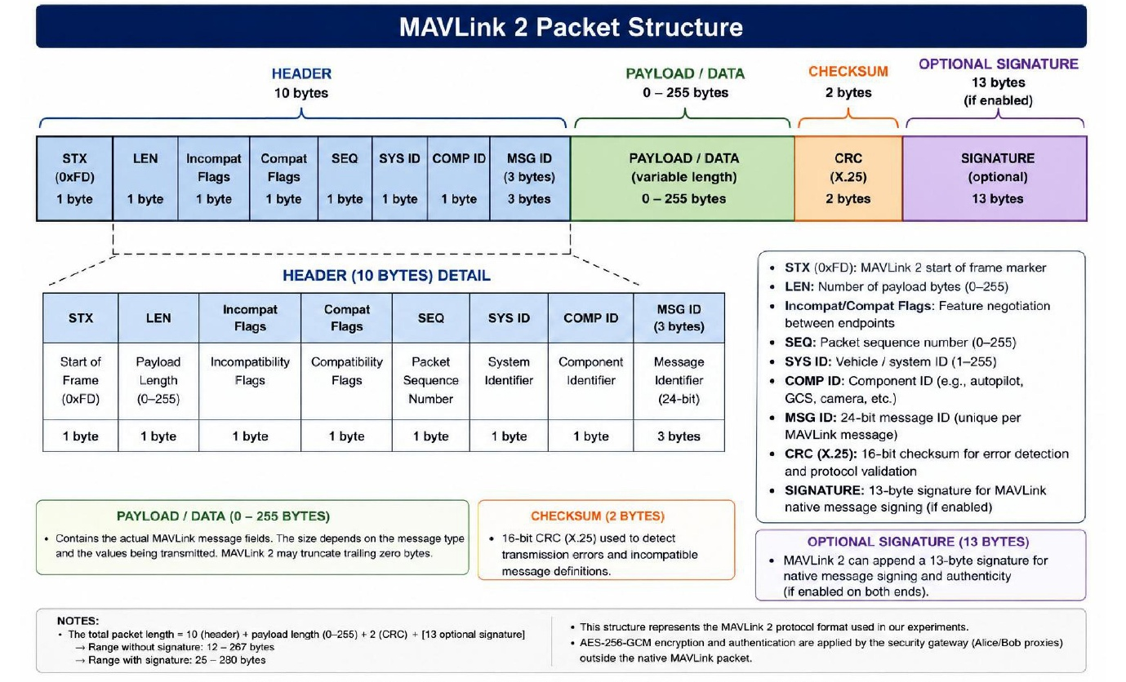
Figure 5.8 MAVLink 2 Packet Structure Highlighting the Fixed Header and Variable-Length Payload
This means that MAVLink packets are not fixed-size packets, but vary in size depending on the data carried. MAVLink 2 can also discard zero-filled payload data bytes if there are more than they can handle, and various messages can have different payload sizes. Thus, the volume of data passed through a security mechanism may be different for packets. To check the effect of this data load variation on the computational cost of the proposed security framework, eight packet-load sizes of 20, 40, 60, 80, 100, 150, 200 and 250 bytes were studied. One thousand arrivals were processed for each size in both configurations (unsecured, and AES-256-GCM), and the average processing time was computed. The size of these payloads is limited based on a range of data payloads that can be supported by MAVLink 2 to enable the effect of data load on cryptographic processing delay to be assessed on a consistent basis.
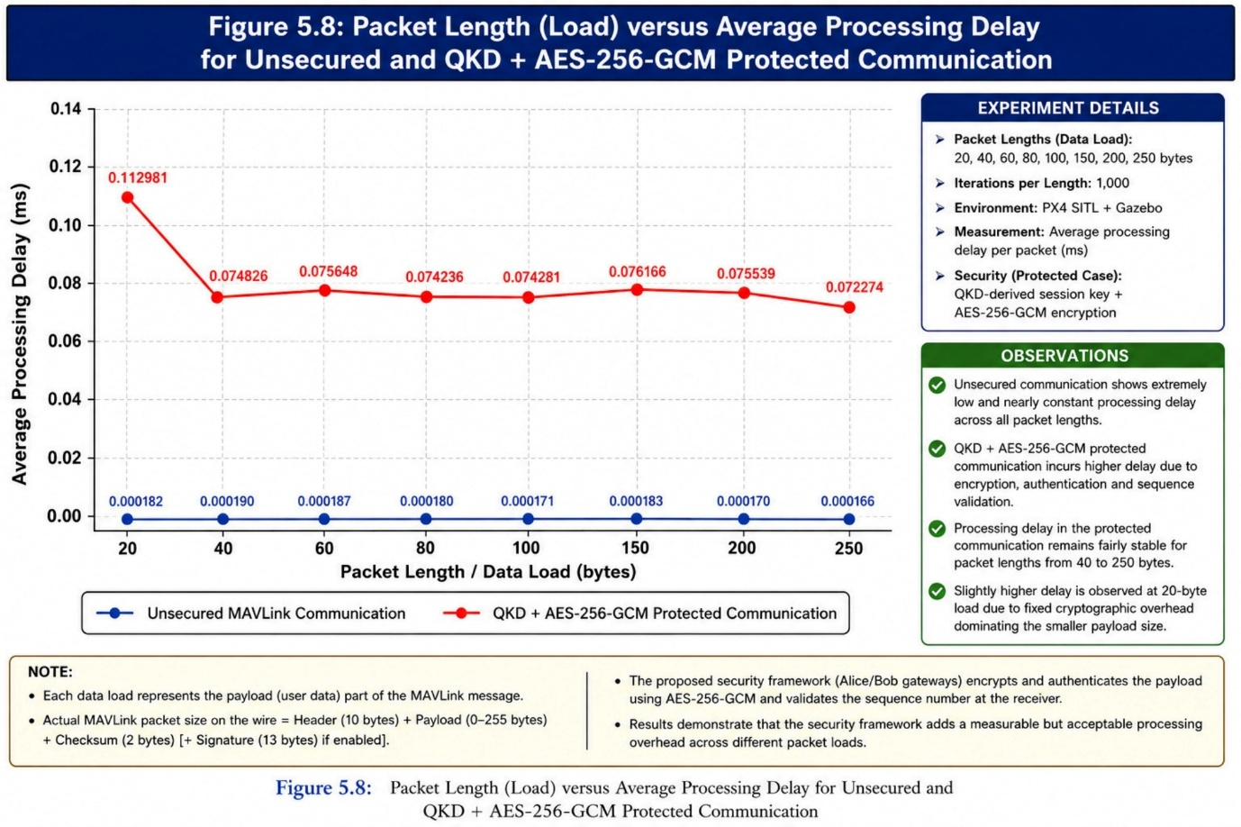
Figure 5.8 Packet Length versus Average Processing Delay for Unsecured and QKD + AES-256-GCM Protected Communication
The processing time of packets of different length was also tested with the load of packets being sent from 20 bytes to 250 bytes while the packets numbers within the processing were set as 1000 and they were run for each packet size. As shown in Figure 5.7, the unsecured processing delay was still very small no matter what the length of the packet was, ranging from 0.000166ms to 0.000190ms. The combination of QKD with AES-256-GCM had larger processing times due to authenticated encryption and decryption. The measurements for the secured version were fairly consistent among the packets for a packet length range between 40 bytes and 250 bytes with the exception of the 20-byte test size which had a higher average value. The results show that the average cryptographic processing delay is not significantly affected by the length of the packets within the range under test.

5.11 Overall Security Evaluation and Discussion

Evaluation Metric | Unsecured MAVLink | QKD+AES-256-GCM Protected MAVLink
MITM packet interception | Possible | Possible
Modified packet acceptance | Accepted in teste unsecured scenario | Rejected
Packet authentication | Not provided by tested baseline | AES-256-GCM authentication
Replay attack | Successful | Detected and rejected
Replay protection | Not implemented in tested baseline | Sequence-number validation
Performance packets measured | 1,000 | 1,000
Average processing delay | 0.012828 ms | 0.220736 ms
Median processing delay | 0.014950 ms | 0.206942 ms
Additional average processing overhead | - | 0.207908 ms
Table -2
The security and performance comparison between the unsecured MAVLink baseline and the proposed QKD + AES-256-GCM protected framework can be summarised in Table 2. The tested MITM modification and Replay attacks were detected and refused by the secured framework, and while introducing an additional average packet-processing overhead of 0.207908 ms per packet.

5.12 Chapter Summary

This chapter compared the unsecured basestition of MAVLink with the proposed framework. In the unsecured configuration, the experiments proved how the MITM attack and Replay attacks were successful while, in the secured configuration, the MITM attack and Replay attacks were rejected thanks to AES-256-GCM authentication and sequence-number validation. Test runs also measured and quantified the added processing overhead of the security framework. Results, limitations and future research are discussed in Chapter 6.

CHAPTER 6

Conclusion and Future Work

6.1 Introduction
In this chapter, the experimental assessment and development of the proposed secure UAV communication system are summarised as the end of the research. This project aimed to assess security deficiencies of MAVLink communication for use in a simulated UAV environment and to research the potential of using a BB84 inspired Quantum Key Distribution (QKD) mechanism as part of AES-256-GCM authenticated encryption to enhance the security of communication.The proposed operating concept was experimented with using PX4 SITL, Gazebo, QGroundControl, and Python for the Alice and Bob security gateways. The effectiveness was tested by comparing the different MAVLink configurations between unsecured and secured with controlled Man-in-the-Middle (MITM) and Replay attack scenarios. The experimental results validated that the unsecured communication path tested was vulnerable to the attack scenarios included in this research. Enabled security was a feature that found more than a few modified ciphertext packets thanks to the presence of AES-GCM authentication failure, and packets replayed could be detected with sequence-number validation rejected. Further, performance testing was performed to evaluate how much the extra security features add to the system overhead. The aim of the chapter is therefore to summarise the key findings, critique the accomplishments of the research aims, reflect on the methodology successfully implemented and outline possible avenues of further research and development.

6.2 Summary of Research Findings
The MITM and Replay attacks were possible on the unsecured baseline configuration. Network traffic was easily captured and altered without detection using MAVLink. Successfully intercepted and altered network traffic without being detected using MAVLink. The packets that had already been transmitted were repetitively sent.
In MITM test mode (in combination with AES-256-GCM in secured configuration), the result was as expected— MITM attacks were unsuccessful, the changed cryptogram failed to decipher at the Bob gateway, while the changed plaintext triggered AES-GCM authentication failure. Sequence number verification: Packet received from another player with the same number was dropped based on sequence number check.
The average delay per packet in test is 0.012828 ms (unsecured) and 0.220736 ms (secured) - which results in an overhead of 0.207908 ms per packet. There was no delay in processing. The framework has limits less than a millisecond for processing packets, protecting against both MITM modification and Replay attacks.

6.3 Achievement of Research Objectives
The proposed secure MAVlink framework was designed and experimented to meet the research objectives. It was proven that unsecured experiments were successful for MITM modification and Replay attack. The proposed framework of QKD + AES-256-GCM was finally implemented with the aid of the security gateways, named Alice and Bob. The authentication and sequence-number validation mechanisms in the AES-GCM algorithm rejected modified and replayed packets, respectively. These packets were periodically tested, with the average delay increased from 0.012828ms to 0.220736ms after performance testing, which indicates enhanced security at relatively low processing costs.

6.4 Limitations of the Research
The proposed framework has provided positive security results, however there are some limitations that should be acknowledged. All experiments were conducted with a PX4 SITL + Gazebo simulation environment using software instead of using physical UAV hardware. Likewise, the QKD protocol based on Text 1 was simulated for the establishment of a session key, without connecting to any real quantum communication channel or the actual QKD hardware.
Additionally, the security evaluation only considered two type of attacks: Replay and Man-in-the-Middle (MITM). The following threats were not covered in this project: GPS spoofing, Denial-of-Service (DoS) attacks, jamming, malware and command-injection attacks. Also, performance data were gathered under a controlled simulation environment and might vary in actual implementations over real wireless UAV networks.
Hence, the experiment results prove the feasibility and security benefits of the proposed framework under the discussed experimental setup, and additional testing needs to be done prior to its deployment in real-life UAV swarms.

6.5 Future Work
The proposed framework could be expanded from the current simulation environment to real UAV platforms and wireless networks in future studies. Using the simulated BB84 mechanism, one can also replace or embed real QKD devices and quantum communication infrastructure to check the feasibility of the proposed implementation. Testing the framework with a swarm of UAVs and with other types of cyber threats like GPS spoofing, DoS attack, command injection and jamming would further validate it. Other experiments may be warranted that explore other key-refresh strategies, scalability, communication latency, packet-loss, and computation overhead for various network conditions. The developments would enable a more extensive evaluation of the concept of secure communication with UAV swarms in the real world.

6.6 Final Conclusion
To develop a secure communication system for UAVs using a secure communication mechanism, this research proposed a UAV system designed, built, and tested with an AES-256-GCM authenticated encryption protocol-based UAV communication system, combined with a BB84 inspired Quantum Key Distribution (QKD) protocol. This was done using a controlled environment comprising of PX4 SITL, Gazebo, QGroundControl, and Python-based Alice and Bob security gateways. Main goal was to design an enhanced MAVLink communication that would be more confidential, secure, authentic and resilient to a set of selected cyber security risks.
The evaluation of the experimental results showed how much different unsecured and secured communication was. The tested attacks Man-in-the-Middle (MITM) modification and Replay attacks were successful in the unsecured configuration. Once configured with the proposed security framework, modified encrypted packets were not able to pass security authentication by AES-GCM and were dropped by the receiving gateway. Likewise, packets previously captured were detected, because previously captured packets were checked for their sequence numbers, and if they were still forewent, their sequence numbers were denied; hence, the previous Anti-replay mechanism functioned successfully.
Over 1 thousand MAVLink packets were approximately 0.012828ms with the unsecured configuration while it was 0.220736ms with the QKD+ AES-256-GCM secured configuration. This equates to an extra average processing time of ~0.207908 ms per packet. The security measures did add a few millisecs of processing time, but didn't exceed 1 millisecond on average, in the experimental setting.
In total, the research reveals the possibility of implementing QKD-inspired key establishment, AES-256-GCM authenticated encryption, along with consecutive replay protection, in a simulated PX4-based UAV communication system. The results are only applicable to software simulation, and the attack scenarios evaluated, but they show a practical proof-of-concept that the MAVlink communication can be strengthened. The framework could be further tested for secure UAV communication in the real-world for future physical UAV-based communication, physical QKD infrastructure, multi-UAV swarm deployments and more extensive cybersecurity testing.
References
Amrin, M., Abutaleb, M. and El-Fishawy, N. (2018) ‘Hybrid key generation algorithm to solve man-in-the-middle attack in BB84 quantum key distribution protocol’, International Journal of Advanced Computer Science and Applications, 9(4), pp. 98–106. Available at: https://doi.org/10.14569/IJACSA.2018.090414 (Accessed: 18 March 2026).
Bennett, C.H. and Brassard, G. (1984) ‘Quantum cryptography: Public key distribution and coin tossing’, Proceedings of IEEE International Conference on Computers, Systems and Signal Processing, Bangalore, India, 9–12 December, pp. 175–179.
Hui, Q. and Xiao, C. (2019) ‘Simulation of BB84 quantum key distribution in depolarization channel’, IOP Conference Series: Materials Science and Engineering, 569(4), p. 042058. Available at: https://doi.org/10.1088/1757-899X/569/4/042058 (Accessed: 22 March 2026).
Marcin, N. and Andrzej, R. (2020) ‘Entropy of security in quantum key distribution’, Entropy, 22(9), p. 1049. Available at: https://doi.org/10.3390/e22091049 (Accessed: 25 March 2026).
Mohsen, S. and Hooshang, A. (2015) ‘Modification and improvement of the BB84 quantum key distribution protocol’, International Journal of Computer Science and Information Security, 13(2), pp. 1–8.
National Institute of Standards and Technology (2022) Post-quantum cryptography standardisation. Gaithersburg, MD: NIST. Available at: https://www.nist.gov/pqcrypto (Accessed: 1 April 2026).
Shor, P.W. (1994) ‘Algorithms for quantum computation: Discrete logarithms and factoring’, Proceedings of the 35th Annual Symposium on Foundations of Computer Science, Santa Fe, New Mexico, 20–22 November, pp. 124–134. Available at: https://doi.org/10.1109/SFCS.1994.365700 (Accessed: 15 March 2026).
Sufyan, T. and Omer, K. (2015) ‘New authentication and key agreement protocol for QKD system using BB84’, Procedia Computer Science, 65, pp. 701–710. Available at: https://doi.org/10.1016/j.procs.2015.09.012 (Accessed: 20 March 2026).
Allouch, A., Cheikhrouhou, O., Koubaa, A., Khalgui, M. and Abbes, T. (2019) ‘MAVSec: Securing the MAVLink protocol for Ardupilot/PX4 unmanned aerial systems’, 15th International Wireless Communications & Mobile Computing Conference (IWCMC). This work specifically discusses MAVLink vulnerabilities and a security mechanism for ArduPilot/PX4 systems. arXiv
Dworkin, M. (2007) Recommendation for Block Cipher Modes of Operation: Galois/Counter Mode (GCM) and GMAC. NIST Special Publication 800-38D. Gaithersburg, MD: National Institute of Standards and Technology. Available at: NIST SP 800-38D. This is a very important source for your AES-GCM section, because NIST defines GCM as an authenticated-encryption mode providing confidentiality and authentication. NIST
Kim, S.J. et al. (2018) ‘Empirical analysis of MAVLink protocol vulnerability for attacking unmanned aerial vehicles’, IEEE Access. doi: 10.1109/ACCESS.2018.2863237. This experimentally analyses MAVLink vulnerabilities and attacks against UAV communication. DGIST Scholar
Liu, H. et al. (2024) ‘Experimental demonstration of drone-based quantum key distribution’, Physical Review Letters, 133, 200801. doi: 10.1103/PhysRevLett.133.200801. This is particularly useful for your dissertation because it demonstrates actual drone-based QKD using a BB84-family protocol, helping support the motivation/future-work side of your project. Physical Review Journals
In addition, for your PX4 + Gazebo simulation methodology, you can use research showing MAVLink/PX4/Gazebo-based UAV simulation and multi-UAV environments.

