Task 1 — VPC • Terraform se 10.0.0.0/16 ka VPC create karo. • VPC ka Name tag Terraform-VPC rakho.
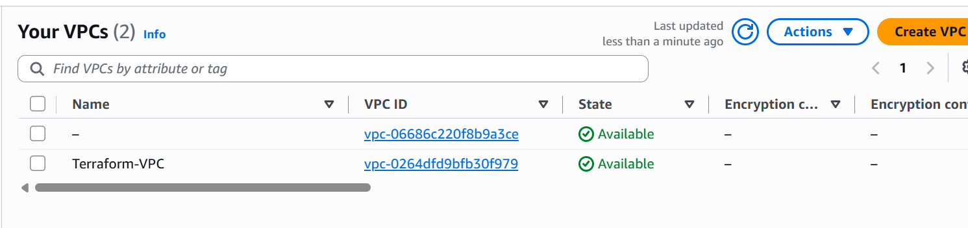

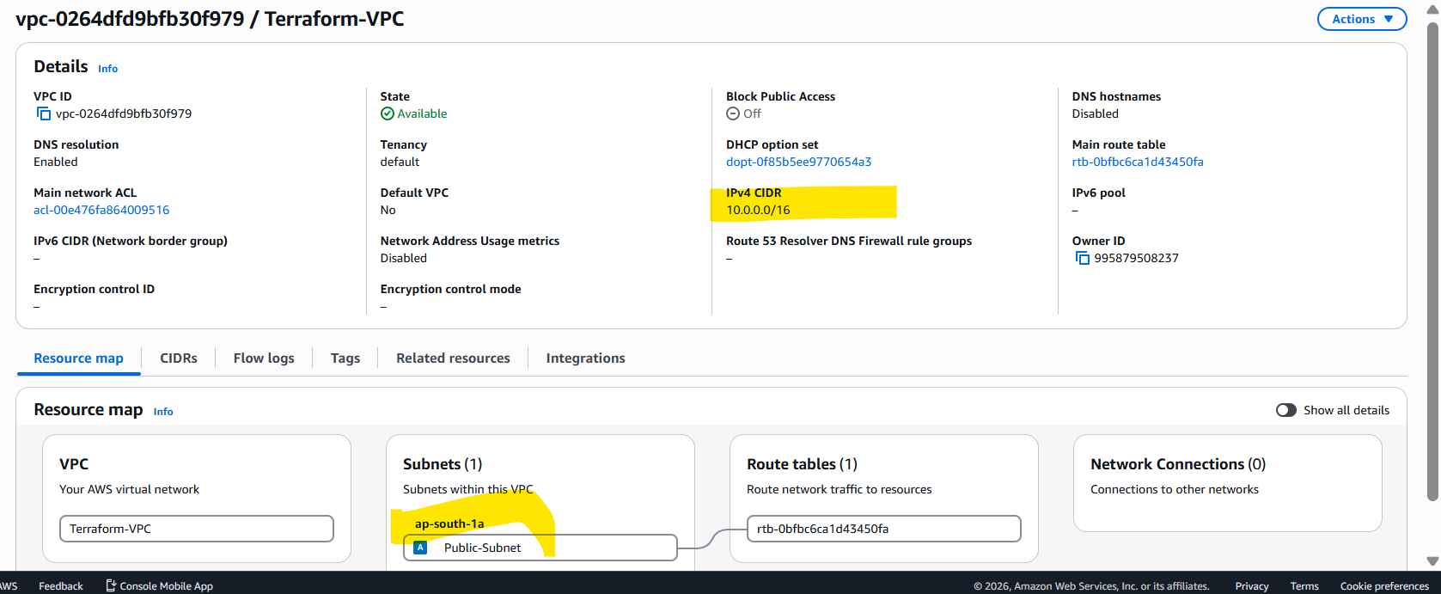

Task 2 — Subnet • Existing VPC ke andar 10.0.1.0/24 ka subnet create karo. • Subnet ko Public-Subnet naam do.

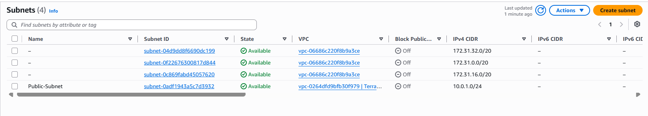

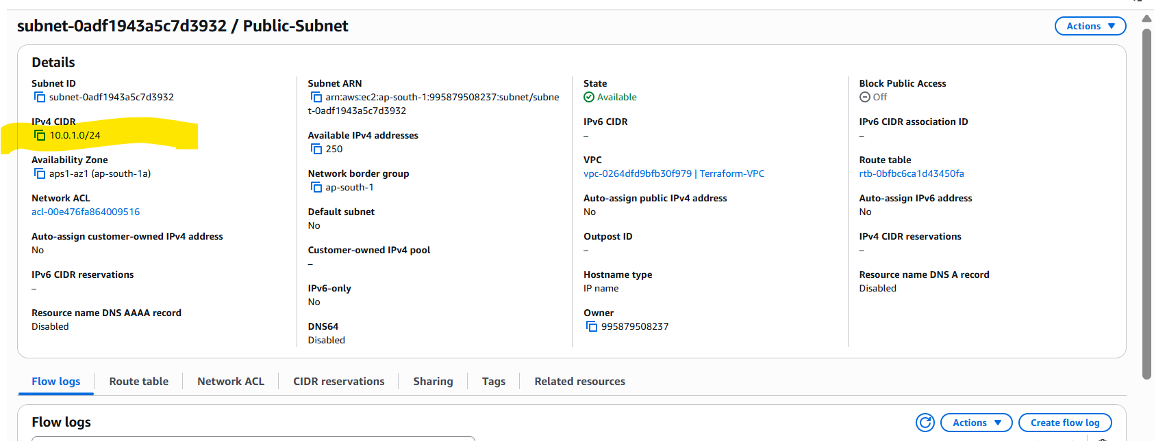

Task 3 — EC2 • Terraform se ek EC2 instance create karo. • Instance type ko variable se define karo. • EC2 ka Name tag Terraform-EC2 rakho.

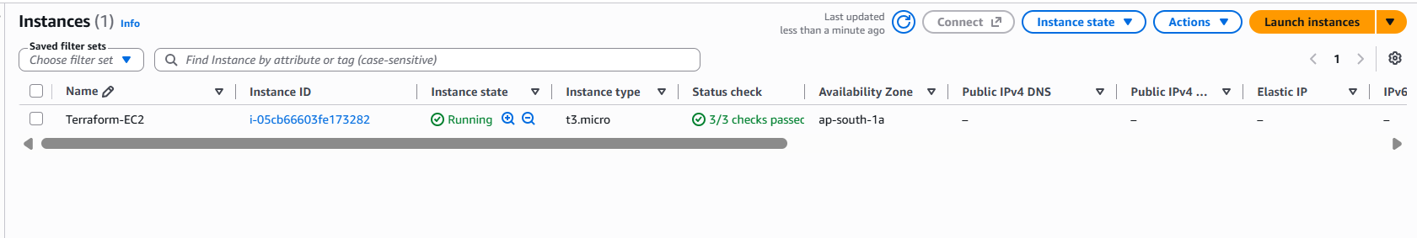

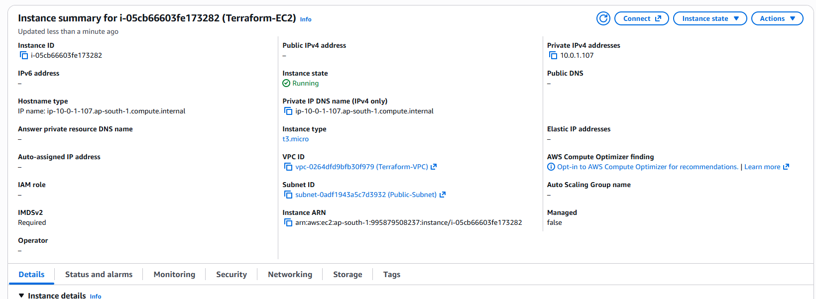

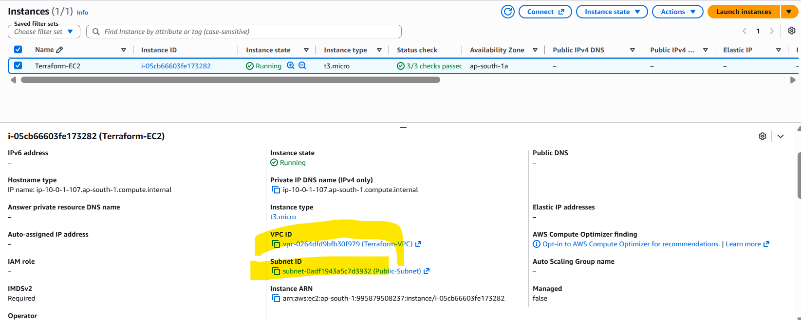
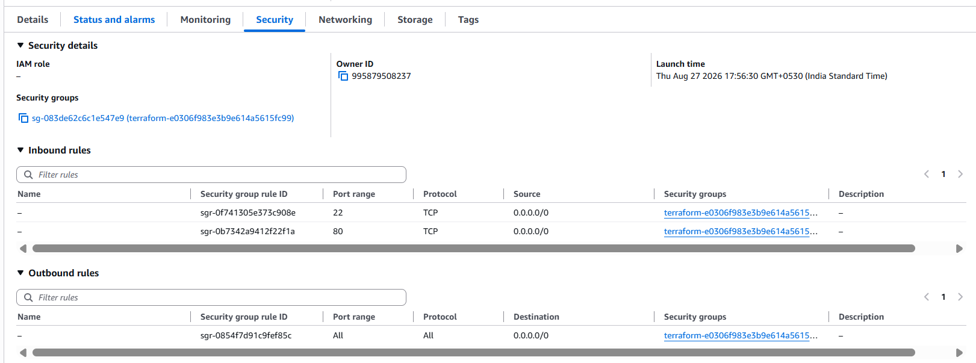
Task 4 — Security Group • Terraform se Security Group create karo. • Port 22 (SSH) aur 80 (HTTP) allow karo. • Security Group ko EC2 instance ke saath attach karo.

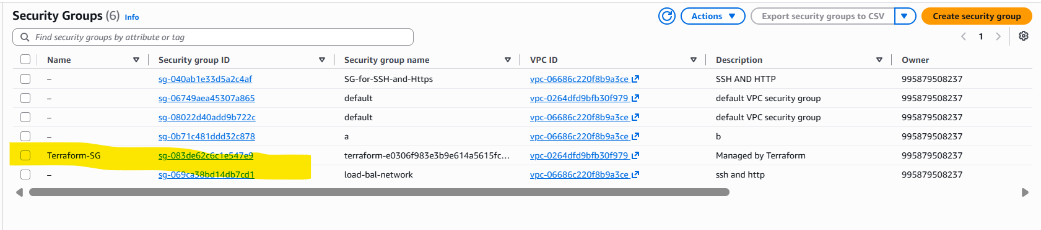
Inbound rules 22 and 80
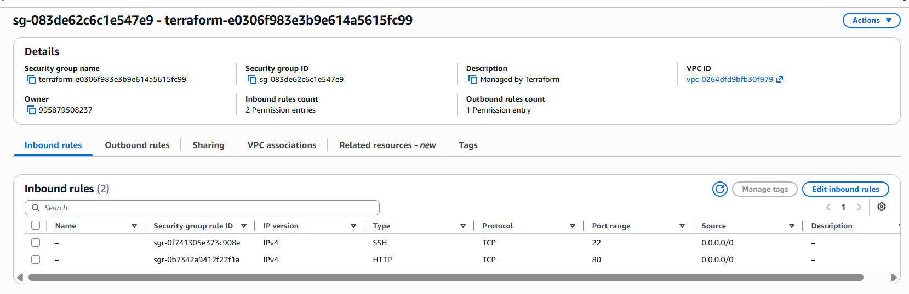
Outbound for All
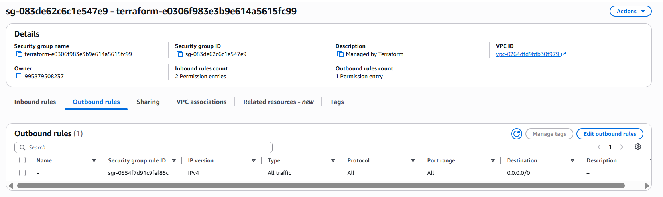

Task 5 — S3 + Output
• Terraform se ek S3 bucket create karo.
• Bucket name ko variable se define karo.
• Terraform output ke through bucket name display karo.
