Ministry of Education and Science of Republic of Kazakhstan



**Department of Computer Engineering and Information Security**

SOFTWARE DEVELOPMENT TOOLS

**LABORATORY WORK 9**

Submitted by: Komekbay D.

Amanzhol A.

Group: CSSE – 1802K

Submitted to: Kalpeyeva Z.B.

Almaty 2020

**Software Development Tools laboratory work 9**

**EXERCISE 01 – CHOOSE THE BEST PATTERN**

**IMPORTANT: PERFORM ALL TASKS ACCORDING TO YOUR OWN TOPIC.**

**PURPOSE**

In this exercise, you will experience using the pattern repository structure and pattern descriptions to identify a suitable pattern for a programming task.

Task 1.

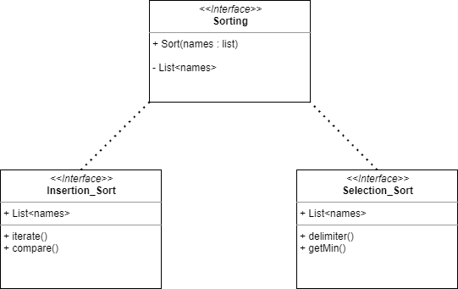

1. Insertion Sort
2. Selection Sort

In our task we have main class Sorting, which have the list of names, and subclasses that implements method sort from main class Sorting, but different methods of sorting

Task 2.

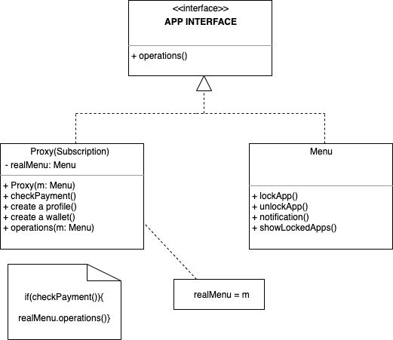

interface AppInterface is

method lockApp()

method unlockApp(id)

method listUnlockedApps(id)

class Menu implements AppInterface is

method lockApp(id) is

method unlockApp(id) is

method listUnlockedApps(id) is

class Subscription implements AppInterface is

private field service: AppInterface

private field hideApp

method lockApp(id) is

if (listCache == null || needReset)

listCache = service.getlockApp()

return listCache

method unlockApp(id) is

if (videoCache == null || needReset)

videoCache = service.getunlockApp(id)

return videoCache

method listUnlockedApps(id) is

if (!downloadExists(id) || needReset)

service.listUnlockedApps(id)

class Biometric is

method init() is

MenuService = new Menu()

Subscription = new Subscription(Menu)

manager.reactOnUserInput()

**Links:**

**https://refactoring.guru/ru/design-patterns/proxy**