

**Department of Computer Engineering and Information Security**

**Web-technologies**

**Milestone 5**

**Topic: University(Priemnaya komissia(like a welcome.kaznu.kz))**

   Done by:   Komekbay D. Amanzhol A.

   Group: CSSE-1802K

Checked by: Alpysbay N.E

 Almaty 2020

## Introduction

In this part of our milestone I should create a some CRUD actions to the part called Bachelors. This sections covers all the functions that related to Bachelors. Admin will add announcements and files, user will download and view files and announcements.

Here in the picture, was some bugs with search table

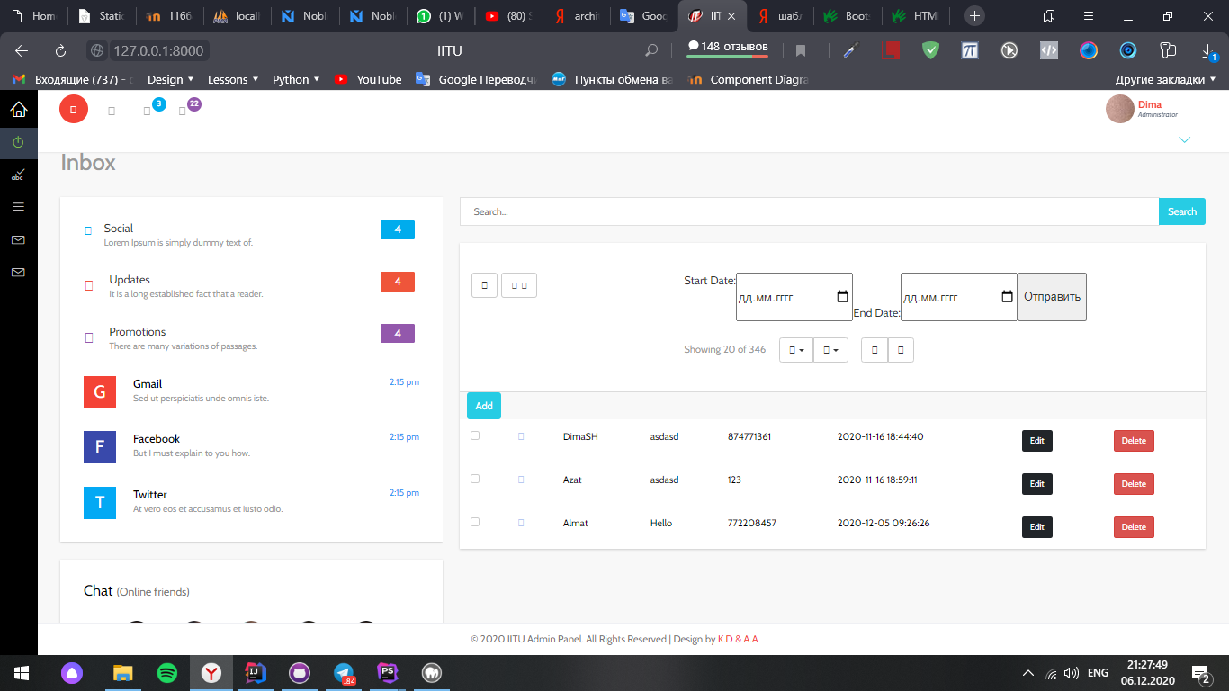

I fixed all bugs about filter date and added text to add button for comfortable

Here is result

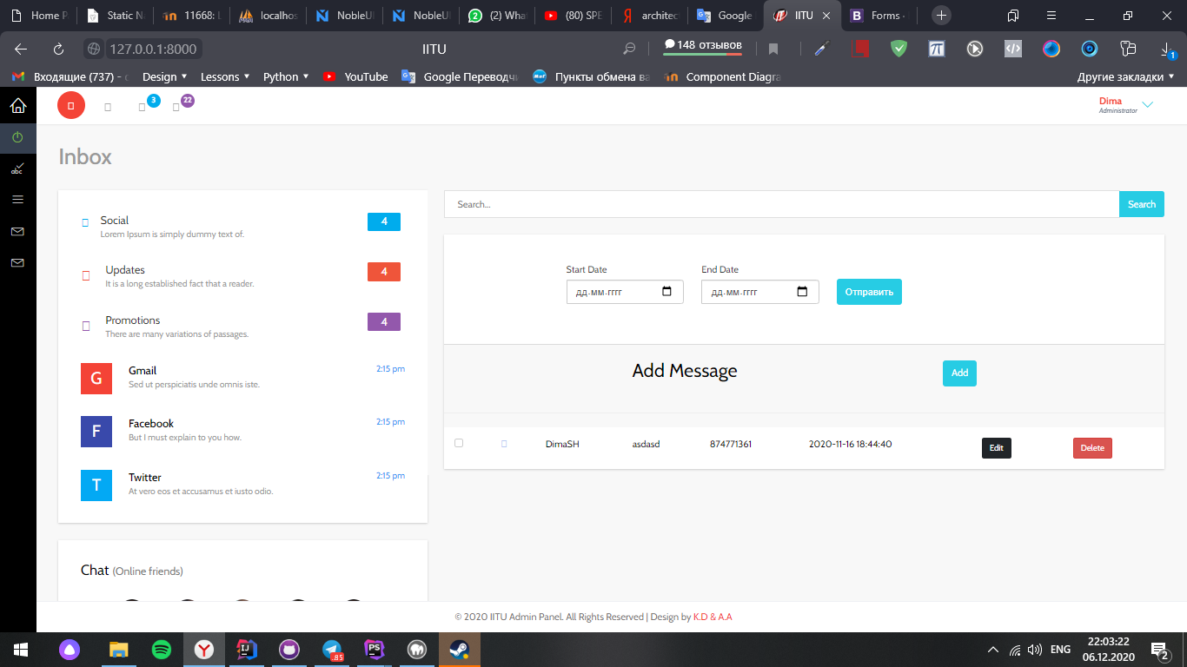

# Conclusion

In 3 milestone I’ve learned how to use CRUD actions in the Laravel, also how to interact with database. Without these four operations, the software cannot be considered complete. I think it’s not easy but not hard, knowledge that I gained from this milestone will be helpful for me in the future, while creating website.

Resources:

<https://en.wikipedia.org/wiki/Create,_read,_update_and_delete>

<https://dev.to/kingsconsult/laravel-8-crud-bi9>

<https://www.youtube.com/watch?v=3xRMUDC74Cw&t=402s>

<https://getbootstrap.com/docs/4.5/getting-started/introduction/>

<https://github.com/azatnt/Admission-office-IITU-full-site>