

**Department of Computer Engineering and Information Security**

**Web-technologies**

**Milestone 2**

**Topic: University(Priemnaya komissia(like a welcome.kaznu.kz))**

   Done by:   Komekbay D. Amanzhol A.

   Group: CSSE-1802K

Checked by: Alpysbay N.E

 Almaty 2020

## Introduction

In this part of our milestone I should create a some CRUD actions to the part called Receptions. It’s same like a reception in our daily life, for example let’s imagine student or user will have a question, he will wrote a message in the contact form which we made in the previous part, but he won’t have a reply message. Then he/she will go to the reception part and call the the people in the table. So our task is to display all the people related to their faculty, and make CRUD actions in the admin side. Let’s start.

We will create a route called ‘admin/receptions’ and controller called AdminController

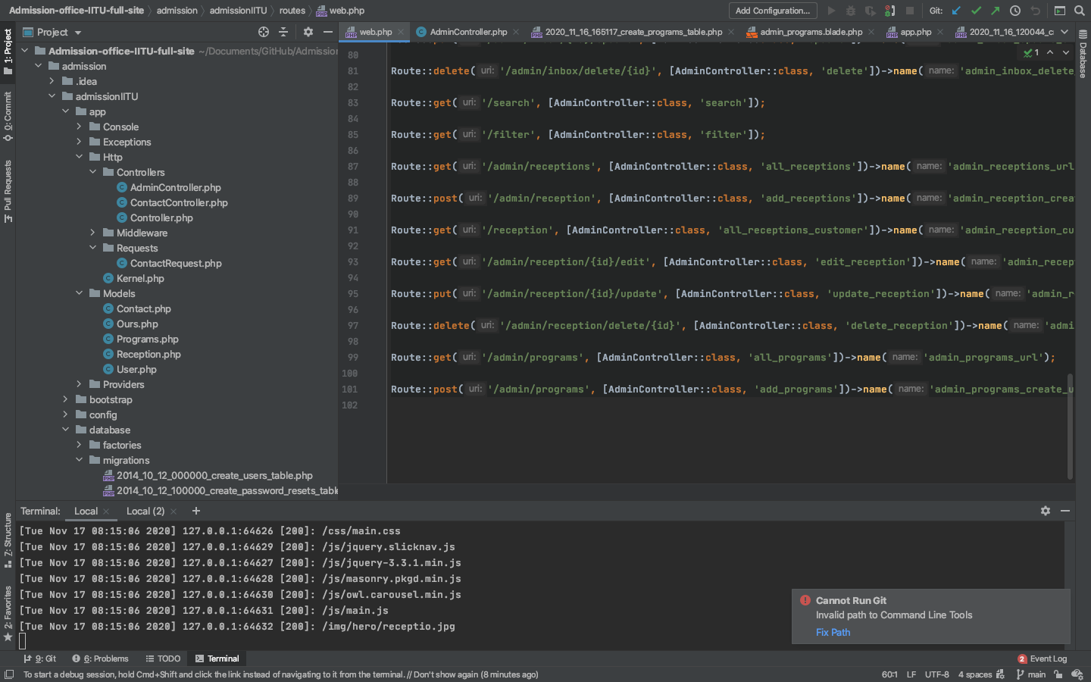

Our next step is, in the database/migrations create a table and fill their columns and migrate.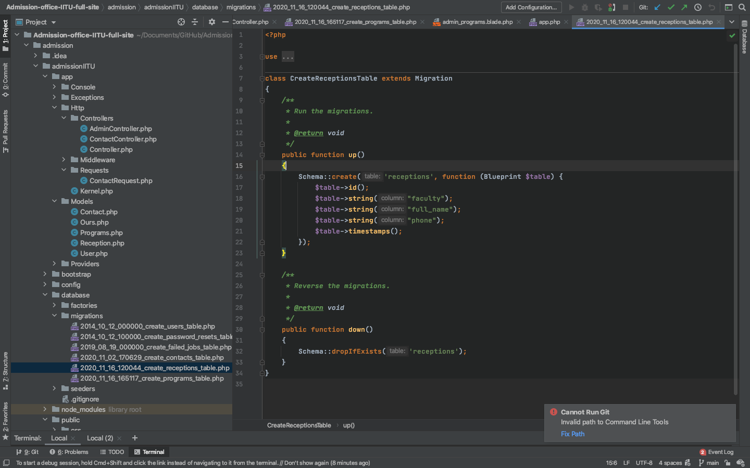

Then we should go to the AdminController and write here all methods.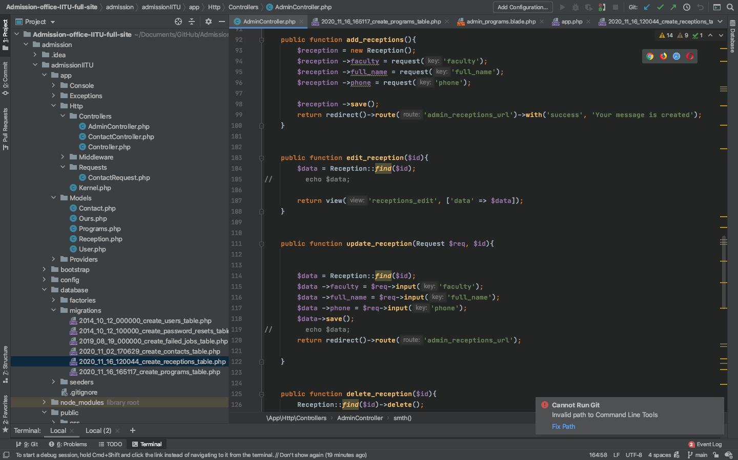

For example in the picture above we see that there is written 4 methods(add(), edit(), delete()).

Then we will send our data from database to related view and output it will loop

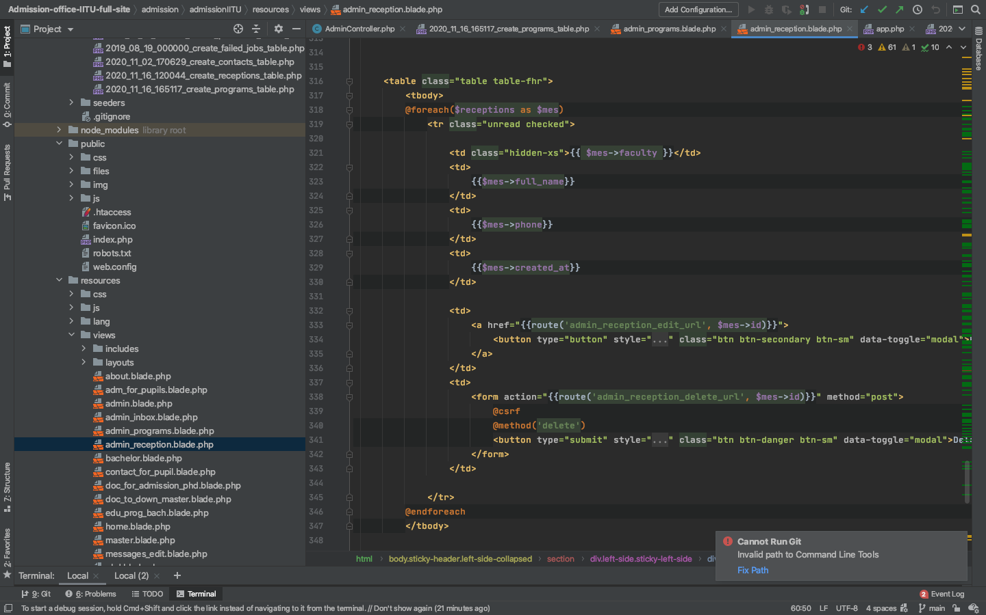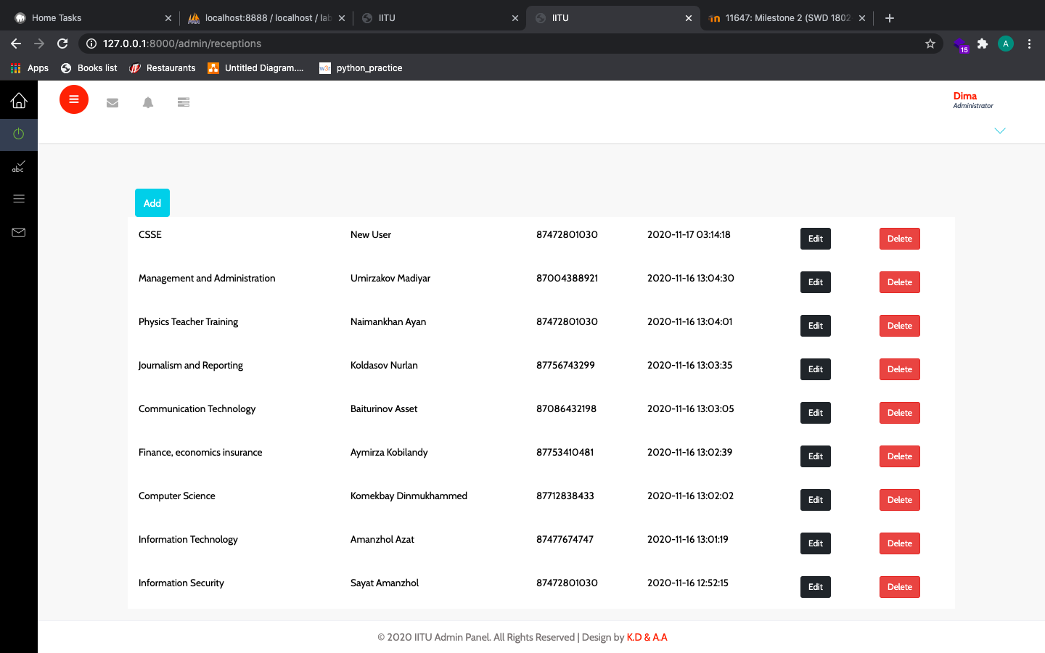

Also it will be displayed in the client side

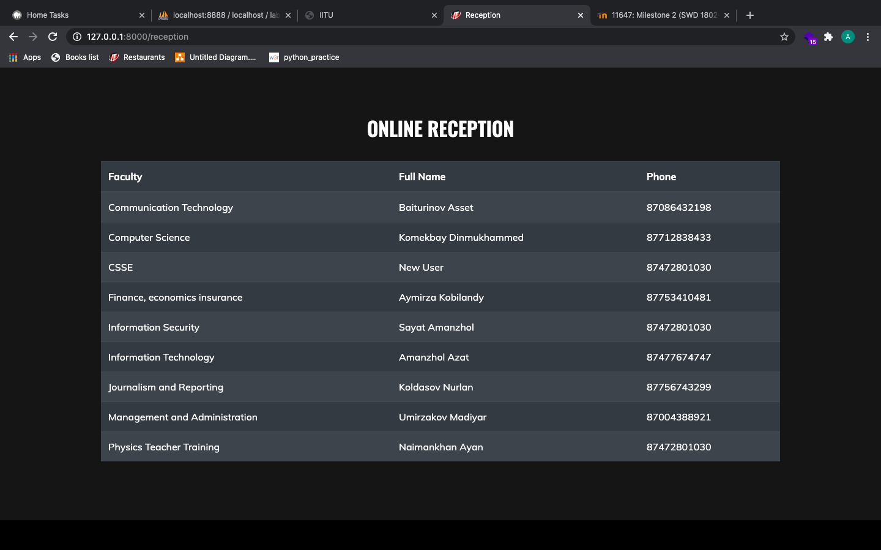

# Conclusion

In this milestone I learned how to realize CRUD actions in the framework Laravel, also how to interact with database. Without these four operations, the software cannot be considered complete. I think it’s not easy but not hard, knowledge that I gained from this milestone will be helpful for me in the future, while creating website.

Resources:

<https://en.wikipedia.org/wiki/Create,_read,_update_and_delete>

<https://dev.to/kingsconsult/laravel-8-crud-bi9>

<https://www.youtube.com/watch?v=3xRMUDC74Cw&t=402s>

<https://getbootstrap.com/docs/4.5/getting-started/introduction/>