Java SE 8.0

Java 8 is expected in late 2012 [64] and will include at a minimum the features that were planned for Java 7 but later deferred.

Modularization of the JDK under Project Jigsaw[65]
Language-level support for lambda expressions (officially, lambda expressions; unofficially, closures) under Project Lambda.[66] There was an ongoing debate in the Java community on whether to add support for lambda expressions.[67][68] Sun later declared that lambda expressions would be included in Java 7 and asked for community input to refine the feature.[69]
Parts of project Coin that are not included in Java 7

Core

Modularization (Project Jigsaw)
An implementation-specific, simple, low-level module system focused upon the goal of modularizing the JDK, and the application of that system to the JDK itself
Upgrade class-loader architecture
Modifications to the ClassLoader API and implementation to avoid deadlocks in non-hierarchical class-loader topologies
Method to close a URLClassLoader
A method that frees the underlying resources, such as open files, held by a URLClassLoader

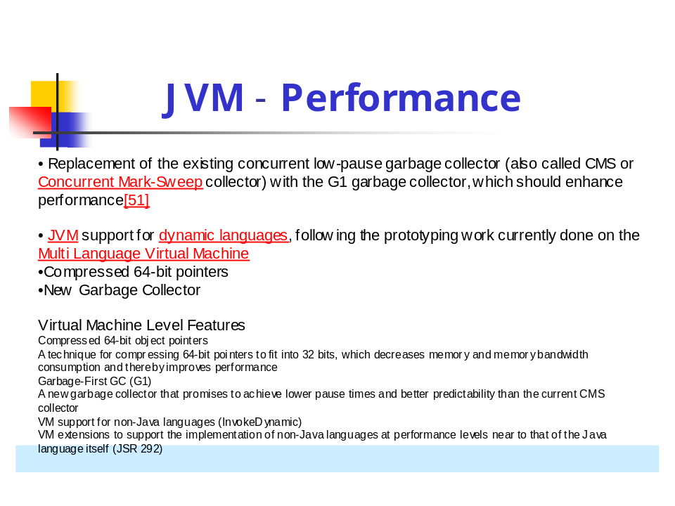

NetworkChannel
• ﬁnish work on channel to network socket
• Multicasting
• DatagramChannel (now supports),
• AsynchronousDatagramChannel (new)
• Asynchronous I/O for ﬁles and sockets
• Future or callback style
• Group support - manage thread pools

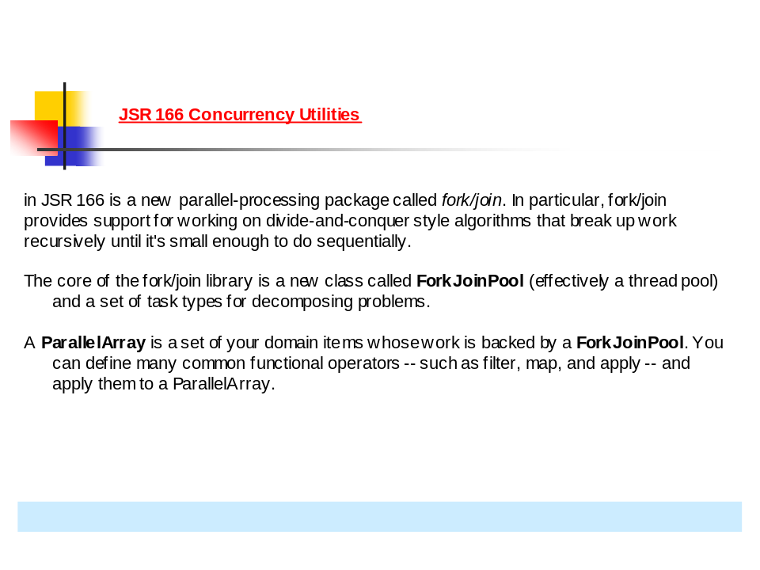

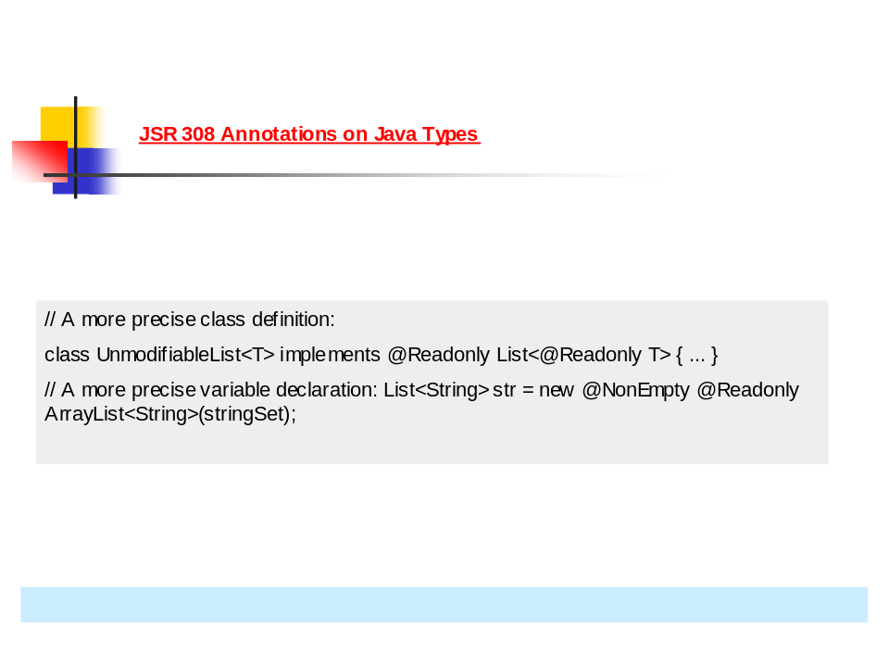

// A more precise class definition:
class UnmodifiableList<T> implements @Readonly List<@Readonly T> { ... }
// A more precise variable declaration: List<String> str = new @NonEmpty @Readonly ArrayList<String>(stringSet);

IDE Support:

Both IDEA and Eclipse support JDK7 at compile level only i.e they can compile the source but advanced features like code complete etc., won't work
NetBeans 6.9 Beta has much better support for JDK7
JetBrains this spring will offer full support for Java 7 in an upgrade to the company's IntelliJ Idea IDE, according to
the JetBrains IntelliJ Idea blog. IntelliJ IDEA 10.5 will support language features of Java 7 across the IDE with capabilities such as code completion, code inspections, and quickfixes.

Release Schedule:

Milestone 7 is the latest release
Milestone 8 to be released in June 2010

In fact, the Java community seems to be faced with two different choices: a two year pushback, to mid-2012, for an all-features-as-promised version of the JDK; or a release in the middle of next year that would exclude Projects HYPERLINK "http://openjdk.java.net/projects/lambda/"
Lambda (closures), HYPERLINK "http://openjdk.java.net/projects/jigsaw/"
Jigsaw (modularity), and HYPERLINK "http://openjdk.java.net/projects/coin/"
Coin ("small language changes"), which would instead by rolled into a JDK release for late 2012.

Here are 7 of the new features that have been completed:

Language support for collections
Automatic Resource Management
Improved Type Inference for Generic Instance Creation (diamond)
Underscores in numeric literals
Strings in switch
Binary literals
Simplified Varargs Method Invocation

There is a lot more to Java 7 then just these language changes. I’ll be exploring the rest of the release in future posts. One of the big debates is currently around Closures, which are a separate JSR.

Concurrency utilities under JSR 166
New file I/O library to enhance platform independence and add support for metadata and symbolic links. The new packages are java.nio.file and java.nio.file.attribute
Library-level support for Elliptic curve cryptography algorithms
Enhanced library-level support for new network protocols, including SCTP and Sockets Direct Protocol
Upstream updates to XML and Unicode

Web

Update the XML stack
Upgrade the JAXP, JAXB, and JAX-WS APIs to the most recent stable versions
Concurrency and collections updates (jsr166y)
A lightweight fork/join framework, generalized barriers and queues, a concurrent-reference HashMap, and fences to control fine-grained read/write ordering
More new I/O APIs for the Java platform (NIO.2)
New APIs for filesystem access, scalable asynchronous I/O operations, socket-channel binding and configuration, and multicast datagrams(JSR 203)
SCTP (Stream Control Transmission Protocol)
An implementation-specific API for the Stream Control Transmission Protocol on Solaris
SDP (Sockets Direct Protocol)
Implementation-specific support for reliable, high-performance network streams over Infiniband connections on Solaris
Elliptic-curve cryptography (ECC)
A portable implementation of the standard Elliptic Curve Cryptographic (ECC) algorithms, so that all Java applications can use ECC out-of-the-box

(More) NIO APIs
JSR 203: NIO 2 extends and completes the work started in JDK 1.4 in the original NIO enhancements. The most obvious addition in NIO 2 is a complete overhaul of the file-access APIs. Most developers have used java.io.File and are aware of the long list of shortcomings:
- No support for symbolic links
- No support for straightforward or atomic move and copy operations
- Cumbersome APIs for walking and filtering directories
- Very limited support for access to permissions and file attributes
- No API for watching directories or files
- Limited error-handling capabilities (reliance on ignorable return flags and generic IOExceptions)
Fortunately, JSR 203 improves in all of these areas and more. The API is designed to be extensible from the start, supporting the idea of pluggable FileSystems in addition to the default FileSystem, flexible option sets for actions like opening and copying files, and system-dependent attribute definitions.
Listing 2 shows an example of how JSR 203 can be used for some common operations. Path is at the core of the API; you can think of it as the new File.

Listing 2. Some uses for JSR 203
import java.nio.file.*;

// FileSystems -> FileSystem -> Path
FileSystem fileSystem = FileSystems.getDefault();
Path homeDir = fileSystem.getPath("/Users/lskywalker");

// Shortcut with Paths helper class
Path homeDir = Paths.get("/Users/lskywalker");
Path secrets = homeDir.resolve("secrets.txt");

// Steal secrets
secrets.moveTo(Paths.get("/Users/dvader/secrets.txt"));

Beyond the filesystem APIs, JSR 203 completes many of the APIs started in the first incarnation of NIO, providing more support for multicast and a new set of APIs for asynchronous IO on files and sockets.

Tackling the time dimension
The Java Date and Calendar classes have long been in need of an overhaul. JSR 310: Date and Time API aims to do just that with a whole new library tackling the treacherous dimension of time.
JSR 310 provides support for both "continuous" time and "human-scale" time. The continuous time scale defines time as a series of discrete ticks at nanosecond resolution. The API defines an Instant as one point in time, and an Interval as the time from one Instant to another (including both open and closed intervals). Also, a Duration is some length of continuous time that is not tied to any particular Instant.
Listing 3 shows some continuous-time examples.

Listing 3. Continuous time
// Create some instants in seconds
Instant start2008 = Instant.instant(1199167200);
Instant start2009 = Instant.instant(1230789600);
assert start2008.isBefore(start2009);

// Create an interval - [inclusive, exclusive] by default
InstantInterval year2008 = InstantInterval.between(start2008, start2009);
assert year2008.contains(start2008);
assert ! year2008.contains(start2009);

// Create a duration in seconds
Duration minute = Duration.duration(60);
Duration hour = minute.multipliedBy(60);
Duration duration2008 = Duration.durationBetween(start2008, start2009);

For human-scale time, JSR 310 defines a series of classes with increasing information. The lowest level is LocalDate (only a date such as July 21, 1969), LocalTime (only a time such as 6:00:00), and a LocalDateTime, which combines the two. The Local classes are not tied to any particular time zone or any particular Instant on the continuous timeline.
OffsetDateTime adds precision by specifying a time-zone offset from universal time (UTC), which specifies a point on the continuous timeline, but it does not allow you to reason about time-zone rules, which are primarily based on government and political decisions. Finally, ZonedDateTime ties an offset to a particular time zone, allowing you to reason about Daylight Saving Time and other locale-specific time-zone matters.
Clock is a facade for accessing current moments in both continuous and human time scales. One nice feature is that Clock is defined as an abstract class with a factory method for obtaining the system Clock. However, because it's abstract, you can define your own subclass Clock implementation and either access time in some other source or have more control over it for testing.
Listing 4 shows an example of using the human-scale date and time classes.

Listing 4. Using human-scale time and Clock
// Local human-scale (not tied to TimeZone or Instant)
LocalDate dDay = LocalDate.date(1944, MonthOfYear.June, 6);
LocalTime quittingTime = LocalTime.time(17, 0);
LocalDateTime start2008 = LocalDateTime.dateTime(2008, MonthOfYear.JANUARY, 1, 0, 0, 0);

// Tie to time zone offset of -6 hours from UTC
OffsetDateTime start2008Offset = OffsetDateTime.dateTime(start2008, ZoneOffset.zoneOffset(-6));

// Tie to current local time zone
ZonedDateTime start2008Zoned = ZonedDateTime.dateTime(start2008, Clock.system().timeZone());
Finally, JSR 310 is built to interoperate with the older Date and Calendar classes, and it has full support for parsing, formatting, time-zone rules, and more.

Parallel processing
JSR 166y is a maintenance revision of the JSR that brought us all the java.util.concurrent goodies in J2SE 5.0 and updates in Java SE 6. The major addition in JSR 166y is a new parallel-processing package called fork/join. In particular, fork/join provides support for working on divide-and-conquer style algorithms that break up work recursively until it's small enough to do sequentially. Fork/join is ultimately implemented with a set of work queues and a technique known as work stealing, which allows idle workers to steal work from other queues. The core of the fork/join library is a new class called ForkJoinPool (effectively a thread pool) and a set of task types for decomposing problems.
Most typical applications don't have much use for a framework for solving computation-intensive divide-and-conquer algorithms. However, JSR 166y also provides a new functional-style API for working in parallel on arrays. A ParallelArray is a set of your domain items whose work is backed by a ForkJoinPool. You can define many common functional operators -- such as filter, map, and apply -- and apply them to a ParallelArray. The real benefit is that these operations execute in parallel via the ForkJoinPool and can automatically take advantage of increasing processor-core counts in the future without modifying the functions. It is still under consideration whether the ParallelArray will be included as part of the JDK in Java SE 7 or whether it will be released as an external library.
Page 5 of 7
Listing 5 shows an example of how you can manage your vast collection of donuts with a ParallelArray.

Listing 5. Using a ParallelArray
// Instantiate the ForkJoinPool with a concurrency level
ForkJoinPool fj = new ForkJoinPool(16);
Donut[] data = ...
ParallelArray<Donut> donuts = new ParallelArray(fj, data);

// Filter
Ops.Predicate<Donut> hasSprinkles = new Ops.Predicate<Donut>() {
public boolean op(Donut donut) {
return donut.hasSprinkles();
}
};

// Map from Donut -> Integer
Ops.Predicate<Donut> daysOld = new Ops.ObjectToInt<Donut>() {
public int op(Donut donut) {
return donut.age();
}
};

SummaryStatistics<Integer> summary =
orders.withFilter(hasSprinkles)
.withMapping(daysOld)
.summary();

System.out.println("with sprinkles: " + summary.size());
System.out.println("avg age: " + summary.average());

The concurrency utilities introduced in J2SE 5.0 and enhanced in Java SE 6 provide a firm base for writing concurrent applications on the 4- to 8-core machines common in our server racks today. The fork/join library takes us a bit further in making our logic parallelizable and scalable for a larger number of cores, such as the 16- to 32-core machines we'll be deploying to for the next couple years. This will give us some runway but in no way "solves" the problem of concurrency. Everyone in the industry is searching for ways to leverage the multicore world we now live in. Although Java has a head-start on this trend, shared-state concurrency is unlikely to be sufficient a decade from now. Fork/join is just another step on the journey.

Better precision through annotations
J2SE 5.0 brought us the world of Java annotations, which is still picking up steam as an alternative to external XML configuration metadata. In Java SE 6, annotations can occur only on class, method, field, and variable declarations. JSR 308: Annotations on Java Types allows annotations to occur anywhere types can occur, opening the possibility of more expressive and precise type systems.
The JSR does not itself define any additional annotations, although it opens the door for annotations such as those defined in JSR 305: Annotations for Software Defect Detection. The goal of JSR 305 annotations is to allow developers to define the semantics of method calls more precisely, such as whether nulls are allowed, whether collections can be empty, and so on.
Listing 6 shows some examples of how new annotations might be used.

Listing 6. Using annotations for greater precision
// A more precise class definition:
class UnmodifiableList<T> implements @Readonly List<@Readonly T> { ... }

// A more precise variable declaration:
List<String> str = new @NonEmpty @Readonly ArrayList<String>(stringSet);
Annotation processors can be plugged into the compiler to verify these annotations at compile time. This allows a great deal more specificity and precision, but it comes with a heavy cost of verbosity and will certainly fill some Java users with dread

Simplifying Swing
A trio of Swing-related JSRs are in the works. JSR 296: Swing Application Framework provides a framework and functionality needed by most Swing applications to simplify development. Specifically, it provides:
JSR 296 seems to have been in limbo ever since the departure in 2008 of the specification lead. There have been hints of revival, but many are questioning whether this effort will be resuscitated in time for Java SE 7.
JSR 295: Beans Binding and JSR 303: Bean Validation are targeted at solving problems prevalent in Swing applications but can also be used in non-Swing use cases as well. JSR 295 addresses the need to bind together fields in two (or more) objects. Properties can be bound in either one direction or both, and extensions exist to support common Swing models such as lists and tables. JSR 303 is a framework to create validators for fields and classes. The JSR defines a set of meta-annotations as well as a common set of constraint annotations.

Java Management Extensions (JMX) updates
JSR 255: JMX 2.0 is a comprehensive update to the JMX specification, taking full advantage of language features introduced in J2SE 5.0 and adding new important features including namespaces, federation of remote JMX servers, a new event service, a query language, and more.
And JSR 262: Web Services Connector for JMX allows clients to connect over Web services to a JMX MBean (which of course works for non-Java Web service clients).

Language changes
Given the limited remaining timeframe for Java SE 7 and the seeming reluctance to add major new language features, it is expected that only small changes will be included in the Java SE 7 platform specification. Joseph Darcy will be leading an OpenJDK project to collect and evaluate these language changes.
Closures are the biggest language feature proposed for Java SE 7. Closures would certainly have the greatest impact on the language, as well as the other JSRs I've discussed here. A number of proposals have been put forth, and the three most popular proposals have working prototypes. In particular, Neal Gafter's work on the BGGA closures proposal includes a complete spec and a working implementation, and it's the most thoroughly vetted of the existing proposals.
Given shrinking resources at Sun, the number of significant JSRs, and pressure to release, it seems that it's unlikely that closures will be included in the Java SE 7 release. That's a shame, in my opinion, because closures could simplify parts of the API in the NIO 2, fork/join, and other libraries. Without closures in Java SE 7, those opportunities will be lost.
Some possible smaller language enhancements include:
- Strings can be used in the case clause of a switch.
- Comparison operators (<, >, and so on) work directly with enum constants.
- Chained invocation - void methods implicitly return this, allowing method chaining.
- Extension methods - Statically imported methods can be called as if they were object methods, allowing APIs to be extended after the fact with static utility classes.
- Improved catch of multiple exception types at once and subsequent rethrow of just those specific types.

Dynamic-language support
JSR 292: Supporting Dynamically Typed Languages on the Java Platform was started to introduce a new JVM bytecode, called invokedynamic, for better support of dynamic languages. John Rose has subsequently used the JSR as a forum to explore a number of possible JVM enhancements that could help languages other than Java on the JVM.
This work culminated in the first JVM Language Summit, held in September 2008, where features such as tail call optimization and interface injection were discussed. For functional languages that make heavy use of recursion, tail call optimization is important to avoid running out of stack space. Scala addresses this in the compiler itself. Clojure has language support for simulated tail calls and recently added language support for trampolining to support mutual recursion. If tail call optimization can be added to the JVM, Scala and Clojure could simplify or remove these features.
Mark Reinhold stated at the JVM Language Summit that JSR 292 will be included in Java SE 7. It is unclear at this point whether any features beyond invokedynamic will be included under JSR 292.

Java SE 7 and the future of Java
I believe we will see a Java SE 7 platform JSR in 2009 that will include most of the JSRs described in this article, but few if any changes to the language itself. It will be a stretch to integrate all of this work into the OpenJDK builds and release Java SE 7 in early 2010, as now planned.
Some question whether Java SE 7 is still relevant and whether anyone will even use it. Java continues to be one of the more important languages in use today, even given the rise of alternative JVM-based languages. Java has such a huge installed base that it will take generations of programmers before it stops being relevant. JSRs like 294, 310, and 203 seek to update core APIs with changes the are compelling to enterprise software developers. The forward march into the multicore era will make JSR 166 and JVM performance improvements compelling as well.
I believe widespread adoption of Java SE 7 will be slow but steady. Assuming the platform is released in early 2010, it will probably be 2011 before the new release gains a significant portion of market share. We've seen the same slow, steady progression happening with Java SE 6. J2SE 1.4 entered the End of Service Lifecycle in November 2008, and J2SE 5.0 will join it in late 2009. By that point, most businesses that do Java-based development will be looking at or deploying on Java SE 6. If Java SE 7 language changes are minimal, as currently indicated, many businesses could skip from J2SE 5.0 straight to Java SE 7.

About the author
Alex Miller is a Tech Lead at Terracotta Inc, the makers of the open-source Java clustering product Terracotta. Previously, Alex worked at BEA Systems on the AquaLogic product line and was Chief Architect at MetaMatrix. Alex blogs at http://tech.puredanger.com and speaks at user groups, conferences, and the No Fluff Just Stuff tour. He has an enduring love for his wife and three children, music, and nachos.
Read more about Core Java in JavaWorld's Core Java section.
Java SE 7, or Java Platform Standard Edition 7, "will promote best coding practices and reduce boilerplate code by adding productivity features to the Java language and the Java SE APIs," the JSR states. Features will increase the abstraction level of most applications in a "pragmatic" way, with no significant impact on existing code and a minimal learning curve for all developers, according to the proposal: "We propose to enable, among other improvements, the automatic management of I/O resources, simpler use of generics, and more concise exception handling."

Also due in Java SE 7 are concurrency APIs to accommodate multicore processors and improvements for dynamic scripting languages. An API for asynchrony is included to boost I/O-intensive operations. The JSR cites July 2011 as the final release date for the specification.
Java SE 8, the specification reads, "will further reduce boilerplate code by adding productivity features to the Java language and the Java SE APIs." Also, Java SE 8 will deal with what the specification refers to as class path Java Archive "hell" by integrating a module system into the platform

Additionally, the Java Collections Framework and related APIs will be enhanced in version 8 to support automatically parallelizable bulk-data operations such as filter, map, and reduce. "Convenient use of these new APIs will be enabled by extending the Java language to include lambda expressions (a.k.a. 'closures') and default methods. These language changes will, as an additional benefit, improve the productivity of developers using existing single-abstract-method APIs across the platform."

Final release of the Java SE 8 specification is planned for October 2012.

JDK 7 is the next major release of the Java SE platform and is currently available as an early access release. JDK 7 documentation will be regularly updated as and when new features are added to the JDK 7 platform. You can also expect to see changes in content for existing features.

The two principal products in the Java SE platform are: Java Development Kit (JDK) and Java SE Runtime Environment (JRE).
The JDK is a superset of the JRE, and contains everything that is in the JRE, plus tools such as the compilers and debuggers necessary for developing applets and applications. The Java Runtime Environment (JRE) provides the libraries, the Java Virtual Machine, and other components to run applets and applications written in the Java programming language.

Java 7 (codename Dolphin) . The development period is organized into thirteen milestones; on February 18, 2011, milestone 13, the last milestone was reached. Multiple builds, which generally include enhancements and bug fixes, are released per milestone. The Feature list at the Open JDK 7 project lists many of the expected feature changes.

Key Features
JDK 7 introduces several key features to improve performance, usability, and security of the Java platform. A detailed list of these features appears on the OpenJDK site.
Based on the feedback from the developer community and Sun's customers, the JDK 7 features primarily focus on the following areas.
Modularization | A large-scale effort to refactor, or break up, the Java SE platform into smaller, separate, interdependent modules. Individual modules can then be downloaded as required by the Java virtual machine and/or Java applications. This effectively shrinks the size of the runtime on the user's machine.  One benefit of modularization is that the platform is a smaller download, potentially improving start-up performance. Having a smaller memory footprint also enables significant performance improvements, especially for desktop applications. A smaller platform also means it can now fit on devices with less memory.  You can find more information about modularization on the OpenJDK site, on Mark Reinhold's blog , or on the Project Jigsaw site.
Multi-Language Support | Improves compatibility between Java and various dynamic languages, such as Ruby and Python, by providing better-than-native implementations of these languages on top of the Java Runtime Environment (JRE).  Refer to JSR 292a>, also called “InvokeDynamic”. This JSR defines the elements critical for Ruby, Python, and other dynamic languages to be addressed for JDK 7.  You can find more information on the Da Vinci Machine project page or on the Sun wiki site.
Developer Productivity | JDK 7 will also include several features to enhance developer productivity. One of Sun's goals is to make JDK 7, and other versions of the JDK, as developer-friendly as possible. Here are some features in JDK 7 to do just that:  - Project Coin: Small language changes  - Concurrency and Collections Updates  - JSR 308: Type Annotations to improve static program checking  - JSR 203: New I/O to define a true filesystem API
Performance | Sun understands the need to improve the performance of the Java SE platform, and several features in JDK 7 address just that. Here are two such features slated for JDK 7:  - Compressed 64-bit object pointers  - G1 Garbage Collector  The new Garbage First (G1) Garbage Collector is a low pause, server-style garbage collector that will eventually replace the Concurrent Mark-Sweep (CMS) garbage collector. G1's primary advantage over CMS are incremental compaction, better predictability, and ease of use. You can find more information on the OpenJDK site or on Alex Miller's blog.

In addition to enhanced API's JDK7 highlights 5 new feature..

* Modularity
* Multi-Language Support
* New Garbage Collector
* NIO.2 New File System API
* Additional Swing API
Virtual Machine Level Features
Compressed 64-bit object pointers
A technique for compressing 64-bit pointers to fit into 32 bits, which decreases memory and memory bandwidth consumption and thereby improves performance
Garbage-First GC (G1)
A new garbage collector that promises to achieve lower pause times and better predictability than the current CMS collector
VM support for non-Java languages (InvokeDynamic)
VM extensions to support the implementation of non-Java languages at performance levels near to that of the Java language itself (JSR 292)
Language
Annotations on Java types
An extension to the Java annotation syntax to permit annotations on any occurrence of a type(JSR 308)
Language enhancements (Project Coin)
A set of small language changes intended to simplify common, day-to-day programming tasks
Language and VM support for modular programming
Enhancements to the Java language and virtual-machine specifications to support modular programming, at both compile time and run time(JSR 294)
Core
Modularization (Project Jigsaw)
An implementation-specific, simple, low-level module system focused upon the goal of modularizing the JDK, and the application of that system to the JDK itself
Upgrade class-loader architecture
Modifications to the ClassLoader API and implementation to avoid deadlocks in non-hierarchical class-loader topologies
Method to close a URLClassLoader
A method that frees the underlying resources, such as open files, held by a URLClassLoader
Unicode 5.1
Upgrade the supported version of Unicode to 5.1
Concurrency and collections updates (jsr166y)
A lightweight fork/join framework, generalized barriers and queues, a concurrent-reference HashMap, and fences to control fine-grained read/write ordering
More new I/O APIs for the Java platform (NIO.2)
New APIs for filesystem access, scalable asynchronous I/O operations, socket-channel binding and configuration, and multicast datagrams(JSR 203)
SCTP (Stream Control Transmission Protocol)
An implementation-specific API for the Stream Control Transmission Protocol on Solaris
SDP (Sockets Direct Protocol)
Implementation-specific support for reliable, high-performance network streams over Infiniband connections on Solaris
Elliptic-curve cryptography (ECC)
A portable implementation of the standard Elliptic Curve Cryptographic (ECC) algorithms, so that all Java applications can use ECC out-of-the-box
Client
XRender pipeline for Java 2D
A new Java2D graphics pipeline based upon the X11 XRender extension, which provides access to much of the functionality of modern GPUs
Forward-port 6u10 deployment features
Forward-port implementation-specific deployment features from the 6u10 release: The new Java Plug-In, Java Kernel, Quickstarter, and related installer features
Create new platform APIs for 6u10 graphics features
Create new platform APIs for features originally implemented in the 6u10 release: Translucent and shaped windows, heavyweight/lightweight mixing, and the improved AWT security warning
Nimbus look-and-feel for Swing
A next-generation cross-platform look-and-feel for Swing
Swing updates
Small additions to the Swing API including the JXLayer component decorator, JXDatePicker, and possibly CSS-based styling
Web
Update the XML stack
Upgrade the JAXP, JAXB, and JAX-WS APIs to the most recent stable versions

Jar Hell in Action
Dependency management is one of the
most important (and challenging) features
of modern software development
JSR 334: Small language enhancements (Project Coin)
JSR 334 is intended to make programmers' jobs easier.

JSR 334 is intended to make programmers' jobs easier. It would amend the Java programming language and API specifications to support features including strings in switch, binary integral literals, multicatch, and more precise rethrow and improved type inference for generic instance creation. The specification also is set for finalization next July.

Language changes under Project Coin.[53][54] The features accepted for inclusion in Project Coin are:

Strings in switch[55]
Automatic resource management[56]
Improved Type Inference for Generic Instance Creation[57]
Simplified Varargs Method Invocation[58]
Better integral literals allowing for underscores as digit separators
Language-level support for Collections[59]

Lambda, Jigsaw, and part of Coin were dropped from Java 7, which will be released in mid 2011. Java 8 will be implemented with the remaining features in late 2012.

