Enhanced Java concurrency
Concepts behind CompletableFuture and reactive programming
1.You can split large tasks and make each subtask run in parallel with the others e.g. via fork/join and and parallel streams

The second trend reflects the increasing availability and use by applications of Internet services. The adoption of microservices architecture, for example, has grown over the past few years. Instead of being one monolithic application, your application is subdivided into smaller services. The coordination of these smaller services requires increased network communication. Similarly, many more internet services are accessible through public APIs, made available by known providers such as Google (localization information), Facebook (social information), and Twitter (news).

Nowadays, it’s relatively rare to develop a website or a network application that works in total isolation.
It’s far more likely that your next web application will be a mashup, using content from multiple sources and aggregating it to ease your users’ lives.

This situation represents the other side of the multitask-programming coin. The fork/join framework and parallel streams, are valuable tools for parallelism; they divide a task into multiple subtasks and perform those subtasks in parallel on different cores, CPUs, or even machines. Conversely, when you’re dealing with concurrency instead of parallelism, or when your main goal is to perform several loosely related tasks on the same CPUs, keeping their cores as busy as possible to maximize the throughput of your application, you want to avoid blocking a thread and wasting its computational resources while waiting (potentially for quite a while) for a result from a remote service or from interrogating a database.

Concurrency is a programming property (overlapped execution) that can occur even for a single-core machine, whereas parallelism is a property of execution hardware (simultaneous execution).

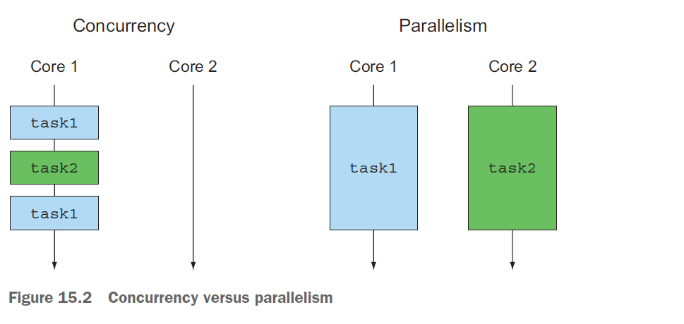

See my honest-blog https://medium.com/modern-mainframe/multithreading-in-java-vs-node-js-c558d59050c9
The advent of multicore processors has helped to speed up application performance. Concepts behind the CompletableFuture and reactive programming are reaching parallelism using non-blocking operations, and ForkJoinPool (in fork/join framework) is designed for this purpose. It understands tasks depend on other tasks, so avoids blocking threads, and changing (context switch expensive) threads. It is an ideal candidate to write asynchronous systems.

Evolving Java support for expressing concurrency
Java has evolved considerably in its support for concurrent programming, largely reflecting the changes in hardware, software systems, and programming concepts over the past 20 years. To be honest, nobody enjoyed working with threads directly!
----- Looks our Zelda because of that Cobol API is born ;) -----
Java 7 added java.util.concurrent.RecursiveTask to support fork/join implementation of divide-and-conquer algorithms, and Java 8 added support for Streams and their parallel processing (building on the newly added support for lambdas).

Java further enriched its concurrency features by providing support for composing Futures (via the Java 8 CompletableFuture implementation of Future, section 15.4 and chapter 16), and Java 9, provided explicit support for distributed asynchronous programming.
application worked by contacting various web services and combining their information in real time for a user or to expose it as a further web service. This process is called reactive programming, and Java 9 provides support for it via the publish-subscribe protocol (specified by the java.util.concurrent.Flow interface; see section 15.5 and chapter 17). A key concept of CompletableFuture and java.util.concurrent.Flow is to provide programming structures that enable independent tasks to execute concurrently wherever possible and in a way that easily exploits as much as possible of the parallelism provided by multicore or multiple machines.

Executors and thread pools
Java 5 provided the Executor framework and the idea of thread pools as a higher-level idea capturing the power of threads, which allow Java programmers to decouple task submission from task execution.
PROBLEMS WITH THREADS
Java threads access operating-system threads directly. The problem is that operating-system threads are expensive to create and to destroy (involving interaction with page tables), and moreover, only a limited number exist. Exceeding the number of operatingsystem threads is likely to cause a Java application to crash mysteriously, so be careful not to leave threads running while continuing to create new ones.

THREAD POOLS AND WHY THEY’RE BETTER
The Java ExecutorService provides an interface where you can submit tasks and obtain their results later. The expected implementation uses a pool of threads, which can be created by one of the factory methods, such as the newFixedThreadPool method: ExecutorService newFixedThreadPool(int nThreads)
This method creates an ExecutorService containing nThreads (often called worker threads) and stores them in a thread pool, from which unused threads are taken to run submitted tasks on a first-come, first-served basis. These threads are returned to the pool when their tasks terminate.

Note the wording: The programmer provides a task (a Runnable or a Callable), which is executed by a thread.

THREAD POOLS AND WHY THEY’RE WORSE
Thread pools are better than explicit thread manipulation in almost all ways, but you
need to be aware of two “gotchas:”
○ A thread pool with k threads can execute only k tasks concurrently. Any further task submissions are held in a queue and not allocated a thread until one of the existing tasks completes. This situation is generally good, in that it allows you to submit many tasks without accidentally creating an excessive number of threads, but you have to be wary of tasks that sleep or wait for I/O or network connections. In the context of blocking I/O, these tasks occupy worker threads but do no useful work while they’re waiting. Try taking four hardware threads and a thread pool of size 5 and submitting 20 tasks to it (figure 15.3). You might expect that the tasks would run in parallel until all 20 have completed. But suppose that three of the first-submitted tasks sleep or wait for I/O. Then only two threads are available for the remaining 15 tasks, so you’re getting only half the throughput you expected (and would have if you created the thread pool with eight threads instead). It’s even possible to cause deadlock in a thread pool if earlier task submissions or already running tasks, need to wait for later task submissions, which is a typical use-pattern for Futures.
The takeaway is to try to avoid submitting tasks that can block (sleep or wait for events) to thread pools, but you can’t always do so in existing systems.
○ Java typically waits for all threads to complete before allowing a return from main to avoid killing a thread executing vital code. Therefore, it’s important in practice and as part of good hygiene to shut down every thread pool before exiting the program (because worker threads for this pool will have been created but not terminated, as they’re waiting for another task submission). In practice, it’s common to have a long-running ExecutorService that manages an alwaysrunning
Internet service. Java does provide the Thread.setDaemon method to control this behavior,
which we discuss in the next section.

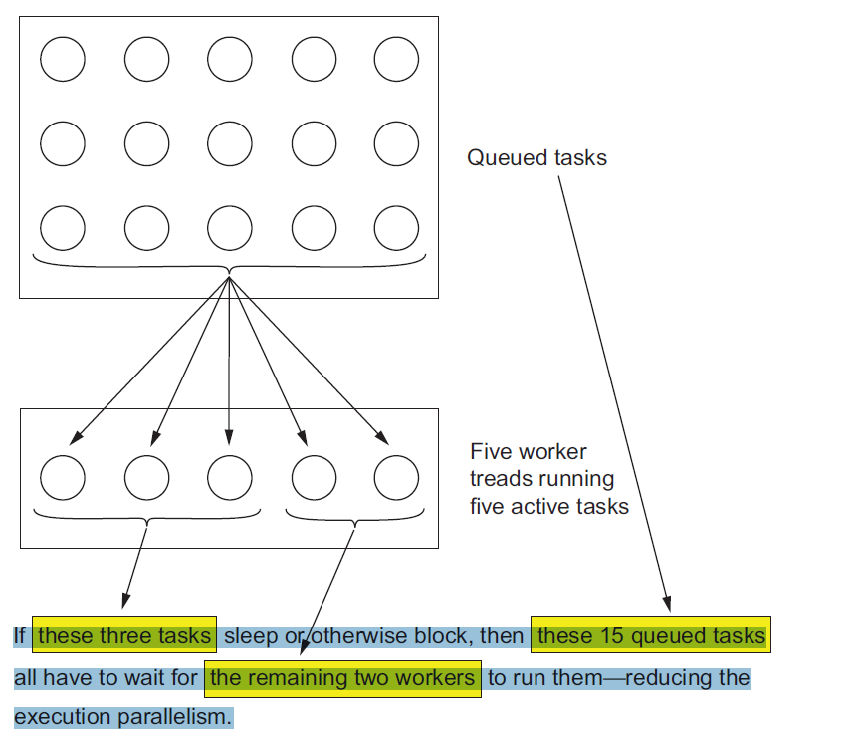
Other abstractions of threads: non-nested with method calls
To explain why the forms of concurrency used in this chapter differ from those used in chapter 7 (parallel Stream processing and the fork/join framework), we’ll note that the forms used in chapter 7 have one special property: whenever any task (or thread) is started within a method call, the same method call waits for it to complete before returning.
In other words, thread creation and the matching join() happen in a way that nests properly within the call-return nesting of method calls. This idea, called strict fork/join.

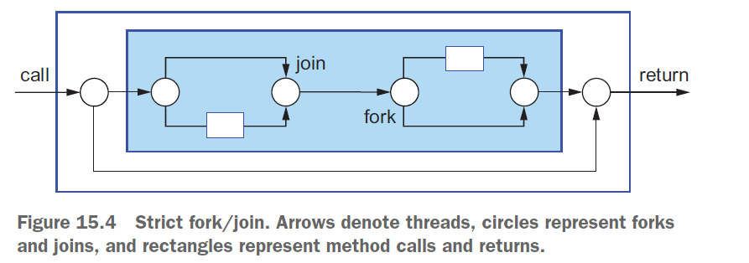
It’s relatively innocuous to have a more relaxed form of fork/join in which a spawned task escapes from an internal method call but is joined in an outer call, so that the interface provided to users still appears to be a normal call,3 as shown in figure 15.5.

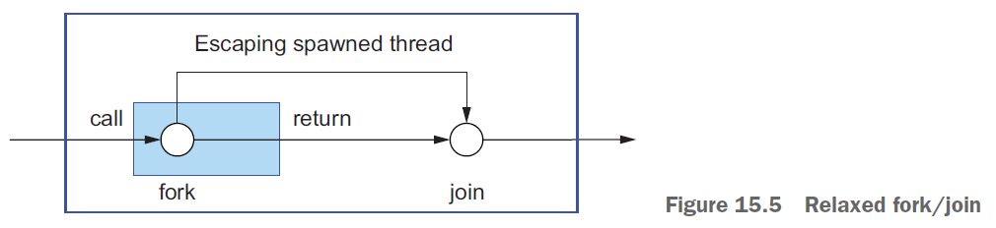
richer forms of concurrency in which threads created (or tasks spawned) by a user’s method call may outlive the call, as shown in figure 15.6. This type of method is often called an asynchronous method, particularly when the ongoing spawned task continues to do work that’s helpful to the method caller.
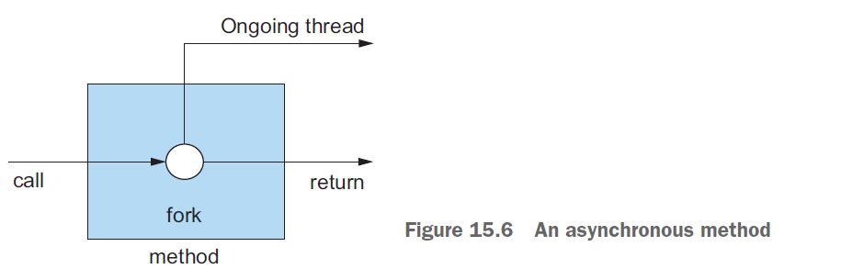
The former solution risks a seeming application crash by never terminating due to a forgotten thread; the latter risks interrupting a sequence of I/O operations writing to disk, thereby leaving an external data in an inconsistent state. To avoid both of these
problems, ensure that your program keeps track of all threads it creates and joins them all before exiting (including shutting down any thread pools).

Java threads can be labeled as daemon4 or nondaemon, using the setDaemon() method call. Daemon threads are killed on exit (and therefore are useful for services that don’t leave the disk in an inconsistent state), whereas returning from main continues to wait for all threads that aren’t daemons to terminate before exiting the program.

Functional Programming and Future Java evolution
are functional programming and domain-specific languages

The fine design choices enable you to see functional-style programming in Java 8 as an additional set of design patterns and idioms to enable you to write clearer, more concise code in less time.

The Java 8 feature of passing code to methods (and being able to return it and incorporate it into data structures) also provides access to a range of additional techniques that are commonly referred to as functional-style programming. In a nutshell, such code, called functions in the functional programming community, can be passed around and combined in a way to produce powerful programming idioms that you’ll see in Java guise throughout this book.

“And functional-style programming, what’s that?” It’s another style of programming, just like object-oriented programming, but centered on using functions as values, just as we mentioned previously when discussing lambdas.

=====================================

3. Parallelism and shared mutable data

The third programming concept is rather more implicit and arises from the phrase “parallelism almost for free” in our previous discussion on stream processing.

You must provide behavior that is safe to execute concurrently on different pieces of the input. Typically this means writing code that doesn’t access shared mutable data to do its job.

Sometimes these are referred to as pure functions or side-effect-free functions or stateless functions, previous parallelism arises only by assuming that multiple copies of your piece of code can work independently.

Java 8 streams exploit parallelism more easily than Java’s existing Threads API, so although it’s possible to use synchronized to break the no-shared-mutable-data rule, it’s fighting the system in that it’s abusing an abstraction optimized around that rule. Using synchronized across multiple processing cores is often far more expensive than you expect, because synchronization forces code to execute sequentially, which works against the goal of parallelism.

Two of these points (no shared mutable data and the ability to pass methods and functions—code—to other methods) are the cornerstones of what’s generally described as the paradigm of functional programming.

Multicore processors aren’t fully served by pre-Java-8 programming practice.

Functions in Java
The word function in programming languages is commonly used as a synonym for method, particularly a static method; this is in addition to it being used for mathematical function, one without side effects (stateless, immutable, .. ).

Java 8 adds functions as new forms of value. These facilitate the use of streams, to exploit parallel programming on multicore processors.

To help answer this, we’ll note that the whole point of a programming language is to manipulate values, which, following historical programming-language tradition, are therefore called first-class values .
Other structures in our programming languages, which perhaps help us express the structure of values but which can’t be passed around during program execution, are second-class citizens.

Values as listed previously are first-class Java citizens, but various other Java concepts, such as methods and classes, exemplify second-class citizens.

Yes, it turns out that being able to pass methods around at runtime, and hence making them first-class citizens, is useful in programming, so the Java 8 designers added the ability to express this directly in Java. Incidentally, you might wonder whether making other second-class citizens such as classes into firstclass- citizen values might also be a good idea. Various languages such as Smalltalk and
JavaScript have explored this route.

Methods and lambdas as first-class citizens
Experiments in other languages, such as Scala and Groovy, have determined that allowing concepts like methods to be used as first-class values made programming easier by adding to the toolset available to programmers.
The designers of Java 8 decided to allow methods to be values—to make it easier for you to program.
the Java 8 feature of methods as values forms the basis of various other Java 8 features (such as Streams).

The first new Java 8 feature we introduce is that of method references.

File[] hiddenFiles = new File(".").listFiles(new FileFilter() {
public boolean accept(File file) {
return file.isHidden();
}
});

now
File[] hiddenFiles = new File(".").listFiles(File::isHidden);
Java 8 method reference :: syntax (meaning “use this method as a value”);

Here’s a taste of what’s coming: methods are no longer second-class values. Analogous to using an object reference when you pass an object around (and object references are created by new), in Java 8 when you write File::isHidden, you create a method reference, which can similarly be passed around.

LAMBDAS: ANONYMOUS FUNCTIONS
As well as allowing (named) methods to be first-class values, Java 8 allows a richer idea
of functions as values, including lambdas4 (or anonymous functions).

you can now write (int x) -> x + 1 to mean “the function that, when called with argument x, returns the value x + 1.”

Programs using these concepts are said to be written in functional-programming style; this phrase means “writing programs that pass functions around as first-class values.”

Other good ideas from functional programming

The previous sections introduced two core ideas from functional programming that are now part of Java: using methods and lambdas as first-class values, and the idea that calls to functions or methods can be efficiently and safely executed in parallel in the absence of mutable shared state. Both of these ideas are exploited by the new Streams API we described earlier. Common functional languages (SML, OCaml, Haskell) also provide further constructs to help programmers. One of these is avoiding null by explicit use of more descriptive data types. Tony Hoare, one of the giants of computer science, said this in a presentation at QCon London 2009:

I call it my billion-dollar mistake. It was the invention of the null reference in 1965. . . .I couldn’t resist the temptation to put in a null reference, simply because it was so easy to implement.

Java 8 introduced the Optional<T> class that, if used consistently, can help you avoid null-pointer exceptions.

A second idea is that of (structural) pattern matching (This phrase has two uses. Here we mean the one familiar from mathematics and functional programming whereby a function is defined by cases, rather than using if-then-else.). This is used in mathematics. For example:
f(0) = 1
f(n) = n*f(n-1) otherwise

Unfortunately, Java 8 doesn’t have full support for pattern matching, although we show. But comes in Java 14 as a part of Amber project.
if (o instanceof String s){
//smart String context available
System.out.println("This is a String of length " + s.length());
} else {
System.out.println("This is not a String");
}

//before CASTING needed
if (obj instanceof String) {
String s = (String) obj;
// use s
}

In object-oriented design, the visitor pattern is a common pattern used to walk through a family of classes (such as the different components of a car: wheel, engine, chassis, and so on) and apply an operation to each object visited. One advantage of pattern matching is that a compiler can report common errors such as, “Class Brakes is part of the family of classes used to represent components of class Car. You forgot to explicitly deal with it.”

Other interesting ideas from functional programming include dealing with null and using pattern matching.

Reactive Programming
via Java Flow API - focusing on practical reactive programming code.

CompletableFuture, which lets you express complex asynchronous computations in a declarative way—paralleling the design of the Streams API.

Java 9 adds a further structuring method for concurrency—reactive programming. Although this has more-specialist use, it standardizes a means of exploiting the RxJava and Akka reactive streams toolkits that are becoming popular for highly concurrent systems.

