Experiment ideas:
Db partitions
Sticky sessions
Master Slave database model

Scalability
- Focus is on increasing throughput by adding more hardware
- GOAL: improve performance
Vertical Scaling
- Increase hardware capacity on a particular machine
- Cost can grow non-linearly
- Limitation on how much you can scale vertically
- High or low load: you are trapped with a particular capacity
Horizontal scaling
- Increasing number of machines to handle load
- Cost grows linearly
- Harder to achieve as software needs to be designed to use more machines
- No Limitation on scaling
- Add more machines if high load and reduce if lower load.
Reverse Proxy
- Sits on server side
- Load balancer is type of reverse proxy
- Client makes request to reverse proxy and reverse proxy handles sending requests to horizontally scaled server machines
- Client does not interact with servers directly. Client only remembers IP address of reverse proxy
- Can act as load balancer

Scalability Principle
- Decentralization
  - Each component handles one specific type of functionality
  - ANTI-MONOLITH
  - This setup allows to have specialized workers for each kind of task
- Independence
  - Multiple workers can do task independently and concurrently
  - Independence is impeded by
    - Shared memory
    - Shared resources
Analogy: decentalization allows to have specialized workers while independence allows many such specialized workers to work independently

Modularity
- Write modular code for scalability.
- Business applications should be broken into modules and modules be loosely couple and then eventually decoupled
Replication
- Making multiple copies of service or data
- GOAL: make system redundant in case of failure for high availability
- Stateless replication: code is replicated
- Stateful replication: data and code are replicated

Stateful web application
- Sticky sessions:
  - Used when LOW LATENCY REQUIRED
  - User assigned to a specific node in application
  - Each time user requests, request directed to same node
  - Node stores user session info like login, shopping card
  - Prevents reaching out to database
  - Cons:
    - sessions occupy memory so each node is limited in number of requests it can handle
    - If a node fails, session data is lost
    - If a node fails, requests need to be directed via other servers who may not have session data for a user and hence database request is done, increasing latency
- Replication:
  - You can replicate these session data to all nodes but it is complicated

Web Stateless Replication
- Nodes do not store session data
- High scalability as more requests can be handled by each server due to no issue with memory. In stateful, we were keeping session data on memory of node.
- High latency as each request is pulled info from database
  - Latency can be reduced by
    - introducing a shared redis cache that all nodes have access to reduce database reads
    - Keeping user data in cookies. Limited data storage in cookies.
      - Cookies are client side. Sticky sessions use cookies to route to correct server node
Clock skew: difference in system time clock of two machines that should show same time. Clock skew in databases can lead to transaction ordering issue if our databases are distributed across regions

Database Replication RDBMS
- We can create replicas of master database and direct requests to read replicas
- Master-Slave
  - One main database with read and write options
  - All others are slave databases with only read option
  - High availability of reads
  - High read scalability
  - No write conflicts as we only write to one master database
  - Asynchronous
    - User write is logged into master and user is sent acknowledgement. Writes to slave databases are done in background
    - Eventual consistent as immediate read on slave may not reflect latest data
    - High write availability as data is only written to master and chances of failure of write is reduce as we do not write in slave database
    - Low write latency as data written only to master database
    - Data loss can happen if data in master not written to slave
    - Ideal for read replicas
  - Synchronous
    - User write is logged into master, then into slave, and then user is acknowledged
    - High consistent because user request to slave database always returns latest info
    - Low write availability as chances of write failing is high as write is done on all slave database before user is acknowledged
    - High latency as data written to master and slave before user gets acknowledged
    - Ideal for Backups. Product of horizontal scaling is if master goes down, others act as backup
- Master – Master
  - Writes and read done on different databases with bi directional replication
  - Asynchronous in nature. NOT synchronous because it can lead to deadlocks when both try to update each other and wait for response. We had sync in master slave because update is uni directional in nature as writes only on master.
  - Different regions can have databases and replicate for a global one
  - High read scalability as latency is low as database is closer to user
  - High read-write availability as we make changes to only one node and then async takes care of replication
  - WRITE CONFLICTS as updates are async and same data might be updated on both nodes of database
Specialized Services
- Each business module is converted to service based on REST and SOAP
- Each service like orders and user service can be scaled independently
- Independent technology
- Gateway service(REST) is single point of contact at web application
- GRPC(binary) can be good for interservice communication for faster performance

Interoperability
- Diff services or systems can operate together and exchange information
- Example: Python service able to send information to java microservices via JSON format

Asynchronous Services
- Message queues are core component
  - They sit between service and database
  - They reduce write load on database because messages are first stored in queue and then written to database in controlled pace without overloading DB.
  - RabbitQ(linkedList) moves head pointer to next as it processes. Deletes older ones in batch
  - Kafka(log-based) moves offset point to next. Deletes older ones in batch.
  - 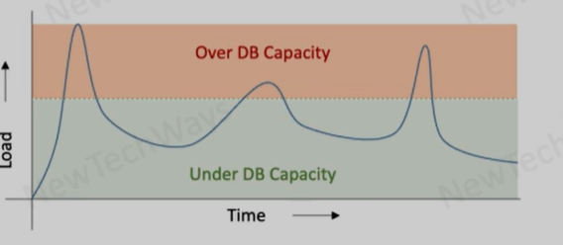

These peaks that exceed capacity of database write can be overcome by having a queue that would store and process later as load reduces. This helps scale write operations without needing to increase db write capacity.

Database-per-service pattern / Functionality Partitioning
- Each microservice like catalog service or inventory service has its own database
- Benefit is separation of concern that allows independent scalability
- Draw backs:
  - some common tables across services now can be accessed via API from main micro service in charge of that table: this leads to eventual consistency
  - Latency as API requests can be slow
  - Complexity of managing multiple db
ACID Transactions
- Group of db operations ALL HAPPEN OR NOTHING HAPPENS
- Why it matters?
  - If two operations are called
    - Deduct money from alex
    - Move into Hari
  - If one operation happens, other breaks. We loose money
  - Hence we need all to happen or nothing to happen
- Atomicity (prevent partial updates)
- Consistency (enforce business rules like id not duplicate)
- Isolation (prevent race condition from concurrent operations)
  - Two people trying to buy same item
  - Without isolation, both will buy and inventory goes -1
  - With isolation: only one succeeds
  - Enforced via locks or optimistic locking
- Durability (if complete transaction: changes persist even if system breaks)
Database Partitioning (horizontal scaling)
- Range partitioning
  - Data is split across multiple database instances(shards) based on a key range (id 1 to 100)
  - Uses B Tree under the hood
- Hash Partitioning
  - Hash(id)% (number of shards) - a diff algo is used in industry
  - Result of above formula maps to a shard where data would be stored
  - Pros: randomizes distribution of data hence no hotspots. In range partitioning, specific id range be hotspot
- Pros
  - High throughput as diff shards can be queried without overloading one db
- DRAW BACK:
  - ACID only for a shard because coordination between two shards breaks ACID principles. Example: if one shard is updated and update to other fails, we loose Atomicity.
Range Partition VS Hash partitioning
- Range Partition useful where query is range based like
  - SELECT * FROM table where id > 150 AND id < 200
  - B Tree structure allows efficient retrieval on range o(logn)
    - To search for data in database, we start from root. Then root helps us narrow search space by using internal node indexing like 11-30. Then we reach leaf node. Leaf nodes store pointer to the data in database.
  - 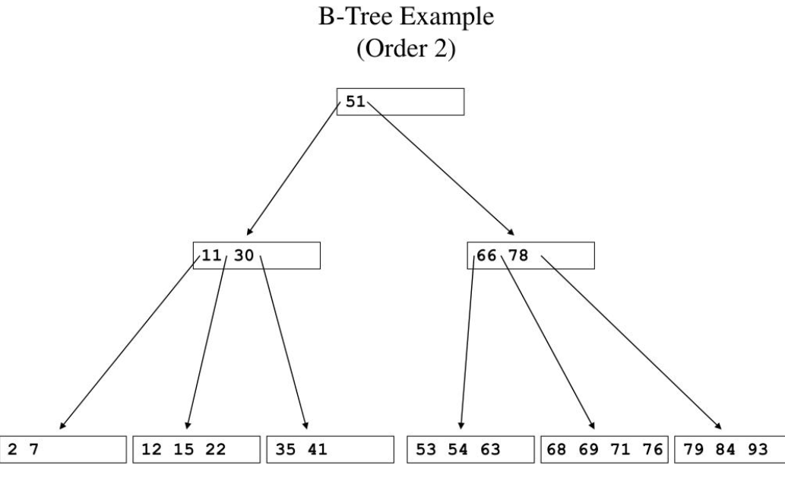
  - Hash partition would literally run query for each id in range across shards, which is slow.
- Hash Partition useful where query finds for one specific id
  - SELECT * FROM table where id = 150;
  - Hash map based with o(1) run time to find correct shard
  - Internally, shard itself can use B+ tree to find answer
Routing To Correct Database partition
- Client Library
  - Logic to map shards is stored on client side
  - No network hops needed to find correct shard
  - Each client updates shard map
  - Faster method but not scalable for many clients
  - MYSQL
  - Client -> correct shard = 1
- Router server
  - Service between client and database
  - It has information about diff shards
  - Sends request to correct database shard
  - Shard map stored on this central router. Clients do not need to update.
  - Slow due to network hop but scalable for large clients
  - Client -> router -> correct shard = 2
- Proxy Request (server side or cluster based)
  - Clients can connect to any database shard
  - That shard is responsible for redirecting clients to correct shard that has data used is requesting
  - One extra hop but client does not need to store shard map
  - DynamoDB
  - Client -> random shard -> correct shard = 2

Load Balancing
- Redirects requests to diff servers
- Provides one IP address that clients can connect to, reducing workload on client to remember all servers
- External load balancers can be discovered via DNS where client fetches ip address from the url of load balancer
- Client can be internal microservice. They fetch from discovery service and use their own load balancer to send request
Discovery Service
- Central registry where ip address of all healthy instances are stored
- Load balancers or individual services use discovery service to pull all servers
- Then load balancers use load balancing strategies to direct request

Hardware Based Load Balancer
- Load balancing at l4 and l7 layer( TCP, UDP, HTTP, DNS)
- In form of a Physical device
- Costly
- Very high throughput(100x times)

Software Based Load Balancer – application level
- balancing at l7 layer
- It is a software program and not a device
- HTTP, HTTPS, DNS
- Nginx
- Cheaper
- Slower than hardware based
- Content-based routing
  - This l7 load balancer operates on HTTP l7 layer so it can read http json
  - It can then redirect depending on url, jwt token, query parameter etcc
  - It is context aware routing
  - L4 only look at ip addresses, which is a draw back.
- Act as reverse proxy
- SSL Termination
  - If user sends request on HTTPS with secure layer, l7 balancer can break ssl and send info to backend server as HTTP for lower latency
- They can do health checks on backend server instances
- TTL are low for load balancers

DNS AS LOAD BALANCER
- Returns a single IP in a round robin fashion
- Can conduct health checks on servers
- Used when request destination(servers) do not change frequently like regions
- Can redirect request to a specific region based on
  - User proximity to data center
  - Client to data center latency
  - Data center geography: EU has policies that EU user request be kept in EU
- Disaster Recovery: if a region goes down, DNS can redirect request to other regions

Active-Active GLOBAL Data Application
- Two regions can accept both reading and writing and then do bidirectional replication
- Replication is async to prevent any deadlocks or failures

Auto Scaling
- Use to create or delete server instances based on demand
- Use monitoring service feedback to understand
  - CPU use
  - Disk use
  - Network use
- Thresholds are set in auto scaler for each service feedback. If threshold breached, auto scaler acts to increase or reduce instances.

Micro services Motivations
- High scalability because of decentralization and independence
  - Decentralization: each component can handle one specific kind of task
  - Independence: each component workers can work independently
- Frequent Deployment because of
  - Independent deployment
  - Independent development
  - Independent services

Service oriented architecture
- Application build as set of independent services that communicate over a network.
- Each service performs a business function.
Independent and PROS
- Each service has own stack and can be scaled independently
Dependent and CONS
- They need to speak same language to understand each other. Hence, common interface/schema. For example, common json format or xml.
- One service sends “userid” while other expects “id” and hence these break.
- Shared databases across services would require common schema across services. Hence, database cannot be scaled independently.
- Deployment challenges as schema changes can break service communication and hence services need to be deployed together.
QUESTION FOR ALEX?
Explain me point about how SOA is bad for databases?

Microservices (share nothing architecture)
- EACH SERVICE gets its own database, schema, and tech stack.
- We do when we have scalability requirements
- Issue of having common schema across service is solved by:
  - There is an adapter/mapping layer between services that maps schema of one service to another. Payment may store “userid” and order may store “id” so aggregator maps this and sends request in format a service understands.
  - API versioning ensures new schema does not affect services as services use older api versions until services upgrade their mapping tables.
- Rest interface used instead of SOAP(XML)
- PROS:
  - This gives loosely coupled desigN
  - Independent dev
  - Independent deployment
  - Independent scaling on services
- Cons:
  - Code and functions cannot be reused across services lead to duplication

Microservice Transaction
- Transactions involve multiple services like order service, inventory, and shipment
- Two ways to achieve transactions in microservices
  - Distributed Acid transactions
    - Order server would ask shipment and inventory
    - Each shipment and inventory would check their db and respond with yes or no
    - If any of them reject, whole transaction is rejected by order service and roll back is issued.
    - This is ACID
    - This is two phase commit.
    - Not scalable as other order request for same data are blocked
    - RARELY USED in industry
  - Compensating transactions
    - Saga pattern
      - We commit to each service
      - We undo all committed services if any service fails or return reject.
      - We call this compensating because we compensate for failed service commits by undo other committed ones.
      - Async processing.
      - Scalable because we do not block or wait for all services to respond.
      - Eventual consistent because failed commits lead to undo to get consistency across all services.
      - Transactions on diff services are not isolated as outcome of one affects others. Business use case is not to have isolation as order service should depend on other services.
      - 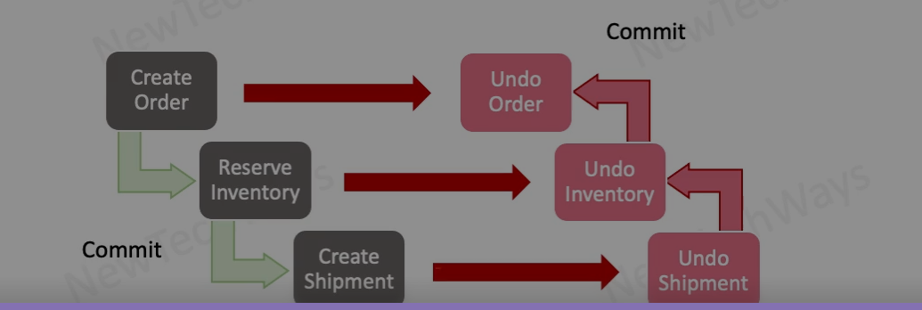

Micro service communication model
- Synchronous
  - Waiting for response
  - For read query or real time system
- Asynchronous
  - Delayed response and no waiting
  - For write transactions
  - High scalability

MICROSERVICE Event Driven Transactions(async)
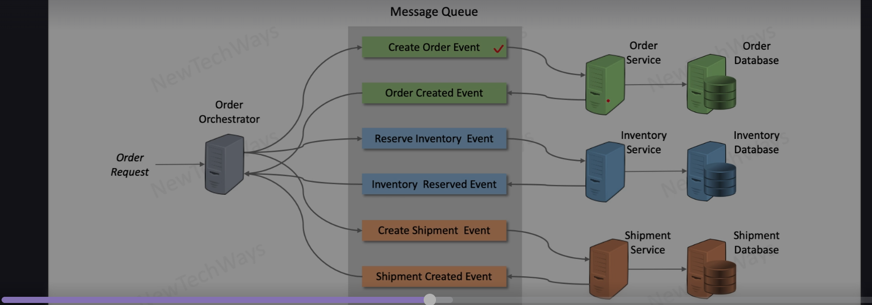
- Edge cases
  - If order event created but not acknowledged back in order create event, we resend “create order event”. Order service should check if order was created by polling database and respond accordingly.
  - If reserve inventory fails and responds with failure, order orchestrator sends undo events to all services as part of SAGA compensation pattern
NOSQL DB
- Transaction at row level is ACID.
- Aggregate output of diff tables in a row to get ACID.
- Eventual consistency across aggregates.
- Low latency as transactions distribute across nodes so no queue building.
- and high scalability

Kafka
- Partitions queue based on data
- Horizontal partitioning and hence scalable.

