Experiment:
- Internal cluster-based monitoring => Alex
  - Fast api servers
  - Send heart beats
  - Pick the unhealthy ones
- Byzantine fault tolerance => Alex
- Pick the next available Node => consensus algo => Hari Lal
  - Diff standby and primary instances
  - Pick the next best standy as primary based on industry standard algorithm

use a known communication protocol to simulate heart beat checks and recovery
- External based monitoring and how to recover
- How exactly are nodes in stateful recovery recovered given they store state?
- Byzantine protocol

Reliability
- Can I trust system long term?
- Components:
  - Fault tolerance
    - Ability for system to continue to function correctly and remain available despite partial failures
  - Availability
    - Probability of system to work correctly in a given time interval

Single point of failure
- One component in a system, if fails, causes entire system to fail
- Load balancer example
- DNS a single point of failure

Partial Failures
- Network Failures
  - Local Area Network (LAN) – like home wifi
  - Wide Area Network (WAN) – like internet
  - Load Balancer
- Machine Failure
  - CPU
  - DISK
  - Memory
- Software Failure – process
- Operations
  - Deployment failure’
  - Config failure (cloud flare had one recently)
  - Load induced failure
  - External service failure
- After a point, it is more economical to build systems that can recover from failure instead of preventing failure
Availability
- Probability of system working correctly at any given time and being available for operations
  - Time based availability:
    - Uptime / (downtime + uptime)
    - Used by most AWS services like EC2
  - Request based on availability
    - (Success request) / total request
    - Used by AWS S3 since it is distributed so time based is hard to compute for entire system
    - API based systems use this method
- Availability requirements are dependent on impact of availability on a business
  - An Atm or payments needs to have 99.999 availability
  - A batch processing load can have 99 percent availability

Fault Tolerance (tolerate the fault)
- Ability of system to continue operating despite partial failures
  - Detect partial failures
  - Handle partial failures
- Example: one server fails but 3 others work so load balancer redirects to health ones and system is working overall and hence fault tolerant
Serviceability
- How easy is it to fix the issues?

Redundancy
- Not same as scalability
  - Scalability => Imagine DNS redirecting to 3 diff active load balancer to handle more load faster
  - Redundancy => each of three active load balancers have stand by load balancer with state replication so that if active fails, standby takes over
- Replication/Duplication of critical components to increase reliability
- Database replica is an example of redundancy
Types of Redundancy
- Active Redundancy – Hot Spare
  - All nodes do processing
  - No concept of primary or secondary
  - Highest availability
  - Example: Several EC2 servers behind load balancers
- Passive Redundancy – Warm spare
  - Only active nodes do processing
  - Primary component handles operations
  - Backup components remain dormant
  - Quick recovery but less availability compared to active redundancy
  - Example: UPS is idle till power system fails
- Cold Redundancy – spare(backup)
  - Spare components brought in when primary fails
  - Less available.

Redundancy for stateless components
- Create replicas with Active-Active redundancy
- Target: make services stateless and use stateless replication
- Load Balancer (stateless)
  - Can be a single point of failure
  - Active-Active Redundancy(most common):
    - Several load balancers used
    - all expose same IP

Redundancy for stateful components
- Databases are stateful
  - For databases, we could use primary and secondary(replica)
  - Active-Active redundancy for synchronous replication
  - Passive redundancy for asynchronous replication
    - With asynchronous replication, there can be data loss if primary db fails completely and we are unable to recover data for secondary instance to use.
      - But it gives high read write availability

- Caches
  - Stateful
  - Not the source of truth
  - Can be lost and rebuilt
  - Caches use
    - active-active caching (most common) != redundancy
      - All nodes are active
      - data is sharded across nodes with range based sharding
      - If one node fails, its requests hit DB, causing db overload
      - Fast as sharding used
      - Scalable as multiple nodes used at once
      - Risky for database due to sudden burst in load
    - Active-passive caching == redundancy
      - Each cache shard has
        - Primary node
        - Replica node
      - Writes go to primary and data copied over to replica
      - High availability as no cache wipeout
      - Less load on database in case of failure
      - Uses double the memory
      - More complex
  - Memcached does not provide redundancy
  - Redis provides cache redundancy

Datacenter Redundancy
- Problems: earthquake, flood, Alien invasion
- Physically separate data centers
- Zonal Redundancy
  - Running your infrastructure across zones within a region(same city) to eliminate a single point of failure
  - Each zonal data center has its own power, cooling, networking
  - AWS us-east-1 has multiple Availability zones like us-east-1a, 1b
  - 10-50 KM apart: far enough to survive power outages and close enough for low-latency network connections
  - ACTIVE-ACTIVE redundancy
    - Requests are directed to load balancers across zones
      - All nodes are active
      - Each write is replicated to other nodes in other zones
  - Active – passive redundancy
    - Primary db in one zone, Replicas in another zone. Synchronous replication.
    - Do not confuse read replicas with active passive redundancy. Read replicas are for different purpose of scalability rather than high availability
  - High availability
- Regional Redundancy
  - Region has multiple AZ
  - Disaster recovery
  - Running infra across regions to eliminate single point of failure
  - DNS used to route traffic
  - Active-passive redundancy
    - Replication is asynchronous due to large distances

Fault Models
- Response Failure: server is alive and does not respond
- Timeout Failure: server responds late
- Incorrect Response Failure: response is unexpected
- Crash Failure: server crashes while running
- Arbitrary Response Failure (aka Byzantine failure):
  - server behaves in an UNPREDICTABLE or malicious way
  - crashes, incorrect responses in unexpected fashion

Health Checks
- External Monitoring Service
  - Ping based
    - Send HTTP or TCP request and check for response
  - Output =>
    - Alerts for recovery
    - Events like CPU usage => used for autoscaling
  - Monitor for response
    - Response code matches expected
    - Response time matches expected
    - Number of retries we plan to do to check health
  - Example: Police checking on people
  - Simpler
- Internal cluster monitoring
  - Used by load balancers, database
  - Heartbeat based
  - Nodes send message at regular intervals to
    - Other nodes directly (peer to peer: gossip protocol))
      - Dynamodb
    - Or Master node
      - RDBMS
  - Requires protocols for communication and recovery
  - Replication happens from primary to secondary all the time. If primary goes down, system chooses secondary that is most upto date information.
  - Example: family members checking in on each other
  - Load balancer example:
    - Primary is down
    - Secondary sends heartbeat and realizes primary is down
    - Secondary initiates recovery by taking on IP of primary
  - Industry pattern
    - Create a new monitoring cluster
    - Put all nodes in that cluster
    - Nodes do communication and heartbeat
    - Cluster handles recovery
    - Cluster as a single unit is highly available
  - Complex
  - 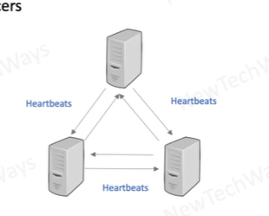

RAFT CONSENSUS ALGORITHM
- Used to ensure all nodes have latest log operations and are consistent
- Here is video for more details: Understand RAFT without breaking your brain

Stateless Recovery
- Hot standby
  - Use already OTHER redundant instances if one fails
- Warm standby
  - Report instance death to autoscaler
  - Kill older instance
  - Launch a new instance and use that
- Examples: load balancers
- Similar to scalability principles
Stateful Recovery
- Active – Passive redundancy because replication is going on between primary to secondary continuously so that state is maintained
- We need to have primary database with latest information so we came up with voting mechanism that choose primary
- Virtual Ip (aka floating IP)
  - 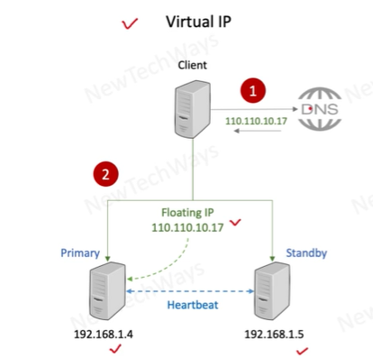
  - Client reaches virtual IP
  - For recovery, standby requests floating IP be transferred to standby in case primary fails
  - Data was already being replicated to standby
  - Load balancers use virtual IP because IP is consistent for the whole time
- Registry/Router/DNS
  - 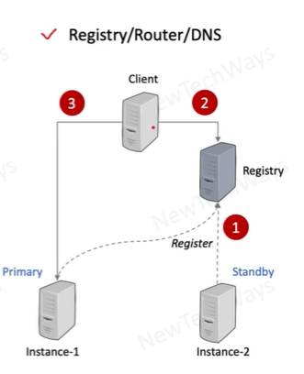
  - Client uses registry to know what IP instance to hit
  - Primary and secondary instances send heartbeats to Registry
  - In case of failure of primary, registry knows and hence redirects user to secondary instance. State was already being replicated to standby even before failure
- Examples: databases, caches

Database Recovery – Hot Standby
- Synchronous replication between primary and secondary
- Prevents data loss
- These instances should be closer in distance to reduce latency
- Lower write availability

Database Recovery – Warm Standby
- Asynchronous replication
- Minimal data loss if changes were not replicated on time
- High write availability
- Distance between instances not a concern hence can be multi-regions

Database Recovery – Cold
- Databases are backed up periodically
- Slowest method of recovery
- Ideal when DB got corrupted and we want to recover from backups non-corrupted one. Replicas get corrupted too so backups are ideal.
- Backups can be stored across regions for disaster recovery

Game Days (BIG TECH companies)
- Monthly and Quarterly failure testing
- Engineers kill ECS tasks, block SQS queue, throttle databases
- Intent is to check system can tolerate the fault and raise alerts

Cascading Failure
- When failure in one component causes failure in dependent components, causing widespread system failure
- Example:
  - Service A has 100 threads.
  - Service A routes request to three services
  - Assume 50% of requests go to service B
  - When Service B does not respond, 50% of threads are blocked.
  - 50% of threads still operate for other services
  - Upon next batch of requests, more threads get blocked as service B is down
  - Eventually, all threads get blocked in Service A cause disruptions
- How to avoid
  - Add timeout in each response.
  - If response comes later than timeout, free threads in Service A
  - This ensures system is operational while team fixes service B
Transient Failure
- Failure that is temporary and goes away itself
- Trans means across. Transport means travel across. Transient means failure that travels across and disappears
- Example
  - Temporary throttle on DynamoDB
  - S3 timeout due to network glitch
System Error
- Errors that persist and cannot be fixed itself
- Example:
  - IAM permissions missing to access S3 bucket
  - Broken code or configuration
- CANNOT be fixed with retries

How to identify whether to retry
- If failure is transient, server can return HTTP 503 Service Unavailable. Client can retry.

Mechanisms to handle RETRY
- Exponential Backoff
  - Client component
  - Exponential Delay = base_delay * 2^n where n is attempt number
  - Random exponential Delay = random(0, Exponential Delay) ensures failed
  - retries happen randomly instead of all at once
- Idempotency Key/Token
- Client generated component
- Use case
  - Client sends request to API for burger
  - API sends request to database with success
  - API encounters transient failure when responding to client with success
  - Client retries as transient failure can be retried
  - API ends up creating duplicate orders in database
  - IDEMPOTENCY is compromised
- Solution
  - Client generates Idempotency key and sends in header to API for each unique order
  - API requests Database for order
  - API stores Idempotency key in cache only if database request was successful
  - Upon retry by client, API verifies that idempotency key exists in cache and hence returns success without duplication in database
  - 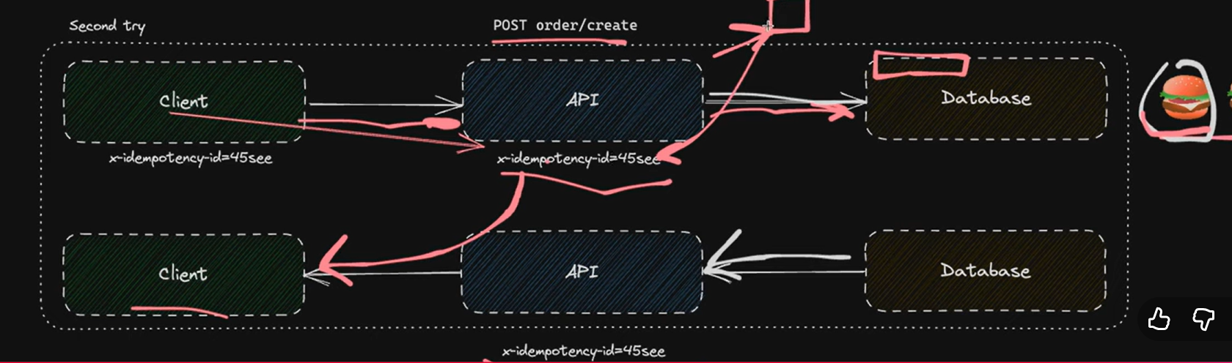

- Circuit Breaker
- Client component
- When dependency is failing, stop the request temporarily to prevent from making things worst and retry after some time
- Client keeps track of rate of failure for responses returned by a service
- If failure rate above threshold,
  - client opens the circuit and stops requests.
  - Uses either
    - Default values
    - Cached values from prior service responses
    - Returns error messages
- Client checks back again after some time by sending a small subset of request to study failure rate
- If failure rate within threshold, client closes circuit and sends all request to service.
- Circuit breaker pattern is a STATE MACHINE with
  - Closed state(all requests sent),
  - open state(no requests sent),
  - half open state(subset of requests sent)
- Circuit breaker prevents cascading failure

Fail Fast
- Server component
- Technique that requires detecting failure early in execution and return failure immediately
- It prevents wasting compute resource, storage cost, and time
- Examples:
  - Validation fails for input csv, fail fast before processing
  - Circuit breaker is open due to high failure rate, fail fast before sending request again to affected service
Shed Load
- Server component
- Inspired by load shedding in electricity where power is cut to certain low-priority areas due to excessive load on power lines. Ensure critical areas get power
- Software load Shed means to reject or drop certain requests when traffic has exceeded thresholds.
- Examples
  - Kafka queue is full, reject new requests to prevent crash
  - Any requests after throttling limit are shed

Back pressure
- Mechanism through which consumer controls rate at which producer sends requests
- Often involves buffer or queue between consumer and producer
- If rate of request is faster than consumer can handle, buffer fills up and producer gets 429 Too Many Requests errors.
- Example:
  - API gateways uses rate limits to limit number of requests sent by client
  - TCP connection has receiver buffer that tells sender how many bytes it can take. Sender uses “bytes left” information to send only that many bytes.

