Security
Network Security
- Security concerned flow of information over network.
- Symmetric Encryption
  - Same key used to encrypt and decrypt
  - Symmetry word refers to same on both sides where same here means same key
  - Key is kept private
  - Both client and server must know key
  - Fast
  - Scalable
  - Example:
    - Enigma machines during world war used this method
  - Issue:
    - Key sharing was concern because key if exposed would reveal secrets
- Asymmetric Encryption
  - Pain point: sharing symmetric key over network is risky.
  - Older solution (RSA):
    - Client generates a symmetric key
    - Client uses publicly available server key to encrypt this symmetric key
    - Server uses its private key to decrypt the symmetric key
    - Only server can decrypt because only server has private key
    - We were able to send encryption keys without vulnerability
    - Actual data still use symmetric key. Asymmetric encryption solved key sharing problem.
    - Actual data uses symmetric key as it is faster for large text than asymmetric key
    - Drawback:
      - If private key is leaked on server side, all past encrypted data is exposed
  - Modern Solution => Diffie-HEllman
    - Client generates temp public and temp private key
    - Server generates temp public and temp private key
    - Both server and client agree on public keys
    - Client uses (server public key + client private key) to produce a new intermediate key
    - Client NEVER SENDS this intermediate key. This is used to encrypt data
    - Server uses (client public key + server private key) and ends up with same intermediate key.
    - Intermediate key is not shared. Both server and client get same intermediate key and hence shared secret that they can use to encrypt and decrypt data
    - Draw back:
      - Still if private keys get exposed on either side, data is hacked
    - Solution:
      - Forward secrecy:
        - Each session generates new public and private key for both server and client
        - Ensures older private keys do not affect new sessions
  - Authentication
    - Server sends these information to verify itself to client
      - Public key
      - Digital Signature signed by Certificate authority
      - Domain name
    - Client has trusted Certificate authority list and can verify
    - Problem:
      - What if handshake message is intercepted and attacker impersonates server?
    - Solution:
      - Server sends handshake message signed by its private key
      - Only server has private key
      - Client decrypts with public key and verifies actual server sent.

Hashing
- Converts text of any size into fixed size value
- One way: you cannot convert hashed value back into raw text
- Fast
- Deterministic: same text should produce same hash value if same algorithm used
- Popular algorithms:
  - SHA 2(SECURE HASH ALGORITHM)
    - 256 BITS size to 512 bits size
    - Less collision but poor performance as large bits are slow
  - MD 5
    - 128 bits so more collisions
- Use case:
  - Data integrity checks to ensure text was not tempered as same text means same hash
  - Passwords are hashed and then compared to prevent attacker from accessing raw password text

Digital Signature
- Application of Hashing + Private/public keys
- Pain points:
  - Hard to verify sender
  - Data integrity if data changed during transfer
  - Sender could deny sending message when they actually did => Non-repudiation
- Goal:
  - Verify sender using old RSA method of private public key
  - This is called RSA Signature. RSA encryption is deprecated in TLS but RSA signature is widely used to establish initial verification.
- Sender’s role:
  - Hash the actual data with hash function known to sender and receiver
  - Encrypt the hash key generated with sender private key
  - Sent the encrypted hash key
  - Sent the actual data.
- Receiver’s role:
  - Hash the data sent by sender with shared hash function => hash key produced
  - Decrypt the encrypted hash key sent by sender using sender’s public key
    - Only sender’s public key can decrypt data signed by sender’s private key
    - If decrypt fails, sender is not actual sender
  - Compare decrypted hash key with hash key receiver got by running hash function on actual data
  - If comparison valid, sender is verified and data is not changed
  - If comparison invalid, data is manipulated because hash key is different on data than one sent by sender
Digital Certificate
- Pain point
  - How do we verify public key belongs to a legitimate source?
  - Digital signatures only help us know that data signed by private key holder matches them because their public key works on decrypting data
- Solution:
  - A domain registers itself with a certified central authority (CA).
  - The domain provides its identity information (name, location, organization) and its public key.
  - The CA verifies ownership of the domain.
  - The CA hashes the certificate data and signs the hash using the CA’s private key, producing a digital signature.
  - Clients have a list of trusted CAs and their public keys pre-installed.
  - The client verifies the CA’s signature using the CA’s public key to recover the original hash.
  - The client hashes the received certificate data itself.
  - The client compares the two hashes.
  - If they match, the domain is authenticated and trusted.

SIGN VS ENCRYPT
- Sign
  - Used to verify sender
  - Private key used to sign
  - Public key used to verify because if public key works, it means sender had private key and private key is only with actual trusted sender so we verified
- Encrypt
  - Used to hide information
  - Data encrypted with public key
  - Decrypted with private key.
  - Once encrypted with public key, only holder of private key can decrypt so information hidden and safe
TLS Handshake modern day
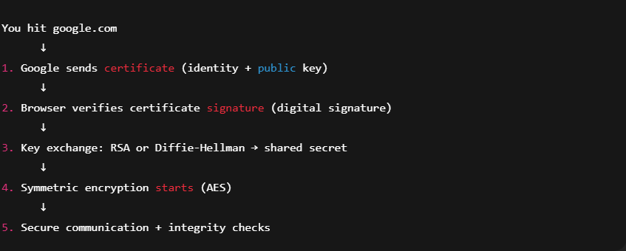

Chain Of Trust
- Pain point
  - Root CA cannot sign all the website in the world. Not Scalable
  - If root CA private key leaked, entire internet exposed. Single point of failure
- Solution
  - Delegate work to intermediate CAs
  - Root CA signs intermediate Cas
  - Intermediate Cas handle millions of websites and verification
  - Scalable and safe
- Should client store public keys of all CAs?
  - No.
  - Client stores information about root CA
  - Recurse through certificate issued by intermediate CA till you find root certificate
  - Flow =>
    - Browser gets certificate from google.com
    - Brower notices certificate authority not in my list
    - Browser verifies this intermediate CA certificate by using digital signature on it
    - Browser reaches parent authority of intermediate CA
    - This process keeps going till root CA is found and verified.
    - 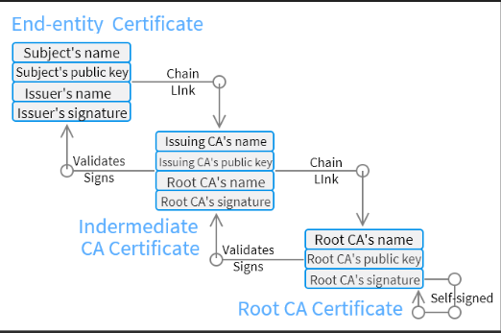

Load Balancer + TLS
- Pain point:
  - Installing certificates on each backend server that is hit by client leads to management overhead and non-scalable system
  - Security often needed at client and server interaction
- Solution:
  - Put certificate on load balancer
  - Load balancers can send client certificates and establish TLS connection
  - Reduces certificate management overhead

Firewalls
- Sits between internal network and external network
- Ingress configs
  - Rules to control flow of request into the internal network
  - Prevent malware from hitting internal system
  - Example
    - Allow TCP 443(443 means TLS SECURE)
    - DENY SSH 22(non-secure)
- Egress configs
  - Rules to control flow of request out of the internal network
  - Help protect leak of confidential information to outer network
- Our microservices can be divided into regions called subnetworks
  - Each subnet can be protected with firewall and allow connection on defined ports like 443 for TLS secure
  - Database subnet, services subnet, demilitarized subnets(closer to clint)

Authentication
- Identifying user’s identity

Credential Transfer methods
- HTML Forms
  - Users enter username and password and these are sent via HTTPS
  - Server validates and generates session id
  - Server stores session id in database or redis cache
  - Server tells browser to set a cookie with session id and http only
  - Server keeps to HTTP only so that cookie could not be read in javascript because attackers can steal cookie
  - Browser stores cookie and sends cookie with request next times
  - Server receives cookie from browser and checks if session id found in database
  - Cookie and session id in it ensures user does not have to log in again.
- Digest Based
  - Server sends hashing algorithm and weights
  - Client enters password and hashes with server suggested algorithm
  - Client sends hashed passwords over
  - Server compares hashed password with hashed password stored in database
  - If they match, authentication done
  - NOT USED in industry due to latency
- Certificate Based
  - Client must posses a certificate
  - Client sends a signature signed with client private key
  - Server verifies signature signed by certificate authority to verify public key is trusted
  - Server uses public key to verify client had private key
  - This method relies on client having private key and client public key verified by CA.
  - Pros: highly secure
  - Cons: clients usually do not hold certificates in online shopping

Credentials Storage methods
- Databases
  - RDMS or NOSQL
  - Used for consumer-facing apps where clients are external users
  - Application has control over authentication
  - Useful for single application setup where each application has its own database for authentication
- Active Directory
  - Uses LDAP protocol
  - Useful when client are employees within organizations
  - Hierarchical TREE like order. For example, within department finance => team financial modelling => user Hari Lal
  - Super-fast for reading but less write performant
  - Often used when internal employees need to authenticate to applications in a big org like Amazon.
  - Active directory stores users, devices, printers, computers. Admin use it to control access.

Stateful Authentication
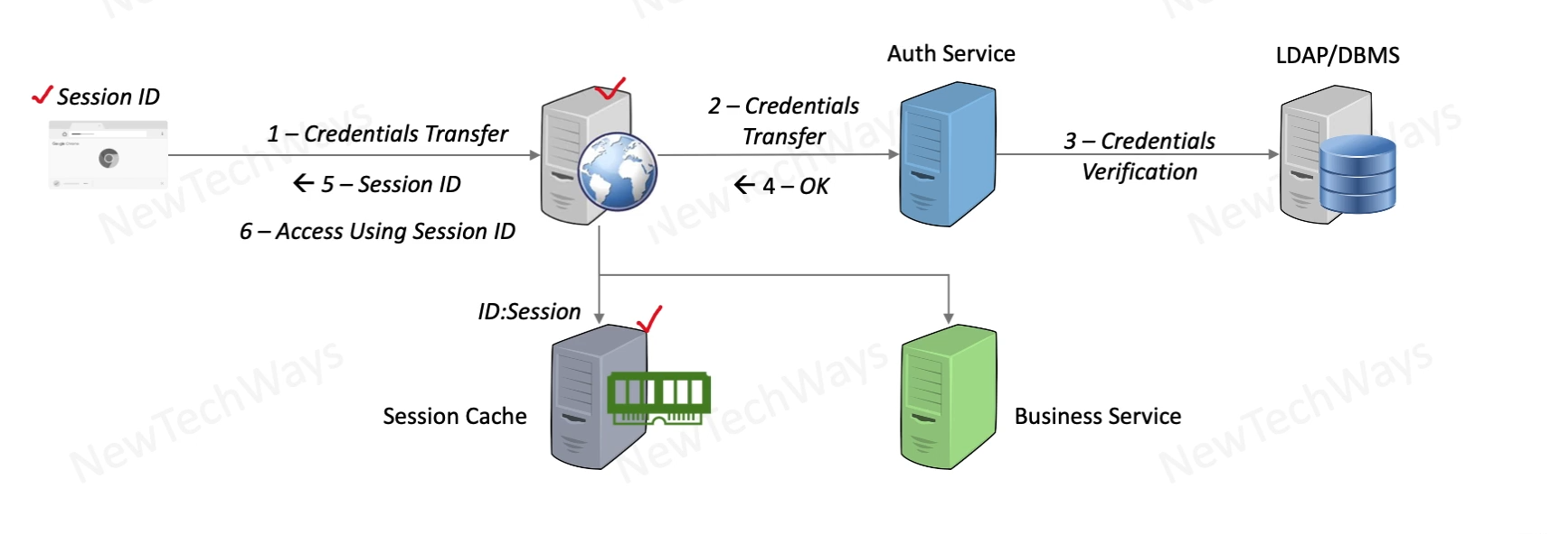
- Auth service is responsible for comparing credentials from database and user request
- Web application layer takes care of maintaining session
- We must use session cache like Redis instead of keeping session id in memory for scalability
- Best Use:
  - web apps that require real users often use session based stateful authentication.
  - Github.com website uses session ids too
  - Reason is stateful gives more control to server to revoke session access when user logs out
  - Scale is concern but not as much concern compared to APIs based workflows.

Stateless Authentication
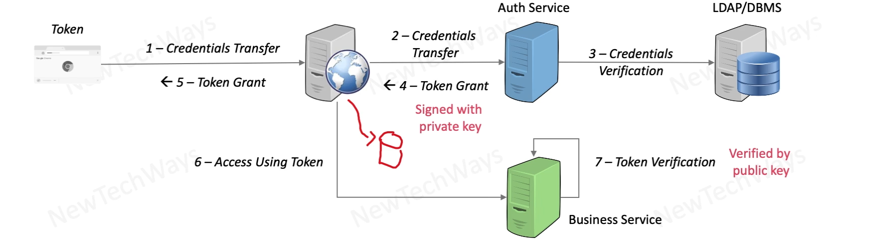
- Server does not store the session ids.
- Used for API based workflows like interaction between microservices
- Highly scalable as web application layer is not a bottleneck anymore
- How it works:
  - Client sends credentials
  - Auth service generates token with information like identity and role of user
  - Auth services signs token with its private signature.
  - Client gets token and sends this token to any new request
  - Business service uses public key to determine if auth service had used its private key to sign this token
  - If public key worked, client is authenticated and client identity and role is stored in token itself.
- Attackers can steal token so keep token short living.

Single Sign On
- Pain point: users had to sign into different apps again and again
- Solution:
  - When user visits any app, redirect to a central authentication system that generates token and returns token
  - User can use token to access multiple apps without reentering passwords.

Access Controls
- Comprises of three components
  - Identity (WHO)
    - Can be user id
    - Can be group of user id
  - Permissions (can do what)
    - Defines methods allowed like GET, POST, PUT
  - Resources (on what)
    - S3 bucket
    - Databases
    - API end point
    - 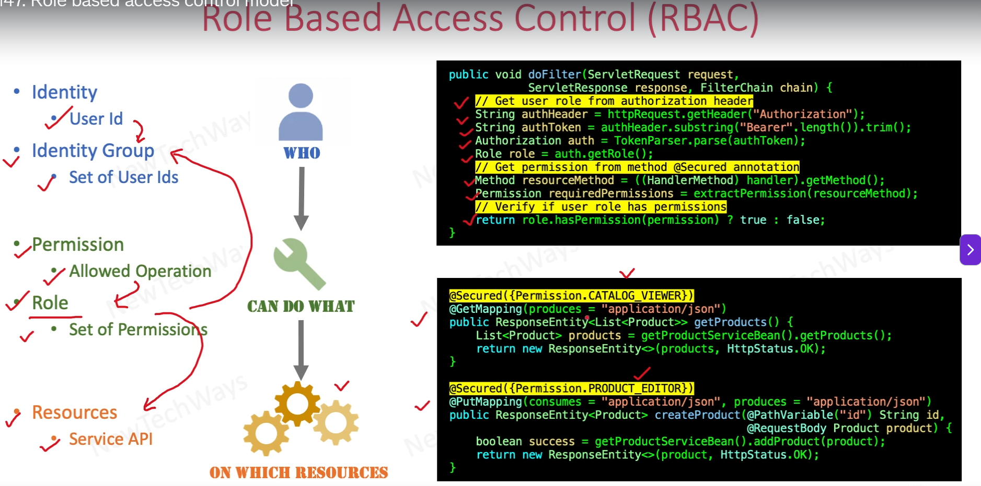
- 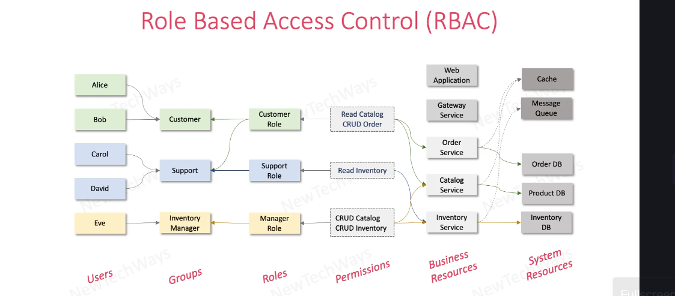
- WHY groups are not given direct access via roles to system resources?
  - User groups are less stable and change as users move around different functions
  - System resources should hence be decoupled for scalability and stability else database reconfigurations would be required
  - Business resources are stable so they provide interface for users to interact with system services

OAuth2.0
- Token type used: Bearer
- Token formats:
  - SAML
    - DEMO THIS TO ALEX Z
    - Written in XAML
    - Used for single sign on with multiple application like Drexel connect with drexel one, dragon network.
    - Heavy payload so slower
    - Stronger contracts and enterprise trusted
    - Supports browser redirects
    - One-time use with shorter expiry makes it more secure for future attacks
    - Flow
      - User tries to connect to service providers like drexel connect
      - Drexel connect redirects user to Identity Provider like Google or Microsoft AD
      - User authenticates with password and idp generates SAML response and redirects user back to service provider
      - User tries to connect to service provider with SAML token
      - Service provider verifies token and issues session id
      - User uses session cookie to navigate.
      - SAML only used ONCE
      - Idp stores user passwords in active directory with LDAP protocol
      - Service providers do not store passwords. They trust idps.
      - SAML is base 64 encoding because xml has tags that are not URL safe.
  - JWT
    - Json web token
    - Header + payload + signature
    - Uses public private cryptography to establish trust
    - Used for APIs or interactions between microservices
    - Used for single application for being fast
    - JSON payload is lightweight, so JWT is scalable
    - Can last as long as expiry hence if compromised, security vulnerabilities.
Api keys
- Used for machine-to-machine interaction
- Used when API is given as service
- Not suited for authentication and authorization
- Regulates API use to ensure API access within rate limits
- Does not usually expire
- Unlike JWT, state of user like identity and role does not live in API key but server must maintain a state to trace api key to identity.

